UNITED STATES
SECURITIES AND EXCHANGE COMMISSION
WASHINGTON, D.C. 20549
___________________________________
FORM 8-K
___________________________________

CURRENT REPORT
Pursuant to Section 13 or 15(d) of
the Securities Exchange Act of 1934
Date of Report (Date of earliest event reported): October 23, 2026
___________________________________
Booz Allen Hamilton Holding Corporation
(Exact name of Registrant as specified in its charter)
___________________________________

Delaware |  |  |  |  |  |  |  |  |  |  |  | 001-34972 |  |  |  |  |  | 26-2634160
(State or other jurisdiction  of incorporation) |  |  |  |  |  |  |  |  |  |  |  | (Commission  File Number) |  |  |  |  |  | (IRS Employer  Identification No.)
8283 Greensboro Drive, |  |  | McLean, |  |  | Virginia |  |  |  |  |  |  |  |  |  |  |  | 22102
(Address of principal executive offices) |  |  |  |  |  |  |  |  |  |  |  |  |  |  |  |  |  | (Zip Code)
Registrant’s telephone number, including area code: (703) 902-5000
___________________________________

Check the appropriate box below if the Form 8-K filing is intended to simultaneously satisfy the filing obligation of the Registrant under any of the following provisions:
☐ |  |  | Written communications pursuant to Rule 425 under the Securities Act (17 CFR 230.425)
☐ |  |  | Soliciting material pursuant to Rule 14a-12 under the Exchange Act (17 CFR 240.14a-12)
☐ |  |  | Pre-commencement communications pursuant to Rule 14d-2(b) under the Exchange Act (17 CFR 240.14d-2(b))
☐ |  |  | Pre-commencement communications pursuant to Rule 13e-4(c) under the Exchange Act (17 CFR 240.13e-4(c))
Securities registered pursuant to Section 12(b) of the Act:
Title of Each Class |  |  | Trading Symbol |  |  | Name of Each Exchange on Which Registered
Class A Common Stock |  |  | BAH |  |  | New York Stock Exchange

Indicate by check mark whether the registrant is an emerging growth company as defined in Rule 405 of the Securities Act of 1933 (§230.405 of this chapter) or Rule 12b-2 of the Securities Exchange Act of 1934 (§240.12b-2 of this chapter).
Emerging growth company ☐

If an emerging growth company, indicate by check mark if the registrant has elected not to use the extended transition period for complying with any new or revised financial accounting standards provided pursuant to Section 13(a) of the Exchange Act. ☐

Item 2.02 Results of Operations and Financial Condition.
On October 23, 2026, Booz Allen Hamilton Holding Corporation (the “Company”) issued a press release announcing its results of operations for the fiscal year ended September 30, 2026. A copy of the press release is attached hereto as Exhibit 99.1.
The information in this Item 2.02 and Exhibit 99.1 shall not be deemed to be “filed” for purposes of Section 18 of the Securities Exchange Act of 1934, as amended (the “Exchange Act”), or otherwise subject to the liability of that section, and shall not be incorporated by reference into any registration statement or other document filed under the Securities Act of 1933, as amended (the “Securities Act”), or the Exchange Act, except as shall be expressly set forth by specific reference in that filing.
Item 7.01 Regulation FD Disclosure.
On October 23, 2026, the Company posted to the “Investor Relations” section of its website the presentation that accompanies the earnings conference call. A copy of the presentation is attached hereto as Exhibit 99.2.
The information in this Item 7.01 and Exhibit 99.2 shall not be deemed to be “filed” for purposes of Section 18 of the Exchange Act or otherwise subject to the liability of that section, and shall not be incorporated by reference into any registration statement or other document filed under the Securities Act, or the Exchange Act, except as shall be expressly set forth by specific reference in that filing.
Item 9.01 Financial Statements and Exhibits.

Exhibit  No. |  |  |  |  |  | Description
99.1 |  |  |  |  |  | Press Release dated October 23, 2026
99.2 |  |  |  |  |  | Earnings Conference Call Presentation
104 |  |  |  |  |  | The cover page of this Current Report on Form 8-K, formatted as inline XBRL.

SIGNATURES
Pursuant to the requirements of the Securities Exchange Act of 1934, the registrant has duly caused this report to be signed on its behalf by the undersigned hereunto duly authorized.

 |  |  | Booz Allen Hamilton Holding Corporation
BY: |  |  | /s/ Troy Lahr
 |  |  | Troy Lahr
 |  |  | Executive Vice President and Chief Financial Officer
Date: October 23, 2026
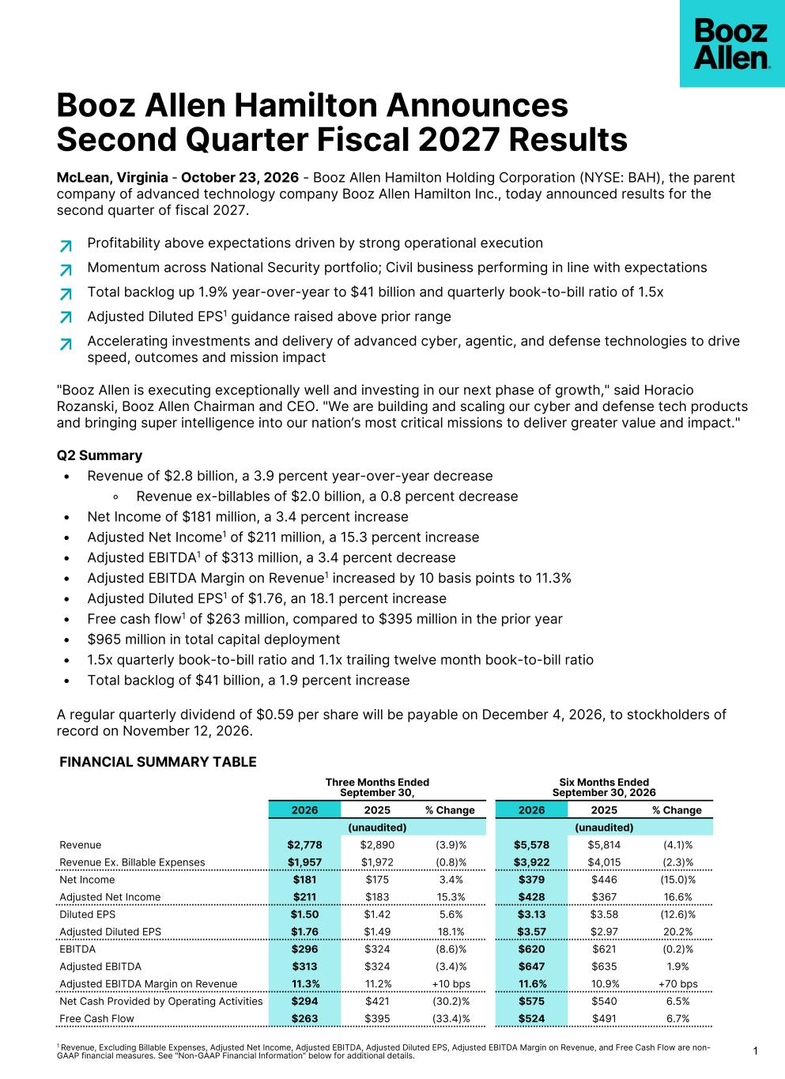

Booz Allen Hamilton Announces Second Quarter Fiscal 2027 Results 11 Revenue, Excluding Billable Expenses, Adjusted Net Income, Adjusted EBITDA, Adjusted Diluted EPS, Adjusted EBITDA Margin on Revenue, and Free Cash Flow are non- GAAP financial measures. See "Non-GAAP Financial Information" below for additional details. McLean, Virginia - October 23, 2026 - Booz Allen Hamilton Holding Corporation (NYSE: BAH), the parent company of advanced technology company Booz Allen Hamilton Inc., today announced results for the second quarter of fiscal 2027. Profitability above expectations driven by strong operational execution Momentum across National Security portfolio; Civil business performing in line with expectations Total backlog up 1.9% year-over-year to $41 billion and quarterly book-to-bill ratio of 1.5x Adjusted Diluted EPS1 guidance raised above prior range Accelerating investments and delivery of advanced cyber, agentic, and defense technologies to drive speed, outcomes and mission impact "Booz Allen is executing exceptionally well and investing in our next phase of growth," said Horacio Rozanski, Booz Allen Chairman and CEO. "We are building and scaling our cyber and defense tech products and bringing super intelligence into our nation’s most critical missions to deliver greater value and impact." Q2 Summary • Revenue of $2.8 billion, a 3.9 percent year-over-year decrease ◦ Revenue ex-billables of $2.0 billion, a 0.8 percent decrease • Net Income of $181 million, a 3.4 percent increase • Adjusted Net Income1 of $211 million, a 15.3 percent increase • Adjusted EBITDA1 of $313 million, a 3.4 percent decrease • Adjusted EBITDA Margin on Revenue1 increased by 10 basis points to 11.3% • Adjusted Diluted EPS1 of $1.76, an 18.1 percent increase • Free cash flow1 of $263 million, compared to $395 million in the prior year • $965 million in total capital deployment • 1.5x quarterly book-to-bill ratio and 1.1x trailing twelve month book-to-bill ratio • Total backlog of $41 billion, a 1.9 percent increase A regular quarterly dividend of $0.59 per share will be payable on December 4, 2026, to stockholders of record on November 12, 2026. FINANCIAL SUMMARY TABLE Three Months Ended September 30, Six Months Ended September 30, 2026 2026 2025 % Change 2026 2025 % Change (unaudited) (unaudited) Revenue $2,778 $2,890 (3.9)% $5,578 $5,814 (4.1)% Revenue Ex. Billable Expenses $1,957 $1,972 (0.8)% $3,922 $4,015 (2.3)% Net Income $181 $175 3.4% $379 $446 (15.0)% Adjusted Net Income $211 $183 15.3% $428 $367 16.6% Diluted EPS $1.50 $1.42 5.6% $3.13 $3.58 (12.6)% Adjusted Diluted EPS $1.76 $1.49 18.1% $3.57 $2.97 20.2% EBITDA $296 $324 (8.6)% $620 $621 (0.2)% Adjusted EBITDA $313 $324 (3.4)% $647 $635 1.9% Adjusted EBITDA Margin on Revenue 11.3% 11.2% +10 bps 11.6% 10.9% +70 bps Net Cash Provided by Operating Activities $294 $421 (30.2)% $575 $540 6.5% Free Cash Flow $263 $395 (33.4)% $524 $491 6.7%

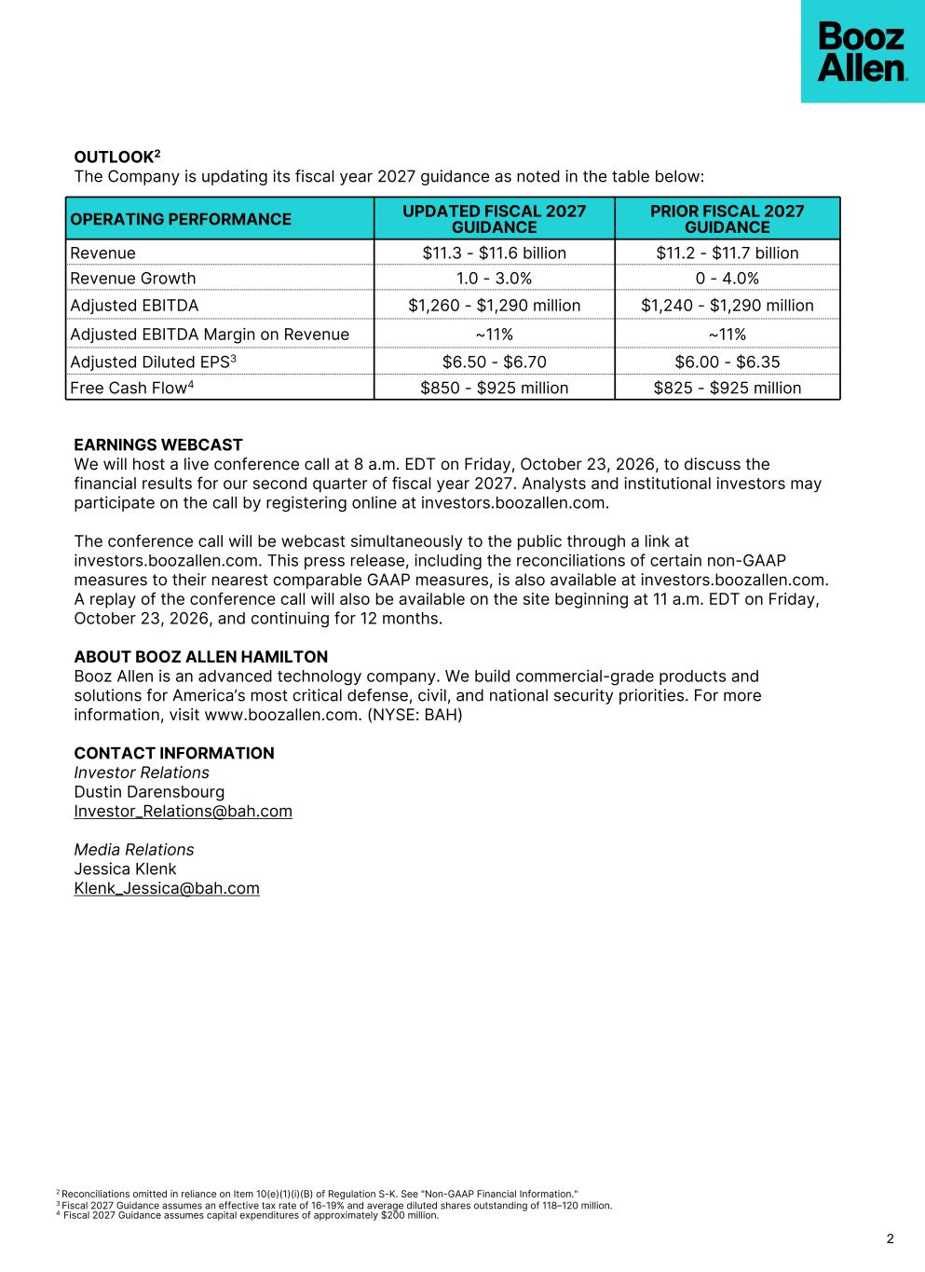
2 2 Reconciliations omitted in reliance on Item 10(e)(1)(i)(B) of Regulation S-K. See "Non-GAAP Financial Information." 3 Fiscal 2027 Guidance assumes an effective tax rate of 16-19% and average diluted shares outstanding of 118–120 million. 4 Fiscal 2027 Guidance assumes capital expenditures of approximately $200 million. OPERATING PERFORMANCE UPDATED FISCAL 2027 GUIDANCE PRIOR FISCAL 2027 GUIDANCE Revenue $11.3 - $11.6 billion $11.2 - $11.7 billion Revenue Growth 1.0 - 3.0% 0 - 4.0% Adjusted EBITDA $1,260 - $1,290 million $1,240 - $1,290 million Adjusted EBITDA Margin on Revenue ~11% ~11% Adjusted Diluted EPS3 $6.50 - $6.70 $6.00 - $6.35 Free Cash Flow4 $850 - $925 million $825 - $925 million EARNINGS WEBCAST We will host a live conference call at 8 a.m. EDT on Friday, October 23, 2026, to discuss the financial results for our second quarter of fiscal year 2027. Analysts and institutional investors may participate on the call by registering online at investors.boozallen.com. The conference call will be webcast simultaneously to the public through a link at investors.boozallen.com. This press release, including the reconciliations of certain non-GAAP measures to their nearest comparable GAAP measures, is also available at investors.boozallen.com. A replay of the conference call will also be available on the site beginning at 11 a.m. EDT on Friday, October 23, 2026, and continuing for 12 months. ABOUT BOOZ ALLEN HAMILTON Booz Allen is an advanced technology company. We build commercial-grade products and solutions for America’s most critical defense, civil, and national security priorities. For more information, visit www.boozallen.com. (NYSE: BAH) CONTACT INFORMATION Investor Relations Dustin Darensbourg Investor_Relations@bah.com Media Relations Jessica Klenk Klenk_Jessica@bah.com OUTLOOK2 The Company is updating its fiscal year 2027 guidance as noted in the table below:

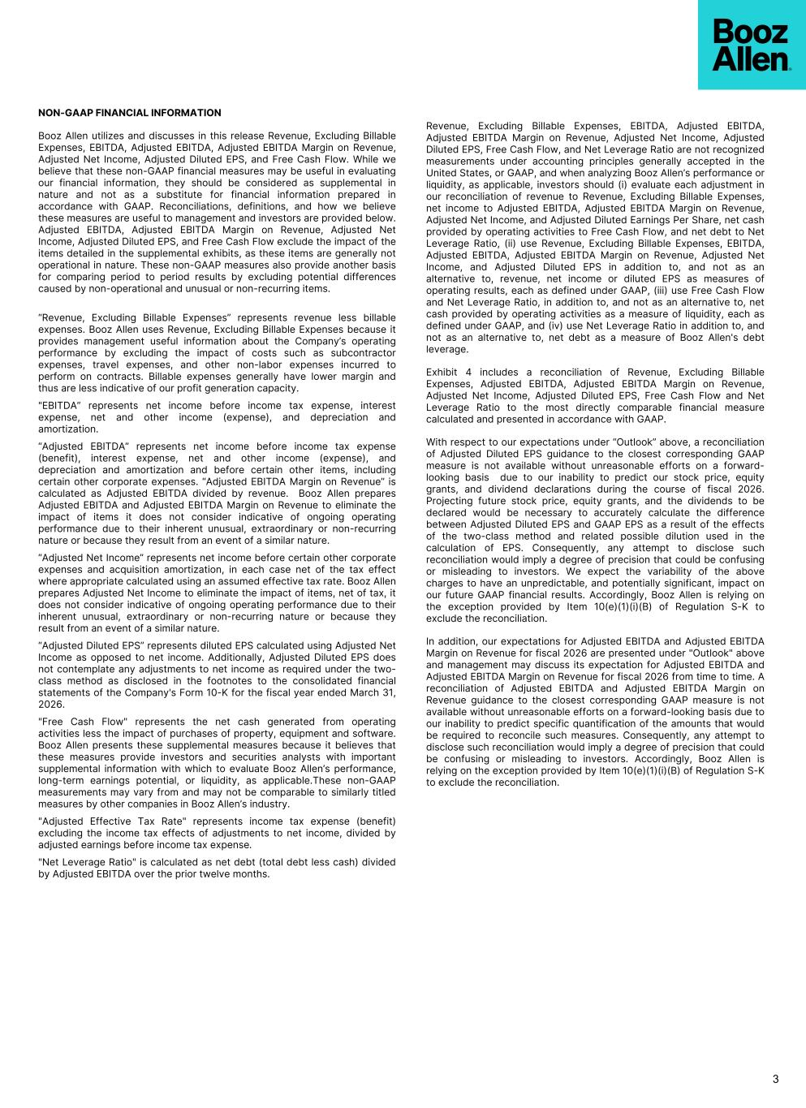
NON-GAAP FINANCIAL INFORMATION Booz Allen utilizes and discusses in this release Revenue, Excluding Billable Expenses, EBITDA, Adjusted EBITDA, Adjusted EBITDA Margin on Revenue, Adjusted Net Income, Adjusted Diluted EPS, and Free Cash Flow. While we believe that these non-GAAP financial measures may be useful in evaluating our financial information, they should be considered as supplemental in nature and not as a substitute for financial information prepared in accordance with GAAP. Reconciliations, definitions, and how we believe these measures are useful to management and investors are provided below. Adjusted EBITDA, Adjusted EBITDA Margin on Revenue, Adjusted Net Income, Adjusted Diluted EPS, and Free Cash Flow exclude the impact of the items detailed in the supplemental exhibits, as these items are generally not operational in nature. These non-GAAP measures also provide another basis for comparing period to period results by excluding potential differences caused by non-operational and unusual or non-recurring items. “Revenue, Excluding Billable Expenses” represents revenue less billable expenses. Booz Allen uses Revenue, Excluding Billable Expenses because it provides management useful information about the Company’s operating performance by excluding the impact of costs such as subcontractor expenses, travel expenses, and other non-labor expenses incurred to perform on contracts. Billable expenses generally have lower margin and thus are less indicative of our profit generation capacity. "EBITDA” represents net income before income tax expense, interest expense, net and other income (expense), and depreciation and amortization. “Adjusted EBITDA” represents net income before income tax expense (benefit), interest expense, net and other income (expense), and depreciation and amortization and before certain other items, including certain other corporate expenses. “Adjusted EBITDA Margin on Revenue” is calculated as Adjusted EBITDA divided by revenue. Booz Allen prepares Adjusted EBITDA and Adjusted EBITDA Margin on Revenue to eliminate the impact of items it does not consider indicative of ongoing operating performance due to their inherent unusual, extraordinary or non-recurring nature or because they result from an event of a similar nature. “Adjusted Net Income” represents net income before certain other corporate expenses and acquisition amortization, in each case net of the tax effect where appropriate calculated using an assumed effective tax rate. Booz Allen prepares Adjusted Net Income to eliminate the impact of items, net of tax, it does not consider indicative of ongoing operating performance due to their inherent unusual, extraordinary or non-recurring nature or because they result from an event of a similar nature. “Adjusted Diluted EPS” represents diluted EPS calculated using Adjusted Net Income as opposed to net income. Additionally, Adjusted Diluted EPS does not contemplate any adjustments to net income as required under the two- class method as disclosed in the footnotes to the consolidated financial statements of the Company's Form 10-K for the fiscal year ended March 31, 2026. "Free Cash Flow" represents the net cash generated from operating activities less the impact of purchases of property, equipment and software. Booz Allen presents these supplemental measures because it believes that these measures provide investors and securities analysts with important supplemental information with which to evaluate Booz Allen’s performance, long-term earnings potential, or liquidity, as applicable.These non-GAAP measurements may vary from and may not be comparable to similarly titled measures by other companies in Booz Allen’s industry. "Adjusted Effective Tax Rate" represents income tax expense (benefit) excluding the income tax effects of adjustments to net income, divided by adjusted earnings before income tax expense. "Net Leverage Ratio" is calculated as net debt (total debt less cash) divided by Adjusted EBITDA over the prior twelve months. Revenue, Excluding Billable Expenses, EBITDA, Adjusted EBITDA, Adjusted EBITDA Margin on Revenue, Adjusted Net Income, Adjusted Diluted EPS, Free Cash Flow, and Net Leverage Ratio are not recognized measurements under accounting principles generally accepted in the United States, or GAAP, and when analyzing Booz Allen’s performance or liquidity, as applicable, investors should (i) evaluate each adjustment in our reconciliation of revenue to Revenue, Excluding Billable Expenses, net income to Adjusted EBITDA, Adjusted EBITDA Margin on Revenue, Adjusted Net Income, and Adjusted Diluted Earnings Per Share, net cash provided by operating activities to Free Cash Flow, and net debt to Net Leverage Ratio, (ii) use Revenue, Excluding Billable Expenses, EBITDA, Adjusted EBITDA, Adjusted EBITDA Margin on Revenue, Adjusted Net Income, and Adjusted Diluted EPS in addition to, and not as an alternative to, revenue, net income or diluted EPS as measures of operating results, each as defined under GAAP, (iii) use Free Cash Flow and Net Leverage Ratio, in addition to, and not as an alternative to, net cash provided by operating activities as a measure of liquidity, each as defined under GAAP, and (iv) use Net Leverage Ratio in addition to, and not as an alternative to, net debt as a measure of Booz Allen's debt leverage. Exhibit 4 includes a reconciliation of Revenue, Excluding Billable Expenses, Adjusted EBITDA, Adjusted EBITDA Margin on Revenue, Adjusted Net Income, Adjusted Diluted EPS, Free Cash Flow and Net Leverage Ratio to the most directly comparable financial measure calculated and presented in accordance with GAAP. With respect to our expectations under “Outlook” above, a reconciliation of Adjusted Diluted EPS guidance to the closest corresponding GAAP measure is not available without unreasonable efforts on a forward- looking basis due to our inability to predict our stock price, equity grants, and dividend declarations during the course of fiscal 2026. Projecting future stock price, equity grants, and the dividends to be declared would be necessary to accurately calculate the difference between Adjusted Diluted EPS and GAAP EPS as a result of the effects of the two-class method and related possible dilution used in the calculation of EPS. Consequently, any attempt to disclose such reconciliation would imply a degree of precision that could be confusing or misleading to investors. We expect the variability of the above charges to have an unpredictable, and potentially significant, impact on our future GAAP financial results. Accordingly, Booz Allen is relying on the exception provided by Item 10(e)(1)(i)(B) of Regulation S-K to exclude the reconciliation. In addition, our expectations for Adjusted EBITDA and Adjusted EBITDA Margin on Revenue for fiscal 2026 are presented under "Outlook" above and management may discuss its expectation for Adjusted EBITDA and Adjusted EBITDA Margin on Revenue for fiscal 2026 from time to time. A reconciliation of Adjusted EBITDA and Adjusted EBITDA Margin on Revenue guidance to the closest corresponding GAAP measure is not available without unreasonable efforts on a forward-looking basis due to our inability to predict specific quantification of the amounts that would be required to reconcile such measures. Consequently, any attempt to disclose such reconciliation would imply a degree of precision that could be confusing or misleading to investors. Accordingly, Booz Allen is relying on the exception provided by Item 10(e)(1)(i)(B) of Regulation S-K to exclude the reconciliation. 3


FORWARD LOOKING STATEMENTS Certain statements contained in this press release and in related comments by our management include “forward-looking statements” within the meaning of the Private Securities Litigation Reform Act of 1995. Examples of forward-looking statements include information concerning Booz Allen’s preliminary financial results, financial outlook and guidance, including forecasted revenue, Diluted EPS, and Adjusted Diluted EPS, future quarterly dividends, and future improvements in operating margins, as well as any other statement that does not directly relate to any historical or current fact. In some cases, you can identify forward-looking statements by terminology such as “may,” “will,” “could,” “should,” “forecasts,” “expects,” “intends,” “plans,” “anticipates,” “projects,” “outlook,” “believes,” “estimates,” “predicts,” “potential,” “continue,” “preliminary,” or the negative of these terms or other comparable terminology. Although we believe that the expectations reflected in the forward-looking statements are reasonable, we can give you no assurance these expectations will prove to have been correct. These forward-looking statements relate to future events or our future financial performance and involve known and unknown risks, uncertainties and other factors that may cause our actual results, levels of activity, performance, or achievements to differ materially from any future results, levels of activity, performance, or achievements expressed or implied by these forward-looking statements. A number of important factors could cause actual results to differ materially from those contained in or implied by these forward-looking statements, including the risks and factors described in our Annual Report on Form 10-K filed with the Securities and Exchange Commission (SEC) on May 22, 2026 and in our other filings with the SEC. In light of these risks, uncertainties, and other factors, the forward-looking statements might not prove to be accurate and you should not place undue reliance upon them. All forward-looking statements speak only as of the date made and we undertake no obligation to update or revise publicly any forward-looking statements, whether as a result of new information, future events, or otherwise. 4

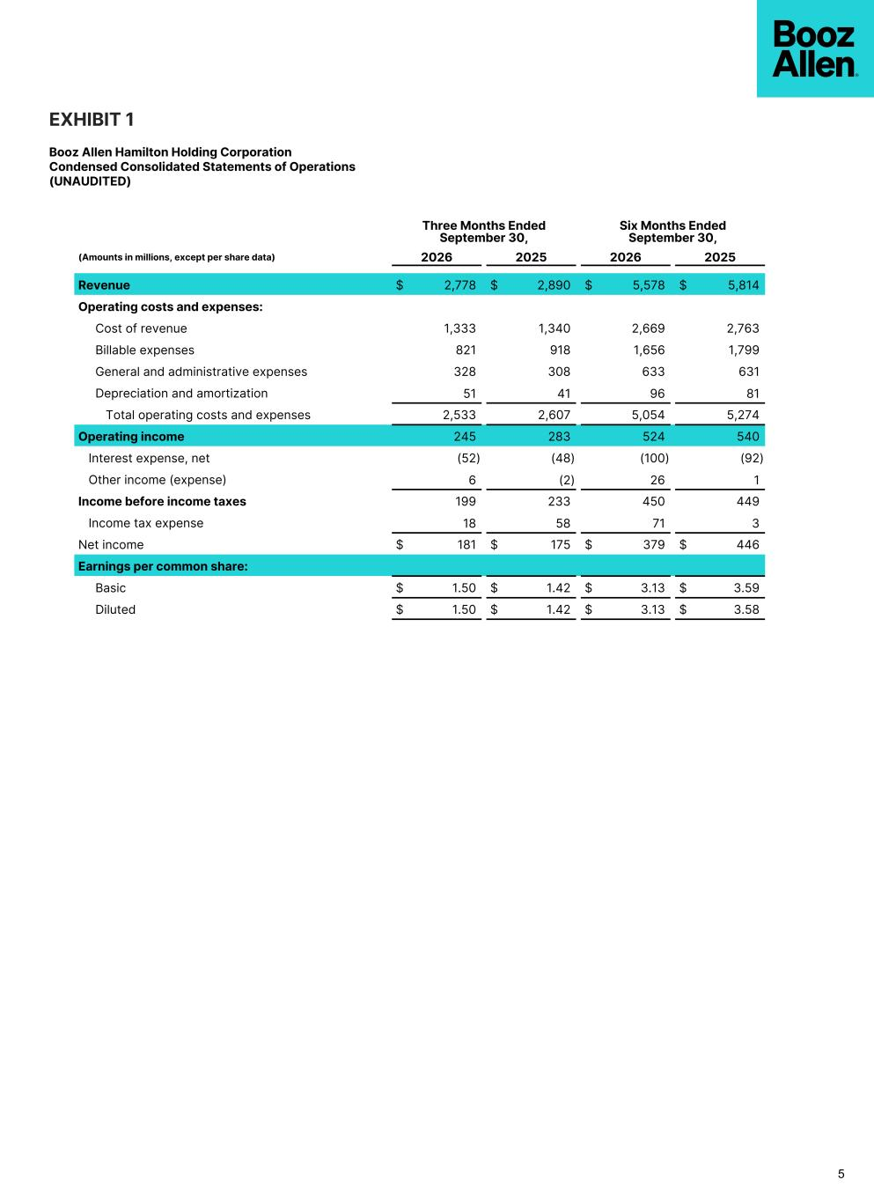
EXHIBIT 1 Booz Allen Hamilton Holding Corporation Condensed Consolidated Statements of Operations (UNAUDITED) 5 Three Months Ended September 30, Six Months Ended September 30, (Amounts in millions, except per share data) 2026 2025 2026 2025 Revenue $ 2,778 $ 2,890 $ 5,578 $ 5,814 Operating costs and expenses: Cost of revenue 1,333 1,340 2,669 2,763 Billable expenses 821 918 1,656 1,799 General and administrative expenses 328 308 633 631 Depreciation and amortization 51 41 96 81 Total operating costs and expenses 2,533 2,607 5,054 5,274 Operating income 245 283 524 540 Interest expense, net (52) (48) (100) (92) Other income (expense) 6 (2) 26 1 Income before income taxes 199 233 450 449 Income tax expense 18 58 71 3 Net income $ 181 $ 175 $ 379 $ 446 Earnings per common share: Basic $ 1.50 $ 1.42 $ 3.13 $ 3.59 Diluted $ 1.50 $ 1.42 $ 3.13 $ 3.58

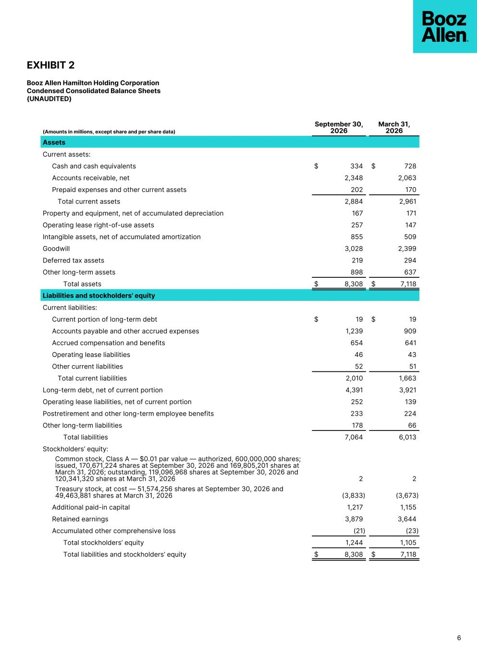
EXHIBIT 2 Booz Allen Hamilton Holding Corporation Condensed Consolidated Balance Sheets (UNAUDITED) (Amounts in millions, except share and per share data) September 30, 2026 March 31, 2026 Assets Current assets: Cash and cash equivalents $ 334 $ 728 Accounts receivable, net 2,348 2,063 Prepaid expenses and other current assets 202 170 Total current assets 2,884 2,961 Property and equipment, net of accumulated depreciation 167 171 Operating lease right-of-use assets 257 147 Intangible assets, net of accumulated amortization 855 509 Goodwill 3,028 2,399 Deferred tax assets 219 294 Other long-term assets 898 637 Total assets $ 8,308 $ 7,118 Liabilities and stockholders' equity Current liabilities: Current portion of long-term debt $ 19 $ 19 Accounts payable and other accrued expenses 1,239 909 Accrued compensation and benefits 654 641 Operating lease liabilities 46 43 Other current liabilities 52 51 Total current liabilities 2,010 1,663 Long-term debt, net of current portion 4,391 3,921 Operating lease liabilities, net of current portion 252 139 Postretirement and other long-term employee benefits 233 224 Other long-term liabilities 178 66 Total liabilities 7,064 6,013 Stockholders’ equity: Common stock, Class A — $0.01 par value — authorized, 600,000,000 shares; issued, 170,671,224 shares at September 30, 2026 and 169,805,201 shares at March 31, 2026; outstanding, 119,096,968 shares at September 30, 2026 and 120,341,320 shares at March 31, 2026 2 2 Treasury stock, at cost — 51,574,256 shares at September 30, 2026 and 49,463,881 shares at March 31, 2026 (3,833) (3,673) Additional paid-in capital 1,217 1,155 Retained earnings 3,879 3,644 Accumulated other comprehensive loss (21) (23) Total stockholders’ equity 1,244 1,105 Total liabilities and stockholders’ equity $ 8,308 $ 7,118 6

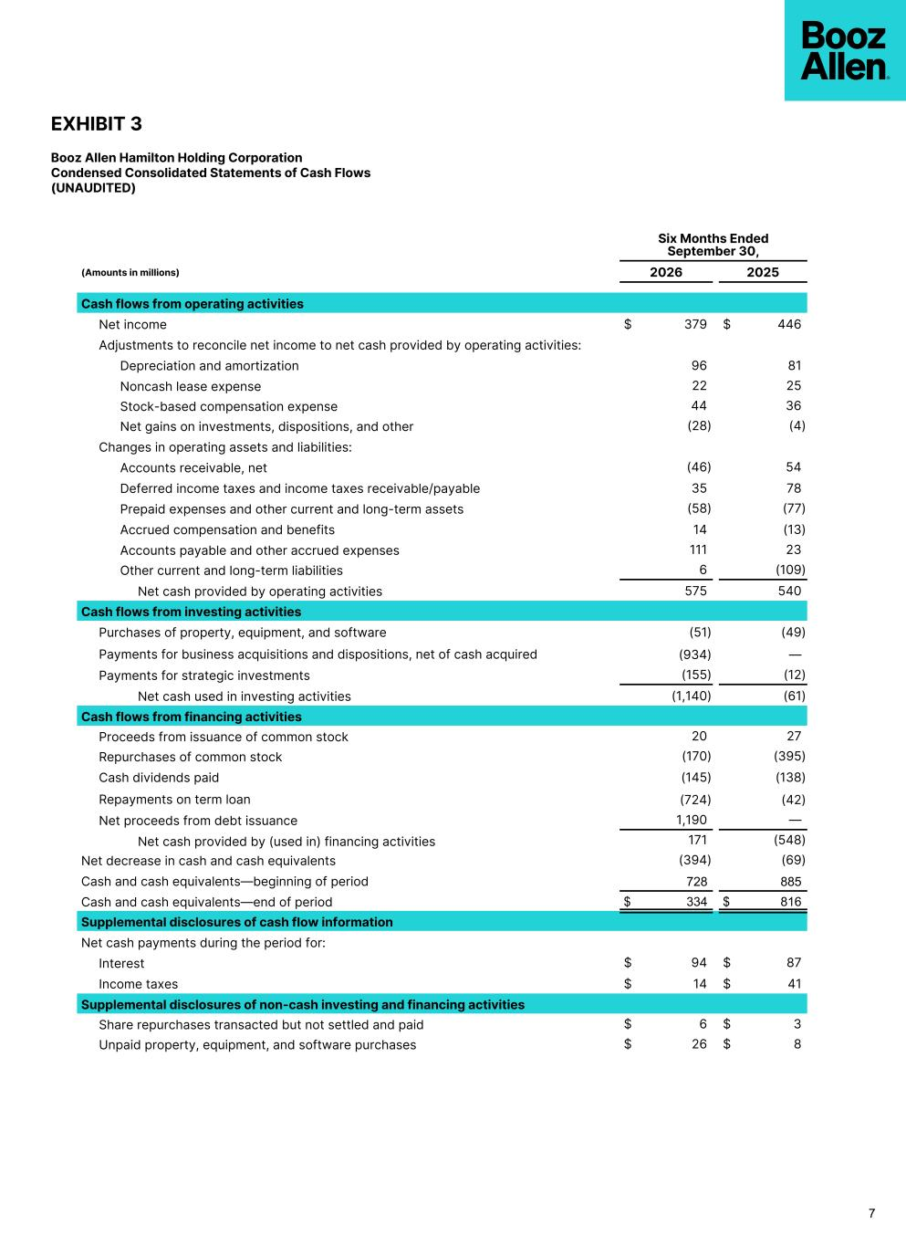
EXHIBIT 3 Booz Allen Hamilton Holding Corporation Condensed Consolidated Statements of Cash Flows (UNAUDITED) Six Months Ended September 30, (Amounts in millions) 2026 2025 Cash flows from operating activities Net income $ 379 $ 446 Adjustments to reconcile net income to net cash provided by operating activities: Depreciation and amortization 96 81 Noncash lease expense 22 25 Stock-based compensation expense 44 36 Net gains on investments, dispositions, and other (28) (4) Changes in operating assets and liabilities: Accounts receivable, net (46) 54 Deferred income taxes and income taxes receivable/payable 35 78 Prepaid expenses and other current and long-term assets (58) (77) Accrued compensation and benefits 14 (13) Accounts payable and other accrued expenses 111 23 Other current and long-term liabilities 6 (109) Net cash provided by operating activities 575 540 Cash flows from investing activities Purchases of property, equipment, and software (51) (49) Payments for business acquisitions and dispositions, net of cash acquired (934) — Payments for strategic investments (155) (12) Net cash used in investing activities (1,140) (61) Cash flows from financing activities Proceeds from issuance of common stock 20 27 Repurchases of common stock (170) (395) Cash dividends paid (145) (138) Repayments on term loan (724) (42) Net proceeds from debt issuance 1,190 — Net cash provided by (used in) financing activities 171 (548) Net decrease in cash and cash equivalents (394) (69) Cash and cash equivalents––beginning of period 728 885 Cash and cash equivalents––end of period $ 334 $ 816 Supplemental disclosures of cash flow information Net cash payments during the period for: Interest $ 94 $ 87 Income taxes $ 14 $ 41 Supplemental disclosures of non-cash investing and financing activities Share repurchases transacted but not settled and paid $ 6 $ 3 Unpaid property, equipment, and software purchases $ 26 $ 8 7

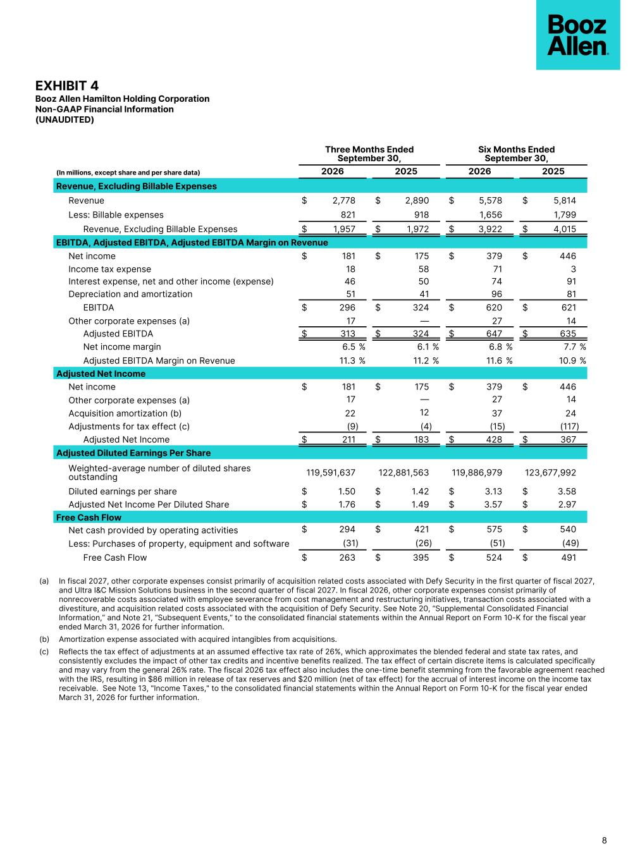
EXHIBIT 4 Booz Allen Hamilton Holding Corporation Non-GAAP Financial Information (UNAUDITED) Three Months Ended September 30, Six Months Ended September 30, (In millions, except share and per share data) 2026 2025 2026 2025 Revenue, Excluding Billable Expenses Revenue $ 2,778 $ 2,890 $ 5,578 $ 5,814 Less: Billable expenses 821 918 1,656 1,799 Revenue, Excluding Billable Expenses $ 1,957 $ 1,972 $ 3,922 $ 4,015 EBITDA, Adjusted EBITDA, Adjusted EBITDA Margin on Revenue Net income $ 181 $ 175 $ 379 $ 446 Income tax expense 18 58 71 3 Interest expense, net and other income (expense) 46 50 74 91 Depreciation and amortization 51 41 96 81 EBITDA $ 296 $ 324 $ 620 $ 621 Other corporate expenses (a) 17 — 27 14 Adjusted EBITDA $ 313 $ 324 $ 647 $ 635 Net income margin 6.5 % 6.1 % 6.8 % 7.7 % Adjusted EBITDA Margin on Revenue 11.3 % 11.2 % 11.6 % 10.9 % Adjusted Net Income Net income $ 181 $ 175 $ 379 $ 446 Other corporate expenses (a) 17 — 27 14 Acquisition amortization (b) 22 12 37 24 Adjustments for tax effect (c) (9) (4) (15) (117) Adjusted Net Income $ 211 $ 183 $ 428 $ 367 Adjusted Diluted Earnings Per Share Weighted-average number of diluted shares outstanding 119,591,637 122,881,563 119,886,979 123,677,992 Diluted earnings per share $ 1.50 $ 1.42 $ 3.13 $ 3.58 Adjusted Net Income Per Diluted Share $ 1.76 $ 1.49 $ 3.57 $ 2.97 Free Cash Flow Net cash provided by operating activities $ 294 $ 421 $ 575 $ 540 Less: Purchases of property, equipment and software (31) (26) (51) (49) Free Cash Flow $ 263 $ 395 $ 524 $ 491 8 (a) In fiscal 2027, other corporate expenses consist primarily of acquisition related costs associated with Defy Security in the first quarter of fiscal 2027, and Ultra I&C Mission Solutions business in the second quarter of fiscal 2027. In fiscal 2026, other corporate expenses consist primarily of nonrecoverable costs associated with employee severance from cost management and restructuring initiatives, transaction costs associated with a divestiture, and acquisition related costs associated with the acquisition of Defy Security. See Note 20, “Supplemental Consolidated Financial Information,” and Note 21, “Subsequent Events,” to the consolidated financial statements within the Annual Report on Form 10-K for the fiscal year ended March 31, 2026 for further information. (b) Amortization expense associated with acquired intangibles from acquisitions. (c) Reflects the tax effect of adjustments at an assumed effective tax rate of 26%, which approximates the blended federal and state tax rates, and consistently excludes the impact of other tax credits and incentive benefits realized. The tax effect of certain discrete items is calculated specifically and may vary from the general 26% rate. The fiscal 2026 tax effect also includes the one-time benefit stemming from the favorable agreement reached with the IRS, resulting in $86 million in release of tax reserves and $20 million (net of tax effect) for the accrual of interest income on the income tax receivable. See Note 13, "Income Taxes," to the consolidated financial statements within the Annual Report on Form 10-K for the fiscal year ended March 31, 2026 for further information.

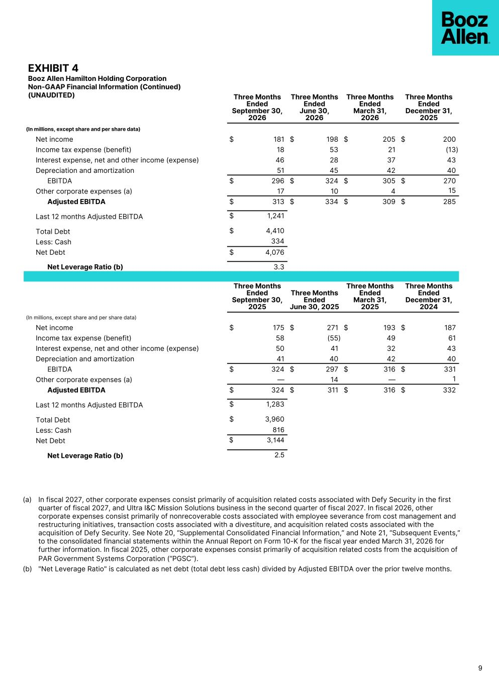
EXHIBIT 4 Booz Allen Hamilton Holding Corporation Non-GAAP Financial Information (Continued) (UNAUDITED) Three Months Ended September 30, 2026 Three Months Ended June 30, 2026 Three Months Ended March 31, 2026 Three Months Ended December 31, 2025 (In millions, except share and per share data) Net income $ 181 $ 198 $ 205 $ 200 Income tax expense (benefit) 18 53 21 (13) Interest expense, net and other income (expense) 46 28 37 43 Depreciation and amortization 51 45 42 40 EBITDA $ 296 $ 324 $ 305 $ 270 Other corporate expenses (a) 17 10 4 15 Adjusted EBITDA $ 313 $ 334 $ 309 $ 285 Last 12 months Adjusted EBITDA $ 1,241 Total Debt $ 4,410 Less: Cash 334 Net Debt $ 4,076 Net Leverage Ratio (b) 3.3 Three Months Ended September 30, 2025 Three Months Ended June 30, 2025 Three Months Ended March 31, 2025 Three Months Ended December 31, 2024 (In millions, except share and per share data) Net income $ 175 $ 271 $ 193 $ 187 Income tax expense (benefit) 58 (55) 49 61 Interest expense, net and other income (expense) 50 41 32 43 Depreciation and amortization 41 40 42 40 EBITDA $ 324 $ 297 $ 316 $ 331 Other corporate expenses (a) — 14 — 1 Adjusted EBITDA $ 324 $ 311 $ 316 $ 332 Last 12 months Adjusted EBITDA $ 1,283 Total Debt $ 3,960 Less: Cash 816 Net Debt $ 3,144 Net Leverage Ratio (b) 2.5 9 (a) In fiscal 2027, other corporate expenses consist primarily of acquisition related costs associated with Defy Security in the first quarter of fiscal 2027, and Ultra I&C Mission Solutions business in the second quarter of fiscal 2027. In fiscal 2026, other corporate expenses consist primarily of nonrecoverable costs associated with employee severance from cost management and restructuring initiatives, transaction costs associated with a divestiture, and acquisition related costs associated with the acquisition of Defy Security. See Note 20, “Supplemental Consolidated Financial Information,” and Note 21, “Subsequent Events,” to the consolidated financial statements within the Annual Report on Form 10-K for the fiscal year ended March 31, 2026 for further information. In fiscal 2025, other corporate expenses consist primarily of acquisition related costs from the acquisition of PAR Government Systems Corporation (“PGSC”). (b) "Net Leverage Ratio" is calculated as net debt (total debt less cash) divided by Adjusted EBITDA over the prior twelve months.

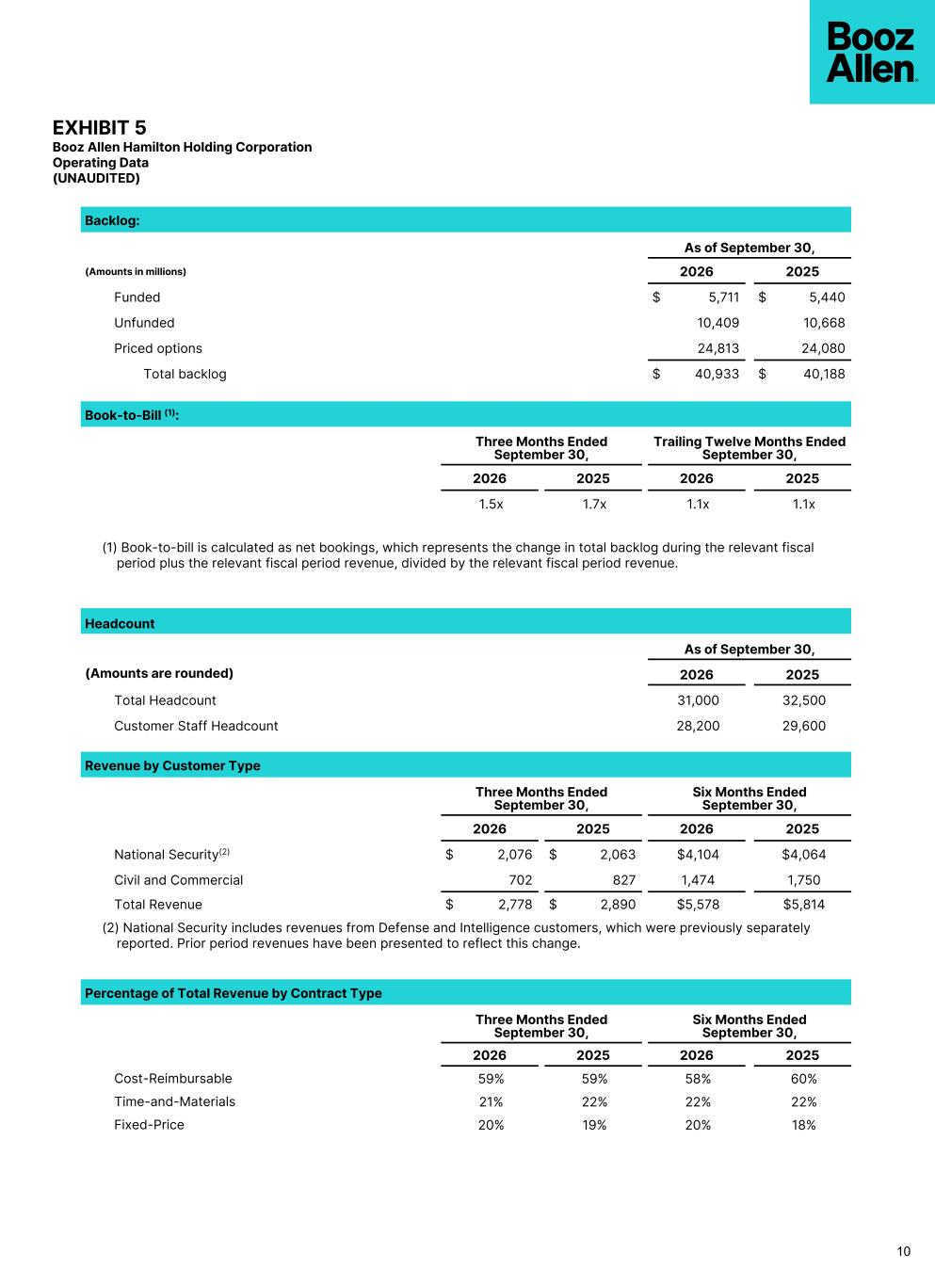
EXHIBIT 5 Booz Allen Hamilton Holding Corporation Operating Data (UNAUDITED) Backlog: As of September 30, (Amounts in millions) 2026 2025 Funded $ 5,711 $ 5,440 Unfunded 10,409 10,668 Priced options 24,813 24,080 Total backlog $ 40,933 $ 40,188 Book-to-Bill (1): Three Months Ended September 30, Trailing Twelve Months Ended September 30, 2026 2025 2026 2025 1.5x 1.7x 1.1x 1.1x (1) Book-to-bill is calculated as net bookings, which represents the change in total backlog during the relevant fiscal period plus the relevant fiscal period revenue, divided by the relevant fiscal period revenue. Headcount As of September 30, (Amounts are rounded) 2026 2025 Total Headcount 31,000 32,500 Customer Staff Headcount 28,200 29,600 Revenue by Customer Type Three Months Ended September 30, Six Months Ended September 30, 2026 2025 2026 2025 National Security(2) $ 2,076 $ 2,063 $4,104 $4,064 Civil and Commercial 702 827 1,474 1,750 Total Revenue $ 2,778 $ 2,890 $5,578 $5,814 (2) National Security includes revenues from Defense and Intelligence customers, which were previously separately reported. Prior period revenues have been presented to reflect this change. Percentage of Total Revenue by Contract Type Three Months Ended September 30, Six Months Ended September 30, 2026 2025 2026 2025 Cost-Reimbursable 59% 59% 58% 60% Time-and-Materials 21% 22% 22% 22% Fixed-Price 20% 19% 20% 18% 10


Q2 FY27 Earnings Call Presentation OCTOBER 23, 2026


Booz Allen Hamilton Internal PARTICIPANTS Earnings Call Participants HORACIO ROZANSKI Chairman, Chief Executive Officer KRISTINE MARTIN ANDERSON President, Chief Operating Officer TROY LAHR Executive Vice President, Chief Financial Officer DUSTIN DARENSBOURG Head of Investor Relations boozallen.com 2Copyright © 2026 BOOZ ALLEN HAMILTON INC.


Booz Allen Hamilton Internal DISCLAIMER Forward Looking Safe Harbor Statement boozallen.com 3Copyright © 2026 BOOZ ALLEN HAMILTON INC. Certain statements contained in this presentation and in related comments by our management include “forward-looking statements” within the meaning of the Private Securities Litigation Reform Act of 1995. Examples of forward-looking statements include information concerning Booz Allen’s preliminary financial results, financial outlook and guidance, including forecasted revenue, Adjusted EBITDA, Diluted EPS, Adjusted Diluted EPS, future quarterly dividends, and future improvements in operating margins, as well as any other statement that does not directly relate to any historical or current fact. In some cases, you can identify forward-looking statements by terminology such as “may,” “will,” “could,” “should,” “forecasts,” “expects,” “intends,” “plans,” “anticipates,” “projects,” “outlook,” “believes,” “estimates,” “predicts,” “potential,” “continue,” “preliminary,” or the negative of these terms or other comparable terminology. Although we believe that the expectations reflected in the forward-looking statements are reasonable, we can give you no assurance these expectations will prove to have been correct. These forward-looking statements relate to future events or our future financial performance and involve known and unknown risks, uncertainties and other factors that may cause our actual results, levels of activity, performance or achievements to differ materially from any future results, levels of activity, performance or achievements expressed or implied by these forward-looking statements. A number of important factors could cause actual results to differ materially from those contained in or implied by these forward-looking statements, including those factors discussed in our filings with the Securities and Exchange Commission (SEC), including our Annual Report on Form 10-K for the fiscal year ended March 31, 2026, which can be found at the SEC’s website at www.sec.gov. All forward-looking statements attributable to us or persons acting on our behalf are expressly qualified in their entirety by the foregoing cautionary statements. All such statements speak only as of the date made and we undertake no obligation to update or revise publicly any forward-looking statements, whether as a result of new information, future events or otherwise. Booz Allen’s fiscal year ends on March 31 and unless otherwise noted, references to fiscal year, fiscal or FY are for fiscal years ended March 31. Note Regarding Non-GAAP Financial Data Information Booz Allen discloses Revenue, Excluding Billable Expenses, Adjusted EBITDA, Adjusted EBITDA Margin on Revenue, Adjusted Net Income, Adjusted Diluted EPS, Free Cash Flow, and Net Leverage Ratio, which are not recognized measurements under accounting principles generally accepted in the United States, or GAAP, and when analyzing Booz Allen’s performance or liquidity as applicable, investors should (i) evaluate each adjustment in our reconciliation of revenue to Revenue, Excluding Billable Expenses, net income attributable to common stockholders to Adjusted EBITDA, Adjusted EBITDA Margin on Revenue, Adjusted Net Income and Adjusted Diluted EPS, net cash used in operating activities to Free Cash Flow, and net debt to Net Leverage Ratio, and the explanatory footnotes regarding those adjustments, each as defined under GAAP, (ii) use Revenue, Excluding Billable Expenses, Adjusted EBITDA, Adjusted EBITDA Margin on Revenue, Adjusted Net Income, and Adjusted Diluted EPS in addition to, and not as an alternative to, revenue, operating income, net income attributable to common stockholders or diluted EPS as measures of operating results, each as defined under GAAP, (iii) use Free Cash Flow in addition to, and not as an alternative to, net cash used in operating activities as a measure of liquidity, each as defined under GAAP, and (iv) use Net Leverage Ratio in addition to, and not as an alternative to, net debt as a measure of Booz Allen's debt leverage. The Appendix includes a reconciliation of Revenue, Excluding Billable Expenses, Adjusted EBITDA, Adjusted EBITDA Margin on Revenue, Adjusted Net Income, Adjusted Diluted EPS, Free Cash Flow and Net Leverage Ratio to the most directly comparable financial measure calculated and presented in accordance with GAAP. Booz Allen presents these supplemental performance measures because it believes that these measures provide investors and securities analysts with important supplemental information with which to evaluate Booz Allen’s performance, long term earnings potential, or liquidity, as applicable, and to enable them to assess Booz Allen’s performance on the same basis as management. These supplemental performance and liquidity measurements may vary from and may not be comparable to similarly titled measures by other companies in Booz Allen’s industry. With respect to our expectations under “Financial Outlook", reconciliation of Adjusted Diluted EPS guidance, Adjusted EBITDA, and Adjusted EBITDA Margin on Revenue, and Adjusted Effective Tax Rate to the closest corresponding GAAP measure is not available without unreasonable efforts on a forward-looking basis due to our inability to predict our stock price, equity grants and dividend declarations with respect to Adjusted Diluted EPS, and our net income, net interest and other expenses with respect to Adjusted EBITDA, Adjusted EBITDA Margin on Revenue, and Adjusted Effective Tax Rate, during the course of fiscal 2027. With respect to Adjusted Diluted EPS guidance, projecting future stock price, equity grants and dividends to be declared would be necessary to accurately calculate the difference between Adjusted Diluted EPS and GAAP EPS as a result of the effects of the two-class method and related possible dilution used in the calculation of EPS. Consequently, any attempt to disclose such reconciliation would imply a degree of precision that could be confusing or misleading to investors. We expect the variability of the above charges to have an unpredictable, and potentially significant, impact on our future GAAP financial results. For the same reason, a reconciliation of Adjusted EBITDA and Adjusted EBITDA Margin on Revenue guidance for fiscal 2027, of Adjusted EBITDA guidance through fiscal 2027, and of Adjusted Effective Tax Rate guidance through fiscal 2027 to the closest corresponding GAAP measures are not available without unreasonable efforts on a forward-looking basis due to our inability to predict specific quantifications of the amounts that would be required to reconcile such measures. Accordingly, Booz Allen is relying on the exception provided by Item 10(e)(1)(i)(B) of Regulation S-K to exclude these reconciliations.

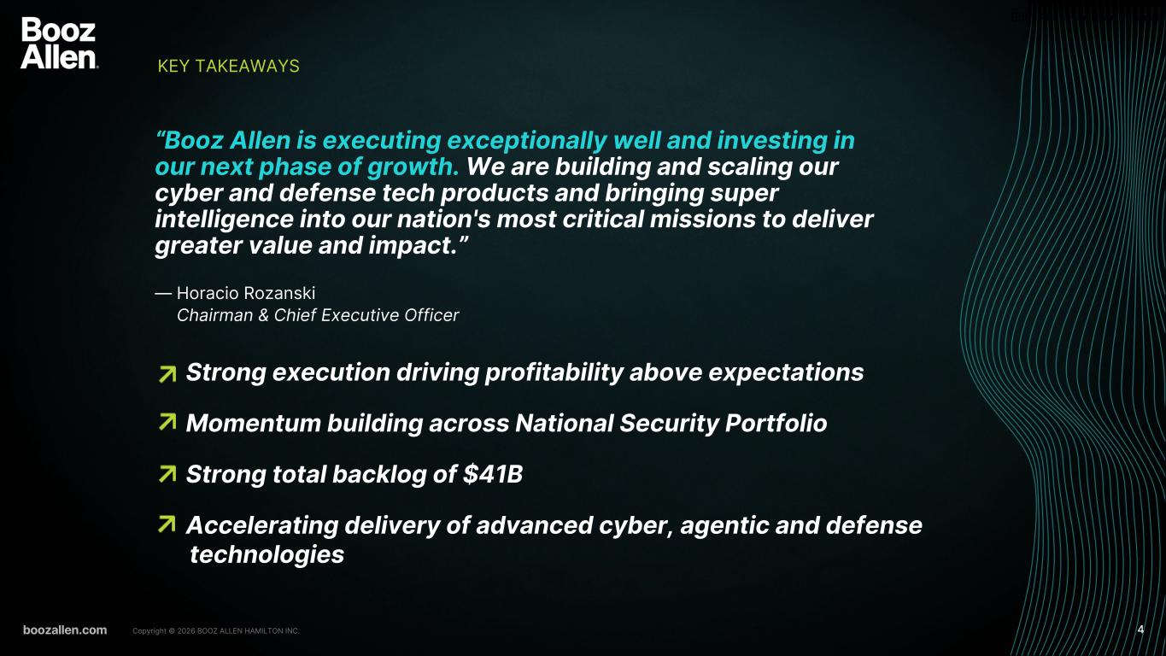
Booz Allen Hamilton Internal Strong execution driving profitability above expectations Momentum building across National Security Portfolio Strong total backlog of $41B Accelerating delivery of advanced cyber, agentic and defense technologies KEY TAKEAWAYS boozallen.com 4Copyright © 2026 BOOZ ALLEN HAMILTON INC. “Booz Allen is executing exceptionally well and investing in our next phase of growth. We are building and scaling our cyber and defense tech products and bringing super intelligence into our nation's most critical missions to deliver greater value and impact.” — Horacio Rozanski Chairman & Chief Executive Officer

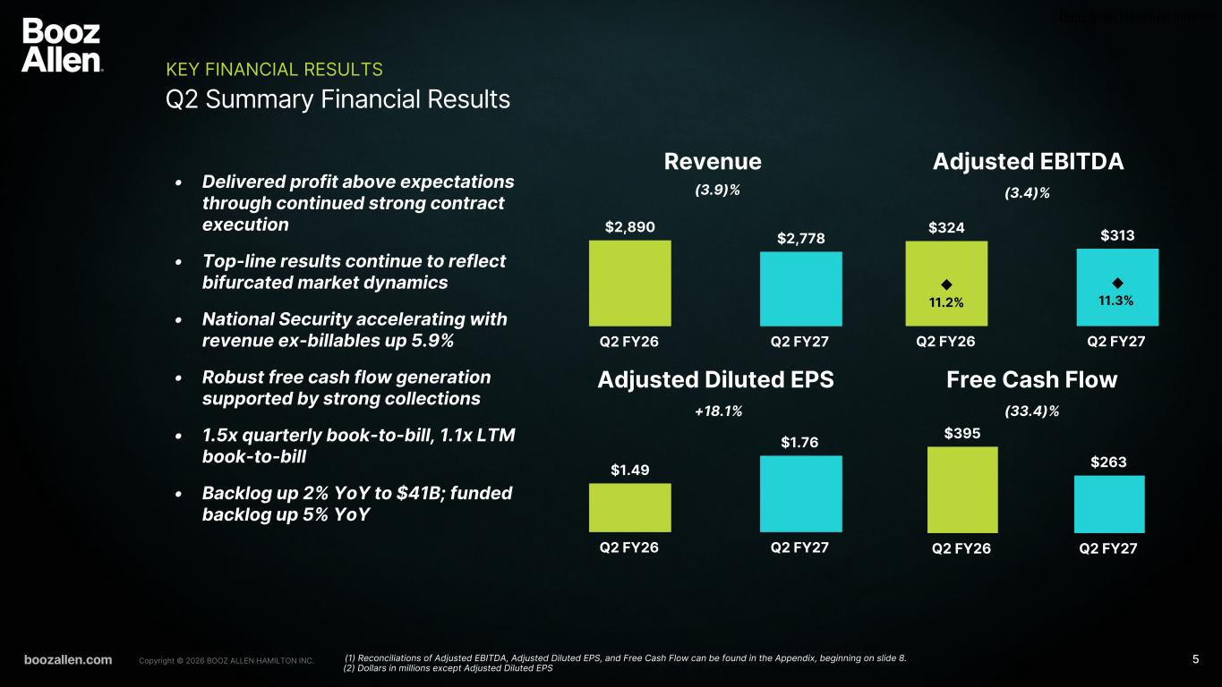
Booz Allen Hamilton Internal • Delivered profit above expectations through continued strong contract execution • Top-line results continue to reflect bifurcated market dynamics • National Security accelerating with revenue ex-billables up 5.9% • Robust free cash flow generation supported by strong collections • 1.5x quarterly book-to-bill, 1.1x LTM book-to-bill • Backlog up 2% YoY to $41B; funded backlog up 5% YoY $395 $263 Q2 FY26 Q2 FY27 $2,890 $2,778 Q2 FY26 Q2 FY27 $1.49 $1.76 Q2 FY26 Q2 FY27 $324 $313 11.2% 11.3% Q2 FY26 Q2 FY27 boozallen.com 5Copyright © 2026 BOOZ ALLEN HAMILTON INC. Q2 Summary Financial Results KEY FINANCIAL RESULTS Revenue Adjusted EBITDA Adjusted Diluted EPS Free Cash Flow (3.9)% (3.4)% (33.4)%+18.1% (1) Reconciliations of Adjusted EBITDA, Adjusted Diluted EPS, and Free Cash Flow can be found in the Appendix, beginning on slide 8. (2) Dollars in millions except Adjusted Diluted EPS

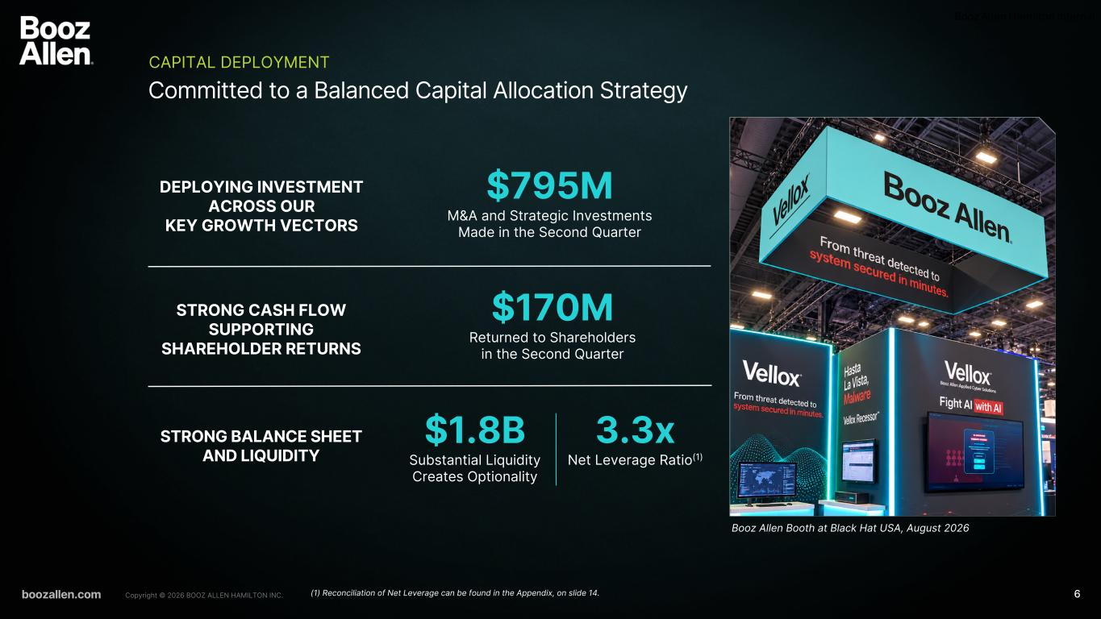
boozallen.com Booz Allen Hamilton Internal Copyright © 2026 BOOZ ALLEN HAMILTON INC. Committed to a Balanced Capital Allocation Strategy CAPITAL DEPLOYMENT DEPLOYING INVESTMENT ACROSS OUR KEY GROWTH VECTORS STRONG CASH FLOW SUPPORTING SHAREHOLDER RETURNS STRONG BALANCE SHEET AND LIQUIDITY $795M M&A and Strategic Investments Made in the Second Quarter 3.3x Net Leverage Ratio(1) $170M Returned to Shareholders in the Second Quarter $1.8B Substantial Liquidity Creates Optionality (1) Reconciliation of Net Leverage can be found in the Appendix, on slide 14. 6 Booz Allen Booth at Black Hat USA, August 2026

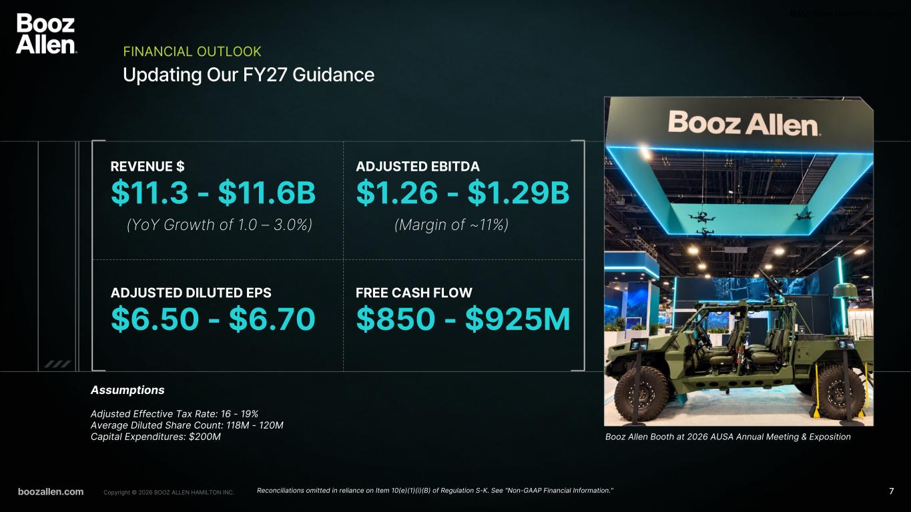
boozallen.com Booz Allen Hamilton Internal Copyright © 2026 BOOZ ALLEN HAMILTON INC. Updating Our FY27 Guidance FINANCIAL OUTLOOK REVENUE $ $11.3 - $11.6B ADJUSTED EBITDA $1.26 - $1.29B ADJUSTED DILUTED EPS $6.50 - $6.70 FREE CASH FLOW $850 - $925M Assumptions Adjusted Effective Tax Rate: 16 - 19% Average Diluted Share Count: 118M - 120M Capital Expenditures: $200M Reconciliations omitted in reliance on Item 10(e)(1)(i)(B) of Regulation S-K. See "Non-GAAP Financial Information." (YoY Growth of 1.0 – 3.0%) (Margin of ~11%) 7 Booz Allen Booth at 2026 AUSA Annual Meeting & Exposition

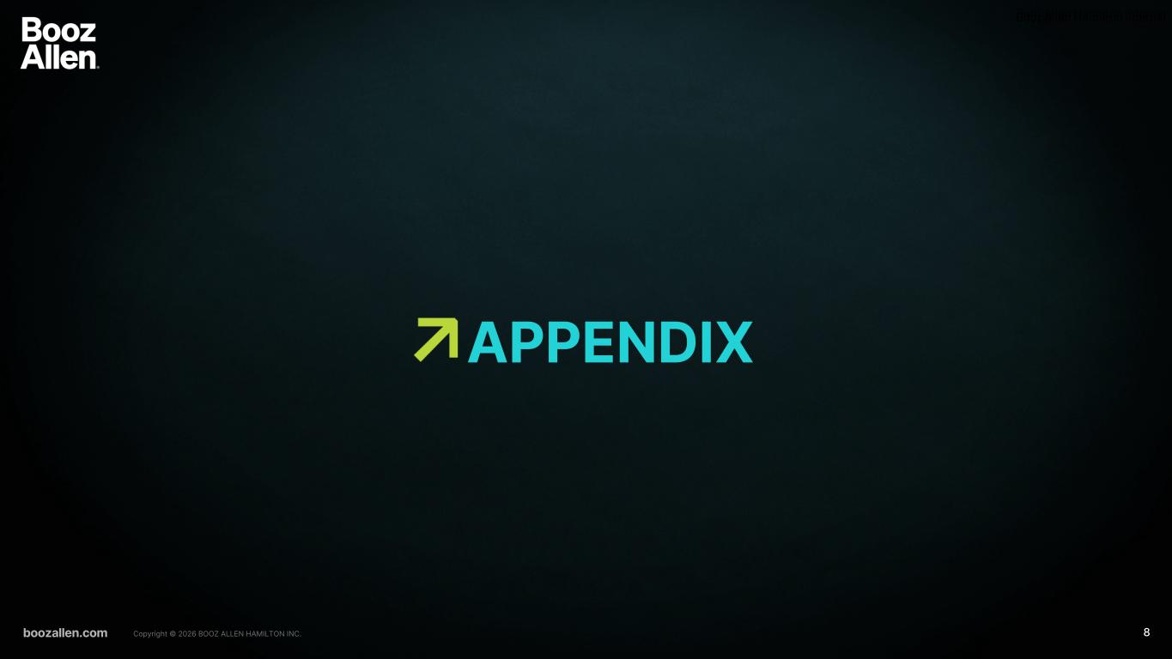
Booz Allen Hamilton Internal boozallen.com 8Copyright © 2026 BOOZ ALLEN HAMILTON INC. APPENDIX

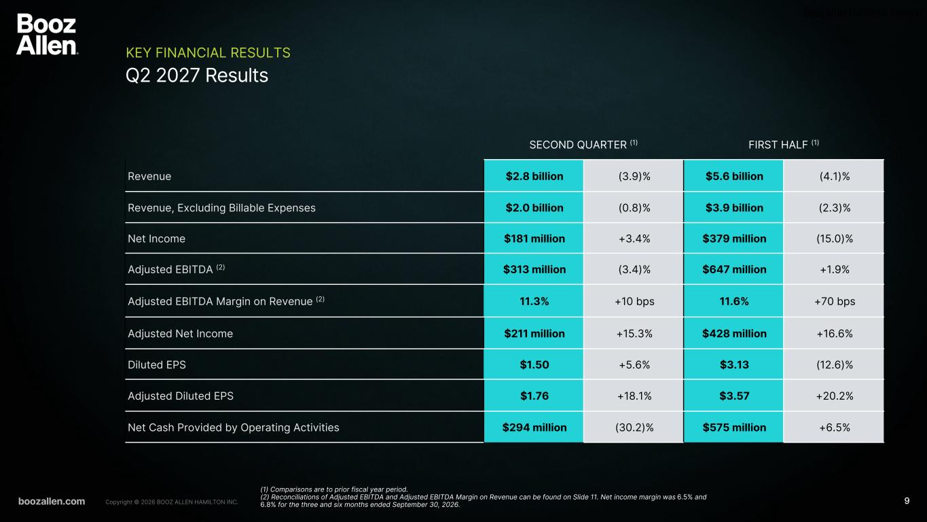
Booz Allen Hamilton Internal boozallen.com 9Copyright © 2026 BOOZ ALLEN HAMILTON INC. Q2 2027 Results KEY FINANCIAL RESULTS SECOND QUARTER (1) FIRST HALF (1) Revenue $2.8 billion (3.9)% $5.6 billion (4.1)% Revenue, Excluding Billable Expenses $2.0 billion (0.8)% $3.9 billion (2.3)% Net Income $181 million +3.4% $379 million (15.0)% Adjusted EBITDA (2) $313 million (3.4)% $647 million +1.9% Adjusted EBITDA Margin on Revenue (2) 11.3% +10 bps 11.6% +70 bps Adjusted Net Income $211 million +15.3% $428 million +16.6% Diluted EPS $1.50 +5.6% $3.13 (12.6)% Adjusted Diluted EPS $1.76 +18.1% $3.57 +20.2% Net Cash Provided by Operating Activities $294 million (30.2)% $575 million +6.5% (1) Comparisons are to prior fiscal year period. (2) Reconciliations of Adjusted EBITDA and Adjusted EBITDA Margin on Revenue can be found on Slide 11. Net income margin was 6.5% and 6.8% for the three and six months ended September 30, 2026.

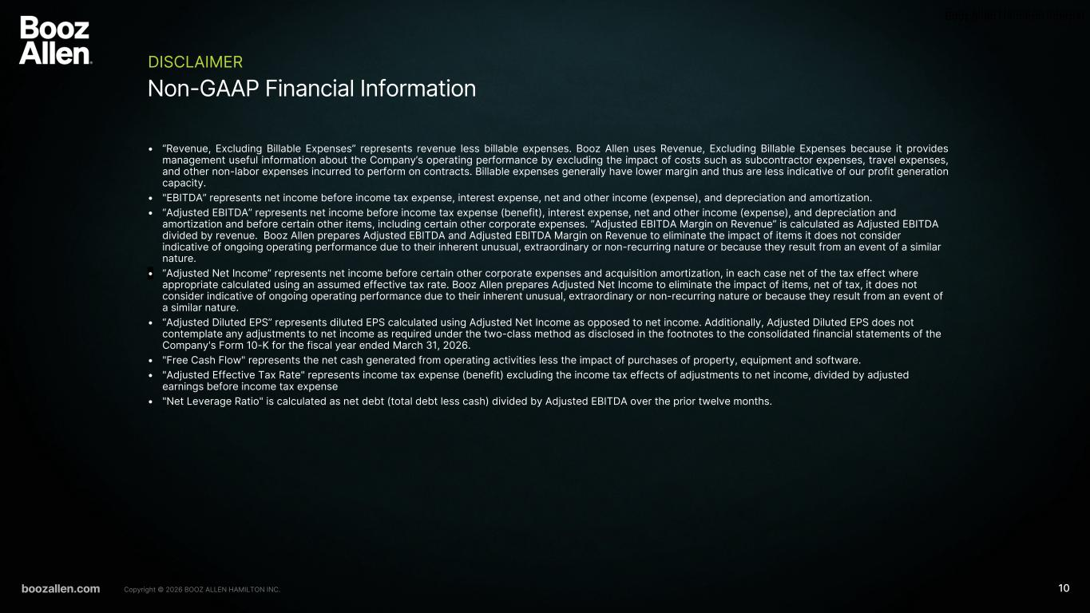
Booz Allen Hamilton Internal boozallen.com 10Copyright © 2026 BOOZ ALLEN HAMILTON INC. Non-GAAP Financial Information DISCLAIMER • “Revenue, Excluding Billable Expenses” represents revenue less billable expenses. Booz Allen uses Revenue, Excluding Billable Expenses because it provides management useful information about the Company’s operating performance by excluding the impact of costs such as subcontractor expenses, travel expenses, and other non-labor expenses incurred to perform on contracts. Billable expenses generally have lower margin and thus are less indicative of our profit generation capacity. • "EBITDA” represents net income before income tax expense, interest expense, net and other income (expense), and depreciation and amortization. • “Adjusted EBITDA” represents net income before income tax expense (benefit), interest expense, net and other income (expense), and depreciation and amortization and before certain other items, including certain other corporate expenses. “Adjusted EBITDA Margin on Revenue” is calculated as Adjusted EBITDA divided by revenue. Booz Allen prepares Adjusted EBITDA and Adjusted EBITDA Margin on Revenue to eliminate the impact of items it does not consider indicative of ongoing operating performance due to their inherent unusual, extraordinary or non-recurring nature or because they result from an event of a similar nature. • “Adjusted Net Income” represents net income before certain other corporate expenses and acquisition amortization, in each case net of the tax effect where appropriate calculated using an assumed effective tax rate. Booz Allen prepares Adjusted Net Income to eliminate the impact of items, net of tax, it does not consider indicative of ongoing operating performance due to their inherent unusual, extraordinary or non-recurring nature or because they result from an event of a similar nature. • “Adjusted Diluted EPS” represents diluted EPS calculated using Adjusted Net Income as opposed to net income. Additionally, Adjusted Diluted EPS does not contemplate any adjustments to net income as required under the two-class method as disclosed in the footnotes to the consolidated financial statements of the Company's Form 10-K for the fiscal year ended March 31, 2026. • "Free Cash Flow" represents the net cash generated from operating activities less the impact of purchases of property, equipment and software. • "Adjusted Effective Tax Rate" represents income tax expense (benefit) excluding the income tax effects of adjustments to net income, divided by adjusted earnings before income tax expense • "Net Leverage Ratio" is calculated as net debt (total debt less cash) divided by Adjusted EBITDA over the prior twelve months.

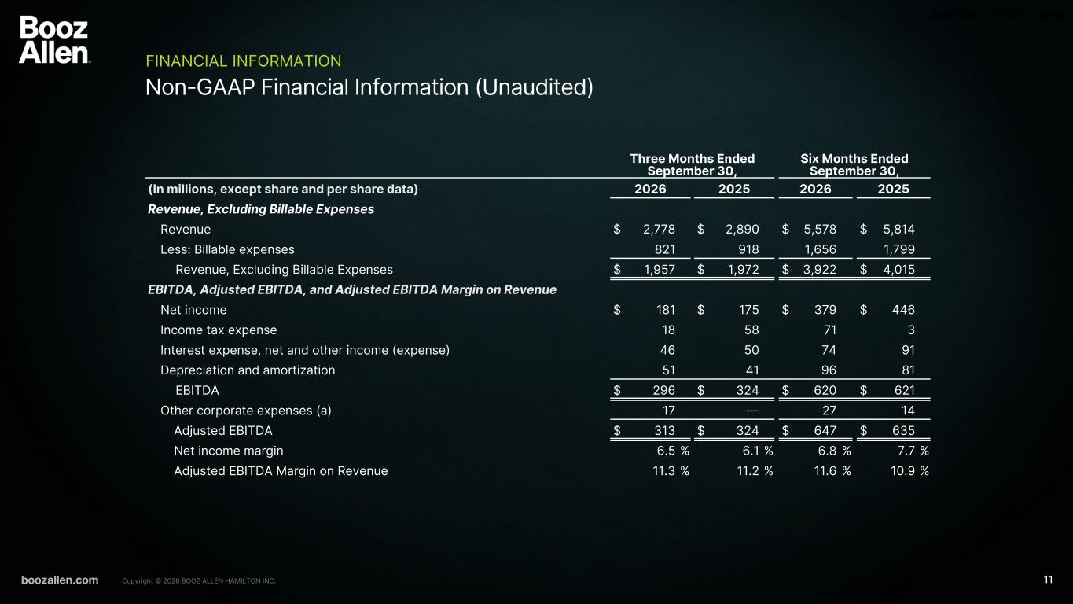
Booz Allen Hamilton Internal boozallen.com 11Copyright © 2026 BOOZ ALLEN HAMILTON INC. Non-GAAP Financial Information (Unaudited) FINANCIAL INFORMATION Three Months Ended September 30, Six Months Ended September 30, (In millions, except share and per share data) 2026 2025 2026 2025 Revenue, Excluding Billable Expenses Revenue $ 2,778 $ 2,890 $ 5,578 $ 5,814 Less: Billable expenses 821 918 1,656 1,799 Revenue, Excluding Billable Expenses $ 1,957 $ 1,972 $ 3,922 $ 4,015 EBITDA, Adjusted EBITDA, and Adjusted EBITDA Margin on Revenue Net income $ 181 $ 175 $ 379 $ 446 Income tax expense 18 58 71 3 Interest expense, net and other income (expense) 46 50 74 91 Depreciation and amortization 51 41 96 81 EBITDA $ 296 $ 324 $ 620 $ 621 Other corporate expenses (a) 17 — 27 14 Adjusted EBITDA $ 313 $ 324 $ 647 $ 635 Net income margin 6.5 % 6.1 % 6.8 % 7.7 % Adjusted EBITDA Margin on Revenue 11.3 % 11.2 % 11.6 % 10.9 %

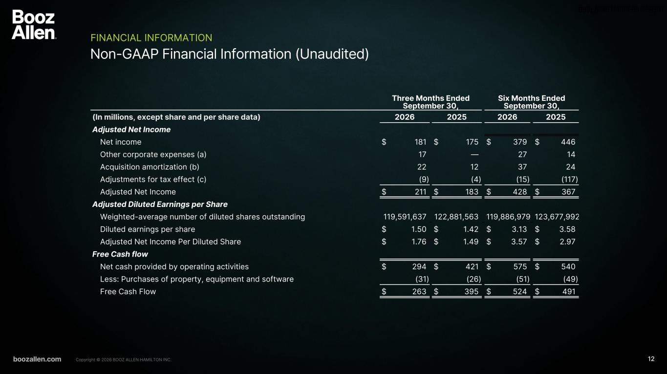
Booz Allen Hamilton Internal boozallen.com 12Copyright © 2026 BOOZ ALLEN HAMILTON INC. Non-GAAP Financial Information (Unaudited) FINANCIAL INFORMATION Three Months Ended September 30, Six Months Ended September 30, (In millions, except share and per share data) 2026 2025 2026 2025 Adjusted Net Income Net income $ 181 $ 175 $ 379 $ 446 Other corporate expenses (a) 17 — 27 14 Acquisition amortization (b) 22 12 37 24 Adjustments for tax effect (c) (9) (4) (15) (117) Adjusted Net Income $ 211 $ 183 $ 428 $ 367 Adjusted Diluted Earnings per Share Weighted-average number of diluted shares outstanding 119,591,637 122,881,563 119,886,979 123,677,992 Diluted earnings per share $ 1.50 $ 1.42 $ 3.13 $ 3.58 Adjusted Net Income Per Diluted Share $ 1.76 $ 1.49 $ 3.57 $ 2.97 Free Cash flow Net cash provided by operating activities $ 294 $ 421 $ 575 $ 540 Less: Purchases of property, equipment and software (31) (26) (51) (49) Free Cash Flow $ 263 $ 395 $ 524 $ 491


Booz Allen Hamilton Internal boozallen.com 13Copyright © 2026 BOOZ ALLEN HAMILTON INC. Non-GAAP Financial Information DISCLAIMER (a) In fiscal 2027, other corporate expenses consist primarily of acquisition related costs associated with Defy Security in the first quarter of fiscal 2027, and Ultra I&C Mission Solutions business in the second quarter of fiscal 2027. In fiscal 2026, other corporate expenses consist primarily of nonrecoverable costs associated with employee severance from cost management and restructuring initiatives, transaction costs associated with a divestiture, and acquisition related costs associated with the acquisition of Defy Security. See Note 20, “Supplemental Consolidated Financial Information,” and Note 21, “Subsequent Events,” to the consolidated financial statements within the Annual Report on Form 10-K for the fiscal year ended March 31, 2026 for further information. (b) Amortization expense associated with acquired intangibles from acquisitions. (c) Reflects the tax effect of adjustments at an assumed effective tax rate of 26%, which approximates the blended federal and state tax rates, and consistently excludes the impact of other tax credits and incentive benefits realized. The tax effect of certain discrete items is calculated specifically and may vary from the general 26% rate. The fiscal 2026 tax effect also includes the one-time benefit stemming from the favorable agreement reached with the IRS, resulting in $86 million in release of tax reserves and $20 million (net of tax effect) for the accrual of interest income on the income tax receivable. See Note 13, "Income Taxes," to the consolidated financial statements within the Annual Report on Form 10-K for the fiscal year ended March 31, 2026 for further information.

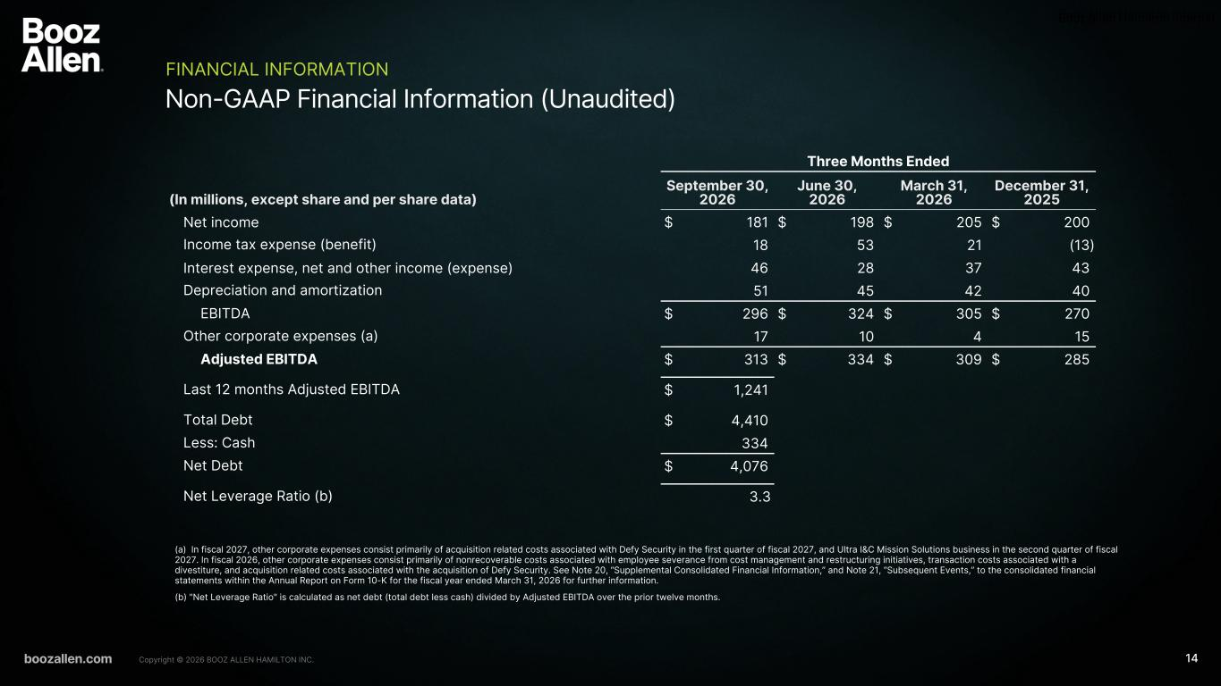
Booz Allen Hamilton Internal boozallen.com 14Copyright © 2026 BOOZ ALLEN HAMILTON INC. Non-GAAP Financial Information (Unaudited) FINANCIAL INFORMATION (a) In fiscal 2027, other corporate expenses consist primarily of acquisition related costs associated with Defy Security in the first quarter of fiscal 2027, and Ultra I&C Mission Solutions business in the second quarter of fiscal 2027. In fiscal 2026, other corporate expenses consist primarily of nonrecoverable costs associated with employee severance from cost management and restructuring initiatives, transaction costs associated with a divestiture, and acquisition related costs associated with the acquisition of Defy Security. See Note 20, “Supplemental Consolidated Financial Information,” and Note 21, “Subsequent Events,” to the consolidated financial statements within the Annual Report on Form 10-K for the fiscal year ended March 31, 2026 for further information. (b) "Net Leverage Ratio" is calculated as net debt (total debt less cash) divided by Adjusted EBITDA over the prior twelve months. Three Months Ended (In millions, except share and per share data) September 30, 2026 June 30, 2026 March 31, 2026 December 31, 2025 Net income $ 181 $ 198 $ 205 $ 200 Income tax expense (benefit) 18 53 21 (13) Interest expense, net and other income (expense) 46 28 37 43 Depreciation and amortization 51 45 42 40 EBITDA $ 296 $ 324 $ 305 $ 270 Other corporate expenses (a) 17 10 4 15 Adjusted EBITDA $ 313 $ 334 $ 309 $ 285 Last 12 months Adjusted EBITDA $ 1,241 Total Debt $ 4,410 Less: Cash 334 Net Debt $ 4,076 Net Leverage Ratio (b) 3.3

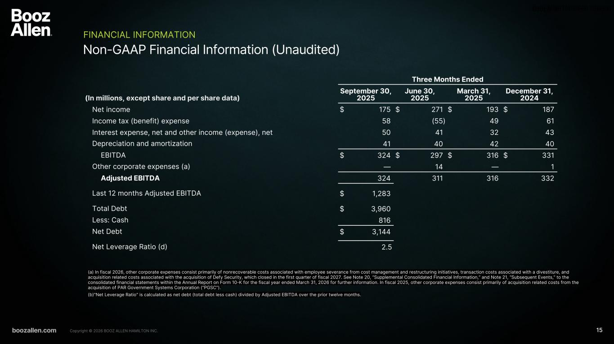
Booz Allen Hamilton Internal boozallen.com 15Copyright © 2026 BOOZ ALLEN HAMILTON INC. Non-GAAP Financial Information (Unaudited) FINANCIAL INFORMATION (a) In fiscal 2026, other corporate expenses consist primarily of nonrecoverable costs associated with employee severance from cost management and restructuring initiatives, transaction costs associated with a divestiture, and acquisition related costs associated with the acquisition of Defy Security, which closed in the first quarter of fiscal 2027. See Note 20, “Supplemental Consolidated Financial Information,” and Note 21, “Subsequent Events,” to the consolidated financial statements within the Annual Report on Form 10-K for the fiscal year ended March 31, 2026 for further information. In fiscal 2025, other corporate expenses consist primarily of acquisition related costs from the acquisition of PAR Government Systems Corporation (“PGSC”). (b)"Net Leverage Ratio" is calculated as net debt (total debt less cash) divided by Adjusted EBITDA over the prior twelve months. Three Months Ended (In millions, except share and per share data) September 30, 2025 June 30, 2025 March 31, 2025 December 31, 2024 Net income $ 175 $ 271 $ 193 $ 187 Income tax (benefit) expense 58 (55) 49 61 Interest expense, net and other income (expense), net 50 41 32 43 Depreciation and amortization 41 40 42 40 EBITDA $ 324 $ 297 $ 316 $ 331 Other corporate expenses (a) — 14 — 1 Adjusted EBITDA 324 311 316 332 Last 12 months Adjusted EBITDA $ 1,283 Total Debt $ 3,960 Less: Cash 816 Net Debt $ 3,144 Net Leverage Ratio (d) 2.5

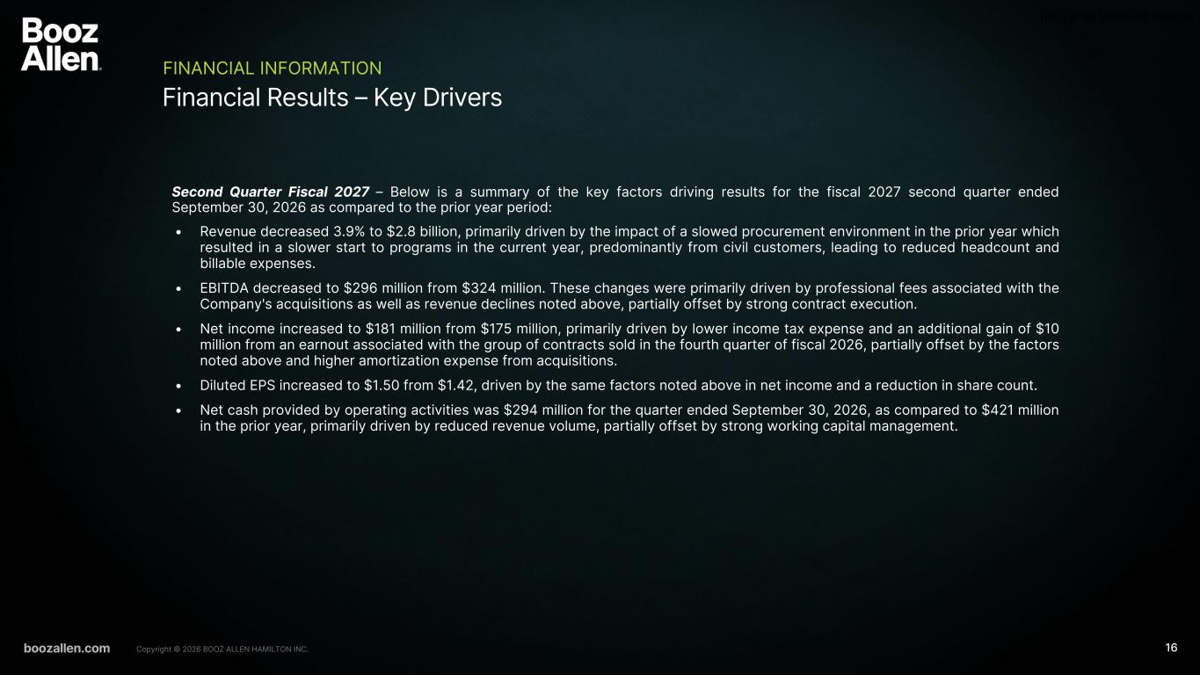
Booz Allen Hamilton Internal boozallen.com 16Copyright © 2026 BOOZ ALLEN HAMILTON INC. Financial Results – Key Drivers FINANCIAL INFORMATION Second Quarter Fiscal 2027 – Below is a summary of the key factors driving results for the fiscal 2027 second quarter ended September 30, 2026 as compared to the prior year period: • Revenue decreased 3.9% to $2.8 billion, primarily driven by the impact of a slowed procurement environment in the prior year which resulted in a slower start to programs in the current year, predominantly from civil customers, leading to reduced headcount and billable expenses. • EBITDA decreased to $296 million from $324 million. These changes were primarily driven by professional fees associated with the Company's acquisitions as well as revenue declines noted above, partially offset by strong contract execution. • Net income increased to $181 million from $175 million, primarily driven by lower income tax expense and an additional gain of $10 million from an earnout associated with the group of contracts sold in the fourth quarter of fiscal 2026, partially offset by the factors noted above and higher amortization expense from acquisitions. • Diluted EPS increased to $1.50 from $1.42, driven by the same factors noted above in net income and a reduction in share count. • Net cash provided by operating activities was $294 million for the quarter ended September 30, 2026, as compared to $421 million in the prior year, primarily driven by reduced revenue volume, partially offset by strong working capital management.

