UNITED STATES
SECURITIES AND EXCHANGE COMMISSION
WASHINGTON, D.C. 20549
___________________________________
FORM 8-K
___________________________________

CURRENT REPORT
Pursuant to Section 13 or 15(d) of
the Securities Exchange Act of 1934
Date of Report (Date of earliest event reported): August 24, 2026 (August 24, 2026)
___________________________________
Booz Allen Hamilton Holding Corporation
(Exact name of Registrant as specified in its charter)
___________________________________

Delaware |  |  |  |  |  |  |  |  |  |  |  | 001-34972 |  |  |  |  |  | 26-2634160
(State or other jurisdiction  of incorporation) |  |  |  |  |  |  |  |  |  |  |  | (Commission  File Number) |  |  |  |  |  | (IRS Employer  Identification No.)
8283 Greensboro Drive, |  |  | McLean, |  |  | Virginia |  |  |  |  |  |  |  |  |  |  |  | 22102
(Address of principal executive offices) |  |  |  |  |  |  |  |  |  |  |  |  |  |  |  |  |  | (Zip Code)
Registrant’s telephone number, including area code: (703) 902-5000
___________________________________

Check the appropriate box below if the Form 8-K filing is intended to simultaneously satisfy the filing obligation of the Registrant under any of the following provisions:
☐ |  |  | Written communications pursuant to Rule 425 under the Securities Act (17 CFR 230.425)
☐ |  |  | Soliciting material pursuant to Rule 14a-12 under the Exchange Act (17 CFR 240.14a-12)
☐ |  |  | Pre-commencement communications pursuant to Rule 14d-2(b) under the Exchange Act (17 CFR 240.14d-2(b))
☐ |  |  | Pre-commencement communications pursuant to Rule 13e-4(c) under the Exchange Act (17 CFR 240.13e-4(c))
Securities registered pursuant to Section 12(b) of the Act:
Title of Each Class |  |  | Trading Symbol |  |  | Name of Each Exchange on Which Registered
Class A Common Stock |  |  | BAH |  |  | New York Stock Exchange

Indicate by check mark whether the registrant is an emerging growth company as defined in Rule 405 of the Securities Act of 1933 (§230.405 of this chapter) or Rule 12b-2 of the Securities Exchange Act of 1934 (§240.12b-2 of this chapter).
Emerging growth company ☐

If an emerging growth company, indicate by check mark if the registrant has elected not to use the extended transition period for complying with any new or revised financial accounting standards provided pursuant to Section 13(a) of the Exchange Act. ☐

Item 8.01 Other Events.

On August 24, 2026, Booz Allen Hamilton Holding Corporation (“Booz Allen”) issued a press release announcing that on August 24, 2026 it closed the previously announced acquisition of Ultra Electronics Advanced Tactical Systems, Inc., a Texas corporation (the “Company”), pursuant to a stock purchase agreement by and among Booz Allen Hamilton Inc., a Delaware corporation and a wholly-owned subsidiary of Booz Allen, the Company, Ultra I&C Holdings Limited, a private limited company incorporated under the Laws of England and Wales, and Ultra Electronics Holdings Limited, a private limited company incorporated under the Laws of England and Wales. A copy of the press release is attached hereto as Exhibit 99.1 and is incorporated herein by reference.
Item 9.01 Financial Statements and Exhibits.
(d) Exhibits
Exhibit  No. |  |  |  |  |  | Description
99.1 |  |  |  |  |  | Press Release of Booz Allen Hamilton Holding Corporation, dated August 24, 2026.
104 |  |  |  |  |  | Cover Page Interactive Data File (embedded within the Inline XBRL document).

SIGNATURES
Pursuant to the requirements of the Securities Exchange Act of 1934, the registrant has duly caused this report to be signed on its behalf by the undersigned hereunto duly authorized.

 |  |  | Booz Allen Hamilton Holding Corporation
BY: |  |  | /s/ Troy Lahr
 |  |  | Troy Lahr
 |  |  | Executive Vice President and Chief Financial Officer
Date: August 24, 2026
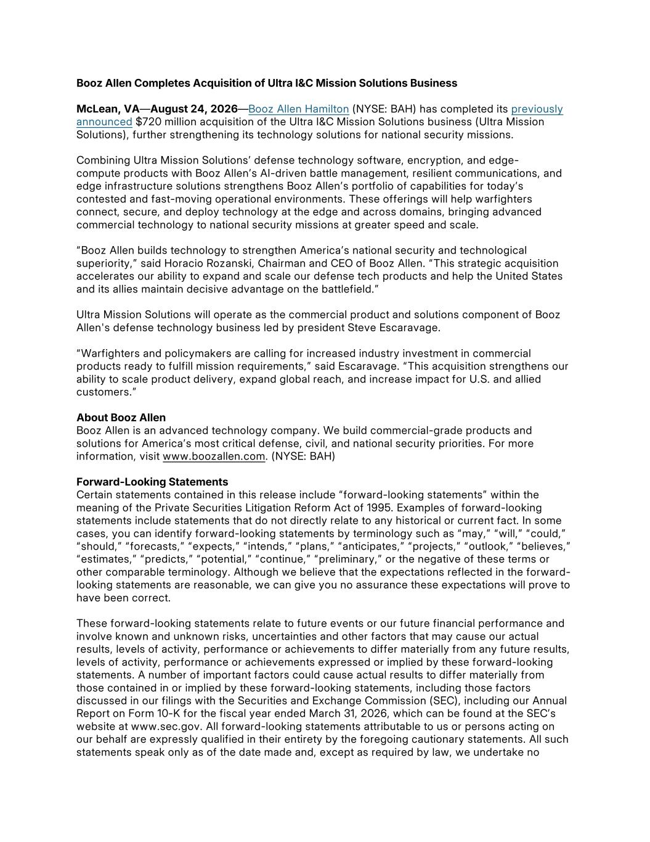

Booz Allen Completes Acquisition of Ultra I&C Mission Solutions Business McLean, VA—August 24, 2026—Booz Allen Hamilton (NYSE: BAH) has completed its previously announced $720 million acquisition of the Ultra I&C Mission Solutions business (Ultra Mission Solutions), further strengthening its technology solutions for national security missions. Combining Ultra Mission Solutions’ defense technology software, encryption, and edge- compute products with Booz Allen’s AI-driven battle management, resilient communications, and edge infrastructure solutions strengthens Booz Allen’s portfolio of capabilities for today’s contested and fast-moving operational environments. These offerings will help warfighters connect, secure, and deploy technology at the edge and across domains, bringing advanced commercial technology to national security missions at greater speed and scale. “Booz Allen builds technology to strengthen America’s national security and technological superiority,” said Horacio Rozanski, Chairman and CEO of Booz Allen. “This strategic acquisition accelerates our ability to expand and scale our defense tech products and help the United States and its allies maintain decisive advantage on the battlefield.” Ultra Mission Solutions will operate as the commercial product and solutions component of Booz Allen's defense technology business led by president Steve Escaravage. “Warfighters and policymakers are calling for increased industry investment in commercial products ready to fulfill mission requirements,” said Escaravage. “This acquisition strengthens our ability to scale product delivery, expand global reach, and increase impact for U.S. and allied customers.” About Booz Allen Booz Allen is an advanced technology company. We build commercial-grade products and solutions for America’s most critical defense, civil, and national security priorities. For more information, visit www.boozallen.com. (NYSE: BAH) Forward-Looking Statements Certain statements contained in this release include “forward-looking statements” within the meaning of the Private Securities Litigation Reform Act of 1995. Examples of forward-looking statements include statements that do not directly relate to any historical or current fact. In some cases, you can identify forward-looking statements by terminology such as “may,” “will,” “could,” “should,” “ forecasts,” “expects,” “ intends,” “plans,” “anticipates,” “projects,” “outlook,” “believes,” “estimates,” “predicts,” “potential,” “continue,” “preliminary,” or the negative of these terms or other comparable terminology. Although we believe that the expectations reflected in the forward- looking statements are reasonable, we can give you no assurance these expectations will prove to have been correct. These forward-looking statements relate to future events or our future financial performance and involve known and unknown risks, uncertainties and other factors that may cause our actual results, levels of activity, performance or achievements to differ materially from any future results, levels of activity, performance or achievements expressed or implied by these forward-looking statements. A number of important factors could cause actual results to differ materially from those contained in or implied by these forward-looking statements, including those factors discussed in our filings with the Securities and Exchange Commission (SEC), including our Annual Report on Form 10-K for the fiscal year ended March 31, 2026, which can be found at the SEC’s website at www.sec.gov. All forward-looking statements attributable to us or persons acting on our behalf are expressly qualified in their entirety by the foregoing cautionary statements. All such statements speak only as of the date made and, except as required by law, we undertake no


obligation to update or revise publicly any forward-looking statements, whether as a result of new information, future events or otherwise. Contacts Media Relations: Jessica Klenk, Klenk_Jessica@bah.com Investor Relations: Dustin Darensbourg, Investor_Relations@bah.com

