(Mark One)

☒

☐

UNITED STATES

SECURITIES AND EXCHANGE COMMISSION

WASHINGTON, D.C. 20549
___________________________________

FORM 10-Q

___________________________________

QUARTERLY REPORT PURSUANT TO SECTION 13 OR 15(D) OF THE SECURITIES EXCHANGE ACT OF 1934

For the quarterly period ended December 31, 2021

TRANSITION REPORT PURSUANT TO SECTION 13 OR 15(D) OF THE SECURITIES EXCHANGE ACT OF 1934

For the transition period from to

Commission File No. 001-34972

___________________________________

Booz Allen Hamilton Holding Corporation

(Exact name of registrant as specified in its charter)

___________________________________

Delaware | 26-2634160
(State or other jurisdiction of | (I.R.S. Employer
incorporation or organization) | Identification No.)

8283 Greensboro Drive, |  | McLean, |  | Virginia |  |  | 22102
(Address of principal executive offices) |  |  |  |  |  |  |  | (Zip Code)
 |  |  |  | (703) 902-5000
 |  |  |  | Registrant’s telephone number, including area code
 |  |  |  | (Former name, former address, and former fiscal year if changed since last report.)
 |  |  |  | ___________________________________
 |  |  |  | Securities registered pursuant to Section 12(b) of the Act:
 |  | Title of Each Class |  |  | Trading Symbol |  |  | Name of Each Exchange on Which Registered
 | Class A Common Stock |  |  |  | BAH |  |  | New York Stock Exchange

Indicate by check mark whether the registrant (1) has filed all reports required to be filed by Section 13 or 15(d) of the Securities Exchange Act of 1934 during the preceding 12 months (or for such shorter period that the registrant was required to file such reports), and (2) has been subject to such filing requirements for the past 90 days. Yes ☒ No ☐

Indicate by check mark whether the registrant has submitted electronically every Interactive Data File required to be submitted pursuant to Rule 405 of Regulation S-T (§232.405 of this chapter) during the preceding 12 months (or for such shorter period that the registrant was required to submit such files). Yes ☒ No ☐

Indicate by check mark whether the registrant is a large accelerated filer, an accelerated filer, a non-accelerated filer or a smaller reporting company. See definition of “accelerated filer,” “large accelerated filer” and “smaller reporting company” in Rule 12b-2 of the Exchange Act.

Large Accelerated Filer | ☒ | Accelerated Filer | ☐
Non-Accelerated Filer |  | Smaller Reporting Company | ☐
 |  | Emerging Growth Company | ☐

If an emerging growth company, indicate by check mark if the registrant has elected not to use the extended transition period for complying with any new or revised financial accounting standards provided pursuant to Section 13(a) of the Exchange Act. ☐

Indicate by check mark whether the registrant is a shell company (as defined in Rule 12b-2 of the Exchange Act). Yes ☐ No ☒

Indicate the number of shares outstanding of each of the issuer’s classes of common stock, as of the latest practicable date.

 | Shares Outstanding
 | as of January 25, 2022
Class A Common Stock | 133,257,688

TABLE OF CONTENTS
 | PART I. Financial Information |  |  |  |  |  |  |  |  |  |  |  |  |  | Page
 |  |  |  |  |  |  |  |  |  |  |  |  |  |  | 1
 | ITEM 1 | Financial Statements |  |  |  |  |  |  |  |  |  |  |  |  | 1
 | ITEM 2 | Management's Discussion and Analysis of Financial Condition and Results of Operations |  |  |  |  |  |  |  |  |  |  |  |  |  | 24
 | ITEM 3 | Quantitative and Qualitative Disclosures About Market Risk |  |  |  |  |  |  |  |  |  |  |  |  |  | 42
 | ITEM 4 | Controls and Procedures |  |  |  |  |  |  |  |  |  |  |  |  | 42
 | PART II. Other Information |  |  |  |  |  |  |  |  |  |  |  |  |  |  | 43
 | ITEM 1 | Legal Proceedings |  |  |  |  |  |  |  |  |  |  |  |  |  | 43
 | ITEM 1A | Risk Factors |  |  |  |  |  |  |  |  |  |  |  |  |  | 44
 | ITEM 2 | Unregistered Sales of Equity Securities and Use of Proceeds |  |  |  |  |  |  |  |  |  |  |  |  |  | 44
 | ITEM 3 | Defaults Upon Senior Securities |  |  |  |  |  |  |  |  |  |  |  |  | 44
 | ITEM 4 | Mine Safety Disclosures |  |  |  |  |  |  |  |  |  |  |  |  |  | 44
 | ITEM 5 | Other Information |  |  |  |  |  |  |  |  |  |  |  |  | 44
 | ITEM 6 | Exhibits |  |  |  |  |  |  |  |  |  |  |  |  |  | 46

Table of Contents
 |  |  |  |  |  |  |  |  |  |  |  |  |  |  |  |  |  |  |  |  | PART I. FINANCIAL INFORMATION
Item 1. Financial Statements
 |  |  |  |  |  |  |  |  |  |  |  |  |  |  |  |  | INDEX TO THE UNAUDITED CONDENSED CONSOLIDATED FINANCIAL STATEMENTS
 |  |  |  |  |  |  |  |  |  |  |  |  |  |  |  |  |  |  |  |  |  | Page
Consolidated Balance Sheets |  |  |  |  |  |  |  |  |  |  |  |  |  |  |  |  |  |  |  |  |  | 1
Consolidated Statements of Operations |  |  |  |  |  |  |  |  |  |  |  |  |  |  |  |  |  |  |  |  |  |  | 2
Consolidated Statements of Comprehensive Income |  |  |  |  |  |  |  |  |  |  |  |  |  |  |  |  |  |  |  |  |  | 3
Consolidated Statements of Cash Flows |  |  |  |  |  |  |  |  |  |  |  |  |  |  |  |  |  |  |  |  |  |  | 4
Consolidated Statement of Stockholders' Equity |  |  |  |  |  |  |  |  |  |  |  |  |  |  |  |  |  |  |  |  |  |  | 5
naudited Condensed Consolidated Financial Statements
ness Overview |  |  |  |  |  |  |  |  |  |  |  |  |  |  |  |  |  |  |  |  |  | 7
s of Presentation |  |  |  |  |  |  |  |  |  |  |  |  |  |  |  |  |  |  |  |  |  |  | 7
nue |  |  |  |  |  |  |  |  |  |  |  |  |  |  |  |  |  |  |  |  |  | 7
ings Per Share |  |  |  |  |  |  |  |  |  |  |  |  |  |  |  |  |  |  |  |  |  | 10
uisition, Goodwill and Intangible Assets |  |  |  |  |  |  |  |  |  |  |  |  |  |  |  |  |  |  |  |  |  | 12
unts Payable and Other Accrued Expenses |  |  |  |  |  |  |  |  |  |  |  |  |  |  |  |  |  |  |  |  |  | 14
ued Compensation and Benefits |  |  |  |  |  |  |  |  |  |  |  |  |  |  |  |  |  |  |  |  |  | 15
 |  |  |  |  |  |  |  |  |  |  |  |  |  |  |  |  |  |  |  |  |  | 15
vatives |  |  |  |  |  |  |  |  |  |  |  |  |  |  |  |  |  |  |  |  |  | 17
ome Taxes |  |  |  |  |  |  |  |  |  |  |  |  |  |  |  |  |  |  |  |  |  | 18
er Long Term Liabilities |  |  |  |  |  |  |  |  |  |  |  |  |  |  |  |  |  |  |  |  |  | 19
ployee Benefit Plans |  |  |  |  |  |  |  |  |  |  |  |  |  |  |  |  |  |  |  |  |  | 19
umulated Other Comprehensive Loss |  |  |  |  |  |  |  |  |  |  |  |  |  |  |  |  |  |  |  |  |  | 20
ck Based Compensation |  |  |  |  |  |  |  |  |  |  |  |  |  |  |  |  |  |  |  |  |  | 20
r Value Measurements |  |  |  |  |  |  |  |  |  |  |  |  |  |  |  |  |  |  |  |  |  | 21
ated Party Transactions |  |  |  |  |  |  |  |  |  |  |  |  |  |  |  |  |  |  |  |  |  | 23
mmitments and Contingencies |  |  |  |  |  |  |  |  |  |  |  |  |  |  |  |  |  |  |  |  |  | 23

Table of Contents
 | BOOZ ALLEN HAMILTON HOLDING CORPORATION
 | CONDENSED CONSOLIDATED BALANCE SHEETS
 | (Amounts in thousands, except share and per share data)
 |  |  | December 31, |  |  | March 31,
 |  |  | 2021 |  |  | 2021
 |  |  | (Unaudited)
 | ASSETS
Current assets:
Cash and cash equivalents |  | $ | 642,709 |  | $ | 990,955
Accounts receivable, net |  |  | 1,618,494 |  |  | 1,411,894
Prepaid expenses and other current assets |  |  | 93,937 |  |  | 233,323
Total current assets |  |  | 2,355,140 |  |  | 2,636,172
Property and equipment, net of accumulated depreciation |  |  | 195,515 |  |  | 204,642
Operating lease right-of-use assets |  |  | 229,041 |  |  | 239,374
Intangible assets, net of accumulated amortization |  |  | 664,640 |  |  | 307,128
Goodwill |  |  | 2,021,931 |  |  | 1,581,160
Other long-term assets |  |  | 477,766 |  |  | 531,125
Total assets |  | $ | 5,944,033 |  | $ | 5,499,601
 | LIABILITIES AND STOCKHOLDERS’ EQUITY
Current liabilities:
Current portion of long-term debt |  | $ | 68,379 |  | $ | 77,865
Accounts payable and other accrued expenses |  |  | 796,438 |  |  | 666,971
Accrued compensation and benefits |  |  | 404,678 |  |  | 425,615
Operating lease liabilities |  |  | 50,717 |  |  | 54,956
Other current liabilities |  |  | 72,142 |  |  | 65,698
Total current liabilities |  |  | 1,392,354 |  |  | 1,291,105
Long-term debt, net of current portion |  |  | 2,747,892 |  |  | 2,278,731
Operating lease liabilities, net of current portion |  |  | 250,792 |  |  | 263,144
Deferred tax liabilities |  |  | 242,859 |  |  | 364,461
Other long-term liabilities |  |  | 235,882 |  |  | 230,984
Total liabilities |  |  | 4,869,779 |  |  | 4,428,425
Commitments and contingencies (Note 17)
Stockholders’ equity:
Common stock, Class A — $0.01 par value — authorized, 600,000,000 shares; issued, 163,721,966 shares at December 31, 2021 and |  |  | 1,637 |  |  | 1,629
162,950,606 shares at March 31, 2021; outstanding, 133,427,292 shares at December 31, 2021 and 136,246,029 shares at March 31, 2021 |  |  | 1,637 |  |  | 1,629
Treasury stock, at cost — 30,294,674 shares at December 31, 2021 and 26,704,577 shares at March 31, 2021 |  |  | (1,515,903) |  |  | (1,216,163)
Additional paid-in capital |  |  | 620,632 |  |  | 557,957
Retained earnings |  |  | 1,981,715 |  |  | 1,757,524
Accumulated other comprehensive loss |  |  | (17,054) |  |  | (29,771)
Total Booz Allen stockholders' equity |  |  | 1,071,027 |  |  | 1,071,176
Non-controlling interest |  |  | 3,227 |  |  | —
Total stockholders’ equity |  |  | 1,074,254 |  |  | 1,071,176
Total liabilities and stockholders’ equity |  | $ | 5,944,033 |  | $ | 5,499,601

The accompanying notes are an integral part of these Condensed Consolidated Financial Statements.

1

Table of Contents

BOOZ ALLEN HAMILTON HOLDING CORPORATION

CONDENSED CONSOLIDATED STATEMENTS OF OPERATIONS

(UNAUDITED)

(Amounts in thousands, except per share data)

 |  | Three Months Ended |  |  |  |  |  | Nine Months Ended
 |  | December 31, |  |  |  |  |  | December 31,
 |  | 2021 |  |  | 2020 |  |  | 2021 |  |  | 2020
Revenue | $ | 2,030,520 |  | $ | 1,904,020 |  | $ | 6,125,624 |  | $ | 5,879,658
Operating costs and expenses:
Cost of revenue |  | 929,568 |  |  | 866,771 |  |  | 2,840,044 |  |  | 2,758,270
Billable expenses |  | 621,550 |  |  | 577,059 |  |  | 1,817,215 |  |  | 1,729,788
General and administrative expenses |  | 262,614 |  |  | 254,820 |  |  | 826,606 |  |  | 745,375
Depreciation and amortization |  | 39,576 |  |  | 21,113 |  |  | 104,923 |  |  | 62,860
Total operating costs and expenses |  | 1,853,308 |  |  | 1,719,763 |  |  | 5,588,788 |  |  | 5,296,293
Operating income |  | 177,212 |  |  | 184,257 |  |  | 536,836 |  |  | 583,365
Interest expense |  | (23,677) |  |  | (20,878) |  |  | (69,201) |  |  | (60,900)
Other income (expense), net |  | 5,401 |  |  | 2,604 |  |  | 11,716 |  |  | (10,266)
Income before income taxes |  | 158,936 |  |  | 165,983 |  |  | 479,351 |  |  | 512,199
Income tax expense |  | 30,090 |  |  | 21,612 |  |  | 103,569 |  |  | 102,418
Net income | $ | 128,846 |  | $ | 144,371 |  | $ | 375,782 |  | $ | 409,781
Net loss attributable to non-controlling interest |  | (85) |  |  | — |  |  | (85) |  |  | —
Net income attributable to common stockholders |  | 128,931 |  |  | 144,371 |  |  | 375,867 |  |  | 409,781
Earnings per common share (Note 4):
Basic | $ | 0.96 |  | $ | 1.04 |  | $ | 2.77 |  | $ | 2.95
Diluted
Diluted | $ | 0.95 |  | $ | 1.03 |  | $ | 2.76 |  | $ | 2.93

The accompanying notes are an integral part of these Condensed Consolidated Financial Statements.

2

Table of Contents

BOOZ ALLEN HAMILTON HOLDING CORPORATION

CONDENSED CONSOLIDATED STATEMENTS OF COMPREHENSIVE INCOME

(UNAUDITED)

(Amounts in thousands)

 |  | Three Months Ended |  |  |  |  |  | Nine Months Ended
 |  | December 31, |  |  |  |  |  | December 31,
 | 2021 |  |  |  | 2020 |  |  | 2021 |  |  | 2020
Net income | $ | 128,846 |  | $ | 144,371 |  | $ | 375,782 |  | $ | 409,781
Other comprehensive income, net of tax:
Change in unrealized gain on derivatives designated as cash flow hedges |  | 6,925 |  |  | 3,758 |  |  | 12,658 |  |  | 5,983
Change in postretirement plan costs |  | 20 |  |  | 22 |  |  | 59 |  |  | 66
Total other comprehensive income, net of tax |  | 6,945 |  |  | 3,780 |  |  | 12,717 |  |  | 6,049
Comprehensive income | $ | 135,791 |  | $ | 148,151 |  | $ | 388,499 |  | $ | 415,830

The accompanying notes are an integral part of these Condensed Consolidated Financial Statements.

3

Table of Contents

BOOZ ALLEN HAMILTON HOLDING CORPORATION

CONDENSED CONSOLIDATED STATEMENTS OF CASH FLOWS

(UNAUDITED)

(Amounts in thousands)

Nine Months Ended
December 31,

 | 2021 |  |  |  | 2020
Cash flows from operating activities
Net income | $ | 375,782 |  | $ | 409,781
Adjustments to reconcile net income to net cash provided by operating activities:
Depreciation and amortization |  | 104,923 |  |  | 62,860
Noncash lease expense |  | 41,718 |  |  | 40,861
Stock-based compensation expense |  | 45,187 |  |  | 40,972
Amortization of debt issuance costs |  | 3,463 |  |  | 3,302
Loss on debt extinguishment |  | 2,515 |  |  | 13,239
Gains on dispositions, and other |  | (3,564) |  |  | (3,479)
Gains associated with equity method investment activities |  | (12,761) |  |  | —
Changes in assets and liabilities:
Accounts receivable, net |  | (150,156) |  |  | 38,270
Deferred income taxes and income taxes receivable / payable |  | 38,453 |  |  | 36,902
Prepaid expenses and other current and long-term assets |  | (19,953) |  |  | (3,656)
Accrued compensation and benefits |  | (5,371) |  |  | 76,658
Accounts payable and other accrued expenses |  | 88,529 |  |  | 125,887
Other current and long-term liabilities |  | (27,614) |  |  | (42,638)
Net cash provided by operating activities |  | 481,151 |  |  | 798,959
Cash flows from investing activities
Purchases of property, equipment, and software |  | (51,608) |  |  | (54,033)
Payments for business acquisitions, net of cash acquired |  | (780,213) |  |  | —
Payment for minority investment in entity |  | — |  |  | (72,152)
Payment for cost method investment |  | (3,000) |  |  | —
Proceeds from sales of assets, net of payment |  | — |  |  | 3,330
Other investing activities |  | (427) |  |  | —
Net cash used in investing activities |  | (835,248) |  |  | (122,855)
Cash flows from financing activities
Proceeds from issuance of common stock |  | 17,240 |  |  | 13,948
Stock option exercises |  | 3,558 |  |  | 10,193
Repurchases of common stock |  | (315,148) |  |  | (143,354)
Cash dividends paid |  | (151,664) |  |  | (129,862)
Debt extinguishment costs |  | — |  |  | (8,971)
Repayments on revolving credit facility and term loan |  | (95,162) |  |  | (508,399)
Net proceeds from debt issuance |  | 487,027 |  |  | 691,496
Proceeds from revolving credit facility |  | 60,000 |  |  | —
Other financing activities |  | — |  |  | (1,755)
Net cash provided by (used in) financing activities |  | 5,851 |  |  | (76,704)
Net (decrease) increase in cash and cash equivalents |  | (348,246) |  |  | 599,400
Cash and cash equivalents––beginning of period |  | 990,955 |  |  | 741,901
Cash and cash equivalents––end of period | $ | 642,709 |  | $ | 1,341,301
Supplemental disclosures of cash flow information
Net cash paid during the period for:
Interest | $ | 34,185 |  | $ | 39,737
Income taxes | $ | 62,142 |  | $ | 69,374

The accompanying notes are an integral part of these Condensed Consolidated Financial Statements.

4

Table of Contents

BOOZ ALLEN HAMILTON HOLDING CORPORATION
CONDENSED CONSOLIDATED STATEMENTS OF STOCKHOLDERS’ EQUITY (UNAUDITED)

 | Class A |  |  |  |  | Treasury |  |  |  |  |  |  |  |  |  |  |  | Accumulated
 |  |  |  |  |  |  |  |  |  |  |  | Additional |  |  |  |  |  | Other |  |  |  |  |  | Total
 | Common Stock |  |  |  |  | Stock |  |  |  |  |  |  |  |  |  |  |  |  |  |  |  |  |  | Total
(Amounts in thousands, except |  |  |  |  |  |  |  |  |  |  |  | Paid-In |  |  | Retained |  | Comprehensive |  |  | Non-Controlling |  |  |  | Stockholders’
share data) | Shares |  |  | Amount |  | Shares |  |  | Amount |  |  | Capital |  |  | Earnings |  |  | Income (Loss) |  |  | Interest |  |  | Equity
Balance at September 30, 2021 | 163,627,651 |  | $ | 1,636 |  | (29,302,541) |  | $ | (1,433,136) |  | $ | 600,930 |  | $ | 1,902,667 |  | $ | (23,999) |  | $ | — |  | $ | 1,048,098
Issuance of common stock | 79,085 |  |  | 1 |  | — |  |  | — |  |  | 5,713 |  |  | — |  |  | — |  |  | — |  |  | 5,714
Stock options exercised | 15,230 |  |  | — |  | — |  |  | — |  |  | 542 |  |  | — |  |  | — |  |  | — |  |  | 542
Repurchase of common stock | — |  |  | — |  | (992,133) |  |  | (82,767) |  |  | – |  |  | — |  |  | — |  |  | — |  |  | (82,767)
Recognition of liability related to future restricted stock units vesting | — |  |  | — |  | — |  |  | — |  |  | — |  |  | — |  |  | — |  |  | — |  |  | —
Net income | — |  |  | — |  | — |  |  | — |  |  | — |  |  | 128,931 |  |  | — |  |  | (85) |  |  | 128,846
Other comprehensive income, net of tax | — |  |  | — |  | — |  |  | — |  |  | – |  |  | — |  |  | 6,945 |  |  | — |  |  | 6,945
Dividends declared of $0.37 per share of common stock | — |  |  | — |  | — |  |  | — |  |  | – |  |  | (49,883) |  |  | — |  |  | — |  |  | (49,883)
Stock-based compensation expense | — |  |  | — |  | — |  |  | — |  |  | 16,759 |  |  | — |  |  | — |  |  | — |  |  | 16,759
Contribution to non-controlling interest | — |  |  | — |  | — |  |  | — |  |  | (3,312) |  |  | — |  |  | — |  |  | 3,312 |  |  | —
Balance at December 31, 2021 | 163,721,966 |  | $ | 1,637 |  | (30,294,674) |  | $ | (1,515,903) |  | $ | 620,632 |  | $ | 1,981,715 |  | $ | (17,054) |  | $ | 3,227 |  | $ | 1,074,254
Balance at March 31, 2021 | 162,950,606 |  | $ | 1,629 |  | (26,704,577) |  | $ | (1,216,163) |  | $ | 557,957 |  | $ | 1,757,524 |  | $ | (29,771) |  | $ | — |  | $ | 1,071,176
Issuance of common stock | 637,766 |  |  | 7 |  | — |  |  | — |  |  | 16,030 |  |  | — |  |  | — |  |  | — |  |  | 16,037
Stock options exercised | 133,594 |  |  | 1 |  | — |  |  | — |  |  | 3,557 |  |  | — |  |  | — |  |  | — |  |  | 3,558
Repurchase of common stock (1) | — |  |  | — |  | (3,590,097) |  |  | (299,740) |  |  | — |  |  | — |  |  | — |  |  | — |  |  | (299,740)
Recognition of liability related to future restricted stock units vesting | — |  |  | — |  | — |  |  | — |  |  | 1,213 |  |  | — |  |  | — |  |  | — |  |  | 1,213
Net income | — |  |  | — |  | — |  |  | — |  |  | — |  |  | 375,867 |  |  | — |  |  | (85) |  |  | 375,782
Other comprehensive income, net of tax | — |  |  | — |  | — |  |  | — |  |  | — |  |  | — |  |  | 12,717 |  |  | — |  |  | 12,717
Dividends declared of $1.11 per share of common stock | — |  |  | — |  | — |  |  | — |  |  | — |  |  | (151,676) |  |  | — |  |  | — |  |  | (151,676)
Stock-based compensation expense | — |  |  | — |  | — |  |  | — |  |  | 45,187 |  |  |  |  |  | — |  |  | — |  |  | 45,187
Contribution to non-controlling interest | — |  |  | — |  | — |  |  | — |  |  | (3,312) |  |  | — |  |  | — |  |  | 3,312 |  |  | —
Balance at December 31, 2021 | 163,721,966 |  | $ | 1,637 |  | (30,294,674) |  | $ | (1,515,903) |  | $ | 620,632 |  | $ | 1,981,715 |  | $ | (17,054) |  | $ | 3,227 |  | $ | 1,074,254

- During the nine months ended December 31, 2021, the Company purchased 3.4 million shares of the Company’s Class A Common Stock in a series of open market transactions for $286.3 million. Additionally, the Company repurchased shares for $13.4 million during the nine months ended December 31, 2021 to cover the minimum statutory withholding taxes on restricted stock units that vested on various dates during the period.

5

Table of Contents

BOOZ ALLEN HAMILTON HOLDING CORPORATION
CONDENSED CONSOLIDATED STATEMENTS OF STOCKHOLDERS’ EQUITY (UNAUDITED) [CONTINUED]

 | Class A |  |  |  |  | Treasury |  |  |  |  |  | Additional |  |  |  |  |  | Accumulated |  |  | Total
 | Common Stock |  |  |  |  | Stock |  |  |  |  |  |  |  |  |  |  |  | Other |  |  | Total
(Amounts in thousands, except |  |  |  |  |  |  |  |  |  |  |  | Paid-In |  |  | Retained |  |  | Comprehensive |  |  | Stockholders’
share data) | Shares |  |  | Amount |  | Shares |  |  | Amount |  |  | Capital |  |  | Earnings |  |  | Income (Loss) |  |  | Equity
Balance at September 30, 2020 | 162,079,334 |  | $ | 1,621 |  | (24,054,733) |  | $ | (1,003,650) |  | $ | 509,512 |  | $ | 1,508,206 |  | $ | (43,732) |  | $ | 971,957
Issuance of common stock | 35,460 |  |  | — |  | — |  |  | — |  |  | 4,262 |  |  | — |  |  | — |  |  | 4,262
Stock options exercised | 128,379 |  |  | 1 |  | — |  |  | — |  |  | 3,700 |  |  | — |  |  | — |  |  | 3,701
Repurchase of common stock | — |  |  | — |  | (323,128) |  |  | (27,063) |  |  | — |  |  | — |  |  | — |  |  | (27,063)
Recognition of liability related to future restricted stock units vesting | — |  |  | — |  | — |  |  | — |  |  | (58) |  |  | — |  |  | — |  |  | (58)
Net income | — |  |  | — |  | — |  |  | — |  |  | — |  |  | 144,371 |  |  | — |  |  | 144,371
Other comprehensive income, net of tax | — |  |  | — |  | — |  |  | — |  |  | — |  |  | — |  |  | 3,780 |  |  | 3,780
Dividends paid of $0.31 per share of common stock | — |  |  | — |  | — |  |  | — |  |  | — |  |  | (43,026) |  |  | — |  |  | (43,026)
Stock-based compensation expense | — |  |  | — |  | — |  |  | — |  |  | 15,341 |  |  | — |  |  | — |  |  | 15,341
Balance at December 31, 2020 | 162,243,173 |  | $ | 1,622 |  | (24,377,861) |  | $ | (1,030,713) |  | $ | 532,757 |  | $ | 1,609,551 |  | $ | (39,952) |  | $ | 1,073,265
Balance at March 31, 2020 | 161,333,973 |  | $ | 1,613 |  | (22,614,052) |  | $ | (898,095) |  | $ | 468,027 |  | $ | 1,330,812 |  | $ | (46,001) |  | $ | 856,356
Topic 326 adoption impact | — |  |  | — |  | — |  |  | — |  |  | — |  |  | (1,180) |  |  | — |  |  | (1,180)
Issuance of common stock | 478,798 |  |  | 5 |  | — |  |  | — |  |  | 13,349 |  |  |  |  |  | — |  |  | 13,354
Stock options exercised | 430,402 |  |  | 4 |  | — |  |  | — |  |  | 10,189 |  |  | — |  |  | — |  |  | 10,193
Repurchase of common stock (2) | — |  |  | — |  | (1,763,809) |  |  | (132,618) |  |  | — |  |  | — |  |  | — |  |  | (132,618)
Recognition of liability related to future restricted stock units vesting | — |  |  | — |  | — |  |  | — |  |  | 222 |  |  | — |  |  | — |  |  | 222
Net income | — |  |  | — |  | — |  |  | — |  |  | — |  |  | 409,781 |  |  | — |  |  | 409,781
Other comprehensive income, net of tax | — |  |  | — |  | — |  |  | — |  |  | — |  |  | — |  |  | 6,049 |  |  | 6,049
Dividends paid of $0.93 per share of common stock | — |  |  | — |  | — |  |  | — |  |  | — |  |  | (129,862) |  |  | — |  |  | (129,862)
Stock-based compensation expense | — |  |  | — |  | — |  |  | — |  |  | 40,970 |  |  | — |  |  | — |  |  | 40,970
Balance at December 31, 2020 | 162,243,173 |  | $ | 1,622 |  | (24,377,861) |  | $ | (1,030,713) |  | $ | 532,757 |  | $ | 1,609,551 |  | $ | (39,952) |  | $ | 1,073,265

- During the nine months ended December 31, 2020, the Company purchased 1.6 million shares of the Company’s Class A Common Stock in a series of open market transactions for $123.4 million. Additionally, the Company repurchased shares for $9.2 million during the nine months ended December 31, 2020 to cover the minimum statutory withholding taxes on restricted stock units that vested on various dates during the period.

The accompanying notes are an integral part of these Condensed Consolidated Financial Statements.

6

Table of Content

BOOZ ALLEN HAMILTON HOLDING CORPORATION

NOTES TO UNAUDITED CONDENSED CONSOLIDATED FINANCIAL STATEMENTS

(Amounts in tables in thousands, except share and per share data or unless otherwise noted)

1. BUSINESS OVERVIEW

Booz Allen Hamilton Holding Corporation, including its wholly owned subsidiaries, or the Company, we, us, and our, was incorporated in Delaware in May 2008. The Company provides management and technology consulting, analytics, engineering, digital solutions, mission operations, and cyber services to U.S. and international governments, major corporations, and not-for-profit organizations. The Company reports operating results and financial data in one reportable segment. The Company is headquartered in McLean, Virginia, with approximately 29,500 employees as of December 31, 2021.

2. BASIS OF PRESENTATION

The accompanying unaudited condensed consolidated financial statements have been prepared in accordance with U.S. generally accepted accounting principles, or GAAP, and pursuant to the rules and regulations of the U.S. Securities and Exchange Commission, or SEC, and should be read in conjunction with the information contained in the Company's Annual Report on Form 10-K for the year ended March 31, 2021. The interim period unaudited condensed consolidated financial statements are presented as described below. Certain information and disclosures normally required for annual financial statements have been condensed or omitted pursuant to GAAP and SEC rules and regulations. In the opinion of management, all adjustments considered necessary for fair presentation of the results of the interim period presented have been included. The Company’s fiscal year ends on March 31 and unless otherwise noted, references to fiscal year or fiscal are for fiscal years ended March 31. The results of operations for the nine months ended December 31, 2021 are not necessarily indicative of results to be expected for the full fiscal year.

The condensed consolidated financial statements and notes of the Company include its subsidiaries, and the joint ventures and partnerships over which the Company has a controlling financial interest. The Company uses the equity method to account for investments in entities that it does not control if it is otherwise able to exert significant influence over the entities' operating and financial policies.

Certain amounts reported in the Company's prior year condensed consolidated financial statements have been reclassified to conform to the current year presentation. Accounting Estimates

The preparation of financial statements in conformity with GAAP requires management to make estimates and assumptions that affect the reported amounts of assets and liabilities and disclosure of contingent assets and liabilities at the date of the financial statements, and the reported amounts of revenue and expenses during the reporting periods. Areas of the financial statements where estimates may have the most significant effect include the provision for claimed indirect costs, valuation and lives of tangible and intangible assets, impairment of long-lived assets, accrued liabilities, revenue recognition, including the accrual of indirect costs, bonus and other incentive compensation, stock-based compensation, reserves for uncertain tax positions and valuation allowances on deferred tax assets, provisions for income taxes, postretirement obligations, collectability of receivables, and loss accruals for litigation. Actual results experienced by the Company may differ materially from management's estimates.

Recent Accounting Pronouncements Not Yet Adopted

In November 2020, the SEC issued Release No. 33-10890, Amendments to Management's Discussion and Analysis, Selected Financial Data, and Supplementary Financial Information, to simplify, modernize and enhance certain financial disclosure requirements in Regulation S-K. This amendment became effective on February 10, 2021. The Company’s adoption is expected to impact fiscal 2022 Form 10-K disclosures.

In October 2021, the FASB issued ASU 2021-08, Business Combinations (Topic 805): Accounting for Contract Assets and Contract Liabilities from Contracts with Customers to improve the accounting for acquired revenue contracts with customers in a business combination to address recognition of an acquired contract liability and payment terms, and their effect on subsequent revenue recognized by the acquirer. ASU 2021-08 is effective for annual periods beginning after December 15, 2022 on a prospective basis. Early adoption is permitted. The Company is currently assessing the impact of this update on its condensed consolidated financial statements and related disclosures.

Other accounting and reporting pronouncements effective after December 31, 2021 and issued through the filing date are not expected to have a material impact on the Company's condensed consolidated financial statements.

3. REVENUE

The Company's revenues from contracts with customers (clients) are derived from offerings that include consulting, analytics, digital solutions, engineering, mission, and cyber services, substantially with the U.S. government and its agencies and, to a lesser extent, subcontractors. The Company also serves foreign governments, as well as domestic and international

7

Table of Content

BOOZ ALLEN HAMILTON HOLDING CORPORATION

NOTES TO UNAUDITED CONDENSED CONSOLIDATED FINANCIAL STATEMENTS

(Amounts in tables in thousands, except share and per share data or unless otherwise noted)

commercial clients. The Company performs under various types of contracts, which include cost-reimbursable contracts, time-and-materials contracts, and fixed-price contracts.

Contract Estimates

Many of our contracts recognize revenue under a contract cost-based input method and require an Estimate-at-Completion ("EAC") process, which management uses to review and monitor the progress towards the completion of our performance obligations. Under this process, management considers various inputs and assumptions related to the EAC, including, but not limited to, progress towards completion, labor costs and productivity, material and subcontractor costs, and identified risks. Estimating the total cost at the completion of our performance obligations is subjective and requires management to make assumptions about future activity and cost drivers under the contract. Changes in these estimates can occur for a variety of reasons and, if significant, may impact the revenue and profitability of the Company’s contracts. Changes in estimates related to contracts accounted for under the EAC process are recognized on a cumulative catch-up basis in the period when such changes are determinable and reasonably estimable. If the estimate of contract profitability indicates an anticipated loss on a contract, the Company recognizes the total loss at the time it is identified. For each of the three and nine months ended December 31, 2021 and 2020, the aggregate impact of adjustments in contract estimates was not material.

Disaggregation of Revenue

We disaggregate our revenue from contracts with customers by contract type, customer, as well as whether the Company acts as prime contractor or subcontractor, as we believe these categories best depict how the nature, amount, timing and uncertainty of our revenue and cash flows are affected by economic factors. The following series of tables presents our revenue disaggregated by these categories.

Revenue by Contract Type:

We generate revenue under the following three basic types of contracts:

- Cost-Reimbursable Contracts: Cost-reimbursable contracts provide for the payment of allowable costs incurred during performance of the contract, up to a ceiling based on the amount that has been funded, plus a fixed fee or award fee.

- Time-and-Materials Contracts: Under contracts in this category, we are paid a fixed hourly rate for each direct labor hour expended, and we are reimbursed for billable material costs and billable out-of-pocket expenses inclusive of allocable indirect costs. We assume the financial risk on time-and-materials contracts because our costs of performance may exceed negotiated hourly rates.

- Fixed-Price Contracts: Under a fixed-price contract, we agree to perform the specified work for a predetermined price. To the extent our actual direct and allocated indirect costs decrease or increase from the estimates upon which the price was negotiated, we will generate more or less profit, respectively, or could incur a loss.

The table below presents the total revenue for each type of contract:

 |  |  | Three Months Ended |  |  |  |  |  |  |  | Nine Months Ended
 |  |  | December 31, |  |  |  |  |  |  |  | December 31,
 |  | 2021 |  |  |  | 2020 |  |  |  | 2021 |  |  |  | 2020
Cost-reimbursable | $ | 1,079,893 | 53 % |  | $ | 1,086,679 | 57 % |  | $ | 3,322,507 | 54 % |  | $ | 3,317,228 | 56 %
Time-and-materials |  | 484,718 | 24 % |  |  | 462,206 | 24 % |  |  | 1,482,431 | 24 % |  |  | 1,469,415 | 25 %
Fixed-price |  | 465,909 | 23 % |  |  | 355,135 | 19 % |  |  | 1,320,686 | 22 % |  |  | 1,093,015 | 19 %
Total Revenue | $ | 2,030,520 | 100 % |  | $ | 1,904,020 | 100 % |  | $ | 6,125,624 | 100 % |  | $ | 5,879,658 | 100 %

8

Table of Content

BOOZ ALLEN HAMILTON HOLDING CORPORATION

NOTES TO UNAUDITED CONDENSED CONSOLIDATED FINANCIAL STATEMENTS

(Amounts in tables in thousands, except share and per share data or unless otherwise noted)

Revenue by Customer Type:

 |  |  | Three Months Ended |  |  |  |  |  |  |  | Nine Months Ended
 |  |  | December 31, |  |  |  |  |  |  |  | December 31,
 |  | 2021 |  |  |  | 2020 |  |  |  | 2021 |  |  |  | 2020
U.S. government⁽¹⁾:
Defense Clients | $ | 946,161 | 47 % |  | $ | 967,671 | 51 % |  | $ | 2,921,262 | 48 % |  | $ | 2,907,842 | 49 %
Intelligence Clients |  | 368,987 | 18 % |  |  | 366,104 | 19 % |  |  | 1,139,312 | 18 % |  |  | 1,159,156 | 20 %
Civil Clients |  | 651,372 | 32 % |  |  | 519,728 | 27 % |  |  | 1,906,528 | 31 % |  |  | 1,648,055 | 28 %
Total U.S. government |  | 1,966,520 | 97 % |  |  | 1,853,503 | 97 % |  |  | 5,967,102 | 97 % |  |  | 5,715,053 | 97 %
Global Commercial Clients |  | 64,000 | 3 % |  |  | 50,517 | 3 % |  |  | 158,522 | 3 % |  |  | 164,605 | 3 %
Total Revenue | $ | 2,030,520 | 100 % |  | $ | 1,904,020 | 100 % |  | $ | 6,125,624 | 100 % |  | $ | 5,879,658 | 100 %

- Certain contracts were reassigned between the various verticals of our U.S. government business shown in the table above to better align our operations to the customers we serve within each market. Prior year revenue by customer type has been recast to reflect the changes.

Revenue by Whether the Company Acts as a Prime Contractor or a Subcontractor:

 |  |  | Three Months Ended |  |  |  |  |  |  |  | Nine Months Ended
 |  |  | December 31, |  |  |  |  |  |  |  | December 31,
 |  | 2021 |  |  |  | 2020 |  |  |  | 2021 |  |  |  | 2020
Prime Contractor | $ | 1,913,657 | 94 % |  | $ | 1,777,878 | 93 % |  | $ | 5,753,596 | 94 % |  | $ | 5,462,260 | 93 %
Subcontractor |  | 116,863 | 6 % |  |  | 126,142 | 7 % |  |  | 372,028 | 6 % |  |  | 417,398 | 7 %
Total Revenue | $ | 2,030,520 | 100 % |  | $ | 1,904,020 | 100 % |  | $ | 6,125,624 | 100 % |  | $ | 5,879,658 | 100 %

Performance Obligations

Remaining performance obligations represent the transaction price of exercised contracts for which work has not yet been performed, irrespective of whether funding has or has not been authorized and appropriated as of the date of exercise. Remaining performance obligations exclude negotiated but unexercised options, the unfunded value of expired contracts, and certain variable consideration which the Company does not expect to recognize as revenue.

As of December 31, 2021 and March 31, 2021, the Company had $7.5 billion and $6.7 billion of remaining performance obligations, respectively. We expect to recognize approximately 70% of the remaining performance obligations at December 31, 2021 as revenue over the next 12 months, and approximately 85% over the next 24 months. The remainder is expected to be recognized thereafter.

Contract Balances

The Company's performance obligations are typically satisfied over time and revenue is generally recognized using a cost-based input method. Fixed-price contracts are typically billed to the customer using milestone or fixed monthly payments, while cost-reimbursable-plus-fee and time-and-material contracts are typically billed to the customer at periodic intervals (e.g. monthly or weekly) as indicated by the terms of the contract. Disparities between the timing of revenue recognition and customer billings and cash collections result in net contract assets or liabilities being recognized at the end of each reporting period.

9

Table of Content

BOOZ ALLEN HAMILTON HOLDING CORPORATION

NOTES TO UNAUDITED CONDENSED CONSOLIDATED FINANCIAL STATEMENTS

(Amounts in tables in thousands, except share and per share data or unless otherwise noted)

Contract assets primarily consist of unbilled receivables typically resulting from revenue recognized exceeding the amount billed to the customer and right to payment is not just subject to the passage of time. Unbilled amounts represent revenues for which billings have not been presented to customers at quarter-end or year-end. These amounts are generally billed and collected within one year subject to various conditions including, without limitation, appropriated and available funding. Long-term unbilled receivables not anticipated to be billed and collected within one year, which are primarily related to retainage, holdbacks, and long-term rate settlements to be billed at contract closeout, are included in other long-term assets in the accompanying condensed consolidated balance sheets. Contract liabilities primarily consist of advance payments, billings in excess of costs incurred and deferred revenue. Contract assets and liabilities are reported on a net contract basis at the end of each reporting period. The Company maintains an allowance for credit losses to provide for an estimate of uncollectible receivables. Provision for credit losses recognized was not material for the three and nine months ended December 31, 2021 and 2020.

The following table summarizes the contract assets and liabilities, and accounts receivable, net of allowance recognized on the Company’s condensed consolidated balance sheets:

 | Contract Balances |  |  | December 31, |  |  | March 31,
 |  |  |  | 2021 |  |  | 2021
Current assets
Accounts receivable–billed |  |  | $ | 509,632 |  | $ | 375,383
Accounts receivable–unbilled | Contract assets |  |  | 1,108,862 |  |  | 1,037,968
Allowance for credit losses |  |  |  | — |  |  | (1,457)
Accounts receivable, net |  |  |  | 1,618,494 |  |  | 1,411,894
Other long-term assets
Accounts receivable–unbilled | Contract assets |  |  | 64,395 |  |  | 63,869
Total accounts receivable, net |  |  | $ | 1,682,889 |  | $ | 1,475,763
Other current liabilities
Advance payments, billings in excess of costs incurred and deferred | Contract liabilities |  | $ | 18,147 |  | $ | 15,906
revenue |  |  | $ | 18,147 |  | $ | 15,906

Changes in contract assets and contract liabilities are primarily due to the timing difference between the Company’s performance of services and billings to customers. For the three months

ended December 31, 2021 and 2020, we recognized revenue of $0.1 million and $1.7 million, respectively, and for the nine months ended December 31, 2021 and 2020, we recognized revenue of

$14.3 million and $23.7 million, respectively, related to our contract liabilities on April 1, 2021 and 2020, respectively. To determine revenue recognized from contract liabilities during the reporting

periods, the Company allocates revenue to individual contract liability balances and applies revenue recognized during the reporting periods first to the beginning balances of contract liabilities until

the revenue exceeds the balances.

4. EARNINGS PER SHARE

The Company computes basic and diluted earnings per share amounts based on net income attributable to common stockholders for the periods presented. The Company uses the weighted-average number of common shares outstanding during the period to calculate basic earnings per share, or EPS. Diluted EPS adjusts the weighted average number of shares outstanding to include the dilutive effect of outstanding common stock options and other stock-based awards.

The Company currently has outstanding shares of Class A Common Stock. Unvested Class A Restricted Common Stock holders are entitled to participate in non-forfeitable dividends or other distributions. These unvested restricted shares participated in the Company's dividends declared and were paid in the first, second and third quarters of fiscal 2022 and 2021. As such, EPS is calculated using the two-class method whereby earnings are reduced by distributed earnings as well as any available undistributed earnings allocable to holders of unvested restricted shares. A reconciliation of the income used to compute basic and diluted EPS for the periods presented are as follows:

10

Table of Content

BOOZ ALLEN HAMILTON HOLDING CORPORATION

NOTES TO UNAUDITED CONDENSED CONSOLIDATED FINANCIAL STATEMENTS

(Amounts in tables in thousands, except share and per share data or unless otherwise noted)

 |  | Three Months Ended |  |  |  |  |  | Nine Months Ended
 |  | December 31, |  |  |  |  |  | December 31,
 |  | 2021 |  |  | 2020 |  |  | 2021 |  |  | 2020
Earnings for basic computations (1) | $ | 127,992 |  | $ | 143,488 |  | $ | 373,413 |  | $ | 407,454
Weighted-average common shares outstanding for basic computations |  | 133,587,858 |  |  | 137,879,820 |  |  | 134,629,367 |  |  | 137,971,114
Earnings for diluted computations (1) | $ | 127,995 |  | $ | 143,492 |  | $ | 373,421 |  | $ | 407,465
Dilutive stock options and restricted stock |  | 674,392 |  |  | 1,006,299 |  |  | 684,859 |  |  | 961,011
Weighted-average common shares outstanding for diluted computations |  | 134,262,250 |  |  | 138,886,119 |  |  | 135,314,226 |  |  | 138,932,125
Earnings per common share
Basic | $ | 0.96 |  | $ | 1.04 |  | $ | 2.77 |  | $ | 2.95
Diluted
Diluted | $ | 0.95 |  | $ | 1.03 |  | $ | 2.76 |  | $ | 2.93

- During the three months ended December 31, 2021 and 2020, approximately 1.0 million and 0.8 million participating securities were paid dividends totaling $0.4 million and $0.3 million, respectively. During the nine months ended December 31, 2021 and 2020, approximately 0.9 million and 0.8 million participating securities were paid dividends totaling $1.0 million and $0.7 million, respectively. For both the three months ended December 31, 2021 and 2020, there were undistributed earnings of $0.6 million, allocated to the participating class of securities in both basic and diluted EPS. For the nine months ended December 31, 2021 and 2020, there were undistributed earnings of $1.5 million and $1.6 million, respectively, allocated to the participating class of securities in both basic and diluted EPS. The allocated undistributed earnings and the dividends paid comprise the difference between net income presented on the condensed consolidated statements of operations and earnings for basic and diluted computations for the three and nine months ended December 31, 2021 and 2020.

The EPS calculation for the three months ended December 31, 2021 and 2020 excludes 0.1 million and 27 thousand options, respectively, as their impact was anti-dilutive. The EPS calculation for the nine months ended December 31, 2021 and 2020 excludes 0.1 million and 29 thousand options, respectively, as their impact was anti-dilutive.

11

Table of Content

BOOZ ALLEN HAMILTON HOLDING CORPORATION

NOTES TO UNAUDITED CONDENSED CONSOLIDATED FINANCIAL STATEMENTS

(Amounts in tables in thousands, except share and per share data or unless otherwise noted)

5. ACQUISITION, GOODWILL AND INTANGIBLE ASSETS

Acquisitions

Tracepoint Holdings, LLC

On September 10, 2021, the Company acquired the remaining 60% equity interest in Tracepoint Holdings, LLC ("Tracepoint"), an industry-leading digital forensics and incident response company serving public and private sector clients, for cash consideration of approximately $120.3 million, net of adjustments (the "Tracepoint Transaction"). As a result of the transaction, Tracepoint and Tracepoint, LLC became wholly owned subsidiaries of Booz Allen Hamilton Inc. The acquisition complements the Company’s existing cybersecurity portfolio and expands its position in the private sector cyber market.

Prior to the closing of the Tracepoint Transaction, the Company held a 40% interest in Tracepoint, which was accounted for as an equity method investment. The equity method investment associated with Tracepoint was remeasured at fair value on the closing date of the Tracepoint Transaction, resulting in a gain of $5.7 million. This gain is presented as a component of Other Income on the Condensed Consolidated Statement of Operations for the nine months ended December 31, 2021. The fair value of the previously held equity method investment was determined based upon valuations of the Tracepoint business and future business outlook using projected future cash flows.

Under the terms of the purchase agreement, the Company has 120 days after closing to provide proposed post-closing working capital adjustments to the sellers which are subject to dispute. The final purchase price allocations will be completed after the underlying information has been finalized and agreed upon by the sellers and the Company.

As a result of the Tracepoint transaction, the Company recognized $90.5 million of intangible assets which primarily consists of channel relationships. Channel relationships were valued using the excess earnings method discounted cash flow approach, incorporating Level 3 inputs as described under the fair value hierarchy of Accounting Standards Codification (ASC) No. 820, Fair Value Measurement (Topic 820). These unobservable inputs reflect the Company's own judgment about which assumptions market participants would use in pricing an asset on a non-recurring basis. The intangible asset is expected to be amortized over the estimated useful life of 10 years. The goodwill of $94.3 million is largely attributable to Tracepoint's specialized workforce.

Liberty IT Solutions, LLC

On June 11, 2021, the Company acquired Liberty IT Solutions, LLC ("Liberty") for cash consideration of approximately $669.1 million, net of adjustments related to working capital, and transaction costs incurred as part of the acquisition, including compensation expenses paid by the Company that were associated with employee retention. As a result of the transaction, Liberty became a wholly owned subsidiary of Booz Allen Hamilton Inc. Liberty is a leading digital partner driving transformation across the federal IT ecosystem. The acquisition complements the Company’s digital transformation portfolio resulting in a deeper range of advanced technology solutions.

The Company recognized $309.0 million of intangible assets which consist of programs and contracts assets, and were valued using the excess earnings method discounted cash flow approach, incorporating Level 3 inputs as described under the fair value hierarchy of Topic 820. These unobservable inputs reflect the Company's own judgment about which assumptions market participants would use in pricing an asset on a non-recurring basis. The intangible assets are expected to be amortized over the estimated useful life of 12 years. The goodwill of $346.5 million is primarily attributable to Liberty's specialized workforce and the expected synergies between the Company and Liberty. During the third quarter of fiscal 2022, the Company finalized Liberty's post-closing working capital.

12

Table of Content

BOOZ ALLEN HAMILTON HOLDING CORPORATION

NOTES TO UNAUDITED CONDENSED CONSOLIDATED FINANCIAL STATEMENTS

(Amounts in tables in thousands, except share and per share data or unless otherwise noted)

Purchase Price Allocation
The following table summarizes the cumulative consideration paid and the preliminary allocation of the purchase price paid for Tracepoint and Liberty:
 | Cash consideration (gross of cash acquired and including net adjustments) |  | $ | 789,429
 | Fair value of non-controlling interest |  |  | 80,063
 | Total purchase consideration |  |  | 869,492
 | Purchase price allocation:
 | Cash |  |  | 9,096
 | Current assets |  |  | 57,519
 | Operating lease right-of-use asset |  |  | 2,532
 | Other long-term assets |  |  | 2,825
 | Intangible assets |  |  | 399,500
 | Current liabilities |  |  | (40,217)
 | Operating lease liabilities-current |  |  | (1,017)
 | Operating lease liabilities-long term |  |  | (1,516)
 | Total fair value of identifiable net assets acquired |  | $ | 428,722
 | Preliminary goodwill |  | $ | 440,770

The acquisitions of Liberty and Tracepoint were accounted for under the acquisition method of accounting, which requires the total acquisition consideration to be allocated to the assets acquired and liabilities assumed based on an estimate of the acquisition date fair value, with the difference reflected in goodwill.

The fair values of assets acquired and liabilities assumed are preliminary and based on valuation estimates and assumptions. The accounting for business combinations require estimates and judgments regarding expectations of future cash flows of the acquired business, and the allocations of those cash flows to identifiable tangible and intangible assets. The estimates and assumptions underlying the preliminary valuations are subject to collection of information necessary to complete the valuations (specifically related to projected financial information) within the measurement periods, which are up to one year from the respective acquisition dates. Although the Company does not currently expect material changes to the initial value of net assets acquired, the Company continues to evaluate assumptions related to the valuation of the assets acquired and liabilities assumed. Any adjustments to our estimates of purchase price allocation will be made in the periods in which the adjustments are determined, and the cumulative effect of such adjustments will be calculated as if the adjustments had been completed as of the acquisition dates. Adjustments recorded during the three and nine months ended December 31, 2021 were not material to our results from operations. As of December 31, 2021, the Company has not finalized the determination of fair values allocated to various assets and liabilities, including, but not limited to, accounts receivable, intangible assets, property, plant, and equipment, other current and long-term assets, accounts payable and accrued liabilities, and goodwill.

Pro forma results of operations for these acquisitions in the aggregate are not presented because these acquisitions are not material to the Company's condensed consolidated results of operations.

Goodwill

As of December 31, 2021 and March 31, 2021, goodwill was $2,021.9 million and $1,581.2 million, respectively. The increase in the carrying amount of goodwill was attributable to the Company's acquisitions of Liberty and Tracepoint, and the majority of goodwill is expected to be deductible for tax purposes.

13

Table of Content

BOOZ ALLEN HAMILTON HOLDING CORPORATION

NOTES TO UNAUDITED CONDENSED CONSOLIDATED FINANCIAL STATEMENTS

(Amounts in tables in thousands, except share and per share data or unless otherwise noted)

Intangible Assets

Intangible assets consisted of the following:

 |  |  |  | December 31, 2021 |  |  |  |  |  |  |  |  |  | March 31, 2021
 |  | Gross Carrying Value |  |  | Accumulated |  | Net Carrying Value |  |  | Gross Carrying Value |  |  |  | Accumulated |  |  | Net Carrying Value
 |  |  |  |  | Amortization |  |  |  |  |  |  |  |  | Amortization |  |  | Net Carrying Value
Amortizable intangible assets:
Customer relationships and other amortizable | $ | 481,900 |  | $ | 85,475 |  | $ | 396,425 | $ |  | 82,400 |  | $ | 50,503 |  | $ | 31,897
intangible assets⁽¹⁾ | $ | 481,900 |  | $ | 85,475 |  |  |  |  |  |  |  | $ | 50,503 |  | $ | 31,897
Software |  | 126,215 |  |  | 48,200 |  |  | 78,015 |  |  | 114,972 |  |  | 29,941 |  |  | 85,031
Total amortizable intangible assets | $ | 608,115 |  | $ | 133,675 |  | $ | 474,440 | $ |  | 197,372 |  | $ | 80,444 |  | $ | 116,928
Unamortizable intangible assets:
Trade name | $ | 190,200 |  | $ | — |  | $ | 190,200 |  | $ | 190,200 |  | $ | — |  | $ | 190,200
Total | $ | 798,315 |  | $ | 133,675 |  | $ | 664,640 | $ |  | 387,572 |  | $ | 80,444 |  | $ | 307,128

⁽¹⁾The increase in the carrying amount of customer relationships and other amortizable intangible assets was attributable to the Company's acquisitions of Liberty and Tracepoint.

The following table summarizes the remainder of fiscal 2022 and estimated annual amortization expense for future periods:

Fiscal Year Ending
Remainder of 2022 | $ | 22,518
2023 |  | 83,390
2024 |  | 69,975
2025 |  | 60,385
2026 |  | 53,223
Thereafter |  | 184,949
 | $ | 474,440

Amortization expense for the three months ended December 31, 2021 and December 31, 2020 was $22.4 million and $4.8 million, respectively. Amortization expense for nine months ended December 31, 2021 and December 31, 2020 was $53.1 million and $14.6 million, respectively.

- ACCOUNTS PAYABLE AND OTHER ACCRUED EXPENSES Accounts payable and other accrued expenses consisted of the following:

 |  | December 31, |  |  | March 31,
 |  | 2021 |  |  | 2021
Vendor payables | $ | 436,558 |  | $ | 371,7
Accrued expenses |  | 359,880 |  |  | 295,2
Total accounts payable and other accrued expenses | $ | 796,438 |  | $ | 666,9

Accrued expenses consisted primarily of the Company’s provision for claimed indirect costs, which were approximately $283.6 million and $263.2 million as of December 31, 2021 and March 31, 2021, respectively. See Note 17 for further discussion of this provision.

14

Table of Content

BOOZ ALLEN HAMILTON HOLDING CORPORATION

NOTES TO UNAUDITED CONDENSED CONSOLIDATED FINANCIAL STATEMENTS

(Amounts in tables in thousands, except share and per share data or unless otherwise noted)

7. ACCRUED COMPENSATION AND BENEFITS

Accrued compensation and benefits consisted of the following:

December 31, March 31,
2021 2021

Bonus

Retirement

Vacation

Other

Total accrued compensation and benefits

8. DEBT

Debt consisted of the following:

$ | 79,748 |  | $ | 130,565
 | 97,359 |  |  | 44,474
 | 174,739 |  |  | 202,100
 | 52,832 |  |  | 48,476
$ | 404,678 |  | $ | 425,615

December 31, 2021 |  |  |  | March 31, 2021
Interest | Outstanding |  | Interest | Outstanding
Rate | Balance |  | Rate | Balance

Term Loan A
Term Loan A | 1.35 % $ |  |  | 1,257,520 | 1.61 % $ |  |  |  | 1,289,764
Term Loan B | 1.85 % |  |  | 381,294 | 1.86 % |  |  |  | 384,212
Senior Notes due 2028 | 3.88 % |  |  | 700,000 | 3.88 % |  |  |  | 700,000
Senior Notes due 2029 | 4.00 % |  |  | 500,000 |  | — % |  |  | —
Less: Unamortized debt issuance costs and discount on debt |  |  |  | (22,543) |  |  |  |  | (17,380)
Total |  |  |  | 2,816,271 |  |  |  |  | 2,356,596
Less: Current portion of long-term debt |  |  |  | (68,379) |  |  |  |  | (77,865)
Long-term debt, net of current portion |  |  | $ | 2,747,892 |  |  |  | $ | 2,278,731

Credit Agreement

On June 24, 2021, Booz Allen Hamilton Inc. ("Booz Allen Hamilton"), Booz Allen Hamilton Investor Corporation ("Investor"), and certain wholly-owned subsidiaries of Booz Allen Hamilton, entered into the eighth amendment (the "Eighth Amendment") to the Credit Agreement dated as of July 31, 2012, as amended (the "Existing Credit Agreement" and, as amended, the "Credit Agreement"), with certain institutional lenders and Bank of America, N.A., as Administrative Agent and Collateral Agent. The Eighth Amendment added an additional tier in the pricing grid and extended the maturity applicable to both the Term Loan A ("Term Loan A") and revolving credit facility (the "Revolving Credit Facility") to June 24, 2026, increased the aggregate principal amount of the Revolving Credit Facility and the letter of credit sublimit thereunder, and made certain other amendments to the financial covenants and other terms under the Existing Credit Agreement. The interest rate and maturity date applicable to Term Loan B ("Term Loan B" and, together with Term Loan A, the "Term Loans") remained unchanged.

As of December 31, 2021, the Credit Agreement provided Booz Allen Hamilton with a $1,257.5 million Term Loan A, a $381.3 million Term Loan B, and a $1,000.0 million Revolving Credit Facility, with a sub-limit for letters of credit of $200.0 million (collectively, the "Secured Credit Facility"). The maturity date of Term Loan B is November 26, 2026. Booz Allen Hamilton’s obligations and the guarantors’ guarantees under the Credit Agreement (the "Guarantee") are secured by a first priority lien on substantially all of the assets (including capital stock of subsidiaries) of Booz Allen Hamilton, Investor, and the subsidiary guarantors, subject to certain exceptions set forth in the Credit Agreement and related documentation. Subject to specified conditions, without the consent of the then-existing lenders (but subject to the receipt of commitments), the Term Loans or the Revolving Credit Facility may be expanded (or a new term loan facility or revolving credit facility added to the existing facilities) by up to (i) the greater of (x) $909.0 million and (y) 100% of consolidated EBITDA of Booz Allen Hamilton, as of the end of the most recently ended four quarter period for which financial statements have been delivered pursuant to the Credit Agreement plus (ii) the aggregate principal amount under which pro forma consolidated net senior secured leverage remains less than or equal to 3.50:1.00.

At Booz Allen Hamilton’s option, borrowings under the Term Loan A and the Revolving Credit Facility bear interest based either at LIBOR (adjusted for maximum reserves, and subject to a floor of zero) for the applicable interest period or a base rate (equal to the highest of (i) the administrative agent’s prime corporate rate, (ii) the overnight federal funds rate plus

15

Table of Content

BOOZ ALLEN HAMILTON HOLDING CORPORATION

NOTES TO UNAUDITED CONDENSED CONSOLIDATED FINANCIAL STATEMENTS

(Amounts in tables in thousands, except share and per share data or unless otherwise noted)

0.50%, and (iii) three-month LIBOR (adjusted for maximum reserves, and subject to a floor of zero) plus 1.00%), in each case plus an applicable margin as determined by the pricing grid, payable at the end of the applicable interest period and in any event at least quarterly. The applicable margin for Term Loan A and borrowings under the Revolving Credit Facility ranges from 1.125% to 2.00% for LIBOR loans and 0.125% to 1.00% for base rate loans, in each case based on Booz Allen Hamilton’s consolidated total net leverage ratio. Unused commitments under the Revolving Credit Facility are subject to a quarterly fee ranging from 0.175% to 0.35% based on Booz Allen Hamilton’s consolidated total net leverage ratio. Booz Allen Hamilton also agreed to pay customary letter of credit and agency fees. The applicable margin for Term Loan B is 1.75% for LIBOR loans and 0.75% for base rate loans.

The Credit Agreement requires quarterly principal payments of 1.25% of the stated principal amount of Term Loan A until maturity, and quarterly principal payments of 0.25% of the stated principal amount of Term Loan B until maturity.

The Credit Agreement contains customary representations and warranties and customary affirmative and negative covenants. The negative covenants include limitations on the following, in each case subject to certain exceptions: (i) indebtedness and liens; (ii) mergers, consolidations or amalgamations, liquidations, wind-ups or dissolutions, and disposition of all or substantially all assets; (iii) dispositions of property; (iv) restricted payments; (v) investments; (vi) transactions with affiliates; (vii) change in fiscal periods; (viii) negative pledges; (ix) restrictive agreements; (x) line of business; and (xi) speculative hedging. The events of default include the following, in each case subject to certain exceptions: (a) failure to make required payments under the Secured Credit Facility; (b) material breaches of representations or warranties under the Secured Credit Facility; (c) failure to observe covenants or agreements under the Secured Credit Facility; (d) failure to pay or default under certain other material indebtedness; (e) bankruptcy or insolvency; (f) certain Employee Retirement Income Security Act, or ERISA, events; (g) certain material judgments; (h) actual or asserted invalidity of the Guarantee and collateral agreements or the other security documents or failure of the guarantees or perfected liens thereunder; and (i) a change of control. In addition, Booz Allen Hamilton is required to meet certain financial covenants at each quarter end, namely consolidated net total leverage and consolidated net interest coverage ratios. As of December 31, 2021 and March 31, 2021, Booz Allen Hamilton was in compliance with all financial covenants associated with its debt and debt-like instruments.

For the three months ended December 31, 2021 and 2020, interest payments of $4.7 million and $5.6 million were made for Term Loan A, respectively, and $1.8 million and $1.9 million were made for Term Loan B, respectively. For the nine months ended December 31, 2021 and 2020, interest payments of $15.2 million and $18.3 million were made for Term Loan A, respectively, and $5.4 million and $6.0 million were made for Term Loan B, respectively.

Borrowings under the Term Loans, and if used, the Revolving Credit Facility, incur interest at a variable rate. As of December 31, 2021, Booz Allen Hamilton had interest rate swaps with an aggregate notional amount of $700.0 million. These instruments hedge the variability of cash outflows for interest payments on the Term Loans and Revolving Credit Facility. The Company's objectives in using cash flow hedges are to reduce volatility due to interest rate movements and to add stability to interest expense (see Note 9 to our condensed consolidated financial statements).

Senior Notes

On June 17, 2021, Booz Allen Hamilton issued $500.0 million aggregate principal amounts of its 4.000% Senior Notes due July 1, 2029 (the “Senior Notes due 2029”) under an Indenture, dated as of June 17, 2021, among Booz Allen Hamilton, certain subsidiaries of Booz Allen Hamilton, as guarantors (the “Subsidiary Guarantors”), and Wilmington Trust, National Association (in such capacity, the “Trustee”), as supplemented by the First Supplemental Indenture, dated as of June 17, 2021, among Booz Allen Hamilton, the Subsidiary Guarantors and the Trustee. The Senior Notes due 2029 and the related guarantees are Booz Allen Hamilton’s and each Subsidiary Guarantors’ senior unsecured obligations and rank equally in right of payment with all of Booz Allen Hamilton’s and the Subsidiary Guarantors’ existing and future senior indebtedness and rank senior in right of payment to any of Booz Allen Hamilton’s and the Subsidiary Guarantors’ future subordinated indebtedness. The net proceeds from the sale of the Senior Notes due 2029 were used to fund the acquisition of Liberty and to pay related fees and expenses.

Interest is payable on the Senior Notes due 2029 semi-annually in cash in arrears on July 1 and January 1 of each year, beginning on January 1, 2022. In connection with the issuance of the Senior Notes due 2029, the Company recognized $6.5 million of issuance costs, which were recorded as an offset against the carrying value of debt and will be amortized to interest expense over the term of the Senior Notes due 2029.

16

Table of Content

BOOZ ALLEN HAMILTON HOLDING CORPORATION

NOTES TO UNAUDITED CONDENSED CONSOLIDATED FINANCIAL STATEMENTS

(Amounts in tables in thousands, except share and per share data or unless otherwise noted)

Interest on debt and debt-like instruments consisted of the following:

 |  | Three Months Ended |  |  |  |  |  |  | Nine Months Ended
 |  | December 31, |  |  |  |  |  |  | December 31,
 | 2021 |  |  |  |  | 2020 |  |  | 2021 |  |  |  | 2020
 |  | (In thousands) |  |  |  |  |  |  | (In thousands)
Term Loan A Interest Expense | $ | 4,724 |  |  | $ | 5,582 |  | $ | 15,187 |  |  | $ | 18,222
Term Loan B Interest Expense |  | 1,795 |  |  |  | 1,872 |  |  | 5,401 |  |  |  | 5,980
Interest on Revolving Credit Facility |  | — |  |  |  | — |  |  | 25 |  |  |  | 799
Senior Notes Interest Expense |  | 11,781 |  |  |  | 6,782 |  |  | 31,121 |  |  |  | 16,771
Amortization of Debt Issuance Cost (DIC) and Original Issue Discount |  | 1,168 |  |  |  | 1,126 |  |  | 3,462 |  |  |  | 3,302
(OID) ⁽¹⁾ |  | 1,168 |  |  |  | 1,126 |  |  | 3,462 |  |  |  | 3,302
Interest Swap Expense |  | 4,097 |  |  |  | 5,410 |  |  | 13,627 |  |  |  | 15,215
Other |  | 112 |  |  |  | 106 |  |  | 378 |  |  |  | 611
Total Interest Expense | $ | 23,677 |  |  | $ | 20,878 |  | $ | 69,201 |  |  | $ | 60,900

  - DIC and OID on the Term Loans and senior notes are recorded as a reduction of long-term debt in the condensed consolidated balance sheet and are amortized ratably over the life of the related debt using the effective rate method. DIC on the Revolving Credit Facility is recorded as a long-term asset on the condensed consolidated balance sheet and amortized ratably over the term of the Revolving Credit Facility.

- DERIVATIVES

The Company utilizes derivative financial instruments to manage interest rate risk related to its variable rate debt. The Company’s objectives in using these interest rate derivatives, which were designated as cash flow hedges, are to manage its exposure to interest rate movements and reduce volatility of interest expense. The aggregate notional amount of all interest rate swap agreements was $700.0 million as of December 31, 2021. The swaps have staggered maturities, ranging from June 30, 2022 to June 30, 2025. These swaps mature within the last tranche of the Company's floating rate debt (November 26, 2026).

The floating-to-fixed interest rate swaps involve the exchange of variable interest amounts from a counterparty for the Company making fixed-rate interest payments over the life of the agreements without exchange of the underlying notional amount and effectively convert a portion of the variable rate debt into fixed interest rate debt.

Derivative instruments are recorded in the condensed consolidated balance sheet on a gross basis at estimated fair value. As of December 31, 2021, $12.5 million and $8.6 million were classified as other current liabilities and other long-term liabilities, respectively, on the condensed consolidated balance sheet. As of March 31, 2021, $17.2 million and $21.0 million were classified as other current liabilities, and other long-term liabilities, respectively, on the condensed consolidated balance sheet.

For interest rate swaps designated as cash flow hedges, the changes in the fair value of derivatives is recorded in Accumulated Other Comprehensive Loss, or AOCL, net of taxes, and is subsequently reclassified into interest expense in the period that the hedged forecasted interest payments are made on the Company's variable-rate debt. The effect of derivative instruments on the accompanying condensed consolidated financial statements for the three and nine months ended December 31, 2021 and 2020 is as follows:

 |  |  |  | Three Months Ended December 31,
 |  |  | Amount of (Loss) or Gain Recognized in |  |  | Amount of (Loss) or Gain Reclassified
Derivatives in Cash Flow Hedging | Location of Gain or Loss Recognized |  | AOCL on Derivatives |  |  | from AOCL into Income ⁽¹⁾
Relationships | in Income on Derivatives |  | 2021 | 2020 |  | 2021 | 2020
Interest rate swaps | Interest expense | $ | 5,271 $ | (326) | $ | (4,097) $ | (5,410)

- The reclassifications from accumulated other comprehensive loss to net income was reduced by taxes of $1.1 million and $1.4 million for the three months ended December 31, 2021 and 2020, respectively.

17

Table of Content

BOOZ ALLEN HAMILTON HOLDING CORPORATION

NOTES TO UNAUDITED CONDENSED CONSOLIDATED FINANCIAL STATEMENTS

(Amounts in tables in thousands, except share and per share data or unless otherwise noted)

 |  |  |  | Nine Months Ended December 31,
 |  |  | Amount of (Loss) or Gain Recognized in |  |  | Amount of (Loss) or Gain Reclassified
Derivatives in Cash Flow Hedging | Location of Gain or Loss Recognized |  | AOCL on Derivatives |  |  | from AOCL into Income ⁽²⁾
Relationships | in Income on Derivatives |  | 2021 | 2020 |  | 2021 | 2020
Interest rate swaps | Interest expense | $ | 3,496 $ | (7,121) | $ | (13,627) $ | (15,215)

- The reclassifications from accumulated other comprehensive loss to net income was reduced by taxes of $3.6 million and $4.0 million for the nine months ended December 31, 2021 and 2020, respectively.

Over the next 12 months, the Company estimates that $12.6 million will be reclassified as an increase to interest expense. Cash flows associated with periodic settlements of interest rate swaps will be classified as operating activities in the condensed consolidated statement of cash flows.

The Company is subject to counterparty risk in connection with its interest rate swap derivative contracts. Credit risk related to a derivative financial instrument represents the possibility that the counterparty will not fulfill the terms of the contract. The Company mitigates this credit risk by entering into agreements with credit-worthy counterparties and regularly reviews its credit exposure and the creditworthiness of the counterparties.

10. INCOME TAXES

The Company’s effective income tax rates were 18.9% and 13.0% for the three months ended December 31, 2021 and December 31, 2020, respectively, and 21.6% and 20.0% for the nine months ended December 31, 2021 and 2020, respectively. Our effective tax rates for these periods differ from the federal statutory rate of 21.0% primarily due to the inclusion of state and foreign income taxes and permanent rate differences, which are predominantly related to certain executive compensation and the accrual of reserves for uncertain tax positions, offset by research and development tax credits, excess tax benefits for employee share-based compensation, and the Foreign Derived Intangible Income deduction.

The Company is currently contesting tax assessments from the District of Columbia Office of Tax and Revenue ("DC OTR") for fiscal years 2013 through 2015. The assessment relates to $11.7 million of taxes, net of federal tax benefits, as of December 31, 2021. During the second quarter of fiscal 2022, the Company received notification that the District of Columbia Office of Administrative Hearings ruled in favor of the DC OTR. The Company is currently appealing the decision with the District of Columbia Court of Appeals. The Company intends to continue to vigorously defend this matter. As a result of the ruling in favor of the DC OTR, the Company made an $8.6 million payment during the second quarter of fiscal 2022 related to these assessments, consisting of $3.7 million of tax related to fiscal 2014 and 2015, as well as $4.9 million of penalties and interest. This payment was made under protest and, given the Company's belief that it will be recovered, the payment has been recorded as a long term income tax-receivable (a component of other long-term assets) on its condensed consolidated balance sheet. There has been no impact to income tax expense during fiscal 2022 related to this payment.

The Company has taken similar tax positions with respect to subsequent fiscal years. As of December 31, 2021, the Company does not maintain reserves for any uncertain tax positions related to the contested tax benefits related to 2013 through 2015, nor does it maintain reserves for the similar tax positions taken in the subsequent fiscal years. If an adverse final resolution were to occur with respect to uncertain tax positions related to the contested tax benefits or the similar tax positions taken for fiscal years 2013 through 2020, the total potential future tax expense that would arise would be approximately $40.2 million to $55.4 million, net of federal benefits.

The Company maintained reserves for uncertain tax positions of $75.6 million and $62.9 million as of December 31, 2021 and March 31, 2021, respectively, $12.2 million of which is reflected as a reduction to deferred taxes with the remaining balance included in other long-term liabilities in the accompanying condensed consolidated balance sheets. As of December 31, 2021, the Company's reserves for uncertain tax positions are related entirely to research and development tax credits. During the second quarter of fiscal 2022, the Company received a notice from the IRS that the Company's fiscal years 2016, 2017, and 2019 were selected for examination. The Company will continue to evaluate its reserves for uncertain tax positions in conjunction with the IRS examination, and as of December 31, 2021 does not believe any modifications to the previously recorded reserves are necessary.

Effective fiscal 2023, the Tax Cuts and Jobs Act of 2017 requires the capitalization of research and development costs for tax purposes, which can then be amortized over five years and 15 years for domestic and foreign costs, respectively. Congress has proposed tax legislation to delay the effective date of this change to 2026, but it is uncertain whether the proposed delay will ultimately be enacted into law. If the current effective date remains in place, the Company's initial assessment is that the Company would experience a material decrease in cash from operations, but that the deferred tax liability would be offset by a corresponding amount. Management is currently evaluating the potential impact on our cash flows from operations.

18

Table of Content

BOOZ ALLEN HAMILTON HOLDING CORPORATION

NOTES TO UNAUDITED CONDENSED CONSOLIDATED FINANCIAL STATEMENTS

(Amounts in tables in thousands, except share and per share data or unless otherwise noted)

11. OTHER LONG-TERM LIABILITIES

Other long-term liabilities consisted of the following:

 |  | December 31, |  |  | March 31,
 |  | 2021 |  |  | 2021
Postretirement benefit obligations |  | 130,105 |  |  | 126,054
Reserves for uncertain tax positions |  | 64,833 |  |  | 53,203
Other⁽¹⁾ |  | 40,944 |  |  | 51,727
Total other long-term liabilities | $ | 235,882 |  | $ | 230,984

- Components of other long-term liabilities at December 31, 2021 and March 31, 2021 primarily include the Company's long-term deferred compensation plan liability, the long-term liability portion of derivative instruments, and the long-term disability obligation.

12. EMPLOYEE BENEFIT PLANS

Defined Contribution Plan

The Company sponsors the Employees’ Capital Accumulation Plan, or ECAP, which is a qualified defined contribution plan that covers eligible U.S. and certain international employees. ECAP provides for distributions to participants by reason of retirement, death, disability, or termination of employment. The Company provides an annual matching contribution of up to 6% of eligible annual compensation. Total expenses recognized under ECAP were $42.3 million and $40.4 million for the three months ended December 31, 2021 and 2020, respectively, and $128.2 million and $121.7 million for the nine months ended December 31, 2021 and 2020, respectively.

Defined Benefit Plan

The Company provides postretirement healthcare benefits to former officers under a medical indemnity insurance plan, with premiums paid by the Company. This plan is referred to as the Officer Medical Plan.

The components of net postretirement medical expense for the Officer Medical Plan were as follows:

 |  | Three Months Ended |  |  |  |  |  | Nine Months Ended
 |  | December 31, |  |  |  |  |  | December 31,
 | 2021 |  |  | 2020 |  |  | 2021 |  |  |  | 2020
Service cost | $ | 1,627 |  | $ | 1,414 |  | $ | 4,879 |  | $ | 4,242
Interest cost |  | 1,015 |  |  | 1,059 |  |  | 3,047 |  |  | 3,177
Total postretirement medical expense | $ | 2,642 |  | $ | 2,473 |  | $ | 7,926 |  | $ | 7,419

The service cost component of net periodic benefit cost is included in cost of revenue and general and administrative expenses, and the non-service cost components of net periodic benefit cost (interest cost and net actuarial loss) is included as part of Other (expense) income, net in the accompanying condensed consolidated statements of operations.

As of December 31, 2021 and March 31, 2021, the unfunded status of the post-retirement medical plan was $125.4 million and $121.5 million, respectively, which is included in other long-term liabilities in the accompanying condensed consolidated balance sheets.

19

Table of Content

BOOZ ALLEN HAMILTON HOLDING CORPORATION

NOTES TO UNAUDITED CONDENSED CONSOLIDATED FINANCIAL STATEMENTS

(Amounts in tables in thousands, except share and per share data or unless otherwise noted)

13. ACCUMULATED OTHER COMPREHENSIVE LOSS

All amounts recorded in other comprehensive loss are related to the Company's post-retirement plans and interest rate swaps designated as cash flow hedges. The following table shows the changes in accumulated other comprehensive loss, net of tax:

 |  | Three Months Ended December 31, 2021 |  |  |  |  |  | Nine Months Ended December 31, 2021
 |  | Post-retirement |  | Derivatives |  |  |  | Post-retirement |  | Derivatives
 |  | Post-retirement |  | designated as cash |  | Totals |  | Post-retirement | designated as cash |  |  | Totals
 |  | plans |  | flow hedges |  | Totals |  | plans |  | flow hedges |  | Totals
Beginning of period | $ | (1,523) | $ | (22,476) | $ | (23,999) | $ | (1,562) | $ | (28,209) | $ | (29,771)
Other comprehensive income (loss) before reclassifications⁽¹⁾ |  | — |  | 3,896 |  | 3,896 |  | — |  | 2,585 |  | 2,585
Amounts reclassified from accumulated other comprehensive |  | 20 |  | 3,029 |  | 3,049 |  | 59 |  | 10,073 |  | 10,132
loss |  | 20 |  | 3,029 |  | 3,049 |  | 59 |  | 10,073 |  | 10,132
Net current-period other comprehensive income |  | 20 |  | 6,925 |  | 6,945 |  | 59 |  | 12,658 |  | 12,717
End of period | $ | (1,503) | $ | (15,551) | $ | (17,054) | $ | (1,503) | $ | (15,551) | $ | (17,054)

- Changes in other comprehensive income (loss) before reclassification for derivatives designated as cash flow hedges are recorded net of tax expense of $1.4 million and $0.9 million for the three and nine months ended December 31, 2021, respectively.

 |  | Three Months Ended December 31, 2020 |  |  |  |  |  | Nine Months Ended December 31, 2020
 |  | Post-retirement |  | Derivatives |  |  |  | Post-retirement |  | Derivatives
 |  | Post-retirement | designated as cash |  |  | Totals |  | Post-retirement |  | designated as cash |  | Totals
 |  | plans |  | flow hedges |  | Totals |  | plans |  | flow hedges |  | Totals
Beginning of period | $ | (4,083) | $ | (39,649) | $ | (43,732) | $ | (4,127) | $ | (41,874) | $ | (46,001)
Other comprehensive income (loss) before reclassifications⁽²⁾ |  | — |  | (241) |  | (241) |  | — |  | (5,264) |  | (5,264)
Amounts reclassified from accumulated other comprehensive loss |  | 22 |  | 3,999 |  | 4,021 |  | 66 |  | 11,247 |  | 11,313
Net current-period other comprehensive income |  | 22 |  | 3,758 |  | 3,780 |  | 66 |  | 5,983 |  | 6,049
End of period | $ | (4,061) | $ | (35,891) | $ | (39,952) | $ | (4,061) | $ | (35,891) | $ | (39,952)

- Changes in other comprehensive income (loss) before reclassification for derivatives designated as cash flow hedges are recorded net of tax benefits of $0.1 million and $1.9 million for the three and nine months ended December 31, 2020, respectively.

14. STOCK-BASED COMPENSATION

The following table summarizes stock-based compensation expense recognized in the condensed consolidated statements of operations:

 |  | Three Months Ended |  |  |  |  |  | Nine Months Ended
 |  | December 31, |  |  |  |  |  | December 31,
 | 2021 |  |  |  | 2020 |  |  | 2021 |  |  | 2020
Cost of revenue | $ | 7,235 |  | $ | 5,834 |  | $ | 19,832 |  | $ | 16,101
General and administrative expenses |  | 9,524 |  |  | 9,507 |  |  | 25,355 |  |  | 24,871
Total | $ | 16,759 |  | $ | 15,341 |  | $ | 45,187 |  | $ | 40,972
 | 20

Table of Content

BOOZ ALLEN HAMILTON HOLDING CORPORATION

NOTES TO UNAUDITED CONDENSED CONSOLIDATED FINANCIAL STATEMENTS

(Amounts in tables in thousands, except share and per share data or unless otherwise noted)

The following table summarizes the total stock-based compensation expense recognized in the condensed consolidated statements of operations by the following types of equity awards:

 |  | Three Months Ended |  |  |  |  |  | Nine Months Ended
 |  | December 31, |  |  |  |  |  | December 31,
 |  | 2021 |  |  | 2020 |  |  | 2021 |  |  | 2020
Equity Incentive Plan Options | $ | 252 |  | $ | 792 |  | $ | 1,477 |  | $ | 1,921
Restricted Stock Awards | $ | 16,507 |  |  | 14,549 |  |  | 43,710 |  |  | 39,051
Total | $ | 16,759 |  | $ | 15,341 |  | $ | 45,187 |  | $ | 40,972

As of December 31, 2021, there was $56.6 million of total unrecognized compensation cost related to unvested stock-based compensation agreements. The unrecognized compensation cost as of December 31, 2021 is expected to be fully amortized over the next 4.9 years. Absent the effect of accelerating stock compensation cost for any departures of employees who may continue to vest in their equity awards, the following table summarizes the unrecognized compensation cost and the weighted-average period the cost is expected to be amortized.

 |  | December 31, 2021
 | Unrecognized Compensation Cost |  |  | Weighted Average Remaining Period to be
 |  |  |  | Recognized (in years)
Equity Incentive Plan Options | $ | 2,929 |  | 3.39
Restricted Stock Awards |  | 53,676 | 1.65
Total | $ | 56,605

Equity Incentive Plan

As of December 31, 2021, there were 1,340,176 EIP options outstanding, of which 574,394 were unvested.

During the three months ended December 31, 2021, the Board of Directors granted 24,359 restricted stock units to certain employees of the Company. The aggregate value of these awards was $2.0 million based on the grant date stock price, which ranged from $82.64 to $83.94.

15. FAIR VALUE MEASUREMENTS

The accounting standard for fair value measurements establishes a three-tier value hierarchy, which prioritizes the inputs used in measuring fair value as follows: observable inputs such as quoted prices in active markets (Level 1); inputs other than quoted prices in active markets that are observable either directly or indirectly (Level 2); and unobservable inputs in which there is little or no market data, which requires the Company to develop its own assumptions (Level 3).

A financial instrument's level within the fair value hierarchy is based on the lowest level of input that is significant to the fair value measurement. The financial instruments measured at fair value in the accompanying condensed consolidated balance sheets consist of the following:

21

Table of Content

BOOZ ALLEN HAMILTON HOLDING CORPORATION

NOTES TO UNAUDITED CONDENSED CONSOLIDATED FINANCIAL STATEMENTS

(Amounts in tables in thousands, except share and per share data or unless otherwise noted)

 |  |  |  |  | Recurring Fair Value Measurements
 |  |  |  |  | as of December 31, 2021
 |  | Level 1 |  |  | Level 2 |  |  | Level 3 |  |  | Total
Assets:
Long-term deferred compensation plan asset ⁽¹⁾ |  | 17,834 |  |  | — |  |  | — |  |  | 17,834
Total Assets | $ | 17,834 |  | $ | — |  | $ | — |  | $ | 17,834
Liabilities:
Current derivative instruments ⁽³⁾ |  | — |  |  | 12,472 |  |  | — |  |  | 12,472
Long-term derivative instruments ⁽³⁾ |  | — |  |  | 8,568 |  |  | — |  |  | 8,568
Long-term deferred compensation plan liability ⁽¹⁾ |  | 17,834 |  |  | — |  |  | — |  |  | 17,834
Total Liabilities | $ | 17,834 |  | $ | 21,040 |  | $ | — |  | $ | 38,874

 |  |  |  |  | Recurring Fair Value Measurements
 |  |  |  |  | as of March 31, 2021
 |  | Level 1 |  |  | Level 2 |  |  | Level 3 |  |  | Total
Assets:
Long-term deferred compensation plan asset ⁽¹⁾ |  | 14,142 |  |  | — |  |  | — |  |  | 14,142
Total Assets | $ | 14,142 |  | $ | — |  | $ | — |  | $ | 14,142
Liabilities:
Contingent consideration liability ⁽²⁾ | $ | — |  | $ | — |  | $ | 1,223 |  | $ | 1,223
Current derivative instruments ⁽³⁾ |  | — |  |  | 17,163 |  |  | — |  |  | 17,163
Long-term derivative instruments ⁽³⁾ |  | — |  |  | 20,999 |  |  | — |  |  | 20,999
Long-term deferred compensation plan liability ⁽¹⁾ |  | 14,142 |  |  | — |  |  | — |  |  | 14,142
Total Liabilities | $ | 14,142 |  | $ | 38,162 |  | $ | 1,223 |  | $ | 53,527

- Investments in these categories consist primarily of mutual funds whose fair values are determined by reference to the quoted market price per unit in active markets multiplied by the number of units held without consideration of transaction costs. These assets and liabilities represent investments held in a consolidated trust to fund the Company's non-qualified deferred compensation plan and are recorded in other long-term assets and other long-term liabilities on our condensed consolidated balance sheets.
- The Company recognized a contingent consideration liability of $3.6 million in connection with its acquisition of Aquilent in fiscal 2017. As of March 31, 2021, the estimated fair value of the contingent consideration liability was $1.2 million, and was valued using probability-weighted cash flows, which is based on the use of Level 3 fair value measurement inputs. As of December 31, 2021 the relevant statute of limitations pertaining to the contingent liability expired at which point the Company wrote off the existing liability balance.

- The Company’s interest rate swaps are considered over-the-counter derivatives and fair value is estimated based on the present value of future cash flows using a model-derived valuation that uses Level 2 observable inputs such as interest rate yield curves. See Note 9 to the condensed consolidated financial statements for further discussion on the Company’s derivative instruments designated as cash flow hedges.

We did not have any material items that were measured at fair value on a non-recurring basis as of December 31, 2021, with the exception of the assets and liabilities acquired through the acquisitions of Liberty and Tracepoint (see Note 5).

The fair value of the Company's cash and cash equivalents, which are Level 1 inputs, approximated its carrying values at December 31, 2021 and March 31, 2021. The fair value of the Company's debt instruments approximated its carrying value at December 31, 2021 and March 31, 2021. The fair value of debt is determined using quoted prices or other market information obtained from recent trading activity of each debt tranche in markets that are not active (Level 2 inputs). The fair value is corroborated by prices derived from the interest rate spreads of recently completed leveraged loan transactions of a similar credit profile, industry, and terms to that of the Company. The fair value of the Senior Notes due 2029 and Booz Allen

22

Table of Content

BOOZ ALLEN HAMILTON HOLDING CORPORATION

NOTES TO UNAUDITED CONDENSED CONSOLIDATED FINANCIAL STATEMENTS

(Amounts in tables in thousands, except share and per share data or unless otherwise noted)

Hamilton's 3.875% Senior Notes due 2028 (the "Senior Notes due 2028") is determined using quoted prices or other market information obtained from recent trading activity in the high-yield bond market (Level 2 inputs).

16. RELATED-PARTY TRANSACTIONS

Two of our directors served on the board of directors of a subcontractor to which the Company subcontracted $18.7 million and $21.4 million of services for the three months ended December 31, 2021 and 2020, respectively, and $53.8 million and $66.4 million of services for the nine months ended December 31, 2021 and 2020, respectively. The subcontractor was acquired by another company in August 2021, at which point the two directors ceased to serve on the board of directors.

17. COMMITMENTS AND CONTINGENCIES

Letters of Credit and Third-Party Guarantees

As of December 31, 2021 and March 31, 2021, the Company was contingently liable under open standby letters of credit and bank guarantees issued by our banks in favor of third parties that totaled $8.6 million and $9.8 million, respectively. These letters of credit and bank guarantees primarily support insurance and bid and performance obligations. At December 31, 2021 and March 31, 2021, approximately $1.0 million and $0.9 million, respectively, of these instruments reduced the available borrowings under the Revolving Credit Facility. The remainder is guaranteed under a separate $20.0 million facility, originally established in fiscal 2015 and most recently increased to $20.0 million in fiscal 2021, of which $12.4 million and $11.1 million were available to the Company at December 31, 2021 and March 31, 2021, respectively.

Government Contracting Matters - Provision for Claimed Indirect Costs

For each of the three and nine months ended December 31, 2021 and 2020, approximately 97% of the Company's revenue was generated from contracts where the end user was an agency or department of the U.S. government, including contracts where the Company performed either as a prime contractor or subcontractor, and regardless of the geographic location in which the work was performed. As noted in the Company's Annual Report on Form 10-K for the fiscal year ended March 31, 2021, in the ordinary course of business, agencies of the U.S. government, including the Defense Contract Audit Agency (DCAA), audit the Company’s claimed indirect costs and conduct inquiries and investigations of our business practices with respect to government contracts to determine whether the Company's operations are conducted in accordance with these requirements and the terms of the relevant contracts. Management believes it has recorded the appropriate provision for claimed indirect costs for any audit, inquiry, or investigation of which it is aware that may be subject to any reductions and/or penalties. As of December 31, 2021 and March 31, 2021, the Company had recorded liabilities of approximately $283.6 million and $263.2 million, respectively, for estimated adjustments to claimed indirect costs based on its historical DCAA audit results, including the final resolution of such audits with the Defense Contract Management Agency, for claimed indirect costs incurred subsequent to fiscal 2011, and for contracts not yet closed that are subject to audit and final resolution.

Litigation

Our performance under U.S. government contracts and compliance with the terms of those contracts and applicable laws and regulations are subject to continuous audit, review, and investigation by the U.S. government, which may include such investigative techniques as subpoenas or civil investigative demands. Given the nature of our business, these audits, reviews, and investigations may focus, among other areas, on various aspects of procurement integrity, labor time reporting, sensitive and/or classified information access and control, executive compensation, and post government employment restrictions. We are not always aware of our status in such matters, but we are currently aware of certain pending audits and investigations involving labor time reporting, procurement integrity, and classified information access. In addition, from time to time, we are also involved in legal proceedings and investigations arising in the ordinary course of business, including those relating to employment matters, relationships with clients and contractors, intellectual property disputes, and other business matters. These legal proceedings seek various remedies, including claims for monetary damages in varying amounts, none of which are considered material, or are unspecified as to amount. Although the outcome of any such matter is inherently uncertain and may be materially adverse, based on current information, we do not expect any of the currently ongoing audits, reviews, investigations, or litigation to have a material adverse effect on our financial condition and results of operations. As of December 31, 2021 and March 31, 2021, there were no material amounts accrued in the condensed consolidated financial statements related to these proceedings. As previously disclosed in Note 21 to the consolidated financial statements of the Company's Annual Report on Form 10-K for the fiscal year ended March 31, 2021, the Company is not able to reasonably estimate the expected amount or range of cost or any loss associated with these matters.

23

Table of Contents

Item 2. Management’s Discussion and Analysis of Financial Condition and Results of Operations

The following discussion and analysis is intended to help the reader understand our business, financial condition, results of operations, and liquidity and capital resources. You should read this discussion in conjunction with our condensed consolidated financial statements and the related notes contained elsewhere in this Quarterly Report on Form 10-Q, or Quarterly Report.

The statements in this discussion regarding industry outlook, our expectations regarding our future performance, liquidity and capital resources, and other non-historical statements in this discussion are forward-looking statements. These forward-looking statements are subject to numerous risks and uncertainties, including, but not limited to, the risks and uncertainties described in our Annual Report on Form 10-K for the fiscal year ended March 31, 2021 filed with the Securities and Exchange Commission on May 21, 2021, or Annual Report, under Part II, Item 1A of our Quarterly Report on Form 10-Q for the three months ended September 30, 2021 filed with the Securities and Exchange Commission on October 29, 2021, and under Part II, “Item 1A. Risk Factors,” and “— Special Note Regarding Forward Looking Statements” of this Quarterly Report. Our actual results may differ materially from those contained in or implied by any forward-looking statements.

Our fiscal year ends March 31 and, unless otherwise noted, references to years or fiscal are for fiscal years ended March 31. See “—Results of Operations.” Overview

We are a leading provider of management and technology consulting, analytics, engineering, digital solutions, mission operations, and cyber services to U.S. and international governments, major corporations, and not-for-profit organizations. Our ability to deliver value to our clients has always been, and continues to be, a product of the strong character, expertise and tremendous passion of our people. Our approximately 29,500 employees work to solve hard problems by making clients' missions their own, combining decades of consulting and domain expertise with functional expertise in areas such as analytics, digital solutions, engineering, and cyber, all fostered by a culture of innovation that extends to all reaches of the company.

Through our dedication to our clients' missions, and a commitment to evolving our business to address their client needs, we have longstanding relationships with our clients, some more than 80 years. We support critical missions for a diverse base of federal government clients, including nearly all of the U.S. government's cabinet-level departments, as well as increasingly for top-tier commercial and international clients. We support our federal government clients by helping them tackle their most complex and pressing challenges such as protecting soldiers in combat and supporting their families, advancing cyber capabilities, keeping our national infrastructure secure, enabling and enhancing digital services, transforming the healthcare system, and improving government efficiency to achieve better outcomes. We serve commercial clients across industries, including financial services, health and life sciences, energy, and technology. We have a presence in the Middle East and other international markets.

Financial and Other Highlights

During the third quarter of fiscal 2022, the Company generated year over year revenue growth and increased client staff headcount.

Revenue increased 6.6% from the three months ended December 31, 2020 to the three months ended December 31, 2021 and increased 4.2% from the nine months ended December 31, 2020 to the nine months ended December 31, 2021. Growth was primarily driven by the impact of acquisitions during the three and nine months ended December 31, 2021, partially offset by, a slower ramp up on new and existing work, lower staff utilization, and continued pressure on billable expenses.

Operating income decreased 3.8% to $177.2 million in the three months ended December 31, 2021 from $184.3 million in the three months ended December 31, 2020, which reflects a decrease in operating margin from 9.7% to 8.7%. Operating income decreased 8.0% to $536.8 million in the nine months ended December 31, 2021 from $583.4 million in the nine months ended December 31, 2020, which reflects a decrease in operating margin from 9.9% to 8.8%. Decreases in operating income and operating margin for the three and nine months ended December 31, 2021 were impacted by acquisition costs of $5.3 million and $85.8 million, respectively, related to our acquisitions as more fully described in Note 5. Increases in depreciation and amortization (primarily due to the recent acquisitions) year over year also contributed to the decline in operating income. These decreases were partially offset by profitable contract level performance and mix, which includes inorganic contributions, as well as prudent cost management.

The Company also incurred incremental legal costs during the three and nine months ended December 31, 2021 in response to the U.S. Department of Justice investigation and matters which purport to relate to the investigation, a portion of which was offset by the receipt of insurance reimbursements. We expect to incur additional costs in the future. Based on the information currently available, the Company is not able to reasonably estimate the expected long-term incremental legal costs or amounts that may be reimbursed associated with this investigation and these related matters.

24

Table of Contents

We are monitoring the evolving situation related to COVID-19 and vaccine rollout, and we continue to work with our stakeholders to assess further possible implications to our business. We could be impacted by the implementation of our Company policy requiring full COVID-19 vaccinations of all employees, except for employees who qualify for medical or religious exemptions. Although we cannot currently predict the overall impact of COVID-19 and vaccine rollout, the longer the duration of the event, the more likely it is that it could have an adverse effect on our business, financial position, results of operations, billable expenses, and/or cash flows.

Non-GAAP Measures

We publicly disclose certain non-GAAP financial measurements, including Revenue, Excluding Billable Expenses, Adjusted Operating Income, Adjusted EBITDA, Adjusted EBITDA Margin on Revenue, Adjusted EBITDA Margin on Revenue, Excluding Billable Expenses, Adjusted Net Income, and Adjusted Diluted Earnings Per Share, or Adjusted Diluted EPS, because management uses these measures for business planning purposes, including to manage our business against internal projected results of operations and measure our performance. We view Adjusted Operating Income, Adjusted EBITDA, Adjusted EBITDA Margin on Revenue, Adjusted EBITDA Margin on Revenue, Excluding Billable Expenses, Adjusted Net Income, and Adjusted Diluted EPS as measures of our core operating business, which exclude the impact of the items detailed below, as these items are generally not operational in nature. These non-GAAP measures also provide another basis for comparing period to period results by excluding potential differences caused by non-operational and unusual or non-recurring items. In addition, we use Revenue, Excluding Billable Expenses because it provides management useful information about the Company's operating performance by excluding the impact of costs that are not indicative of the level of productivity of our consulting staff headcount and our overall direct labor, which management believes provides useful information to our investors about our core operations. We also utilize and discuss Free Cash Flow because management uses this measure for business planning purposes, measuring the cash generating ability of the operating business, and measuring liquidity generally. We present these supplemental measures because we believe that these measures provide investors and securities analysts with important supplemental information with which to evaluate our performance, long term earnings potential, or liquidity, as applicable, and to enable them to assess our performance on the same basis as management. These supplemental performance measurements may vary from and may not be comparable to similarly titled measures by other companies in our industry. Revenue, Excluding Billable Expenses, Adjusted Operating Income, Adjusted EBITDA, Adjusted EBITDA Margin on Revenue, Adjusted EBITDA Margin on Revenue, Excluding Billable Expenses, Adjusted Net Income, Adjusted Diluted EPS, and Free Cash Flow are not recognized measurements under accounting principles generally accepted in the United States, or GAAP, and when analyzing our performance or liquidity, as applicable, investors should (i) evaluate each adjustment in our reconciliation of revenue to Revenue, Excluding Billable Expenses, operating income to Adjusted Operating Income, net income to Adjusted EBITDA, Adjusted EBITDA Margin on Revenue, Adjusted EBITDA Margin on Revenue, Excluding Billable Expenses, Adjusted Net Income and Adjusted Diluted EPS, and net cash provided by operating activities to Free Cash Flow, (ii) use Revenue, Excluding Billable Expenses, Adjusted Operating Income, Adjusted EBITDA, Adjusted EBITDA Margin on Revenue, Adjusted EBITDA Margin on Revenue, Excluding Billable Expenses, Adjusted Net Income, and Adjusted Diluted EPS in addition to, and not as an alternative to, revenue, operating income, net income or diluted EPS, as measures of operating results, each as defined under GAAP and (iii) use Free Cash Flow in addition to, and not as an alternative to, net cash provided by operating activities as a measure of liquidity, each as defined under GAAP. We have defined the aforementioned non-GAAP measures as follows:

- "Revenue, Excluding Billable Expenses" represents revenue less billable expenses. We use Revenue, Excluding Billable Expenses because it provides management useful information about the Company's operating performance by excluding the impact of costs that are not indicative of the level of productivity of our consulting staff headcount and our overall direct labor, which management believes provides useful information to our investors about our core operations.

- "Adjusted Operating Income" represents operating income before financing transaction costs, supplemental employee benefits due to COVID-19, and acquisition-related costs, including significant acquisition amortization. We prepare Adjusted Operating Income to eliminate the impact of items we do not consider indicative of ongoing operating performance due to their inherent unusual, extraordinary, or non-recurring nature or because they result from an event of a similar nature.

- "Adjusted EBITDA" represents net income before income taxes, net interest and other expense and depreciation and amortization and before certain other items, including financing transaction costs, supplemental employee benefits due to COVID-19, and acquisition-related costs. "Adjusted EBITDA Margin on Revenue" is calculated as Adjusted EBITDA divided by revenue. "Adjusted EBITDA Margin on Revenue, Excluding Billable Expenses" is calculated as Adjusted EBITDA divided by Revenue, Excluding Billable Expenses. The Company prepares Adjusted EBITDA, Adjusted EBITDA Margin on Revenue, and Adjusted EBITDA Margin on Revenue, Excluding Billable Expenses to eliminate the impact of items it does not consider indicative of ongoing operating performance due to their inherent unusual, extraordinary or non-recurring nature or because they result from an event of a similar nature.

25

Table of Contents

- "Adjusted Net Income" represents net income before: (i) acquisition costs, (ii) financing transaction costs, (iii) supplemental employee benefits due to COVID-19, (iv) significant acquisition amortization, (v) gains associated with equity method investment activities, (vi) research and development tax credits, (vii) release of income tax reserves, (viii) loss on debt extinguishment and (ix) amortization or write-off of debt issuance costs and debt discount, in each case net of the tax effect where appropriate calculated using an assumed effective tax rate. We prepare Adjusted Net Income to eliminate the impact of items, net of tax, we do not consider indicative of ongoing operating performance due to their inherent unusual, extraordinary, or non-recurring nature or because they result from an event of a similar nature. We view Adjusted Net Income as an important indicator of performance consistent with the manner in which management measures and forecasts the Company's performance and the way in which management is incentivized to perform.

- "Adjusted Diluted EPS" represents diluted EPS calculated using Adjusted Net Income as opposed to net income. Additionally, Adjusted Diluted EPS does not contemplate any adjustments to net income as required under the two-class method as disclosed in the footnotes to the condensed consolidated financial statements.

- "Free Cash Flow" represents the net cash generated from operating activities less the impact of purchases of property, equipment and software.

Below is a reconciliation of Revenue, Excluding Billable Expenses, Adjusted Operating Income, Adjusted EBITDA, Adjusted EBITDA Margin on Revenue, Adjusted EBITDA Margin on Revenue, Excluding Billable Expenses, Adjusted Net Income, Adjusted Diluted EPS, and Free Cash Flow to the most directly comparable financial measure calculated and presented in accordance with GAAP.

26

Table of Contents

 |  |  | Three Months Ended |  |  |  |  |  | Nine Months Ended
 |  |  | December 31, |  |  |  |  |  | December 31,
(In thousands, except share and per share data) |  |  | 2021 |  |  | 2020 |  |  | 2021 |  |  | 2020
 |  |  | (Unaudited) |  |  |  |  |  | (Unaudited)
Revenue, Excluding Billable Expenses
Revenue | $ |  | 2,030,520 |  | $ | 1,904,020 |  | $ | 6,125,624 |  | $ | 5,879,658
Less: Billable expenses |  |  | 621,550 |  |  | 577,059 |  |  | 1,817,215 |  |  | 1,729,788
Revenue, Excluding Billable Expenses |  | $ | 1,408,970 |  | $ | 1,326,961 |  | $ | 4,308,409 |  | $ | 4,149,870
Adjusted Operating Income
Operating Income | $ |  | 177,212 |  | $ | 184,257 |  | $ | 536,836 |  | $ | 583,365
Acquisition costs (a) |  |  | 5,346 |  |  | — |  |  | 85,815 |  |  | —
Financing transaction costs (b) |  |  | — |  |  | — |  |  | 2,348 |  |  | —
COVID-19 supplemental employee benefits (c) |  |  | — |  |  | 68 |  |  | — |  |  | 577
Significant acquisition amortization (d) |  |  | 11,884 |  |  | — |  |  | 26,410 |  |  | —
Adjusted Operating Income |  | $ | 194,442 |  | $ | 184,325 |  | $ | 651,409 |  | $ | 583,942
EBITDA, Adjusted EBITDA, Adjusted EBITDA Margin on Revenue & Adjusted EBITDA
Margin on Revenue, Excluding Billable Expenses
Net income | $ |  | 128,846 |  | $ | 144,371 |  | $ | 375,782 |  | $ | 409,781
Income tax expense |  |  | 30,090 |  |  | 21,612 |  |  | 103,569 |  |  | 102,418
Interest and other, net (e) |  |  | 18,276 |  |  | 18,274 |  |  | 57,485 |  |  | 71,166
Depreciation and amortization |  |  | 39,576 |  |  | 21,113 |  |  | 104,923 |  |  | 62,860
EBITDA |  |  | 216,788 |  |  | 205,370 |  |  | 641,759 |  |  | 646,225
Acquisition costs (a) |  |  | 5,346 |  |  | — |  |  | 85,815 |  |  | —
Financing transaction costs (b) |  |  | — |  |  | — |  |  | 2,348 |  |  | —
COVID-19 supplemental employee benefits (c) |  |  | — |  |  | 68 |  |  | — |  |  | 577
Adjusted EBITDA |  | $ | 222,134 |  | $ | 205,438 |  | $ | 729,922 |  | $ | 646,802
Adjusted EBITDA Margin on Revenue
Adjusted EBITDA Margin on Revenue |  |  | 10.9% |  |  | 10.8% |  |  | 11.9% |  |  | 11.0%
Adjusted EBITDA Margin on Revenue, Excluding Billable Expenses |  |  | 15.8% |  |  | 15.5% |  |  | 16.9% |  |  | 15.6%
Adjusted Net Income
Net income | $ |  | 128,846 |  | $ | 144,371 |  | $ | 375,782 |  | $ | 409,781
Acquisition costs (a) |  |  | 5,346 |  |  | — |  |  | 85,815 |  |  | —
Financing transaction costs (b) |  |  | — |  |  | — |  |  | 2,348 |  |  | —
COVID-19 supplemental employee benefits (c) |  |  | — |  |  | 68 |  |  | — |  |  | 577
Significant acquisition amortization (d) |  |  | 11,884 |  |  | — |  |  | 26,410 |  |  | —
Gain associated with equity method investment activities (f) |  |  | (7,095) |  |  | — |  |  | (12,761) |  |  | —
Research and development tax credits (g) |  |  | — |  |  | — |  |  | — |  |  | (2,928)
Release of income tax reserves (h) |  |  | — |  |  | — |  |  | — |  |  | (29)
Loss on debt extinguishment (i) |  |  | — |  |  | — |  |  | — |  |  | 13,239
Amortization and write-off of debt issuance costs and debt discount |  |  | 821 |  |  | 705 |  |  | 2,524 |  |  | 1,722
Adjustments for tax effect (j) |  |  | (2,848) |  |  | (201) |  |  | (27,127) |  |  | (4,040)
Adjusted Net Income |  | $ | 136,954 |  | $ | 144,943 |  | $ | 452,991 |  | $ | 418,322
Adjusted Diluted Earnings Per Share
Weighted-average number of diluted shares outstanding |  |  | 134,262,250 |  |  | 138,886,119 |  |  | 135,314,226 |  |  | 138,932,125
Adjusted Net Income Per Diluted Share (k) |  | $ | 1.02 |  | $ | 1.04 |  | $ | 3.35 |  | $ | 3.01
Free Cash Flow
Net cash provided by operating activities | $ |  | 21,405 |  | $ | 232,935 |  | $ | 481,151 |  | $ | 798,959
Less: Purchases of property, equipment and software |  |  | (21,933) |  |  | (15,949) |  |  | (51,608) |  |  | (54,033)
Free Cash Flow |  | $ | (528) |  | $ | 216,986 |  | $ | 429,543 |  | $ | 744,926
 | 27

Table of Contents

- Represents costs associated with the acquisition efforts of the Company related to transactions for which the Company has entered into a letter of intent to acquire a controlling financial interest in the target entity. Acquisition costs primarily include costs associated with (i) due diligence activities, (ii) compensation expenses associated with employee retention, and (iii) legal and advisory fees associated with the completion of the acquisitions of Liberty and Tracepoint, as disclosed in Note 5.

- Reflects expenses associated with debt financing activities incurred during the first quarter of fiscal 2022.

- Represents the supplemental contribution to employees' dependent care FSA accounts in response to COVID-19.

- Amortization expense associated with acquired intangibles from significant acquisitions. Significant acquisitions include acquisitions which the Company considers to be beyond the scope of our normal operations. Significant acquisition amortization includes amortization expense associated with the acquisition of Liberty in the first quarter of fiscal 2022.
- Reflects the combination of Interest expense and Other income (expense), net from the condensed consolidated statement of operations.

- Represents (i) a gain in the second quarter of fiscal 2022 associated with the Company's previously held equity method investment in Tracepoint and (ii) a gain in the third quarter of fiscal 2022 associated with the divestiture of a controlling financial interest of a certain product offering.

- Reflects tax credits, net of reserves for uncertain tax positions, recognized in fiscal 2021 related to an increase in research and development credits available for fiscal years 2016 to 2019.

- Release of pre-acquisition income tax reserves assumed by the Company in connection with the Carlyle acquisition.

- Reflects the loss on debt extinguishment resulting from the redemption of Booz Allen Hamilton Inc.'s 5.125% Senior Notes due 2025 ("Senior Notes due 2025"), including $9.0 million of the premium paid at redemption, and write-off of the unamortized debt issuance cost.

- Reflects the tax effect of adjustments at an assumed effective tax rate of 26%, which approximates the blended federal and state tax rates, and consistently excludes the impact of other tax credits and incentive benefits realized.

- Excludes adjustments of approximately $0.9 million and $2.4 million of net earnings for the three and nine months ended December 31, 2021, respectively, and excludes adjustments of approximately $0.9 million and $2.3 million of net earnings for the three and nine months ended December 31, 2020, respectively, associated with the application of the two-class method for computing diluted earnings per share.

Factors and Trends Affecting Our Results of Operations

Our results of operations have been, and we expect them to continue to be, affected by the following factors, which may cause our future results of operations to differ from our historical results of operations discussed under “— Results of Operations.”

Business Environment and Key Trends in Our Markets

We believe that the following trends and developments in the U.S. government services industry and our markets may influence our future results of operations:

- uncertainty around the timing, extent, nature and effect of Congressional and other U.S. government actions to approve funding of the U.S. government, address budgetary constraints, including caps on the discretionary budget for defense and non-defense departments and agencies, as established by the Bipartisan Budget Control Act of 2011 ("BCA") and subsequently adjusted by the American Taxpayer Relief Act of 2012, the Bipartisan Budget Act of 2013, the Bipartisan Budget Act of 2015, the Bipartisan Budget Act of 2018, and the Bipartisan Budget Act of 2019, the Coronavirus Aid, Relief, and Economic Security Act (the "CARES Act"), and the Consolidated Appropriations Act of 2021, and address the ability of Congress to determine how to allocate the available budget authority and pass appropriations bills to fund both U.S. government departments and agencies that are, and those that are not, subject to the caps;

- budget deficits and the growing U.S. national debt increasing pressure on the U.S. government to reduce federal spending across all federal agencies together with associated uncertainty about the size and timing of those reductions;

28

Table of Contents

- cost-cutting and efficiency initiatives, current and future budget restrictions, continued implementation of Congressionally mandated automatic spending cuts and other efforts to reduce U.S. government spending could cause clients to reduce or delay funding for orders for services or invest appropriated funds on a less consistent or rapid basis or not at all, particularly when considering long-term initiatives and in light of current uncertainty around Congressional efforts to approve funding of the U.S. government beyond February 18, 2022 and to craft a long-term agreement on the U.S. government's ability to incur indebtedness in excess of its current limits, and generally in the current political environment, there is a risk that clients will not issue task orders in sufficient volume to reach current contract ceilings, alter historical patterns of contract awards, including the typical increase in the award of task orders or completion of other contract actions by the U.S. government in the period before the end of the U.S. government's fiscal year on September 30, delay requests for new proposals and contract awards, rely on short-term extensions and funding of current contracts, or reduce staffing levels and hours of operation;

- delays in the completion of future U.S. government’s budget processes, which have in the past and could in the future delay procurement of the products, services, and solutions we provide;

- changes in the relative mix of overall U.S. government spending and areas of spending growth, with lower spending on homeland security, intelligence, defense-related programs as certain overseas operations end, and continued increased spending on Command, Control, Computers, Communications, Cyber, Intelligence, Surveillance, and Reconnaissance (C5ISR), advanced analytics, technology integration, and healthcare, including as a result of the presidential and administration transition;

- the extent, nature and effect of COVID-19, including the impact on federal budgets, current and pending procurements, supply chains, demand for services, deployment and productivity of our employees and the economic and societal impact of a pandemic, and the expected continued volatility in billable expenses, as well as the impact of our Company policy requiring full COVID-19 vaccinations of all employees, except for employees who qualify for medical or religious exemptions;

- legislative and regulatory changes to limitations on the amount of allowable executive compensation permitted under flexibly priced contracts following implementation of interim rules adopted by federal agencies pursuant to the Bipartisan Budget Act of 2013, which substantially further reduce the amount of allowable executive compensation under these contracts and extend these limitations to a larger segment of our executives and our entire contract base;

- efforts by the U.S. government to address organizational conflicts of interest and related issues and the impact of those efforts on us and our competitors;

- increased audit, review, investigation, and general scrutiny by U.S. government agencies of government contractors' performance under U.S. government contracts and compliance with the terms of those contracts and applicable laws;

- the federal focus on refining the definition of “inherently governmental” work, including proposals to limit contractor access to sensitive or classified information and work assignments, which will continue to drive pockets of insourcing in various agencies, particularly in the intelligence market;

- negative publicity and increased scrutiny of government contractors in general, including us, relating to U.S. government expenditures for contractor services and incidents involving the mishandling of sensitive or classified information;

- U.S. government agencies awarding contracts on a technically acceptable/lowest cost basis, which could have a negative impact on our ability to win certain contracts;

- increased competition from other government contractors and market entrants seeking to take advantage of certain of the trends identified above, and an industry trend towards consolidation, which may result in the emergence of companies that are better able to compete against us;

- cost cutting and efficiency and effectiveness efforts by U.S. civilian agencies with a focus on increased use of performance measurement, “program integrity” efforts to reduce waste, fraud and abuse in entitlement programs, and renewed focus on improving procurement practices for and interagency use of IT services, including through the use of cloud based options and data center consolidation;

- restrictions by the U.S. government on the ability of federal agencies to use lead system integrators, in response to cost, schedule, and performance problems with large defense acquisition programs where contractors were performing the lead system integrator role;

29

Table of Contents

- increasingly complex requirements of the Department of Defense and the U.S. intelligence community, including cybersecurity, managing federal health care cost growth, and focus on reforming existing government regulation of various sectors of the economy, such as financial regulation and healthcare; and

- increasing small business regulations across the Department of Defense and civilian agency clients continue to gain traction, agencies are required to meet high small business set aside targets, and large business prime contractors are required to subcontract in accordance with considerable small business participation goals necessary for contract award.

Sources of Revenue

Substantially all of our revenue is derived from services provided under contracts and task orders with the U.S. government, primarily by our consulting staff and, to a lesser extent, our subcontractors. Funding for our contracts and task orders is generally linked to trends in budgets and spending across various U.S. government agencies and departments. We provide services under a large portfolio of contracts and contract vehicles to a broad client base, and we believe that our diversified contract and client base lessens potential volatility in our business; however, a reduction in the amount of services that we are contracted to provide to the U.S. government or any of our significant U.S. government clients could have a material adverse effect on our business and results of operations. In particular, the Department of Defense is one of our significant clients, and the BCA originally required nine automatic spending cuts (referred to as “sequestration”) of $109 billion annually from 2013 to 2021, half of which was intended to come from defense programs, though less than $1 billion has been cut for defense programs per year under the BCA. Mandatory sequestrations under the BCA were subsequently extended by the Bipartisan Budget Act of 2013, the Bipartisan Budget Act of 2015, the Bipartisan Budget Act of 2018, the Bipartisan Budget Act of 2019, the CARES Act and the Consolidated Appropriations Act of 2021, which did not specify an amount of savings required to be achieved through sequestration after 2021 but apply an 8.3% reduction in defense spending in each year from 2021 to 2030. This could result in a commensurate reduction in the amount of services that we are contracted to provide to the Department of Defense and could have a material adverse effect on our business and results of operations, and given the uncertainty of when and how these automatic reductions required by the BCA may return and/or be applied, we are unable to predict the nature or magnitude of the potential adverse effect.

Contract Types

We generate revenue under the following three basic types of contracts:

- Cost-Reimbursable Contracts. Cost-reimbursable contracts provide for the payment of allowable costs incurred during performance of the contract, up to a ceiling based on the amount that has been funded, plus a fixed fee or award fee. As we increase or decrease our spending on allowable costs, our revenue generated on cost-reimbursable contracts will increase, up to the ceiling and funded amounts, or decrease, respectively. We generate revenue under two general types of cost-reimbursable contracts: cost-plus-fixed-fee and cost-plus-award-fee, both of which reimburse allowable costs and provide for a fee. The fee under each type of cost-reimbursable contract is generally payable upon completion of services in accordance with the terms of the contract. Cost-plus-fixed-fee contracts offer no opportunity for payment beyond the fixed fee. Cost-plus-award-fee contracts also provide for an award fee that varies within specified limits based upon the client’s assessment of our performance against a predetermined set of criteria, such as targets for factors like cost, quality, schedule, and performance.

- Time-and-Materials Contracts. Under contracts in this category, we are paid a fixed hourly rate for each direct labor hour expended, and we are reimbursed for billable material costs and billable out-of-pocket expenses inclusive of allocable indirect costs. We assume the financial risk on time-and-materials contracts because our costs of performance may exceed negotiated hourly rates. To the extent our actual direct labor, including allocated indirect costs, and associated billable expenses decrease or increase in relation to the fixed hourly billing rates provided in the contract, we will generate more or less profit, respectively, or could incur a loss.

- Fixed-Price Contracts. Under a fixed-price contract, we agree to perform the specified work for a predetermined price. To the extent our actual direct and allocated indirect costs decrease or increase from the estimates upon which the price was negotiated, we will generate more or less profit, respectively, or could incur a loss. Some fixed-price contracts have a performance-based component, pursuant to which we can earn incentive payments or incur financial penalties based on our performance. Fixed-price level of effort contracts require us to provide a specified level of effort (i.e., labor hours), over a stated period of time, for a fixed price.

30

Table of Contents

The amount of risk and potential reward varies under each type of contract. Under cost-reimbursable contracts, there is limited financial risk, because we are reimbursed for all allowable costs up to a ceiling. However, profit margins on this type of contract tend to be lower than on time-and-materials and fixed-price contracts. Under time-and-materials contracts, we are reimbursed for the hours worked using the predetermined hourly rates for each labor category. In addition, we are typically reimbursed for other contract direct costs and expenses at cost. We assume financial risk on time-and-materials contracts because our labor costs may exceed the negotiated billing rates. Profit margins on well-managed time-and-materials contracts tend to be higher than profit margins on cost-reimbursable contracts as long as we are able to staff those contracts with people who have an appropriate skill set. Under fixed-price contracts, we are required to deliver the objectives under the contract for a predetermined price. Compared to time-and-materials and cost-reimbursable contracts, fixed-price contracts generally offer higher profit margin opportunities because we receive the full benefit of any cost savings but generally involve greater financial risk because we bear the impact of any cost overruns. In the aggregate, the contract type mix in our revenue for any given period will affect that period's profitability. Changes in contract type as a result of re-competes and new business could influence the percentage/mix in unanticipated ways.

The table below presents the percentage of total revenue for each type of contract:

 |  | Three Months Ended |  |  |  |  | Nine Months Ended
 |  | December 31, |  |  |  |  | December 31,
 | 2021 | 2020 |  |  |  | 2021 | 2020
Cost-reimbursable | 53% |  |  | 57% |  | 54% |  |  | 56%
Time-and-materials | 24% | 24% |  |  |  | 24% | 25%
Fixed-price | 23% | 19% |  |  |  | 22% | 19%

Contract Diversity and Revenue Mix

We provide services to our clients through a large number of single award contracts, contract vehicles, and multiple award contract vehicles. Most of our revenue is generated under indefinite delivery/indefinite quantity, or IDIQ, contract vehicles, which include multiple award government wide acquisition contract vehicles, or GWACs, and General Services Administration Multiple Award Schedule Contracts, or GSA schedules, and certain single award contracts. GWACs and GSA schedules are available to all U.S. government agencies. Any number of contractors typically competes under multiple award IDIQ contract vehicles for task orders to provide particular services, and we earn revenue under these contract vehicles only to the extent that we are successful in the bidding process for task orders.

We generate revenue under our contracts and task orders through our provision of services as both a prime contractor and subcontractor, as well as from the provision of services by subcontractors under contracts and task orders for which we act as the prime contractor. The mix of these types of revenue affects our operating margin. Substantially all of our operating margin is derived from direct consulting staff labor, as the portion of our operating margin derived from fees we earn on services provided by our subcontractors is not significant. We view growth in direct consulting staff labor as the primary driver of earnings growth. Direct consulting staff labor growth is driven by consulting staff headcount growth, after attrition, and total backlog growth.

Our People

Revenue from our contracts is derived from services delivered by consulting staff and, to a lesser extent, from our subcontractors. Our ability to hire, retain, and deploy talent with skills appropriately aligned with client needs is critical to our ability to grow our revenue. We continuously evaluate whether our talent base is properly sized and appropriately compensated, and contains an optimal mix of skills to be cost competitive and meet the rapidly evolving needs of our clients. We seek to achieve that result through recruitment and management of capacity and compensation. As of December 31, 2021 and 2020, we employed approximately 29,500 and 27,600 people, respectively, of which approximately 26,300 and 24,700, respectively, were consulting staff.

Contract Backlog

We define backlog to include the following three components:

- Funded Backlog. Funded backlog represents the revenue value of orders for services under existing contracts for which funding is appropriated or otherwise authorized less revenue previously recognized on these contracts.

- Unfunded Backlog. Unfunded backlog represents the revenue value of orders (including optional orders) for services under existing contracts for which funding has not been appropriated or otherwise authorized.

31

Table of Contents

- Priced Options. Priced contract options represent 100% of the revenue value of all future contract option periods under existing contracts that may be exercised at our clients’ option and for which funding has not been appropriated or otherwise authorized.

Our backlog does not include contracts that have been awarded but are currently under protest and also does not include any task orders under IDIQ contracts, except to the extent that task orders have been awarded to us under those contracts.

The following table summarizes the value of our contract backlog at the respective dates presented:

 | December 31, |  |  |  | December 31,
 | 2021 |  |  |  | 2020
 |  | (In millions)
Backlog:
Funded | $ | 4,044 |  | $ | 3,620
Unfunded |  | 9,415 |  |  | 5,971
Priced options |  | 14,302 |  |  | 13,695
Total backlog | $ | 27,761 |  | $ | 23,286

- Backlog presented as of December 31, 2021 includes backlog acquired from the Company's acquisitions made during the nine months ended December 31, 2021. Total backlog acquired was approximately $2.0 billion as of December 31, 2021.

Our total backlog consists of remaining performance obligations, certain orders under contracts for which the period of performance has expired, and unexercised option period and other unexercised optional orders. As of December 31, 2021 and March 31, 2021, the Company had $7.5 billion and $6.7 billion of remaining performance obligations, respectively. We expect to recognize approximately 70% of the remaining performance obligations at December 31, 2021 as revenue over the next 12 months, and approximately 85% over the next 24 months. The remainder is expected to be recognized thereafter. However, given the uncertainties discussed below, as well as the risks described in "Item 1A. Risk Factors" of our Annual Report on Form 10-K for the fiscal year ended March 31, 2021, and Part II, "Item 1A. Risk Factors" of our Quarterly Report on Form 10-Q for the three months ended September 30, 2021, we can give no assurance that we will be able to convert our backlog into revenue in any particular period, if at all. Our backlog includes orders under contracts that in some cases extend for several years. The U.S. Congress generally appropriates funds for our clients on a yearly basis, even though their contracts with us may call for performance that is expected to take a number of years to complete. As a result, contracts typically are only partially funded at any point during their term and all or some of the work to be performed under the contracts may remain unfunded unless and until the U.S. Congress makes subsequent appropriations and the procuring agency allocates funding to the contract.

We view growth in total backlog and consulting staff headcount as the two key measures of our potential business growth. Growing and deploying consulting staff is the primary means by which we are able to achieve revenue growth. To the extent that we are able to hire additional consulting staff and deploy them against funded backlog, we generally recognize increased revenue. Total backlog increased by 19.2% from December 31, 2020 to December 31, 2021. Additions to funded backlog during the twelve months ended December 31, 2021 totaled $8.5 billion in comparison to $7.9 billion for the comparable period in 2020, as a result of the conversion of unfunded backlog to funded backlog, the award of new contracts and task orders under which funding was appropriated, and the exercise and subsequent funding of priced options. We report internally on our backlog on a monthly basis and review backlog upon occurrence of certain events to determine if any adjustments are necessary.

We cannot predict with any certainty the portion of our backlog that we expect to recognize as revenue in any future period and we cannot guarantee that we will recognize any revenue from our backlog. The primary risks that could affect our ability to recognize such revenue on a timely basis or at all are: program schedule changes, contract modifications, and our ability to assimilate and deploy new consulting staff against funded backlog; cost-cutting initiatives and other efforts to reduce U.S. government spending, which could reduce or delay funding for orders for services; and delayed funding of our contracts due to delays in the completion of the U.S. government's budgeting process and the use of continuing resolutions by the U.S. government to fund its operations. The amount of our funded backlog is also subject to change, due to, among other factors: changes in congressional appropriations that reflect changes in U.S. government policies or priorities resulting from various military, political, economic or international developments; changes in the use of U.S. government contracting vehicles, and the provisions therein used to procure our services and adjustments to the scope of services, or cancellation of contracts, by the U.S. government at any time. In our recent experience, none of the following additional risks have had a material negative effect on our ability to realize revenue from our funded backlog: the unilateral right of the U.S. government to cancel multi-year contracts and related orders or to terminate existing contracts for convenience or default; in the case of unfunded backlog, the potential

32

Table of Contents

that funding will not be made available; and, in the case of priced options, the risk that our clients will not exercise their options.

In addition, contract backlog includes orders under contracts for which the period of performance has expired, and we may not recognize revenue on the funded backlog that includes such orders due to, among other reasons, the tardy submission of invoices by our subcontractors and the expiration of the relevant appropriated funding in accordance with a predetermined expiration date such as the end of the U.S. government's fiscal year. The revenue value of orders included in contract backlog that has not been recognized as revenue due to period of performance expirations has not exceeded approximately 5.1% of total backlog as of December 31, 2021 and any of the four preceding fiscal quarters.

We expect to recognize revenue from a substantial portion of funded backlog as of December 31, 2021 within the next twelve months. However, given the uncertainties discussed above, as well as the risks described in Part I, Item 1A, of our Annual Report on Form 10-K and Part II, Item 1A. of our Quarterly Report on Form 10-Q for the three months ended September 30, 2021, we can give no assurance that we will be able to convert our backlog into revenue in any particular period, if at all.

Operating Costs and Expenses

Costs associated with compensation and related expenses for our people are the most significant component of our operating costs and expenses. The principal factors that affect our costs are additional people as we grow our business and are awarded new contracts, task orders, and additional work under our existing contracts, and the hiring of people with specific skill sets and security clearances as required by our additional work.

Our most significant operating costs and expenses are described below.

- Cost of Revenue. Cost of revenue includes direct labor, related employee benefits, and overhead. Overhead consists of indirect costs, including indirect labor relating to infrastructure, management and administration, and other expenses.

- Billable Expenses. Billable expenses include direct subcontractor expenses, travel expenses, and other expenses incurred to perform on contracts.

- General and Administrative Expenses. General and administrative expenses include indirect labor of executive management and corporate administrative functions, marketing and bid and proposal costs, and other discretionary spending.

- Depreciation and Amortization. Depreciation and amortization includes the depreciation of computers, leasehold improvements, furniture and other equipment, and the amortization of internally developed software, as well as third-party software that we use internally, and of identifiable long-lived intangible assets over their estimated useful lives.

Seasonality

The U.S. government's fiscal year ends on September 30 of each year. While not certain, it is not uncommon for U.S. government agencies to award extra tasks or complete other contract actions in the weeks before the end of its fiscal year in order to avoid the loss of unexpended fiscal year funds. In addition, we also have historically experienced higher bid and proposal costs in the months leading up to the U.S. government's fiscal year end as we pursue new contract opportunities being awarded shortly after the U.S. government fiscal year end as new opportunities are expected to have funding appropriated in the U.S. government's subsequent fiscal year. We may continue to experience this seasonality in future periods, and our future periods may be affected by it. While not certain, changes in the government's funding and spending patterns have altered historical seasonality trends, supporting our approach to managing the business on an annual basis. Seasonality is just one of a number of factors, many of which are outside of our control, which may affect our results in any period.

Critical Accounting Estimates and Policies

Our critical accounting estimates and policies are disclosed in the Critical Accounting Estimates and Policies section in Part II, "Item 7. Management's Discussion and Analysis of Financial Condition and Results of Operations" of our Annual Report on Form 10-K for the year ended March 31, 2021. There were no other material changes to our critical accounting policies, estimates or judgments that occurred in the quarterly period covered by this report.

33

Table of Contents

Results of Operations

The following table sets forth items from our condensed consolidated statements of operations for the periods indicated. Significant trends and changes are discussed within each section for the three and nine months ended December 31, 2021. Trends and changes that are consistent for both the three and nine month periods are discussed on a nine-month period basis only.

 |  | Three Months Ended |  |  |  |  | Percent |  |  | Nine Months Ended |  |  |  |  | Percent
 |  | December 31, |  |  |  |  |  |  |  | December 31, |  |  |  |  | Percent
 |  | 2021 |  |  | 2020 |  | Change |  |  | 2021 |  |  | 2020 |  | Change
 |  | (Unaudited) |  |  | (Unaudited) |  |  |  |  | (Unaudited) |  |  | (Unaudited)
 |  | (In thousands) |  |  |  |  |  |  |  | (In thousands)
Revenue | $ | 2,030,520 |  | $ | 1,904,020 |  | 6.6 % |  | $ | 6,125,624 |  | $ | 5,879,658 |  | 4.2 %
Operating costs and expenses:
Cost of revenue |  | 929,568 |  |  | 866,771 |  | 7.2 % |  |  | 2,840,044 |  |  | 2,758,270 |  | 3.0 %
Billable expenses |  | 621,550 |  |  | 577,059 |  | 7.7 % |  |  | 1,817,215 |  |  | 1,729,788 |  | 5.1 %
General and administrative expenses |  | 262,614 |  |  | 254,820 |  | 3.1 % |  |  | 826,606 |  |  | 745,375 |  | 10.9 %
Depreciation and amortization |  | 39,576 |  |  | 21,113 |  | 87.4 % |  |  | 104,923 |  |  | 62,860 |  | 66.9 %
Total operating costs and expenses |  | 1,853,308 |  |  | 1,719,763 |  | 7.8 % |  |  | 5,588,788 |  |  | 5,296,293 |  | 5.5 %
Operating income |  | 177,212 |  |  | 184,257 |  | (3.8)% |  |  | 536,836 |  |  | 583,365 |  | (8.0)%
Interest expense |  | (23,677) |  |  | (20,878) |  | 13.4 % |  |  | (69,201) |  |  | (60,900) |  | 13.6 %
Other income (expense), net |  | 5,401 |  |  | 2,604 |  | NM |  |  | 11,716 |  |  | (10,266) |  | NM
Income before income taxes |  | 158,936 |  |  | 165,983 |  | (4.2)% |  |  | 479,351 |  |  | 512,199 |  | (6.4)%
Income tax expense |  | 30,090 |  |  | 21,612 |  | 39.2 % |  |  | 103,569 |  |  | 102,418 |  | 1.1 %
Net income | $ | 128,846 |  | $ | 144,371 |  | (10.8)% |  | $ | 375,782 |  | $ | 409,781 |  | (8.3)%
Net loss attributable to non-controlling interest |  | (85) |  |  | — |  |  |  |  | (85) |  |  | —
Net income attributable to common stockholders | $ | 128,931 |  | $ | 144,371 |  | (10.7)% |  | $ | 375,867 |  | $ | 409,781 |  | (8.3)%

NM - Not meaningful.

Revenue

Revenue increased to $2,030.5 million from $1,904.0 million, or a 6.6% increase, for the three months ended December 31, 2021 as compared to the three months ended December 31, 2020, and increased to $6,125.6 million from $5,879.7 million, or a 4.2% increase, for the nine months ended December 31, 2021 as compared to the nine months ended December 31, 2020. The increases were primarily driven by the impact of acquisitions during the three and nine months ended December 31, 2021 of approximately $116.8 million and $223.1 million, respectively. This was partially offset by a slower ramp up on new and existing work, lower staff utilization, and continued pressure on billable expenses. Total headcount as of December 31, 2021 increased approximately 1,900 as compared to December 31, 2020.

Cost of Revenue

Cost of revenue as a percentage of revenue remained relatively flat at 45.8% and 45.5% for the three months ended December 31, 2021 and 2020, respectively, and 46.4% and 46.9% for the nine months ended December 31, 2021 and 2020, respectively. Cost of revenue increased to $929.6 million from $866.8 million, or a 7.2% increase, for the three months ended December 31, 2021 as compared to the three months ended December 31, 2020, and increased to $2,840.0 million from $2,758.3 million, or a 3.0% increase, for the nine months ended December 31, 2021 as compared to the nine months ended December 31, 2020. The increases were primarily due to increases in salaries and salary-related benefits in the three and nine months ended December 31, 2021 of $67.5 million and $149.2 million, respectively, driven by increased headcount and annual base salary increases, partially offset by decreases in other direct costs of $75.8 million for nine months ended December 31, 2021.

34

Table of Contents

Billable Expenses

Billable expenses as a percentage of revenue were 30.6% and 30.3% for the three months ended December 31, 2021 and 2020, respectively, and 29.7% and 29.4% for the nine months ended December 31, 2021 and 2020, respectively. Billable expenses increased to $621.6 million from $577.1 million, or a 7.7% increase, for the three months ended December 31, 2021 as compared to the three months ended December 31, 2020, and increased to $1,817.2 million from $1,729.8 million, or a 5.1% increase, for the nine months ended December 31, 2021 as compared to the nine months ended December 31, 2020. Increases were primarily attributable to increases in expenses from contracts that require the Company to incur other direct expenses and travel on behalf of clients as compared to the prior year period and an increase in the use of subcontractors driven by client demand and timing of client needs.

General and Administrative Expenses

General and administrative expenses as a percentage of revenue were 12.9% and 13.4% for the three months ended December 31, 2021 and 2020, respectively, and 13.5% and 12.7% for the nine months ended December 31, 2021 and 2020, respectively. General and administrative expenses increased to $262.6 million from $254.8 million, or a 3.1% increase, for the three months ended December 31, 2021 as compared to the three months ended December 31, 2020, and increased to $826.6 million from $745.4 million, or a 10.9% increase, for the nine months ended December 31, 2021 as compared to the nine months ended December 31, 2020. General and administrative expenses were impacted by $5.3 million and $85.8 million of acquisition costs associated with our acquisitions of Liberty and Tracepoint incurred during the three and nine months ended December 31, 2021, respectively. In addition, salaries and salary-related benefits in the three and nine months ended December 31, 2021 increased $2.7 million and $20.7 million, respectively, partially offset by decreases in other business expenses and professional fees for the nine months ended December 31, 2021 as compared to the nine months ended December 31, 2020.

Depreciation and Amortization

Depreciation and amortization increased to $39.6 million from $21.1 million, or an 87.4% increase, for the three months ended December 31, 2021 as compared to the three months ended December 31, 2020, and increased to $104.9 million from $62.9 million, or a 66.9% increase, for the nine months ended December 31, 2021 as compared to the nine months ended December 31, 2020, primarily due to increases in intangible amortization related to the acquisitions in fiscal 2022, and depreciation expense resulting from the implementation of our new financial management systems on April 1, 2021.

Interest Expense

Interest expense increased to $23.7 million from $20.9 million, or a 13.4% increase, for the three months ended December 31, 2021 as compared to the three months ended December 31, 2020, and increased to $69.2 million from $60.9 million, or a 13.6% increase, for the nine months ended December 31, 2021 as compared to the nine months ended December 31, 2020, respectively, primarily due to increased expense related to the Senior Notes due 2029 (as defined below) and the Senior Notes due 2028 (as defined below).

Other Income (Expense), net

Other income (expense), net increased to $5.4 million from $2.6 million for the three months ended December 31, 2021 as compared to the three months ended December 31, 2020, respectively, primarily due to the net gain of $7.1 million recognized from a transaction in the third quarter of fiscal 2022 in which the Company transferred all assets related to SnapAttack™ to a new cyber threat hunting and detection company and disposed of the controlling interest to an unrelated third party and retained an equity method investment, partially offset by the net gain of $3.1 million recognized from the sale of certain company assets in fiscal 2021. Other income (expense), net increased to an $11.7 million net other income for the nine months ended December 31, 2021 from a $10.3 million net other expense for the nine months ended December 31, 2020. The changes were primarily due to the net gain of $7.1 million recognized from the spin-off transaction noted above, the $5.7 million gain from the Company’s remeasurement of its previously held equity method investment in Tracepoint in the second quarter of fiscal 2022, and the $13.2 million loss on debt extinguishment resulting from the redemption of the 2017 Senior Notes recognized in the second quarter of fiscal 2021.

35

Table of Contents

Income Tax Expense

Income tax expense increased to $30.1 million from $21.6 million, or a 39.2% increase, for the three months ended December 31, 2021 as compared to the three months ended December 31, 2020, respectively, and increased to $103.6 million from $102.4 million, or a 1.1% increase, for the nine months ended December 31, 2021 as compared to the nine months ended December 31, 2020, respectively. The increases were primarily due to the release of $10.2 million in reserves in the third quarter of fiscal 2021 for uncertain tax positions related to the acquisition of eGov Holdings, Inc. (d/b/a/ Aquilent), established in the fourth quarter of fiscal 2017, due to the expiration of the statute of limitations, partially offset by changes in pre-tax income as compared to the prior year period. The effective tax rate increased to 18.9% for the three months ended December 31, 2021 from 13.0% for the three months ended December 31, 2020, and increased to 21.6% for the nine months ended December 31, 2021 from 20.0% for the nine months ended December 31, 2020.

Liquidity and Capital Resources

The following table presents selected financial information as of December 31, 2021 and March 31, 2021 and for the first nine months of fiscal 2022 and 2021:

 |  | December 31, |  |  | March 31,
 |  | 2021 |  |  | 2021
 |  | (Unaudited)
 |  | (In thousands)
Cash and cash equivalents | $ | 642,709 |  | $ | 990,955
Total debt |  | 2,816,271 |  |  | 2,356,596
 |  | Nine Months Ended
 |  | December 31,
 |  | 2021 |  |  | 2020
 |  | (Unaudited) |  |  | (Unaudited)
 |  | (In thousands)
Net cash provided by operating activities | $ | 481,151 |  | $ | 798,959
Net cash used in investing activities |  | (835,248) |  |  | (122,855)
Net cash provided by (used in) financing activities |  | 5,851 |  |  | (76,704)
Total (decrease) increase in cash and cash equivalents | $ | (348,246) |  | $ | 599,400

To date, COVID-19 has not had a significant impact on our liquidity, cash flows or capital resources. However, the continued spread of COVID-19 has led to disruption and volatility in the global capital markets, which, depending on future developments, could impact our capital resources and liquidity in the future. In the opinion of management, we will be able to meet our liquidity and cash needs through a combination of cash flows from operating activities, available cash balances, and available borrowing under the Revolving Credit Facility.

From time to time, we evaluate alternative uses for excess cash resources once our operating cash flow and required debt servicing needs have been met. Some of the possible uses of our remaining excess cash at any point in time may include funding strategic acquisitions, further investment in our business and returning value to shareholders through share repurchases, quarterly dividends, and special dividends. While the timing and financial magnitude of these possible actions are currently indeterminable, the Company expects to be able to manage and adjust its capital structure in the future to meet its liquidity needs.

Effective fiscal 2023, the Tax Cuts and Jobs Act of 2017 requires the capitalization of research and development costs for tax purposes, which can then be amortized over five years and 15 years, for domestic and foreign costs respectively. Congress has proposed tax legislation to delay the effective date of this change to 2026, but it is uncertain whether the proposed delay will ultimately be enacted into law. If the current effective date remains in place, the Company's initial assessment is that the Company would experience a material decrease in cash from operations, but that the deferred tax liability would be offset by a corresponding amount.

Historically, we have been able to generate sufficient cash to fund our operations, mandatory debt and interest payments, capital expenditures, and discretionary funding needs. However, due to fluctuations in cash flows, including as a result of the trends and developments described above under "—Factors and Trends Affecting Our Results of Operations" relating to U.S. government shutdowns, U.S. government cost-cutting, reductions or delays in the U.S. government appropriations and spending process and other budgetary matters, it may be necessary from time-to-time in the future to borrow under our Secured Credit Facility to meet cash demands. While the timing and financial magnitude of these possible actions are currently indeterminable,

36

Table of Contents

we expect to be able to manage and adjust our capital structure to meet our liquidity needs. Our expected liquidity and capital structure may also be impacted by discretionary investments and acquisitions that we could pursue. We anticipate that cash provided by operating activities, existing cash and cash equivalents, and borrowing capacity under the Revolving Credit Facility will be sufficient to meet our anticipated cash requirements for the next twelve months, which primarily include:

- operating expenses, including salaries;

- working capital requirements to fund the growth of our business;

- capital expenditures which primarily relate to the purchase of computers, business systems, furniture and leasehold improvements to support our operations;

- the implementation and operation of new financial management systems;

- commitments and other discretionary investments;

- debt service requirements for borrowings under our Secured Credit Facility and interest payments for the Senior Notes due 2029 and the Senior Notes due 2028; and

- cash taxes to be paid.

Our ability to fund our operating needs depends, in part, on our ability to continue to generate positive cash flows from operations or, if necessary, raise cash in the capital markets. In addition, from time to time we evaluate conditions to opportunistically access the financing markets to secure additional debt capital resources and improve the terms of our indebtedness.

Cash Flows

Cash received from clients, either from the payment of invoices for work performed or for advances in excess of costs incurred, is our primary source of cash. We generally do not begin work on contracts until funding is appropriated by the client. Billing timetables and payment terms on our contracts vary based on a number of factors, including whether the contract type is cost-reimbursable, time-and-materials, or fixed-price. We generally bill and collect cash more frequently under cost-reimbursable and time-and-materials contracts, as we are authorized to bill as the costs are incurred or work is performed. In contrast, we may be limited to bill certain fixed-price contracts only when specified milestones, including deliveries, are achieved. In addition, a number of our contracts may provide for performance-based payments, which allow us to bill and collect cash prior to completing the work.

Accounts receivable is the principal component of our working capital and is generally driven by revenue growth with other short-term fluctuations related to the payment practices of our clients. Our accounts receivable reflects amounts billed to our clients as of each balance sheet date. Our clients generally pay our invoices within 30 days of the invoice date, although we experience a longer billing and collection cycle with our global commercial customers. At any month-end, we also include in accounts receivable the revenue that was recognized in the preceding month, which is generally billed early in the following month. Finally, we include in accounts receivable amounts related to revenue accrued in excess of amounts billed, primarily on our fixed-price and cost-reimbursable-plus-award-fee contracts. The total amount of our accounts receivable can vary significantly over time, but is generally sensitive to revenue levels and customer mix.

Operating Cash Flow

Net cash provided by operations is primarily affected by the overall profitability of our contracts, our ability to invoice and collect cash from clients in a timely manner, our ability to manage our vendor payments and the timing of cash paid for income taxes. Continued uncertainty in global economic conditions, as well as any impact on the budget, funding and debt ceiling pending Congressional negotiations, including any impact as a result of new legislation to fund the U.S. government beyond February 18, 2022, may also affect our business as customers and suppliers may decide to downsize, defer, or cancel contracts, which could negatively affect the operating cash flows. Net cash provided by operations was $481.2 million for the nine months ended December 31, 2021 compared to $799.0 million in the prior year period. The decrease in operating cash flows was primarily driven by lower collections on accounts receivable, higher disbursements, and approximately $85.8 million of acquisition costs incurred and paid during fiscal 2022, primarily associated with our acquisition of Liberty.

Investing Cash Flow

Net cash used in investing activities was $835.2 million in the nine months ended December 31, 2021 compared to $122.9 million in the prior year period. The increase in net cash used in investing activities was primarily due to the Company's acquisitions of Liberty and Tracepoint, partially offset by the initial 40% minority investment in Tracepoint of $72.2 million in the prior year.

37

Table of Contents

Financing Cash Flow

Net cash provided by financing activities was $5.9 million in the nine months ended December 31, 2021 compared to net cash used in financing activities of $76.7 million in the prior year period. The increase in net cash provided by financing activities was primarily due to an increase in net proceeds of $152.2 million received from the fiscal 2022 issuance of the Senior Notes due 2029 as compared to the proceeds received from the fiscal 2021 issuance of the Senior Notes due 2028. In addition, there was a $100.0 million draw on the Revolving Credit Facility in the prior year and a $23.2 million decrease in payments on the Company's term loans over the prior year period. This was partially offset by an increase in share repurchases of $171.8 million and cash dividends paid of $21.8 million as compared to the prior year period.

Dividends and Share Repurchases

On January 28, 2022, the Company announced a regular quarterly cash dividend in the amount of $0.43 per share. The quarterly dividend is payable on March 2, 2022 to stockholders of record on February 11, 2022.

During the three and nine months ended December 31, 2021, quarterly cash dividends of $0.37 and $1.11 per share, respectively, were declared and paid totaling $49.9 million and $151.7 million, respectively. During the three and nine months ended December 31, 2020, quarterly cash dividends of $0.31 and $0.93 per share, respectively, were declared and paid totaling $43.0 million and $129.9 million, respectively.

On December 12, 2011, the Board of Directors approved a share repurchase program, which was most recently increased to $2,160.0 million on January 26, 2022. The Company may repurchase shares pursuant to the program by means of open market repurchases, directly negotiated repurchases or through agents acting pursuant to negotiated repurchase agreements. During the first nine months of fiscal 2022, the Company purchased 3.4 million shares of the Company's Class A Common Stock for an aggregate of $286.3 million. As of January 26, 2022, giving effect to the increase in the share repurchase authorization, the Company had approximately $740.3 million of remaining capacity under its repurchase program.

Any determination to pursue one or more of the above alternative uses for excess cash is subject to the discretion of our Board of Directors, and will depend upon various factors, including our results of operations, financial condition, liquidity requirements, restrictions that may be imposed by applicable law, our contracts, and our Credit Agreement as amended and other factors deemed relevant by our Board of Directors.

Indebtedness

On June 24, 2021, Booz Allen Hamilton Inc. ("Booz Allen Hamilton"), Booz Allen Hamilton Investor Corporation, and certain wholly-owned subsidiaries of Booz Allen Hamilton, entered into the eighth amendment (the "Eighth Amendment") to the Credit Agreement dated as of July 31, 2012, as amended (the "Existing Credit Agreement" and, as amended, the "Credit Agreement"), with certain institutional lenders and Bank of America, N.A., as Administrative Agent and Collateral Agent. The Eighth Amendment added an additional tier in the pricing grid and extended the maturity applicable to both the Term Loan A (the "Term Loan A") and revolving credit facility (the "Revolving Credit Facility") to June 24, 2026, increased the aggregate principal amount of the Revolving Credit Facility and the letter of credit sublimit thereunder, and made certain other amendments to the financial covenants and other terms under the Existing Credit Agreement. The interest rate and maturity date applicable to the Term Loan B (the "Term Loan B" and, together with the Term Loan A, the "Term Loans") remained unchanged.

As of December 31, 2021, the Credit Agreement provided Booz Allen Hamilton with a $1,257.5 million Term Loan A, a $381.3 million Term Loan B, and $1,000.0 million in New Revolving Commitments with a sub-limit for letters of credit of $200.0 million (collectively, the "Secured Credit Facility"). The maturity date of Term Loan B is November 26, 2026. Booz Allen Hamilton’s obligations and the guarantors’ guarantees under the Credit Agreement (the "Guarantee") are secured by a first priority lien on substantially all of the assets (including capital stock of subsidiaries) of Booz Allen Hamilton, Investor and the subsidiary guarantors, subject to certain exceptions set forth in the Credit Agreement and related documentation. Subject to specified conditions, without the consent of the then-existing lenders (but subject to the receipt of commitments), the Term Loans or the Revolving Credit Facility may be expanded (or a new term loan facility or revolving credit facility added to the existing facilities) by up to (i) the greater of (x) $909 million and (y) 100% of consolidated EBITDA of Booz Allen Hamilton, as of the end of the most recently ended four quarter period for which financial statements have been delivered pursuant to the Credit Agreement plus (ii) the aggregate principal amount under which pro forma consolidated net senior secured leverage remains less than or equal to 3.50:1.00.

38

Table of Contents

At Booz Allen Hamilton's option, borrowings under the Term Loan A and the Revolving Credit Facility bear interest based either on LIBOR (adjusted for maximum reserves, and subject to a floor of zero) for the applicable interest period or a base rate equal to the highest of (i) the administrative agent’s prime corporate rate, (ii) the overnight federal funds rate plus 0.50%, and (iii) three-month LIBOR (adjusted for maximum reserves, and subject to a floor of zero) plus 1.00%), in each case plus an applicable margin, payable at the end of the applicable interest period and in any event at least quarterly. The applicable margin for Term Loan A and borrowings under the Revolving Credit Facility ranges from 1.125% to 2.00% for LIBOR loans and 0.125% to 1.00% for base rate loans, in each case based on Booz Allen Hamilton’s consolidated total net leverage ratio. Unused commitments under the Revolving Credit Facility are subject to a quarterly fee ranging from 0.175% to 0.35% based on Booz Allen Hamilton’s consolidated total net leverage ratio. Booz Allen Hamilton also agreed to pay customary letter of credit and agency fees. The applicable margin for Term Loan B is 1.75% for LIBOR loans and 0.75% for base rate loans.

The Credit Agreement requires quarterly principal payments of 1.25% of the stated principal amount of Term Loan A until maturity and quarterly principal payments of 0.25% of the stated principal amount of Term Loan B until maturity.

As of December 31, 2021 and March 31, 2021, Booz Allen Hamilton was contingently liable under open standby letters of credit and bank guarantees issued by its banks in favor of third parties that totaled $8.6 million and $9.8 million, respectively. These letters of credit and bank guarantees primarily support insurance and bid and performance obligations. For December 31, 2021 and March 31, 2021, approximately $1.0 million and $0.9 million, of these instruments reduced the available borrowings under the Revolving Credit Facility. The remainder is guaranteed under a separate $20.0 million facility of which $12.4 million and $11.1 million, respectively, was available to Booz Allen Hamilton at December 31, 2021 and March 31, 2021. As of December 31, 2021, Booz Allen Hamilton had $999.0 million of capacity available for additional borrowings under the Revolving Credit Facility.

The Credit Agreement contains customary representations and warranties and customary affirmative and negative covenants. The negative covenants include limitations on the following, in each case subject to certain exceptions: (i) indebtedness and liens; (ii) mergers, consolidations or amalgamations, liquidations, wind-ups or dissolutions, and disposition of all or substantially all assets; (iii) dispositions of property; (iv) restricted payments; (v) investments; (vi) transactions with affiliates; (vii) change in fiscal periods; (viii) negative pledges; (ix) restrictive agreements; (x) line of business; and (xi) speculative hedging. The events of default include the following, in each case subject to certain exceptions: (a) failure to make required payments under the Secured Credit Facility; (b) material breaches of representations or warranties under the Secured Credit Facility; (c) failure to observe covenants or agreements under the Secured Credit Facility; (d) failure to pay or default under certain other material indebtedness; (e) bankruptcy or insolvency; (f) certain Employee Retirement Income Security Act, or ERISA events; (g) certain material judgments; (h) actual or asserted invalidity of the Guarantee and collateral agreements or the other security documents or failure of the guarantees or perfected liens thereunder; and (i) a change of control. Booz Allen Hamilton is required to meet certain financial covenants at each quarter end, namely consolidated net total leverage and consolidated net interest coverage ratios. As of December 31, 2021 and March 31, 2021, we were compliant with these covenants.

For the three months ended December 31, 2021 and 2020, interest payments of $4.7 million and $5.6 million were made for Term Loan A, respectively, and $1.8 million and $1.9 million were made for Term Loan B, respectively. For the nine months ended December 31, 2021 and 2020, interest payments of $15.2 million and $18.3 million were made for Term Loan A, respectively, and $5.4 million and $6.0 million were made for Term Loan B, respectively.

Borrowings under the Term Loans and, if used, the Revolving Credit Facility, incur interest at a variable rate. In accordance with Booz Allen Hamilton's risk management strategy, Booz Allen Hamilton executed a series of interest rate swaps. As of December 31, 2021, Booz Allen Hamilton had interest rate swaps with an aggregate notional amount of $700.0 million. These instruments hedge the variability of cash outflows for interest payments on the Term Loans and Revolving Credit Facility. The Company's objectives in using cash flow hedges are to reduce volatility due to interest rate movements and to add stability to interest expense (See Note 9 to our condensed consolidated financial statements).

On June 17, 2021, Booz Allen Hamilton issued $500.0 million aggregate principal amounts of its 4.000% Senior Notes due July 1, 2029 (the “Senior Notes due 2029”) under an Indenture, dated as of June 17, 2021, among Booz Allen Hamilton, certain subsidiaries of Booz Allen Hamilton, as guarantors (the “Subsidiary Guarantors”), and Wilmington Trust, National Association (in such capacity, the “Trustee”), as supplemented by the First Supplemental Indenture, dated as of June 17, 2021, among Booz Allen Hamilton, the Subsidiary Guarantors and the Trustee. The Senior Notes due 2029 and the related guarantees are Booz Allen Hamilton’s and each Subsidiary Guarantors’ senior unsecured obligations and rank equally in right of payment with all of Booz Allen Hamilton’s and the Subsidiary Guarantors’ existing and future senior indebtedness and rank senior in right of payment to any of Booz Allen Hamilton’s and the Subsidiary Guarantors’ future subordinated indebtedness. The net proceeds from the sale of the Senior Notes due 2029 were used to fund the acquisition of Liberty and to pay related fees and expenses.

Interest is payable on the Senior Notes due 2029 semi-annually in cash in arrears on July 1 and January 1 of each year, beginning on January 1, 2022. In connection with the issuance of the Senior Notes due 2029, the Company

39

Table of Contents

recognized $6.5 million of issuance costs, which were recorded as an offset against the carrying value of debt and will be amortized to interest expense over the term of the Senior Notes due 2029.

On August 24, 2020, Booz Allen Hamilton issued $700.0 million aggregate principal amount of its 3.875% Senior Notes due 2028 (the “Senior Notes due 2028”). Interest is payable on the Senior Notes due 2028 semi-annually on March 1 and September 1 of each year, beginning on March 1, 2021, and the principal is due at maturity on September 1, 2028. In connection with the issuance of the Senior Notes due 2028, the Company recognized $9.2 million of issuance costs, which were recorded as an offset against the carrying value of the debt and will be amortized to interest expense over the term of the Senior Notes due 2028. Booz Allen Hamilton used a portion of the net proceeds from the sale of the Senior Notes due 2028 to redeem in full $350 million aggregate principal amount of the outstanding Senior Notes due 2025 and used the remaining net proceeds from the sale of the Senior Notes due 2028 for working capital and other general corporate purposes.

Capital Structure and Resources

Our stockholders’ equity amounted to $1,071.0 million as of December 31, 2021, compared to stockholders’ equity of $1,071.2 million as of March 31, 2021, primarily due to $299.7 million in treasury stock resulting from the repurchase of shares of our Class A Common Stock, and $151.7 million in quarterly dividend payments for the nine months ended December 31, 2021, offset by net income of $375.8 million, stock-based compensation expense of $45.2 million, and issuance of common stock of $16.0 million during the nine months ended December 31, 2021.

Capital Expenditures

Since we do not own any of our facilities, our capital expenditure requirements primarily relate to the purchase of computers, management systems, furniture, and leasehold improvements to support our operations. Direct facility and equipment costs billed to clients are not treated as capital expenditures. Our capital expenditures for the nine months ended December 31, 2021 and 2020 were $51.6 million and $54.0 million, respectively. The decrease in capital expenditures was primarily driven by lower spend related to the implementation of our new financial management systems on April 1, 2021 as compared to the prior year period, as well as lower facilities expenses reflecting the investment in technology and tools needed to support the virtual work environment.

Commitments and Contingencies

We are subject to a number of reviews, investigations, claims, lawsuits, and other uncertainties related to our business. For a discussion of these items, refer to Note 17 to our condensed consolidated financial statements.

Special Note Regarding Forward Looking Statements

Certain statements contained or incorporated in this Quarterly Report on Form 10-Q, or Quarterly Report, include forward-looking statements. In some cases, you can identify forward-looking statements by terminology such as “may,” “will,” “could,” “should,” “forecasts,” “expects,” “intends,” “plans,” “anticipates,” “projects,” “outlook,” “believes,” “estimates,” “predicts,” “potential,” “continue,” “preliminary,” or the negative of these terms or other comparable terminology. Although we believe that the expectations reflected in the forward-looking statements are reasonable, we can give you no assurance these expectations will prove to have been correct. These forward-looking statements relate to future events or our future financial performance and involve known and unknown risks, uncertainties and other factors that may cause our actual results, levels of activity, performance, or achievements to differ materially from any future results, levels of activity, performance or achievements expressed or implied by these forward-looking statements. These risks and other factors include:

- any issue that compromises our relationships with the U.S. government or damages our professional reputation, including negative publicity concerning government contractors in general or us in particular;
- changes in U.S. government spending, including a continuation of efforts by the U.S. government to decrease spending for management support service contracts, and mission priorities that shift expenditures away from agencies or programs that we support, or as a result of the U.S. administration transition;

- efforts by Congress and other U.S. government bodies to reduce U.S. government spending and address budgetary constraints and the U.S. deficit, as well as associated uncertainty around the timing, extent, nature and effect of such efforts;

- delayed funding of our contracts due to uncertainty relating to funding of the U.S. government and a possible failure of Congressional efforts to approve such funding of the U.S. government beyond February 18, 2022 and to craft a long-term agreement on the U.S. government’s ability to incur indebtedness in excess of its current limits, or changes in the pattern or timing of government funding and spending;

- U.S. government shutdowns, as a result of the failure by elected officials to fund the government;

40

Table of Contents

- failure to comply with numerous laws and regulations, including but not limited to, the Federal Acquisition Regulation ("FAR"), the False Claims Act, the Defense Federal Acquisition Regulation Supplement and FAR Cost Accounting Standards and Cost Principles;

- the effects of COVID-19, and other pandemics or widespread health epidemics, including disruptions to our workforce and the impact on government spending and demand for our solutions, as well as the impact of our Company policy requiring full COVID-19 vaccinations of all employees, except for employees who qualify for medical or religious exemptions;

- our ability to compete effectively in the competitive bidding process and delays or losses of contract awards caused by competitors' protests of major contract awards received by us;

- variable purchasing patterns under U.S. government General Services Administration Multiple Award schedule contracts, or GSA schedules, blanket purchase agreements and indefinite delivery, indefinite quantity, or IDIQ contracts;

- the loss of GSA schedules or our position as prime contractor on government-wide acquisition contract vehicles, or GWACs;

- changes in the mix of our contracts and our ability to accurately estimate or otherwise recover expenses, time, and resources for our contracts;

- changes in estimates used in recognizing revenue;

- our ability to realize the full value of and replenish our backlog, generate revenue under certain of our contracts, and the timing of our receipt of revenue under contracts included in backlog;

- internal system or service failures and security breaches, including, but not limited to, those resulting from external or internal cyber attacks on our network and internal systems;

- risks related to the implementation and operation of new financial management systems;

- an inability to attract, train, or retain employees with the requisite skills and experience;

- an inability to timely hire, assimilate and effectively utilize our employees, ensure that employees obtain and maintain necessary security clearances and/or effectively manage our cost structure;

- the loss of members of senior management or failure to develop new leaders;

- misconduct or other improper activities from our employees or subcontractors, including the improper use or release of our clients' sensitive or classified information;

- increased competition from other companies in our industry;

- failure to maintain strong relationships with other contractors, or the failure of contractors with which we have entered into a sub- or prime- contractor relationship to meet their obligations to us or our clients;

- inherent uncertainties and potential adverse developments in legal or regulatory proceedings, including litigation, audits, reviews, and investigations, which may result in materially adverse judgments, settlements, withheld payments, penalties, or other unfavorable outcomes including debarment, as well as disputes over the availability of insurance or indemnification;

- failure to comply with special U.S. government laws and regulations relating to our international operations;

- risks associated with increased competition, new relationships, clients, capabilities, and service offerings in our U.S. and international businesses;

- risks related to changes to our operating structure, capabilities, or strategy intended to address client needs, grow our business or respond to market developments;

- the adoption by the U.S. government of new laws, rules, and regulations, such as those relating to organizational conflicts of interest issues or limits;

- risks related to completed and future acquisitions and dispositions, including our ability to realize the expected benefits from such acquisitions and dispositions;

- the incurrence of additional tax liabilities, including as a result of changes in tax laws or management judgments involving complex tax matters;

- risks inherent in the government contracting environment;

41

Table of Contents

- continued efforts to change how the U.S. government reimburses compensation related costs and other expenses or otherwise limits such reimbursements and an increased risk of compensation being deemed unreasonable and unallowable or payments being withheld as a result of U.S. government audit, review, or investigation;

- increased insourcing by various U.S. government agencies due to changes in the definition of “inherently governmental” work, including proposals to limit contractor access to sensitive or classified information and work assignments;

- the size of our addressable markets and the amount of U.S. government spending on private contractors;

- risks related to our indebtedness and credit facilities which contain financial and operating covenants;

- the impact of changes in accounting rules and regulations, or interpretations thereof, that may affect the way we recognize and report our financial results, including changes in accounting rules governing recognition of revenue; and

- other risks and factors listed under “Item 1A. Risk Factors” and elsewhere in this Quarterly Report.

In light of these risks, uncertainties and other factors, the forward-looking statements might not prove to be accurate and you should not place undue reliance upon them. All forward-looking statements speak only as of the date made and we undertake no obligation to update or revise publicly any forward-looking statements, whether as a result of new information, future events or otherwise.

Item 3. Quantitative and Qualitative Disclosures About Market Risk

There have been no material changes during the period covered by this Quarterly Report on Form 10-Q to the information disclosed in the Quantitative and Qualitative Disclosures About Market Risk section in Part II, “Item 7. Management’s Discussion and Analysis of Financial Condition and Results of Operations” of our Annual Report on Form 10-K for the fiscal year ended March 31, 2021 filed with the Securities and Exchange Commission on May 21, 2021.

Item 4. Controls and Procedures

Disclosure Controls and Procedures

Management, with the participation of our Chief Executive Officer and Chief Financial Officer, has evaluated the effectiveness of our disclosure controls and procedures, as defined in Rules 13a-15(e) and 15d-15(e) of the Securities Exchange Act of 1934, as amended, or Exchange Act, as of the end of the period covered by this Quarterly Report. Based on that evaluation, our Chief Executive Officer and Chief Financial Officer concluded that, as of the end of the period covered by this Quarterly Report, our disclosure controls and procedures were effective.

Changes in Internal Control Over Financial Reporting

During the first quarter of fiscal 2022, the Company implemented new accounting and procurement systems. As part of the implementation, we have designed new internal controls and modified and/or enhanced existing internal controls in order to align with the new systems and business processes. The Company does not believe this implementation has had or will have a material adverse effect on the Company's internal control over financial reporting in the future. Except as disclosed above, there have not been any additional changes in our internal control over financial reporting (as such term is defined in Rules 13a-15(f) and 15d-15(f) under the Exchange Act) during the last fiscal quarter that have materially affected, or are reasonably likely to materially affect, our internal control over financial reporting.

42

Table of Contents

PART II. OTHER INFORMATION

Item 1. Legal Proceedings

Our performance under U.S. government contracts and compliance with the terms of those contracts and applicable laws and regulations are subject to continuous audit, review, and investigation by the U.S. government which may include such investigative techniques as subpoenas or civil investigative demands. Given the nature of our business, these audits, reviews, and investigations may focus, among other areas, on various aspects of procurement integrity, labor time reporting, sensitive and/or classified information access and control, executive compensation, and post government employment restrictions. We are not always aware of our status in such matters, but we are currently aware of certain pending audits and investigations involving labor time reporting, procurement integrity, and classified information access. In addition, from time to time, we are also involved in legal proceedings and investigations arising in the ordinary course of business, including those relating to employment matters, relationships with clients and contractors, intellectual property disputes, and other business matters. These legal proceedings seek various remedies, including claims for monetary damages in varying amounts, none of which are considered material, or are unspecified as to amount. Although the outcome of any such matter is inherently uncertain and may be materially adverse, based on current information, we do not expect any of the currently ongoing audits, reviews, investigations, or litigation to have a material adverse effect on our financial condition and results of operations. As of December 31, 2021 and March 31, 2021, there were no material amounts accrued in the condensed consolidated financial statements related to these proceedings.

On June 7, 2017, Booz Allen Hamilton was informed that the U.S. Department of Justice (DOJ) is conducting a civil and criminal investigation of the Company. In connection with the investigation, the DOJ has requested information from the Company relating to certain elements of the Company’s cost accounting and indirect cost charging practices with the U.S. government. Since learning of the investigation, the Company has engaged a law firm experienced in these matters to represent the Company in connection with this matter and respond to the government's requests. As is commonly the case with this type of matter, the Company has also been in contact with other regulatory agencies and bodies, including the Securities and Exchange Commission, which notified the Company that it is conducting an investigation that the Company believes relates to the matters that are also the subject of the DOJ's investigation. The Company may receive additional regulatory or governmental inquiries related to the matters that are the subject of the DOJ's investigation. In accordance with the Company's practice, the Company is cooperating with all relevant government parties. On May 12, 2021, the Company was informed that the DOJ has closed its criminal investigation. The total cost associated with these matters will depend on many factors, including the duration of these matters and any related findings. At this stage, the Company is not able to reasonably estimate the expected amount or range of cost or any loss associated with these matters.

On June 19, 2017, a purported stockholder of the Company filed a putative class action lawsuit in the United States District Court for the Eastern District of Virginia styled Langley v. Booz Allen Hamilton Holding Corp., No. 17-cv-00696 naming the Company, its Chief Executive Officer and its Chief Financial Officer as defendants purportedly on behalf of all purchasers of the Company’s securities from May 19, 2016 through June 15, 2017. On September 5, 2017, the court named two lead plaintiffs, and on October 20, 2017, the lead plaintiffs filed a consolidated amended complaint. The complaint asserts claims under Sections 10(b) and 20(a) of the Exchange Act and Rule 10b-5 promulgated thereunder, alleging misrepresentations or omissions by the Company purporting to relate to matters that are the subject of the DOJ investigation described above. The plaintiffs seek to recover from the Company and the individual defendants an unspecified amount of damages. The Company believes the suit lacks merit and intends to defend against the lawsuit. Motions to dismiss were argued on January 12, 2018, and on February 8, 2018, the court dismissed the amended complaint in its entirety without prejudice. At this stage of the lawsuit, the Company is not able to reasonably estimate the expected amount or range of cost or any loss associated with the lawsuit.

On November 13, 2017, a Verified Shareholder Derivative Complaint was filed in the United States District Court for the District of Delaware styled Celine Thum v. Rozanski et al., C.A. No. 17-cv-01638, naming the Company as a nominal defendant and numerous current and former officers and directors as defendants. The complaint asserts claims for breach of fiduciary duties, unjust enrichment, waste of corporate assets, abuse of control, gross mismanagement, and violations of Sections 14(a), 10(b) and 20(a) of the Exchange Act, purportedly relating to matters that are the subject of the DOJ investigation described above. The parties have stipulated to a stay of the proceedings pending the outcome of the securities litigation (described above), which the court so ordered on January 24, 2018. On December 12, 2019, the court ordered that the stay remain in effect and ordered the parties to submit periodic status reports. On May 27, 2020, November 23, 2020, May 24, 2021, and November 22, 2021, the parties submitted status reports stating that plaintiff believes the stay should remain in effect and defendants do not object to the stay remaining in effect. At this stage of the lawsuit, the Company is not able to reasonably estimate the expected amount or range of cost or any loss associated with the lawsuit.

43

Table of Contents

Item 1A. Risk Factors

There have been no material changes during the period covered by this Quarterly Report on Form 10-Q to the risk factors disclosed in Part I, Item 1A, of our Annual Report on Form 10-K for the fiscal year ended March 31, 2021 filed with the Securities and Exchange Commission on May 21, 2021, and Part II, Item 1A, of our Quarterly Report on Form 10-Q for the three months ended September 30, 2021 filed with the Securities and Exchange Commission on October 29, 2021.

Item 2. Unregistered Sales of Equity Securities and Use of Proceeds

Issuer Purchases of Equity Securities

The following table shows the share repurchase activity during the three months ended December 31, 2021:

 |  |  |  |  |  | Total Number of Shares |  |  | Approximate Dollar Value of
 |  | Total Number of Shares |  |  |  | Total Number of Shares |  |  | Shares that May Yet Be
Period |  | Total Number of Shares |  | Average Price Paid per Share |  | Purchased as Part of Publicly |  |  | Purchased Under the Plans or
 |  | Purchased |  |  |  | Announced Plans or Programs |  |  | Programs (1)
October 2021 |  | 485,334 |  | $80.23 |  | 485,334 |  | $ | 348,872,904
November 2021 |  | 321,711 | $86.83 |  |  | 321,711 | $ |  | 320,937,208
December 2021 |  | 182,850 | $85.78 |  |  | 182,850 | $ |  | 305,251,609
Total |  | 989,895 |  |  |  | 989,895

- On December 12, 2011, the Board of Directors approved a share repurchase program, which was most recently increased to $2,160.0 million on January 26, 2022. A special committee of the Board of Directors was appointed to evaluate market conditions and other relevant factors and initiate repurchases under the program from time to time. The share repurchase program may be suspended, modified or discontinued at any time at the Company’s discretion without prior notice.

Item 3. Defaults Upon Senior Securities

None.

Item 4. Mine Safety Disclosures

Not applicable.

Item 5. Other Information

On January 26, 2022, Laura S. Adams, Vice President and Chief Accounting Officer (Principal Accounting Officer) of the Company, was promoted to Treasurer of the Company and resigned from her position as Chief Accounting Officer (Principal Accounting Officer) of the Company, effective February 1, 2022. As Vice President and Treasurer, Ms. Adams will have increased responsibility, serving as a key finance executive and officer leading a multidisciplinary department in strategically executing and managing capital structure transactions, liquidity requirements, corporate debt facilities, risk management, banking relationships, and investor relations.

In connection with the foregoing, Lloyd W. Howell, Jr., Executive Vice President, Chief Financial Officer and Treasurer of the Company, resigned from his position as Treasurer of the Company, and Scott M. Murphy, Vice President and Controller of the Company, was promoted to Chief Accounting Officer (Principal Accounting Officer) of the Company, effective February 1, 2022.

Mr. Murphy, age 41, joined the Company in May 2021 as Vice President and Controller. Prior to joining the Company, Mr. Murphy spent 11 years at Iron Mountain, Incorporated, where he most recently served as their Americas Controller and Global Controller. Prior to joining Iron Mountain, Incorporated, Mr. Murphy spent seven years at Ernst & Young, LLP in the assurance practice. There were no material changes to Mr. Murphy’s compensation arrangements relating to this change. Mr. Murphy has no family relationships with any of our directors or executive officers. There are no relationships between the Company or its subsidiaries, on one hand, and Mr. Murphy, on the other hand, that would require disclosure pursuant to Item 404(a) of

44

Table of Contents

Regulation S-K, and there are no arrangements or understanding between Mr. Murphy and any other person pursuant to which he was appointed as Chief Accounting Officer (Principal Accounting Officer) of the Company.

45

Table of Contents

Item 6. |  | Exhibits
 | Exhibit |  | Description
 | Number
4.1 |  |  | Second Supplemental Indenture, dated as of November 5, 2021, among Booz Allen Hamilton Inc., the New Subsidiary Guarantors party thereto and Wilmington Trust, National
 |  |  | Association.*
4.2 |  |  | Second Supplemental Indenture, dated as of November 5, 2021, among Booz Allen Hamilton Inc., the New Subsidiary Guarantors party thereto and Wilmington Trust, National
 |  |  | Association.*
10.1 |  |  | Assumption Agreement, dated as of November 5, 2021, by Liberty IT Solutions, LLC, in favor of Bank of America, N.A., as collateral agent for the banks and other financial
 |  |  | institutions or entities party to the Credit Agreement, as amended.*
31.1 |  |  | Rule 13a-14(a)/15d-14(a) Certification of the Chief Executive Officer*
31.2 |  |  | Rule 13a-14(a)/15d-14(a) Certification of the Chief Financial Officer*
32.1 |  |  | Certification of the Chief Executive Officer required by Rule 13a-14(b) or Rule 15d-14(b) and Section 1350 of Chapter 63 of Title 18 of the United States Code (18 U.S.C. 1350)*
32.2 |  |  | Certification of the Chief Financial Officer required by Rule 13a-14(b) or Rule 15d-14(b) and Section 1350 of Chapter 63 of Title 18 of the United States Code (18 U.S.C. 1350)*

- The following materials from Booz Allen Hamilton Holding Corporation’s Quarterly Report on Form 10-Q for the three and nine months ended December 31, 2021 formatted in Inline XBRL (eXtensible Business Reporting Language): (i) Condensed Consolidated Balance Sheets at December 31, 2021 and March 31, 2021; (ii) Condensed Consolidated Statements of Operations for the three and nine months ended December 31, 2021 and 2020; (iii) Condensed Consolidated Statements of Comprehensive Income for the three and nine months ended December 31, 2021 and 2020; (iv) Condensed Consolidated Statements of Cash Flows for the nine months ended December 31, 2021 and 2020; and (v) Notes to Condensed Consolidated Financial Statements.

  - Cover Page Interactive Data File (embedded within the Inline XBRL document)

___________________________________

* Filed electronically herewith.

46

Table of Contents

SIGNATURES

Pursuant to the requirements of the Securities Exchange Act of 1934, the Registrant has duly caused this report to be signed on its behalf by the undersigned hereunto duly authorized.

Booz Allen Hamilton Holding Corporation

Registrant

Date: January 28, 2022 By: /s/ Lloyd W. Howell, Jr.
Lloyd W. Howell, Jr.
Executive Vice President, Chief Financial Officer and Treasurer
(Principal Financial Officer)

47

EXECUTION VERSION

THIS SECOND SUPPLEMENTAL INDENTURE, dated as of November 5, 2021 (this “Supplemental Indenture”), is by and among Booz Allen Hamilton Inc., a corporation duly organized and existing under the laws of the State of Delaware (and its successors and assigns, the “Issuer”), each of the parties identified as a New Subsidiary Guarantor on the signature pages hereto (each, a “New Subsidiary Guarantor” and collectively, the “New Subsidiary Guarantors”) and Wilmington Trust, National Association, as trustee (the “Trustee”).

W I T N E S S E T H:

WHEREAS, the Issuer and the Trustee are parties to an indenture dated as of August 24, 2020 (as amended, supplemented, waived or otherwise modified, the “Indenture”), providing for the issuance of Notes in series;

WHEREAS, the Indenture provides that under certain circumstances the New Subsidiary Guarantors shall execute and deliver to the Trustee a supplemental indenture pursuant to which the New Subsidiary Guarantors shall unconditionally guarantee all of the Issuer’s obligations under the Notes and the Indenture on the terms and conditions set forth herein; and

WHEREAS, pursuant to Section 9.1 of the Indenture, the Trustee is authorized to execute and deliver this Supplemental Indenture, without the consent of any Holder.

NOW, THEREFORE, in consideration of the foregoing and for other good and valuable consideration, the receipt of which is hereby acknowledged, the Issuer, the New Subsidiary Guarantors and the Trustee mutually covenant and agree for the equal and ratable benefit of the Holders as follows:

- Capitalized Terms. Capitalized terms used herein without definition shall have the meanings assigned to them in the Indenture.

- Agreements to Become Guarantors. Each of the New Subsidiary Guarantors hereby jointly and severally, irrevocably, fully and unconditionally guarantees, as guarantor and not as a surety, the Issuer’s obligations for the full and punctual payment when due, whether at maturity, by acceleration, by redemption or otherwise, of the principal of, premium, if any, and interest on all the Notes and all other Obligations of the Issuer under the Indenture and the Notes (including, without limitation, interest accruing after the filing of any petition in bankruptcy, or the commencement of any insolvency, reorganization or like proceeding, relating to the Issuer, or any Guarantor whether or not a claim for post-filing or post-petition interest is allowed in such proceeding and the obligations under Section 7.6 of the Indenture), on the terms and subject to the conditions set forth in Article X of the Indenture and agrees to be bound by all other provisions of the Indenture and the Notes applicable to a Guarantor therein.

- Ratification of Indenture; Supplemental Indenture Part of Indenture. Except as expressly amended hereby, the Indenture is in all respects ratified and confirmed and all the terms, conditions and provisions thereof shall remain in full force and effect. This Supplemental Indenture shall form a part of the Indenture for all purposes, and every Holder of Notes heretofore or hereafter authenticated and delivered shall be bound hereby.

- No Recourse Against Others. No director, officer, employee, incorporator or stockholder of the Issuer or any other direct or indirect parent shall have any liability for any obligations of the Issuer or the New Subsidiary Guarantors under the Notes, the Indenture, the Guarantees or for any claim based on, in respect of, or by reason of, such obligations or their creation. Each Holder of Notes, by accepting a Note, waives and releases all such liability. This waiver and release are part of the consideration for issuance of the Notes. This waiver may not be effective to waive liabilities under the federal securities laws.

- Notices. For purposes of Section 12.1 of the Indenture, the address for notices to the Issuer and the New Subsidiary Guarantors shall be:

1006890206v3

Booz Allen Hamilton Inc.
8283 Greensboro Drive
McLean, Virginia 22102
Attention: Chief Financial Officer

- Governing Law. THIS SUPPLEMENTAL INDENTURE SHALL BE GOVERNED BY, AND CONSTRUED IN ACCORDANCE WITH, THE LAWS OF THE STATE OF NEW YORK. THE TRUSTEE, THE ISSUER, EACH SUBSIDIARY GUARANTOR, ANY OTHER OBLIGOR UPON THE NOTES, AND (BY THEIR ACCEPTANCE OF THE NOTES) THE HOLDERS AGREE TO SUBMIT TO THE JURISDICTION OF ANY UNITED STATES FEDERAL OR STATE COURT LOCATED IN THE BOROUGH OF MANHATTAN, IN THE CITY OF NEW YORK IN ANY ACTION OR LEGAL PROCEEDING ARISING OUT OF OR RELATING TO THIS SUPPLEMENTAL INDENTURE OR THE TRANSACTIONS CONTEMPLATED THEREBY.

- Counterparts. The parties may sign any number of copies of this Supplemental Indenture. Each signed copy shall be an original, but all of them together shall represent the same agreement. Delivery of an executed counterpart of a signature page to this Supplemental Indenture by telecopier, facsimile or other electronic transmission (i.e. a “.pdf” or “.tif”) shall be effective as delivery of a manually executed counterpart thereof.

- Effect of Headings. The section headings herein are for convenience only and shall not affect the construction hereof.

- The Trustee. The Trustee shall not be responsible in any manner whatsoever for or in respect of the validity or sufficiency of this Supplemental Indenture or for or in respect of the recitals contained herein, all of which recitals are made solely by the Issuer or each of the New Subsidiary Guarantors, as applicable.

2

1006890206v3

IN WITNESS WHEREOF, the parties hereto have caused this Supplemental Indenture to be duly executed as of the date first above written.

LIBERTY IT SOLUTIONS, LLC,
as Subsidiary Guarantor

By: /s/ Jacob D. Bernstein
Name: Jacob D. Bernstein
Title: Secretary

BOOZ ALLEN HAMILTON INC.

By: /s/ Jacob D. Bernstein
Name: Jacob D. Bernstein
Title: Vice President, Deputy General

Counsel and Secretary

3

1006890206v3

WILMINGTON TRUST, NATIONAL ASSOCIATION, as Trustee

By: /s/ Barry Somrock
Name: Barry Somrock
Title: Vice President

4

1006890206v3

EXECUTION VERSION

THIS SECOND SUPPLEMENTAL INDENTURE, dated as of November 5, 2021 (this “Supplemental Indenture”), is by and among Booz Allen Hamilton Inc., a corporation duly organized and existing under the laws of the State of Delaware (and its successors and assigns, the “Issuer”), each of the parties identified as a New Subsidiary Guarantor on the signature pages hereto (each, a “New Subsidiary Guarantor” and collectively, the “New Subsidiary Guarantors”) and Wilmington Trust, National Association, as trustee (the “Trustee”).

W I T N E S S E T H:

WHEREAS, the Issuer and the Trustee are parties to an indenture dated as of June 17, 2021 (as amended, supplemented, waived or otherwise modified, the “Indenture”), providing for the issuance of Notes in series;

WHEREAS, the Indenture provides that under certain circumstances the New Subsidiary Guarantors shall execute and deliver to the Trustee a supplemental indenture pursuant to which the New Subsidiary Guarantors shall unconditionally guarantee all of the Issuer’s obligations under the Notes and the Indenture on the terms and conditions set forth herein; and

WHEREAS, pursuant to Section 9.1 of the Indenture, the Trustee is authorized to execute and deliver this Supplemental Indenture, without the consent of any

Holder.

NOW, THEREFORE, in consideration of the foregoing and for other good and valuable consideration, the receipt of which is hereby acknowledged, the
Issuer, the New Subsidiary Guarantors and the Trustee mutually covenant and agree for the equal and ratable benefit of the Holders as follows:

- Capitalized Terms. Capitalized terms used herein without definition shall have the meanings assigned to them in the Indenture.

- Agreements to Become Guarantors. Each of the New Subsidiary Guarantors hereby jointly and severally, irrevocably, fully and unconditionally guarantees, as guarantor and not as a surety, the Issuer’s obligations for the full and punctual payment when due, whether at maturity, by acceleration, by redemption or otherwise, of the principal of, premium, if any, and interest on all the Notes and all other Obligations of the Issuer under the Indenture and the Notes (including, without limitation, interest accruing after the filing of any petition in bankruptcy, or the commencement of any insolvency, reorganization or like proceeding, relating to the Issuer, or any Guarantor whether or not a claim for post-filing or post-petition interest is allowed in such proceeding and the obligations under Section 7.6 of the Indenture), on the terms and subject to the conditions set forth in Article X of the Indenture and agrees to be bound by all other provisions of the Indenture and the Notes applicable to a Guarantor therein.

- Ratification of Indenture; Supplemental Indenture Part of Indenture. Except as expressly amended hereby, the Indenture is in all respects ratified and confirmed and all the terms, conditions and provisions thereof shall remain in full force and effect. This Supplemental Indenture shall form a part of the Indenture for all purposes, and every Holder of Notes heretofore or hereafter authenticated and delivered shall be bound hereby.

1006890204v3

- No Recourse Against Others. No director, officer, employee, incorporator or stockholder of the Issuer or any other direct or indirect parent shall have any liability for any obligations of the Issuer or the New Subsidiary Guarantors under the Notes, the Indenture, the Guarantees or for any claim based on, in respect of, or by reason of, such obligations or their creation. Each Holder of Notes, by accepting a Note, waives and releases all such liability. This waiver and release are part of the consideration for issuance of the Notes. This waiver may not be effective to waive liabilities under the federal securities laws.

- Notices. For purposes of Section 12.1 of the Indenture, the address for notices to the Issuer and the New Subsidiary Guarantors shall be:

Booz Allen Hamilton Inc.
8283 Greensboro Drive
McLean, Virginia 22102

Attention: Chief Financial Officer

- Governing Law. THIS SUPPLEMENTAL INDENTURE SHALL BE GOVERNED BY, AND CONSTRUED IN ACCORDANCE WITH, THE LAWS OF THE STATE OF NEW YORK. THE TRUSTEE, THE ISSUER, EACH SUBSIDIARY GUARANTOR, ANY OTHER OBLIGOR UPON THE NOTES, AND (BY THEIR ACCEPTANCE OF THE NOTES) THE HOLDERS AGREE TO SUBMIT TO THE JURISDICTION OF ANY UNITED STATES FEDERAL OR STATE COURT LOCATED IN THE BOROUGH OF MANHATTAN, IN THE CITY OF NEW YORK IN ANY ACTION OR LEGAL PROCEEDING ARISING OUT OF OR RELATING TO THIS SUPPLEMENTAL INDENTURE OR THE TRANSACTIONS CONTEMPLATED THEREBY.

- Counterparts. The parties may sign any number of copies of this Supplemental Indenture. Each signed copy shall be an original, but all of them together shall represent the same agreement. Delivery of an executed counterpart of a signature page to this Supplemental Indenture by telecopier, facsimile or other electronic transmission (i.e. a “.pdf” or “.tif”) shall be effective as delivery of a manually executed counterpart thereof.

- Effect of Headings. The section headings herein are for convenience only and shall not affect the construction hereof.

- The Trustee. The Trustee shall not be responsible in any manner whatsoever for or in respect of the validity or sufficiency of this Supplemental Indenture or for or in respect of the recitals contained herein, all of which recitals are made solely by the Issuer or each of the New Subsidiary Guarantors, as applicable.

2

1006890204v3

IN WITNESS WHEREOF, the parties hereto have caused this Supplemental Indenture to be duly executed as of the date first above written.

LIBERTY IT SOLUTIONS, LLC,
as Subsidiary Guarantor

By: /s/ Jacob D. Bernstein
Name: Jacob D. Bernstein
Title: Secretary

BOOZ ALLEN HAMILTON INC.

By: /s/ Jacob D. Bernstein
Name: Jacob D. Bernstein
Title: Vice President, Deputy General

Counsel and Secretary

3

1006890204v3

WILMINGTON TRUST, NATIONAL ASSOCIATION, as Trustee

By: /s/ Barry Somrock
Name: Barry Somrock
Title: Vice President

4

1006890204v3

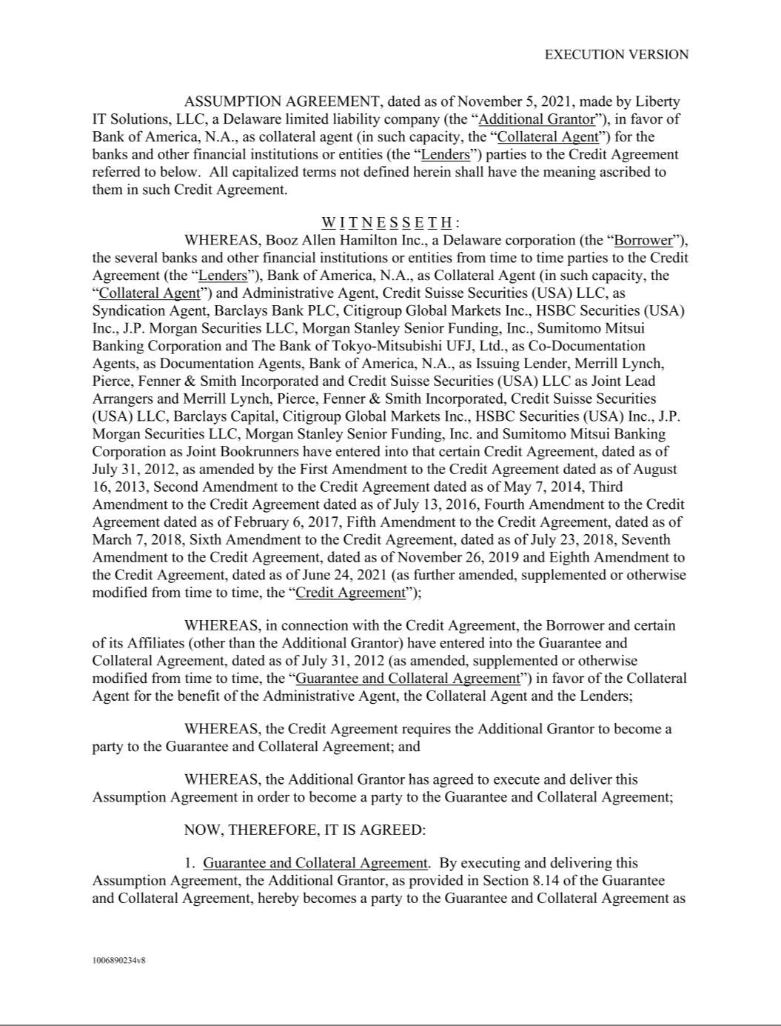

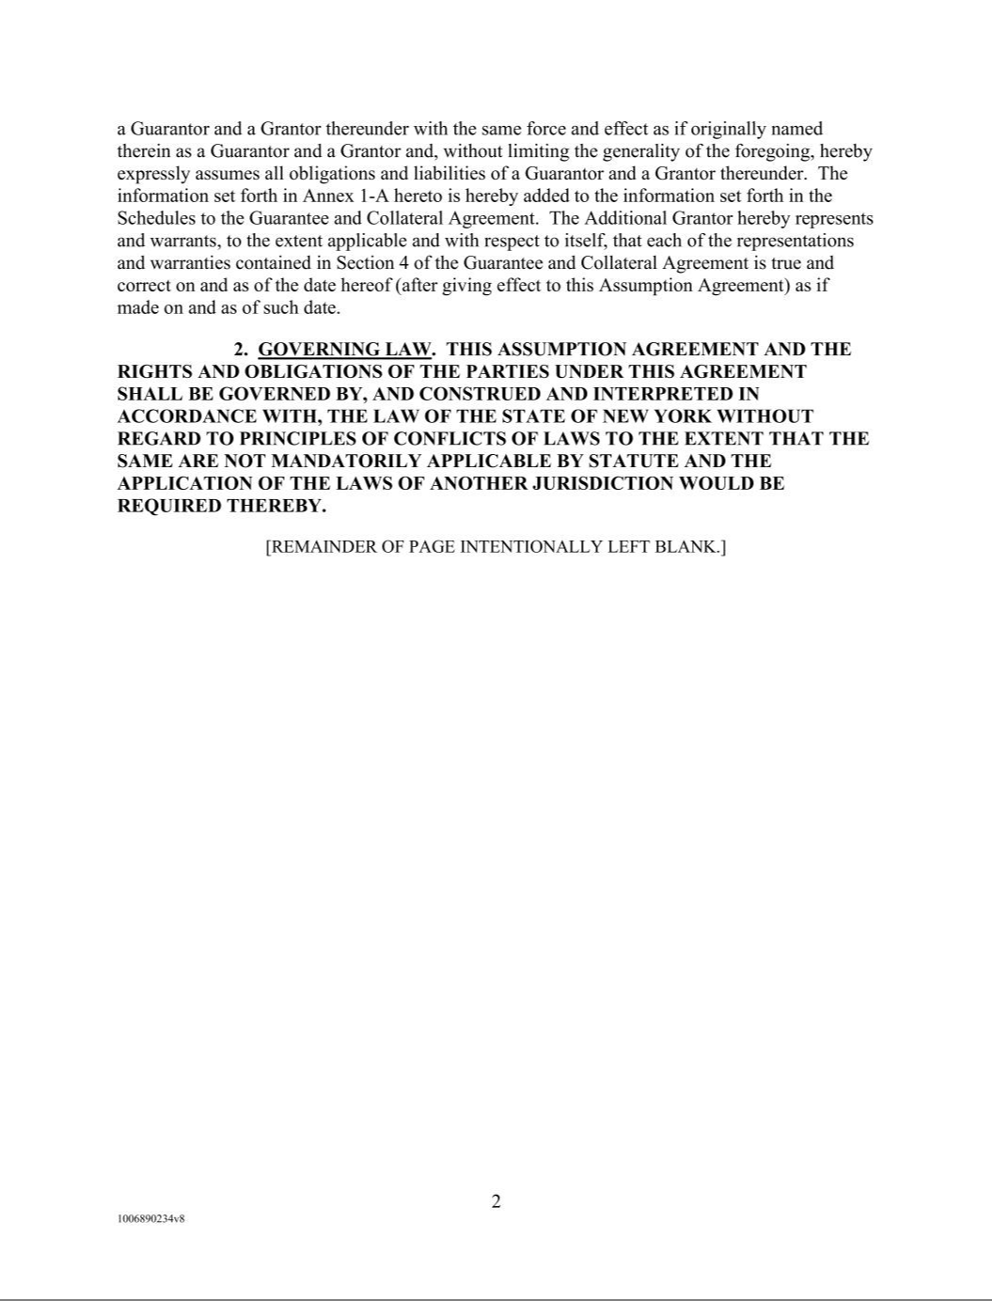

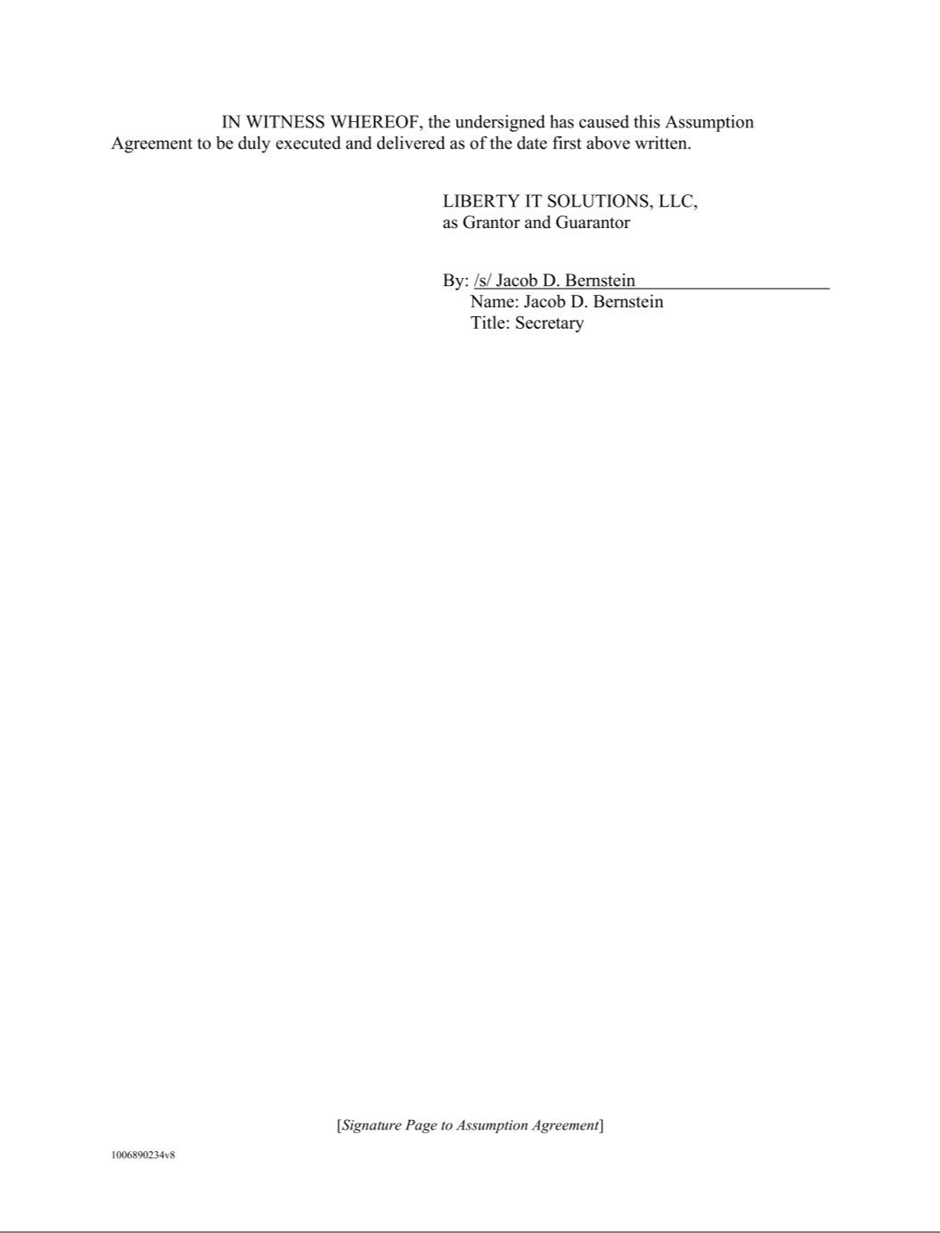

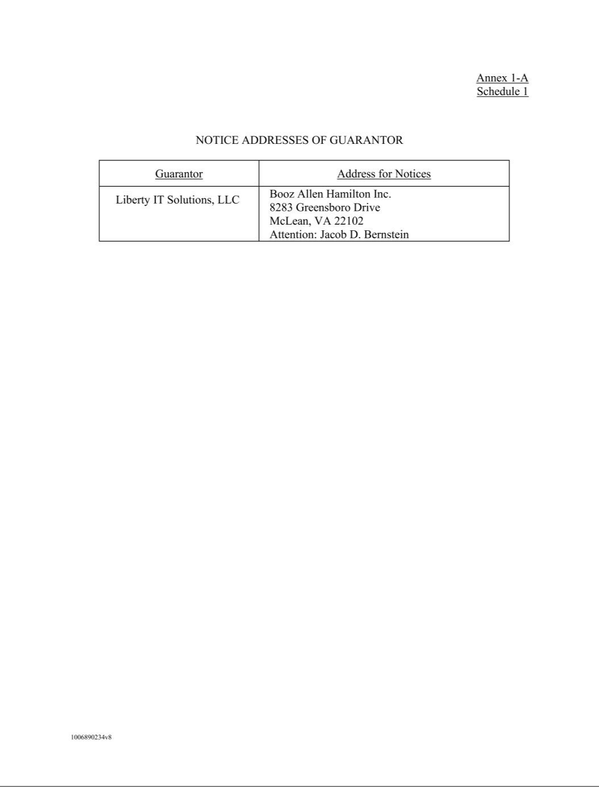

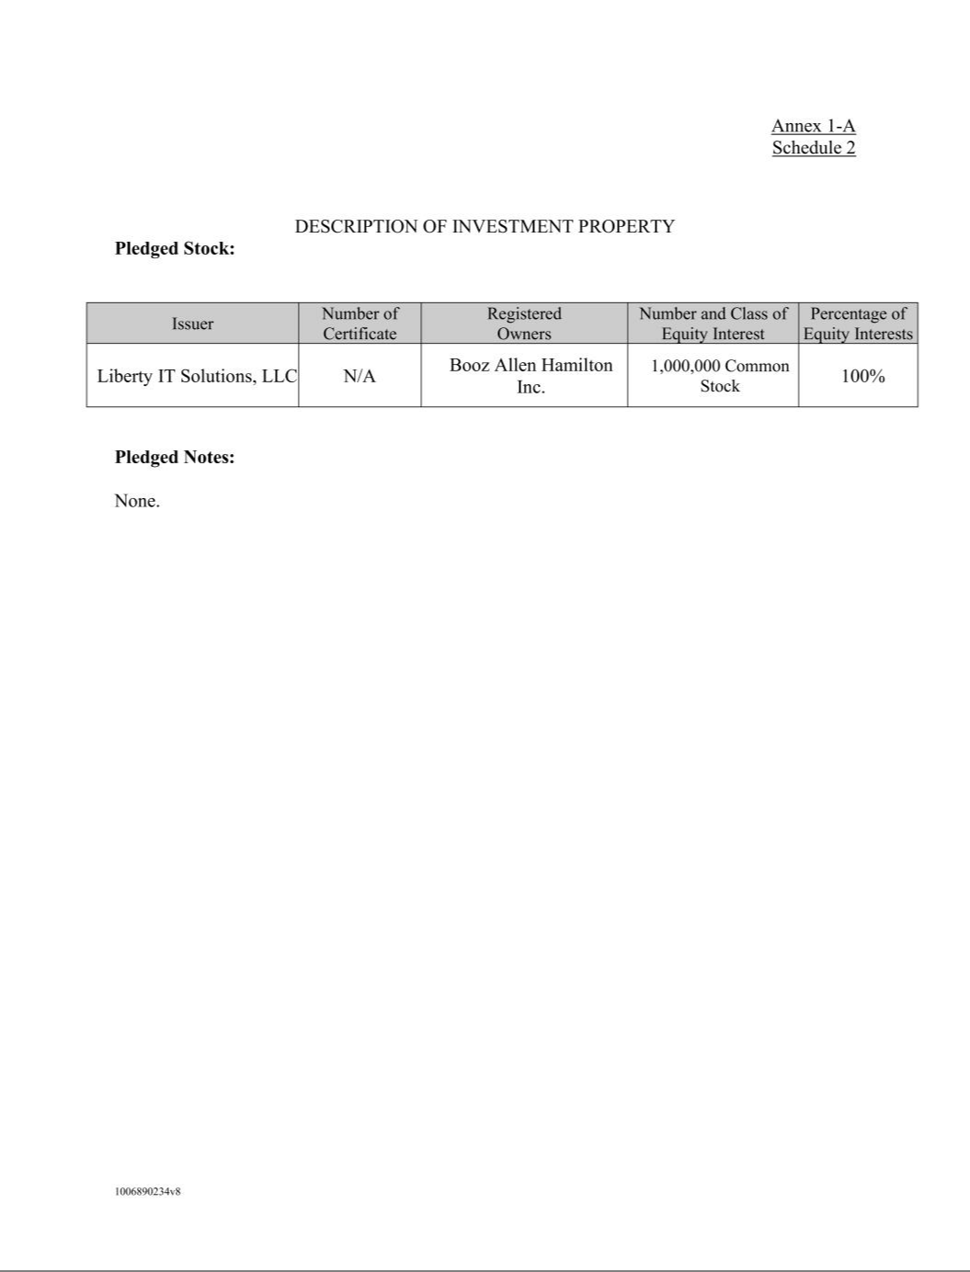

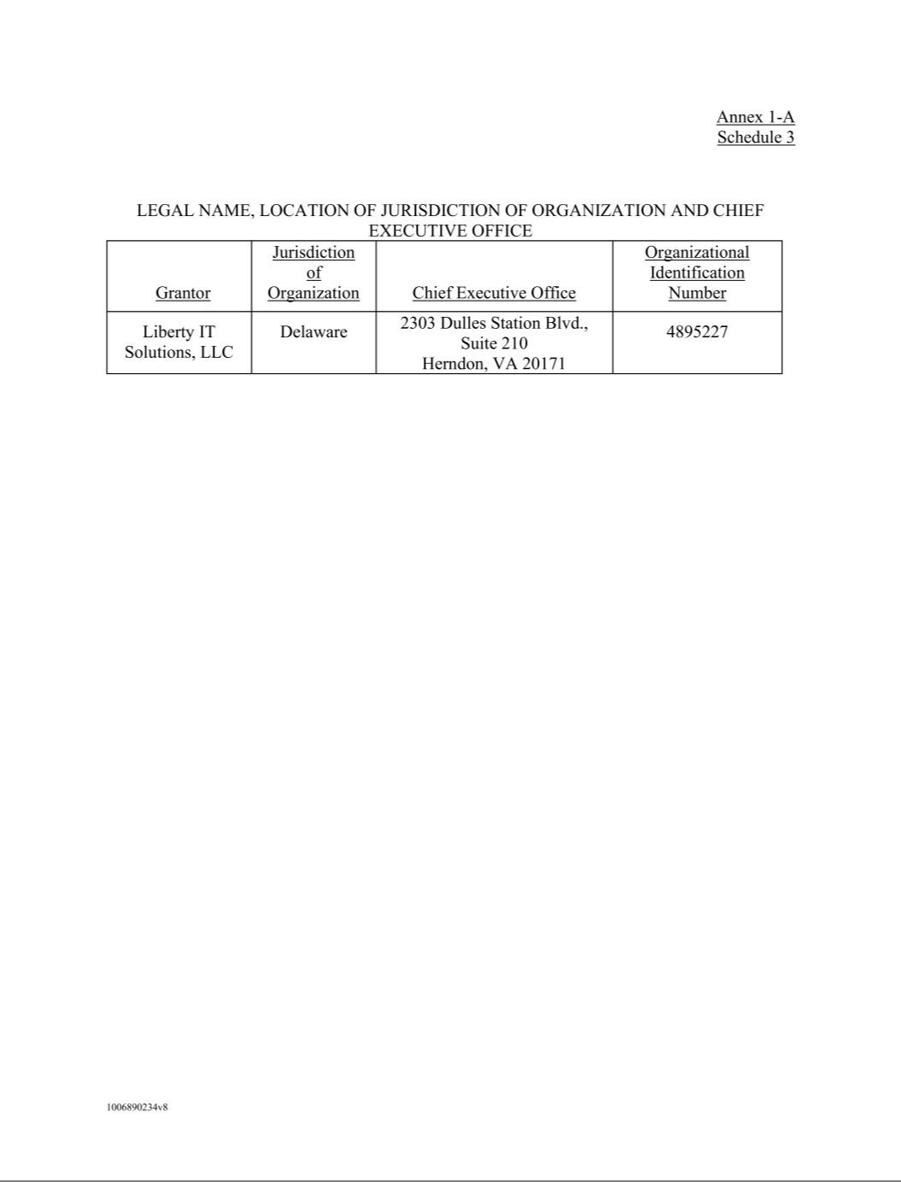

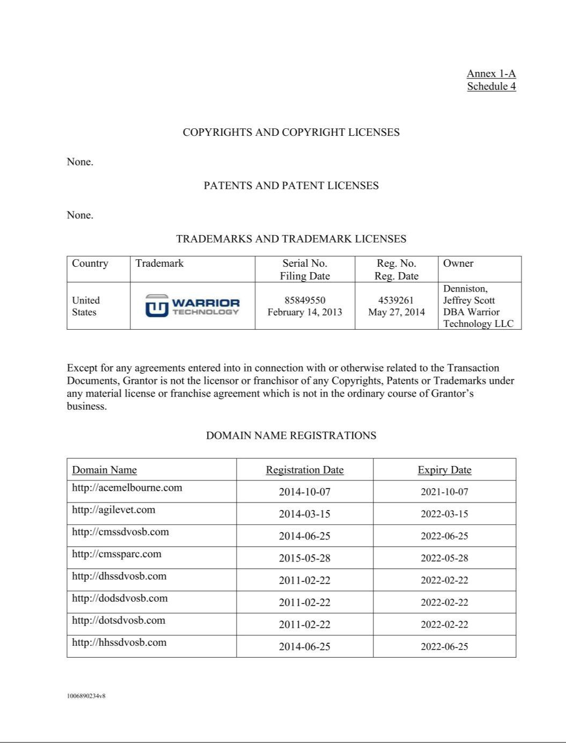

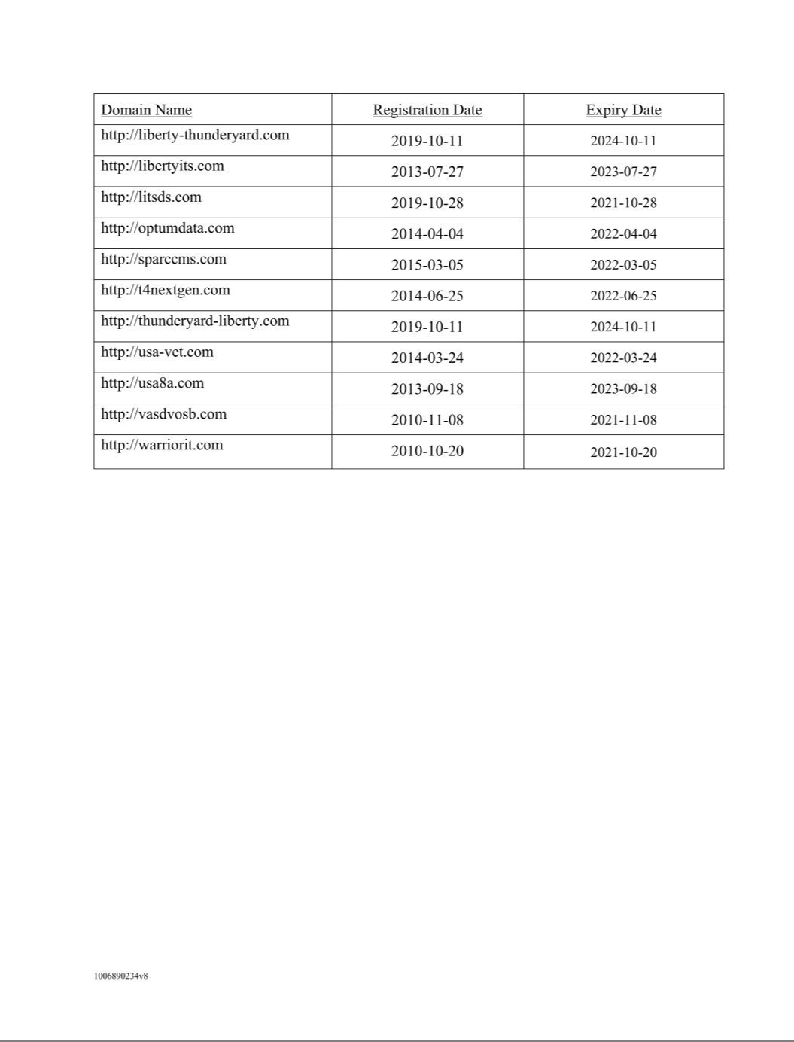

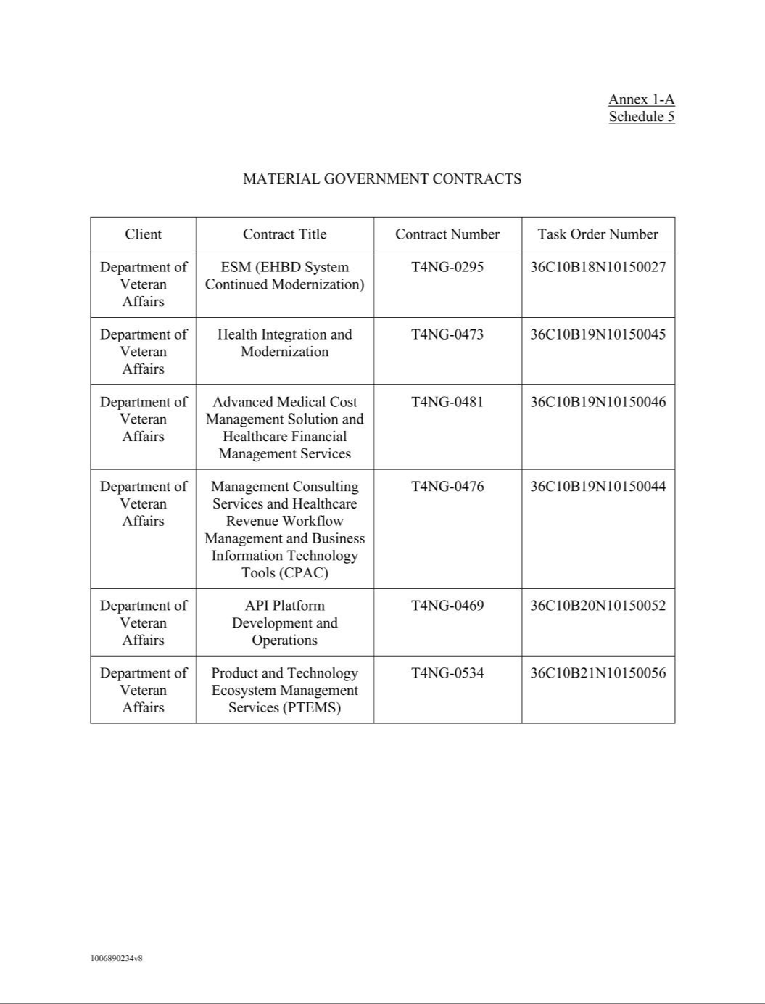

Exhibit 31.1

CERTIFICATION OF THE CHIEF EXECUTIVE OFFICER PURSUANT TO RULE 13A-14(A) OF THE

SECURITIES EXCHANGE ACT OF 1934, AS AMENDED

I, Horacio D. Rozanski, certify that:

- I have reviewed this Quarterly Report on Form 10-Q of Booz Allen Hamilton Holding Corporation.

- Based on my knowledge, this report does not contain any untrue statement of a material fact or omit to state a material fact necessary to make the statements made, in light of the circumstances under which such statements were made, not misleading with respect to the period covered by this report.

- Based on my knowledge, the financial statements, and other financial information included in this report, fairly present in all material respects the financial condition, results of operations and cash flows of the registrant as of, and for, the periods presented in this report.

- The registrant’s other certifying officer and I are responsible for establishing and maintaining disclosure controls and procedures (as defined in Exchange Act Rules 13a-15(e) and 15d-15(e)) and internal control over financial reporting (as defined in Exchange Act Rules 13a-15(f) and 15d-15(f)) for the registrant and have:

- Designed such disclosure controls and procedures, or caused such disclosure controls and procedures to be designed under our supervision, to ensure that material information relating to the registrant, including its consolidated subsidiaries, is made known to us by others within those entities, particularly during the period in which this report is being prepared;

- Designed such internal control over financial reporting, or caused such internal control over financial reporting to be designed under our supervision, to provide reasonable assurance regarding the reliability of financial reporting and the preparation of financial statements for external purposes in accordance with generally accepted accounting principles;

- Evaluated the effectiveness of the registrant's disclosure controls and procedures and presented in this report our conclusions about the effectiveness of the disclosure controls and procedures, as of the end of the period covered by this report based on such evaluation; and

- Disclosed in this report any change in the registrant's internal control over financial reporting that occurred during the registrant's most recent fiscal quarter (the registrant's fourth fiscal quarter in the case of an annual report) that has materially affected, or is reasonably likely to materially affect, the registrant's internal control over financial reporting.

- The registrant's other certifying officer and I have disclosed, based on our most recent evaluation of internal control over financial reporting, to the registrant's auditors and the audit committee of the registrant's Board of Directors (or persons performing the equivalent function):

- All significant deficiencies and material weaknesses in the design or operation of internal control over financial reporting which are reasonably likely to adversely affect the registrant's ability to record, process, summarize and report financial information; and

- Any fraud, whether or not material, that involves management or other employees who have a significant role in the registrant's internal control over financial reporting.

Date: January 28, 2022 By: /s/ Horacio D. Rozanski
Horacio D. Rozanski
President and Chief Executive Officer
(Principal Executive Officer)

Exhibit 31.2

CERTIFICATION OF THE CHIEF FINANCIAL OFFICER PURSUANT TO RULE 13A-14(A) OF THE

SECURITIES EXCHANGE ACT OF 1934, AS AMENDED

I, Lloyd W. Howell, Jr., certify that:

- I have reviewed this Quarterly Report on Form 10-Q of Booz Allen Hamilton Holding Corporation.

- Based on my knowledge, this report does not contain any untrue statement of a material fact or omit to state a material fact necessary to make the statements made, in light of the circumstances under which such statements were made, not misleading with respect to the period covered by this report.

- Based on my knowledge, the financial statements, and other financial information included in this report, fairly present in all material respects the financial condition, results of operations and cash flows of the registrant as of, and for, the periods presented in this report.

- The registrant’s other certifying officer and I are responsible for establishing and maintaining disclosure controls and procedures (as defined in Exchange Act Rules 13a-15(e) and 15d-15(e)) and internal control over financial reporting (as defined in Exchange Act Rules 13a-15(f) and 15d-15(f)) for the registrant and have:

- Designed such disclosure controls and procedures, or caused such disclosure controls and procedures to be designed under our supervision, to ensure that material information relating to the registrant, including its consolidated subsidiaries, is made known to us by others within those entities, particularly during the period in which this report is being prepared;

- Designed such internal control over financial reporting, or caused such internal control over financial reporting to be designed under our supervision, to provide reasonable assurance regarding the reliability of financial reporting and the preparation of financial statements for external purposes in accordance with generally accepted accounting principles;

- Evaluated the effectiveness of the registrant's disclosure controls and procedures and presented in this report our conclusions about the effectiveness of the disclosure controls and procedures, as of the end of the period covered by this report based on such evaluation; and

- Disclosed in this report any change in the registrant's internal control over financial reporting that occurred during the registrant's most recent fiscal quarter (the registrant's fourth fiscal quarter in the case of an annual report) that has materially affected, or is reasonably likely to materially affect, the registrant's internal control over financial reporting.

- The registrant's other certifying officer and I have disclosed, based on our most recent evaluation of internal control over financial reporting, to the registrant's auditors and the audit committee of the registrant's Board of Directors (or persons performing the equivalent function):

- All significant deficiencies and material weaknesses in the design or operation of internal control over financial reporting which are reasonably likely to adversely affect the registrant's ability to record, process, summarize and report financial information; and

- Any fraud, whether or not material, that involves management or other employees who have a significant role in the registrant's internal control over financial reporting.

Date: January 28, 2022 By: /s/ Lloyd W. Howell, Jr.
Lloyd W. Howell, Jr.
Executive Vice President, Chief Financial Officer and Treasurer (Principal Financial
Officer)

Exhibit 32.1

CERTIFICATIONS PURSUANT TO

SECTION 906 OF THE SARBANES-OXLEY ACT OF 2002

(18 U.S.C. SECTION 1350)

In connection with the report on Form 10-Q of Booz Allen Hamilton Holding Corporation (the “Company”) for the fiscal quarter ended December 31, 2021, as filed with the Securities and Exchange Commission on the date hereof (the “Report”), the undersigned President and Chief Executive Officer of the Company certifies, to the best of his knowledge and belief pursuant to 18 U.S.C. Section 1350, as adopted pursuant to Section 906 of the Sarbanes-Oxley Act of 2002, that:

- The Report fully complies with the requirements of Section 13(a) or 15(d) of the Securities Exchange Act of 1934.

- The information contained in the Report fairly presents, in all material respects, the financial condition and results of operations of the Company.

Date: January 28, 2022 By: /s/ Horacio D. Rozanski
Horacio D. Rozanski
President and Chief Executive Officer
(Principal Executive Officer)

A signed original of this written statement required by Section 906, or other document authenticating, acknowledging, or otherwise adopting the signature that appears in typed form within the electronic version of this written statement required by Section 906, has been provided to Booz Allen Hamilton Holding Corporation and will be retained by Booz Allen Hamilton Holding Corporation and furnished to the Securities and Exchange Commission or its staff upon request.

Exhibit 32.2

CERTIFICATIONS PURSUANT TO

SECTION 906 OF THE SARBANES-OXLEY ACT OF 2002

(18 U.S.C. SECTION 1350)

In connection with the report on Form 10-Q of Booz Allen Hamilton Holding Corporation (the “Company”) for the fiscal quarter ended December 31, 2021, as filed with the Securities and Exchange Commission on the date hereof (the “Report”), the undersigned Executive Vice President, Chief Financial Officer and Treasurer of the Company certifies, to the best of his knowledge and belief pursuant to 18 U.S.C. Section 1350, as adopted pursuant to Section 906 of the Sarbanes-Oxley Act of 2002, that:

- The Report fully complies with the requirements of Section 13(a) or 15(d) of the Securities Exchange Act of 1934.

- The information contained in the Report fairly presents, in all material respects, the financial condition and results of operations of the Company.

Date: January 28, 2022 By: /s/ Lloyd W. Howell, Jr.
Lloyd W. Howell, Jr.
Executive Vice President, Chief Financial Officer and Treasurer (Principal Financial Officer)

A signed original of this written statement required by Section 906, or other document authenticating, acknowledging, or otherwise adopting the signature that appears in typed form within the electronic version of this written statement required by Section 906, has been provided to Booz Allen Hamilton Holding Corporation and will be retained by Booz Allen Hamilton Holding Corporation and furnished to the Securities and Exchange Commission or its staff upon request.

