UNITED STATES
SECURITIES AND EXCHANGE COMMISSION
WASHINGTON, D.C. 20549
___________________________________
FORM 8-K
___________________________________

CURRENT REPORT
Pursuant to Section 13 or 15(d) of
the Securities Exchange Act of 1934
Date of Report (Date of earliest event reported): July 24, 2026
___________________________________
Booz Allen Hamilton Holding Corporation
(Exact name of Registrant as specified in its charter)
___________________________________

Delaware |  |  |  |  |  |  |  |  |  |  |  | 001-34972 |  |  |  |  |  | 26-2634160
(State or other jurisdiction  of incorporation) |  |  |  |  |  |  |  |  |  |  |  | (Commission  File Number) |  |  |  |  |  | (IRS Employer  Identification No.)
8283 Greensboro Drive, |  |  | McLean, |  |  | Virginia |  |  |  |  |  |  |  |  |  |  |  | 22102
(Address of principal executive offices) |  |  |  |  |  |  |  |  |  |  |  |  |  |  |  |  |  | (Zip Code)
Registrant’s telephone number, including area code: (703) 902-5000
___________________________________

Check the appropriate box below if the Form 8-K filing is intended to simultaneously satisfy the filing obligation of the Registrant under any of the following provisions:
☐ |  |  | Written communications pursuant to Rule 425 under the Securities Act (17 CFR 230.425)
☐ |  |  | Soliciting material pursuant to Rule 14a-12 under the Exchange Act (17 CFR 240.14a-12)
☐ |  |  | Pre-commencement communications pursuant to Rule 14d-2(b) under the Exchange Act (17 CFR 240.14d-2(b))
☐ |  |  | Pre-commencement communications pursuant to Rule 13e-4(c) under the Exchange Act (17 CFR 240.13e-4(c))
Securities registered pursuant to Section 12(b) of the Act:
Title of Each Class |  |  | Trading Symbol |  |  | Name of Each Exchange on Which Registered
Class A Common Stock |  |  | BAH |  |  | New York Stock Exchange

Indicate by check mark whether the registrant is an emerging growth company as defined in Rule 405 of the Securities Act of 1933 (§230.405 of this chapter) or Rule 12b-2 of the Securities Exchange Act of 1934 (§240.12b-2 of this chapter).
Emerging growth company ☐

If an emerging growth company, indicate by check mark if the registrant has elected not to use the extended transition period for complying with any new or revised financial accounting standards provided pursuant to Section 13(a) of the Exchange Act. ☐

Item 2.02 Results of Operations and Financial Condition.
On July 24, 2026, Booz Allen Hamilton Holding Corporation (the “Company”) issued a press release announcing its results of operations for the fiscal year ended June 30, 2026. A copy of the press release is attached hereto as Exhibit 99.1.
The information in this Item 2.02 and Exhibit 99.1 shall not be deemed to be “filed” for purposes of Section 18 of the Securities Exchange Act of 1934, as amended (the “Exchange Act”), or otherwise subject to the liability of that section, and shall not be incorporated by reference into any registration statement or other document filed under the Securities Act of 1933, as amended, or the Exchange Act, except as shall be expressly set forth by specific reference in that filing.
Item 7.01 Regulation FD Disclosure.
On July 24, 2026, the Company posted to the “Investor Relations” section of its website the presentation that accompanies the earnings conference call. A copy of the presentation is attached hereto as Exhibit 99.2.
The information in this Item 7.01 and Exhibit 99.2 shall not be deemed to be “filed” for purposes of Section 18 of the Securities Exchange Act of 1934, as amended (the “Exchange Act”), or otherwise subject to the liability of that section, and shall not be incorporated by reference into any registration statement or other document filed under the Securities Act of 1933, as amended, or the Exchange Act, except as shall be expressly set forth by specific reference in that filing.
Item 9.01 Financial Statements and Exhibits.

Exhibit  No. |  |  |  |  |  | Description
99.1 |  |  |  |  |  | Press Release dated July 24, 2026
99.2 |  |  |  |  |  | Earnings Conference Call Presentation
104 |  |  |  |  |  | The cover page of this Current Report on Form 8-K, formatted as inline XBRL.

SIGNATURES
Pursuant to the requirements of the Securities Exchange Act of 1934, the registrant has duly caused this report to be signed on its behalf by the undersigned hereunto duly authorized.

 |  |  | Booz Allen Hamilton Holding Corporation
BY: |  |  | /s/ Troy Lahr
 |  |  | Troy Lahr
 |  |  | Executive Vice President and Chief Financial Officer
Date: July 24, 2026
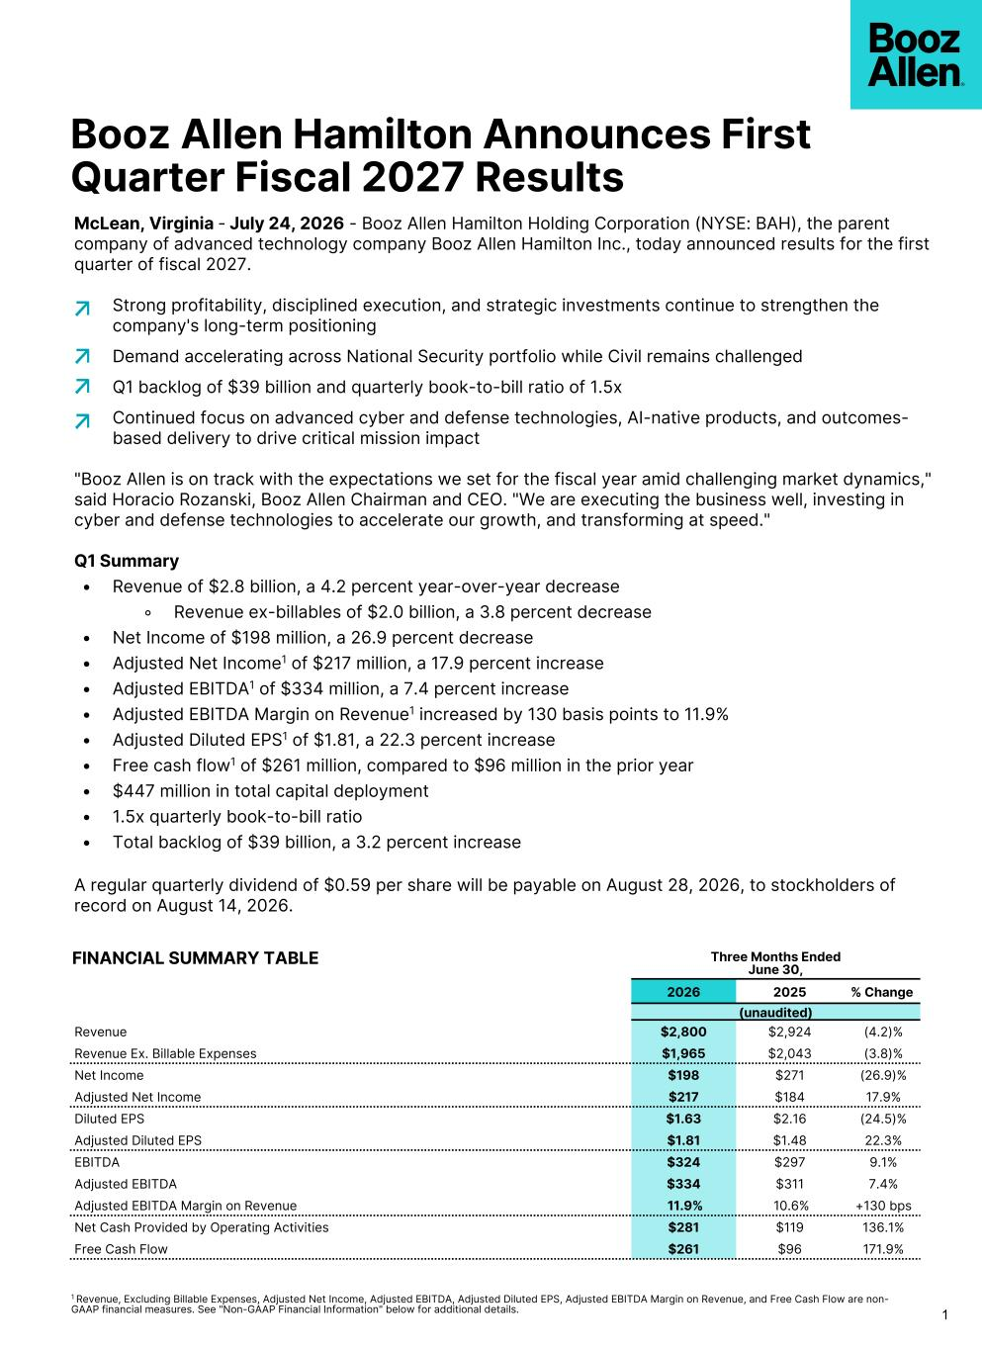

Booz Allen Hamilton Announces First Quarter Fiscal 2027 Results 1 1 Revenue, Excluding Billable Expenses, Adjusted Net Income, Adjusted EBITDA, Adjusted Diluted EPS, Adjusted EBITDA Margin on Revenue, and Free Cash Flow are non- GAAP financial measures. See "Non-GAAP Financial Information" below for additional details. Three Months Ended June 30, 2026 2025 % Change (unaudited) Revenue $2,800 $2,924 (4.2)% Revenue Ex. Billable Expenses $1,965 $2,043 (3.8)% Net Income $198 $271 (26.9)% Adjusted Net Income $217 $184 17.9% Diluted EPS $1.63 $2.16 (24.5)% Adjusted Diluted EPS $1.81 $1.48 22.3% EBITDA $324 $297 9.1% Adjusted EBITDA $334 $311 7.4% Adjusted EBITDA Margin on Revenue 11.9% 10.6% +130 bps Net Cash Provided by Operating Activities $281 $119 136.1% Free Cash Flow $261 $96 171.9% FINANCIAL SUMMARY TABLE McLean, Virginia - July 24, 2026 - Booz Allen Hamilton Holding Corporation (NYSE: BAH), the parent company of advanced technology company Booz Allen Hamilton Inc., today announced results for the first quarter of fiscal 2027. Strong profitability, disciplined execution, and strategic investments continue to strengthen the company's long-term positioning Demand accelerating across National Security portfolio while Civil remains challenged Q1 backlog of $39 billion and quarterly book-to-bill ratio of 1.5x Continued focus on advanced cyber and defense technologies, AI-native products, and outcomes- based delivery to drive critical mission impact "Booz Allen is on track with the expectations we set for the fiscal year amid challenging market dynamics," said Horacio Rozanski, Booz Allen Chairman and CEO. "We are executing the business well, investing in cyber and defense technologies to accelerate our growth, and transforming at speed." Q1 Summary • Revenue of $2.8 billion, a 4.2 percent year-over-year decrease ◦ Revenue ex-billables of $2.0 billion, a 3.8 percent decrease • Net Income of $198 million, a 26.9 percent decrease • Adjusted Net Income1 of $217 million, a 17.9 percent increase • Adjusted EBITDA1 of $334 million, a 7.4 percent increase • Adjusted EBITDA Margin on Revenue1 increased by 130 basis points to 11.9% • Adjusted Diluted EPS1 of $1.81, a 22.3 percent increase • Free cash flow1 of $261 million, compared to $96 million in the prior year • $447 million in total capital deployment • 1.5x quarterly book-to-bill ratio • Total backlog of $39 billion, a 3.2 percent increase A regular quarterly dividend of $0.59 per share will be payable on August 28, 2026, to stockholders of record on August 14, 2026.

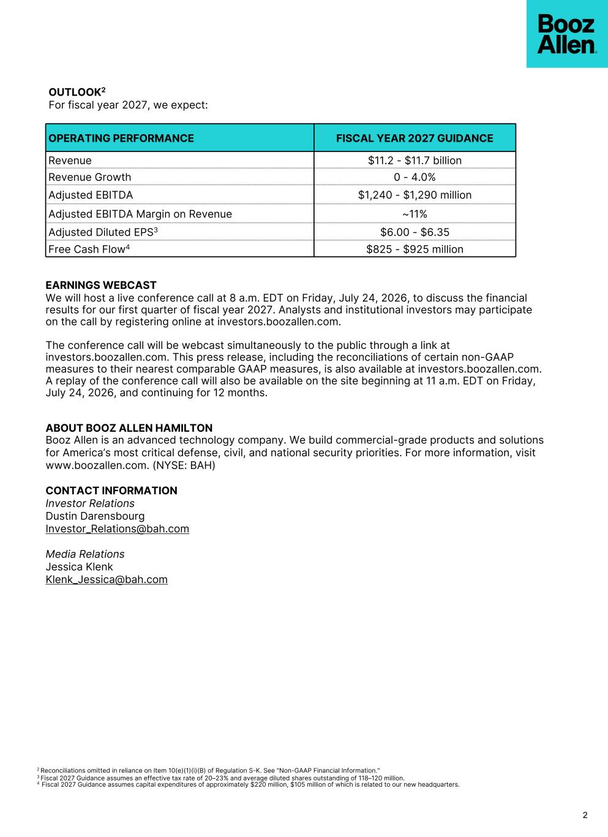
2 2 Reconciliations omitted in reliance on Item 10(e)(1)(i)(B) of Regulation S-K. See "Non-GAAP Financial Information." 3 Fiscal 2027 Guidance assumes an effective tax rate of 20–23% and average diluted shares outstanding of 118–120 million. 4 Fiscal 2027 Guidance assumes capital expenditures of approximately $220 million, $105 million of which is related to our new headquarters. OPERATING PERFORMANCE FISCAL YEAR 2027 GUIDANCE Revenue $11.2 - $11.7 billion Revenue Growth 0 - 4.0% Adjusted EBITDA $1,240 - $1,290 million Adjusted EBITDA Margin on Revenue ~11% Adjusted Diluted EPS3 $6.00 - $6.35 Free Cash Flow4 $825 - $925 million EARNINGS WEBCAST We will host a live conference call at 8 a.m. EDT on Friday, July 24, 2026, to discuss the financial results for our first quarter of fiscal year 2027. Analysts and institutional investors may participate on the call by registering online at investors.boozallen.com. The conference call will be webcast simultaneously to the public through a link at investors.boozallen.com. This press release, including the reconciliations of certain non-GAAP measures to their nearest comparable GAAP measures, is also available at investors.boozallen.com. A replay of the conference call will also be available on the site beginning at 11 a.m. EDT on Friday, July 24, 2026, and continuing for 12 months. ABOUT BOOZ ALLEN HAMILTON Booz Allen is an advanced technology company. We build commercial-grade products and solutions for America’s most critical defense, civil, and national security priorities. For more information, visit www.boozallen.com. (NYSE: BAH) CONTACT INFORMATION Investor Relations Dustin Darensbourg Investor_Relations@bah.com Media Relations Jessica Klenk Klenk_Jessica@bah.com OUTLOOK2 For fiscal year 2027, we expect:

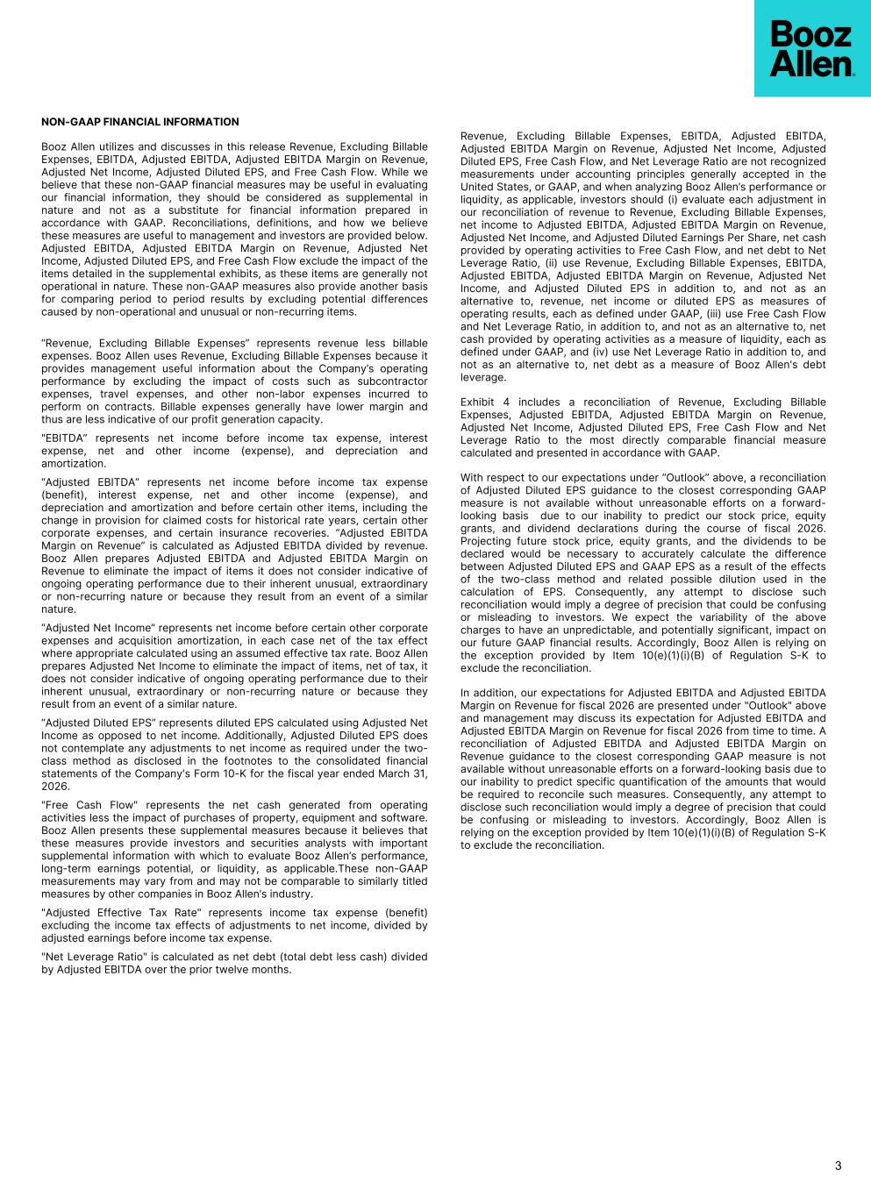
NON-GAAP FINANCIAL INFORMATION Booz Allen utilizes and discusses in this release Revenue, Excluding Billable Expenses, EBITDA, Adjusted EBITDA, Adjusted EBITDA Margin on Revenue, Adjusted Net Income, Adjusted Diluted EPS, and Free Cash Flow. While we believe that these non-GAAP financial measures may be useful in evaluating our financial information, they should be considered as supplemental in nature and not as a substitute for financial information prepared in accordance with GAAP. Reconciliations, definitions, and how we believe these measures are useful to management and investors are provided below. Adjusted EBITDA, Adjusted EBITDA Margin on Revenue, Adjusted Net Income, Adjusted Diluted EPS, and Free Cash Flow exclude the impact of the items detailed in the supplemental exhibits, as these items are generally not operational in nature. These non-GAAP measures also provide another basis for comparing period to period results by excluding potential differences caused by non-operational and unusual or non-recurring items. “Revenue, Excluding Billable Expenses” represents revenue less billable expenses. Booz Allen uses Revenue, Excluding Billable Expenses because it provides management useful information about the Company’s operating performance by excluding the impact of costs such as subcontractor expenses, travel expenses, and other non-labor expenses incurred to perform on contracts. Billable expenses generally have lower margin and thus are less indicative of our profit generation capacity. "EBITDA” represents net income before income tax expense, interest expense, net and other income (expense), and depreciation and amortization. “Adjusted EBITDA” represents net income before income tax expense (benefit), interest expense, net and other income (expense), and depreciation and amortization and before certain other items, including the change in provision for claimed costs for historical rate years, certain other corporate expenses, and certain insurance recoveries. “Adjusted EBITDA Margin on Revenue” is calculated as Adjusted EBITDA divided by revenue. Booz Allen prepares Adjusted EBITDA and Adjusted EBITDA Margin on Revenue to eliminate the impact of items it does not consider indicative of ongoing operating performance due to their inherent unusual, extraordinary or non-recurring nature or because they result from an event of a similar nature. “Adjusted Net Income” represents net income before certain other corporate expenses and acquisition amortization, in each case net of the tax effect where appropriate calculated using an assumed effective tax rate. Booz Allen prepares Adjusted Net Income to eliminate the impact of items, net of tax, it does not consider indicative of ongoing operating performance due to their inherent unusual, extraordinary or non-recurring nature or because they result from an event of a similar nature. “Adjusted Diluted EPS” represents diluted EPS calculated using Adjusted Net Income as opposed to net income. Additionally, Adjusted Diluted EPS does not contemplate any adjustments to net income as required under the two- class method as disclosed in the footnotes to the consolidated financial statements of the Company's Form 10-K for the fiscal year ended March 31, 2026. "Free Cash Flow" represents the net cash generated from operating activities less the impact of purchases of property, equipment and software. Booz Allen presents these supplemental measures because it believes that these measures provide investors and securities analysts with important supplemental information with which to evaluate Booz Allen’s performance, long-term earnings potential, or liquidity, as applicable.These non-GAAP measurements may vary from and may not be comparable to similarly titled measures by other companies in Booz Allen’s industry. "Adjusted Effective Tax Rate" represents income tax expense (benefit) excluding the income tax effects of adjustments to net income, divided by adjusted earnings before income tax expense. "Net Leverage Ratio" is calculated as net debt (total debt less cash) divided by Adjusted EBITDA over the prior twelve months. Revenue, Excluding Billable Expenses, EBITDA, Adjusted EBITDA, Adjusted EBITDA Margin on Revenue, Adjusted Net Income, Adjusted Diluted EPS, Free Cash Flow, and Net Leverage Ratio are not recognized measurements under accounting principles generally accepted in the United States, or GAAP, and when analyzing Booz Allen’s performance or liquidity, as applicable, investors should (i) evaluate each adjustment in our reconciliation of revenue to Revenue, Excluding Billable Expenses, net income to Adjusted EBITDA, Adjusted EBITDA Margin on Revenue, Adjusted Net Income, and Adjusted Diluted Earnings Per Share, net cash provided by operating activities to Free Cash Flow, and net debt to Net Leverage Ratio, (ii) use Revenue, Excluding Billable Expenses, EBITDA, Adjusted EBITDA, Adjusted EBITDA Margin on Revenue, Adjusted Net Income, and Adjusted Diluted EPS in addition to, and not as an alternative to, revenue, net income or diluted EPS as measures of operating results, each as defined under GAAP, (iii) use Free Cash Flow and Net Leverage Ratio, in addition to, and not as an alternative to, net cash provided by operating activities as a measure of liquidity, each as defined under GAAP, and (iv) use Net Leverage Ratio in addition to, and not as an alternative to, net debt as a measure of Booz Allen's debt leverage. Exhibit 4 includes a reconciliation of Revenue, Excluding Billable Expenses, Adjusted EBITDA, Adjusted EBITDA Margin on Revenue, Adjusted Net Income, Adjusted Diluted EPS, Free Cash Flow and Net Leverage Ratio to the most directly comparable financial measure calculated and presented in accordance with GAAP. With respect to our expectations under “Outlook” above, a reconciliation of Adjusted Diluted EPS guidance to the closest corresponding GAAP measure is not available without unreasonable efforts on a forward- looking basis due to our inability to predict our stock price, equity grants, and dividend declarations during the course of fiscal 2026. Projecting future stock price, equity grants, and the dividends to be declared would be necessary to accurately calculate the difference between Adjusted Diluted EPS and GAAP EPS as a result of the effects of the two-class method and related possible dilution used in the calculation of EPS. Consequently, any attempt to disclose such reconciliation would imply a degree of precision that could be confusing or misleading to investors. We expect the variability of the above charges to have an unpredictable, and potentially significant, impact on our future GAAP financial results. Accordingly, Booz Allen is relying on the exception provided by Item 10(e)(1)(i)(B) of Regulation S-K to exclude the reconciliation. In addition, our expectations for Adjusted EBITDA and Adjusted EBITDA Margin on Revenue for fiscal 2026 are presented under "Outlook" above and management may discuss its expectation for Adjusted EBITDA and Adjusted EBITDA Margin on Revenue for fiscal 2026 from time to time. A reconciliation of Adjusted EBITDA and Adjusted EBITDA Margin on Revenue guidance to the closest corresponding GAAP measure is not available without unreasonable efforts on a forward-looking basis due to our inability to predict specific quantification of the amounts that would be required to reconcile such measures. Consequently, any attempt to disclose such reconciliation would imply a degree of precision that could be confusing or misleading to investors. Accordingly, Booz Allen is relying on the exception provided by Item 10(e)(1)(i)(B) of Regulation S-K to exclude the reconciliation. 3

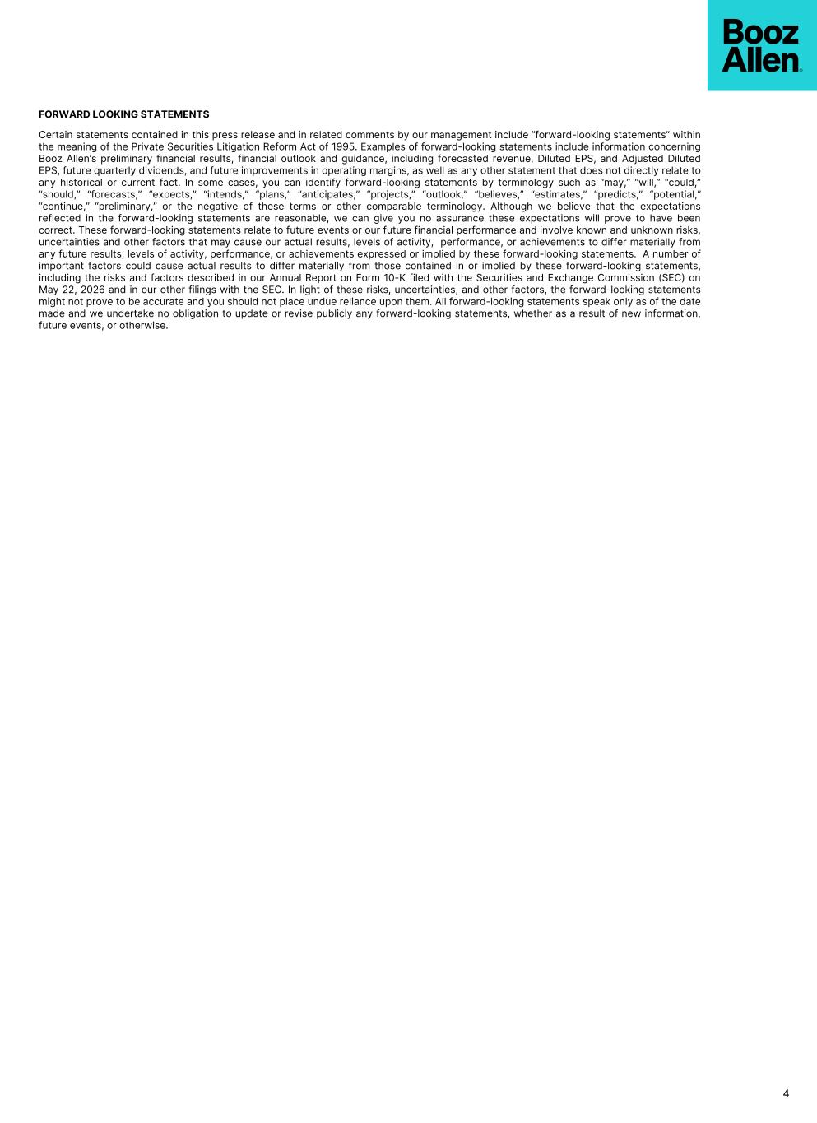
FORWARD LOOKING STATEMENTS Certain statements contained in this press release and in related comments by our management include “forward-looking statements” within the meaning of the Private Securities Litigation Reform Act of 1995. Examples of forward-looking statements include information concerning Booz Allen’s preliminary financial results, financial outlook and guidance, including forecasted revenue, Diluted EPS, and Adjusted Diluted EPS, future quarterly dividends, and future improvements in operating margins, as well as any other statement that does not directly relate to any historical or current fact. In some cases, you can identify forward-looking statements by terminology such as “may,” “will,” “could,” “should,” “forecasts,” “expects,” “intends,” “plans,” “anticipates,” “projects,” “outlook,” “believes,” “estimates,” “predicts,” “potential,” “continue,” “preliminary,” or the negative of these terms or other comparable terminology. Although we believe that the expectations reflected in the forward-looking statements are reasonable, we can give you no assurance these expectations will prove to have been correct. These forward-looking statements relate to future events or our future financial performance and involve known and unknown risks, uncertainties and other factors that may cause our actual results, levels of activity, performance, or achievements to differ materially from any future results, levels of activity, performance, or achievements expressed or implied by these forward-looking statements. A number of important factors could cause actual results to differ materially from those contained in or implied by these forward-looking statements, including the risks and factors described in our Annual Report on Form 10-K filed with the Securities and Exchange Commission (SEC) on May 22, 2026 and in our other filings with the SEC. In light of these risks, uncertainties, and other factors, the forward-looking statements might not prove to be accurate and you should not place undue reliance upon them. All forward-looking statements speak only as of the date made and we undertake no obligation to update or revise publicly any forward-looking statements, whether as a result of new information, future events, or otherwise. 4

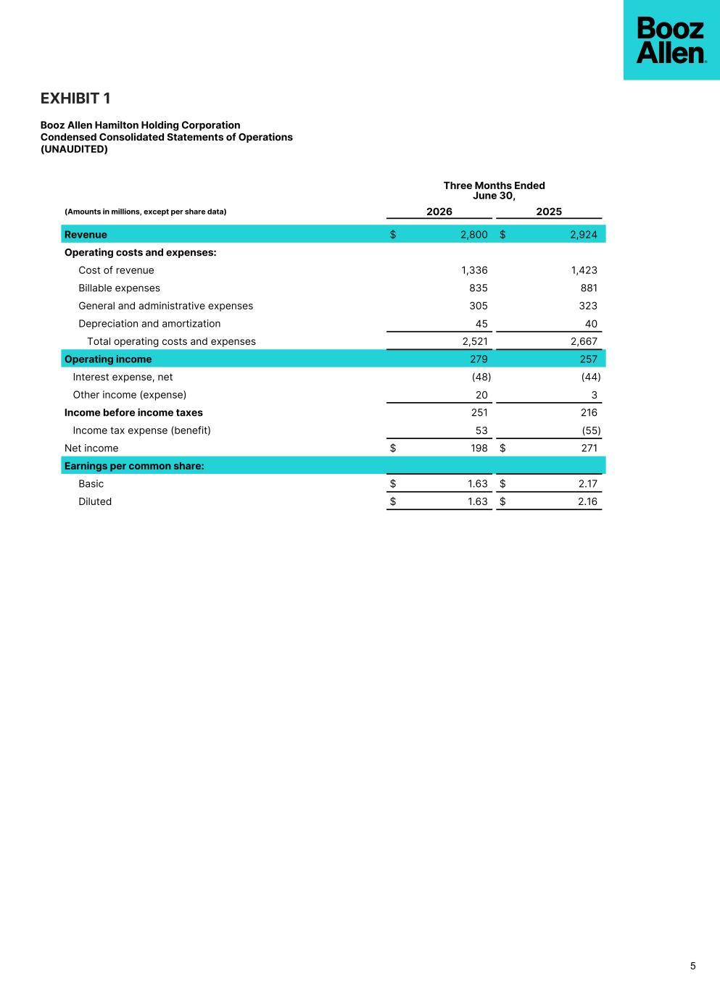
EXHIBIT 1 Booz Allen Hamilton Holding Corporation Condensed Consolidated Statements of Operations (UNAUDITED) 5 Three Months Ended June 30, (Amounts in millions, except per share data) 2026 2025 Revenue $ 2,800 $ 2,924 Operating costs and expenses: Cost of revenue 1,336 1,423 Billable expenses 835 881 General and administrative expenses 305 323 Depreciation and amortization 45 40 Total operating costs and expenses 2,521 2,667 Operating income 279 257 Interest expense, net (48) (44) Other income (expense) 20 3 Income before income taxes 251 216 Income tax expense (benefit) 53 (55) Net income $ 198 $ 271 Earnings per common share: Basic $ 1.63 $ 2.17 Diluted $ 1.63 $ 2.16

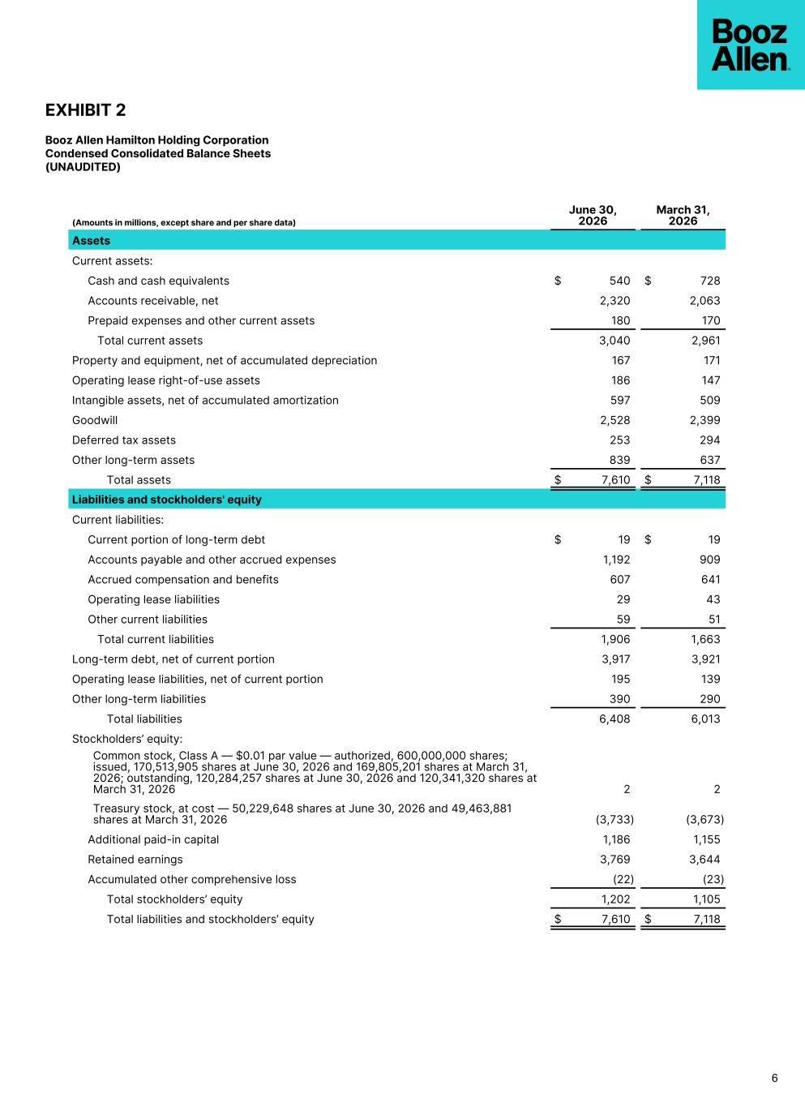
EXHIBIT 2 Booz Allen Hamilton Holding Corporation Condensed Consolidated Balance Sheets (UNAUDITED) (Amounts in millions, except share and per share data) June 30, 2026 March 31, 2026 Assets Current assets: Cash and cash equivalents $ 540 $ 728 Accounts receivable, net 2,320 2,063 Prepaid expenses and other current assets 180 170 Total current assets 3,040 2,961 Property and equipment, net of accumulated depreciation 167 171 Operating lease right-of-use assets 186 147 Intangible assets, net of accumulated amortization 597 509 Goodwill 2,528 2,399 Deferred tax assets 253 294 Other long-term assets 839 637 Total assets $ 7,610 $ 7,118 Liabilities and stockholders' equity Current liabilities: Current portion of long-term debt $ 19 $ 19 Accounts payable and other accrued expenses 1,192 909 Accrued compensation and benefits 607 641 Operating lease liabilities 29 43 Other current liabilities 59 51 Total current liabilities 1,906 1,663 Long-term debt, net of current portion 3,917 3,921 Operating lease liabilities, net of current portion 195 139 Other long-term liabilities 390 290 Total liabilities 6,408 6,013 Stockholders’ equity: Common stock, Class A — $0.01 par value — authorized, 600,000,000 shares; issued, 170,513,905 shares at June 30, 2026 and 169,805,201 shares at March 31, 2026; outstanding, 120,284,257 shares at June 30, 2026 and 120,341,320 shares at March 31, 2026 2 2 Treasury stock, at cost — 50,229,648 shares at June 30, 2026 and 49,463,881 shares at March 31, 2026 (3,733) (3,673) Additional paid-in capital 1,186 1,155 Retained earnings 3,769 3,644 Accumulated other comprehensive loss (22) (23) Total stockholders’ equity 1,202 1,105 Total liabilities and stockholders’ equity $ 7,610 $ 7,118 6

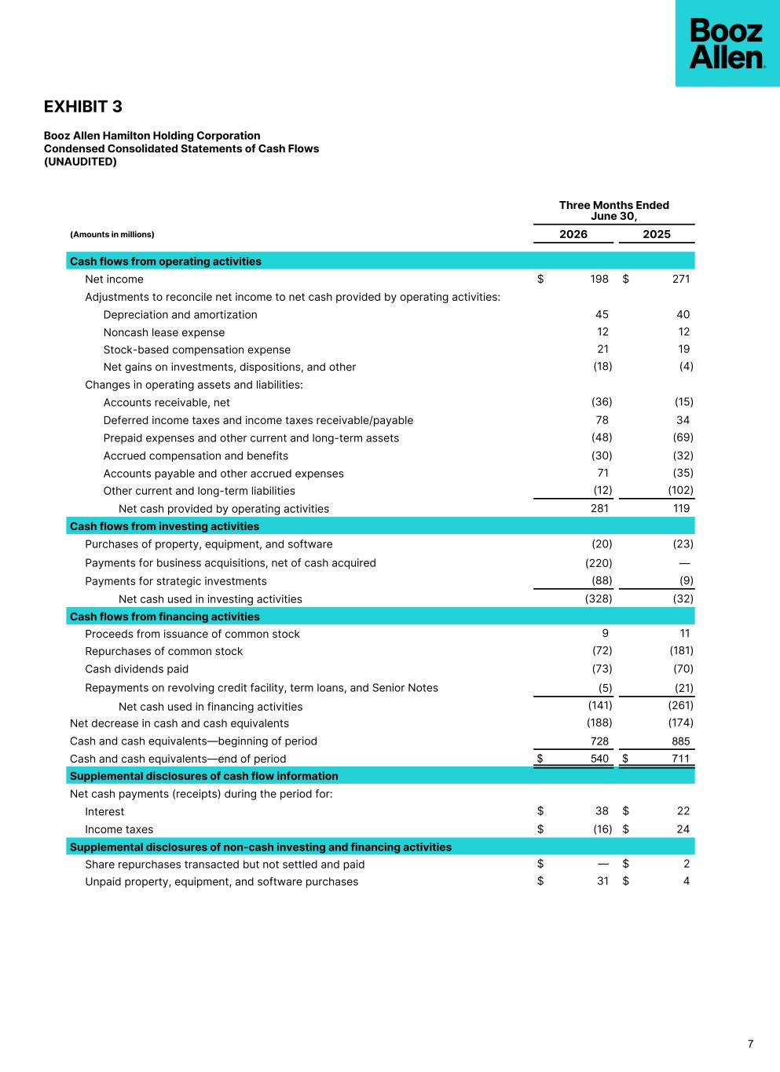
EXHIBIT 3 Booz Allen Hamilton Holding Corporation Condensed Consolidated Statements of Cash Flows (UNAUDITED) Three Months Ended June 30, (Amounts in millions) 2026 2025 Cash flows from operating activities Net income $ 198 $ 271 Adjustments to reconcile net income to net cash provided by operating activities: Depreciation and amortization 45 40 Noncash lease expense 12 12 Stock-based compensation expense 21 19 Net gains on investments, dispositions, and other (18) (4) Changes in operating assets and liabilities: Accounts receivable, net (36) (15) Deferred income taxes and income taxes receivable/payable 78 34 Prepaid expenses and other current and long-term assets (48) (69) Accrued compensation and benefits (30) (32) Accounts payable and other accrued expenses 71 (35) Other current and long-term liabilities (12) (102) Net cash provided by operating activities 281 119 Cash flows from investing activities Purchases of property, equipment, and software (20) (23) Payments for business acquisitions, net of cash acquired (220) — Payments for strategic investments (88) (9) Net cash used in investing activities (328) (32) Cash flows from financing activities Proceeds from issuance of common stock 9 11 Repurchases of common stock (72) (181) Cash dividends paid (73) (70) Repayments on revolving credit facility, term loans, and Senior Notes (5) (21) Net cash used in financing activities (141) (261) Net decrease in cash and cash equivalents (188) (174) Cash and cash equivalents––beginning of period 728 885 Cash and cash equivalents––end of period $ 540 $ 711 Supplemental disclosures of cash flow information Net cash payments (receipts) during the period for: Interest $ 38 $ 22 Income taxes $ (16) $ 24 Supplemental disclosures of non-cash investing and financing activities Share repurchases transacted but not settled and paid $ — $ 2 Unpaid property, equipment, and software purchases $ 31 $ 4 7

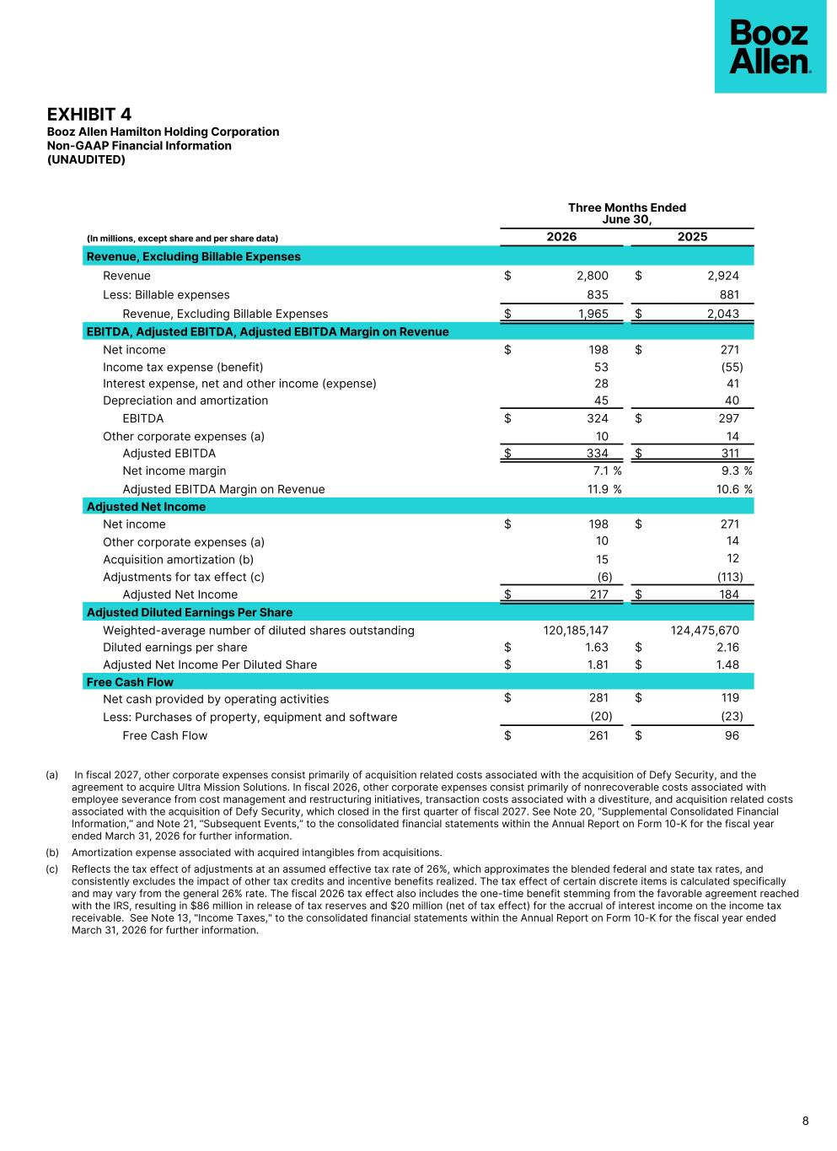
EXHIBIT 4 Booz Allen Hamilton Holding Corporation Non-GAAP Financial Information (UNAUDITED) Three Months Ended June 30, (In millions, except share and per share data) 2026 2025 Revenue, Excluding Billable Expenses Revenue $ 2,800 $ 2,924 Less: Billable expenses 835 881 Revenue, Excluding Billable Expenses $ 1,965 $ 2,043 EBITDA, Adjusted EBITDA, Adjusted EBITDA Margin on Revenue Net income $ 198 $ 271 Income tax expense (benefit) 53 (55) Interest expense, net and other income (expense) 28 41 Depreciation and amortization 45 40 EBITDA $ 324 $ 297 Other corporate expenses (a) 10 14 Adjusted EBITDA $ 334 $ 311 Net income margin 7.1 % 9.3 % Adjusted EBITDA Margin on Revenue 11.9 % 10.6 % Adjusted Net Income Net income $ 198 $ 271 Other corporate expenses (a) 10 14 Acquisition amortization (b) 15 12 Adjustments for tax effect (c) (6) (113) Adjusted Net Income $ 217 $ 184 Adjusted Diluted Earnings Per Share Weighted-average number of diluted shares outstanding 120,185,147 124,475,670 Diluted earnings per share $ 1.63 $ 2.16 Adjusted Net Income Per Diluted Share $ 1.81 $ 1.48 Free Cash Flow Net cash provided by operating activities $ 281 $ 119 Less: Purchases of property, equipment and software (20) (23) Free Cash Flow $ 261 $ 96 8 (a) In fiscal 2027, other corporate expenses consist primarily of acquisition related costs associated with the acquisition of Defy Security, and the agreement to acquire Ultra Mission Solutions. In fiscal 2026, other corporate expenses consist primarily of nonrecoverable costs associated with employee severance from cost management and restructuring initiatives, transaction costs associated with a divestiture, and acquisition related costs associated with the acquisition of Defy Security, which closed in the first quarter of fiscal 2027. See Note 20, “Supplemental Consolidated Financial Information,” and Note 21, “Subsequent Events,” to the consolidated financial statements within the Annual Report on Form 10-K for the fiscal year ended March 31, 2026 for further information. (b) Amortization expense associated with acquired intangibles from acquisitions. (c) Reflects the tax effect of adjustments at an assumed effective tax rate of 26%, which approximates the blended federal and state tax rates, and consistently excludes the impact of other tax credits and incentive benefits realized. The tax effect of certain discrete items is calculated specifically and may vary from the general 26% rate. The fiscal 2026 tax effect also includes the one-time benefit stemming from the favorable agreement reached with the IRS, resulting in $86 million in release of tax reserves and $20 million (net of tax effect) for the accrual of interest income on the income tax receivable. See Note 13, "Income Taxes," to the consolidated financial statements within the Annual Report on Form 10-K for the fiscal year ended March 31, 2026 for further information.

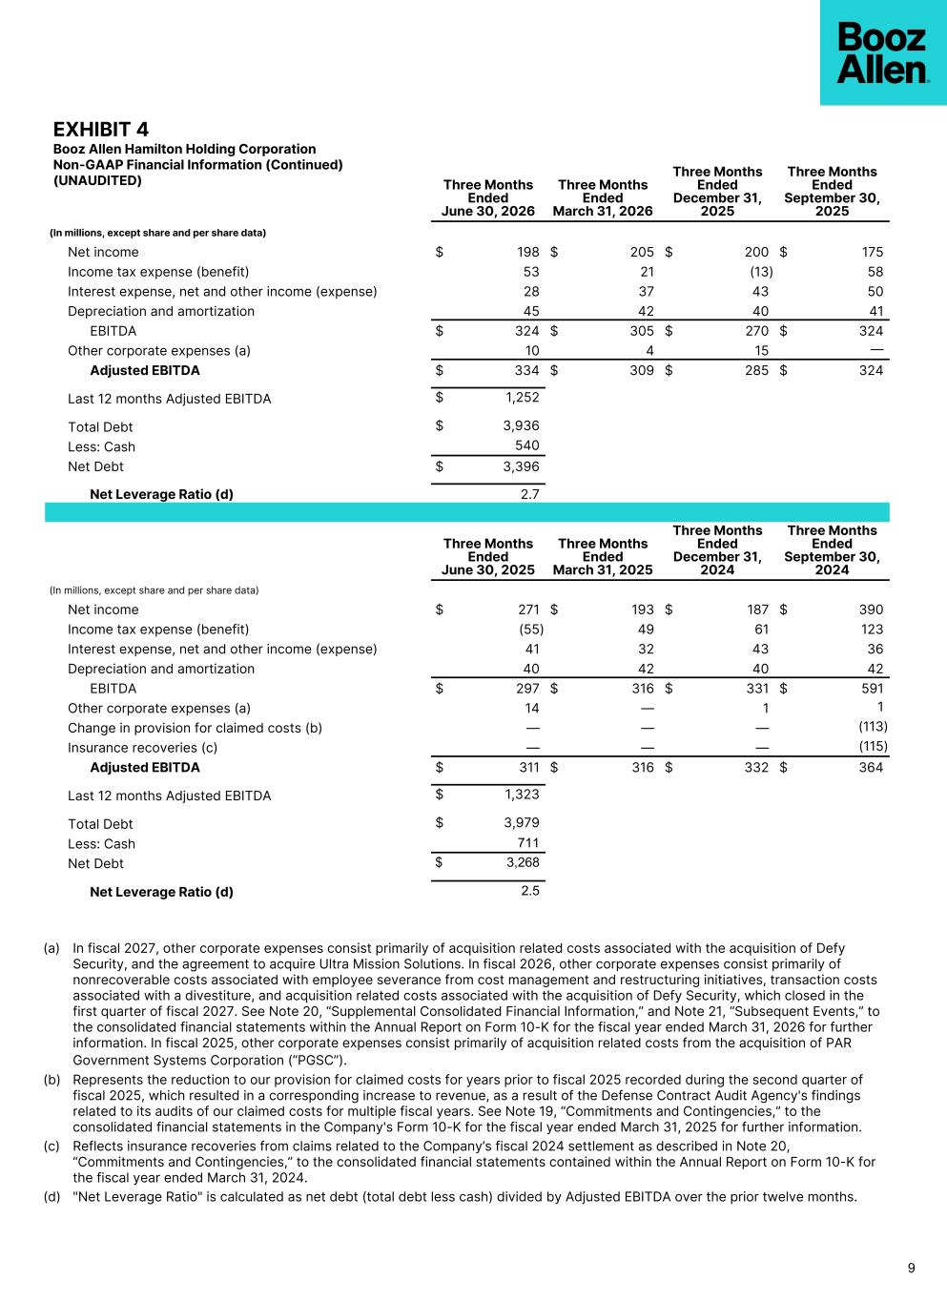
EXHIBIT 4 Booz Allen Hamilton Holding Corporation Non-GAAP Financial Information (Continued) (UNAUDITED) Three Months Ended June 30, 2026 Three Months Ended March 31, 2026 Three Months Ended December 31, 2025 Three Months Ended September 30, 2025 (In millions, except share and per share data) Net income $ 198 $ 205 $ 200 $ 175 Income tax expense (benefit) 53 21 (13) 58 Interest expense, net and other income (expense) 28 37 43 50 Depreciation and amortization 45 42 40 41 EBITDA $ 324 $ 305 $ 270 $ 324 Other corporate expenses (a) 10 4 15 — Adjusted EBITDA $ 334 $ 309 $ 285 $ 324 Last 12 months Adjusted EBITDA $ 1,252 Total Debt $ 3,936 Less: Cash 540 Net Debt $ 3,396 Net Leverage Ratio (d) 2.7 Three Months Ended June 30, 2025 Three Months Ended March 31, 2025 Three Months Ended December 31, 2024 Three Months Ended September 30, 2024 (In millions, except share and per share data) Net income $ 271 $ 193 $ 187 $ 390 Income tax expense (benefit) (55) 49 61 123 Interest expense, net and other income (expense) 41 32 43 36 Depreciation and amortization 40 42 40 42 EBITDA $ 297 $ 316 $ 331 $ 591 Other corporate expenses (a) 14 — 1 1 Change in provision for claimed costs (b) — — — (113) Insurance recoveries (c) — — — (115) Adjusted EBITDA $ 311 $ 316 $ 332 $ 364 Last 12 months Adjusted EBITDA $ 1,323 Total Debt $ 3,979 Less: Cash 711 Net Debt $ 3,268 Net Leverage Ratio (d) 2.5 9 (a) In fiscal 2027, other corporate expenses consist primarily of acquisition related costs associated with the acquisition of Defy Security, and the agreement to acquire Ultra Mission Solutions. In fiscal 2026, other corporate expenses consist primarily of nonrecoverable costs associated with employee severance from cost management and restructuring initiatives, transaction costs associated with a divestiture, and acquisition related costs associated with the acquisition of Defy Security, which closed in the first quarter of fiscal 2027. See Note 20, “Supplemental Consolidated Financial Information,” and Note 21, “Subsequent Events,” to the consolidated financial statements within the Annual Report on Form 10-K for the fiscal year ended March 31, 2026 for further information. In fiscal 2025, other corporate expenses consist primarily of acquisition related costs from the acquisition of PAR Government Systems Corporation (“PGSC”). (b) Represents the reduction to our provision for claimed costs for years prior to fiscal 2025 recorded during the second quarter of fiscal 2025, which resulted in a corresponding increase to revenue, as a result of the Defense Contract Audit Agency's findings related to its audits of our claimed costs for multiple fiscal years. See Note 19, “Commitments and Contingencies,” to the consolidated financial statements in the Company's Form 10-K for the fiscal year ended March 31, 2025 for further information. (c) Reflects insurance recoveries from claims related to the Company’s fiscal 2024 settlement as described in Note 20, “Commitments and Contingencies,” to the consolidated financial statements contained within the Annual Report on Form 10-K for the fiscal year ended March 31, 2024. (d) "Net Leverage Ratio" is calculated as net debt (total debt less cash) divided by Adjusted EBITDA over the prior twelve months.

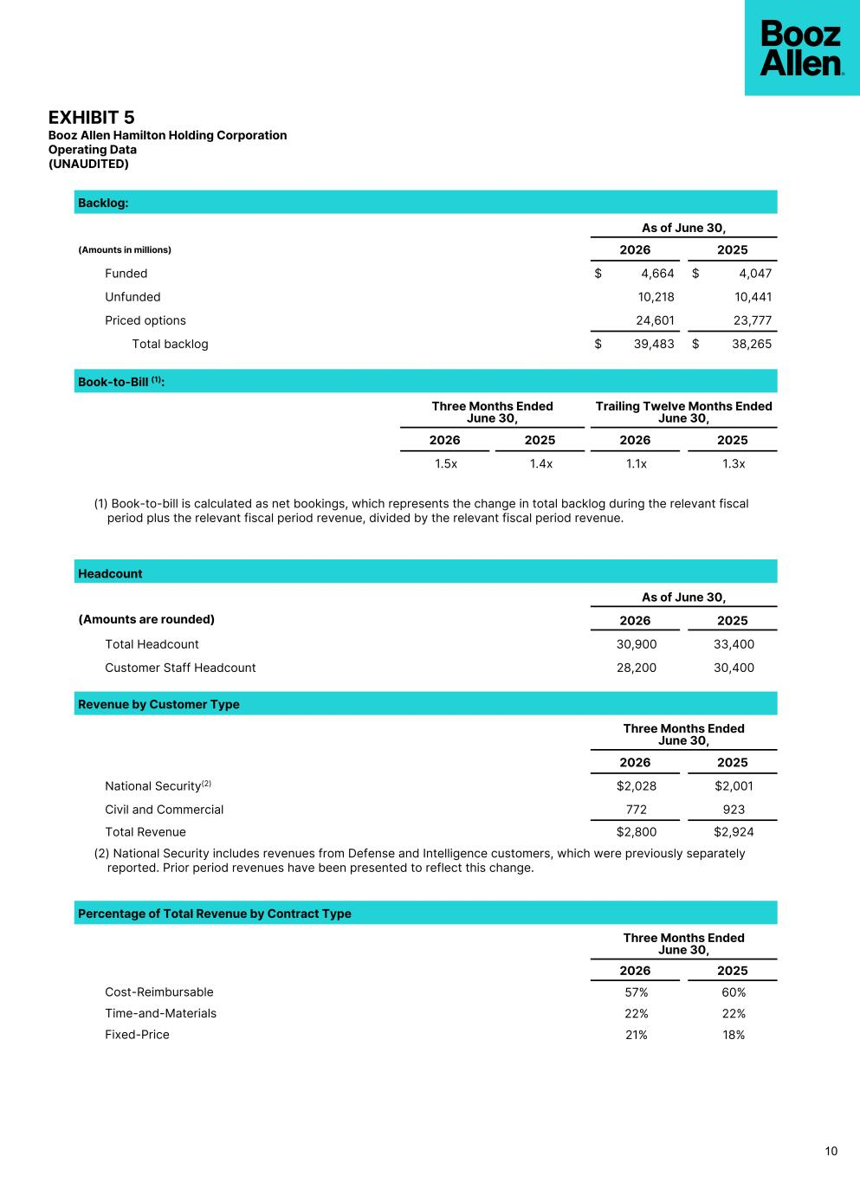
EXHIBIT 5 Booz Allen Hamilton Holding Corporation Operating Data (UNAUDITED) Backlog: As of June 30, (Amounts in millions) 2026 2025 Funded $ 4,664 $ 4,047 Unfunded 10,218 10,441 Priced options 24,601 23,777 Total backlog $ 39,483 $ 38,265 Book-to-Bill (1): Three Months Ended June 30, Trailing Twelve Months Ended June 30, 2026 2025 2026 2025 1.5x 1.4x 1.1x 1.3x (1) Book-to-bill is calculated as net bookings, which represents the change in total backlog during the relevant fiscal period plus the relevant fiscal period revenue, divided by the relevant fiscal period revenue. Headcount As of June 30, (Amounts are rounded) 2026 2025 Total Headcount 30,900 33,400 Customer Staff Headcount 28,200 30,400 Revenue by Customer Type Three Months Ended June 30, 2026 2025 National Security(2) $2,028 $2,001 Civil and Commercial 772 923 Total Revenue $2,800 $2,924 (2) National Security includes revenues from Defense and Intelligence customers, which were previously separately reported. Prior period revenues have been presented to reflect this change. Percentage of Total Revenue by Contract Type Three Months Ended June 30, 2026 2025 Cost-Reimbursable 57% 60% Time-and-Materials 22% 22% Fixed-Price 21% 18% 10


Q1 FY27 Earnings Call Presentation JULY 24, 2026


Booz Allen Hamilton Internal PARTICIPANTS Earnings Call Participants HORACIO ROZANSKI Chairman, Chief Executive Officer KRISTINE MARTIN ANDERSON President, Chief Operating Officer TROY LAHR Executive Vice President, Chief Financial Officer DUSTIN DARENSBOURG Head of Investor Relations boozallen.com 2Copyright © 2026 BOOZ ALLEN HAMILTON INC.


Booz Allen Hamilton Internal DISCLAIMER Forward Looking Safe Harbor Statement boozallen.com 3Copyright © 2026 BOOZ ALLEN HAMILTON INC. Certain statements contained in this presentation and in related comments by our management include “forward-looking statements” within the meaning of the Private Securities Litigation Reform Act of 1995. Examples of forward-looking statements include information concerning Booz Allen’s preliminary financial results, financial outlook and guidance, including forecasted revenue, Adjusted EBITDA, Diluted EPS, Adjusted Diluted EPS, future quarterly dividends, and future improvements in operating margins, as well as any other statement that does not directly relate to any historical or current fact. In some cases, you can identify forward-looking statements by terminology such as “may,” “will,” “could,” “should,” “forecasts,” “expects,” “intends,” “plans,” “anticipates,” “projects,” “outlook,” “believes,” “estimates,” “predicts,” “potential,” “continue,” “preliminary,” or the negative of these terms or other comparable terminology. Although we believe that the expectations reflected in the forward-looking statements are reasonable, we can give you no assurance these expectations will prove to have been correct. These forward-looking statements relate to future events or our future financial performance and involve known and unknown risks, uncertainties and other factors that may cause our actual results, levels of activity, performance or achievements to differ materially from any future results, levels of activity, performance or achievements expressed or implied by these forward-looking statements. A number of important factors could cause actual results to differ materially from those contained in or implied by these forward-looking statements, including those factors discussed in our filings with the Securities and Exchange Commission (SEC), including our Annual Report on Form 10-K for the fiscal year ended March 31, 2026, which can be found at the SEC’s website at www.sec.gov. All forward-looking statements attributable to us or persons acting on our behalf are expressly qualified in their entirety by the foregoing cautionary statements. All such statements speak only as of the date made and we undertake no obligation to update or revise publicly any forward-looking statements, whether as a result of new information, future events or otherwise. Booz Allen’s fiscal year ends on March 31 and unless otherwise noted, references to fiscal year, fiscal or FY are for fiscal years ended March 31. Note Regarding Non-GAAP Financial Data Information Booz Allen discloses Revenue, Excluding Billable Expenses, Adjusted EBITDA, Adjusted EBITDA Margin on Revenue, Adjusted Net Income, Adjusted Diluted EPS, Free Cash Flow, and Net Leverage Ratio, which are not recognized measurements under accounting principles generally accepted in the United States, or GAAP, and when analyzing Booz Allen’s performance or liquidity as applicable, investors should (i) evaluate each adjustment in our reconciliation of revenue to Revenue, Excluding Billable Expenses, net income attributable to common stockholders to Adjusted EBITDA, Adjusted EBITDA Margin on Revenue, Adjusted Net Income and Adjusted Diluted EPS, net cash used in operating activities to Free Cash Flow, and net debt to Net Leverage Ratio, and the explanatory footnotes regarding those adjustments, each as defined under GAAP, (ii) use Revenue, Excluding Billable Expenses, Adjusted EBITDA, Adjusted EBITDA Margin on Revenue, Adjusted Net Income, and Adjusted Diluted EPS in addition to, and not as an alternative to, revenue, operating income, net income attributable to common stockholders or diluted EPS as measures of operating results, each as defined under GAAP, (iii) use Free Cash Flow in addition to, and not as an alternative to, net cash used in operating activities as a measure of liquidity, each as defined under GAAP, and (iv) use Net Leverage Ratio in addition to, and not as an alternative to, net debt as a measure of Booz Allen's debt leverage. The Appendix includes a reconciliation of Revenue, Excluding Billable Expenses, Adjusted EBITDA, Adjusted EBITDA Margin on Revenue, Adjusted Net Income, Adjusted Diluted EPS, Free Cash Flow and Net Leverage Ratio to the most directly comparable financial measure calculated and presented in accordance with GAAP. Booz Allen presents these supplemental performance measures because it believes that these measures provide investors and securities analysts with important supplemental information with which to evaluate Booz Allen’s performance, long term earnings potential, or liquidity, as applicable, and to enable them to assess Booz Allen’s performance on the same basis as management. These supplemental performance and liquidity measurements may vary from and may not be comparable to similarly titled measures by other companies in Booz Allen’s industry. With respect to our expectations under “Financial Outlook", reconciliation of Adjusted Diluted EPS guidance, Adjusted EBITDA, and Adjusted EBITDA Margin on Revenue, and Adjusted Effective Tax Rate to the closest corresponding GAAP measure is not available without unreasonable efforts on a forward-looking basis due to our inability to predict our stock price, equity grants and dividend declarations with respect to Adjusted Diluted EPS, and our net income, net interest and other expenses with respect to Adjusted EBITDA, Adjusted EBITDA Margin on Revenue, and Adjusted Effective Tax Rate, during the course of fiscal 2027. With respect to Adjusted Diluted EPS guidance, projecting future stock price, equity grants and dividends to be declared would be necessary to accurately calculate the difference between Adjusted Diluted EPS and GAAP EPS as a result of the effects of the two-class method and related possible dilution used in the calculation of EPS. Consequently, any attempt to disclose such reconciliation would imply a degree of precision that could be confusing or misleading to investors. We expect the variability of the above charges to have an unpredictable, and potentially significant, impact on our future GAAP financial results. For the same reason, a reconciliation of Adjusted EBITDA and Adjusted EBITDA Margin on Revenue guidance for fiscal 2027, of Adjusted EBITDA guidance through fiscal 2027, and of Adjusted Effective Tax Rate guidance through fiscal 2027 to the closest corresponding GAAP measures are not available without unreasonable efforts on a forward-looking basis due to our inability to predict specific quantifications of the amounts that would be required to reconcile such measures. Accordingly, Booz Allen is relying on the exception provided by Item 10(e)(1)(i)(B) of Regulation S-K to exclude these reconciliations.

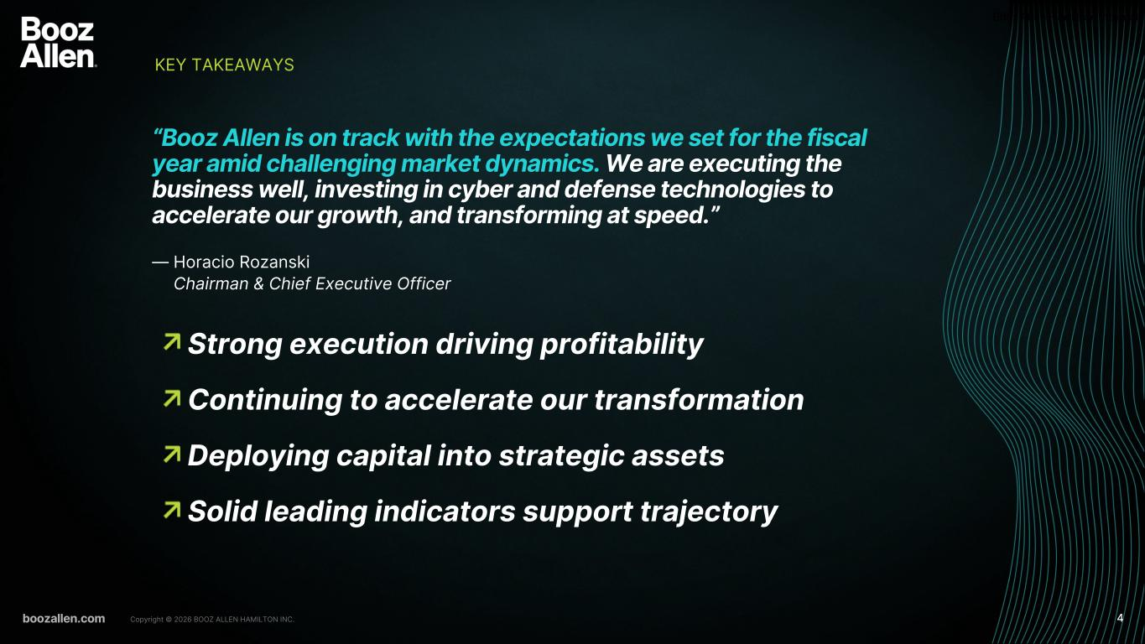
Booz Allen Hamilton Internal • Strong execution driving profitability • Continuing to accelerate our transformation • Deploying capital into strategic assets • Solid leading indicators support trajectory KEY TAKEAWAYS boozallen.com 4Copyright © 2026 BOOZ ALLEN HAMILTON INC. “Booz Allen is on track with the expectations we set for the fiscal year amid challenging market dynamics. We are executing the business well, investing in cyber and defense technologies to accelerate our growth, and transforming at speed.” — Horacio Rozanski Chairman & Chief Executive Officer

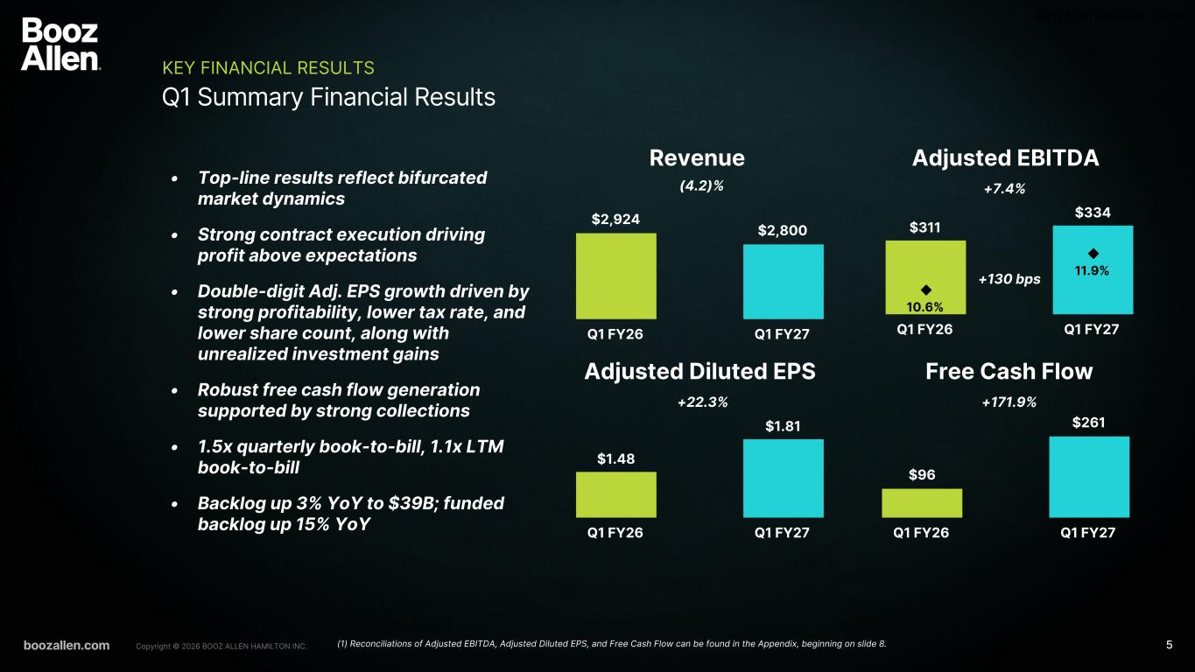
Booz Allen Hamilton Internal $96 $261 Q1 FY26 Q1 FY27 $2,924 $2,800 Q1 FY26 Q1 FY27 $1.48 $1.81 Q1 FY26 Q1 FY27 $311 $334 10.6% 11.9% Q1 FY26 Q1 FY27 boozallen.com 5Copyright © 2026 BOOZ ALLEN HAMILTON INC. Q1 Summary Financial Results KEY FINANCIAL RESULTS Revenue Adjusted EBITDA • Top-line results reflect bifurcated market dynamics • Strong contract execution driving profit above expectations • Double-digit Adj. EPS growth driven by strong profitability, lower tax rate, and lower share count, along with unrealized investment gains • Robust free cash flow generation supported by strong collections • 1.5x quarterly book-to-bill, 1.1x LTM book-to-bill • Backlog up 3% YoY to $39B; funded backlog up 15% YoY Adjusted Diluted EPS Free Cash Flow (4.2)% +7.4% +171.9%+22.3% +130 bps (1) Reconciliations of Adjusted EBITDA, Adjusted Diluted EPS, and Free Cash Flow can be found in the Appendix, beginning on slide 8.

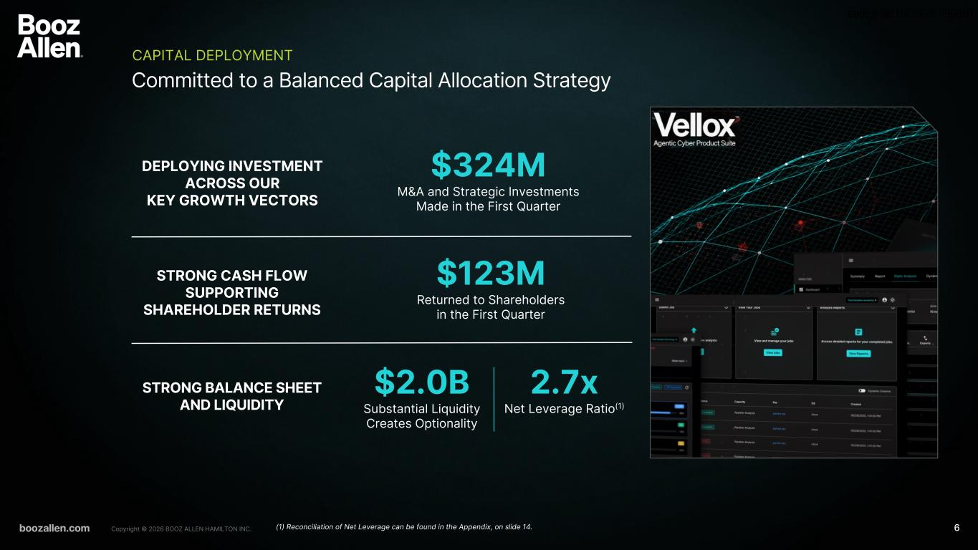
Booz Allen Hamilton Internal Committed to a Balanced Capital Allocation Strategy CAPITAL DEPLOYMENT boozallen.com 6Copyright © 2026 BOOZ ALLEN HAMILTON INC. DEPLOYING INVESTMENT ACROSS OUR KEY GROWTH VECTORS STRONG CASH FLOW SUPPORTING SHAREHOLDER RETURNS STRONG BALANCE SHEET AND LIQUIDITY $324M M&A and Strategic Investments Made in the First Quarter 2.7x Net Leverage Ratio(1) $123M Returned to Shareholders in the First Quarter $2.0B Substantial Liquidity Creates Optionality (1) Reconciliation of Net Leverage can be found in the Appendix, on slide 14.

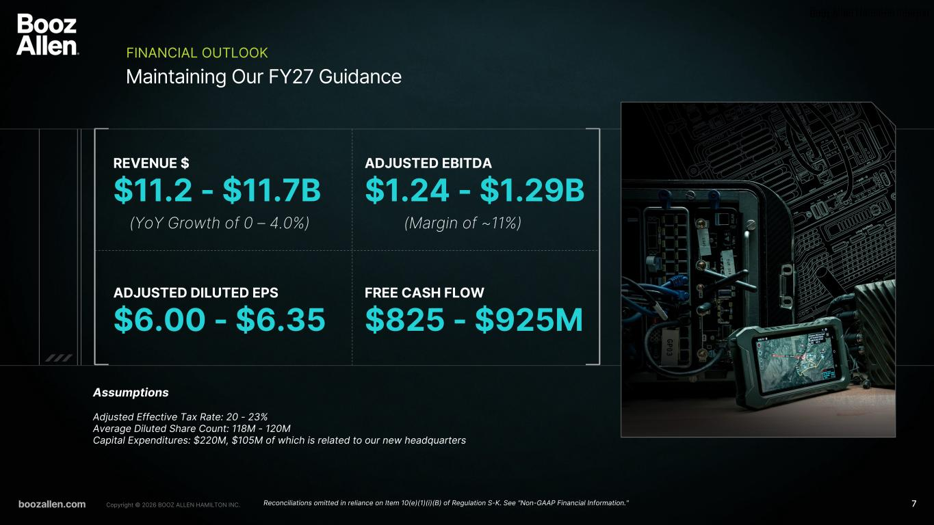
Booz Allen Hamilton Internal REVENUE $ $11.2 - $11.7B (YoY Growth of 0 – 4.0%) ADJUSTED EBITDA $1.24 - $1.29B ADJUSTED DILUTED EPS $6.00 - $6.35 FREE CASH FLOW $825 - $925M Assumptions Adjusted Effective Tax Rate: 20 - 23% Average Diluted Share Count: 118M - 120M Capital Expenditures: $220M, $105M of which is related to our new headquarters (Margin of ~11%) Maintaining Our FY27 Guidance FINANCIAL OUTLOOK boozallen.com 7Copyright © 2026 BOOZ ALLEN HAMILTON INC. Reconciliations omitted in reliance on Item 10(e)(1)(i)(B) of Regulation S-K. See "Non-GAAP Financial Information."

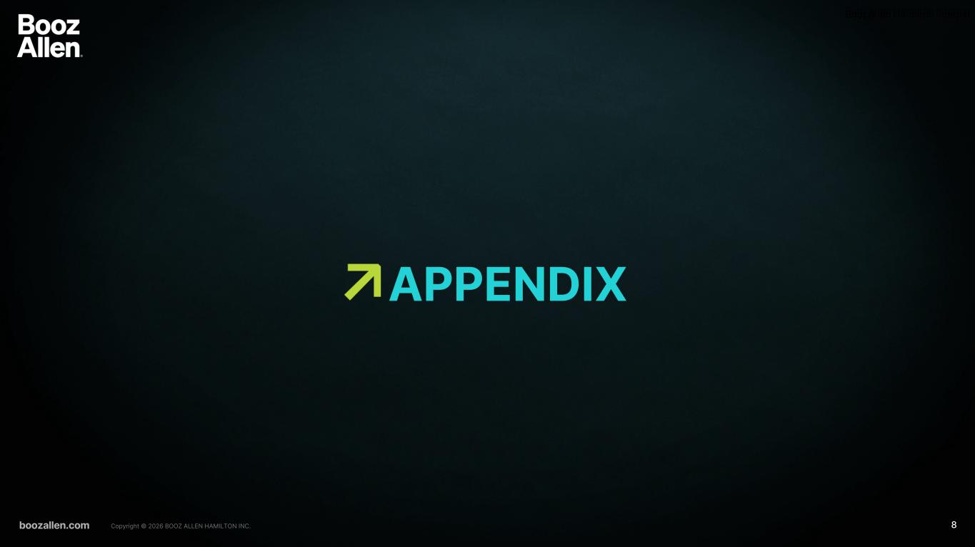
Booz Allen Hamilton Internal boozallen.com 8Copyright © 2026 BOOZ ALLEN HAMILTON INC. APPENDIX

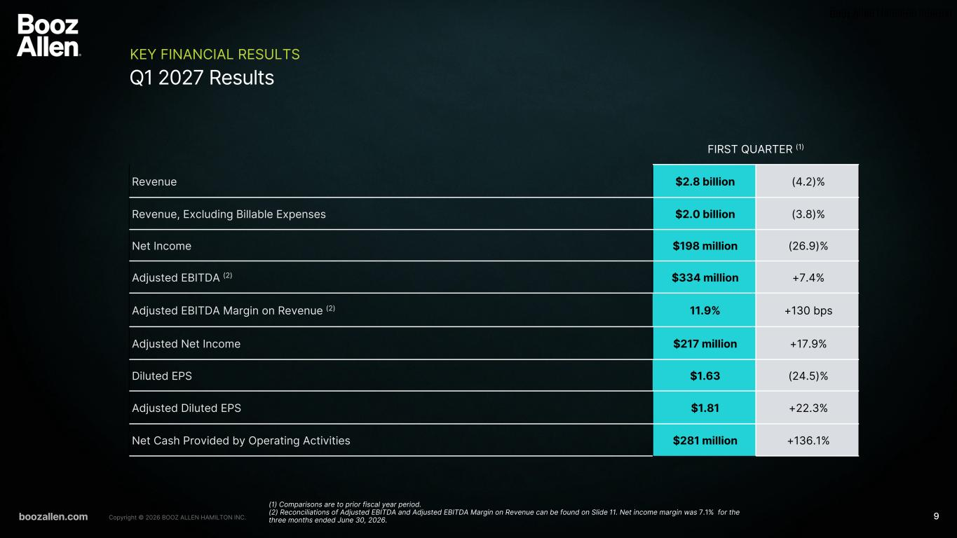
Booz Allen Hamilton Internal boozallen.com 9Copyright © 2026 BOOZ ALLEN HAMILTON INC. Q1 2027 Results KEY FINANCIAL RESULTS FIRST QUARTER (1) Revenue $2.8 billion (4.2)% Revenue, Excluding Billable Expenses $2.0 billion (3.8)% Net Income $198 million (26.9)% Adjusted EBITDA (2) $334 million +7.4% Adjusted EBITDA Margin on Revenue (2) 11.9% +130 bps Adjusted Net Income $217 million +17.9% Diluted EPS $1.63 (24.5)% Adjusted Diluted EPS $1.81 +22.3% Net Cash Provided by Operating Activities $281 million +136.1% (1) Comparisons are to prior fiscal year period. (2) Reconciliations of Adjusted EBITDA and Adjusted EBITDA Margin on Revenue can be found on Slide 11. Net income margin was 7.1% for the three months ended June 30, 2026.

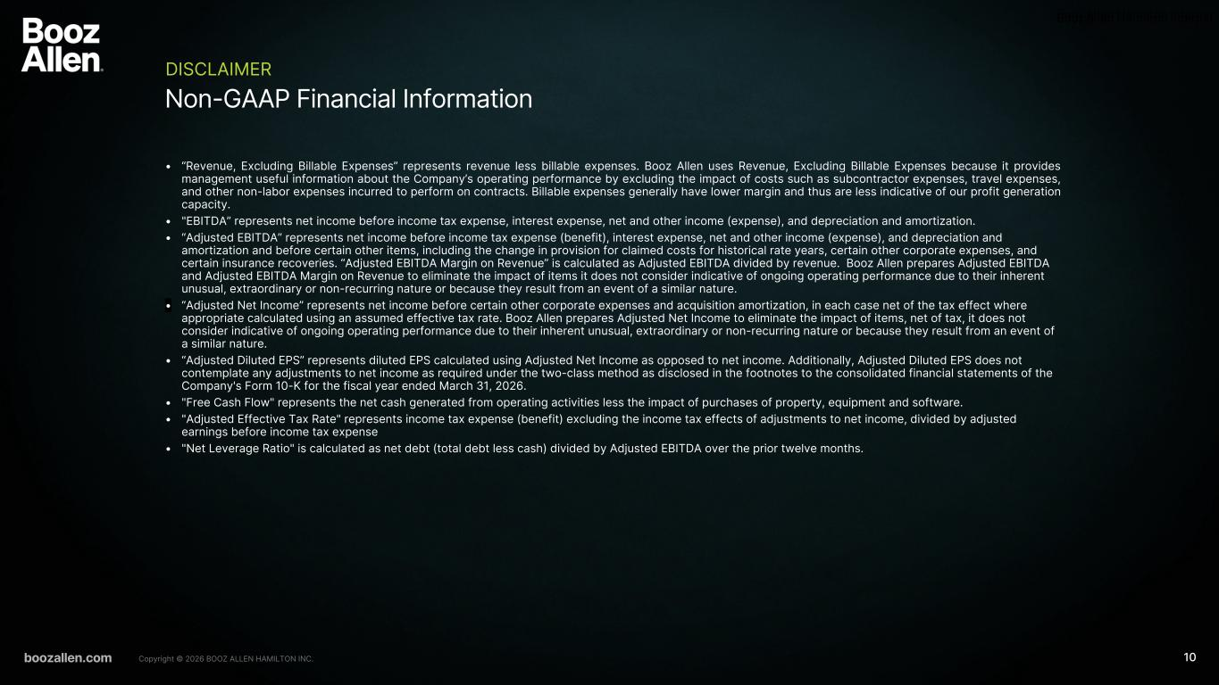
Booz Allen Hamilton Internal boozallen.com 10Copyright © 2026 BOOZ ALLEN HAMILTON INC. Non-GAAP Financial Information DISCLAIMER • “Revenue, Excluding Billable Expenses” represents revenue less billable expenses. Booz Allen uses Revenue, Excluding Billable Expenses because it provides management useful information about the Company’s operating performance by excluding the impact of costs such as subcontractor expenses, travel expenses, and other non-labor expenses incurred to perform on contracts. Billable expenses generally have lower margin and thus are less indicative of our profit generation capacity. • "EBITDA” represents net income before income tax expense, interest expense, net and other income (expense), and depreciation and amortization. • “Adjusted EBITDA” represents net income before income tax expense (benefit), interest expense, net and other income (expense), and depreciation and amortization and before certain other items, including the change in provision for claimed costs for historical rate years, certain other corporate expenses, and certain insurance recoveries. “Adjusted EBITDA Margin on Revenue” is calculated as Adjusted EBITDA divided by revenue. Booz Allen prepares Adjusted EBITDA and Adjusted EBITDA Margin on Revenue to eliminate the impact of items it does not consider indicative of ongoing operating performance due to their inherent unusual, extraordinary or non-recurring nature or because they result from an event of a similar nature. • “Adjusted Net Income” represents net income before certain other corporate expenses and acquisition amortization, in each case net of the tax effect where appropriate calculated using an assumed effective tax rate. Booz Allen prepares Adjusted Net Income to eliminate the impact of items, net of tax, it does not consider indicative of ongoing operating performance due to their inherent unusual, extraordinary or non-recurring nature or because they result from an event of a similar nature. • “Adjusted Diluted EPS” represents diluted EPS calculated using Adjusted Net Income as opposed to net income. Additionally, Adjusted Diluted EPS does not contemplate any adjustments to net income as required under the two-class method as disclosed in the footnotes to the consolidated financial statements of the Company's Form 10-K for the fiscal year ended March 31, 2026. • "Free Cash Flow" represents the net cash generated from operating activities less the impact of purchases of property, equipment and software. • "Adjusted Effective Tax Rate" represents income tax expense (benefit) excluding the income tax effects of adjustments to net income, divided by adjusted earnings before income tax expense • "Net Leverage Ratio" is calculated as net debt (total debt less cash) divided by Adjusted EBITDA over the prior twelve months.

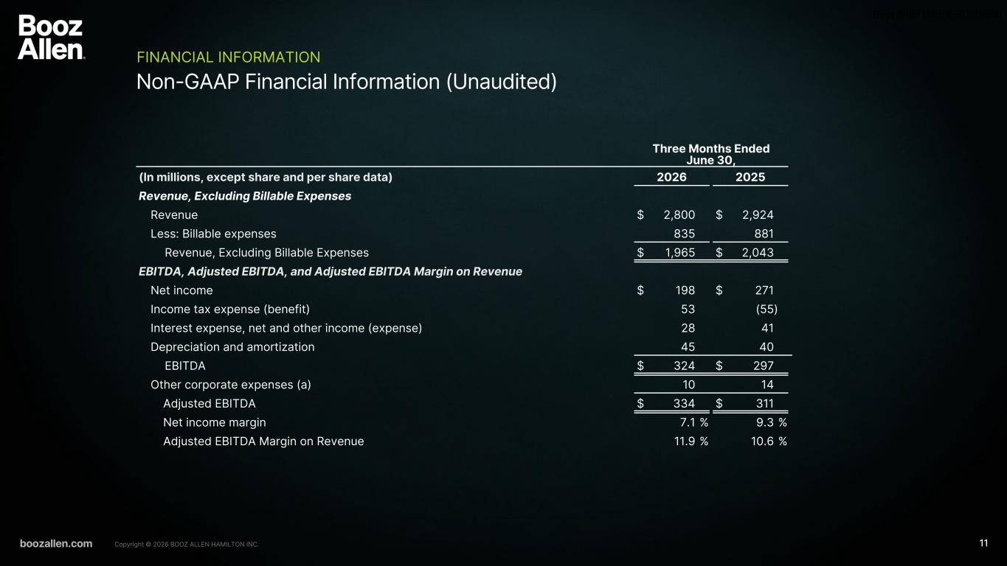
Booz Allen Hamilton Internal boozallen.com 11Copyright © 2026 BOOZ ALLEN HAMILTON INC. Non-GAAP Financial Information (Unaudited) FINANCIAL INFORMATION Three Months Ended June 30, (In millions, except share and per share data) 2026 2025 Revenue, Excluding Billable Expenses Revenue $ 2,800 $ 2,924 Less: Billable expenses 835 881 Revenue, Excluding Billable Expenses $ 1,965 $ 2,043 EBITDA, Adjusted EBITDA, and Adjusted EBITDA Margin on Revenue Net income $ 198 $ 271 Income tax expense (benefit) 53 (55) Interest expense, net and other income (expense) 28 41 Depreciation and amortization 45 40 EBITDA $ 324 $ 297 Other corporate expenses (a) 10 14 Adjusted EBITDA $ 334 $ 311 Net income margin 7.1 % 9.3 % Adjusted EBITDA Margin on Revenue 11.9 % 10.6 %

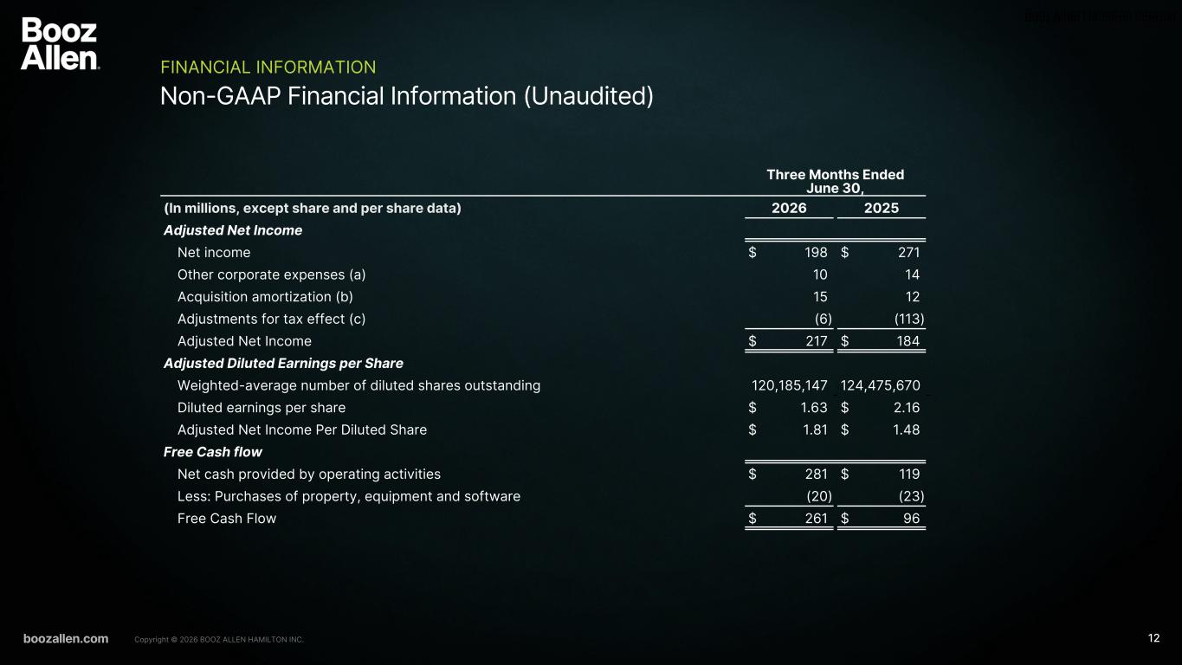
Booz Allen Hamilton Internal boozallen.com 12Copyright © 2026 BOOZ ALLEN HAMILTON INC. Non-GAAP Financial Information (Unaudited) FINANCIAL INFORMATION Three Months Ended June 30, (In millions, except share and per share data) 2026 2025 Adjusted Net Income Net income $ 198 $ 271 Other corporate expenses (a) 10 14 Acquisition amortization (b) 15 12 Adjustments for tax effect (c) (6) (113) Adjusted Net Income $ 217 $ 184 Adjusted Diluted Earnings per Share Weighted-average number of diluted shares outstanding 120,185,147 124,475,670 Diluted earnings per share $ 1.63 $ 2.16 Adjusted Net Income Per Diluted Share $ 1.81 $ 1.48 Free Cash flow Net cash provided by operating activities $ 281 $ 119 Less: Purchases of property, equipment and software (20) (23) Free Cash Flow $ 261 $ 96


Booz Allen Hamilton Internal boozallen.com 13Copyright © 2026 BOOZ ALLEN HAMILTON INC. Non-GAAP Financial Information DISCLAIMER (a) In fiscal 2027, other corporate expenses consist primarily of acquisition related costs associated with the acquisition of Defy Security, and the agreement to acquire Ultra Mission Solutions. In fiscal 2026, other corporate expenses consist primarily of nonrecoverable costs associated with employee severance from cost management and restructuring initiatives, transaction costs associated with a divestiture, and acquisition related costs associated with the acquisition of Defy Security, which closed in the first quarter of fiscal 2027. See Note 20, “Supplemental Consolidated Financial Information,” and Note 21, “Subsequent Events,” to the consolidated financial statements within the Annual Report on Form 10-K for the fiscal year ended March 31, 2026 for further information. (b) Amortization expense associated with acquired intangibles from acquisitions. (c) Reflects the tax effect of adjustments at an assumed effective tax rate of 26%, which approximates the blended federal and state tax rates, and consistently excludes the impact of other tax credits and incentive benefits realized. The tax effect of certain discrete items is calculated specifically and may vary from the general 26% rate. The fiscal 2026 tax effect also includes the one-time benefit stemming from the favorable agreement reached with the IRS, resulting in $86 million in release of tax reserves and $20 million (net of tax effect) for the accrual of interest income on the income tax receivable. See Note 13, "Income Taxes," to the consolidated financial statements within the Annual Report on Form 10-K for the fiscal year ended March 31, 2026 for further information.

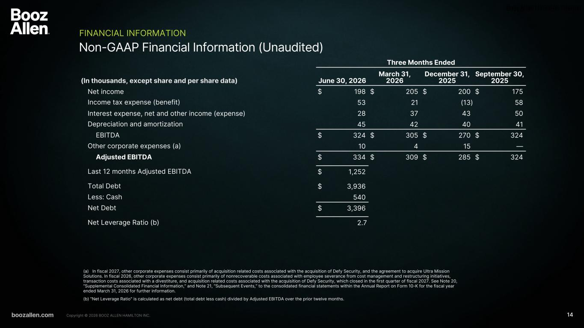
Booz Allen Hamilton Internal boozallen.com 14Copyright © 2026 BOOZ ALLEN HAMILTON INC. Non-GAAP Financial Information (Unaudited) FINANCIAL INFORMATION (a) In fiscal 2027, other corporate expenses consist primarily of acquisition related costs associated with the acquisition of Defy Security, and the agreement to acquire Ultra Mission Solutions. In fiscal 2026, other corporate expenses consist primarily of nonrecoverable costs associated with employee severance from cost management and restructuring initiatives, transaction costs associated with a divestiture, and acquisition related costs associated with the acquisition of Defy Security, which closed in the first quarter of fiscal 2027. See Note 20, “Supplemental Consolidated Financial Information,” and Note 21, “Subsequent Events,” to the consolidated financial statements within the Annual Report on Form 10-K for the fiscal year ended March 31, 2026 for further information. (b) "Net Leverage Ratio" is calculated as net debt (total debt less cash) divided by Adjusted EBITDA over the prior twelve months. Three Months Ended (In thousands, except share and per share data) June 30, 2026 March 31, 2026 December 31, 2025 September 30, 2025 Net income $ 198 $ 205 $ 200 $ 175 Income tax expense (benefit) 53 21 (13) 58 Interest expense, net and other income (expense) 28 37 43 50 Depreciation and amortization 45 42 40 41 EBITDA $ 324 $ 305 $ 270 $ 324 Other corporate expenses (a) 10 4 15 — Adjusted EBITDA $ 334 $ 309 $ 285 $ 324 Last 12 months Adjusted EBITDA $ 1,252 Total Debt $ 3,936 Less: Cash 540 Net Debt $ 3,396 Net Leverage Ratio (b) 2.7

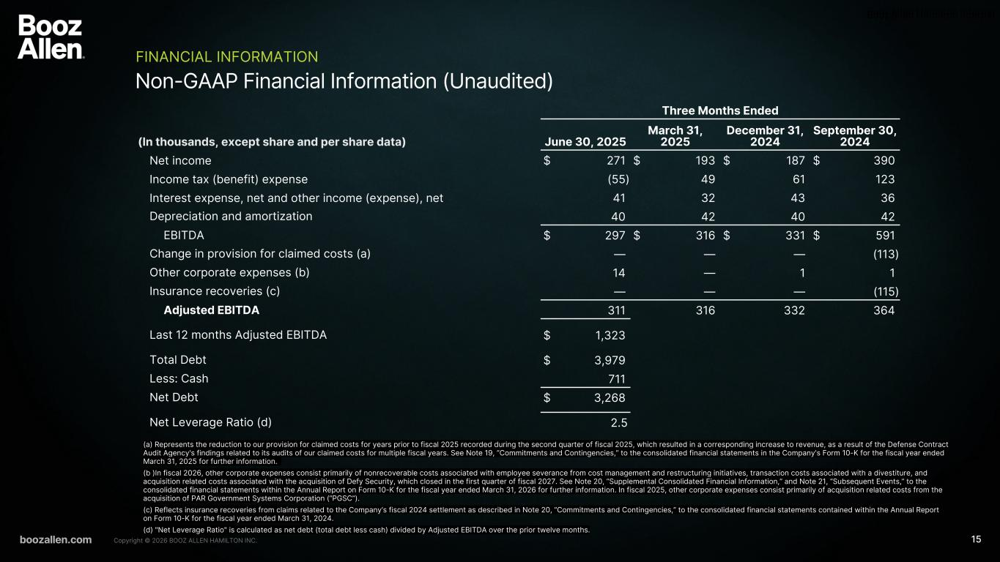
Booz Allen Hamilton Internal boozallen.com 15Copyright © 2026 BOOZ ALLEN HAMILTON INC. Non-GAAP Financial Information (Unaudited) FINANCIAL INFORMATION (a) Represents the reduction to our provision for claimed costs for years prior to fiscal 2025 recorded during the second quarter of fiscal 2025, which resulted in a corresponding increase to revenue, as a result of the Defense Contract Audit Agency's findings related to its audits of our claimed costs for multiple fiscal years. See Note 19, “Commitments and Contingencies,” to the consolidated financial statements in the Company's Form 10-K for the fiscal year ended March 31, 2025 for further information. (b )In fiscal 2026, other corporate expenses consist primarily of nonrecoverable costs associated with employee severance from cost management and restructuring initiatives, transaction costs associated with a divestiture, and acquisition related costs associated with the acquisition of Defy Security, which closed in the first quarter of fiscal 2027. See Note 20, “Supplemental Consolidated Financial Information,” and Note 21, “Subsequent Events,” to the consolidated financial statements within the Annual Report on Form 10-K for the fiscal year ended March 31, 2026 for further information. In fiscal 2025, other corporate expenses consist primarily of acquisition related costs from the acquisition of PAR Government Systems Corporation (“PGSC”). (c) Reflects insurance recoveries from claims related to the Company’s fiscal 2024 settlement as described in Note 20, “Commitments and Contingencies,” to the consolidated financial statements contained within the Annual Report on Form 10-K for the fiscal year ended March 31, 2024. (d) "Net Leverage Ratio" is calculated as net debt (total debt less cash) divided by Adjusted EBITDA over the prior twelve months. Three Months Ended (In thousands, except share and per share data) June 30, 2025 March 31, 2025 December 31, 2024 September 30, 2024 Net income $ 271 $ 193 $ 187 $ 390 Income tax (benefit) expense (55) 49 61 123 Interest expense, net and other income (expense), net 41 32 43 36 Depreciation and amortization 40 42 40 42 EBITDA $ 297 $ 316 $ 331 $ 591 Change in provision for claimed costs (a) — — — (113) Other corporate expenses (b) 14 — 1 1 Insurance recoveries (c) — — — (115) Adjusted EBITDA 311 316 332 364 Last 12 months Adjusted EBITDA $ 1,323 Total Debt $ 3,979 Less: Cash 711 Net Debt $ 3,268 Net Leverage Ratio (d) 2.5

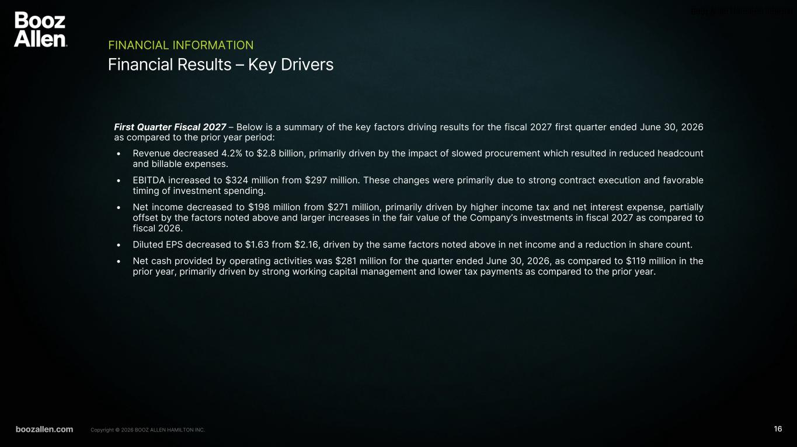
Booz Allen Hamilton Internal boozallen.com 16Copyright © 2026 BOOZ ALLEN HAMILTON INC. Financial Results – Key Drivers FINANCIAL INFORMATION First Quarter Fiscal 2027 – Below is a summary of the key factors driving results for the fiscal 2027 first quarter ended June 30, 2026 as compared to the prior year period: • Revenue decreased 4.2% to $2.8 billion, primarily driven by the impact of slowed procurement which resulted in reduced headcount and billable expenses. • EBITDA increased to $324 million from $297 million. These changes were primarily due to strong contract execution and favorable timing of investment spending. • Net income decreased to $198 million from $271 million, primarily driven by higher income tax and net interest expense, partially offset by the factors noted above and larger increases in the fair value of the Company’s investments in fiscal 2027 as compared to fiscal 2026. • Diluted EPS decreased to $1.63 from $2.16, driven by the same factors noted above in net income and a reduction in share count. • Net cash provided by operating activities was $281 million for the quarter ended June 30, 2026, as compared to $119 million in the prior year, primarily driven by strong working capital management and lower tax payments as compared to the prior year.

