Table of Contents

UNITED STATES

SECURITIES AND EXCHANGE COMMISSION

WASHINGTON, D.C. 20549

___________________________________

FORM 10-K

___________________________________

(Mark One)

- ANNUAL REPORT PURSUANT TO SECTION 13 OR 15(D) OF THE SECURITIES EXCHANGE ACT OF 1934

For the fiscal year ended March 31, 2023

- TRANSITION REPORT PURSUANT TO SECTION 13 OR 15(D) OF THE SECURITIES EXCHANGE ACT OF 1934

 |  |  |  | For the transition period from |  |  |  | to
 |  |  |  | Commission File No. 001-34972
 |  |  |  | ___________________________________
 |  | Booz Allen Hamilton Holding Corporation
 |  |  |  | (Exact name of registrant as specified in its charter)
 |  |  |  | ___________________________________
Delaware |  |  |  |  |  |  |  | 26-2634160
(State or other jurisdiction of |  |  |  |  |  |  |  |  | (I.R.S. Employer
incorporation or organization) |  |  |  |  |  |  |  |  | Identification No.)
8283 Greensboro Drive, |  | McLean, |  | Virginia |  |  |  | 22102
(Address of principal executive offices) |  |  |  |  |  |  |  |  | (Zip Code)
 |  |  |  | (703) 902-5000
 |  |  |  | Registrant’s telephone number, including area code
 |  |  |  | Securities registered pursuant to Section 12(b) of the Act:
 |  | Title of Each Class |  | Trading Symbol |  |  |  |  | Name of Each Exchange on Which Registered
 | Class A Common Stock |  |  |  | BAH |  |  |  | New York Stock Exchange
 |  |  |  | Securities registered pursuant to Section 12(g) of the Act:
 |  |  |  |  | None.
 |  |  |  | __________________ |  |  |  | No ☐
Indicate by check mark if the registrant is a well-known seasoned issuer, as defined in Rule 405 of the Securities Act. |  |  |  |  |  |  | Yes ☒
Indicate by check mark if the registrant is not required to file reports pursuant to Section 13 or Section 15(d) of the Act. |  |  |  |  |  |  | Yes | ☐ No ☒
Indicate by check mark whether the registrant (1) has filed all reports required to be filed by Section 13 or 15(d) of the Securities Exchange Act of 1934 during the preceding 12 months (or for such shorter period that the registrant was required to file such reports), and (2) has been subject to such filing requirements for the past 90 days. Yes ☒ No ☐

Indicate by check mark whether the registrant has submitted electronically every Interactive Data File required to be submitted pursuant to Rule 405 of Regulation S-T (§232.405 of this chapter) during the preceding 12 months (or for such shorter period that the registrant was required to submit such files). Yes ☒ No ☐

Indicate by check mark whether the registrant is a large accelerated filer, an accelerated filer, a non-accelerated filer, a smaller reporting company, or an emerging growth company. See definition of “large accelerated filer”, “accelerated filer”, “smaller reporting company” and “emerging growth company” in Rule 12b-2 of the Exchange Act.

Large Accelerated Filer | ☒ | Accelerated filer | ☐
Non-accelerated filer | ☐ | Smaller reporting company | ☐
 |  | Emerging growth company | ☐

If an emerging growth company, indicate by check mark if the registrant has elected not to use the extended transition period for complying with any new or revised financial accounting standards provided pursuant to Section 13(a) of the Exchange Act. ☐

Indicate by check mark whether the registrant has filed a report on and attestation to its management's assessment of the effectiveness of its internal control over financial reporting under Section 404(b) of the Sarbanes-Oxley Act (15 U.S.C. 7262(b)) by the registered public accounting firm that prepared or issued its audit report. ☒

Table of Contents

If securities are registered pursuant to Section 12(b) of the Act, indicate by check mark whether the financial statements of the registrant included in the filing reflect the correction of an error to previously issued financial statements. Yes ☐ No ☐

Indicate by check mark whether any of those error corrections are restatements that required a recovery analysis of incentive-based compensation received by any of the registrant’s executive officers during the relevant recovery period pursuant to §240.10D-1(b). Yes ☐ No ☐

Indicate by check mark whether the registrant is a shell company (as defined in Rule 12b-2 of the Exchange Act). Yes ☐ No ☒

As of September 30, 2022, the last business day of the registrant's most recently completed second quarter, the aggregate market value of the registrant's voting and non-voting common stock held by non-affiliates was $12,022,055,123.

Indicate the number of shares outstanding of each of the issuer’s classes of common stock, as of the latest practicable date.

 |  | Shares Outstanding
 |  | as of May 23, 2023
Class A Common Stock |  | 130,824,544

DOCUMENTS INCORPORATED BY REFERENCE

Portions of the registrant’s Proxy Statement for its Annual Meeting of Stockholders scheduled for July 26, 2023 are incorporated by reference into Part III.

Table of Contents

 |  |  |  |  |  |  |  |  |  |  |  |  |  |  |  |  |  | TABLE OF CONTENTS
 | INTRODUCTORY NOTE |  |  |  |  |  |  |  |  |  |  |  |  |  |  |  |  |  |  |  |  |  |  |  |  |  | 1
 | PART I |  |  |  |  |  |  |  |  |  |  |  |  |  |  |  |  |  |  |  |  |  |  |  |  |  |  | 3
 |  | Item 1. |  |  |  | Business |  |  |  |  |  |  |  |  |  |  |  |  |  |  |  |  |  |  |  |  | 3
 |  | Item 1A. |  |  |  | Risk Factors |  |  |  |  |  |  |  |  |  |  |  |  |  |  |  |  |  |  |  |  | 15
 |  | Item 1B. |  |  |  | Unresolved Staff Comments |  |  |  |  |  |  |  |  |  |  |  |  |  |  |  |  |  |  |  |  | 44
 |  | Item 2. |  |  |  | Properties |  |  |  |  |  |  |  |  |  |  |  |  |  |  |  |  |  |  |  |  | 44
 |  | Item 3. |  |  |  | Legal Proceedings |  |  |  |  |  |  |  |  |  |  |  |  |  |  |  |  |  |  |  |  | 44
 |  | Item 4. |  |  |  | Mine Safety Disclosures |  |  |  |  |  |  |  |  |  |  |  |  |  |  |  |  |  |  |  |  | 45
 |  | Information on Our Executive Officers |  |  |  |  |  |  |  |  |  |  |  |  |  |  |  |  |  |  |  |  |  |  |  |  | 46
 | PART II |  |  |  |  |  |  |  |  |  |  |  |  |  |  |  |  |  |  |  |  |  |  |  |  |  | 48
 |  | Item 5. |  |  |  | Market for Registrant's Common Equity, Related Stockholder Matters and Issuer Purchases of Equity Securities |  |  |  |  |  |  |  |  |  |  |  |  |  |  |  |  |  |  |  |  | 48
 |  | Item 6. |  |  |  | Reserved |  |  |  |  |  |  |  |  |  |  |  |  |  |  |  |  |  |  |  |  | 49
 |  | Item 7. |  |  |  | Management's Discussion and Analysis of Financial Condition and Results of Operations |  |  |  |  |  |  |  |  |  |  |  |  |  |  |  |  |  |  |  |  | 50
 |  | Item 7A. |  |  |  | Quantitative and Qualitative Disclosures About Market Risk |  |  |  |  |  |  |  |  |  |  |  |  |  |  |  |  |  |  |  |  | 71
 |  | Item 8. |  |  |  | Financial Statements and Supplementary Data |  |  |  |  |  |  |  |  |  |  |  |  |  |  |  |  |  |  |  |  | F-1
 |  | Item 9. |  |  |  | Changes in and Disagreements With Accountants on Accounting and Financial Disclosure |  |  |  |  |  |  |  |  |  |  |  |  |  |  |  |  |  |  |  |  | 72
 |  | Item 9A. |  |  |  | Controls and Procedures |  |  |  |  |  |  |  |  |  |  |  |  |  |  |  |  |  |  |  |  | 72
 |  | Item 9B. |  |  |  | Other Information |  |  |  |  |  |  |  |  |  |  |  |  |  |  |  |  |  |  |  |  | 74
 |  | Item 9C. |  |  |  | Disclosure Regarding Foreign Jurisdictions that Prevent Inspections |  |  |  |  |  |  |  |  |  |  |  |  |  |  |  |  |  |  |  |  | 74
 | PART III |  |  |  |  |  |  |  |  |  |  |  |  |  |  |  |  |  |  |  |  |  |  |  |  |  | 74
 |  | Item 10. |  |  |  | Directors, Executive Officers and Corporate Governance |  |  |  |  |  |  |  |  |  |  |  |  |  |  |  |  |  |  |  |  | 74
 |  | Item 11. |  |  |  | Executive Compensation |  |  |  |  |  |  |  |  |  |  |  |  |  |  |  |  |  |  |  |  | 74
 |  | Item 12. |  |  |  | Security Ownership of Certain Beneficial Owners and Management and Related Stockholder Matters |  |  |  |  |  |  |  |  |  |  |  |  |  |  |  |  |  |  |  |  | 75
 |  | Item 13. |  |  |  | Certain Relationships and Related Transactions, and Director Independence |  |  |  |  |  |  |  |  |  |  |  |  |  |  |  |  |  |  |  |  | 75
 |  | Item 14. |  |  |  | Principal Accounting Fees and Services |  |  |  |  |  |  |  |  |  |  |  |  |  |  |  |  |  |  |  |  | 75
 |  | Item 15. |  |  |  | Exhibits, Financial Statement Schedules |  |  |  |  |  |  |  |  |  |  |  |  |  |  |  |  |  |  |  |  | 75
 |  | Item 16. |  |  |  | Form 10-K Summary |  |  |  |  |  |  |  |  |  |  |  |  |  |  |  |  |  |  |  |  | 79

Table of Contents

INTRODUCTORY NOTE

Unless the context otherwise indicates or requires, as used in this Annual Report on Form 10-K for the fiscal year ended March 31, 2023, references to: (i) “we,” “us,” “our,” or our “company” refer to Booz Allen Hamilton Holding Corporation, its consolidated subsidiaries and predecessors; (ii) “Booz Allen Holding” refers to Booz Allen Hamilton Holding Corporation, exclusive of its subsidiaries; (iii) “Booz Allen Investor” refers to Booz Allen Hamilton Investor Corporation, a wholly-owned subsidiary of Booz Allen Holding; (iv) “Booz Allen Hamilton” and “Booz Allen” refer to Booz Allen Hamilton Inc., our primary operating company and a wholly-owned subsidiary of Booz Allen Holding; and (v) “fiscal,” when used in reference to any twelve-month period ended March 31, refers to our fiscal years ended March 31. Unless otherwise indicated, information contained in this Annual Report is as of March 31, 2023. We have made rounding adjustments to reach some of the figures included in this Annual Report and, unless otherwise indicated, percentages presented in this Annual Report are approximate.

Cautionary Note Regarding Forward-Looking Statements

Certain statements contained or incorporated in this Annual Report include forward-looking statements. In some cases, you can identify forward-looking statements by terminology such as “may,” “will,” “could,” “should,” “forecasts,” “expects,” “intends,” “plans,” “anticipates,” “projects,” “outlook,” “believes,” “estimates,” “predicts,” “potential,” “continue,” “preliminary,” or the negative of these terms or other comparable terminology. Although we believe that the expectations reflected in the forward-looking statements are reasonable, we can give you no assurance these expectations will prove to have been correct. These forward-looking statements relate to future events or our future financial performance and involve known and unknown risks, uncertainties and other factors that may cause our actual results, levels of activity, performance, or achievements to differ materially from any future results, levels of activity, performance, or achievements expressed or implied by these forward-looking statements. These risks and other factors include:

- any issue that compromises our relationships with the U.S. government or damages our professional reputation, including negative publicity concerning government contractors in general or us in particular;

- changes in U.S. government spending, including a continuation of efforts by the U.S. government to decrease spending for management support service contracts, and mission priorities that shift expenditures away from agencies or programs that we support, or as a result of the U.S. administration transition;

- efforts by Congress and other U.S. government bodies to reduce U.S. government spending and address budgetary constraints and the U.S. deficit, as well as associated uncertainty around the timing, extent, nature, and effect of such efforts;

- delayed long-term funding of our contracts, including uncertainty relating to funding the U.S. government and increasing the debt ceiling;

- U.S. government shutdowns as a result of the failure by elected officials to fund the government;

- failure to comply with numerous laws and regulations, including, but not limited to, the Federal Acquisition Regulation (“FAR”), the False Claims Act, the Defense Federal Acquisition Regulation Supplement, and FAR Cost Accounting Standards and Cost Principles;

- the effects of disease outbreaks, pandemics, or widespread health epidemics, such as COVID-19, including disruptions to our workforce and the impact on government spending and demand for our solutions;

- our ability to compete effectively in the competitive bidding process and delays or losses of contract awards caused by competitors’ protests of major contract awards received by us;

- variable purchasing patterns under U.S. government General Services Administration Multiple Award schedule contracts, or GSA schedules, blanket purchase agreements, and indefinite delivery/indefinite quantity, or IDIQ, contracts;

- the loss of GSA schedules or our position as prime contractor on government-wide acquisition contract vehicles, or GWACs;

- changes in the mix of our contracts and our ability to accurately estimate or otherwise recover expenses, time, and resources for our contracts;

- changes in estimates used in recognizing revenue;

- our ability to realize the full value of and replenish our backlog, generate revenue under certain of our contracts, and the timing of our receipt of revenue under contracts included in backlog;

- internal system or service failures and security breaches, including, but not limited to, those resulting from external or internal threats, including cyber attacks on our network and internal systems;

- risks related to the operations of financial management systems;

- an inability to attract, train, or retain employees with the requisite skills and experience;

1

Table of Contents

- an inability to timely hire, assimilate, and effectively utilize our employees, ensure that employees obtain and maintain necessary security clearances, and/or effectively manage our cost structure;

- risks related to inflation that could impact the cost of doing business and/or reduce customer buying power;

- the loss of members of senior management or failure to develop new leaders;

- misconduct or other improper activities from our employees or subcontractors, including the improper access, use or release of our or our clients’ sensitive or classified information;

- increased competition from other companies in our industry;

- failure to maintain strong relationships with other contractors, or the failure of contractors with which we have entered into a sub- or prime-contractor relationship to meet their obligations to us or our clients;

- inherent uncertainties and potential adverse developments in legal or regulatory proceedings, including litigation, audits, reviews, and investigations, which may result in materially adverse judgments, settlements, withheld payments, penalties, or other unfavorable outcomes including debarment, as well as disputes over the availability of insurance or indemnification;
- failure to comply with special U.S. government laws and regulations relating to our international operations;

- risks associated with increased competition, new relationships, clients, capabilities, and service offerings in our U.S. and international businesses;

- risks related to changes to our operating structure, capabilities, or strategy intended to address client needs, grow our business, or respond to market developments;

- the adoption by the U.S. government of new laws, rules, and regulations, such as those relating to organizational conflicts of interest issues or limits;

- risks related to a possible recession and volatility or instability of the global financial system, including the failures of financial institutions and the resulting impact on counterparties and business conditions generally;

- risks related to a deterioration of economic conditions or weakening in credit or capital markets;

- risks related to pending, completed, and future acquisitions and dispositions, including the ability to satisfy specified closing conditions for pending transactions, such as those related to receipt of regulatory approval or lack of regulatory intervention, and to realize the expected benefits from completed acquisitions and dispositions;

- the incurrence of additional tax liabilities, including as a result of changes in tax laws or management judgments involving complex tax matters;

- risks inherent in the government contracting environment;

- continued efforts to change how the U.S. government reimburses compensation related costs and other expenses or otherwise limits such reimbursements, and an increased risk of compensation being deemed unreasonable and unallowable or payments being withheld as a result of U.S. government audit, review, or investigation;
- increased insourcing by various U.S. government agencies due to changes in the definition of “inherently governmental” work, including proposals to limit contractor access to sensitive or classified information and work assignments;

- the size of our addressable markets and the amount of U.S. government spending on private contractors;

- risks related to our indebtedness and credit facilities which contain financial and operating covenants;

- the impact of changes in accounting rules and regulations, or interpretations thereof, that may affect the way we recognize and report our financial results, including changes in accounting rules governing recognition of revenue;

- the impact of ESG-related risks and climate change generally on our and our clients' businesses and operations; and

- other risks and factors listed under “Item 1A. Risk Factors” and elsewhere in this Annual Report.

In light of these risks, uncertainties, and other factors, the forward-looking statements might not prove to be accurate and you should not place undue reliance upon them. All forward-looking statements speak only as of the date made and we undertake no obligation to update or revise publicly any forward-looking statements, whether as a result of new information, future events, or otherwise.

2

Table of Contents

PART I

Item 1. Business

Overview

For more than 100 years, business, government, and military leaders have turned to Booz Allen Hamilton to solve their most complex problems. A values-driven organization with a guiding purpose to empower people to change the world, we remain focused on providing long-term solutions to our clients’ emerging and ever-changing challenges. Our people are passionate about their service to our clients and their missions and supporting the communities in which we live and work. This is our heritage, and it is as true today as when the Company was founded in 1914.

A collaborative culture is an integral part of our unique operating model and encourages our people to bring a diversity of ideas and talent to every client engagement. Building on our legacy of passionate client service and guided by our long-term growth strategy, we blend deep expertise in management consulting with advanced technical capabilities to deliver powerful solutions. By investing in markets, capabilities, and talent, and building new business models, including ventures, partnerships, and product offerings, we believe we are creating sustainable quality growth for the Company.

Through our dedication to our clients' missions, and a commitment to evolving our business to address their needs, we have longstanding relationships with our clients, the longest of which is more than 80 years. We support critical missions for a diverse base of federal government clients, including nearly all of the U.S. government’s cabinet-level departments, as well as for commercial clients, both domestically and internationally. We support our federal government clients by helping them tackle their most complex and pressing challenges, such as protecting soldiers in combat and supporting their families, advancing cyber capabilities, keeping our national infrastructure secure, enabling and enhancing digital services, transforming the healthcare system, and improving governmental efficiency to achieve better outcomes. We serve commercial clients across industries, including financial services, health and life sciences, energy, and technology.

History and Corporate Structure

We were founded in 1914 by Edwin Booz, one of the pioneers of management consulting. In 1940, we began serving the U.S. government by advising the Secretary of the Navy in preparation for World War II. As the needs of our clients have grown more complex, we have expanded beyond our management consulting foundation to develop deep expertise in the fields of analytics, digital solutions, engineering, and cyber.

We are organized and operate as a corporation, but sometimes use the term “partner” to refer to our Chief Executive Officer and our Executive and Senior Vice Presidents. The use of the term “partner” reflects our collaborative culture and is not meant to imply that we operate our Company as, or have any intention to create a legal entity that is, a partnership.

Booz Allen Holding was incorporated in Delaware in May 2008 to serve as the top-level holding company for the consolidated Booz Allen Hamilton U.S. government consulting business. On July 31, 2008, Booz Allen Hamilton completed the separation of its U.S. government consulting business from its legacy commercial and international consulting business, the spin-off of the commercial and international business, and the sale of 100% of its outstanding common stock to Booz Allen Holding, or the Carlyle Acquisition, which was majority owned by The Carlyle Group and certain of its affiliated investment funds, or Carlyle. Our Company is a corporation that is the successor to the U.S. government consulting business of Booz Allen Hamilton following the separation. Between 2013 and 2016, we registered the offering and sale of common stock by Carlyle, and on December 6, 2016, Carlyle disposed of its remaining shares of the Company's Class A Common Stock in a registered secondary offering.

Our Institution and Operating Model

We operate as a single profit/loss center with a single bonus pool for leadership. Our operating model encourages collaboration allowing us to bring a mix of the best talent to every client engagement. Our partnership-style culture provides the operational flexibility necessary to quickly mobilize people and capabilities to react to market changes faster than our competitors. As a result, we can go to market as a whole company rather than as a collection of individual competing business units or profit centers. Our operating model also encourages and enables continuous investment in the right markets, capabilities, and talent to position the Company for further growth by anticipating what government and commercial clients will need next.

3

Table of Contents

Across all markets, we address our clients’ complex and evolving needs by deploying multifaceted teams with a combination of deep mission understanding, market-leading functional capabilities, consulting talent, and true technical and engineering expertise. These client-facing teams, which are fundamental to our differentiated value proposition, better position us to create market-relevant growth strategies and plan for and meet current, future, and prospective market needs. They also help us identify and deliver against diverse client needs in a more agile manner. Our significant win rates during fiscal 2023 on new and re-competed contracts of 66% and 88%, respectively, as compared to 64% and 90%, respectively, in fiscal 2022, demonstrate the strength of this approach.

Human Capital Management

As we embrace new and future-focused ways of working, we remain true to what has always defined who we are: our commitments to our purpose and values, our clients and their missions, and our people.

Booz Allen is a place where you can be you.

At Booz Allen, we strive to create an environment where all of our 31,900 employees feel a sense of belonging and feel empowered to bring their diverse skills, perspectives, and talents to bear on our clients’ biggest challenges and to create careers that are meaningful to them.

Diversity, Equity, and Inclusion (“DEI”). Empowering our people starts with our commitment to making Booz Allen a more diverse, equitable, and inclusive workplace so our people can achieve their full potential. We celebrate diversity in all forms, fostering a sense of belonging for our workforce across all ethnicities, religions, genders, sexual orientations, ages, and disabilities.

- Our DEI Strategy & Action Plan focuses on leading by example through transparency and modeling inclusion; empowering potential by driving equitable access and outcomes, inspiring belonging, and being a force for advancing equity.

- Nearly a quarter of our employees are members of at least one of our five company-sponsored Business Resource Groups and associated networks, which any employee can join. These groups support our people at every stage of the employment lifecycle by cultivating meaningful networks and development opportunities across locations, job roles, levels, and functional expertise. They are a facet of our devotion to inspiring belonging.

- “Unstoppable Together” is our global, employee-led, DEI movement. Through the power of storytelling, it strives to humanize the complex issues facing the modern workforce. Its assets, all of which are available to employees and non-employees alike, include an annual summit, syndicated podcast, digital quarterly magazine, video library, and discussion guides and conversation cards.

As of March 31, 2023, based upon voluntary self-reporting:

- 35.8% of our global workforce identified as female, including 36.7% of senior management.

- 34.1% of our U.S. workforce identified as a person of color, including 11.8% Asian, 11.5% Black or African American, and 6.4% Hispanic or Latino; 20.0% of senior management identified as a person of color.

- Nearly 28.0% of our employees identified as a veteran or an individual with military experience.

- 9.8% of our employees identified as an individual with a disability.

- 2.7% of our U.S. workforce identified as LGBTQIA+.

- Approximately 87.0% of our employees hold bachelor’s degrees; approximately 40.1% hold master’s degrees; and approximately 3.4% hold doctoral degrees.

- Approximately 65.4% of our employees hold security clearances.

- Of new employee hires, 31.4% globally identified as female and 39.6% in the U.S. identified as people of color.

- Of employee departures, 32.0% globally identified as female and 35.5% in the U.S. identified as people of color.

Employee Engagement. We conduct an annual Employee Experience Survey. The survey results provide insights into our employees’ experience. Eighty-three percent of our employees reported having a favorable experience, with higher results than competitors against whom we benchmark our performance.

Booz Allen is a place where you are part of something bigger than yourself.

We look out for one another, solve the world’s toughest problems, and do what’s right. With our purpose and values as our North Star, our unique culture provides us with a platform to set ourselves apart from our competitors.

4

Table of Contents

Purpose and values. Our purpose—to empower people to change the world—is an expression of our values. Together, they form the foundation of everything at Booz Allen. Our values are:

- Ferocious Integrity: Do right, and hold yourself and each other accountable.

- Unflinching Courage: Bring bold thinking and speak truth to power. Maintain conviction no matter the circumstances.

- Passionate Service: Listen and act with empathy as you make meaningful connections. Build community through generosity, and above all, embrace the mission.

- Champion’s Heart: Bring joy to the pursuit and learn from failure. Compete with passion and crave being the best.

- Collective Ingenuity: Be resourceful and creative, seek to make the biggest difference in every problem you solve. Be devoted to the team and harness the power of diversity.

Ethics & Compliance. As one of the first organizations in the United States to adopt a formal code of business ethics, we believe that doing right and holding ourselves and others accountable is the only way to do business. Our Code of Business Ethics and Conduct applies to every employee. It outlines what is expected of us and how we meet those expectations.

- In March 2023, the Ethisphere Institute once again named Booz Allen among the World’s Most Ethical Companies. The annual list recognizes global companies dedicated to integrity, sustainability, governance, and community with a commitment to ethical behavior, accountability, and driving positive change.

Community Impact. To create a more secure, resilient, and equitable future for all, we support and partner with charitable organizations. In 2022, Booz Allen donated $5.9 million to nonprofit organizations. Through Booz Allen initiatives, our employees donated $1.4 million to more than 2,000 nonprofit organizations and engaged in more than 50,000 hours of volunteer service to more than 470 nonprofit organizations. Some calendar year 2022 highlights include:

- Partnering with the Asian Business Association of San Diego to help build its data science capabilities and increase support for Asian-owned businesses in San Diego;

- Through employee gifts matched by Booz Allen, donating $380,000 to our humanitarian response partner CARE in support of people affected by crises in Ukraine and Afghanistan; and

- Working directly with small business owners in Washington, DC, providing data-based recommendations to improve content and delivery of workforce-development services available through the Coalition for Nonprofit Housing and Economic Development’s Family Rehousing and Stabilization Program.

Booz Allen is a place where you are empowered with knowledge and support to change the world.

Our “think global, act local” approach to total rewards aims to provide our people with access to meaningful benefits and programs across a spectrum of life and career stages regardless of where they are based.

Learning without Limits. From in-house, award-winning training and badging programs to external tuition reimbursement and more, we strive to provide our employees with limitless opportunities to enhance and broaden their skill set—anytime, anywhere. In support of our VoLT growth strategy and its reliance on a highly skilled, technical workforce, we launched Technical Experience Groups (“TXGs”) to help attract, engage, and retain technically focused employees. Through TXGs, all Booz Allen employees can build technical acumen, unlock career opportunities, build connections through technical mentorships, and access and create technical thought leadership and intellectual property.

Owning the Experience. Our Talent Mobility and Performance programs move employees from where they are now to where they want to be. Our programs emphasize the importance of goal-setting, regular touchpoints to share feedback and aspirations, and career profiles that display and unlock experiences—all with the support system of trained managers and leaders who help build and guide personalized career journeys.

Enjoying the Pursuit. Appreciation is personal for us. Our Total Rewards program supports a resilient, high-performing workforce by investing in the financial, emotional, and physical well-being of our employees and the people they care most about.

Pay Practices & Pay Equity. Our commitment to provide a fair and equitable workplace for employees, including through our pay practices, is woven into our Code of Business Ethics and Conduct, other policies, and practices, with support and oversight from the Compensation, Culture and People Committee of the Company’s board of directors (the “Board”). We have designed our compensation structure to pay our people competitively in the market and equitably based on their skills, qualifications, roles, and abilities.

As part of our commitment to pay equity, we have processes in place to monitor our compensation practices, and we conduct a pay equity analysis on an annual basis in the U.S. to examine differences in pay between employees of different genders, races and ethnicities.

5

Table of Contents

Booz Allen is a place that is recognized for providing an exceptional experience.

We are proud of the recognition we continue to receive for empowering great talent, exhibiting a spirit of corporate citizenship, and achieving excellence. Some of our recent awards and recognitions include:

Empowering the Best Talent

- Fortune’s America’s Most Innovative Companies: This award recognizes a company’s entrepreneurial innovation based on product innovation, process innovation, innovation culture, and revenue growth

- Forbes’ America’s Best Large Employers

- Fortune’s World’s Most Admired Companies

- Glassdoor’s Best 100 Places to Work

- Fast Company’s Best Workplace for Innovators Large Company-Size Category

- Vault’s Top 50 Consulting Firms

- The Consulting Report’s Top 50 list of consulting firms

- Diversity First’s Top 50 Companies for Diversity

- Black Engineer of the Year Award: 100+ employees recognized since 2005

- Women of Color in STEM: 250+ employees recognized since 2004

Spirit of Corporate Citizenship

- Ethisphere’s World’s Most Ethical Companies

- Human Rights Campaign’s Best Place to Work for LGBTQ Equality

- Disability Equality Index’s Best Places to Work

- Forbes’ America’s Best Employers for Veterans

- National Veteran Small Business Coalition’s Champion of Veteran Enterprise

- Washington Business Journal’s Corporate Diversity Index

- CAREERS & the disABLED’s Top 50 Employers Readers’ Choice Awards

- Washington Business Journal’s Corporate Philanthropy Award (greater Washington, DC area in large companies by volunteer hours)

Global Enterprise Recognition

- Frost & Sullivan’s Frost Radar: Global Managed Detection and Response Market Report - Most Innovative Vendor

- Bloomberg Government’s BGOV200 Federal Industry Leaders Report

- DefenseNews’ Top 100 Defense Companies

Innovation and Solutions

The firm's innovation engine is focused on harnessing our ability to identify and ride successive waves of emerging technologies, with the goal to amass a portfolio of differentiated and mission-centric technology businesses.

We identify, assess, build, and deploy emerging technology solutions, while ensuring that our technical expertise is closely integrated with mission insight from across the business. Within the larger innovation ecosystem, we cultivate relationships through technology scouting, partnerships, and venturing to identify emerging technology with applicability to our clients' missions. We then incubate and prototype that technology against mission use cases to assess market readiness. Once proven, we focus on building capacity in emerging technology capabilities and solutions, such as AI, Cyber, and 5G, in partnership with our business sectors. Throughout this innovation lifecycle, we are focused on advancing our solution engineering standards, the creation of reusable Intellectual Property/Intellectual Capital, and the application of new business and delivery models.

To complement our innovation engine, we are deeply invested in cultivating and inspiring our technical talent. We lead programs to grow the firm's capacity in emerging technology skills and cultivate a vibrant technical community that fuels innovation for our client missions. We also maintain an active network of innovation centers, labs, and studios that serve clients with some of the best technologies, talent, and research that our industry has to offer. Beyond The Helix—our innovation center in Washington, DC—Booz Allen’s regional research-and-development labs are stationed close to critical missions, providing clients with access to on-demand innovation and the latest in experimentation, from 5G to the metaverse.

6

Table of Contents

Empowering Our Technical Communities

Booz Allen is intentional about building a culture of empowerment where we can grow today’s talent and future leaders from within. Our Technical Experience Groups (“TXGs”) are open to all employees and are designed to build technical affiliation and skills, generate opportunities for career growth, and advance our technical capabilities and solutions around the following eight functional areas that are important to the Company’s growth:

- Artificial Intelligence: The Artificial Intelligence (“AI”) TXG’s computer programmers, mathematicians, and scientists harness computer learning to tackle complex decision-making with speed and precision. The group focuses on current and emerging AI capability areas, including machine learning (“ML”), predictive modeling, automation and decision analytics, and quantum computing.

- Cyber: The Cyber TXG’s threat hunters, intelligence analysts, and ethical hackers utilize cybersecurity expertise to protect and defend computer networks, cyber physical systems, and infrastructure. The group prioritizes cyber capability areas, including strategy and policy, risk management, architecture and engineering, defense operations, analytics and AI/ML, and computer network operations.

- Data Science & Data Engineering: The Data Science & Data Engineering TXG’s data scientists, analysts, and engineers transform data into insights to inform decisions. The group emphasizes data science and data engineering capability areas, such as data science, engineering, visualization, strategy, and analysis.

- Experience & Immersive: The Experience & Immersive TXG’s artists, engineers, strategists, and storytellers combine human-centered design, digital, and data expertise to create meaningful customer experiences that improve how people interact with their environments. The group highlights experience and immersive capability areas, including User Experience (“UX”)/User Interface (“UI”), design thinking, sketching, graphic design, web design, and digital product design.

- Platform & Infrastructure: The Platform & Infrastructure TXG’s architects and engineers help accelerate, scale, secure, and transform mission and business outcomes using the latest technologies and partner offerings. The group advances platform and infrastructure capabilities, including hybrid and multi-cloud deployment, edge cloud, cloud migration and modernization, DevSecOps, and enterprise mobility, security, and infrastructure modernization.

- Software Engineering: The Software Engineering TXG’s front end, back end, and full stack developers, architects, designers, testers, and UX resources apply engineering methods and principles to the design, development, testing, and maintenance of software. The group harnesses modern software and systems development capability areas, in particular agile practices, DevSecOps, automation and Cloud, and Low/No Code Platform engineering.

- Systems & Digital Engineering: The Systems & Digital Engineering TXG’s engineers, system architects, computer programmers, and digital analysts combine traditional engineering with modern digital tools and practices to more efficiently and effectively conceptualize, design, develop, and deploy integrated services and solutions. The group focuses on systems and digital engineering capability areas, like engineering and science, data and ML, cloud automation, Digital Twin, and 5G.

- Tech Strategy & Product Management: The Tech Strategy & Product Management TXG’s agile practitioners, operational specialists, and product and project managers manage the strategic, operational, and management functions that enable digital execution and IT transformation. The group prioritizes tech strategy and product management capability areas, including corporate venture capital, digital transformation, emerging tech, partnerships, product management, strategic assessments and technology adoption, and tech scouting.

Our Long-Term Growth Strategy

Fiscal year 2023 was the first year of our VoLT strategy, which acknowledges that continued growth requires us to operate with increased speed, agility, and scale in a rapidly changing, highly competitive, and increasingly technical environment. The competitive landscape is changing, and investments in technology from both public and private sectors are gaining momentum. The need for highly qualified technical professionals greatly exceeds availability. In this context, our clients are increasingly reliant on technology as their missions grow in size, complexity, and digital focus. We must continually adapt to keep pace with these shifts and guide our clients towards a future of digital missions. Our ability to embrace and drive change is crucial to our success, which is why we are using our VoLT strategy and its framework to rapidly innovate and scale solutions to transform missions and address our clients’ complex challenges.

VoLT is the next era of Booz Allen and is accelerating our growth by focusing on the powerful convergence of Velocity, Leadership, and Technology—the blueprint for transforming our firm.

7

Table of Contents

Velocity: Get There First

Leverage our mission knowledge to get to the future at speed and scale

- Double-down on innovation

- Strategically use mergers and acquisitions and partnerships to build market positions

- Make decisions closer to the needs of clients

Leadership: Transform with Conviction

Redefine mission leadership to stand apart in this new era

- Identify client needs ripe for hyper-growth

- Scale businesses at the nexus of mission and technology

Technology: Differentiate to Win

Put technology at the heart of the client mission to define the next generation of impact

- Use mission insights to develop solutions

- Identify, build, and scale next generation technology to transform mission

With VoLT as the catalyst, our ambition is that by 2030 Booz Allen will be a market-leading mission partner for the U.S. government in the new digital environment, highly differentiated across a portfolio of scaled mission and technology businesses, and recognized for integrating, applying, and scaling technologies in the service of national mission priorities.

Our Clients

Booz Allen is committed to solving our clients’ toughest challenges, and we work with a diverse base of public and private sector clients across a number of industries in the U.S. and internationally, operating at the intersection of technology and mission understanding.

Our clients call us to work on their hardest problems, such as delivering effective healthcare, protecting soldiers in combat and their families, and keeping our national infrastructure secure. We are investing in markets, capabilities, and talent and are building new business models through strategic ventures, partnerships, and product offerings.

Our government clients include nearly all of the cabinet-level departments of the U.S. government. We also serve large commercial clients across industries, including financial services, health and life sciences, energy, and technology to solve their hardest and most sophisticated cyber challenges. Internationally, we also serve a portfolio of U.S. and non-U.S. government and commercial clients.

A Large Addressable Market

We believe that the U.S. government is the world’s largest consumer of management and technology consulting services. According to the Congressional Budget Office and the U.S. Department of the Treasury, the U.S. government’s total spending for its fiscal year ended September 30, 2022 was $6.3 trillion. Memorandum baseline estimates for fiscal year 2022 indicate approximately $1.7 trillion was for discretionary budget authority, including $752 billion for the Department of Defense and intelligence community and $912 billion for civil agencies. Based on data from the Federal Procurement Data System, approximately $704.9 billion, including an estimated $38.3 billion in contract spending tied directly to the COVID-19 National Interest Action code (code P20C), of the U.S. government’s fiscal year 2022 discretionary outlays were non-intelligence agency funding-related products and services procured from private contractors. We estimate that $156.1 billion of the spending directed toward private contractors in U.S. government fiscal year 2022 was for management, technology, and engineering services, with $81.6 billion spent by the Department of Defense and $74.5 billion spent by civil agencies. The agencies of the U.S. intelligence community that we serve represent an additional addressable market that is classified and, therefore, excluded from these numbers. These numbers also exclude a large addressable market for our services and capabilities in the global commercial markets where we have a modest footprint.

Highlights of Booz Allen’s fiscal 2023 are as follows:

- We derived 97% of our revenue from contracts where the end client was an agency or department of the U.S. government.

- We delivered services under 4,161 contracts and task orders.

- We derived 95% of our revenue in fiscal 2023 from engagements for which we acted as the prime contractor.

8

Table of Contents

- We derived 13% of our revenue in fiscal 2023 from the Department of Veterans Affairs, which was the single largest client that we served in that year.

Selected Long-Term Client Relationships
 |  |  | Relationship
 | Client ⁽¹⁾ |  | Length
 |  |  | (Years)
 | U.S. Navy |  | 80+
 | U.S. Army |  | 70+
 | Department of Energy |  | 45+
 | U.S. Air Force |  | 45+
 | National Security Agency |  | 40+
 | Department of Homeland Security |  | 40+
 | Federal Bureau of Investigation |  | 30+
 | Internal Revenue Service |  | 25+
 | Department of Health and Human Services |  | 25+
 | National Reconnaissance Office |  | 25+
 | A U.S. intelligence agency |  | 25+
(1) |  | Includes predecessor organizations.

Defense Clients

We are the premier digital integrator for the Department of Defense, blending decades of mission experience with state of-the-art AI/ML, next-generation data solutions, resilient communications, cyber, and advanced software development. As we operate in an environment where our adversaries are deeply investing in technology, we design open architectures to avoid vendor lock, lower lifecycle cost, and maintain a technical edge to modernize, achieve interoperability, and win. Our technologists partner with our mission experts to build solutions that deliver the warfighter mission-critical information in today's digital battlespace, the fully networked conflict space extending across all warfighting domains.

We count among our many defense clients all four branches of the U.S. military, the Office of the Secretary of Defense, NASA and the Joint Staff. Our key defense clients include the Army, Navy/Marine Corps, Air Force, Space Force, and Joint Combatant Commands.

Revenue generated from defense clients was $4.2 billion, or approximately 45.5% of our revenue, in fiscal 2023, as compared to $4.0 billion, or approximately 47.2% of our revenue, in fiscal 2022. Revenue generated from defense clients also includes foreign military sales and work performed under status of forces agreements to U.S. and non-U.S. government clients.

Intelligence Clients

We deliver innovative, high-value services, capabilities, and solutions that directly impact core national security missions across the Intelligence Community and national cyber mission providers. We leverage our knowledge of the mission and tailor our capabilities for our clients—our biggest driver is the demand for innovation, requiring us to be ahead of the pace of technology adoption. Technology is at the center of our clients' missions and ours—we are investing in emerging technologies like AI, zero trust cyber solutions, multi-cloud, and 5G to adapt ahead of adversaries. The national security workforce remains focused on what's next, blending cleared and uncleared talent across dispersed geographies, ensuring mission impact. Our combination of technology, innovation, and talent is helping to shape the future of our national security ecosystem.

Our intelligence clients are the 18 organizations of the U.S. Intelligence Community, which includes independent agencies, the Department of Defense elements, such as the National Security Agency and Defense Intelligence Agency, and other departments or agencies.

Revenue generated from intelligence clients was $1.7 billion, or approximately 18.3% of our revenue, in fiscal 2023, as compared to $1.6 billion, or approximately 18.9% of our revenue, in fiscal 2022.

Civil Clients

Our civil work centers on the federal missions that are the highest priority to the domestic agenda, and we excel at helping our clients innovate their most-critical missions. From healthcare, homeland security, and financial services to justice, law enforcement, immigration, energy, transportation, and labor, we work at the core of the mission to address our clients' most pressing needs.

9

Table of Contents

Our major civil government clients include the Departments of Veterans Affairs, Health and Human Services, Treasury, Labor, Homeland Security, Justice, Energy, Commerce, and Transportation. Modernization, transformation, and reform are key needs of our clients, and we offer the technical expertise and mission understanding that is required to deliver innovative solutions to all our clients' needs across the civil portfolio.

Revenue generated from civil clients was $3.1 billion, or approximately 33.8% of our revenue, in fiscal 2023, as compared to $2.6 billion, or approximately 31.3% of our revenue, in fiscal

2022.

Global Commercial Clients

The Global Commercial business partners with clients, from sophisticated multinational organizations to small-to-medium organizations, to elevate their businesses to new heights. We deliver advanced cyber defense solutions across two industry leading lines of business: enterprise consulting and incident response. Our team is led by practitioners with decades of cyber operational, strategic consulting, incident response, commercial, and federal experience. Our extensive industry expertise is earned through years of working with market leading clients in financial services, health and life sciences, software and technology, high tech manufacturing, logistics, and energy.

In fiscal 2023, the Company completed the divestiture of its management consulting business serving the Middle East and North Africa region, and also the divestiture of its commercial Managed Threat Services business.

Revenue generated from global commercial clients was $229.7 million, or approximately 2.5% of our revenue, in fiscal 2023, as compared to $216.3 million, or approximately 2.6% of our revenue, in fiscal 2022.

Contracts

Booz Allen’s approach has long been to ensure that we have prime or subcontractor positions on a wide range of contracts that allow clients maximum opportunity to access our services. Our diverse contract base provides stability to our business. This diversity shows that more than 84% of our revenue for fiscal 2023 was derived from 2,924 active task orders under IDIQ contract vehicles. Our top IDIQ contract vehicle represented approximately 12.6% of our revenue in fiscal 2023. Our largest task order under an IDIQ contract vehicle accounted for approximately 3.0% of our revenue in fiscal 2023. Our largest definite contract represented approximately 2.5% of our revenue in fiscal 2023.

The U.S. government procures services through two predominant contracting methods: indefinite contract vehicles and definite contracts. Each of these is described below:

- Indefinite contract vehicles provide for the issuance by the client of orders for services or products under the terms of the contract. Indefinite contracts are often referred to as contract vehicles or ordering contracts. IDIQ contracts may be awarded to one contractor (single award) or several contractors (multiple award). Under a multiple award IDIQ contract, there is no guarantee of work as contract holders must compete for individual work orders. IDIQ contracts will often include pre-established labor categories and rates, and the ordering process is streamlined (usually taking less than a month from recognition of a need to an established order with a contractor). IDIQ contracts often have multiyear terms and unfunded ceiling amounts, thereby enabling but not committing the U.S. government to purchase substantial amounts of products and services from one or more contractors in a streamlined procurement process.

- Definite contracts call for the performance of specified services or the delivery of specified products. The U.S. government procures services and solutions through single award, definite contracts that specify the scope of services that will be delivered and identify the contractor that will provide the specified services. When an agency recognizes a need for services or products, it develops an acquisition plan, which details how it will procure those services or products. During the acquisition process, the agency may release a request for information to determine if qualified bidders exist, a draft request for a proposal to allow the industry to comment on the scope of work and acquisition strategy, and finally a formal request for a proposal. Following the evaluation of submitted proposals, the agency will award the contract to the winning bidder.

10

Table of Contents

Listed below are our top IDIQ contracts for fiscal 2023 and the number of active task orders under these contracts as of March 31, 2023.
 | Fiscal |  | % of |  | Number of
 | Fiscal |  | Total |  | Task Orders as of |  | Expiration Date ⁽¹⁾
 | 2023 Revenue |  | Revenue |  | March 31, 2023 |  | Expiration Date ⁽¹⁾
 | (in millions)
BAH Alliant 2 | $1,164.5 | 12.6% |  | 64 |  | 6/30/2028
(OASIS) One Acquisition Solution for Integrated Services | 993.6 | 10.7% |  | 95 |  | 9/2/2024
(T4NG) Transformation Twenty-One Total Technology Next Generation | 602.1 | 6.5% |  | 19 |  | 3/6/2026
Liberty IT - VA T4NG IDIQ | 509.5 | 5.5% |  | 30 |  | 3/6/2026
DTIC Information Analysis Center Multiple Award Contract (IAC MAC) | 438.1 | 4.7% |  | 48 |  | 9/29/2027
SeaPort Next Generation (SeaPort NxG) IDIQ | 414.9 | 4.5% |  | 14 |  | 1/1/2029
BAH Alliant 1 | 389.8 | 4.2% |  | 25 |  | 4/30/2019
IT-70 GS-35F-386DA NSF IT | 345.0 | 3.7% |  | 53 |  | 11/14/2031
(PSS) Professional Services Schedule | 277.0 | 3.0% |  | 82 |  | 1/2/2032
(CIOSP3) Chief Information Officer - Solutions & Partners 3 | 216.9 | 2.3% |  | 25 |  | 4/30/2023

(1) Expiration date applies to the IDIQ vehicle. Task orders awarded under the IDIQ can run past the expiration of the IDIQ itself.

Listed below for each specified revenue band is the number of task orders, revenue derived from the task orders, and average duration of the task orders as of March 31, 2023. The table includes revenue earned during fiscal 2023 under all task orders that were active during fiscal 2023 under these IDIQ contracts and the number of active task orders on which this revenue was earned. Average duration reflected in the table below is calculated based on the inception date of the task order, which may be prior to the beginning of fiscal 2023, and the completion date which may have been prior or subsequent to March 31, 2023. As a result, the actual average remaining duration for task orders included in this table may be less than the average duration shown in the table, and task orders included in the table may have been complete on March 31, 2023.

 |  | Number of Task |  | Fiscal 2023 |  |  |  | Average
Segmentation of Task Order by Revenue Fiscal 2023 |  | Orders Active During Fiscal |  | Revenue |  | % of Total |  | Duration
Segmentation of Task Order by Revenue Fiscal 2023 |  | 2023 |  | (in millions) |  | Revenue |  | (Years)
Less than $1 million | 2,146 |  | $383.9 |  | 4% |  | 2.0
Between $1 million and $3 million | 365 |  | 654.0 |  | 7% |  | 3.4
Between $3 million and $5 million | 134 |  | 509.4 |  | 6% |  | 4.0
Between $5 million and $10 million | 139 |  | 970.4 |  | 11% |  | 4.1
Greater than $10 million |  | 140 |  | 5,209.0 |  | 56% |  | 5.0
Total | 2,924 |  | $7,726.7 |  | 84% |  | 2.5
 | 11

Table of Contents

Listed below are our top definite contracts for fiscal 2023 and revenue recognized under these contracts. Classified contracts that cannot be named are noted generically in the table:

 |  | Fiscal |  | % of |  | Expiration
 |  | 2023 Revenue |  | Total Revenue |  | Date
 |  | (in millions)
Classified Contract | $ | 230.0 | 2.5% |  | 9/30/2023
Classified Contract |  | 67.9 | 0.7% |  | 6/30/2025
PEO USC Bridge |  | 57.4 | 0.6% |  | 4/15/2023
R1S Recreation One Stop Support Services |  | 45.2 | 0.5% |  | 9/30/2028
Classified Contract |  | 42.6 | 0.5% |  | 3/31/2025
ARPA-E SETA - BRIDGE#4 |  | 35.2 | 0.4% |  | 5/31/2023
Classified Contract |  | 35.0 | 0.4% |  | 9/16/2024
Classified Contract |  | 34.0 | 0.4% |  | 4/18/2028
Classified Contract |  | 33.6 | 0.4% |  | 3/7/2023
Classified Contract |  | 26.1 | 0.3% |  | 3/31/2024

Backlog

We define backlog to include the following three components:

- Funded Backlog. Funded backlog represents the revenue value of orders for services under existing contracts for which funding is appropriated or otherwise authorized less revenue previously recognized on these contracts.

- Unfunded Backlog. Unfunded backlog represents the revenue value of orders (including optional orders) for services under existing contracts for which funding has not been appropriated or otherwise authorized.

- Priced Options. Priced contract options represent 100% of the revenue value of all future contract option periods under existing contracts that may be exercised at our clients’ option and for which funding has not been appropriated or otherwise authorized.

Our backlog does not include contracts that have been awarded but are currently under protest, and also does not include any task orders under IDIQ contracts except to the extent that task orders have been awarded to us under those contracts.

The following table summarizes the value of our contract backlog as of the respective dates presented:

 |  | As of March 31,
 | 2023 |  |  |  | 2022
 |  | (in millions)
Funded | $ | 4,619 | $ |  | 3,710
Unfunded |  | 9,519 |  |  | 9,925
Priced options |  | 17,064 |  |  | 15,612
Total backlog | $ | 31,202 | $ |  | 29,247

We may never realize all of the revenue that is included in our total backlog, and there is a higher degree of risk in this regard with respect to unfunded backlog and priced options. See “Item 7. Management’s Discussion and Analysis of Financial Condition and Results of Operations—Factors and Trends Affecting Our Results of Operations—Sources of Revenue—Contract Backlog” for additional disclosure regarding our backlog. See also “Item 1A. Risk Factors—Industry and Economic Risks—We may not realize the full value of our backlog, which may result in lower than expected revenue.”

Competition

The government services market is highly fragmented and competition within the government professional services industry has intensified as a result of market pressure and consolidation activity. In addition to professional service companies like ours that focus principally on the provision of services to the U.S. government, other companies active in our markets include large defense contractors; diversified consulting, technology, and outsourcing service providers; and small businesses.

Changing government policies and market dynamics are impacting the competitive landscape. In the past, the government’s focus on organizational conflicts of interest has driven divestitures, which have changed the competitive landscape. More recently, there has been increasing pressure from government clients to utilize small businesses, in large part because of a push by both past and present administrations to bolster the economy by helping small business owners. Finally, as a result of the foregoing factors and the drive in our markets to quickly build competencies in growth areas and achieve economies of scale, we believe that consolidation activity among market participants will continue.

12

Table of Contents

In the course of doing business, we compete and collaborate with companies of all types and sizes. We strive to maintain positive and productive relationships with these organizations. Some of them hire us as a subcontractor, and we hire some of them to work with us as our subcontractors. Our major competitors include: (1) contractors focused principally on the provision of services to the U.S. government, (2) large defense contractors that provide both products and services to the U.S. government, and (3) diversified service providers. We compete based on our technical expertise and client knowledge, our ability to successfully recruit and retain appropriately skilled and experienced talent, our ability to deliver cost-effective multifaceted services in a timely manner, our reputation and relationship with our clients, our past performance, security clearances, and the size and scale of our Company. In addition, to maintain our competitive position, we routinely review our operating structure, capabilities, and strategy to determine whether we are effectively meeting the needs of existing clients, effectively responding to developments in our markets, and successfully building a platform intended to provide the foundation for the future growth of our business.

Patents and Proprietary Information

Our management and technology consulting services business utilizes a variety of proprietary rights in delivering products and services to our clients. We claim a proprietary interest in certain service offerings, products, software tools, methodologies, and know-how, and also have certain licenses to third-party intellectual property that may be significant to our business. While we have several patents issued and pending in the United States and in certain foreign countries, we do not consider our overall business to be materially dependent on the protection of such patents. In addition, we have a number of trade secrets that contribute to our success and competitive position, and we endeavor to protect this proprietary information. While protecting trade secrets and proprietary information is important, we are not materially dependent on any specific trade secret or group of trade secrets.

We rely on a combination of nondisclosure agreements and other contractual arrangements, as well as copyright, trademark, patent, and trade secret laws, to protect our proprietary information. We also enter into proprietary information and intellectual property agreements with employees, which require them to disclose any inventions created during employment, to convey such rights to inventions to us, and to restrict any disclosure of proprietary information. We have a variety of trademarks registered in the United States and certain foreign countries, including “Booz Allen Hamilton.” Generally, registered trademarks have perpetual life, provided that they are renewed on a timely basis and continue to be used properly as trademarks. We have registered trademarks related to our name and logo in the United States, with the earliest renewal in May 2027, while the earliest renewal for our trademarks outside of the United States is June 2023.

For our work under U.S. government funded contracts and subcontracts, the U.S. government obtains certain rights to data, software, and related information developed under such contracts or subcontracts. These rights may allow the U.S. government to disclose such data, software, and related information to third parties, which may include our competitors in some instances. In the case of our work as a subcontractor, our prime contractor may also have certain rights to data, information, and products we develop under the subcontract.

Booz Allen Hamilton and other trademarks or service marks of Booz Allen Hamilton Inc. appearing in this Annual Report are the trademarks or registered trademarks of Booz Allen Hamilton Inc. Trade names, trademarks, and service marks of other companies appearing in this Annual Report are the property of their respective owners.

Regulation

As a contractor to the U.S. government, as well as state and local governments, we are heavily regulated in most fields in which we operate. We deal with numerous U.S. government agencies and entities, and, when working with these and other entities, we must comply with and are affected by unique laws and regulations relating to the formation, administration, and performance of public government contracts. Some significant laws and regulations that affect us include the following:

- the FAR, and agency regulations supplemental to the FAR, which regulate the formation, administration, and performance of U.S. government contracts. For example, FAR 52.203-13 requires contractors to establish a Code of Business Ethics and Conduct, implement a comprehensive internal control system, and report to the government when the contractor has credible evidence that a principal, employee, agent, or subcontractor, in connection with a government contract, has violated certain federal criminal laws, violated the civil False Claims Act, or has received a significant overpayment;

- the False Claims Act, which imposes civil and criminal liability for violations, including substantial monetary penalties, for, among other things, presenting false or fraudulent claims for payments or approval;

- the False Statements Act, which imposes civil and criminal liability for making false statements to the U.S. government;

13

Table of Contents

- the Truthful Cost or Pricing Data Statute (formerly known as the Truth in Negotiations Act), which requires certification and disclosure of cost and pricing data in connection with the negotiation of certain contracts, modifications, or task orders;

- the Procurement Integrity Act, which regulates access to competitor bid and proposal information and certain internal government procurement sensitive information, and our ability to provide compensation to certain former government procurement officials;

- laws and regulations restricting the ability of a contractor to provide gifts or gratuities to employees of the U.S. government;

- post-government employment laws and regulations, which restrict the ability of a contractor to recruit and hire current employees of the U.S. government and deploy former employees of the U.S. government;

- laws, regulations, and executive orders restricting the handling, use, and dissemination of information classified for national security purposes or determined to be “controlled unclassified information” or “for official use only,” and the export of certain products, services, and technical data, including requirements regarding any applicable licensing of our employees involved in such work;

- laws, regulations, and executive orders, regulating the handling, use, and dissemination of personally identifiable information in the course of performing a U.S. government contract;

- international trade compliance laws, regulations, and executive orders that prohibit business with certain sanctioned entities and require authorization for certain exports or imports in order to protect national security and global stability;

- laws, regulations, and executive orders governing organizational conflicts of interest that may restrict our ability to compete for certain U.S. government contracts because of the work that we currently perform for the U.S. government or may require that we take measures such as firewalling off certain employees or restricting their future work activities due to the current work that they perform under a U.S. government contract;

- laws, regulations, and executive orders that impose requirements on us to ensure compliance with requirements and protect the government from risks related to our supply chain;

- laws, regulations, and mandatory contract provisions providing protections to employees or subcontractors seeking to report alleged fraud, waste, and abuse related to a government contract;

- the Contractor Business Systems rule, which authorizes Department of Defense agencies to withhold a portion of our payments if we are determined to have a significant deficiency in our accounting, cost estimating, purchasing, earned value management, material management and accounting, and/or property management system; and

- the Cost Accounting Standards and Cost Principles, which impose accounting and allowability requirements that govern our right to reimbursement under certain cost-based U.S. government contracts and require consistency of accounting practices over time.

Given the magnitude of our revenue derived from contracts with the Department of Defense, the Defense Contract Audit Agency (“DCAA”) is our cognizant government audit agency. The DCAA audits the adequacy of our internal control systems and policies including, among other areas, compensation. The Defense Contract Management Agency (DCMA), as our cognizant government contract management agency, may determine that a portion of our employee compensation is unallowable based on the findings and recommendations in the DCAA's audits. In addition, the DCMA directly reviews the adequacy of certain of our business systems, such as our purchasing system. See “Item 1A. Risk Factors—Legal and Regulatory Risks—Our work with government clients exposes us to additional risks inherent in the government contracting environment, which could reduce our revenue, disrupt our business, or otherwise materially adversely affect our results of operations.” We are also subject to audit by Inspectors General of other U.S. government agencies.

The U.S. government may revise its procurement practices or adopt new contract rules and regulations at any time. To help ensure compliance with these laws and regulations, all of our employees are required to attend ethics training at least annually, and to participate in other compliance training relevant to their position. Internationally, we are subject to special U.S. government laws and regulations (such as the Foreign Corrupt Practices Act), local government regulations and procurement policies and practices, including regulations relating to import-export control, investments, exchange controls, and repatriation of earnings, as well as varying currency, political, and economic risks.

14

Table of Contents

U.S. government contracts are, by their terms, subject to termination by the U.S. government either for its convenience or default by the contractor. In addition, U.S. government contracts are conditioned upon the continuing availability of Congressional appropriations. Congress usually appropriates funds for a given program on a September 30 fiscal year basis, even though contract performance could take many years. As is common in the industry, our Company is subject to business risks, including changes in governmental appropriations, national defense policies, service modernization plans, and availability of funds. Any of these factors could materially adversely affect our Company’s business with the U.S. government in the future.

The U.S. government has a broad range of actions that it can instigate to enforce its procurement law and policies. These include proposing a contractor, certain of its operations or individual employees for debarment or suspending or debarring a contractor, certain of its operations or individual employees from future government business. In addition to criminal, civil, and administrative actions by the U.S. government, under the False Claims Act, an individual alleging fraud related to payments under a U.S. government contract or program may file a qui tam lawsuit on behalf of the government against us; if successful in obtaining a judgment or settlement, the individual filing the suit may receive up to 30% of the amount recovered by the government.

See “Item 1A. Risk Factors—Legal and Regulatory Risks—We are required to comply with numerous laws and regulations, some of which are highly complex, and our failure to comply could result in fines or civil or criminal penalties or suspension or debarment by the U.S. government that could result in our inability to continue to work on or receive U.S. government contracts, which could materially and adversely affect our results of operations.”

Available Information

We file annual, quarterly, and current reports and other information with the Securities and Exchange Commission (the “SEC”). The SEC maintains a website (www.sec.gov) that contains reports, proxy and information statements, and other information regarding registrants that file electronically with the SEC, including us. You may also access, free of charge, our reports filed with the SEC (for example, our Annual Report on Form 10-K, Quarterly Reports on Form 10-Q, and Current Reports on Form 8-K, and any amendments to those forms) through the “Investors” portion of our website (www.boozallen.com). Reports filed with or furnished to the SEC will be available as soon as reasonably practicable after they are filed with or furnished to the SEC. Our website is included in this Annual Report as an inactive textual reference only. The information found on our website is not part of this or any other report filed with or furnished to the SEC.

Item 1A. Risk Factors

You should consider and read carefully all of the risks and uncertainties described below, as well as other information included in this Annual Report, including our consolidated financial statements and related notes. The risks described below are not the only ones facing us. The occurrence of any of the following risks or additional risks and uncertainties not presently known to us or that we currently believe to be immaterial could materially and adversely affect our business, financial condition, and results of operations. This Annual Report also contains forward-looking statements and estimates that involve risks and uncertainties. Our actual results could differ materially from those anticipated in the forward-looking statements as a result of specific factors, including the risks and uncertainties described below.

This risk factor summary contains a high-level summary of risks associated with our business. It does not contain all of the information that may be important to you, and you should read this risk factor summary together with the more detailed discussion of risks and uncertainties set forth following this summary. A summary of our risks includes, but is not limited to, the following:

Industry and Economic Risks

- risks relating to our relationships with the U.S. government;

- changes in U.S. government spending and mission priorities, including due to uncertainty relating to funding of the U.S. government and increasing the debt ceiling;

- the effects of disease outbreaks, pandemics, or widespread health epidemics, including disruptions to our workforce and the impact on government spending and demand for our solutions;

- our ability to compete effectively in the competitive bidding process and delays or losses of contract awards caused by competitors’ protests of major contract awards received by us;

- the loss of GSA schedules, or our position as prime contractor on GWACs;

- variable purchasing patterns under GSA schedules, blanket purchase agreements, and IDIQ contracts;

- changes in the mix of our contracts and our ability to accurately estimate or otherwise recover expenses, time, and resources for our contracts;

- changes in estimates used in recognizing revenue;

15

Table of Contents

- our ability to realize the full value of and replenish our backlog, generate revenue under certain of our contracts, and the timing of our receipt of revenue under contracts included in backlog;

- risks related to inflation that could impact the cost of doing business and/or reduce customer buying power;

- risks related to the deterioration of economic conditions or weakening in the credit or capital markets;

- internal system or service failures and security breaches, including, but not limited to, those resulting from external or internal threats, including cyber attacks on our network and internal systems;

- risks related to the operation of financial management systems;

- our ability to attract, train, or retain employees with the requisite skills and experience and ensure that employees obtain and maintain necessary security clearances and effectively manage our cost structure;

- the loss of members of senior management or failure to develop new leaders;

- misconduct or other improper activities from our employees or subcontractors, including the improper access, use, or release of our or our clients’ sensitive or classified information;

- the impact of increased competition from other companies in our industry;

- failure to maintain strong relationships with other contractors, or the failure of contractors with which we have entered into a sub- or prime-contractor relationship to meet their obligations to us or our clients;

- risks related to changes to our operating structure, capabilities, or strategy intended to address client needs, grow our business, or respond to market developments; and

- risks related to completed and future acquisitions, including our ability to realize the expected benefits from such acquisitions.

Legal and Regulatory Risks

- failure to comply with numerous laws and regulations, including FAR, the False Claims Act, the Defense Federal Acquisition Regulation Supplement (“DFARS”), and FAR Cost Accounting Standards and Cost Principles;

- risks related to our international operations;

- the adoption by the U.S. government of new laws, rules, and regulations, such as those relating to organizational conflicts of interest issues or limits;

- the incurrence of additional tax liabilities, including as a result of changes in tax laws or management judgments involving complex tax matters;

- continued efforts to change how the U.S. government reimburses compensation related costs and other expenses or otherwise limit such reimbursements and an increased risk of compensation being deemed unreasonable and unallowable or payments being withheld as a result of U.S. government audit, review, or investigation;
- inherent uncertainties and potential adverse developments in legal or regulatory proceedings;

- the impact of changes in accounting rules and regulations, or interpretations thereof, that may affect the way we recognize and report our financial results, including changes in accounting rules governing recognition of revenue; and

- the impact of ESG-related risks and climate change generally on our and our clients' businesses and operations.

Risks Related to Our Indebtedness

- the impact of our substantial indebtedness and our ability to service and refinance such indebtedness; and

- the restrictions and limitations in the agreements and instruments governing our indebtedness.

Risks Related to Our Common Stock

- the volatility of the market price of our Class A common stock;

- the timing and amount of our dividends, if any; and

- the impact of fulfilling our obligations incident to being a public company.

16

Table of Contents

Industry and Economic Risks

We depend on contracts with U.S. government agencies for substantially all of our revenue. If our relationships with such agencies are harmed, our future revenue and operating profits would decline.

The U.S. government is our primary client, with revenue from contracts and task orders, either as a prime or a subcontractor, with U.S. government agencies accounting for 97% of our revenue for fiscal 2023. Our belief is that the successful future growth of our business will continue to depend primarily on our ability to be awarded work under U.S. government contracts, as we expect this will be the primary source of substantially all of our revenue in the foreseeable future. For this reason, any issue that compromises our relationship with the U.S. government generally or any U.S. government agency that we serve would cause our revenue to decline. Among the key factors in maintaining our relationship with U.S. government agencies is our performance on contracts and task orders, the strength of our professional reputation, compliance with applicable laws and regulations, and the strength of our relationships with client personnel. In addition, the mishandling or the perception of mishandling of sensitive information, such as our failure to maintain the confidentiality of the existence of our business relationships with certain of our clients, including as a result of misconduct or other improper activities by our employees or subcontractors, or a failure to maintain adequate protection against security breaches, including those resulting from cyber attacks, could harm our relationship with U.S. government agencies. See “—Our employees or subcontractors may engage in misconduct or other improper activities, which could harm our ability to conduct business with the U.S. government.” Our relationship with the U.S. government could also be damaged as a result of an agency’s dissatisfaction with work performed by us, a subcontractor, or other third parties who provide services or products for a specific project for any reason, including due to perceived or actual deficiencies in the performance or quality of our work, and we may incur additional costs to address any such situation and the profitability of that work might be impaired. Further, negative publicity concerning government contractors in general, or us, regardless of accuracy, may harm our reputation among federal agencies and federal government contractors. Due to the sensitive nature of our work and our confidentiality obligations to our customers, we may be unable or limited in our ability to respond to such negative publicity, which could also harm our reputation and business. To the extent our reputation or relationships with U.S. government agencies is impaired, our revenue and operating profits could materially decline.

U.S. government spending levels and mission priorities could change in a manner that adversely affects our future revenue and limits our growth prospects.

Our business depends upon continued U.S. government expenditures on defense, intelligence, and civil programs for which we provide support. These expenditures have not remained constant over time, have been reduced in certain periods, and have been affected by the U.S. government’s efforts to improve efficiency and reduce costs affecting U.S. government programs generally. Our business, prospects, financial condition, or operating results could be materially harmed by, among other causes, the following:

- budgetary constraints, including mandated automatic spending cuts, affecting U.S. government spending generally, or specific agencies in particular, and changes in available funding;

- a shift in the permissible federal debt limit;

- a shift in expenditures away from agencies or programs that we support;

- reduced U.S. government outsourcing of functions that we are currently contracted to provide, including as a result of increased insourcing by various U.S. government agencies due to changes in the definition of “inherently governmental” work, including proposals to limit contractor access to sensitive or classified information and work assignments;
- changes or delays in U.S. government programs that we support or related requirements;

- U.S. government shutdowns due to, among other reasons, a failure to fund the government and other potential delays in the appropriations process;

- U.S. government agencies awarding contracts on a technically acceptable/lowest cost basis in order to reduce expenditures;

- delays in the payment of our invoices by government payment offices;

- an inability by the U.S. government to fund its operations as a result of a failure to increase the U.S. government’s debt ceiling, the exhaustion of “extraordinary measures” to borrow additional funds without breaching the government’s debt ceiling, a credit downgrade of U.S. government obligations or for any other reason; and
- changes in the political climate and general economic conditions, including political changes from successive presidential administrations, a slowdown of the economy or unstable economic conditions and responses to COVID-19 or other conditions, such as emergency spending, that reduce funds available for other government priorities.

17

Table of Contents

In addition, any disruption in the functioning of U.S. government agencies, including as a result of U.S. government closures and shutdowns, terrorism, war, international conflicts (including the ongoing conflict between Russia and Ukraine), natural disasters, public health crises (such as COVID-19), destruction of U.S. government facilities, and other potential calamities could have a negative impact on our operations and cause us to lose revenue or incur additional costs due to, among other things, our inability to deploy our staff to client locations or facilities as a result of such disruptions.

The U.S. government budget deficits, the national debt, and prevailing economic conditions, and actions taken to address them, could negatively affect U.S. government expenditures on defense, intelligence, and civil programs for which we provide support. The Department of Defense is one of our significant clients and cost cutting, including through consolidation and elimination of duplicative organizations and insourcing, has become a major initiative for the Department of Defense. A reduction in the amount of, or delays or cancellations of funding for, services that we are contracted to provide as a result of any of these related initiatives, legislation, or otherwise could have a material adverse effect on our business and results of operations. In addition, government agencies have reduced management support services spending in recent years. If federal awards for management support services continue to decline, our revenue and operating profits may materially decline and could have a material and adverse effect on our business and results of operations.

Considerable uncertainty exists regarding how future budget and program decisions will unfold, including the spending priorities of the U.S. government. In 2023, the U.S. Congress will have to contend with the legal limit on U.S. debt commonly known as the debt ceiling. The current statutory limit was reached in January 2023, requiring “extraordinary measures” to continue normally financing U.S. government obligations while avoiding breaching the debt ceiling. However, it is expected the U.S. government will exhaust these measures by June 2023. If the debt ceiling is not raised, the U.S. government may not be able to fulfill its funding obligations and there could be significant disruption to all discretionary programs, which would have corresponding impacts on us and our industry.

If government funding relating to our contracts with the U.S. government or Department of Defense becomes unavailable, or is reduced or delayed, or planned orders are reduced, our contract or subcontract under such programs may be terminated or adjusted by the U.S. government or the prime contractor, if applicable. Our operating results could also be adversely affected by spending caps or changes in the budgetary priorities of the U.S. government or Department of Defense, as well as delays in program starts or the award of contracts or task orders under contracts.

These or other factors could cause our defense, intelligence, or civil clients to decrease the number of new contracts awarded generally and fail to award us new contracts, reduce their purchases under our existing contracts, exercise their right to terminate our contracts, or not exercise options to renew our contracts, any of which could cause a material decline in our revenue.

The effects of a disease outbreak, pandemic or widespread health epidemic could have a material adverse effect on our business and results of operations.

Disease outbreaks, pandemics or similar widespread health epidemics, such as the COVID-19 pandemic, and attempts to contain and reduce their spread may adversely affect U.S. and global economies, including impacts to supply chains, customer demand, international trade, and capital markets. These effects may adversely affect certain of our business operations and may materially and adversely affect our financial condition, results of operations, cash flows, and equity.

We have taken precautionary measures intended to minimize the risk of disease outbreaks, pandemics or similar widespread health epidemics, such as the COVID-19 pandemic, to our employees, our clients, and the communities in which we operate, as well as remedial measures to address residual, lasting issues, including increased medical costs and a rise in mental health issues, which could negatively impact our business. In addition, some of our employees, clients, and subcontractors are located in foreign countries, which may be impacted differently from the United States depending on the situation. Although the Company has business continuity plans and other safeguards in place, there is no assurance that such plans and safeguards will be effective or that such measures will not adversely affect our operations or long-term plans. In addition, as local conditions and regulations respond to the risks of disease outbreaks, pandemics or similar widespread health epidemics regarding with respect to the return of employees to business generally, our workforce may not be able to return to work in person immediately, if at all, or may instead choose to pursue competing employment opportunities, including as a result of transportation, childcare, and ongoing health issues, which could negatively affect our business.

In addition, COVID-19 and such other disease outbreaks, pandemics or widespread health epidemics may continue to disrupt the operations of our clients, suppliers, vendors, service providers, and subcontractors, including as a result of travel restrictions, business shutdowns, key material shortages, or lack of access to financial markets, all of which could negatively impact our business and results of operations. Any inability to develop alternative sources of supply on a cost-effective and timely basis could materially impair our ability to provide products, systems, and services to our clients.

18

Table of Contents

We derive a majority of our revenue from contracts awarded through a competitive bidding process, and our revenue and profitability may be adversely affected if we are unable to compete effectively in the process or if there are delays caused by our competitors protesting major contract awards received by us.

We derive a majority of our revenue from U.S. government contracts awarded through competitive bidding processes. We do not expect this to change for the foreseeable future. Our failure to compete effectively in this procurement environment would have a material adverse effect on our revenue and profitability.

The competitive bidding process involves risk and significant costs to businesses operating in this environment, including:

- the necessity to expend resources, make financial commitments (such as procuring leased premises), and bid on engagements in advance of the completion of their design, which may result in unforeseen difficulties in execution, cost overruns and, in the case of an unsuccessful competition, the loss of committed costs;

- the substantial cost and managerial time and effort spent to prepare bids and proposals for contracts that may not be awarded to us;

- the ability to accurately estimate the resources and costs that will be required to service any contract we are awarded;

- the expense and delay that may arise if our competitors protest or challenge contract awards made to us pursuant to competitive bidding, and the risk that any such protest or challenge could result in the resubmission of bids on modified specifications, or in termination, reduction, or modification of the awarded contract; and

- any opportunity cost of not bidding and winning other contracts we might have otherwise pursued.

In circumstances where contracts are held by other companies and are scheduled to expire, we still may not be provided the opportunity to bid on those contracts if the U.S. government determines to extend the existing contract. If we are unable to win particular contracts that are awarded through the competitive bidding process, we may not be able to operate in the market for services that are provided under those contracts for the duration of those contracts to the extent that there is no additional demand for such services. An inability to consistently win new contract awards over any extended period would have a material adverse effect on our business and results of operations.

We have seen our current competitive environment result in an increase in the number of bid protests from unsuccessful bidders on new program awards. It can take many months for the relevant U.S. government agency to resolve protests by one or more of our competitors of contract awards we receive. Bid protests may result in significant expense to us, contract modification, or loss of an awarded contract as a result of the award being overturned. Even where we do not lose the awarded contract, the resulting delay in the startup and funding of the work under these contracts may cause our actual results to differ materially and adversely from those anticipated.

A significant majority of our revenue is derived from task orders under indefinite delivery/indefinite quantity, or IDIQ, contract vehicles where we perform in either a prime or subcontractor position.

We believe that one of the key elements of our success is our position as the holder of 2,924 active task orders under IDIQ contract vehicles as of March 31, 2023.

IDIQ contracts provide for the issuance by the client of orders for services or products under the contract, and often contain multi-year terms and unfunded ceiling amounts, which allow but do not commit the U.S. government to purchase products and services from contractors. Our ability to generate revenue under each of these types of contracts depends upon our ability to be awarded task orders for specific services by the client. IDIQ contracts may be awarded to one contractor (single award) or several contractors (multiple award). Multiple contractors must compete under multiple award IDIQ contracts for task orders to provide particular services, and contractors earn revenue only to the extent that they successfully compete for these task orders. A failure to be awarded task orders under such contracts would have a material adverse effect on our results of operations and financial condition.

In addition, our ability to maintain our existing business and win new business depends on our ability to maintain our prime and subcontractor positions on these contracts. The loss, without replacement, of certain of these contract vehicles could have a material adverse effect on our ability to win new business and our operating results. If the U.S. government elects to use a contract vehicle that we do not hold, we will not be able to compete for work under that contract vehicle as a prime contractor.

Our earnings and profitability may vary based on the mix of our contracts and may be adversely affected by our failure to accurately estimate or otherwise recover the expenses, time, and resources for our contracts.

We enter into three general types of U.S. government contracts for our services: cost-reimbursable, time-and-materials, and fixed-price. Each of these types of contracts, to varying degrees, involves the risk that we could underestimate our cost of fulfilling the contract, which may reduce the profit we earn or lead to a financial loss on the contract and adversely affect our operating results.

19

Table of Contents

Under cost-reimbursable contracts, we are reimbursed for allowable costs up to a ceiling and paid a fee, which may be fixed or performance-based. If our actual costs exceed the contract ceiling or are not allowable under the terms of the contract or applicable regulations, we may not be able to recover those costs. In particular, there is ongoing focus by the U.S. government on the extent to which government contractors, including us, are able to receive reimbursement for employee compensation, including the adoption of interim rules by federal agencies implementing a section of the Bipartisan Budget Act of 2013, as amended, that substantially decreased the level of allowable compensation cost for executive-level employees and further applied the newly reduced limitation to all employees. In addition, there is an increased risk of compensation being deemed unallowable or payments being withheld as a result of U.S. government audit, review, or investigation.

Under time-and-materials contracts, we are reimbursed for labor at negotiated hourly billing rates and for certain allowable expenses. We assume financial risk on time-and-materials contracts because our costs of performance may exceed these negotiated hourly rates.

Under fixed-price contracts, we perform specific tasks for a predetermined price. Compared to time-and-materials and cost-reimbursable contracts, fixed-price contracts generally offer higher margin opportunities because we receive the benefits of any cost savings, but involve greater financial risk because we bear the impact of any cost overruns. The U.S. government has generally indicated that it intends to increase its use of fixed price contract procurements. Because we assume the risk for cost overruns and contingent losses on fixed-price contracts, an increase in the percentage of fixed-price contracts in our contract mix would increase our risk of suffering losses.

Additionally, our profits could be adversely affected if our costs under any such contract exceed the assumptions we used in bidding for the contract. For example, we may miscalculate the costs, resources, or time needed to complete projects or meet contractual milestones as a result of delays on a particular project, including delays in designs, engineering information, or materials provided by the customer or a third party, delays or difficulties in equipment and material delivery, schedule changes, and other factors, some of which are beyond our control. We record provisions in our consolidated financial statements for losses on our contracts when necessary, as required under accounting principles generally accepted in the United States, or GAAP, but our contract loss provisions may not be adequate to cover all actual losses that we may incur in the future.

Our professional reputation and relationships with U.S. government agencies are critical to our business, and any harm to our reputation or relationships could decrease the amount of business the U.S. government does with us, which could have a material adverse effect on our future revenue and growth prospects.

We depend on our contracts with U.S. government agencies for substantially all of our revenue and if our reputation or relationships with these agencies were harmed, our future revenue and growth prospects would be materially and adversely affected. Our reputation and relationship with the U.S. government is a key factor in maintaining and growing revenue under contracts with the U.S. government. In addition, a significant portion of our business relates to designing, developing, and implementing advanced defense and technology systems and products, including cybersecurity products and services. Negative press reports regarding poor contract performance, employee misconduct, information security breaches, engagements in or perceived connections to politically or socially sensitive activities, or other aspects of our business, or regarding government contractors generally, could harm our reputation. In addition, to the extent our performance under a contract does not meet a U.S. government agency’s expectations, the client might seek to terminate the contract prior to its scheduled expiration date, provide a negative assessment of our performance to government-maintained contractor past-performance data repositories, fail to award us additional business under existing contracts or otherwise, and direct future business to our competitors. If our reputation or relationships with these agencies are negatively affected, or if we are suspended or debarred from contracting with government agencies for any reason, such actions would decrease the amount of business that the U.S. government does with us, which would have a material adverse effect on our future revenue and growth prospects.

We use estimates in recognizing revenue and if we make changes to estimates used in recognizing revenue, our profitability may be adversely affected.

Revenue from our fixed-price contracts is primarily recognized using the percentage-of-completion method with progress toward completion of a particular contract based on actual costs incurred relative to total estimated costs to be incurred over the life of the contract. Revenue from our cost-reimbursable-plus-award-fee contracts are based on our estimation of award fees over the life of the contract. Estimating costs at completion and award fees on our long-term contracts is complex and involves significant judgment. Adjustments to original estimates are often required as work progresses, experience is gained, and additional information becomes known, even though the scope of the work required under the contract may not change. Any adjustment as a result of a change in estimate is recognized as events become known.

In the event updated estimates indicate that we will experience a loss on the contract, we recognize the estimated loss at the time it is determined. Additional information may subsequently indicate that the loss is more or less than initially recognized, which requires further adjustments in our consolidated financial statements. Changes in the underlying assumptions, circumstances, or estimates could result in adjustments that could have a material adverse effect on our future results of operations.

20

Table of Contents

We may not realize the full value of our backlog, which may result in lower than expected revenue.

Our backlog does not include contracts that have been awarded but are currently under protest and also does not include any task orders under IDIQ contracts, except to the extent that task orders have been awarded to us under those contracts. For additional disclosure regarding our backlog, please see “Item 7. Management's Discussion and Analysis of Financial Condition and Results of Operations—Factors and Trends Affecting Our Results of Operations—Sources of Revenue—Contract Backlog.”

We historically have not realized all of the revenue included in our total backlog, and we may not realize all of the revenue included in our current or future total backlog. There is a higher degree of risk in this regard with respect to unfunded backlog and priced options. In addition, there can be no assurance that our backlog will result in actual revenue in any particular period. This is because the actual receipt, timing, and amount of revenue under contracts included in backlog are subject to various contingencies, including congressional appropriations, many of which are beyond our control. The actual receipt of revenue from contracts included in backlog may never occur or may be delayed because: a program schedule could change or the program could be canceled; a contract’s funding or scope could be reduced, modified, delayed, de-obligated, or terminated early, including as a result of a lack of appropriated funds or cost cutting initiatives and other efforts to reduce U.S. government spending and/or the automatic federal defense spending cuts required by sequestration; in the case of funded backlog, the period of performance for the contract has expired or the U.S. government has exercised its unilateral right to cancel multi-year contracts and related orders or terminate existing contracts for convenience or default; in the case of unfunded backlog, funding may not be available; or, in the case of priced options, our clients may not exercise their options. In addition, client staff headcount growth is the primary means by which we are able to recognize revenue growth. Any inability to hire additional appropriately qualified personnel or failure to timely and effectively deploy such additional personnel against funded backlog could negatively affect our ability to grow our revenue. We may also not recognize revenue on funded backlog due to, among other reasons, the tardy submissions of invoices by our subcontractors and the expiration of the relevant appropriated funding in accordance with a predetermined expiration date such as the end of the U.S. government's fiscal year. The amount of our funded backlog is also subject to change, due to, among other factors: changes in congressional appropriations that reflect changes in U.S. government policies or priorities resulting from various military, political, economic, or international developments; changes in the use of U.S. government contracting vehicles, and the provisions therein used to procure our services; and adjustments to the scope of services under, or cancellation of contracts, by the U.S. government at any time. Furthermore, even if our backlog results in revenue, the contracts may not be profitable.

Systems that we develop, integrate, maintain, or otherwise support could experience security breaches which may damage our reputation with our clients and hinder future contract win

rates.

We develop, integrate, maintain, or otherwise support systems and provide services that include managing and protecting information involved in intelligence, national security, and other sensitive or classified government functions. Our systems also store and process sensitive information for commercial clients, including personally identifiable, health and financial information. The cyber and security threats that our clients face have grown more frequent and sophisticated. A security breach, including from insider threats, in one of these systems could cause the exfiltration of our or our clients’ data or serious harm to our business, damage our reputation, and prevent us from being eligible for further work on sensitive systems for U.S. government or commercial clients or hinder future contract win rates. Work for non-U.S. government and commercial clients involving the protection of information systems or that store clients' information could also be harmed due to associated security breaches. Damage to our reputation or limitations on our eligibility for additional work or any liability resulting from a security breach in one of the systems we develop, install, maintain, or otherwise support could have a material adverse effect on our results of operations.

Certain services we provide and technologies we develop are designed to detect and monitor threats to our clients and may expose our staff to financial loss or physical or reputational

harm.

We help our clients detect, monitor and mitigate threats to their people, information, and facilities. These threats may originate from nation states, terrorists or criminal actors, activist hackers or others who seek to harm our clients. Successful attacks on our clients may cause reputational harm to us and our clients, as well as liability to our clients or third parties. In addition, if we are associated with our clients in this regard, our staff, systems, information, and facilities may be targeted by a similar group of threat actors and may be at risk for financial loss, or physical or reputational harm.

21

Table of Contents

Internal system or service failures, or those of our vendors, including as a result of cyber or other security threats, could disrupt our business and impair our ability to effectively provide our services to our clients, which could damage our reputation and have a material adverse effect on our business and results of operations.

We create, implement, and maintain information technology and engineering systems and also use vendors to provide services that are often critical to our clients' operations, some of which involve sensitive information and may be conducted in war zones or other hazardous environments, or include information whose confidentiality is protected by law or contract. As a result, we are subject to systems or service failures, not only resulting from our own failures or the failures of third-party service providers, natural disasters, power shortages, insider threats (including improper access, employee error, or malfeasance), or terrorist attacks, but also from continuous exposure to constantly evolving cyber and other security threats, including computer viruses and malware, attacks by computer hackers, or physical break-ins. There has been an increase in the frequency and sophistication of the cyber and security threats we face, with attacks ranging from those common to businesses generally to those that are more advanced and persistent, which may target us because, as a cybersecurity services contractor, we hold classified, controlled unclassified, and other sensitive information. As a result, we and our vendors face a heightened risk of a security breach or disruption resulting from an attack by computer hackers, persons with access to systems inside our organization, foreign governments, and cyber terrorists.

While we put in place policies, controls, and technologies to help detect and protect against such attacks, we cannot guarantee that future incidents will not occur. If an incident occurs, we may not be able to successfully mitigate the impact. We have been the target of these types of attacks in the past, and future attacks are likely to continue. The ongoing geopolitical conflict between Russia and Ukraine, and increased tensions in Asia, increase the potential threat of cybersecurity attacks. If successful, these types of attacks on our network or other systems or service failures could have a material adverse effect on our business and results of operations, due to, among other things, the loss of client or proprietary data, interruptions or delays in our clients' businesses, or damage to our reputation. In addition, the failure or disruption of our systems, communications, vendors, or utilities could cause us to interrupt or suspend our operations, which could have a material adverse effect on our business and results of operations. In addition, if our employees do not adhere (whether inadvertently or intentionally) to appropriate information security protocols, our protocols are inadequate, or our or our clients' sensitive information is released and/or compromised, thereby causing significant negative impacts to our reputation and expose us or our clients to liability. We are not immune from the possibility of a malicious insider compromising our information systems and infrastructure, including but not limited to insiders exfiltrating the personal data of clients, stealing corporate trade secrets and key financial metrics, and illegally diverting funds. No series of measures can fully safeguard against every insider threat.

If our or our vendors' systems, services, or other applications have significant defects, errors, or vulnerabilities, are successfully attacked by cyber and other security threats, suffer delivery delays, or otherwise fail to meet our clients’ expectations, we may:

- lose revenue due to adverse client reaction;

- be required to provide additional services to a client at no charge;

- incur additional costs related to remediation, monitoring, and enhancing our cybersecurity;

- lose revenue due to the deployment of employees for remediation efforts instead of client assignments;

- receive negative publicity, which could damage our reputation and adversely affect our ability to attract or retain clients or talent;

- be unable to successfully market services that are reliant on the creation and maintenance of secure information technology systems to U.S. government, international, and commercial clients;

- suffer claims by clients or impacted third parties for substantial damages, particularly as a result of any successful network or systems breach and exfiltration of client and/or third-party information; or

- incur significant costs, including fines from government regulators, related to complying with applicable federal or state laws, including laws pertaining to the security and protection of personal information.

In addition to any costs resulting from contract performance or required corrective action, these failures may result in increased costs or loss of revenue if they result in clients postponing subsequently scheduled work or canceling or failing to renew contracts.

22

Table of Contents

The costs related to cyber or other security threats or disruptions may not be fully insured or indemnified by other means. Additionally, some cyber technologies and techniques that we utilize or develop may raise potential liabilities related to legal compliance, intellectual property, and civil liberties, including privacy concerns, which may not be fully insured or indemnified. We may not be able to obtain and maintain insurance coverage on reasonable terms or in sufficient amounts to cover one or more large claims, or the insurer may disclaim coverage as to some types of future claims. The successful assertion of any large claim against us could seriously harm our business. Even if not successful, these claims could result in significant legal and other costs, may be a distraction to our management, may harm our client relationships, and may adversely affect our ability to attract or retain talent. In certain new business areas, we may not be able to obtain sufficient insurance and may decide not to accept or solicit business in these areas.

Implementation of and compliance with various data privacy and cybersecurity laws, regulations and standards could require significant investment into ongoing compliance activities, trigger potential liability, and limit our ability to use personal data.

Any failure by us, our vendors or other business partners to comply with international, U.S. federal, state or local laws and regulations regarding data privacy or cybersecurity could result in regulatory actions or lawsuits against us, legal liability, injunctions, fines, damages or other costs. We may also incur substantial expenses in implementing and maintaining compliance with such laws and regulations, including those that require certain types of data to be retained on servers within these jurisdictions. Our failure to comply with applicable laws and regulations may result in privacy claims or enforcement actions against us, including liabilities, fines and damage to our reputation, any of which may have a material adverse effect on our results of operations.

For example, the European Union’s General Data Protection Regulation, or “GDPR”, and the United Kingdom’s GDPR impose compliance obligations on companies that process personal data of people in the European Union and United Kingdom, respectively. Compliance with these laws requires investment into ongoing data protection activities and documentation requirements, and creates the potential for fines and liabilities for noncompliance. In addition, California, Colorado, Connecticut, Iowa, Virginia, and Utah have enacted comprehensive state privacy laws that provide rights to residents of those respective states, and other states are considering similar legislation. The California Consumer Privacy Act, or “CCPA” (as amended by the California Privacy Rights Act, or “CPRA”), the Virginia Consumer Data Protection Act, or “VCDPA”, and the Colorado Privacy Act, or “CPA”, provide for consumer rights for residents of those respective states and create corresponding compliance obligations and litigation risks. The impact from the VCDPA and the CPA to Booz Allen is currently low because most of our personal information is client- or employee-related and therefore not defined as consumer-related. However, the CCPA now covers personal information collected from California individuals in the context of recruitment and employment, as well as business-to-business arrangements, and therefore imposes additional compliance obligations on Booz Allen with respect to such personal information. The CCPA will require additional investment in compliance programs and potential modifications to business processes, and could result in fines, individual claims, and liabilities for certain compliance failures. As other states follow this trend, laws of this nature could be deemed applicable to some aspects of our business. This will impose new compliance obligations and require additional investment into data protection activities. Any obligations that may be imposed on us under CCPA, CPRA, VCDPA, CPA or similar laws may increase our compliance costs and potential liability, particularly in the event of a data breach, and could have a material adverse effect on our business, including how we use personal information or our results of operations.

The U.S. Congress is considering federal privacy and cybersecurity legislation that would create requirements similar to or possibly exceeding CCPA, CPRA, VCDPA, and CPA on a 50-state basis. Any federal legislation may or may not preempt the CCPA, CPRA, VCDPA, and CPA or other state laws, creating the possibility of different compliance measures or enforcement risks nationally or on a per-state basis. Any obligations that may be imposed on us under the CCPA, CPRA, VCDPA, CPA or similar laws may be different from or in addition to those required by GDPR, which may cause additional expense for compliance across jurisdictions. The GDPR and the laws of other U.S. states also impose obligations to maintain and implement an information security program that includes administrative, technical, physical, or organizational safeguards, as well as obligations to give notice to affected individuals and to certain regulators in the event of a data breach. We may be required to spend significant resources to comply with these information security and data breach legal requirements. A significant data breach (including various forms of external attack, such as ransomware, as well as data incidents resulting from internal actions or omissions) could have negative consequences for our business and future prospects, including possible penalties, fines, damages, reduced customer demand, legal claims against and by clients, personnel, business partners or other persons claiming to be affected, harm to our systems and operations and harm to our reputation and brand.

23

Table of Contents

In addition, as a contractor supporting defense and national security clients, we are subject to certain additional regulatory compliance requirements relating to data privacy and cybersecurity. Under the Defense Federal Acquisition Regulation Supplement and other federal regulations, our networks and IT systems are required to comply with the security and privacy controls in National Institute of Standards and Technology Special Publications, or “NIST SP”. To the extent that we do not comply with the applicable security and control requirements, unauthorized access or disclosure of sensitive information could result in a contract termination, which could have a material adverse effect on our business and financial results and lead to reputational harm. We are also subject to the Department of Defense Cybersecurity Maturity Model Certification, or “CMMC”, requirements, which will require all contractors to receive specific third-party certifications relating to specified cybersecurity standards in order to be eligible for contract awards. Under “CMMC 1.0,” released in January 2020, there were 5 maturity levels, comprised of 171 requirements and 14 required processes. In March 2021, the Department of Defense initiated an interim review of CMMC’s implementation, which led to a refinement of the overall program and implementation strategy. In November 2021, the Department of Defense announced “CMMC 2.0”, which included updated program structure and requirements. These refinements included a reduction in levels from 5 to 3, which includes the removal of CMMC-unique practices and reliance on the practices set forth in NIST SP 800-171(r2). The Department of Defense announced that CMMC 2.0 will become a contract requirement once rule making is completed and indicated that the rule making process and timeline would take place within 9 to 24 months of November 2021. However, rule making is not yet complete and questions remain as to the precise timing of that rule and its effective date. Despite uncertainties regarding ultimate timing of the effective date and final details regarding the CMMC 2.0 requirements, we are in the process of preparing for certification against the CMMC program. To the extent we are unable to achieve certification in advance of applicable contract awards that specify the requirement, we will be unable to bid on such contract awards or on follow-on awards for existing work with the Department of Defense, depending on the level of standard as required for each solicitation, which could adversely impact our revenue and profitability. The extended rule making timeline adds an additional degree of uncertainty as to when such a risk may occur. In addition, our subcontractors, and in some cases our vendors, may also be required to adhere to the CMMC program requirements and potentially to achieve certification. Should our supply chain fail to meet compliance requirements or achieve certification, this may adversely affect our ability to receive award or execute on relevant government programs. In addition, any obligations that may be imposed on us under the CMMC may be different from or in addition to those otherwise required by applicable laws and regulations, which may cause additional expense for compliance.

The operation of financial management systems may have an adverse effect on our business and results of operations.

We, from time to time, modernize and upgrade our management systems. In particular, we launched new financial management systems in fiscal 2022 designed to modernize and enhance our financial systems infrastructure and cost accounting practices through minimizing manual processes, increasing automation, and providing enhanced business analytics. Operation of the new systems required significant investment of human and financial resources. With the operation of these new systems, we have incurred additional expenses and experienced certain one-time impacts to profitability related to the roll-out and operation of the financial systems. In addition, any significant difficulties in the operation could have a material adverse effect on our ability to fulfill and invoice customer orders, apply cash receipts, place purchase orders with suppliers, and make cash disbursements, and could negatively impact data processing and electronic communications among business locations, which may have a material adverse effect on our business, consolidated financial condition, or results of operations. We also face the challenge of supporting our legacy systems and implementing necessary upgrades to those systems to support routine government and financial audits while operating our new systems.

We may fail to attract, train, and retain skilled and qualified employees, which may impair our ability to generate revenue, effectively serve our clients, and execute our growth strategy.

Our business depends in large part upon our ability to attract and retain sufficient numbers of highly qualified individuals who may have advanced degrees in areas such as information technology as well as appropriate security clearances. We compete for such qualified personnel with other U.S. government contractors, the U.S. government, and private industry, and such competition is intense. Personnel with the requisite skills, qualifications, or security clearance may be in short supply or generally unavailable. The government and industry have recognized that the current process for obtaining security clearances is time-consuming, sometimes taking years to complete, and can present a risk to customer mission. See “—We may fail to obtain and maintain necessary security clearances which may adversely affect our ability to perform on certain contracts.”

Our ability to attract and retain skilled and qualified employees may also be impacted by our engagements in, or perceived connections to, politically or socially sensitive activities. In addition, our ability to recruit, hire, and internally deploy former employees of the U.S. government is subject to complex laws and regulations, which may serve as an impediment to our ability to attract such former employees, and failure to comply with these laws and regulations may expose us and our employees to civil or criminal penalties. Additionally, our ability to attract, hire, and retain skilled and qualified employees may be impacted by disease outbreaks, pandemics, or widespread health epidemics.

24

Table of Contents

Adverse labor and economic market conditions and intense competition for skilled personnel may inhibit our ability to recruit new employees, including any necessary actions in response to any disease outbreaks, pandemics, or widespread health epidemics. If we are unable to recruit and retain a sufficient number of qualified employees, or cannot obtain their appropriate security clearances in a timely manner, or fail to deploy such employees, our ability to maintain and grow our business and to effectively serve our clients could be limited and our future revenue and results of operations could be materially and adversely affected. Furthermore, to the extent that we are unable to make necessary permanent hires to appropriately serve our clients, we could be required to engage larger numbers of contracted personnel, which could reduce our profit margins.

If we are able to attract sufficient numbers of qualified new hires, training and retention costs may place significant demands on our resources. In addition, to the extent we experience attrition in our employee ranks, we may realize only a limited or no return on such invested resources, and we would have to expend additional resources to hire and train replacement employees. The loss of key personnel could also impair our ability to perform required services under some of our contracts and to retain such contracts, as well as our ability to win new business.

We may fail to obtain and maintain necessary security clearances which may adversely affect our ability to perform on certain contracts.

Many U.S. government programs require contractor employees and facilities to have security clearances. Depending on the level of required clearance, security clearances can be difficult and time-consuming to obtain. If we or our employees are unable to obtain or retain necessary security clearances in a timely manner, we may not be able to win new business, and our existing clients could terminate their contracts with us or decide not to renew them. To the extent we are not able to obtain and maintain facility security clearances or engage employees with the required security clearances for a particular contract, we may not be able to bid on or win new contracts, effectively rebid on expiring contracts, or retain existing contracts, which may adversely affect our operating results and inhibit the execution of our growth strategy.

Our profitability could suffer if we are not able to timely and effectively utilize our employees or manage our cost structure.

The cost of providing our services, including the degree to which our employees are utilized, affects our profitability. The degree to which we are able to utilize our employees in a timely manner or at all is affected by a number of factors, including:

- our ability to transition employees from completed projects to new assignments and to hire, assimilate, and deploy new employees;

- our ability to forecast demand for our services and to maintain and deploy headcount that is aligned with demand, including employees with the right mix of skills and experience to support our projects;

- our employees’ inability to obtain or retain necessary security clearances;

- our ability to manage attrition; and

- our need to devote time and resources to training, business development, and other non-chargeable activities.

If our employees are under-utilized, our profit margin and profitability could suffer. Additionally, if our employees are over-utilized, it could have a material adverse effect on employee engagement and attrition, which would in turn have a material adverse impact on our business.

Our profitability is also affected by the extent to which we are able to effectively manage our overall cost structure for operating expenses, such as wages and benefits, overhead and capital, and other investment-related expenditures. If we are unable to effectively manage our costs and expenses and achieve efficiencies, our competitiveness and profitability may be adversely affected.

25

Table of Contents

Global inflationary pressures have increased the prices of goods and services, which could raise the costs associated with providing our services, diminish our ability to compete for new contracts or task orders, and/or reduce customer buying power.

For a variety of reasons, including geopolitical factors and the COVID-19 pandemic, the global economy in which we operate is facing heightened inflationary pressure, impacting the cost of doing business (in both supply and labor markets). These inflationary pressures have been and could continue to be exacerbated by geopolitical turmoil and economic policy actions, and the duration of such pressures is uncertain. We generate revenue through various fixed price and multi-year government contracts, our primary customer being the U.S. government, which has traditionally been viewed as less affected by inflationary pressures. However, with inflation rising at historic levels, our approach to include modest annual price escalations in our bids for multi-year work may be insufficient to counter inflationary cost pressures, which may result in significant cost overruns on each contract. This could result in reduced profits, or even losses, as inflation increases, particularly for fixed priced contracts, and our longer-term multi-year contracts as contractual prices become less favorable to us over time. In the competitive environment in which we operate as a government contractor, the lack of pricing leverage and power to renegotiate long-term, multi-year contracts, coupled with reduced customer buying power as a result of inflation, could reduce our profits, disrupt our business, or otherwise materially adversely affect our results of operations.

Deterioration of economic conditions or weakening in credit or capital markets may have a material adverse effect on our business, results of operations and financial condition. Volatile, negative, or uncertain economic conditions, an increase in the likelihood of a recession, or concerns about these or other similar risks may negatively impact our clients’ ability and
willingness to fund their projects. For example, declines in state and local tax revenues as well as other economic declines may result in lower state and local government spending. Our clients reducing, postponing or cancelling spending on projects in respect of which we provide services may reduce demand for our services quickly and with little warning, which could have a material adverse effect on our business, results of operations and financial condition.
Moreover, instability in the credit or capital markets in the U.S., including as a result of failures of financial institutions and any related market-wide reduction in liquidity, or concerns or rumors about events of these kinds or similar risks, could affect the availability of credit, making it relatively difficult or expensive to obtain additional capital at competitive rates, on commercially reasonable terms or in sufficient amounts, or at all, thus making it more difficult or expensive for us to access funds or refinance our existing indebtedness, or obtain financing for acquisitions. Such instability could also cause counterparties, including vendors, suppliers and subcontractors, to be unable to perform their obligations, or to breach their obligations, to us under our contracts with them. In addition, instability in the credit or capital markets could negatively impact our clients’ ability to fund their project and, therefore, utilize our services, which could have a material adverse effect on our business, results of operations and financial condition.

We may lose one or more members of our senior management team or fail to develop new leaders, which could cause the disruption of the management of our business.

We believe that the future success of our business and our ability to operate profitably depends on the continued contributions of the members of our senior management and the continued development of new members of senior management. We rely on our senior management to generate business and execute programs successfully. In addition, the relationships and reputation that many members of our senior management team have established and maintain with our clients are important to our business and our ability to identify new business opportunities. The loss of any member of our senior management or our failure to continue to develop new members could impair our ability to identify and secure new contracts, to maintain good client relations, and to otherwise manage our business.

26

Table of Contents

Our employees or subcontractors may engage in misconduct or other improper activities, which could harm our ability to conduct business with the U.S. government.

We are exposed to the risk that employee or subcontractor fraud or other misconduct could occur. Misconduct by employees or subcontractors could include intentional or unintentional failures to comply with U.S. government procurement regulations, engaging in other unauthorized activities, or falsifying time records. Employee or subcontractor misconduct could also involve the improper use of our clients’ sensitive or classified information, or the inadvertent or intentional disclosure of our or our clients' sensitive information in violation of our contractual, statutory, or regulatory obligations. It is not always possible to deter employee or subcontractor misconduct, and the precautions we take to prevent and detect this activity may not be effective in controlling unknown or unmanaged risks or losses, which could materially harm our business. As a result of such misconduct, our employees could lose their security clearances and we could face fines and civil or criminal penalties, loss of facility clearance accreditation, and suspension, proposed debarment or debarment from bidding for or performing under contracts with the U.S. government, as well as reputational harm, which would materially and adversely affect our results of operations and financial condition.

We face intense competition from many competitors, which could cause us to lose business, lower prices and suffer employee departures.

Our business operates in a highly competitive industry, and we generally compete with a wide variety of U.S. government contractors, including large defense contractors, diversified service providers, and small businesses. We also face competition from entrants into our markets including companies divested by large prime contractors in response to increasing scrutiny of organizational conflicts of interest issues. There is also a significant industry trend towards consolidation, which may result in the emergence of companies that are better able to compete against us. Some of these companies possess greater financial resources and larger technical staffs, and others have smaller and more specialized staffs. These competitors could, among other things:

- make acquisitions of businesses, or establish teaming or other agreements among themselves or third parties, that allow them to offer more competitive and comprehensive solutions;

- divert sales from us by winning very large-scale government contracts, a risk that is enhanced by the recent trend in government procurement practices to bundle services into larger contracts;

- force us to charge lower prices in order to win or maintain contracts;

- seek to hire our employees; or

- adversely affect our relationships with current clients, including our ability to continue to win competitively awarded engagements where we are the incumbent.

If we lose business to our competitors or are forced to lower our prices or suffer employee departures, our revenue and our operating profits could decline. In addition, we may face competition from our subcontractors who, from time to time, seek to obtain prime contractor status on contracts for which they currently serve as a subcontractor to us. If our current subcontractors are awarded prime contractor status on such contracts in the future, it could divert sales from us and could force us to charge lower prices, which could have a material adverse effect on our revenue and profitability.

Our failure to maintain strong relationships with other contractors, or the failure of contractors with which we have entered into a sub- or prime-contractor relationship to meet their obligations to us or our clients, could have a material adverse effect on our business and results of operations.

Maintaining strong relationships with other U.S. government contractors, who may also be our competitors, is important to our business and our failure to do so could have a material adverse effect on our business, prospects, financial condition, and operating results. To the extent that we fail to maintain good relations with our subcontractors or other prime contractors due to either perceived or actual performance failures or other conduct, they may refuse to hire us as a subcontractor in the future or to work with us as our subcontractor. In addition, other contractors may choose not to use us as a subcontractor or choose not to perform work for us as a subcontractor for any number of additional reasons, including because they choose to establish relationships with our competitors or because they choose to directly offer services that compete with our business.

27

Table of Contents

As a prime contractor, we often rely on other companies to perform some of the work under a contract, and we expect to continue to depend on relationships with other contractors for portions of our delivery of services and revenue in the foreseeable future. If our subcontractors fail to perform their contractual obligations, our operating results and future growth prospects could be impaired. There is a risk that we may have disputes with our subcontractors arising from, among other things, the quality and timeliness of work performed by the subcontractor, client concerns about the subcontractor, our failure to extend existing task orders or issue new task orders under a subcontract, or our hiring of a subcontractor’s personnel. In addition, if any of our subcontractors fail to deliver the agreed-upon supplies or perform the agreed-upon services on a timely basis, our ability to fulfill our obligations as a prime contractor may be jeopardized. Material losses could arise in future periods and subcontractor performance deficiencies could result in a client terminating a contract for default. A termination for default could expose us to liability and have an adverse effect on our ability to compete for future contracts and orders.

As a subcontractor, we often lack control over fulfillment of a contract, and poor performance on the contract could tarnish our reputation, even when we perform as required, and could cause other contractors to choose not to hire us as a subcontractor in the future. If the U.S. government terminates or reduces other prime contractors’ programs or does not award them new contracts, subcontracting opportunities available to us could decrease, which would have a material adverse effect on our financial condition and results of operations. In addition, as a subcontractor, we may be unable to collect payments owed to us by the prime contractor, even if we have performed our obligations under the contract, as a result of, among other things, the prime contractor’s inability to fulfill the contract. Due to certain common provisions in subcontracts in certain countries, we could also experience delays in receiving payment if the prime contractor experiences payment delays, which could have an adverse effect on our financial condition and results of operations.

A delay in the completion of the U.S. government’s budget process, including as a result of a failure to raise the debt ceiling, could result in a reduction in our backlog and have a material adverse effect on our revenue and operating results.

To the extent the U.S. Congress is unable to approve the annual federal budget or raise the debt ceiling on a timely basis, and enacts a continuing resolution, funding for new projects may not be available and funding on contracts we are already performing may be delayed. If Congressional efforts to approve such funding fail, and Congress is unable to craft a long-term agreement on the U.S. government’s ability to incur indebtedness in excess of its current limits, the U.S. government may not be able to fulfill its current funding obligations and there could be significant disruption to all discretionary programs, which would have corresponding impacts on us and our industry. Any such delays would likely result in new business initiatives being delayed or canceled and a reduction in our backlog, and could have a material adverse effect on our revenue and operating results.

In addition, a failure to complete the budget process and fund government operations pursuant to a continuing resolution may result in a U.S. government shutdown, which could result in us incurring substantial costs without reimbursement under our contracts. The delay or cancellation of key programs or the delay of contract payments may have a material adverse effect on our revenue and operating results. In addition, when supplemental appropriations are required to operate the U.S. government or fund specific programs and the passage of legislation needed to approve any supplemental appropriation bill is delayed, the overall funding environment for our business could be adversely affected.

We face certain significant risk exposures and potential liabilities that may not be adequately covered by indemnity or insurance.

A significant portion of our business relates to designing, developing, and implementing advanced defense and technology systems and products, including cybersecurity products and services. New technologies may be untested or unproven, and insurance may not be available. We maintain insurance policies that mitigate against risk and potential liabilities related to our operations, including data breaches. This insurance is maintained in amounts that we believe are reasonable. However, our insurance coverage may not be adequate to cover those claims or liabilities, and we may be forced to bear significant costs from an accident or incident. The amount of the insurance coverage we maintain or indemnification to which we may be contractually or otherwise entitled may not be adequate to cover all claims or liabilities. Accordingly, we may be forced to bear substantial costs resulting from risks and uncertainties of our business which would negatively impact our results of operations, financial condition, or liquidity.

28

Table of Contents

Failure to adequately protect, maintain, or enforce our rights in our intellectual property may adversely limit our competitive position.

We rely upon a combination of nondisclosure agreements and other contractual arrangements, as well as employment, copyright, trademark, patent, and trade secret laws to protect our proprietary information. We also enter into proprietary information and intellectual property agreements with employees, which require them to disclose any inventions created prior to and during employment. Inventions created during employment require inventors to convey such rights to inventions to us, and to restrict any disclosure of proprietary information. Trade secrets are generally difficult to protect. Although our employees are subject to confidentiality obligations, this protection may be inadequate to deter or prevent misappropriation of our confidential information and/or the infringement of our trade secrets, trademarks, patents, and copyrights. Further, we may be unable to detect unauthorized use of our intellectual property or otherwise take appropriate steps to enforce our rights. Failure to adequately protect, maintain, or enforce our intellectual property rights may adversely limit our competitive position.

Assertions by third parties of infringement, misappropriation or other violations by us of their intellectual property rights could result in significant costs and substantially harm our business and operating results.

In recent years, there has been significant litigation involving intellectual property rights in technology industries. We may face from time to time, allegations that we or a supplier or customer have violated the rights of third parties, including patent, copyright, trademark, trade secret, and other intellectual property rights. If, with respect to any claim against us for violation of third-party intellectual property rights, we are unable to prevail in the litigation or retain or obtain sufficient rights or develop non-infringing intellectual property or otherwise alter our business practices on a timely or cost-efficient basis, our business and competitive position may be adversely affected.

Any infringement, misappropriation, or related claims, whether or not meritorious, are time consuming, divert technical and management personnel, and are costly to resolve. As a result of any such dispute, we may have to develop non-infringing technology, pay damages, enter into royalty or licensing agreements, cease utilizing certain products or services, or take other actions to resolve the claims. These actions, if required, may be costly or unavailable on terms acceptable to us.

Our focus on new growth areas for our business entails risks, including those associated with new relationships, clients, talent needs, capabilities, service offerings, and maintaining our collaborative culture and core values.

We are focused on growing our presence in our addressable markets by: expanding our relationships with existing clients, developing new clients by leveraging our core competencies, further developing our existing capabilities and service offerings, creating new capabilities and service offerings to address our clients' emerging needs, and undertaking business development efforts focused on identifying near-term developments and long-term trends that may pose significant challenges for our clients. These efforts entail inherent risks associated with innovation and competition from other participants in those areas, potential failure to help our clients respond to the challenges they face, our ability to comply with uncertain evolving legal standards applicable to certain service offerings, including those in the cybersecurity area, and, with respect to potential international growth, risks associated with operating in foreign jurisdictions, such as compliance with applicable foreign and U.S. laws and regulations that may impose different and, occasionally, conflicting or contradictory requirements, and the economic, legal, and political conditions in the foreign jurisdictions in which we operate, including the GDPR. See “—Implementation of and compliance with various data privacy and cybersecurity laws, regulations and standards could require significant investment into ongoing compliance activities, trigger potential liability, and limit our ability to use personal data.” As we attempt to develop new relationships, clients, capabilities, and service offerings, these efforts could harm our results of operations due to, among other things, a diversion of our focus and resources and actual costs, opportunity costs of pursuing these opportunities in lieu of others and a failure to reach a profitable return on our investments in new technologies, capabilities, and businesses, including expenses on research and development investments, and these efforts could ultimately be unsuccessful.

The needs of our customers change and evolve regularly due to complex and rapidly changing technologies. Our success depends upon our ability to identify emerging technological trends; develop technologically advanced, innovative, and cost-effective products and services; and market these products and services to our customers. Our success also depends on our continued access to suppliers of important technologies and components. The possibility exists that our competitors might develop new capabilities or service offerings that might cause our existing capabilities and service offerings to become obsolete. If we fail in our new capabilities development efforts or our capabilities or services fail to achieve market acceptance more rapidly than our competitors, our ability to procure new contracts could be negatively impacted, which would negatively impact our results of operations and financial condition.

Our ability to grow our business by leveraging our operating model to efficiently and effectively deploy our people across our client base is also largely dependent on our ability to maintain our collaborative culture. To the extent that we are unable to maintain our culture for any reason, including our effort to focus on new growth areas or acquire new businesses with different corporate cultures, we may be unable to grow our business. Any such failure could have a material adverse effect on our business and results of operations.

29

Table of Contents

In addition, with the growth of our U.S. and international operations, we are providing client services and undertaking business development efforts in numerous and disparate geographic locations both domestically and internationally. Our ability to effectively serve our clients is dependent upon our ability to successfully leverage our operating model across all of these and any future locations, maintain effective management controls over all of our locations to ensure, among other things, compliance with applicable laws, rules and regulations, and instill our core values in all of our personnel at each of these and any future locations. Any inability to ensure any of the foregoing could have a material adverse effect on our business and results of operations.

Changes to our operating structure, capabilities, or strategy intended to address our clients’ needs, respond to developments in our markets, and grow our business may not be successful.

We routinely review our operating structure, capabilities and strategy to determine whether we are effectively meeting the needs of existing clients, effectively responding to developments in our markets and successfully building platforms intended to provide the foundation to support the future growth of our business. The outcome of any such review is difficult to predict and the extent of changes to our business following such a review, if any, are dependent in part upon the nature and extent of the review.

The implementation of changes to our operating structure, capabilities, strategy or any other aspect of our business following an internal review, may materially alter various aspects of our business or our business model as an entirety and there can be no assurance that any such changes will be successful or that they will not ultimately have a negative effect on our business and results of operations.

Many of our contracts with the U.S. government are classified or subject to other security restrictions, which may limit investor insight into portions of our business.

We derive a substantial portion of our revenue from contracts with the U.S. government that are classified or subject to security restrictions that preclude the dissemination of certain information. In addition, a significant number of our employees have security clearances which preclude them from providing information regarding certain clients and services provided to such clients to other employees without security clearances and investors. Because we are limited in our ability to provide information about these contracts and services, the various risks associated with these contracts or services or any dispute or claims relating to such contracts or services, you may not have important information concerning our business, which will limit your insight into a substantial portion of our business and therefore may be less able to fully evaluate the risks related to that portion of our business.

If we cannot collect our receivables or if payment is delayed, our business may be adversely affected by our inability to generate cash flow, provide working capital, or continue our business operations.

We depend on the timely collection of our receivables to generate cash flow, provide working capital, and continue our business operations. If the U.S. or any other government or any prime contractor for whom we are a subcontractor fails to pay or delays the payment of invoices for any reason, our business and financial condition may be materially and adversely affected. The U.S. or any other government may delay or fail to pay invoices for a number of reasons, including lack of appropriated funds, lack of an approved budget, lack of revised or final settled billing rates as a result of open audit years or as a result of audit findings by government regulatory agencies. Some prime contractors for whom we are a subcontractor have significantly fewer financial resources than we do, which may increase the risk that we may not be paid in full or that payment may be delayed.

We may consummate acquisitions, investments, joint ventures and divestitures, which involve numerous risks and uncertainties.

As part of our operating strategy, we continually monitor U.S. government spending and budgetary priorities to align our investments in new capabilities to drive organic growth, and selectively pursue acquisitions, investments, partnerships, and joint ventures that broaden our domain expertise and service offerings, and/or establish relationships with new customers. These transactions pose many risks, including:

- we may not be able to identify suitable acquisition and investment candidates at prices we consider attractive;

- as a result of deterioration of economic conditions, acquisition and investment candidates may choose to delay entering into acquisition or investment transactions until overall company valuations recover;

- we may not be able to compete successfully for identified acquisition and investment candidates, complete acquisitions and investments on intended terms and timeline (including, without limitation, by failing to obtain required regulatory or other approvals in a timely manner, or required financing on acceptable terms), or accurately estimate the financial effect of acquisitions and investments on our business;

30

Table of Contents

- as a result of increased scrutiny by antitrust authorities, we may announce an acquisition or investment transaction that is challenged by such authorities or is ultimately not completed due to a failure to obtain antitrust or other related regulatory approvals;

- future acquisitions and investments may require us to issue common stock or spend significant cash, resulting in dilution of ownership or additional debt leverage;

- we may have difficulty retaining an acquired company’s key employees or clients;

- we may have difficulty integrating personnel from the acquired company with our people and our core values;

- we may have difficulty integrating acquired businesses and investments, resulting in diminished strategic value of a potential transaction and unforeseen difficulties, such as incompatible accounting, information management, or other control systems, and greater expenses than expected;

- acquisitions and investments may disrupt our business or distract our management from other responsibilities;

- as a result of an acquisition or investment, we may incur additional debt and we may need to record write-downs from future impairments of intangible assets, each of which could reduce our future reported earnings; and

- we may not be able to effectively influence the operations of our joint ventures or partnerships, or we may be exposed to certain liabilities if our partners do not fulfill their obligations.

In connection with any acquisition or investment that we make, there may be liabilities that we fail to discover or that we inadequately assess, and we may fail to discover any failure of a target company to have fulfilled its contractual obligations to the U.S. government or other clients. Acquired entities and investments may not operate profitably or result in improved operating performance. Additionally, we may not realize anticipated synergies, business growth opportunities, cost savings, and other benefits, which could have a material adverse effect on our business and results of operations.

In addition, we may divest businesses, including businesses that are no longer a part of our ongoing strategic plan. These divestitures similarly require significant investment of time and resources, may disrupt our business, distract management from other responsibilities and may result in losses on disposal or continued financial involvement in the divested business, including through indemnification, guarantees or other financial arrangements, which could adversely affect our financial results. In addition, we may be unable to complete strategic divestitures on satisfactory terms and conditions, including non-competition arrangements, within expected time frames or due to a failure of a prospective purchaser to obtain financing or a failure to obtain antitrust or other related regulatory approvals.

Goodwill represents a significant asset on our balance sheet, and changes in future business conditions could cause these investments to become impaired, requiring substantial write-downs that would reduce our operating income.

As of March 31, 2023, the value of our goodwill was $2.3 billion. The amount of our recorded goodwill may substantially increase in the future as a result of any acquisitions that we make. We evaluate the recoverability of recorded goodwill amounts annually, or when evidence of potential impairment exists. Impairment analysis is based on several factors requiring judgment and the use of estimates, which are inherently uncertain and based on assumptions that may prove to be inaccurate. Additionally, material changes in our financial outlook, as well as events outside of our control, such as deteriorating market conditions for companies in our industry, may indicate a potential impairment. When there is an impairment, we are required to write down the recorded amount of goodwill, which is reflected as a charge against operating income. Such non-cash impairment charges could have a material adverse effect on our results of operations in the period in which they are recognized.

Legal and Regulatory Risks

We are required to comply with numerous laws and regulations, some of which are highly complex, and our failure to comply could result in fines or civil or criminal penalties or suspension or debarment by the U.S. government that could result in our inability to continue to work on or receive U.S. government contracts, which could materially and adversely affect our results of operations.

As a U.S. government contractor, we must comply with laws and regulations relating to the formation, administration, and performance of U.S. government contracts, which affect how we do business with our clients. Such laws and regulations may potentially impose added costs on our business and our failure to comply with them may lead to civil or criminal penalties, termination of our U.S. government contracts, and/or suspension or debarment from contracting with federal agencies. Some significant laws and regulations that affect us include:
- the FAR, and agency regulations supplemental to the FAR, which regulate the formation, administration, and performance of U.S. government contracts. For example, the FAR 52.203-13 requires contractors to establish a Code of Business Ethics and Conduct, implement a comprehensive internal control system, and report to the government when the contractor has credible evidence that a principal, employee, agent, or subcontractor, in connection with a

31

Table of Contents

government contract, has violated certain federal criminal laws, violated the civil False Claims Act, or has received a significant overpayment;

- the False Claims Act, which imposes civil and criminal liability for violations, including substantial monetary penalties, for, among other things, presenting false or fraudulent claims for payments or approval;

- the False Statements Act, which imposes civil and criminal liability for making false statements to the U.S. government;

- the Truthful Cost or Pricing Data Statute (formerly known as the Truth in Negotiations Act), which requires certification and disclosure of cost and pricing data in connection with the negotiation of certain contracts, modifications, or task orders;

- the Procurement Integrity Act, which regulates access to competitor bid and proposal information and certain internal government procurement sensitive information, and our ability to provide compensation to certain former government procurement officials;

- laws and regulations restricting the ability of a contractor to provide gifts or gratuities to employees of the U.S. government;

- post-government employment laws and regulations, which restrict the ability of a contractor to recruit and hire current employees of the U.S. government and deploy former employees of the U.S. government;

- laws, regulations, and executive orders restricting the handling, use and dissemination of information classified for national security purposes or determined to be “controlled unclassified information” or “for official use only” and the export of certain products, services, and technical data, including requirements regarding any applicable licensing of our employees involved in such work;

- laws, regulations, and executive orders regulating the handling, use, and dissemination of personally identifiable information in the course of performing a U.S. government contract;

- international trade compliance laws, regulations and executive orders that prohibit business with certain sanctioned entities and require authorization for certain exports or imports in order to protect national security and global stability;

- laws, regulations, and executive orders governing organizational conflicts of interest that may restrict our ability to compete for certain U.S. government contracts because of the work that we currently perform for the U.S. government or may require that we take measures such as firewalling off certain employees or restricting their future work activities due to the current work that they perform under a U.S. government contract;

- laws, regulations and executive orders that impose requirements on us to ensure compliance with requirements and protect the government from risks related to our supply chain;

- laws, regulations and mandatory contract provisions providing protections to employees or subcontractors seeking to report alleged fraud, waste, and abuse related to a government contract;

- the Contractor Business Systems rule, which authorizes Department of Defense agencies to withhold a portion of our payments if we are determined to have a significant deficiency in our accounting, cost estimating, purchasing, earned value management, material management and accounting, and/or property management system; and

- the FAR Cost Accounting Standards and Cost Principles, which impose accounting and allowability requirements that govern our right to reimbursement under certain cost-based U.S. government contracts and require consistency of accounting practices over time.

In addition, the U.S. government adopts new laws, rules, and regulations from time to time that could have a material impact on our results of operations. Adverse developments in legal or regulatory proceedings on matters relating to, among other things, cost accounting practices and compliance, contract interpretations and statutes of limitations, could also result in materially adverse judgments, settlements, withheld payments, penalties, or other unfavorable outcomes.

32

Table of Contents

Our performance under our U.S. government contracts and our compliance with the terms of those contracts and applicable laws and regulations are subject to periodic audit, review, and investigation by various agencies of the U.S. government and the current environment has led to increased regulatory scrutiny and sanctions for non-compliance by such agencies generally. In addition, from time to time we report potential or actual violations of applicable laws and regulations to the relevant governmental authority. Any such report of a potential or actual violation of applicable laws or regulations could lead to an audit, review, or investigation by the relevant agencies of the U.S. government. If such an audit, review, or investigation uncovers a violation of a law or regulation, or improper or illegal activities relating to our U.S. government contracts, we may be subject to civil or criminal penalties or administrative sanctions, including the termination of contracts, forfeiture of profits, triggering of price reduction clauses, withholding or suspension of payments, fines and suspension, or debarment from contracting with U.S. government agencies. Such penalties and sanctions are not uncommon in the industry and there is inherent uncertainty as to the outcome of any particular audit, review, or investigation. If we incur a material penalty or administrative sanction or otherwise suffer harm to our reputation, our profitability, cash position, and future prospects could be materially and adversely affected.

Further, if the U.S. government were to initiate suspension or debarment proceedings against us or if we are indicted for or convicted of illegal activities relating to our U.S. government contracts following an audit, review, or investigation, we may lose our ability to be awarded contracts in the future or receive renewals of existing contracts for a period of time which could materially and adversely affect our results of operations or financial condition. We could also suffer harm to our reputation if allegations of impropriety were made against us, which would impair our ability to win awards of contracts in the future or receive renewals of existing contracts. See “Item 1. Business — Regulation.”

Adverse judgments or settlements in legal disputes could result in materially adverse monetary damages or injunctive relief and damage our reputation.

We are subject to, and may become a party to, a variety of litigation or other claims and suits that arise from time to time in the ordinary course of our business. For example, our performance under U.S. government contracts and compliance with the terms of those contracts and applicable laws and regulations are subject to continuous audit, review, and investigation by the U.S. government which may include such investigative techniques as subpoenas or civil investigative demands. As more fully described under “Item 3. Legal Proceedings”, the U.S. Department of Justice (the “DOJ”) is conducting a civil investigation of the Company, and the Company has also been in contact with other regulatory agencies and bodies, including the Securities and Exchange Commission, which notified the Company that it is conducting an investigation that the Company believes relates to matters that are also the subject of the DOJ's investigation. The Company may receive additional regulatory or governmental inquiries related to the matters that are the subject of the DOJ's investigation. The total cost associated with these matters will depend on many factors, including the duration of these matters and any related finding. Given the nature of our business, these audits, reviews, and investigations may focus, among other areas, on various aspects of procurement integrity, labor time reporting, sensitive and/or classified information access and control, executive compensation, and post government employment restrictions. In addition, from time to time, we are also involved in legal proceedings and investigations arising in the ordinary course of business, including those relating to employment matters (such as matters involving alleged violations of civil rights, wage and hour, and worker’s compensation laws), relationships with clients and contractors, intellectual property disputes, and other business matters. Any such claims, proceedings or investigations may be time-consuming, costly, divert management resources, or otherwise have a material adverse effect on our result of operations.

The results of litigation and other legal proceedings, including the other claims described under “Item 3. Legal Proceedings,” are inherently uncertain and adverse judgments or settlements in some or all of these legal disputes may result in materially adverse monetary damages or injunctive relief against us. Any claims or litigation, even if fully indemnified or insured, could damage our reputation and make it more difficult to compete effectively or obtain adequate insurance coverage in the future. The litigation and other legal proceedings described under “Item 3. Legal Proceedings” are subject to future developments and management’s view of these matters may change in the future.

We cannot predict the consequences of future geopolitical events, but they may adversely affect the markets in which we operate and our results of operations.

Ongoing instability and current conflicts in global markets, including in Eastern Europe, the Middle East and Asia, and the potential for other conflicts and future terrorist activities and other recent geopolitical events throughout the world, including the ongoing conflict between Russia and Ukraine, and increased tensions in Asia, have created and may continue to create economic and political uncertainties and impacts that could have a material adverse effect on our business, operations and profitability. These types of matters cause uncertainty in financial markets and may significantly increase the political, economic and social instability in the geographic areas in which we operate.

33

Table of Contents

In addition, in connection with the current status of international relations with Russia, particularly in light of the conflict between Russia and Ukraine, the U.S. government has imposed enhanced export controls on certain products and sanctions on certain industry sectors and parties in Russia. The governments of other jurisdictions in which we operate, such as the European Union and Canada, may also implement sanctions or other restrictive measures. These potential sanctions and export controls, as well as any responses from Russia, could adversely affect the Company and/or our supply chain, business partners, or customers.

We are subject to risks associated with operating internationally.

Our business operations are subject to a variety of risks associated with conducting business internationally, including:

- Changes in or interpretations of laws or policies that may adversely affect the performance of our services;

- Political instability in foreign countries and international security concerns, such as those relating to the geopolitical conflict, including the ongoing conflict between Russia and Ukraine and increased tensions in Asia, and potential actions or retaliatory measures taken in respect thereof;

- Imposition of inconsistent or conflicting laws or regulations;

- Reliance on the U.S. or other governments to authorize us to export products, technology, and services to clients and other business partners;

- Reliance on foreign countries for critical parts in order to meet our technical delivery requirements;

- Conducting business in places where laws, business practices, and customs are unfamiliar or unknown;

- Failure to comply with U.S. government and foreign laws and regulations applicable to international business, employment, privacy, data protection, information security, or data transfer could have an adverse impact on our business with the U.S. government and could expose us to risks and costs of non-compliance with such laws and regulations, in addition to administrative, civil, or criminal penalties;

- U.S. and foreign government import and export control requirements and regulations, including International Traffic in Arms Regulations and the anti-boycott provisions of the U.S. Export Administration Act, technology transfer restrictions and other administrative, legislative, or regulatory actions that could materially interfere with our ability to offer our products or services in certain countries;

- Imposition of limitations on or increase of withholding and other taxes on payments by foreign subsidiaries or joint ventures;

- Changes in state and federal regulations in state money transmission regulations, anti-money laundering regulations, economic and trade sanctions administered by the U.S. Treasury Department's Office of Foreign Asset Control;

- Volatility resulting from the United Kingdom's withdrawal from the European Union in January 2020, particularly in countries where the Company has substantial activities; and

- Imposition of tariffs or embargoes, export controls, and other trade restrictions.

In addition, we are subject to the U.S. Foreign Corrupt Practices Act, or the FCPA, and other laws that prohibit improper payments or offers of payments to foreign government officials and political parties by business entities for the purpose of obtaining or retaining business. We have operations and deal with governmental clients and regulators in countries known to create heightened corruption risk, including certain developing countries. Our activities in these countries create the risk of unauthorized payments or offers of payments by one of our employees or third parties that we work with that could implicate Booz Allen for violations of various laws including the FCPA and other anti-corruption laws, even though these parties are not always subject to our control. Our international operations also involve activities involving the transmittal of information, which may include personal data, which may expose us to data privacy laws in the jurisdictions in which we operate. If our data protection practices become subject to new or different restrictions, and to the extent such practices are not compliant with the laws of the countries in which we process data, we could face increased compliance expenses and face penalties for violating such laws or be excluded from those markets altogether, in which case our operations could be adversely affected. We are also subject to import-export control regulations restricting the use and dissemination of information classified for national security purposes and the export of certain products, services, and technical data, including requirements regarding any applicable licensing of our employees involved in such work.

If we were to fail to comply with the FCPA, other anti-corruption laws, applicable import-export control regulations, data privacy laws, or other applicable rules and regulations, we could be subject to substantial civil and criminal penalties, including fines for our Company and incarceration for responsible employees and managers, suspension or debarment, and the possible loss of export or import privileges which could have a material adverse effect on our business and results of operations.

34

Table of Contents

Efforts by the U.S. government to revise its organizational conflict of interest rules could limit our ability to successfully compete for new contracts or task orders, which would adversely affect our results of operations.

Efforts by the U.S. government to reform its procurement practices have focused on, among other areas, the separation of certain types of work to facilitate objectivity and avoid or mitigate organizational conflicts of interest and the strengthening of regulations governing organizational conflicts of interest. Organizational conflicts of interest may arise from circumstances in which a contractor has:

- impaired objectivity during performance;

- unfair access to non-public information; or

- the ability to set the “ground rules” for another procurement for which the contractor competes.

A focus on organizational conflicts of interest issues has resulted in legislation and a proposed regulation aimed at increasing organizational conflicts of interest requirements, including, among other things, separating sellers of products and providers of advisory services in major defense acquisition programs. The passage of a new Federal law in December 2022 requires the FAR council within eighteen months to provide and update definitions of each of the above types of conflicts of interest and provide illustrative examples of various relationships that contractors could have that would give rise to potential conflicts of interest. The passage of this legislation comes as this topic continues to garner increased scrutiny of such alleged conflicts among federal contractors. The resulting rule making process, as well as continuing reform initiatives in procurement practices may however result in future amendments to the FAR, increasing the restrictions in current organizational conflicts of interest regulations and rules. Similarly, organizational conflicts of interest remain an active area of bid protest litigation, increasing the likelihood that competitors may leverage such arguments in an attempt to overturn agency award decisions. To the extent that proposed and future organizational conflicts of interest laws, regulations, and rules or interpretations thereof limit our ability to successfully compete for new contracts or task orders with the U.S. government, either because of organizational conflicts of interest issues arising from our business, or because companies with which we are affiliated, or with which we otherwise conduct business, create organizational conflicts of interest issues for us, our results of operations could be materially and adversely affected.

Changes in tax law or judgments by management related to complex tax matters could adversely impact our results of operations.

We are subject to taxation in the U.S. and certain other foreign jurisdictions. Any future changes in applicable federal, state and local, or foreign tax laws and regulations or their interpretation or application, including those that could have a retroactive effect, could result in the Company incurring additional tax liabilities in the future. In particular, effective starting in fiscal 2023, the Tax Cuts and Jobs Act requires the capitalization of research and development costs for tax purposes, which can then be amortized over five or fifteen years. We expect to amortize these costs over five years. While the most significant impact of this provision is to cash tax liability for fiscal 2023, the tax year in which the provision took effect, the impact is expected to decline annually over the five-year amortization period to an immaterial amount in the sixth year. The actual impact will depend on a number of factors, including the amount of research and development costs incurred by the Company, whether Congress modifies or repeals the provision requiring such capitalization, and whether new guidance and interpretive rules are issued by the U.S. Treasury, among other factors. For additional information, see “Item 7. Management's Discussion and Analysis of Financial Condition and Results of Operations”.

Additionally, we recognize liabilities for uncertainty in income taxes when it is more likely than not that a tax position will not be sustained on examination and settlement with various taxing authorities. We regularly assess the adequacy of our uncertain tax positions and other reserves, which requires a significant amount of judgment. Although we accrue for uncertain tax positions and other reserves, the results of regulatory audits and negotiations with taxing and customs authorities may be in excess of our accruals, resulting in the payment of additional taxes, duties, penalties and interest. As a result, any final determination of tax audits or related litigation may be materially different than our current provisional amounts, which could materially affect our tax obligations and effective tax rate. For example, during fiscal 2023, we recorded additional uncertain tax positions of approximately $472.4 million related to the required capitalization of research and development expenditures, which became effective in fiscal 2023, based on a lack of guidance in the existing law, and research and development credits available, as in prior years. Any increase to the liability we established as of March 31, 2023 for these uncertain tax positions as a result of audits by taxing authorities, changes in tax laws and regulations or otherwise relating to this, or any other, tax matter could have a material effect on our results of operations. For a description of our related accounting policies, refer to Note 2, “Summary of Significant Accounting Policies,” and Note 13, “Income Taxes,” to the consolidated financial statements.

35

Table of Contents

Our U.S. government contracts may be terminated by the government at any time and may contain other provisions permitting the government to discontinue contract performance, and if lost contracts are not replaced, our operating results may differ materially and adversely from those anticipated.

U.S. government contracts contain provisions and are subject to laws and regulations that provide government clients with rights and remedies not typically found in commercial contracts.

These rights and remedies allow government clients, among other things, to:

- terminate existing contracts, with short notice, for convenience as well as for default;

- reduce orders under or otherwise modify contracts;

- for contracts subject to the Truthful Cost or Pricing Data Statute, reduce the contract price or cost where it was increased because a contractor or subcontractor furnished cost or pricing data during negotiations that was not complete, accurate or current;

- for some contracts, (i) demand a refund, make a forward price adjustment, or terminate a contract for default if a contractor provided inaccurate or incomplete data during the contract negotiation process and (ii) reduce the contract price under certain triggering circumstances, including the revision of price lists or other documents upon which the contract award was predicated;

- terminate our facility security clearances and thereby prevent us from receiving classified contracts;

- cancel multi-year contracts and related orders if funds for contract performance for any subsequent year become unavailable;

- decline to exercise an option to renew a multi-year contract or issue task orders in connection with IDIQ contracts;

- claim rights in solutions, systems, and technology produced by us, appropriate such work-product for their continued use without continuing to contract for our services and disclose such work-product to third parties, including other U.S. government agencies and our competitors, which could harm our competitive position;

- prohibit future procurement awards with a particular agency due to a finding of organizational conflicts of interest based upon prior related work performed for the agency that would give a contractor an unfair advantage over competing contractors, or the existence of conflicting roles that might bias a contractor’s judgment;

- subject the award of contracts to protest by competitors, which may require the contracting federal agency or department to suspend our performance pending the outcome of the protest and may also result in a requirement to resubmit offers for the contract or in the termination, reduction, or modification of the awarded contract;

- suspend or debar us from doing business with the U.S. government; and

- control or prohibit the export of our services.

Recent and potential future budget cuts and recent efforts to decrease federal awards for management support services may cause agencies with which we currently have contracts to terminate, reduce the number of task orders under or fail to renew such contracts. If a U.S. government client were to unexpectedly terminate, cancel, or decline to exercise an option to renew with respect to one or more of our significant contracts, or suspend or debar us from doing business with the U.S. government, our revenue and operating results would be materially harmed.

36

Table of Contents

Our work with government clients exposes us to additional risks inherent in the government contracting environment, which could reduce our revenue, disrupt our business, or otherwise materially adversely affect our results of operations.

U.S. government contractors (including their subcontractors and others with whom they do business) operate in a highly regulated environment and are routinely audited and reviewed by the U.S. government and its agencies, including the DCAA, DCMA, Department of Defense Inspector General, and others. These agencies review our performance on contracts, pricing practices, cost accounting practices, and compliance with applicable policies, laws, regulations, and standards, including applicable government cost accounting standards, as well as our contract costs, including allocated indirect costs. The DCAA audits and the DCMA reviews, among other areas, the adequacy of our internal control systems and policies, including our Defense Federal Acquisition Regulation Supplement (“DFARS”) required business systems, which are comprised of our purchasing, property, estimating, earned value, accounting and material management and accounting systems. These internal control systems could focus on significant elements of costs, such as executive compensation. Determination of a significant internal control deficiency by a government agency could result in increased payment withholding that might adversely affect our cash flow. In particular, over time the DCMA has increased and may continue to increase the proportion of executive compensation that it deems unallowable and the size of the executive population whose compensation is disallowed, which will continue to materially and adversely affect our results of operations or financial condition including the requirement to carry an increased level of reserves. We recognize as revenue, net of reserves, executive compensation that we determine, based on management's estimates, to be allowable; management's estimates in this regard are based on a number of factors that may change over time, including executive compensation survey data, our and other government contractors' experiences with the DCAA audit practices in our industry, and relevant decisions of courts and boards of contract appeals. Any costs found to be unallowable under a contract will not be reimbursed, and any such costs already reimbursed must be refunded. Further, the amount of any such refund may exceed the provision of claimed indirect costs, which is based on management's estimates and assumptions that are inherently uncertain and may not cover actual losses. For example, DCAA audits may result in, and have historically resulted in, the Company's inability to retain certain claimed indirect costs, including executive and employee compensation, due to differing views of the allowability and reasonableness of such costs. As of March 31, 2023, years subsequent to the Company's fiscal year 2011 remained subject to audit and final resolution. As of March 31, 2023, the Company recognized a liability of $326.7 million for estimated adjustments to claimed indirect costs based on its historical DCAA audit results, including the final resolution of such audits with the DCMA. Determining the provision for claimed indirect costs is complex and subject to management's estimate of adjustments to claimed indirect costs based on the number of years that remain open to audit and expected final resolution by U.S. government agencies. As a result, significant changes in estimates could have a material effect on the Company's results of operations. Furthermore, the disallowance of any costs previously charged could directly and negatively affect our current results of operations for the relevant prior fiscal periods, and we could be required to repay any such disallowed amounts. Each of these results could materially and adversely affect our results of operations or financial condition.

Moreover, if any of the administrative processes and business systems, some of which are currently certified as effective, are found not to comply with government imposed requirements, we

may be subjected to increased government scrutiny and approval that could delay or otherwise adversely affect our ability to compete for or perform contracts or to be paid timely. Unfavorable

U.S. government audit, review, or investigation results could subject us to civil or criminal penalties or administrative sanctions, require us to retroactively and prospectively adjust previously agreed

to billing or pricing rates for our work, and could harm our reputation and relationships with our clients and impair our ability to be awarded new contracts, which could affect our future sales and

profitability by preventing us, by operation of law or in practice, from receiving new government contracts for some period of time. In addition, if our invoicing system were found to be inadequate

following an audit by the DCAA, our ability to directly invoice U.S. government payment offices could be eliminated. As a result, we would be required to submit each invoice to the DCAA for

approval prior to payment, which could materially increase our accounts receivable days sales outstanding and adversely affect our cash flow. In addition, proposed regulatory changes, if adopted,

would require the Department of Defense’s contracting officers to impose contractual withholding at no less than certain minimum levels based on assessments of a contractor’s business systems. If a

government investigation uncovers improper or illegal activities, we may be subject to civil and criminal penalties and administrative sanctions, including termination of contracts, forfeitures of

profits, withholding of payments, suspension of payments, fines, and suspension or debarment from doing business with the U.S. government. We could also suffer serious reputational harm if

allegations of impropriety were made against us.

In addition, operation of our financial management systems and certain changes to our cost accounting practices that we have adopted may negatively impact our profitability. In particular, the changes to our cost accounting practices required us to estimate changes in costs for certain contracts and make payments in connection with such estimates. The changes are subject to audit by the DCAA and negotiation with the DCMA, which could result in additional payments that may be material and not recoverable. To the extent we are unable to fully mitigate the costs associated with changes to our cost accounting practices as we implement the new systems, our business and financial results may be adversely affected.

37

Table of Contents

The U.S. government may revise its procurement, contract, or other practices in a manner adverse to us.

The U.S. government may:

- revise its procurement practices or adopt new contract laws, rules, and regulations, such as cost accounting standards, organizational conflicts of interest, and other rules governing inherently governmental functions at any time;

- reduce, delay, or cancel procurement programs resulting from U.S. government efforts to improve procurement practices and efficiency;

- limit the creation of new government-wide or agency-specific multiple award contracts;

- face restrictions or pressure from government employees and their unions regarding the amount of services the U.S. government may obtain from private contractors;

- award contracts on a technically acceptable/lowest cost basis in order to reduce expenditures, and we may not be the lowest cost provider of services;

- adopt new socio-economic requirements, including setting aside procurement opportunities to small, disadvantaged businesses;

- change the basis upon which it reimburses our compensation and other expenses or otherwise limits such reimbursements; and

- at its option, terminate or decline to renew our contracts.

In addition, any new contracting methods could be costly or administratively difficult for us to implement and could adversely affect our future revenue and profit margin. In addition, changes to the procurement system could cause delays in the procurement decision-making process. Any such changes to the U.S. government’s procurement practices or the adoption of new contracting rules or practices could impair our ability to obtain new or re-compete contracts and any such changes or increased associated costs could materially and adversely affect our results of operations.

The U.S. government may prefer minority-owned, small and small disadvantaged businesses; therefore, we may have fewer opportunities to bid for.

As a result of the Small Business Administration set-aside program, the U.S. government may decide to restrict certain procurements only to bidders that qualify as minority-owned, small, or small disadvantaged businesses. As a result, we would not be eligible to perform as a prime contractor on those programs and would be restricted to a maximum of 49% of the work as a subcontractor on those programs. An increase in the amount of procurements under the Small Business Administration set-aside program may impact our ability to bid on new procurements as a prime contractor or restrict our ability to re-compete on incumbent work that is placed in the set-aside program.

Increasing scrutiny and changing expectations from governmental organizations, clients and our employees with respect to our ESG related practices may impose additional costs on us or expose us to new or additional risks.

There is increased scrutiny from governmental organizations, clients and employees on environmental, social and governance (“ESG”) issues such as diversity, equity and inclusion, workplace culture, community investment, environmental management, climate impact and information security. We have expended and may further expend resources to monitor, report on and adopt policies and practices that we believe will improve alignment with our evolving ESG strategy and goals, as well as ESG-related standards and expectations of legal regimes and stakeholders such as clients, investors, stockholders, raters, employees, and business partners. If our ESG practices, including our goals for diversity, equity and inclusion, environmental sustainability and information security, do not meet evolving rules and regulations or stakeholder expectations and standards (or if we are viewed negatively based on positions we do or do not take or work we do or do not perform or cannot publicly disclose for certain clients and industries), then our reputation, our ability to attract or retain leading experts, employees and other professionals and our ability to attract new business and clients could be negatively impacted, as could our attractiveness as an investment, service provider, employer, or business partner. Similarly, our failure or perceived failure in our efforts to execute our ESG strategy and achieve our current or future ESG-related goals, targets and objectives, or to satisfy various reporting standards within the timelines expected by stakeholders, or at all, could also result in similar negative impacts. Organizations that provide information to investors on corporate governance and related matters have developed ratings processes for evaluating companies on their approach to ESG matters, and unfavorable ratings of our ESG efforts may lead to negative investor sentiment, diversion of investment to other companies, and difficulty in hiring skilled employees. In addition, complying or failing to comply with existing or future federal, state, local, and foreign ESG legislation and regulations applicable to our business and operations, including related to greenhouse gas emissions, climate change, or other matters could cause us to incur additional compliance and operational costs or actions and suffer reputational harm, which could adversely affect our business.

38

Table of Contents

We are exposed to certain physical and regulatory risks, and could incur additional costs, related to climate change and other natural disasters.

Due to the global nature of our business, we are exposed to a variety of physical risks related to climate change, including rising temperatures and sea levels, extreme heat, and other extreme weather events. Our worldwide operations and the operations of our customers could be subject to natural disasters (including those from climate change) such as hurricanes, typhoons, tsunamis, floods, earthquakes, fires, water shortages and prolonged drought. Such events could disrupt our operations or those of our customers and suppliers, including the inability of employees to work, destruction of facilities, loss of life, and adverse effects on supply chains, power, infrastructure, and the integrity of information technology systems, all of which could materially increase our costs and expenses, delay or decrease revenue from our customers, and disrupt our ability to maintain business continuity. We could incur significant costs to improve the climate-related resiliency of our infrastructure and otherwise prepare for, respond to, and mitigate the effects of climate change. Additionally, if insurance or other risk transfer mechanisms are unavailable or insufficient to recover all costs or if we experience a significant disruption to our business due to a natural disaster, our results of operations could be adversely affected.

We may also face operational costs and transition risks due to decisions we make to conduct or change our activities in response to considerations relating to climate change, such as our goal to eventually reach net-zero greenhouse gas emissions. In addition, complying or failing to comply with existing or future federal, state, local, and foreign legislation and regulations applicable to our business and operations related to greenhouse gas emissions and climate change could cause us to incur additional compliance and operational costs.

Risks Related to Our Indebtedness

We have substantial indebtedness and may incur substantial additional indebtedness, which could adversely affect our financial health and our ability to obtain financing in the future as well as to react to changes in our business.

As of March 31, 2023, we had total indebtedness of approximately $2.8 billion and $998.7 million of availability under our revolving credit facility (the “Revolving Credit Facility”). We are able to, and may, incur additional indebtedness in the future, subject to the limitations contained in the agreements governing our indebtedness. Our substantial indebtedness could have important consequences to holders of our common stock, including:

- making it more difficult for us to satisfy our obligations with respect to our Senior Credit Facility, consisting of a $1.6 billion term loan facility (“Term Loan A”), a $1.0 billion Revolving Credit Facility, with a sublimit for letters of credit of $200.0 million, our $700.0 million in aggregate principal amount of 3.875% Senior Notes due 2028 (the “Senior Notes due 2028”), our $500 million in aggregate principal amount of 4.000% Senior Notes due 2029 (the “Senior Notes due 2029”, and together with the Senior Notes due 2028, the “Senior Notes”) and our other debt;

- limiting our ability to obtain additional financing to fund future working capital, capital expenditures, acquisitions or other general corporate requirements;

- requiring a substantial portion of our cash flows to be dedicated to debt service payments instead of other purposes, thereby reducing the amount of cash flows available for working capital, capital expenditures, acquisitions and other general corporate purposes;

- increasing our vulnerability to general adverse economic and industry conditions;

- exposing us to the risk of increased interest rates as certain of our borrowings, including under the Senior Credit Facility, are at variable rates of interest;

- limiting our flexibility in planning for and reacting to changes in the industry in which we compete;

- placing us at a disadvantage compared to other, less leveraged competitors or competitors with comparable debt and more favorable terms and thereby affecting our ability to compete; and

- increasing our cost of borrowing.

39

Table of Contents

Although the Senior Credit Facility and the indentures governing the Senior Notes contain restrictions on the incurrence of additional indebtedness, these restrictions are subject to a number of qualifications and exceptions, and the additional indebtedness incurred in compliance with these restrictions could be substantial. These restrictions also will not prevent us from incurring obligations that do not constitute indebtedness. In addition, the Revolving Credit Facility provides for commitments of $1.0 billion, which as of March 31, 2023, had availability of $998.7 million. Additionally, the used portion as it pertains to open standby letters of credit and bank guarantees totaled $1.3 million. Furthermore, subject to specified conditions, without the consent of the then-existing lenders (but subject to the receipt of commitments), the indebtedness under the Senior Credit Facility may be increased by up to (i) the greater of (x) $909 million and (y) 100% of consolidated EBITDA of Booz Allen Hamilton, as of the end of the most recently ended four quarter period for which financial statements have been delivered pursuant to the Credit Agreement, plus (ii) the aggregate principal amount under which the pro forma consolidated net secured leverage ratio is equal to or less than 3.50:1.00. If new debt is added to our current debt levels, the related risks that we and the guarantors now face would increase and we may not be able to meet all our debt obligations, including the repayment of the Senior Notes.

We may not be able to generate sufficient cash to service our indebtedness and may be forced to take other actions to satisfy our obligations under our indebtedness, which may not be successful.

Our ability to make scheduled payments on or refinance our debt obligations will depend on our financial condition and operating performance, which are subject to prevailing economic and competitive conditions and to financial, business, legislative, regulatory and other factors beyond our control. We might not be able to maintain a level of cash flows from operating activities sufficient to permit us to pay the principal, premium, if any, and interest on our indebtedness. For information regarding the risks to our business that could impair our ability to satisfy our obligations under our indebtedness, see “— Risks Related to Our Indebtedness.”

If our cash flows and capital resources are insufficient to fund our debt service obligations, we could face substantial liquidity problems and could be forced to reduce or delay investments and capital expenditures or to dispose of material assets or operations, seek additional debt or equity capital or restructure or refinance our indebtedness. We may not be able to effect any such alternative measures on commercially reasonable terms or at all and, even if successful, those alternative actions may not allow us to meet our scheduled debt service obligations.

The agreements governing our indebtedness restrict our ability to dispose of assets and use the proceeds from those dispositions and also restrict our ability to raise debt to be used to repay other indebtedness when it becomes due.

We may not be able to consummate those dispositions or to obtain proceeds in an amount sufficient to meet any debt service obligations then due. In addition, under the Senior Credit Facility, we are subject to mandatory prepayments of our Term Loans from a portion of our excess cash flows, which may be stepped down upon the achievement of specified first lien leverage ratios. To the extent that we are required to prepay any amounts under our Term Loans, we may have insufficient cash to make required principal and interest payments on other indebtedness.

Our inability to generate sufficient cash flows to satisfy our debt obligations, or to refinance our indebtedness on commercially reasonable terms or at all, would materially and adversely affect our financial condition and results of operations and our ability to satisfy our obligations under our indebtedness.

If we cannot make scheduled payments on our debt, we would be in default and the following events could occur: lenders under our Senior Credit Facility and holders of the Senior Notes could declare all outstanding principal and interest to be due and payable; and lenders under the Revolving Credit Facility could terminate their commitments to provide loans. All of these events could force us into bankruptcy or liquidation and result in investors' losing some or all of the value of their investment.

The terms of the agreements governing our indebtedness restrict our current and future operations, particularly our ability to respond to changes or to take certain actions, which could harm our long-term interests.

The Senior Credit Facility and the indentures governing the Senior Notes contain covenants that, among other things, impose significant operating and financial restrictions on us and limit our ability to engage in actions that may be in our long-term best interest, including restrictions on our ability to:

- incur additional indebtedness, guarantee indebtedness, or issue disqualified stock or preferred stock;

- pay dividends on or make other distributions in respect of, or repurchase or redeem, our capital stock;

- prepay, redeem, or repurchase subordinated indebtedness;

- make loans and investments;

- sell or otherwise dispose of assets;

- incur liens securing indebtedness;

- enter into transactions with affiliates;

40

Table of Contents

- enter into agreements restricting our subsidiaries’ ability to pay dividends to us or the guarantors or make other intercompany transfers;

- consolidate, merge or sell all or substantially all of our or any guarantor’s assets;

- designate our subsidiaries as unrestricted subsidiaries; and

- enter into certain lines of business.

These covenants are subject to a number of important exceptions and qualifications. In addition, the restrictive covenants in the Senior Credit Facility require us to maintain a consolidated net total leverage ratio that will be tested at the end of each fiscal quarter. Our ability to satisfy such financial ratio test may be affected by events beyond our control.

A breach of the covenants under the agreements governing our indebtedness could result in an event of default under those agreements. Such a default may allow certain creditors to accelerate the related debt and may result in the acceleration of any other debt to which a cross-acceleration or cross-default provision applies. In addition, an event of default under the Senior Credit Facility would also permit the lenders under the Revolving Credit Facility to terminate all other commitments to extend further credit under that facility. In the event the lenders accelerate the repayment of our borrowings, we may not have sufficient assets to repay that indebtedness.

As a result of these restrictions, we may be:

- limited in how we conduct our business;

- unable to raise additional debt or equity financing to operate during general economic or business downturns; or

- unable to compete effectively or to take advantage of new business opportunities.

These restrictions might hinder our ability to grow in accordance with our strategy.

Our variable rate indebtedness subjects us to interest rate risk, which could cause our debt service obligations to increase significantly.

Borrowings under the Senior Credit Facility are at variable rates of interest and expose us to interest rate risk. During 2022, interest rates increased significantly and interest rates may continue to rapidly increase or remain at higher than recent historical levels. With an increase in interest rates, our debt service obligations on the variable rate indebtedness would increase even though the amount borrowed remains the same, and our net income and cash flows, including cash available for servicing our indebtedness, would correspondingly decrease.

Based on Term Loan A outstanding as of March 31, 2023 and assuming all revolving loans are fully drawn, and after considering interest rate swaps that fixed the interest rate on $550.0 million of principal of our variable rate debt each quarter point change in interest rates would result in a $5.2 million change in our projected annual interest expense on our indebtedness under the Senior Credit Facility. We have entered into interest rate swaps and may in the future enter into additional interest rate swaps that involve the exchange of floating for fixed rate interest payments in order to reduce future interest rate volatility of our variable rate indebtedness. However, due to risks for hedging gains and losses and cash settlement costs, we may not elect to maintain such interest rate swaps, and any swaps may not fully mitigate our interest rate risk.

A downgrade, suspension or withdrawal of the rating assigned by a rating agency to us or our indebtedness could make it more difficult for us to obtain additional debt financing in the future.

We and our indebtedness have been rated by nationally recognized rating agencies and may in the future be rated by additional rating agencies. We cannot assure you that any rating assigned to us or our indebtedness will remain for any given period of time or that a rating will not be lowered or withdrawn entirely by a rating agency if, in that rating agency’s judgment, circumstances relating to the basis of the rating, such as adverse changes in our business, so warrant. Any downgrade, suspension or withdrawal of a rating by a rating agency (or any anticipated downgrade, suspension or withdrawal) could make it more difficult or more expensive for us to obtain additional debt financing in the future.

Risks Related to Our Common Stock

Booz Allen Holding is a holding company with no operations of its own, and it depends on its subsidiaries for cash to fund all of its operations and expenses, including to make future dividend payments, if any.

The operations of Booz Allen Holding are conducted almost entirely through its subsidiaries and its ability to generate cash to meet its debt service obligations or to pay dividends is highly dependent on the earnings and receipt of funds from its subsidiaries via dividends or intercompany loans. Further, the Senior Credit Facility and indentures governing the Senior Notes significantly restrict the ability of our subsidiaries to pay dividends or otherwise transfer assets to us. In addition, Delaware law may impose requirements that may restrict our ability to pay dividends to holders of our common stock.

41

Table of Contents

Our financial results may vary significantly from period to period as a result of a number of factors, many of which are outside our control, which could cause the market price of our Class A Common Stock to fluctuate.

Our financial results may vary significantly from period to period in the future as a result of many external factors that are outside of our control. Factors that may affect our financial results and could cause the market price of our outstanding securities, including our Class A Common Stock, to fluctuate include those listed in this “Risk Factors” section and others such as:

- any cause of reduction or delay in U.S. government funding;

- fluctuations in revenue earned on existing contracts;

- commencement, completion, or termination of contracts during a particular period;

- a potential decline in our overall profit margins if our other direct costs and subcontract revenue grow at a faster rate than labor-related revenue;

- strategic decisions by us or our competitors, such as changes to business strategy, strategic investments, acquisitions, divestitures, spin offs, and joint ventures;

- a change in our contract mix to less profitable contracts;

- changes in policy or budgetary measures that adversely affect U.S. government contracts in general;

- variable purchasing patterns under U.S. government GSA schedules, blanket purchase agreements, which are agreements that fulfill repetitive needs under GSA schedules, and IDIQ contracts;

- changes in demand for our services and solutions;

- fluctuations in the degree to which we are able to utilize our professionals;

- seasonality associated with the U.S. government’s fiscal year;

- an inability to utilize existing or future tax benefits for any reason, including a change in law;

- alterations to contract requirements; and

- adverse judgments or settlements in legal disputes.

We cannot assure you that we will pay special or regular dividends on our stock in the future.

The Board has authorized and declared a regular quarterly dividend for each quarter in the last several years. The Board has also authorized and declared special cash dividends from time to time. The declaration of any future dividends and the establishment of the per share amount, record dates, and payment dates for any such future dividends are subject to the discretion of the Board taking into account future earnings, cash flows, financial requirements and other factors. There can be no assurance that the Board will declare any dividends in the future. To the extent that expectations by market participants regarding the potential payment, or amount, of any special or regular dividend prove to be incorrect, the price of our common stock may be materially and negatively affected and investors that bought shares of our common stock based on those expectations may suffer a loss on their investment. Further, to the extent that we declare a regular or special dividend at a time when market participants hold no such expectations or the amount of any such dividend exceeds current expectations, the price of our common stock may increase and investors that sold shares of our common stock prior to the record date for any such dividend may forego potential gains on their investment.

Fulfilling our obligations incident to being a public company, including with respect to the requirements of and related rules under the Sarbanes Oxley Act of 2002, is expensive and time consuming and any delays or difficulty in satisfying these obligations could have a material adverse effect on our future results of operations and our stock price.

As a public company, the Sarbanes-Oxley Act of 2002 and the related rules and regulations of the SEC, as well as the New York Stock Exchange rules, require us to implement various corporate governance practices and adhere to a variety of reporting requirements and complex accounting rules. Compliance with these public company obligations requires us to devote significant management time and place significant additional demands on our finance, accounting, and legal staff and on our management systems, including our financial, accounting, and information systems. Other expenses associated with being a public company include increased auditing, accounting, and legal fees and expenses, investor relations expenses, increased directors’ fees and director and officer liability insurance costs, registrar and transfer agent fees, listing fees, as well as other expenses.

42

Table of Contents

In particular, the Sarbanes-Oxley Act of 2002 requires us to document and test the effectiveness of our internal control over financial reporting in accordance with an established internal control framework, and to report on our conclusions as to the effectiveness of our internal controls. It also requires an independent registered public accounting firm to test our internal control over financial reporting and report on the effectiveness of such controls. In addition, we are required under the Exchange Act to maintain disclosure controls and procedures and internal control over financial reporting. Because of inherent limitations in any internal control environment, there can be no assurance that all control issues and instances of fraud, errors or misstatements, if any, within our Company have been or will be detected on a timely basis. Such deficiencies could result in the correction or restatement of financial statements of one or more periods. Any failure to maintain effective controls or implement new or improved controls, or difficulties encountered in their implementation, could harm our operating results or cause us to fail to meet our reporting obligations. We also rely on third parties for certain calculations and other information that support our accounting and financial reporting, which includes reports from such organizations on their controls and systems that are used to generate this data and information. Any failure by such third parties to provide us with accurate or timely information or implement and maintain effective controls may cause us to fail to meet our reporting obligations as a publicly traded company. In addition, as we operate our financial management systems, we could experience deficiencies in their operation that could have an adverse effect on the effectiveness of our internal control over financial reporting.

If we are unable to conclude that we have effective internal control over financial reporting, or if our independent registered public accounting firm is unable to provide us with an unqualified report regarding the effectiveness of our internal control over financial reporting, investors could lose confidence in the reliability of our consolidated financial statements, which could result in a decrease in the value of our common stock. Failure to comply with the Sarbanes-Oxley Act of 2002 could potentially subject us to sanctions or investigations by the SEC, the New York Stock Exchange, or other regulatory authorities.

Provisions in our organizational documents and in the Delaware General Corporation Law may prevent takeover attempts that could be beneficial to our stockholders.

Our amended and restated certificate of incorporation and amended and restated bylaws include a number of provisions that may have the effect of delaying, deterring, preventing, or rendering more difficult a change in control of Booz Allen Holding that our stockholders might consider in their best interests. These provisions include:

- granting to the Board the sole power to set the number of directors and to fill any vacancy on the Board;

- granting to the Board the ability to designate and issue one or more series of preferred stock without stockholder approval, the terms of which may be determined at the sole discretion of the Board;

- the establishment of advance notice requirements for stockholder proposals and nominations for election to the Board at stockholder meetings; and

- prohibiting our stockholders from acting by written consent.

In addition, we are subject to the anti-takeover provisions of Section 203 of the Delaware General Corporation Law, which imposes additional requirements regarding mergers and other business combinations. These provisions may prevent our stockholders from receiving the benefit from any premium to the market price of our common stock offered by a bidder in a takeover context. Even in the absence of a takeover attempt, the existence of these provisions may adversely affect the prevailing market price of our common stock if the provisions are viewed as discouraging takeover attempts in the future.

Our amended and restated certificate of incorporation and amended and restated by-laws may also make it difficult for stockholders to replace or remove our management. These provisions may facilitate management entrenchment that may delay, deter, render more difficult, or prevent a change in our control, which may not be in the best interests of our stockholders.

The market for our Class A Common Stock may be adversely affected by the performance of other companies in the government services market.

In addition to factors that may affect our financial results and operations, the price of our Class A Common Stock may be impacted by the financial performance and outlook of other companies in the government services market. While certain factors may affect all participants in the markets in which we operate, such as U.S. government spending conditions and changes in rules and regulations applicable to government contractors, the market for our Class A Common Stock may be adversely affected by financial results or negative events only affecting other market participants or financial results of such participants. While such events or results may not impact or be indicative of our current or future performance, the price of our securities may nonetheless be adversely affected as a result thereof.

Our amended and restated certificate of incorporation designates the Court of Chancery of the State of Delaware as the sole and exclusive forum for certain litigation that may be initiated by our stockholders, which could limit our stockholders' ability to obtain a favorable judicial forum for disputes with us or our current or former directors, officers, or stockholders.

43

Table of Contents

Our sixth amended and restated certificate of incorporation requires that the Court of Chancery of the State of Delaware be the sole and exclusive forum for (i) any derivative action or proceeding brought on behalf of the Company, (ii) any action asserting a claim of breach of a fiduciary duty owed by any director, officer, or other employee of the Company to the Company or the Company's stockholders, (iii) any action asserting a claim against the Company arising pursuant to any provision of the Delaware General Corporation Law, the Company's sixth amended and restated certificate of incorporation or the Company's bylaws, or (iv) any action asserting a claim against the Company governed by the internal affairs doctrine. Because the applicability of the exclusive forum provision is limited to the extent permitted by applicable law, we do not intend that the exclusive forum provision would apply to suits brought to enforce any duty or liability created by the Exchange Act or any other claim for which the federal courts have exclusive jurisdiction, and acknowledge that federal courts have concurrent jurisdiction over all suits brought to enforce any duty or liability created by the Securities Act. We note that there is uncertainty as to whether a court would enforce the provision and that investors cannot waive compliance with federal securities laws and the rules and regulations thereunder. Although we believe this provision benefits us by providing increased consistency in the application of Delaware law in the types of lawsuits to which it applies, the provision may have the effect of discouraging lawsuits against our directors and officers.

Item 1B. Unresolved Staff Comments

None.

Item 2. Properties

We do not own any facilities or real estate. Our corporate headquarters is located at 8283 Greensboro Drive, McLean, Virginia 22102. We lease other operating offices and facilities throughout North America, and a limited number of overseas locations. Our principal offices outside of McLean, Virginia include: Annapolis Junction, Maryland; Bethesda, Maryland; Laurel, Maryland;
San Diego, California; Herndon, Virginia; Charleston, South Carolina; Arlington, Virginia; Alexandria, Virginia; and Washington, D.C. We have a number of Sensitive Compartmented Information Facilities, which are enclosed areas within buildings that are used to perform classified work for the U.S. Intelligence Community. Many of our employees are located in facilities provided by the U.S. government. The total square footage of our leased offices and facilities is approximately 2.45 million square feet. We believe our facilities meet our current needs.

Item 3. Legal Proceedings

The Company is involved in legal proceedings and investigations arising in the ordinary course of business, including those relating to employment matters, relationships with clients and contractors, intellectual property disputes, compliance with various laws and regulations, and other business matters. We have provided information about these legal proceedings and investigations in Note 20, “Commitments and Contingencies,” to the consolidated financial statements contained within this Annual Report on Form 10-K. These legal proceedings seek various remedies, including claims for monetary damages in varying amounts, none of which are considered material, or are unspecified as to amount. Although the outcome of any such matter is inherently uncertain and may be materially adverse, based on current information, we do not expect any of the currently ongoing audits, reviews, investigations, or litigation to have a material adverse effect on our financial condition and results of operations. As of March 31, 2023 and 2022, there were no material amounts accrued in the consolidated financial statements related to these proceedings.

44

Table of Contents

On June 7, 2017, Booz Allen Hamilton was informed that the U.S. Department of Justice (“DOJ”) is conducting a civil and criminal investigation of the Company. In connection with the investigation, the DOJ has requested information from the Company relating to certain elements of the Company’s cost accounting and indirect cost charging practices with the U.S. government. Since learning of the investigation, the Company has engaged a law firm experienced in these matters to represent the Company in connection with this matter and respond to the government's requests. As is commonly the case with this type of matter, the Company has also been in contact with other regulatory agencies and bodies, including the SEC, which notified the Company that it is conducting an investigation that the Company believes relates to the matters that are also the subject of the DOJ's investigation. The Company may receive additional regulatory or governmental inquiries related to the matters that are the subject of the DOJ's investigation. On May 12, 2021, the Company was informed that the DOJ has closed its criminal investigation. In accordance with the Company's practice, the Company continues to cooperate with all relevant government parties and believes that it has meritorious defenses to the concerns raised by the DOJ. In order to explore whether a negotiated resolution is possible, the Company is engaged in settlement discussions with the DOJ. In connection with these settlement discussions, the Company recorded a $226.0 million increase to its reserve for this matter in the fourth quarter of fiscal 2023 as a component of general and administrative expenses in our consolidated statements of operations, which brings the Company’s total reserve for this matter to $350.0 million. The Company believes that the range of reasonably possible loss in connection with the DOJ’s investigation, which investigation covers the

period from April 1, 2011 through March 31, 2021, is between $350 million and $378 million, inclusive of the probable amount recorded in our consolidated financial statements. There can be no

assurance that any settlement will be achieved and, if a settlement is achieved, what the final terms or ultimate total dollar amount will be of any such settlement. In the event that a settlement is achieved, the Company would not admit any liability, and the Company would be settling in order to avoid the delay, uncertainty, and expense of protracted litigation. Changes in the reserve may be required in future periods as discussions with the DOJ continue and additional information becomes available. The total cost associated with these matters will depend on many factors, including the duration of these matters and any related findings. Any settlement that is achieved or any adverse outcome in any litigation that is brought could have a material adverse impact on our financial condition and results of operations.

On June 19, 2017, a purported stockholder of the Company filed a putative class action lawsuit in the United States District Court for the Eastern District of Virginia styled Langley v. Booz Allen Hamilton Holding Corp., No. 17-cv-00696 naming the Company, its Chief Executive Officer, and its Chief Financial Officer as defendants purportedly on behalf of all purchasers of the Company’s securities from May 19, 2016 through June 15, 2017. On September 5, 2017, the court named two lead plaintiffs, and on October 20, 2017, the lead plaintiffs filed a consolidated amended complaint. The complaint asserts claims under Sections 10(b) and 20(a) of the Exchange Act and Rule 10b-5 promulgated thereunder, alleging misrepresentations or omissions by the Company purporting to relate to matters that are the subject of the DOJ investigation described above. The plaintiffs seek to recover from the Company and the individual defendants an unspecified amount of damages. The Company believes the suit lacks merit and intends to defend against the lawsuit. Motions to dismiss were argued on January 12, 2018, and on February 8, 2018, the court dismissed the amended complaint in its entirety without prejudice. At this stage of the lawsuit, the Company is not able to reasonably estimate the expected amount or range of cost or any loss associated with the lawsuit.

On November 13, 2017, a Verified Shareholder Derivative Complaint was filed in the United States District Court for the District of Delaware styled Celine Thum v. Rozanski et al., C.A. No. 17-cv-01638, naming the Company as a nominal defendant and numerous current and former officers and directors as defendants. The complaint asserts claims for breach of fiduciary duties, unjust enrichment, waste of corporate assets, abuse of control, gross mismanagement, and violations of Sections 14(a), 10(b), and 20(a) of the Exchange Act, purportedly relating to matters that are the subject of the DOJ investigation described above. The parties have stipulated to a stay of the proceedings pending the outcome of the securities litigation (described above), which the court so ordered on January 24, 2018. On December 12, 2019, the court ordered that the stay remain in effect and ordered the parties to submit periodic status reports. On May 27, 2020, November 23, 2020, May 24, 2021, and November 22, 2021, the parties submitted status reports stating that plaintiff believes the stay should remain in effect and defendants do not object to the stay remaining in effect. At this stage of the lawsuit, the Company is not able to reasonably estimate the expected amount or range of cost or any loss associated with the lawsuit.

Item 4. Mine Safety Disclosures

None.

45

Table of Contents

Information about our Executive Officers

The following table sets forth information about our executive officers as of the date hereof:

Name | Age | Position
Horacio D. Rozanski | 55 | President and Chief Executive Officer
Matthew A. Calderone | 51 | Executive Vice President and Chief Financial Officer
Kristine Martin Anderson | 54 | Executive Vice President and Chief Operating Officer
Richard Crowe | 55 | Executive Vice President
Judith Dotson | 59 | Executive Vice President
Thomas Pfeifer | 63 | Executive Vice President
Nancy J. Laben | 61 | Executive Vice President and Chief Legal Officer
Susan L. Penfield | 61 | Executive Vice President and Chief Technology Officer
Elizabeth M. Thompson | 68 | Executive Vice President and Chief People Officer
Scott M. Murphy | 43 | Vice President, Chief Accounting Officer and Controller

Horacio D. Rozanski is our President and Chief Executive Officer. A respected authority and leader in the consulting industry, Mr. Rozanski has expertise in business strategy, technology and operations, talent and diversity, and the future of consulting. He joined Booz Allen in 1992 as a consultant to commercial clients, was elected Vice President in 1999, and served as our Chief Personnel Officer, Chief Strategy and Talent Officer, Chief Operating Officer, and President before becoming Chief Executive Officer in 2015. He also is a member of our board of directors. Mr. Rozanski currently serves as Chairman of the board of directors for Children’s National Hospital and is a member of the board of directors at Marriott International, Inc. (NASDAQ: MAR), CARE USA, and the Economic Club of Washington, D.C. He is also a member of the Business Roundtable, the United States Holocaust Memorial Museum’s Committee on Conscience, Defense Advisory Committee on Diversity and Inclusion, and Vice Chair of the Kennedy Center Corporate Fund Board.

Matthew A. Calderone is an Executive Vice President at Booz Allen and our Chief Financial Officer. Mr. Calderone joined Booz Allen in 1999, and has held a variety of leadership roles in finance and strategy over the last decade. Prior to becoming Chief Financial Officer in October 2022, Mr. Calderone served as our Chief Strategy Officer, during which he led M&A activity, long-term financial strategy, and the development and rollout of VoLT, Booz Allen’s growth strategy. From 2016 to 2020, Mr. Calderone led the Company’s strategic finance and Forecasting, Planning and Analysis (FP&A) functions. In addition, in 2014, Mr. Calderone built the Company’s corporate development team. Mr. Calderone holds a B.A. in economics from the University of Maryland and an M.B.A. from the Yale School of Management.

Kristine Martin Anderson is an Executive Vice President at Booz Allen and our Chief Operating Officer. Prior to assuming her current role in June 2022, Ms. Anderson led the Company’s Civil sector from 2018 to May 2022, after leading the Company's civil health business from 2015 to 2018. Prior to joining Booz Allen in 2006, Ms. Anderson was Vice President for Operations and Strategy at CareScience, a software solutions company. Ms. Anderson currently serves as treasurer of the Executives for Health Innovation (formerly the eHealth Initiative) board of directors. In addition, she serves as co-Chair of the Cost and Resource Use Standing Committee of the National Quality Forum.

Richard Crowe is an Executive Vice President at Booz Allen and President for the Company’s Civil sector. Mr. Crowe joined Booz Allen in 2004. Prior to assuming his current role in June 2022, Mr. Crowe was the Company’s Chief Growth Officer from 2021 to May 2022 where he built an exemplary business development organization aligned to the Company’s business strategy and growth. Prior to that role, Mr. Crowe led the Company’s Health business from 2018 to 2021. Mr. Crowe has more than 30 years of strategy development and technology delivery experience.

Judith Dotson is an Executive Vice President at Booz Allen and President for the Company's Global Defense sector. Ms. Dotson joined Booz Allen in 1989 and became a Senior Vice President in 2004. Prior to assuming her current role in August 2022, Ms. Dotson led the Company's Finance, Economic Development, and Energy business from 2014 to 2017, the Joint Combatant Command business from 2017 to 2020, and she served as President for the Company’s National Security sector from 2020 to July 2022. Previously, she led the Company's Enterprise Integration Capability Development Team, the Defense System Development Capability Team, and the Environment & Energy Technology Team. Ms. Dotson previously served on the board of directors for the Nature Generation, a not-for-profit that inspires and empowers environmental stewardship in youth.

46

Table of Contents

Thomas Pfeifer is an Executive Vice President at Booz Allen and President for the Company's National Security sector. Mr. Pfeifer joined Booz Allen in 1989 and has over 40 years of industry experience. Prior to assuming his current role in August 2022, Mr. Pfeifer led several business units focused on defense military intelligence, space, national agencies, the Air Force, and NASA, where he focused on evolving the businesses closer to the mission. Mr. Pfeifer is a member of the Institute of Navigation (ION), the Institute of Electrical and Electronic Engineering (IEEE) Computer Society, the American Society for Quality (ASQ), and the Armed Forces Communications and Electronics Association (AFCEA).

Nancy J. Laben is an Executive Vice President at Booz Allen and our Chief Legal Officer. She also served as the Secretary of the Company until August 2019. Ms. Laben joined Booz Allen in September 2013. She oversees the Legal functions, Ethics & Compliance, and Corporate Affairs. Before joining our Company, Ms. Laben served as General Counsel of AECOM Technology Corporation from 2010 to 2013, where she was responsible for all legal support. Prior to joining AECOM Technology Corporation, Ms. Laben served as Deputy General Counsel at Accenture plc beginning in 1989. Prior to joining Accenture, Ms. Laben served in the law department at IBM Corporation.

Susan L. Penfield is an Executive Vice President at Booz Allen and our Chief Technology Officer, and leads our Strategic Innovation Group. Prior to her role as Chief Technology Officer, she served as our Chief Innovation Officer. Ms. Penfield joined Booz Allen in 1994. She has over 25 years of strategy, technology, marketing, and solutions delivery experience. Prior to joining the Strategic Innovation Group, Ms. Penfield led the Company's Health business, where she drove technology and transformation initiatives across the federal, commercial, and non-profit health space. She serves as Chair of the board of directors of the Children's Inn at the National Institutes of Health, and also on the boards of directors of Seed Spot Inc., the Northern Virginia Technology Council, and the American Cancer Society Cancer Action Network. Ms. Penfield is a member of the National Association for Female Executives (NAFE), and was recognized by NAFE as its 2015 Digital Trailblazer.

Elizabeth M. Thompson is an Executive Vice President at Booz Allen and our Chief People Officer. Ms. Thompson joined Booz Allen in 2008. Ms. Thompson served as Vice President of Human Resources for Fannie Mae from 2000 to 2008. Ms. Thompson is the Chair of the board of the Society for Human Resource Management.

Scott M. Murphy is a Vice President at Booz Allen and our Chief Accounting Officer and Controller. Mr. Murphy joined Booz Allen in 2021 as the Company's Controller, and has served as the Company’s Chief Accounting Officer since 2022. Prior to joining Booz Allen, Mr. Murphy spent 11 years at Iron Mountain Incorporated, where he most recently served as their Americas Controller and Global Controller. Prior to joining Iron Mountain Incorporated, Mr. Murphy spent seven years at Ernst & Young, LLP in the assurance practice.

47

Table of Contents

PART II

Item 5. Market for Registrant's Common Equity, Related Stockholder Matters and Issuer Purchases of Equity Securities

Market Information

Our Class A Common Stock began trading on the New York Stock Exchange on November 17, 2010. On May 19, 2023, there were 338,528 beneficial holders of our Class A Common Stock.

Our Class A Common Stock is listed on the New York Stock Exchange under the ticker symbol “BAH”.

Dividends

The Company plans to continue paying recurring dividends in the future and assessing its excess cash resources to determine the best way to utilize its excess cash flow to meet its objectives. Any future dividends declared will be at the discretion of the Board and will depend, among other factors, upon our earnings, liquidity, financial condition, alternate capital allocation opportunities, or any other factors the Board deems relevant. On May 26, 2023, the Company announced that the Board had declared a quarterly cash dividend of $0.47 per share. Payment of the dividend will be made on June 30, 2023 to stockholders of record at the close of business on June 15, 2023.

Recent Sales of Unregistered Securities

None.

Issuer Purchases of Equity Securities

The following table shows the share repurchase activity for each of the three months in the quarter ended March 31, 2023:

 |  |  |  |  |  | Total Number of Shares |  |  | Approximate Dollar Value of
 |  | Total Number of Shares |  |  |  | Total Number of Shares |  |  | Shares that May Yet Be
Period |  | Total Number of Shares |  | Average Price Paid per Share |  | Purchased as Part of Publicly |  |  | Purchased Under the Plans or
Period |  | Purchased |  | Average Price Paid per Share |  | Announced Plans or Programs |  |  | Programs (1)
January 2023 |  | 102,098 |  | $97.94 |  | 102,098 |  | $ | 955,188,264
February 2023 | 516,614 |  | $95.42 |  | 516,614 |  | $ |  | 905,893,262
March 2023 | 532,454 |  | $93.90 |  | 532,454 |  |  | $ | 855,893,282
Total |  | 1,151,166 |  |  |  | 1,151,166

- On December 12, 2011, the Board of Directors approved a share repurchase program, which was most recently increased by $400.0 million to $2,560.0 million on July 27, 2022. As of March 31, 2023, the Company had approximately $855.9 million remaining under the repurchase program. A special committee of the Board of Directors was appointed to evaluate market conditions and other relevant factors and initiate repurchases under the program from time to time. The share repurchase program may be suspended, modified or discontinued at any time at the Company’s discretion without prior notice.

Use of Proceeds from Registered Securities

None.

48

Table of Contents

Performance

The graph set forth below compares the cumulative shareholder return on our Class A Common Stock between March 31, 2018 and March 31, 2023, to the cumulative return of (i) the Russell 1000 Index and (ii) S&P Software & Services Select Industry Index over the same period. The Russell 1000 and S&P Software & Services Select Industry Indices represent comparator groups for relative cumulative return performance to Booz Allen Hamilton. This graph assumes an initial investment of $100 on March 31, 2018 in our Class A Common Stock, the Russell 1000 Index, and the S&P Software & Services Select Industry Index and assumes the reinvestment of dividends, if any. The stock price performance included in this graph is not necessarily indicative of future stock price performance.
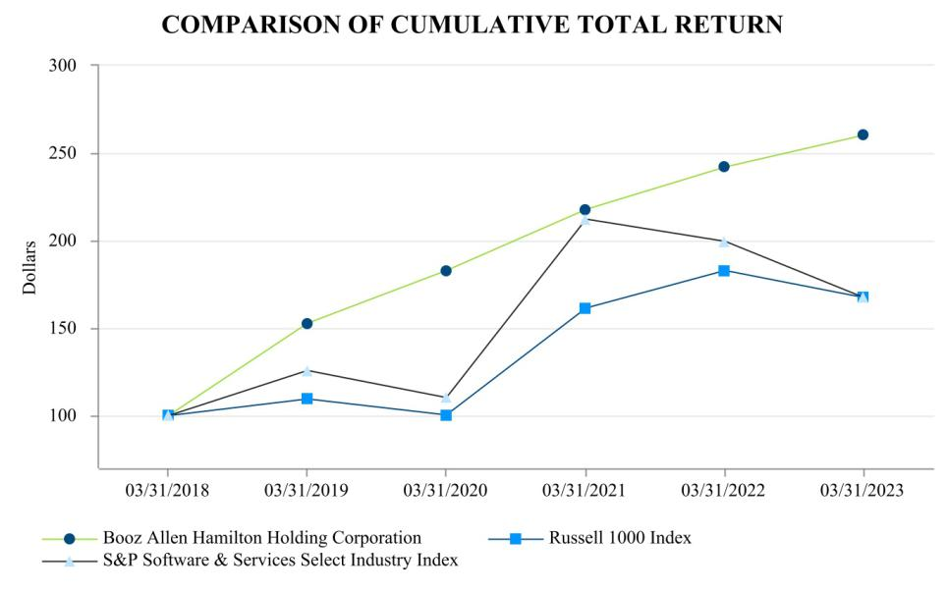

ASSUMES $100 INVESTED ON MARCH 31, 2018

ASSUMES DIVIDEND REINVESTED

Company/Market/Peer Group |  | 3/31/2018 |  |  | 3/31/2019 |  |  | 3/31/2020 |  |  | 3/31/2021 |  | 3/31/2022 |  | 3/31/2023
Booz Allen Hamilton Holding Corp. | $ | 100.00 | $ |  | 152.56 | $ |  | 182.72 | $ |  | 217.70 | $ | 241.90 | $ | 260.03
Russell 1000 Index | $ | 100.00 | $ |  | 109.30 | $ |  | 100.53 | $ |  | 161.44 | $ | 182.86 | $ | 167.51
S&P Software & Services Select Industry Index | $ | 100.00 | $ |  | 125.75 | $ |  | 110.31 | $ |  | 212.27 | $ | 199.45 | $ | 167.37

This performance graph and other information furnished under this Part II Item 5 of this Annual Report shall not be deemed to be “soliciting material” or to be “filed” with the SEC or subject to Regulation 14A or 14C, or to the liabilities of Section 18 of the Exchange Act.

Item 6. Reserved

49

Table of Contents

Item 7. Management’s Discussion and Analysis of Financial Condition and Results of Operations

The following discussion and analysis is intended to help the reader understand our business, financial condition, results of operations, and liquidity and capital resources. You should read this discussion in conjunction with our consolidated financial statements and the related notes contained elsewhere in this Annual Report, and Part II, Item 7 “Management's Discussion and Analysis of Financial Condition and Results of Operations” of our Form 10-K for the fiscal year ended March 31, 2022, which provides additional information on comparisons of fiscal 2022 and 2021.

The statements in this discussion regarding industry outlook, our expectations regarding our future performance, liquidity and capital resources, and other non-historical statements in this discussion are forward-looking statements. These forward-looking statements are subject to numerous risks and uncertainties, including, but not limited to, the risks and uncertainties described in “Item 1A. Risk Factors” and “Introductory Note — Cautionary Note Regarding Forward-Looking Statements”. Our actual results may differ materially from those contained in or implied by any forward-looking statements.

Our fiscal year ends March 31 and, unless otherwise noted, references to years or fiscal are for fiscal years ended March 31. See “— Results of Operations.” Overview
Trusted to transform missions with the power of tomorrow’s technologies, Booz Allen advances the nation’s most critical civil, defense, and national security priorities. Our ability to deliver value to our clients has always been, and continues to be, a product of the strong character, expertise and tremendous passion of our people. Our approximately 31,900 employees work to solve hard problems by making clients' missions their own, combining decades of consulting and domain expertise with functional expertise in areas such as analytics, digital solutions, engineering, and cyber, all fostered by a culture of innovation that extends to all reaches of the Company.

Through our dedication to our clients' missions, and a commitment to evolving our business to address their needs, we have longstanding relationships with our clients, the longest of which is more than 80 years. We support critical missions for a diverse base of federal government clients, including nearly all of the U.S. government's cabinet-level departments, as well as for commercial clients, both domestically and internationally. We support our federal government clients by helping them tackle their most complex and pressing challenges such as protecting soldiers in combat and supporting their families, advancing cyber capabilities, keeping our national infrastructure secure, enabling and enhancing digital services, transforming the healthcare system, and improving government efficiency to achieve better outcomes. We serve commercial clients across industries including financial services, health and life sciences, energy, and technology.

Financial and Other Highlights

During fiscal 2023, the Company generated year over year revenue growth and increased client staff headcount. Revenue increased 10.7% from fiscal 2022 to fiscal 2023 primarily driven by headcount growth, higher staff utilization compared to the prior year period, and the impact of acquisitions.

Operating income decreased 34.8% to $446.8 million in fiscal 2023 from $685.2 million in fiscal 2022, which reflects a decrease in operating margin to 4.8% from 8.2% in the comparable year. Margins were impacted by a $350.0 million reserve associated with the Department of Justice’s investigation of the Company (see Note 20, “Commitments and Contingencies,” to the consolidated financial statements for further information). Margin results reflect strong contract-level performance coupled with ongoing cost management efforts, offset by higher unallowable spending and inflationary pressure for the full fiscal year period.

The Company also incurred incremental legal costs during fiscal 2023 and 2022 in response to the U.S. Department of Justice investigation and matters which purport to relate to the investigation, a portion of which was offset by the receipt of insurance reimbursements. We expect to incur additional costs in the future. Based on the information currently available, the Company is not able to reasonably estimate the expected long-term incremental legal costs or amounts that may be reimbursed associated with this investigation and these related matters.

50

Table of Contents

Non-GAAP Measures

We publicly disclose certain non-GAAP financial measurements, including Revenue, Excluding Billable Expenses, Adjusted Operating Income, Adjusted EBITDA, Adjusted EBITDA Margin on Revenue, Adjusted EBITDA Margin on Revenue, Excluding Billable Expenses, Adjusted Net Income, and Adjusted Diluted Earnings Per Share, or Adjusted Diluted EPS, because management uses these measures for business planning purposes, including to manage our business against internal projected results of operations and measure our performance. We view Adjusted Operating Income, Adjusted EBITDA, Adjusted EBITDA Margin on Revenue, Adjusted EBITDA Margin on Revenue, Excluding Billable Expenses, Adjusted Net Income, and Adjusted Diluted EPS as measures of our core operating business, which exclude the impact of the items detailed below, as these items are generally not operational in nature. These non-GAAP measures also provide another basis for comparing period to period results by excluding potential differences caused by non-operational and unusual or non-recurring items. In addition, we use Revenue, Excluding Billable Expenses because it provides management useful information about the Company's operating performance by excluding the impact of costs that are not indicative of the level of productivity of our client staff headcount and our overall direct labor, which management believes provides useful information to our investors about our core operations. We also utilize and discuss Free Cash Flow because management uses this measure for business planning purposes, measuring the cash generating ability of the operating business, and measuring liquidity generally. We present these supplemental measures because we believe that these measures provide investors and securities analysts with important supplemental information with which to evaluate our performance, long-term earnings potential, or liquidity, as applicable, and to enable them to assess our performance on the same basis as management. These supplemental performance measurements may vary from and may not be comparable to similarly titled measures by other companies in our industry. Revenue, Excluding Billable Expenses, Adjusted Operating Income, Adjusted EBITDA, Adjusted EBITDA Margin on Revenue, Adjusted EBITDA Margin on Revenue, Excluding Billable Expenses, Adjusted Net Income, Adjusted Diluted EPS, and Free Cash Flow are not recognized measurements under accounting principles generally accepted in the United States, or GAAP, and when analyzing our performance or liquidity, as applicable, investors should (i) evaluate each adjustment in our reconciliation of revenue to Revenue, Excluding Billable Expenses, operating income to Adjusted Operating Income, net income to Adjusted EBITDA, Adjusted EBITDA Margin on Revenue, Adjusted EBITDA Margin on Revenue, Excluding Billable Expenses, Adjusted Net Income and Adjusted Diluted Earnings Per Share, and net cash provided by operating activities to Free Cash Flow,

- use Revenue, Excluding Billable Expenses, Adjusted Operating Income, Adjusted EBITDA, Adjusted EBITDA Margin on Revenue, Adjusted EBITDA Margin on Revenue, Excluding Billable Expenses, Adjusted Net Income, and Adjusted Diluted EPS in addition to, and not as an alternative to, revenue, operating income, net income or diluted EPS, as measures of operating results, each as defined under GAAP and (iii) use Free Cash Flow in addition to, and not as an alternative to, net cash provided by operating activities as a measure of liquidity, each as defined under GAAP. We have defined the aforementioned non-GAAP measures as follows:

  - “Revenue, Excluding Billable Expenses” represents revenue less billable expenses. We use Revenue, Excluding Billable Expenses because it provides management useful information about the Company's operating performance by excluding the impact of costs that are not indicative of the level of productivity of our client staff headcount and our overall direct labor, which management believes provides useful information to our investors about our core operations.

  - “Adjusted Operating Income” represents operating income before acquisition and divestiture costs, financing transaction costs, supplemental employee benefits due to COVID-19, significant acquisition amortization, the reserve associated with the U.S. Department of Justice investigation disclosed in Note 20 to the consolidated financial statements in the Company’s annual report on Form 10-K, and restructuring costs. We prepare Adjusted Operating Income to eliminate the impact of items we do not consider indicative of ongoing operating performance due to their inherent unusual, extraordinary, or non-recurring nature or because they result from an event of a similar nature.

  - “Adjusted EBITDA” represents net income attributable to common stockholders before income taxes, net interest and other expense and depreciation and amortization and before certain other items, including acquisition and divestiture costs, financing transaction costs, the reserve associated with the U.S. Department of Justice investigation disclosed in Note 20 to the consolidated statements, supplemental employee benefits due to COVID-19, and restructuring costs. “Adjusted EBITDA Margin on Revenue” is calculated as Adjusted EBITDA divided by revenue. “Adjusted EBITDA Margin on Revenue, Excluding Billable Expenses” is calculated as Adjusted EBITDA divided by Revenue, Excluding Billable Expenses. The Company prepares Adjusted EBITDA, Adjusted EBITDA Margin on Revenue, and Adjusted EBITDA Margin on Revenue, Excluding Billable Expenses to eliminate the impact of items it does not consider indicative of ongoing operating performance due to their inherent unusual, extraordinary or non-recurring nature or because they result from an event of a similar nature.

51

Table of Contents

- “Adjusted Net Income” represents net income attributable to common stockholders before: (i) acquisition and divestiture costs, (ii) financing transaction costs, (iii) supplemental employee benefits due to COVID-19, (iv) significant acquisition amortization, (v) the reserve associated with the U.S. Department of Justice investigation disclosed in Note 20 to the consolidated financial statements in the Company’s annual report on Form 10-K, (vi) restructuring costs, (vii) gain associated with equity method investment activity, (viii) gain associated with divestitures or deconsolidation, (ix) research and development tax credits, (x) release of income tax reserves, (xi) loss on debt extinguishment, (xii) remeasurement of deferred tax assets/liabilities, and (xiii) amortization or write-off of debt issuance costs and debt discount, in each case net of the tax effect where appropriate calculated using an assumed effective tax rate. We prepare Adjusted Net Income to eliminate the impact of items, net of tax, we do not consider indicative of ongoing operating performance due to their inherent unusual, extraordinary, or non-recurring nature or because they result from an event of a similar nature. We view net income excluding the impact of the re-measurement of the Company's deferred tax assets and liabilities as an important indicator of performance consistent with the manner in which management measures and forecasts the Company's performance and the way in which management is incentivized to perform.

- “Adjusted Diluted EPS” represents diluted EPS calculated using Adjusted Net Income as opposed to net income. Additionally, Adjusted Diluted EPS does not contemplate any adjustments to net income as required under the two-class method as disclosed in the footnotes to the consolidated financial statements.

- “Free Cash Flow” represents the net cash generated from operating activities less the impact of purchases of property, equipment, and software.

Below is a reconciliation of Revenue, Excluding Billable Expenses, Adjusted Operating Income, Adjusted EBITDA, Adjusted EBITDA Margin on Revenue, Adjusted EBITDA Margin on Revenue, Excluding Billable Expenses, Adjusted Net Income, Adjusted Diluted EPS, and Free Cash Flow to the most directly comparable financial measure calculated and presented in accordance with GAAP.

52

Table of Contents
 |  |  |  |  |  |  | Fiscal Year Ended
 |  |  |  |  |  |  | March 31,
 |  | (Amounts in thousands, except share and per share data) |  |  | 2023 | 2022 |  | 2021
 |  |  |  |  |  |  | (Unaudited)
 |  | Revenue, Excluding Billable Expenses
 |  | Revenue |  | $9,258,911 |  | $8,363,700 |  | $7,858,938
 |  | Less: Billable expenses |  | 2,808,857 |  | 2,474,163 |  | 2,325,888
 |  | Revenue, Excluding Billable Expenses |  |  | $6,450,054 |  | $5,889,537 |  | $5,533,050
 |  | Adjusted Operating Income
 |  | Operating Income |  | $446,848 |  | $685,181 |  | $754,371
 |  | Acquisition and divestiture costs (a) |  | 44,269 |  | 97,485 |  | 411
 |  | Financing transaction costs (b) |  | 6,888 |  | 2,348 |  |  | —
 |  | COVID-19 supplemental employee benefits (c) |  |  | — |  | — | 577
 |  | Significant acquisition amortization (d) |  | 51,553 |  | 38,295 |  |  | —
 |  | Legal matter reserve (e) |  | 350,000 |  |  | — |  | —
 |  | Restructuring costs (f) |  |  | — | 4,164 |  |  | —
 |  | Adjusted Operating Income |  |  | $899,558 |  | $827,473 |  | $755,359
 |  | EBITDA, Adjusted EBITDA, Adjusted EBITDA Margin on Revenue & Adjusted EBITDA Margin on Revenue, Excluding Billable Expenses
 |  | Net income attributable to common stockholders |  | $271,791 |  | $466,740 |  | $608,958
 |  | Income tax expense |  | 96,734 |  | 137,466 |  | 53,481
 |  | Interest and other, net (g) |  | 78,899 |  | 81,138 |  | 91,932
 |  | Depreciation and amortization |  | 165,484 |  | 145,747 |  | 84,315
 |  | EBITDA |  |  | 612,908 |  | 831,091 |  | 838,686
 |  | Acquisition and divestiture costs (a) |  | 44,269 |  | 97,485 |  | 411
 |  | Financing transaction costs (b) |  | 6,888 |  | 2,348 |  |  | —
 |  | Legal matter reserve (e) |  | 350,000 |  |  | — |  | —
 |  | COVID-19 supplemental employee benefits (c) |  |  | — |  | — | 577
 |  | Restructuring costs (f) |  |  | — | 4,164 |  |  | —
 |  | Adjusted EBITDA |  |  | $1,014,065 |  | $935,088 |  | $839,674
 |  | Net income margin attributable to common stockholders
 |  |  |  |  | 2.9% |  | 5.6% |  | 7.7%
 |  | Adjusted EBITDA Margin on Revenue |  | 11.0% |  | 11.2% |  | 10.7%
 |  | Adjusted EBITDA Margin on Revenue, Excluding Billable Expenses |  | 15.7% |  | 15.9% |  | 15.2%
 |  |  |  | 53

Table of Contents
 |  |  |  |  | Fiscal Year Ended
 |  |  |  |  | March 31,
 | (Amounts in thousands, except share and per share data) |  | 2023 | 2022 |  | 2021
 |  |  |  |  | (Unaudited)
 | Adjusted Net Income
 | Net income attributable to common stockholders |  | $271,791 | $466,740 |  | $608,958
 | Acquisition and divestiture costs (a) |  | 44,269 | 97,485 |  | 411
 | Financing transaction costs (b) |  | 6,888 | 2,348 |  |  | —
 | COVID-19 supplemental employee benefits (c) |  | — |  | — | 577
 | Significant acquisition amortization (d) |  | 51,553 | 38,295 |  |  | —
 | Legal matter reserve (e) |  | 350,000 |  | — |  | —
 | Restructuring costs (f) |  | — | 4,164 |  |  | —
 | Gains associated with equity method investment activity (h) |  | — | (12,761) |  |  | —
 | Gains associated with divestitures or deconsolidation (i) |  | (44,632) |  | — |  | —
 | Research and development tax credits (j) |  | — |  | — | (2,928)
 | Release of income tax reserves (k) |  | — |  | — | (29)
 | Loss on debt extinguishment (l) |  | — |  | — | 13,239
 | Remeasurement of deferred tax assets/liabilities (m) |  | — |  | — | (76,767)
 | Amortization or write-off of debt issuance costs and debt discount |  | 6,554 | 3,340 |  | 2,402
 | Adjustments for tax effect (n) |  | (81,389) |  | (31,399) |  | (4,324)
 | Adjusted Net Income |  | $605,034 | $568,212 |  | $541,539
 | Adjusted Diluted Earnings Per Share
 | Weighted-average number of diluted shares outstanding |  | 132,716,436 |  | 134,850,808 |  | 138,703,220
 | Diluted earnings per share |  | $2.03 | $3.44 |  | $4.37
 | Adjusted Net Income Per Diluted Share (o) |  | $4.56 | $4.21 |  | $3.90
 | Free Cash Flow
 | Net cash provided by operating activities |  | 602,822 | 736,526 |  | 718,684
 | Less: Purchases of property, equipment and software |  | (76,130) | (79,964) |  | (87,210)
 | Free Cash Flow |  | $526,692 |  | $656,562 |  | $631,474
 | Operating cash flow conversion |  | 222% |  | 158% |  | 118%
 | Free cash flow conversion |  | 87% | 116% |  | 117%

- Represents costs associated with the acquisition efforts of the Company related to transactions for which the Company has entered into a letter of intent to acquire a controlling financial interest in the target entity, as well as the divestiture costs incurred in divesting a portion of our business. Acquisition and divestiture costs primarily include costs associated with (i) buy-side and sell-side due diligence activities, (ii) compensation expenses associated with employee retention, and (iii) legal and advisory fees, primarily associated with the acquisitions of Liberty IT Solutions, LLC (“Liberty”) and Tracepoint Holdings, LLC (“Tracepoint”) in fiscal 2022, and the acquisition of EverWatch Corp. (“EverWatch”) and the divestitures of our management consulting business serving the Middle East and North Africa (“MENA”) and our Managed Threat Services business (“MTS”) in fiscal 2023. See Note 5, “Acquisitions and Divestitures,” to the consolidated financial statements for further information.

- Reflects expenses associated with debt financing activities incurred during the second quarter of fiscal 2023 and first quarter of fiscal 2022.

- Represents the supplemental contribution to employees' dependent care FSA accounts in response to COVID-19.

- Amortization expense associated with acquired intangibles from significant acquisitions. Significant acquisitions include acquisitions which the Company considers to be beyond the scope of our normal operations. Significant acquisition amortization includes amortization expense associated with the acquisition of Liberty in the second quarter of fiscal 2022 and EverWatch in the third quarter of fiscal 2023.

- Reserve associated with the U.S. Department of Justice's investigation of the Company. See Note 20, “Commitments and Contingencies,” to the consolidated financial statements for further information.

54

Table of Contents

- Represents restructuring charges of $8.3 million incurred during the fourth quarter of fiscal 2022, net of approximately $4.2 million of revenue recognized on recoverable expenses, associated with severance costs of a restructuring plan to reduce certain executive administrative personnel costs.

- Reflects the combination of Interest expense and Other income (expense), net from the consolidated statement of operations.

- Represents (i) a gain in the second quarter of fiscal 2022 associated with the Company's previously held equity method investment in Tracepoint and (ii) a gain in the third quarter of fiscal 2022 associated with the divestiture of a controlling financial interest in SnapAttack.

- Represents the gain recognized on the divestitures of the Company's MENA business in the second quarter of fiscal 2023, its MTS business in the third quarter of fiscal 2023, and the gain on the deconsolidation of an artificial intelligence software platform business in the third quarter of fiscal 2023.

- Reflects tax credits, net of reserves for uncertain tax positions, recognized in fiscal 2021 related to an increase in research and development credits available for fiscal years 2016 to 2020.

- Release of pre-acquisition income tax reserves assumed by the Company in connection with the Carlyle Acquisition.

- Reflects the loss on debt extinguishment resulting from the fiscal 2021 redemption of Booz Allen Hamilton Inc.'s 5.125% Senior Notes due 2025 (the “2025 Senior Notes”), including $9.0 million of the premium paid at redemption, and write-off of the unamortized debt issuance cost.

- Reflects the income tax benefit associated with tax losses generated during fiscal 2021 as a result of a change in certain tax methods of accounting. The Company intends to carry these losses back to fiscal 2016 and subsequent periods under the Coronavirus Aid Relief and Economic Security Act and has re-measured the fiscal 2021 loss accordingly.
- Reflects the tax effect of adjustments at an assumed effective tax rate of 26%, which approximates the blended federal and state tax rates, and consistently excludes the impact of other tax credits and incentive benefits realized. The tax effect of certain discrete items is calculated specifically and may vary from the general 26% rate. The tax effect also includes the indirect effects of uncertainty around the application of Section 174 of the Tax Cuts and Jobs Act of 2017.

- Excludes adjustments of approximately $2.1 million, $3.1 million, and $3.5 million of net earnings for fiscal 2023, 2022, and 2021, respectively, associated with the application of the two-class method for computing diluted earnings per share.

Factors and Trends Affecting Our Results of Operations

Our results of operations have been, and we expect them to continue to be, affected by the following factors, which may cause our future results of operations to differ from our historical results of operations discussed under “—Results of Operations.”

Business Environment and Key Trends in Our Markets

We believe that the following trends and developments in the U.S. government services industry and our markets may influence our future results of operations:

- uncertainty around the timing, extent, nature and effect of Congressional and other U.S. government actions to approve funding of the U.S. government, address budgetary constraints, including caps on the discretionary budget for defense and non-defense departments and agencies, as established by the Bipartisan Budget Control Act of 2011 (“BCA”) and subsequently adjusted by the American Taxpayer Relief Act of 2012, the Bipartisan Budget Act of 2013, the Bipartisan Budget Act of 2015, the Bipartisan Budget Act of 2018, and the Bipartisan Budget Act of 2019, the Coronavirus Aid, Relief, and Economic Security Act (the “CARES Act”), and the Consolidated Appropriations Act of 2021, and address the ability of Congress to determine how to allocate the available budget authority and pass appropriations bills to fund both U.S. government departments and agencies that are, and those that are not, subject to the caps;

- budget deficits and the growing U.S. national debt increasing pressure on the U.S. government to reduce federal spending across all federal agencies together with associated uncertainty about the size and timing of those reductions;

55

Table of Contents

- cost-cutting and efficiency initiatives, current and future budget restrictions, continued implementation of Congressionally mandated automatic spending cuts, and other efforts to reduce U.S. government spending could cause clients to reduce or delay funding for orders for services or invest appropriated funds on a less consistent or rapid basis or not at all, particularly when considering long-term initiatives and in light of current uncertainty around Congressional efforts to craft a long-term agreement on the U.S. government's ability to incur indebtedness in excess of its current limits, and generally in the current political environment, there is a risk that clients will not issue task orders in sufficient volume to reach current contract ceilings, alter historical patterns of contract awards, including the typical increase in the award of task orders or completion of other contract actions by the U.S. government in the period before the end of the U.S. government's fiscal year on September 30, delay requests for new proposals and contract awards, rely on short-term extensions and funding of current contracts, or reduce staffing levels and hours of operation;

- delays in the completion of future U.S. government’s budget processes, which have in the past and could in the future delay procurement of the products, services, and solutions we provide;

- changes in the relative mix of overall U.S. government spending and areas of spending growth, with lower spending on homeland security, intelligence, defense-related programs as certain overseas operations end, and continued increased spending on cybersecurity, Command, Control, Communications, Computers, Intelligence, Surveillance, and Reconnaissance (C4ISR), advanced analytics, technology integration, and healthcare, including as a result of the presidential and administration transition;

- the extent, nature and effect of disease outbreaks, pandemics and widespread health epidemics, such as COVID-19, including the impact on federal budgets, current and pending procurements, supply chains, demand for services, deployment and productivity of our employees and the economic and societal impact of a pandemic, and the expected continued volatility in billable expenses;

- increased inflationary pressure that could impact the cost of doing business and/or reduce customer buying power;

- risks related to a possible recession and volatility or instability of the global financial system, including bank failures and the resulting impact on counterparties and business conditions generally;

- legislative and regulatory changes to limitations on the amount of allowable executive compensation permitted under flexibly priced contracts following implementation of interim rules adopted by federal agencies pursuant to the Bipartisan Budget Act of 2013, which substantially further reduce the amount of allowable executive compensation under these contracts and extend these limitations to a larger segment of our executives and our entire contract base;

- efforts by the U.S. government to address organizational conflicts of interest and related issues and the impact of those efforts on us and our competitors;

- increased audit, review, investigation, and general scrutiny by U.S. government agencies of government contractors' performance under U.S. government contracts and compliance with the terms of those contracts and applicable laws;

- the federal focus on refining the definition of “inherently governmental” work, including proposals to limit contractor access to sensitive or classified information and work assignments, which will continue to drive pockets of insourcing in various agencies, particularly in the intelligence market;

- negative publicity and increased scrutiny of government contractors in general, including us, relating to U.S. government expenditures for contractor services and incidents involving the mishandling of sensitive or classified information;

- U.S. government agencies awarding contracts on a technically acceptable/lowest cost basis, which could have a negative impact on our ability to win certain contracts;

- increased competition from other government contractors and market entrants seeking to take advantage of certain of the trends identified above, and an industry trend towards consolidation, which may result in the emergence of companies that are better able to compete against us;

- cost cutting and efficiency and effectiveness efforts by U.S. civilian agencies with a focus on increased use of performance measurement, “program integrity” efforts to reduce waste, fraud and abuse in entitlement programs, and renewed focus on improving procurement practices for and interagency use of IT services, including through the use of cloud based options and data center consolidation;

- restrictions by the U.S. government on the ability of federal agencies to use lead system integrators, in response to cost, schedule, and performance problems with large defense acquisition programs where contractors were performing the lead system integrator role;

56

Table of Contents

- increasingly complex requirements and enforcement and reporting landscapes of the Department of Defense and the U.S. intelligence community, including cybersecurity, managing federal health care cost growth, competition, and focus on reforming existing government regulation of various sectors of the economy, such as financial regulation and healthcare; and

- increasing small business regulations across the Department of Defense and civilian agency clients continue to gain traction, agencies are required to meet high small business set aside targets, and large business prime contractors are required to subcontract in accordance with considerable small business participation goals necessary for contract award.

Sources of Revenue

Substantially all of our revenue is derived from services provided under contracts and task orders with the U.S. government, primarily by our client staff and, to a lesser extent, our subcontractors. Funding for our contracts and task orders is generally linked to trends in budgets and spending across various U.S. government agencies and departments. We provide services under a large portfolio of contracts and contract vehicles to a broad client base, and we believe that our diversified contract and client base lessens potential volatility in our business; however, a reduction in the amount of services that we are contracted to provide to the U.S. government or any of our significant U.S. government clients could have a material adverse effect on our business and results of operations. In particular, the Department of Defense is one of our significant clients, and the BCA originally required nine automatic spending cuts (referred to as “sequestration”) of $109 billion annually from 2013 to 2021, half of which was intended to come from defense programs, though less than $1 billion has been cut for defense programs per year under the BCA. Mandatory sequestrations under the BCA were subsequently extended by the Bipartisan Budget Acts of 2013, 2015, 2018 and 2019, the Military Retired Pay Restoration Act, the CARES Act and the Infrastructure Investment and Jobs Act. The extension of the mandatory sequestration applies an 8.3% reduction in defense spending in each year from 2021 through 2031. This could result in a commensurate reduction in the amount of services that we are contracted to provide to the Department of Defense and could have a material adverse effect on our business and results of operations, and given the uncertainty of when and how these automatic reductions required by the BCA may return and/or be applied, we are unable to predict the nature or magnitude of the potential adverse effect.

Contract Types

We generate revenue under the following three basic types of contracts:

- Cost-Reimbursable Contracts. Cost-reimbursable contracts provide for the payment of allowable costs incurred during performance of the contract, up to a ceiling based on the amount that has been funded, plus a fixed fee or award fee. As we increase or decrease our spending on allowable costs, our revenue generated on cost-reimbursable contracts will increase, up to the ceiling and funded amounts, or decrease, respectively. We generate revenue under two general types of cost-reimbursable contracts: cost-plus-fixed-fee and cost-plus-award-fee, both of which reimburse allowable costs and provide for a fee. The fee under each type of cost-reimbursable contract is generally payable upon completion of services in accordance with the terms of the contract. Cost-plus-fixed-fee contracts offer no opportunity for payment beyond the fixed fee. Cost-plus-award-fee contracts also provide for an award fee that varies within specified limits based upon the client’s assessment of our performance against a predetermined set of criteria, such as targets for factors like cost, quality, schedule, and performance.

- Time-and-Materials Contracts. Under contracts in this category, we are paid a fixed hourly rate for each direct labor hour expended, and we are reimbursed for billable material costs and billable out-of-pocket expenses inclusive of allocable indirect costs. We assume the financial risk on time-and-materials contracts because our costs of performance may exceed negotiated hourly rates. To the extent our actual direct labor, including allocated indirect costs, and associated billable expenses decrease or increase in relation to the fixed hourly billing rates provided in the contract, we will generate more or less profit, respectively, or could incur a loss.

- Fixed-Price Contracts. Under a fixed-price contract, we agree to perform the specified work for a predetermined price. To the extent our actual direct and allocated indirect costs decrease or increase from the estimates upon which the price was negotiated, we will generate more or less profit, respectively, or could incur a loss. Some fixed-price contracts have a performance-based component, pursuant to which we can earn incentive payments or incur financial penalties based on our performance. Fixed-price level of effort contracts require us to provide a specified level of effort (i.e., labor hours), over a stated period of time, for a fixed price.

57

Table of Contents

The amount of risk and potential reward varies under each type of contract. Under cost-reimbursable contracts, there is limited financial risk, because we are reimbursed for all allowable costs up to a ceiling. However, profit margins on this type of contract tend to be lower than on time-and-materials and fixed-price contracts. Under time-and-materials contracts, we are reimbursed for the hours worked using the predetermined hourly rates for each labor category. In addition, we are typically reimbursed for other contract direct costs and expenses at cost. We assume financial risk on time-and-materials contracts because our labor costs may exceed the negotiated billing rates. Profit margins on well-managed time-and-materials contracts tend to be higher than profit margins on cost-reimbursable contracts as long as we are able to staff those contracts with people who have an appropriate skill set. Under fixed-price contracts, we are required to deliver the objectives under the contract for a predetermined price. Compared to time-and-materials and cost-reimbursable contracts, fixed-price contracts generally offer higher profit margin opportunities because we receive the full benefit of any cost savings but generally involve greater financial risk because we bear the impact of any cost overruns. In the aggregate, the contract type mix in our revenue for any given period will affect that period's profitability. Changes in contract type as a result of re-competes and new business could influence the percentage/mix in unanticipated ways.

The table below presents the percentage of total revenue for each type of contract:

Fiscal Year Ended
March 31,

 | 2023 | 2022 |  | 2021
Cost-reimbursable | 53% |  | 54% |  | 56%
Time-and-materials | 25% | 24% |  | 25%
Fixed-price | 22% | 22% |  | 19%

Contract Diversity and Revenue Mix

We provide services to our clients through a large number of single award contracts, contract vehicles, and multiple award contract vehicles. Most of our revenue is generated under indefinite delivery/indefinite quantity, or IDIQ, contract vehicles, which include multiple award government wide acquisition contract vehicles, or GWACs, and General Services Administration Multiple Award Schedule Contracts, or GSA schedules, and certain single award contracts. GWACs and GSA schedules are available to all U.S. government agencies. Any number of contractors typically competes under multiple award IDIQ contract vehicles for task orders to provide particular services, and we earn revenue under these contract vehicles only to the extent that we are successful in the bidding process for task orders. No single task order under any IDIQ contract represented more than 3.0% of our revenue in fiscal 2023. No single definite contract accounted for more than 2.5% of our revenue in fiscal 2023.

We generate revenue under our contracts and task orders through our provision of services as both a prime contractor and subcontractor, as well as from the provision of services by subcontractors under contracts and task orders for which we act as the prime contractor. For fiscal 2023, 2022, and 2021, 95%, 94%, and 93%, respectively, of our revenue was generated by contracts and task orders for which we served as a prime contractor; 5%, 6%, and 7%, respectively, of our revenue was generated by contracts and task orders for which we served as a subcontractor; and 25%, 24%, and 25%, respectively, of our revenue was generated by services provided by our subcontractors. The mix of these types of revenue affects our operating margin. Substantially all of our operating margin is derived from direct client staff labor as the portion of our operating margin derived from fees we earn on services provided by our subcontractors is not significant. We view growth in direct client staff labor as the primary driver of earnings growth. Direct client staff labor growth is driven by client staff headcount growth, after attrition, and total backlog growth.

Our People

Revenue from our contracts is derived from services delivered by client staff and, to a lesser extent, from our subcontractors. Our ability to hire, retain, and deploy talent with skills appropriately aligned with client needs is critical to our ability to grow our revenue. We continuously evaluate whether our talent base is properly sized and appropriately compensated, and contains an optimal mix of skills to be cost competitive and meet the rapidly evolving needs of our clients. We seek to achieve that result through recruitment and management of capacity and compensation. As of March 31, 2023, 2022, and 2021, we employed approximately 31,900, 29,300, and 27,700 people, respectively, of which approximately 29,100, 26,300, and 24,800, respectively, were client staff.

Contract Backlog

We define backlog to include the following three components:

- Funded Backlog. Funded backlog represents the revenue value of orders for services under existing contracts for which funding is appropriated or otherwise authorized less revenue previously recognized on these contracts.

58

Table of Contents

- Unfunded Backlog. Unfunded backlog represents the revenue value of orders (including optional orders) for services under existing contracts for which funding has not been appropriated or otherwise authorized.

- Priced Options. Priced contract options represent 100% of the revenue value of all future contract option periods under existing contracts that may be exercised at our clients’ option and for which funding has not been appropriated or otherwise authorized.

Our backlog does not include contracts that have been awarded but are currently under protest and also does not include any task orders under IDIQ contracts, except to the extent that task orders have been awarded to us under those contracts.

The following table summarizes the value of our contract backlog at the respective dates presented:

Fiscal Year Ended
March 31,

 | 2023 |  |  |  | 2022 |  |  | 2021
 |  |  |  |  | (In millions)
Backlog: ⁽¹⁾
Funded | $ | 4,619 | $ |  | 3,710 | $ |  | 3,510
Unfunded |  | 9,519 |  |  | 9,925 |  |  | 6,086
Priced options |  | 17,064 |  |  | 15,612 |  |  | 14,436
Total backlog | $ | 31,202 |  | $ | 29,247 |  | $ | 24,032 | (1)

Backlog presented as of March 31, 2023 includes backlog acquired from the Company's acquisition of EverWatch Corp. made during the fiscal year ended March 31, 2023. Total backlog acquired from EverWatch Corp. was approximately $282 million as of March 31, 2023

Our total backlog consists of remaining performance obligations, certain orders under contracts for which the period of performance has expired, and unexercised option period and other unexercised optional orders. As of March 31, 2023 and March 31, 2022, the Company had $7.9 billion and $7.4 billion of remaining performance obligations, respectively, and we expect to recognize approximately 75% of the remaining performance obligations as of March 31, 2023 as revenue over the next 12 months, and approximately 85% over the next 24 months. The remainder is expected to be recognized thereafter. However, given the uncertainties discussed below, as well as the risks described in “Item 1A. Risk Factors”, we can give no assurance that we will be able to convert our backlog into revenue in any particular period, if at all. Our backlog includes orders under contracts that in some cases extend for several years. The U.S. Congress generally appropriates funds for our clients on a yearly basis, even though their contracts with us may call for performance that is expected to take a number of years to complete. As a result, contracts typically are only partially funded at any point during their term and all or some of the work to be performed under the contracts may remain unfunded unless and until the U.S. Congress makes subsequent appropriations and the procuring agency allocates funding to the contract.

We view growth in total backlog and client staff headcount as the two key measures of our potential business growth. Growing and deploying client staff is the primary means by which we are able to achieve profitable revenue growth. To the extent that we are able to hire additional client staff and deploy them against funded backlog, we generally recognize increased revenue. Total backlog increased by 6.7% from March 31, 2022 to March 31, 2023 and increased by 21.7% from March 31, 2021 to March 31, 2022. Additions to funded backlog during fiscal 2023 and 2022 totaled $10.2 billion and $8.6 billion respectively, as a result of the conversion of unfunded backlog to funded backlog, the award of new contracts and task orders under which funding was appropriated, and the exercise and subsequent funding of priced options. We report internally on our backlog on a monthly basis and review backlog upon occurrence of certain events to determine if any adjustments are necessary.

59

Table of Contents

We cannot predict with any certainty the portion of our backlog that we expect to recognize as revenue in any future period and we cannot guarantee that we will recognize any revenue from our backlog. The primary risks that could affect our ability to recognize such revenue on a timely basis or at all are: program schedule changes, contract modifications, and our ability to assimilate and deploy new client staff against funded backlog; cost-cutting initiatives and other efforts to reduce U.S. government spending, which could reduce or delay funding for orders for services; and delayed funding of our contracts due to delays in the completion of the U.S. government's budgeting process and the use of continuing resolutions by the U.S. government to fund its operations. The amount of our funded backlog is also subject to change, due to, among other factors: changes in congressional appropriations that reflect changes in U.S. government policies or priorities resulting from various military, political, economic, or international developments; changes in the use of U.S. government contracting vehicles, and the provisions therein used to procure our services and adjustments to the scope of services, or cancellation of contracts, by the U.S. government at any time. In our recent experience, none of the following additional risks have had a material negative effect on our ability to realize revenue from our funded backlog: the unilateral right of the U.S. government to cancel multi-year contracts and related orders or to terminate existing contracts for convenience or default; in the case of unfunded backlog, the potential that funding will not be made available; and, in the case of priced options, the risk that our clients will not exercise their options.

In addition, contract backlog includes orders under contracts for which the period of performance has expired, and we may not recognize revenue on the funded backlog that includes such orders due to, among other reasons, the tardy submission of invoices by our subcontractors and the expiration of the relevant appropriated funding in accordance with a predetermined expiration date such as the end of the U.S. government's fiscal year. The revenue value of orders included in contract backlog that has not been recognized as revenue due to period of performance expirations has not exceeded approximately 5.1% of total backlog as of March 31, 2023 and any of the four preceding fiscal quarters.

We expect to recognize revenue from a substantial portion of funded backlog as of March 31, 2023 within the next twelve months. However, given the uncertainties discussed above, as well as the risks described in “Item 1A. Risk Factors,” we can give no assurance that we will be able to convert our backlog into revenue in any particular period, if at all.

Operating Costs and Expenses

Costs associated with compensation and related expenses for our people are the most significant component of our operating costs and expenses. The principal factors that affect our costs are additional people as we grow our business and are awarded new contracts, task orders, and additional work under our existing contracts, and the hiring of people with specific skill sets and security clearances as required by our additional work.

Our most significant operating costs and expenses are described below.

- Cost of Revenue. Cost of revenue includes direct labor, related employee benefits, and overhead. Overhead consists of indirect costs, including indirect labor relating to infrastructure, management and administration, and other expenses.

- Billable Expenses. Billable expenses include direct subcontractor expenses, travel expenses, and other expenses incurred to perform on contracts.

- General and Administrative Expenses. General and administrative expenses include indirect labor of executive management and corporate administrative functions, marketing and bid and proposal costs, and other discretionary spending.

- Depreciation and Amortization. Depreciation and amortization includes the depreciation of computers, leasehold improvements, furniture and other equipment, and the amortization of internally developed software, as well as third-party software that we use internally, and of identifiable long-lived intangible assets over their estimated useful lives.

Seasonality

The U.S. government's fiscal year ends on September 30 of each year. While not certain, it is not uncommon for U.S. government agencies to award extra tasks or complete other contract actions in the weeks before the end of its fiscal year in order to avoid the loss of unexpended fiscal year funds. In addition, we also have historically experienced higher bid and proposal costs in the months leading up to the U.S. government's fiscal year end as we pursue new contract opportunities being awarded shortly after the U.S. government fiscal year end as new opportunities are expected to have funding appropriated in the U.S. government's subsequent fiscal year. We may continue to experience this seasonality in future periods, and our future periods may be affected by it. While not certain, changes in the government's funding and spending patterns have altered historical seasonality trends, supporting our approach to managing the business on an annual basis.

Seasonality is just one of a number of factors, many of which are outside of our control, which may affect our results in any period. See “Item 1A. Risk Factors.”

60

Table of Contents

Critical Accounting Estimates and Policies

Our discussion and analysis of our financial condition and results of operations are based on our consolidated financial statements, which have been prepared in accordance with GAAP. The preparation of these consolidated financial statements in accordance with GAAP requires management to make estimates and assumptions that affect the reported amounts of assets and liabilities and the disclosure of contingencies at the date of the consolidated financial statements as well as the reported amounts of revenue and expenses during the reporting period. Management evaluates these estimates and assumptions on an ongoing basis. Our estimates and assumptions have been prepared on the basis of the most current reasonably available information. Actual results may differ from these estimates under different assumptions or conditions.

Our significant accounting policies, including the critical policies and practices listed below, are more fully described and discussed in the notes to the consolidated financial statements. We consider the following accounting policies to be critical to an understanding of our financial condition and results of operations because these policies require the most difficult, subjective or complex judgments on the part of our management in their application, often as a result of the need to make estimates about the effect of matters that are inherently uncertain.

Revenue Recognition and Cost Estimation

Our revenues from contracts with customers (clients) are derived from offerings that include consulting, analytics, digital solutions, engineering, and cyber services, substantially with the U.S. government and its agencies, and to a lesser extent, subcontractors. We also serve foreign governments, as well as domestic and international commercial clients. We perform under various types of contracts, which include cost-reimbursable-plus-fee contracts, time-and-materials contracts, and fixed-price contracts.

We consider a contract with a customer to exist under Topic 606 when there is approval and commitment from us and the customer, the rights of the parties and payment terms are identified, the contract has commercial substance, and collectability of consideration is probable. We will also consider whether two or more contracts entered into with the same customer should be combined and accounted for as a single contract. Furthermore, in certain transactions with commercial clients and with the U.S. government, we may commence providing services prior to receiving a formal approval from the customer. In these situations, we will consider the factors noted above, the risks associated with commencing the work, and legal enforceability in determining whether a contract with the customer exists under Topic 606.

Customer contracts are often modified to change the scope, price, specifications or other terms within the existing arrangement. Contract modifications are evaluated by management to determine whether the modification should be accounted for as part of the original performance obligation(s) or as a separate contract. If the modification adds distinct goods or services and increases the contract value proportionate to the stand-alone selling price of the additional goods or services, it will be accounted for as a separate contract. Generally, our contract modifications do not include goods or services which are distinct, and therefore are accounted for as part of the original performance obligation(s) with any impact on transaction price or estimated costs at completion being recorded as through a cumulative catch-up adjustment to revenue.

We evaluate each service deliverable contracted with the customer to determine whether it represents promises to transfer distinct goods or services. Under Topic 606, these are referred to as performance obligations. One or more service deliverables often represent a single performance obligation. This evaluation requires significant judgment and the impact of combining or separating performance obligations may change the time over which revenue from the contract is recognized. Our contracts generally provide a set of integrated or highly interrelated tasks or services and are therefore accounted for as a single performance obligation. However, in cases where we provide more than one distinct good or service within a customer contract, the contract is separated into individual performance obligations which are accounted for discretely.

61

Table of Contents

Contracts with the U.S. government are generally subject to the FAR and are priced based on estimated or actual costs of providing the goods or services. We derive a majority of our revenue from contracts awarded through a competitive bidding process. Pricing for non-U.S. government agencies and commercial customers is based on discrete negotiations with each customer. Certain of our contracts contain award fees, incentive fees or other provisions that may increase or decrease the transaction price. These variable amounts generally are awarded upon achievement of certain performance metrics, program milestones or cost targets and may be based upon customer discretion. Management estimates variable consideration as the most likely amount that we expect to achieve based on our assessment of the variable fee provisions within the contract, prior experience with similar contracts or clients, and management’s evaluation of the performance on such contracts. We may perform work under a contract that has not been fully funded if the work has been authorized by the management and the customer to proceed. We evaluate unfunded amounts as variable consideration in estimating the transaction price. We include the estimated variable consideration in our transaction price to the extent that it is probable that a significant reversal of revenue will not occur upon the ultimate settlement of the variable fee provision. In the limited number of situations where our contracts with customers contain more than one performance obligation, we allocate the transaction price of a contract between the performance obligations in the proportion to their respective stand-alone selling prices. We generally estimate the stand-alone selling price of performance obligations based on an expected cost-plus margin approach as allowed under Topic 606. Our U.S. government contracts generally contain FAR provisions that enable the customer to terminate a contract for default or for the convenience of the U.S. government.

We recognize revenue for each performance obligation identified within our customer contracts when, or as, the performance obligation is satisfied by transferring the promised goods or services. Revenue may either be recognized over time or at a point in time. We generally recognize revenue over time as our contracts typically involve a continuous transfer of control to the customer. A continuous transfer of control under contracts with the U.S. government and its agencies is evidenced by clauses which require us to be paid for costs incurred plus a reasonable margin in the event that the customer unilaterally terminates the contract for convenience. For contracts where we recognize revenue over time, a contract cost-based input method is generally used to measure progress towards satisfaction of the underlying performance obligation(s). Contract costs include direct costs such as materials, labor and subcontract costs, as well as indirect costs identifiable with, or allocable to, a specific contract that are expensed as incurred. We do not incur material incremental costs to acquire or fulfill contracts. Under a contract cost-based input method, revenue is recognized based on the proportion of contract costs incurred to the total estimated costs expected to be incurred upon completion of the underlying performance obligation. We generally include both funded and unfunded portions of customer contracts in this estimation process.

For interim financial reporting periods, contract revenue attributable to indirect costs is recognized based upon agreed-upon annual forward-pricing rates established with the U.S. government at the start of each fiscal year. Forward pricing rates are estimated and agreed upon between us and the U.S. government and represent indirect contract costs required to execute and administer contract obligations. The impact of any agreed-upon changes, or changes in the estimated annual forward-pricing rates, are recorded in the interim financial reporting period when such changes are identified. These changes relate to the interim financial reporting period differences between the actual indirect costs incurred and allocated to customer contracts compared to the estimated amounts allocated to contracts using the estimated annual forward-pricing rates established with the U.S. government.

On certain contracts, principally time-and-materials and cost-reimbursable-plus-fee contracts, revenue is recognized using the right-to-invoice practical expedient as we are contractually able to invoice the customer based on the control transferred. However, we did not elect to use the practical expedient which would allow us to exclude contracts recognized using the right-to-invoice practical expedient from the remaining performance obligations disclosed below. Additionally, for stand-ready performance obligations to provide services under fixed-price contracts, revenue is recognized over time using a straight-line measure of progress as the control of the services is provided to the customer ratably over the term of the contract. If a contract does not meet the criteria for recognition of revenue over time, we recognize revenue at the point in time when control of the good or service is transferred to the customer. Determining a measure of progress towards the satisfaction of performance obligations requires management to make judgments that may affect the timing of revenue recognition.

Many of our contracts recognize revenue under a contract cost-based input method and require an Estimate-at-Completion (EAC) process, which management uses to review and monitor the progress towards the completion of our performance obligations. Under this process, management considers various inputs and assumptions related to the EAC, including, but not limited to, progress towards completion, labor costs and productivity, material and subcontractor costs, and identified risks. Estimating the total cost at completion of performance obligations is subjective and requires management to make assumptions about future activity and cost drivers under the contract. Changes in these estimates can occur for a variety of reasons and, if significant, may impact the profitability of our contracts. Changes in estimates related to contracts accounted for under the EAC process are recognized in the period when such changes are made on a cumulative catch-up basis. If the estimate of contract profitability indicates an anticipated loss on a contract, we recognize the total loss at the time it is identified. For fiscal 2023, 2022, and 2021, the aggregate impact of adjustments in contract estimates was not material.

62

Table of Contents

Remaining performance obligations represent the transaction price of exercised contracts for which work has not yet been performed, irrespective of whether funding has or has not been authorized and appropriated as of the date of exercise. Remaining performance obligations do not include negotiated but unexercised options or the unfunded value of expired contracts.

Business Combinations

The accounting for the Company's business combinations consists of allocating the purchase price to tangible and intangible assets acquired and liabilities assumed based on their fair values, with the excess recorded as goodwill. Certain fair value measurements include inputs that are unobservable, requiring management to make judgments and estimates that can be affected by contract performance and other factors that may cause final amounts to differ materially from original estimates. We have up to one year from the acquisition date to use additional information obtained to adjust the fair value of the acquired assets and liabilities which may result in changes to the recorded values with an offsetting adjustment to goodwill.

Goodwill and Intangible Assets Impairment

We test goodwill and trade name for impairment at least annually as of January 1 of each year and more frequently if interim indicators of impairment exist. We perform our impairment testing of goodwill at the reporting level. As our business is highly integrated and all of our components have similar economic characteristics, we conclude that we have one reporting unit at the consolidated entity level, which is the same as our single operating segment. We test goodwill for impairment using the quantitative method (primarily based on market capitalization). We test the trade name for impairment using the relief from royalty method that requires management to make significant amount of judgments and estimates in the valuation. We do not consider goodwill, trade name, or any other amortizable intangible assets at risk of impairment. A 10% change in our enterprise value would not result in a goodwill or trade name impairment.

Amortizable intangible assets are tested for impairment when an event occurs or circumstances change indicating that the carrying amount of the asset may not be recoverable. A significant amount of management judgment is required to determine if an event representing an impairment indicator has occurred during the year, including but not limited to: a decline in forecasted cash flows; a sustained, material decline in the stock price and market capitalization; a significant adverse change in the business climate or economy; or unanticipated competition. An adverse change in any of these factors could have a significant impact on the recoverability of other intangible assets.

During the fiscal years ended March 31, 2023, March 31, 2022, and March 31, 2021, the Company did not record any impairment of goodwill and intangible assets. Accounting for Income Taxes

Provisions for federal, state, and foreign income taxes are calculated from the income reported on our consolidated financial statements based on current tax law and also include the cumulative effect of any changes in tax rates from those previously used in determining deferred tax assets and liabilities. Such provisions differ from the amounts currently receivable or payable because certain items of income and expense are recognized in different time periods for purposes of preparing consolidated financial statements than for income tax purposes.

Significant judgment is required in determining income tax provisions and evaluating tax positions. We establish reserves for uncertain tax positions when, despite the belief that our tax positions are supportable, there remains uncertainty in a tax position taken in our previously filed income tax returns. For tax positions where it is more likely than not that a tax benefit will be sustained, we record the largest amount of tax benefit with a greater than 50% likelihood of being realized upon settlement with a taxing authority that has full knowledge of all relevant information. To the extent we prevail in matters for which accruals have been established or are required to pay amounts in excess of reserves, our effective tax rate in a given consolidated financial statement period may be materially impacted.

The carrying value of our net deferred tax assets assumes that we will be able to generate sufficient future taxable income in certain tax jurisdictions to realize the value of these assets. If we are unable to generate sufficient future taxable income in these jurisdictions, a valuation allowance is recorded when it is more likely than not that the value of the deferred tax assets is not realizable.

Recent Accounting Pronouncements

See Note 2, “Summary of Significant Accounting Policies,” to our accompanying audited consolidated financial statements for information related to our adoption of new accounting standards and for information on our anticipated adoption of recently issued accounting standards.

63

Table of Contents

Segment Reporting

We report operating results and financial data in one operating and reportable segment. We manage our business as a single profit center in order to promote collaboration, provide comprehensive functional service offerings across our entire client base, and provide incentives to employees based on the success of the organization as a whole. Although certain information regarding served markets and functional capabilities is discussed for purposes of promoting an understanding of our complex business, we manage our business and allocate resources at the consolidated level of a single operating segment.

Basis of Presentation

The accompanying consolidated financial statements include the accounts of the Company and its wholly-owned subsidiaries, and have been prepared in accordance with GAAP, and the rules and regulations of the U.S. Securities and Exchange Commission (the “SEC”). All intercompany balances and transactions have been eliminated in consolidation.

The accompanying consolidated financial statements and notes of the Company include its subsidiaries, and the joint ventures and partnerships over which the Company has a controlling financial interest. The Company uses the equity method to account for investments in entities that it does not control if it is otherwise able to exert significant influence over the entities' operating and financial policies.

The Company’s fiscal year ends on March 31 and unless otherwise noted, references to fiscal year or fiscal are for fiscal years ended March 31. The accompanying consolidated financial statements present the financial position of the Company as of March 31, 2023 and 2022 and the Company’s results of operations for fiscal 2023, fiscal 2022, and fiscal 2021.

Certain amounts reported in the Company's prior year consolidated financial statements have been reclassified to conform to the current year presentation.

Results of Operations

The following table sets forth items from our consolidated statements of operations for the periods indicated:

 |  | Fiscal Year Ended March 31, |  |  |  |  |  |  |  | Fiscal 2023 |  | Fiscal 2022
 |  |  |  |  |  |  |  |  |  | Versus |  | Versus
 |  | 2023 |  |  | 2022 |  |  | 2021 |  | Fiscal 2022 |  | Fiscal 2021
 |  |  |  |  | (In thousands)
Revenue | $ | 9,258,911 | $ |  | 8,363,700 | $ |  | 7,858,938 | 10.7 % |  | 6.4 %
Operating costs and expenses:
Cost of revenue |  | 4,304,810 |  |  | 3,899,622 |  |  | 3,657,530 | 10.4 % |  | 6.6 %
Billable expenses |  | 2,808,857 |  |  | 2,474,163 |  |  | 2,325,888 | 13.5 % |  | 6.4 %
General and administrative expenses |  | 1,532,912 |  |  | 1,158,987 |  |  | 1,036,834 | 32.3 % |  | 11.8 %
Depreciation and amortization |  | 165,484 |  |  | 145,747 |  |  | 84,315 | 13.5 % |  | 72.9 %
Total operating costs and expenses |  | 8,812,063 |  |  | 7,678,519 |  |  | 7,104,567 |  | 14.8 % |  | 8.1 %
Operating income |  | 446,848 |  |  | 685,181 |  |  | 754,371 |  | (34.8)% |  | (9.2)%
Interest expense |  | (119,850) |  |  | (92,352) |  |  | (81,270) | 29.8 % |  | 13.6 %
Other income (expense), net |  | 40,951 |  |  | 11,214 |  |  | (10,662) |  | NM |  | NM
Income before income taxes |  | 367,949 |  |  | 604,043 |  |  | 662,439 |  | (39.1)% |  | (8.8)%
Income tax expense |  | 96,734 |  |  | 137,466 |  |  | 53,481 | (29.6)% |  | 157.0 %
Net income | $ | 271,215 |  | $ | 466,577 |  | $ | 608,958 |  | (41.9)% |  | (23.4)%
Net loss attributable to non-controlling interest | $ | 576 |  | $ | 163 |  | $ | — |  | NM |  | NM
Net income attributable to common stockholders | $ | 271,791 | $ |  | 466,740 | $ |  | 608,958 | (41.8)% |  | (23.4)%

NM - Not meaningful

Fiscal 2023 Compared to Fiscal 2022

Revenue

Revenue increased to $9,258.9 million from $8,363.7 million, or a 10.7% increase, primarily driven by headcount growth, as well as higher staff utilization compared to the prior year period.

The increase in revenue also includes approximately $62.9 million of contributions related to the Company’s acquisition of EverWatch in the third quarter of fiscal 2023.

64

Table of Contents

Cost of Revenue

Cost of revenue increased to $4,304.8 million from $3,899.6 million, or a 10.4% increase, and remained relatively flat as a percentage of revenue at 46.5% and 46.6% for fiscal 2023 and 2022, respectively. This increase was primarily due to an increase in salaries and salary-related benefits of $349.0 million, driven by increased headcount (including the impact of acquisitions) and annual base salary increases. Incentive and stock-based compensation also increased $35.6 million over the prior year.

Billable Expenses

Billable expenses increased to $2,808.9 million from $2,474.2 million, or a 13.5% increase, and increased as a percentage of revenue to 30.3% from 29.6%. This increase was primarily attributable to an increase in the use of subcontractors driven by client demand and timing of client needs as well as increases in expenses from contracts that require the Company to incur other direct expenses and travel on behalf of clients as compared to the prior year.

General and Administrative Expenses

General and administrative expenses increased to $1,532.9 million from $1,159.0 million, or a 32.3% increase, and increased as a percentage of revenue to 16.6% from 13.9%. For fiscal 2023, general and administrative expenses were impacted by a $350.0 million reserve associated with the U.S. Department of Justice’s investigation of the Company (see Note 20, “Commitments and Contingencies,” to the consolidated financial statements for further information). In addition, other business expenses and professional fees increased by $55.6 million and salaries and salary related benefits increased by $23.8 million, driven by annual base salary increases. These increases were partially offset by a decrease of approximately $54.8 million in acquisition costs over the prior year period.

Depreciation and Amortization

Depreciation and amortization expense increased to $165.5 million from $145.7 million, or a 13.5% increase, primarily due to increases in intangible amortization related to the acquisitions in fiscal 2022 and fiscal 2023.

Interest Expense

Interest expense increased to $119.9 million from $92.4 million, or a 29.8% increase, primarily due to an overall increase in interest rates.

Other (Income) Expense, net

Other (income) expense, net increased to a $41.0 million net other income from $11.2 million in the prior year period primarily due to the following:

- A $31.2 million pre-tax gain recognized in the second quarter of fiscal 2023 associated with the divestiture of the Company's MENA business;

- An increase of $9.6 million in interest income primarily due to an overall increase in interest rates;

- A pre-tax gain of $8.9 million recognized in the third quarter of fiscal 2023 from the de-consolidation of a business;

- A $4.6 million pre-tax gain recognized in the third quarter of fiscal 2023 associated with the divestiture of the Company's MTS business;

- $3.4 million in fees related to the Company's debt refinancing in the second quarter of fiscal 2023;

- A $5.7 million gain from the Company's remeasurement of its previously held equity method investment in Tracepoint in the second quarter of fiscal 2022, not present in the current year; and

- A net gain of $7.1 million associated with the divestiture of a controlling financial interest in SnapAttack in the third quarter of fiscal 2022, not present in the current fiscal year.

Income Tax Expense

Income tax expense decreased to $96.7 million from $137.5 million. The effective tax rate increased to 26.3% in fiscal 2023 from 22.8% in fiscal 2022. The increase in our effective tax rate from fiscal 2022 to fiscal 2023 was primarily a result of a decrease in pre-tax income and an increase in nondeductible expenses.

Liquidity and Capital Resources

As of March 31, 2023, our total liquidity was $1.4 billion, consisting of $404.9 million of cash and cash equivalents and $998.7 million available under the Revolving Credit Facility. In the opinion of management, we will be able to meet our liquidity and cash needs through a combination of cash flows from operating activities, available cash balances, and available borrowing under the Revolving Credit Facility. If these resources need to be augmented, additional cash requirements would likely be financed through the issuance of debt or equity securities.

65

Table of Contents

The following table presents selected financial information for the periods presented:
 |  |  |  |  | Fiscal Year Ended
 |  |  |  |  | March 31,
 |  | 2023 |  |  | 2022 |  |  | 2021
 |  |  |  |  | (In thousands)
Cash and cash equivalents | $ | 404,862 | $ |  | 695,910 | $ |  | 990,955
Total debt | $ | 2,812,145 | $ |  | 2,800,072 | $ |  | 2,356,596
Net cash provided by operating activities | $ | 602,822 | $ |  | 736,526 | $ |  | 718,684
Net cash used in investing activities | $ | (468,016) | $ |  | (867,725) | $ |  | (158,284)
Net cash used in financing activities |  | (425,854) |  |  | (163,846) |  |  | (311,346)
Total (decrease) increase in cash and cash equivalents | $ | (291,048) |  | $ | (295,045) |  | $ | 249,054

From time to time we evaluate alternative uses for excess cash resources once our operating cash flow and required debt servicing needs have been met. Some of the possible uses of our remaining excess cash at any point in time may include funding strategic acquisitions, further investment in our business, and returning value to shareholders through share repurchases, quarterly dividends, and special dividends. While the timing and financial magnitude of these possible actions are currently indeterminable, the Company expects to be able to manage and adjust its capital structure in the future to meet its liquidity needs.

Historically, we have been able to generate sufficient cash to fund our operations, mandatory debt and interest payments, capital expenditures, and discretionary funding needs. However, due to fluctuations in cash flows, including as a result of the trends and developments described above under “—Factors and Trends Affecting Our Results of Operations” relating to U.S. government shutdowns, U.S. government cost-cutting, reductions or delays in the U.S. government appropriations and spending process and other budgetary matters, it may be necessary from time-to-time in the future to borrow under our Senior Credit Facility to meet cash demands. While the timing and financial magnitude of these possible actions are currently indeterminable, we expect to be able to manage and adjust our capital structure to meet our liquidity needs. Our expected liquidity and capital structure may also be impacted by discretionary investments and acquisitions that we could pursue. We anticipate that cash provided by operating activities, existing cash and cash equivalents, and borrowing capacity under our Revolving Credit Facility will be sufficient to meet our anticipated cash requirements for the next twelve months, which primarily include:

- operating expenses, including salaries;

- working capital requirements to fund both organic and inorganic growth of our business;

- capital expenditures which primarily relate to the purchase of computers, business systems, furniture and leasehold improvements to support our operations;

- the on-going maintenance around all financial management systems;

- commitments and other discretionary investments;

- debt service requirements for borrowings under our Senior Credit Facility and interest payments for the Senior Notes; and

- cash taxes to be paid.

Our ability to fund our operating needs depends, in part, on our ability to continue to generate positive cash flows from operations or, if necessary, raise cash in the capital markets. In addition, from time to time we evaluate conditions to opportunistically access the financing markets to secure additional debt capital resources and improve the terms of our indebtedness.

On October 14, 2022, the Company acquired EverWatch Corp. (“EverWatch”) for approximately $445.1 million, net of post-closing adjustments, and also incurred transaction costs as part of the acquisition. As a result of the transaction, EverWatch became a wholly owned subsidiary of Booz Allen Hamilton Inc. EverWatch is a leading provider of advanced solutions to the defense and intelligence communities. See Note 5, “Acquisitions and Divestitures,” to our consolidated financial statements for additional information related to the acquisition of EverWatch.

66

Table of Contents

Cash Flows

Cash received from clients, either from the payment of invoices for work performed or for advances in excess of costs incurred, is our primary source of cash. We generally do not begin work on contracts until funding is appropriated by the client. Billing timetables and payment terms on our contracts vary based on a number of factors, including whether the contract type is cost-reimbursable, time-and-materials, or fixed-price. We generally bill and collect cash more frequently under cost-reimbursable and time-and-materials contracts, as we are authorized to bill as the costs are incurred or work is performed. In contrast, we may be limited to bill certain fixed-price contracts only when specified milestones, including deliveries, are achieved. In addition, a number of our contracts may provide for performance-based payments, which allow us to bill and collect cash prior to completing the work.

Accounts receivable is the principal component of our working capital and is generally driven by revenue growth with other short-term fluctuations related to the payment practices of our clients. Our accounts receivable reflects amounts billed to our clients as of each balance sheet date. Our clients generally pay our invoices within 30 days of the invoice date, although we experience a longer billing and collection cycle with our global commercial customers. At any month-end, we also include in accounts receivable the revenue that was recognized in the preceding month, which is generally billed early in the following month. Finally, we include in accounts receivable amounts related to revenue accrued in excess of amounts billed, primarily on our fixed-price and cost-reimbursable-plus-award-fee contracts. The total amount of our accounts receivable can vary significantly over time, but is generally sensitive to revenue levels and customer mix.

Operating Cash Flow

Net cash provided by operations is primarily affected by the overall profitability of our contracts, our ability to invoice and collect cash from clients in a timely manner, our ability to manage our vendor payments, and the timing of cash paid for income taxes. Continued uncertainty in global economic conditions, including any potential impact of the U.S. government’s failure to raise the debt ceiling, may also affect our business as customers and suppliers may decide to downsize, defer, or cancel contracts, which could negatively affect the operating cash flows. Net cash provided by operations was $602.8 million in fiscal 2023 compared to $736.5 million in fiscal 2022, or an 18.2% decrease. Collections were in line with revenue growth but were primarily offset by additional tax payments made in accordance with newly effective U.S. research and development capitalization rules (Section 174), higher interest expense and higher disbursements to fund investments in our people and business.

Beginning in fiscal 2023, the Tax Cuts and Jobs Act of 2017 eliminates the option to deduct research and development expenditures immediately in the year incurred and requires taxpayers to amortize such expenditures over five years. This provision negatively impacted our fiscal 2023 cash from operations, but had an offsetting impact on the deferred tax asset. This change in deduction methodology is the primary driver of the increase in net cash taxes paid referenced in the paragraph above. Prospectively, the future impact of this provision will depend on if and when this provision is deferred, modified, or repealed by Congress, including if retroactively, any guidance issued by the Treasury Department regarding the identification of appropriate costs for capitalization, and the amount of future research and development expenses paid or incurred (among other factors). While the largest impact will be to fiscal 2023 cash from operations, the impact would continue over the five year amortization period, but would decrease over the period and is expected to be immaterial in year six.

Investing Cash Flow

Net cash used in investing activities was $468.0 million in fiscal 2023 compared to $867.7 million in the prior year. The decrease in net cash used in investing activities was primarily due to the Company’s lower acquisition and divestiture activity in fiscal 2023 as compared to fiscal 2022. In fiscal 2022, the Company completed the acquisitions of Liberty and Tracepoint. In fiscal 2023, the Company completed the acquisition of EverWatch, as well as the divestitures of its MENA strategy consulting and MTS businesses.

Financing Cash Flow

Net cash used in financing activities was $425.9 million in fiscal 2023 compared to $163.8 million in the prior year. The increase in net cash used in financing activities was primarily due to the following:

- A decrease in net proceeds associated with the Company’s debt refinancing transactions year over year:

  - Fiscal 2023 - $414.8 million was received from the Company’s September 2022 debt refinancing, partially offset by a $379.3 million repayment

  - Fiscal 2022 - $493.7 million was received from the issuance of the 4.000% Senior Notes due 2029;

- An increase in dividends paid of $26.7 million as compared to the prior year, partially offset by;

- A decrease in share repurchases of $195.0 million,

- A decrease of $14.5 million in payments on the Company's Term Loans

67

Table of Contents

Dividends and Share Repurchases

The Company paid $1.76 in dividends per share to shareholders of record in fiscal 2023. On May 26, 2023, the Company announced a regular quarterly cash dividend in the amount of $0.47 per share. The quarterly dividend is payable on June 30, 2023 to stockholders of record on June 15, 2023.

The following table summarizes the cash distributions recognized in the consolidated statement of cash flows:

Fiscal Year Ended
March 31,

 |  | 2023 |  | 2022 |  | 2021
 |  |  |  | (In thousands)
Recurring dividends ⁽¹⁾ | $ | 235,726 | $ | 209,057 | $ | 181,066

- Amounts represent recurring dividends that were declared and paid for during each quarter of fiscal 2023, 2022, and 2021, respectively.

On December 12, 2011, the Board of Directors approved a share repurchase program, which was most recently increased to $2,560.0 million on July 27, 2022. The Company may repurchase shares pursuant to the program by means of open market repurchases, directly negotiated repurchases or through agents acting pursuant to negotiated repurchase agreements. During fiscal 2023 and 2022, the Company purchased 2.1 million and 4.7 million shares of the Company’s Class A Common Stock, respectively, for an aggregate of $196.2 million and $389.9 million, respectively. As of March 31, 2023, the Company had approximately $855.9 million remaining under the repurchase program.

Any determination to pursue one or more of the above alternative uses for excess cash is subject to the discretion of our Board of Directors, and will depend upon various factors, including our results of operations, financial condition, liquidity requirements, restrictions that may be imposed by applicable law, our contracts, and our Credit Agreement, as amended, and other factors deemed relevant by our Board of Directors.

Indebtedness

Our debt totaled $2.8 billion as of both March 31, 2023 and 2022. Our debt bears interest at specified rates (see Note 10, “Debt,” to our consolidated financial statements).

On September 7, 2022 (the “Ninth Amendment Effective Date”), Booz Allen Hamilton Inc. (“Booz Allen Hamilton”), Booz Allen Hamilton Investor Corporation (“Investor”), and certain wholly owned subsidiaries of Booz Allen Hamilton, entered into the Ninth Amendment (the “Ninth Amendment”) to the Credit Agreement dated as of July 31, 2012, as amended (the “Existing Credit Agreement” and, as amended, the “Credit Agreement”), with certain institutional lenders and Bank of America, N.A., as Administrative Agent, Collateral Agent, Issuing Lender, Refinancing Revolver Lender, New Refinancing Tranche A Term Lender and 2022 Supplemental Tranche A Lender. As of March 31, 2023, the Credit Agreement provided Booz Allen Hamilton with a $1,629.4 million Term Loan A (“New Term Loan A”) and a $1,000.0 million revolving credit facility (the “Revolving Credit Facility”), with a sub-limit for letters of credit of $200.0 million (collectively, the “Senior Credit Facility”). Booz Allen Hamilton’s obligations and the guarantors’ guarantees under the Credit Agreement were secured by a first priority lien on substantially all of the assets (including capital stock of subsidiaries) of Booz Allen Hamilton, Investor and the subsidiary guarantors, subject to certain exceptions set forth in the Credit Agreement and related documentation; such security was released in connection with Booz Allen Hamilton obtaining investment grade ratings from both Moody's and S&P.

Pursuant to the Ninth Amendment, (i) $1,000.0 million of revolving commitments outstanding under the Existing Credit Agreement were refinanced by a new tranche of revolving commitments (the “New Revolving Commitments” and the revolving credit loans made thereunder, the “New Revolving Loans”) in an aggregate amount of $1,000.0 million, with a sublimit for letters of credit of $200.0 million and (ii) approximately $1,225.3 million of Term Loan A loans (the “Existing Term Loan A Loans”) and $379.3 million of Term Loan B loans (the “Existing Term Loan B Loans”) outstanding under the Existing Credit Agreement were refinanced by a new tranche of Term Loan A loans in an aggregate amount, along with additional new tranche A term loans advanced by certain lenders, totaling $1,650.0 million. The majority of the proceeds of the New Term Loan A were used to prepay in full all of the Existing Term Loan A Loans and Existing Term Loan B Loans.

The Ninth Amendment extended the maturity of the New Term Loan A and the New Revolving Commitments to September 7, 2027. Voluntary prepayments of the New Term Loan A and the New Revolving Loans are permitted at any time, in minimum principal amounts, without premium or penalty.

68

Table of Contents

The New Term Loan A amortizes in consecutive quarterly installments in an amount equal to (i) on the last business day of each full fiscal quarter that begins after the Ninth Amendment Effective Date but on or before the two year anniversary of the Ninth Amendment Effective Date, 0.625% of the stated principal amount of the New Term Loan A and (ii) on the last business day of each full fiscal quarter that begins after the two year anniversary of the Ninth Amendment Effective Date but before the five year anniversary of the Ninth Amendment Effective Date, 1.25% of the stated principal amount of the New Term Loan A. The remaining balance of the New Term Loan A will be payable upon maturity.

The rate at which the New Term Loan A and the New Revolving Loans bear interest will be based either on Term SOFR (subject to a 0.10% adjustment and a floor of zero) for the applicable interest period or a base rate (equal to the highest of (i) the administrative agent’s prime corporate rate, (ii) the overnight federal funds rate plus 0.50% and (iii) three-month Term SOFR (subject to a 0.10% adjustment and a floor of zero) plus 1.00%), in each case plus an applicable margin, payable at the end of the applicable interest period and in any event at least quarterly. The applicable margin for the New Term Loan A and the New Revolving Loans ranges from 1.00% to 2.00% for Term SOFR loans and zero to 1.00% for base rate loans, in each case based on the lower of (i) the applicable rate per annum determined pursuant to a consolidated total net leverage ratio grid and (ii) the applicable rate per annum determined pursuant to a ratings grid. Unused New Revolving Commitments are subject to a quarterly fee ranging from 0.10% to 0.35% based on the lower of (i) the applicable fee rate per annum determined pursuant to a consolidated total net leverage ratio grid and (ii) the applicable fee rate per annum determined pursuant to a ratings grid. Booz Allen Hamilton has also agreed to pay customary letter of credit and agency fees.

The Credit Agreement contains customary representations and warranties and customary affirmative and negative covenants. In addition, Booz Allen Hamilton is required to meet a financial covenant at each quarter end based on a consolidated net total leverage ratio. As of March 31, 2023 and March 31, 2022, Booz Allen Hamilton was in compliance with all financial covenants associated with its debt and debt-like instruments. In connection with Booz Allen Hamilton obtaining investment grade ratings from both Moody's and S&P, activities restricted by certain negative covenants are expected to be permitted subject to pro forma compliance with the financial covenant and no event of default having occurred and continuing.

The following table summarizes interest payments made on the Company’s term loans:

 |  | Three Months Ended |  |  |  |  |  | Fiscal Year Ended
 |  | March 31, |  |  |  |  |  | March 31,
 | 2023 |  | 2022 |  |  |  |  | 2023 |  |  | 2022
New Term Loan A | $ | 24,233 |  | $ | — |  | $ | 49,079 |  | $ | —
Existing Term Loan A |  | — |  |  | 4,371 |  |  | 14,165 |  |  | 19,568
Existing Term Loan B |  | — |  |  | 1,802 |  |  | 5,209 |  |  | 7,203
Total | $ | 24,233 |  | $ | 6,173 |  | $ | 68,453 |  | $ | 26,771

Borrowings under the New Term Loan A, and if used, the Revolving Credit Facility, incur interest at a variable rate. As of March 31, 2023, Booz Allen Hamilton had interest rate swaps with an aggregate notional amount of $700.0 million (which includes $550.0 million of active and $150.0 million of forward-starting hedges). These instruments hedge the variability of cash outflows for interest payments on the New Term Loan A and the Revolving Credit Facility. The Company's objectives in using cash flow hedges are to reduce volatility due to interest rate movements and to add stability to interest expense (see Note 11, “Derivatives,” in our consolidated financial statements).

Booz Allen Hamilton also has agreed to pay customary letter of credit and agency fees. As of March 31, 2023 and 2022, Booz Allen Hamilton was contingently liable under open standby letters of credit and bank guarantees issued by its banks in favor of third parties that totaled $6.1 million and $8.4 million, respectively. These letters of credit and bank guarantees primarily support insurance and bid and performance obligations. As of March 31, 2023 and 2022, approximately $1.3 million and $1.0 million, respectively, of these instruments reduced our available borrowings under the Revolving Credit Facility. The remainder is guaranteed under a separate $7.5 million facility of which $2.7 million was available to the Company at March 31, 2023. In fiscal 2022, the remainder was guaranteed under a separate $20.0 million facility of which $12.6 million was available to the Company at March 31, 2022. As of March 31, 2023, we had $998.7 million of capacity available for additional borrowings under the Revolving Credit Facility.

69

Table of Contents

The Credit Agreement contains customary representations and warranties and customary affirmative and negative covenants. The negative covenants include limitations on the following, in each case subject to certain exceptions: (i) indebtedness and liens; (ii) mergers, consolidations or amalgamations, liquidations, wind-ups or dissolutions, and disposition of all or substantially all assets; (iii) dispositions of property; (iv) restricted payments; (v) investments; (vi) transactions with affiliates; (vii) change in fiscal periods; (viii) negative pledges; (ix) restrictive agreements; (x) line of business; and (xi) speculative hedging. The events of default include the following, in each case subject to certain exceptions: (a) failure to make required payments under the Senior Credit Facility; (b) material breaches of representations or warranties under the Senior Credit Facility; (c) failure to observe covenants or agreements under the Senior Credit Facility; (d) failure to pay or default under certain other material indebtedness; (e) bankruptcy or insolvency; (f) certain Employee Retirement Income Security Act, or ERISA, events; (g) certain material judgments; (h) actual or asserted invalidity of the Guarantee and Collateral Agreements or the other security documents or failure of the guarantees or perfected liens thereunder; and (i) a change of control. In addition, we are required to meet certain financial covenants at each quarter end, namely Consolidated Net Total Leverage and Consolidated Net Interest Coverage Ratios. As of March 31, 2023, we were compliant with these covenants.

The total outstanding debt balance is recorded in the accompanying consolidated balance sheets net of unamortized discount and debt issuance costs of $17.2 million and $21.6 million as of March 31, 2023 and 2022, respectively.

On August 24, 2020, Booz Allen Hamilton issued $700 million aggregate principal amount of its Senior Notes under an Indenture, dated as of August 24, 2020, among Booz Allen Hamilton, certain subsidiaries of Booz Allen Hamilton, as guarantors (the “Subsidiary Guarantors”), and Wilmington Trust, National Association as trustee (the “Trustee”), as supplemented by the First Supplemental Indenture, dated as of August 24, 2020, among Booz Allen Hamilton, the Subsidiary Guarantors and the Trustee. A portion of the net proceeds from the sale of the Senior Notes was used to redeem in full $350 million aggregate principal amount of the outstanding 2017 Senior Notes at a redemption price of 102.56% of the principal amount thereof, plus accrued and unpaid interest thereon to (but excluding) the redemption date, and to pay all fees and expenses related to the foregoing. Booz Allen Hamilton intends to use the remaining net proceeds from the sale of the Senior Notes for working capital and other general corporate purposes (see Note 10, “Debt,” in our consolidated financial statements). For fiscal 2023 and 2022, total interest payments of $47.1 million and $37.9 million were made for the Senior Notes, respectively.

Borrowings under the New Term Loan A and, if used, the Revolving Credit Facility, incur interest at a variable rate. In accordance with our risk management strategy between April 6, 2017 and April 4, 2019, Booz Allen Hamilton executed a series of interest rate swaps. As of March 31, 2023, we had interest rate swaps with an aggregate notional amount of $700.0 million. These instruments hedge the variability of cash outflows for interest payments on the floating portion of our debt. The Company's objectives in using cash flow hedges are to reduce volatility due to interest rate movements and to add stability to interest expense (see Note 11, “Derivatives,” in our consolidated financial statements).

Capital Structure and Resources

Our stockholders’ equity amounted to $992.0 million as of March 31, 2023, a decrease of $54.7 million compared to stockholders’ equity of $1,046.7 million as of March 31, 2022. The decrease was primarily due to $224.5 million in treasury stock resulting from the repurchase of shares of our Class A Common Stock and $235.4 million in aggregate quarterly dividend payments, partially offset by net income of $271.2 million and stock-based compensation expense of $80.3 million.

Capital Expenditures

Since we do not own any of our facilities, our capital expenditure requirements primarily relate to the purchase of computers, management systems, furniture, and leasehold improvements to support our operations. Direct facility and equipment costs billed to clients are not treated as capital expenses. Our capital expenditures for fiscal 2023 and 2022 were $76.1 million and $80.0 million, respectively.

Commitments and Contingencies

We are subject to a number of reviews, investigations, claims, lawsuits, and other uncertainties related to our business. For a discussion of these items, refer to Note 20, “Commitments and Contingencies,” to our consolidated financial statements.

70

Table of Contents

Item 7A. Quantitative and Qualitative Disclosures About Market Risk

Market risk is the potential loss arising from adverse changes in market rates and market prices such as those related to interest rates. Due to the wide-ranging adverse impacts on global financial markets and the ensuing economic crisis, we may be exposed to greater interest rate volatility and market risk in the near future. We actively monitor these exposures and manage such risks through our regular financing activities and through the use of derivative financial instruments.

Our exposure to market risk for changes in interest rates relates primarily to our outstanding debt, cash equivalents, which consist primarily of funds invested in U.S. government money-market funds, our cash flow hedges and our Rabbi trust.

Our exposure to market risk for changes in interest rates related to our outstanding debt will impact our Senior Credit Facility. The interest expense associated with our term loans and any loans under our Revolving Credit Facility will vary with market rates. A hypothetical interest rate increase of 25 basis points would have increased interest expense related to the term facilities under our Senior Credit Facility by approximately $5.2 million in fiscal 2023 and $4.8 million in fiscal 2022, and likewise decreased our income and cash flows. The year over year increase in interest expense was primarily due to increasing interest rates year over year as well as an increase in principal resulting from the 2023 term loan refinance pursuant to the Ninth Amendment of our Credit Agreement. See Note 10, “ Debt,” to our consolidated financial statements for further information on the refinance.

As of March 31, 2023 and 2022, we had $404.9 million and $695.9 million, respectively, in cash and cash equivalents. As of March 31, 2023 and 2022 the interest income on balance sheet cash was approximately 2% and less than 1%, respectively. Therefore, the corresponding impact to our interest income, and likewise to our income and cash flow, was not material.

Pursuant to our interest rate risk management strategies, we use interest rate cash flow hedges to add stability to our incurrence of interest rate expense and to manage our exposure to related interest rate movement. See Note 11, “Derivatives,” to our consolidated financial statements for further discussion. As of March 31, 2023, we had effective interest rate swaps with an aggregate notional amount of $550 million. These derivative instruments hedge the variability of cash outflows for interest payments on our variable rate debt and are recorded at fair value on our consolidated balance sheet. As of March 31, 2023, a 25 basis point increase in interest rates would increase the fair value of our interest rate swaps by approximately $1.6 million and a 25 basis point decrease in interest rates would decrease the fair value of our interest rate swaps by approximately $1.6 million.

During fiscal 2019, we established a Rabbi trust to provide for the payment of benefits under our non-qualified deferred compensation plan. As of March 31, 2023, fund assets totaled $20.1 million which include mutual fund investments that are subject to fluctuations in market prices and interest rates. Cash distributions made to plan participants are recognized as operating cash flows in the consolidated statement of cash flows and have the effect of lowering both fund assets and the corresponding fund liabilities on a one-for-one basis. Changes in fair value on fund liabilities offset the changes in fair value of fund assets, and changes in fair value on both fund assets and fund liabilities are recognized in earnings on our consolidated statements of operations. See Note 18, “Fair Value Measurements,” to our consolidated financial statements for further discussion.

71

Table of Contents

Item 8. Financial Statements and Supplementary Data
 |  | INDEX TO THE CONSOLIDATED FINANCIAL STATEMENTS
 |  |  |  |  |  |  |  |  | Page
 | Report of Independent Registered Public Accounting Firm (PCAOB ID#00042) |  |  |  |  |  |  |  |  |  | F-2
 | Consolidated Balance Sheets as of March 31, 2023 and 2022 |  |  |  |  |  |  |  |  |  | F-5
 | Consolidated Statements of Operations for the Fiscal Years Ended March 31, 2023, 2022 and 2021 |  |  |  |  |  |  |  |  |  | F-6
 | Consolidated Statements of Comprehensive Income for the Fiscal Years Ended March 31, 2023, 2022 and 2021 |  |  |  |  |  |  |  |  |  | F-7
 | Consolidated Statements of Cash Flows for the Fiscal Years Ended March 31, 2023, 2022 and 2021 |  |  |  |  |  |  |  |  |  | F-8
 | Consolidated Statements of Stockholders' Equity for the Fiscal Years Ended March 31, 2023, 2022 and 2021 |  |  |  |  |  |  |  |  |  | F-9
 | Notes to Consolidated Financial Statements |  |  |  |  |  |  |  | F-10
 |  |  |  | F-1

Table of Contents

Report of Independent Registered Public Accounting Firm

To the Shareholders and the Board of Directors of

Booz Allen Hamilton Holding Corporation

Opinion on the Financial Statements

We have audited the accompanying consolidated balance sheets of Booz Allen Hamilton Holding Corporation (the Company) as of March 31, 2023 and 2022, the related consolidated statements of

operations, comprehensive income, stockholders' equity and cash flows for each of the three years in the period ended March 31, 2023, and the related notes(collectively referred to as the “consolidated financial statements”). In our opinion, the consolidated financial statements present fairly, in all material respects, the financial position of the Company at March 31, 2023 and 2022, and the results of its operations and its cash flows for each of the three years in the period ended March 31, 2023, in conformity with U.S. generally accepted accounting principles.

We also have audited, in accordance with the standards of the Public Company Accounting Oversight Board (United States) (PCAOB), the Company's internal control over financial reporting as of

March 31, 2023, based on criteria established in Internal Control-Integrated Framework issued by the Committee of Sponsoring Organizations of the Treadway Commission (2013 framework) and our report dated May 26, 2023 expressed an unqualified opinion thereon.

Basis for Opinion

These financial statements are the responsibility of the Company's management. Our responsibility is to express an opinion on the Company’s financial statements based on our audits. We are a public accounting firm registered with the PCAOB and are required to be independent with respect to the Company in accordance with the U.S. federal securities laws and the applicable rules and regulations of the Securities and Exchange Commission and the PCAOB.

We conducted our audits in accordance with the standards of the PCAOB. Those standards require that we plan and perform the audit to obtain reasonable assurance about whether the financial statements are free of material misstatement, whether due to error or fraud. Our audits included performing procedures to assess the risks of material misstatement of the financial statements, whether due to error or fraud, and performing procedures that respond to those risks. Such procedures included examining, on a test basis, evidence regarding the amounts and disclosures in the financial statements. Our audits also included evaluating the accounting principles used and significant estimates made by management, as well as evaluating the overall presentation of the financial statements. We believe that our audits provide a reasonable basis for our opinion.

Critical Audit Matters

The critical audit matters communicated below are matters arising from the current period audit of the financial statements that were communicated or required to be communicated to the audit committee and that: (1) relate to accounts or disclosures that are material to the financial statements and (2) involved our especially challenging, subjective or complex judgments. The communication of critical audit matters does not alter in any way our opinion on the consolidated financial statements, taken as a whole, and we are not, by communicating the critical audit matters below, providing separate opinions on the critical audit matters or on the accounts or disclosures to which they relate.

F-2

Table of Contents

Revenue recognition related to the cost-based input method

Description of the Matter As described in Notes 2 and 3 to the consolidated financial statements, the Company generally recognizes revenue over time as services are provided, as most

of its contracts involve a continuous transfer of control to the customer. For certain of these contracts, revenue is recognized under a cost-based input method that requires an estimate of total costs of the performance obligation at completion (EAC). Estimates of costs at completion are highly subjective to develop and can change over the contract performance period for a variety of reasons and, if significant, these changes could have a material effect on the Company’s results of operations.

Auditing revenue recognition based on the cost-based input method involved subjective auditor judgment because the Company’s estimates include costs at completion. The estimates of costs at completion are based on management’s assessment of the stage of completion of the performance obligations and the time

and materials necessary to fulfill its performance obligations under the contracts.

How We Addressed the We obtained an understanding, evaluated the design, and tested the operating effectiveness of controls over revenue recognition under the cost-based input
Matter in Our Audit method. For example, we tested controls over the determination of significant assumptions regarding the estimation of costs to be incurred for the performance

obligations and controls evaluating the appropriateness of changes in estimated future costs.

To test the recognition of revenue under the cost-based input method, our audit procedures included among others, reviewing management’s projected costs for

consistency with contract terms, obtaining an understanding of the stage of completion through review of customer correspondence, evidence of stage of completion including discussion with program teams, and comparing actual results to prior management estimates.

Government Contracting Matters - Provision for Claimed Indirect Costs

Description of the Matter As discussed in Note 20 to the consolidated financial statements, in the ordinary course of business, agencies of the U.S. government, including the Defense Contract Audit Agency (DCAA), routinely audit the Company’s indirect costs and business practices for compliance with the Cost Accounting Standards and the Federal Acquisition Regulation. Such audits may result in, and have historically resulted in, the Company’s inability to retain certain claimed indirect costs, including executive and employee compensation, due to differing views of the allowability and reasonableness of such costs. As of March 31, 2023, years subsequent to the Company’s fiscal year 2011 remained subject to audit and final resolution. The Company recognized a liability of $326.7 million for estimated adjustments to claimed indirect costs based on its historical DCAA audit results, including the final resolution of such audits with the Defense Contract Management Agency (DCMA) (the provision for claimed indirect costs).

Auditing the provision for claimed indirect costs was complex due to the inherently judgmental nature of management’s estimate of adjustments to claimed indirect costs based on the number of years that remain open to audit and expected final resolution by agencies of the U.S. government. Significant changes in management’s estimate could have a material effect on the Company’s results of operations.

How We Addressed the Matter in Our Audit

We obtained an understanding, evaluated the design, and tested the operating effectiveness of controls over the Company’s determination of its provision for claimed indirect costs. For example, we tested controls over the application of the available historical information from resolution of audits and communications from agencies of the U.S. government utilized in the determination of the estimate. We also tested management’s controls over the completeness and accuracy of the data used.

To test the provision for claimed indirect costs, we performed audit procedures that included, among others, testing the clerical accuracy of the estimates and the completeness and accuracy of the data utilized in determining the provision, and performing analytic procedures over incremental reserves recorded in the current year. We inspected communications with the DCAA or DCMA including prior audit reports and final resolutions. We also engaged our government

contracting specialists to assist in identifying trends and recent experience in DCAA audits to evaluate the data the Company used to estimate the provision for claimed indirect costs.

F-3

Table of Contents

Unrecognized Tax Benefits

Description of the Matter As discussed in Notes 2 and 13 to the consolidated financial statements, the Company is subject to federal, state and foreign taxation in various jurisdictions.

The Company reserves for uncertain tax positions related to unrecognized income tax benefits where it is not more likely than not that the Company’s tax position will be sustained. As of March 31, 2023, the Company has recorded $91.1 million of reserves for uncertain tax positions that, if recognized, would affect the effective income tax rate. These reserves involve considerable judgment and estimation and are evaluated by management based on available information.

Auditing the unrecognized tax benefits was complex due to the significant judgment in applying the tax law and inherent uncertainty involved in predicting the ultimate resolution of the matter with the taxing authority.

How We Addressed the We obtained an understanding, evaluated the design, and tested the operating effectiveness of controls over the Company’s accounting for uncertain tax
Matter in Our Audit positions. For example, we tested controls over management’s review of the application of the tax law and the analysis performed to determine the

unrecognized tax benefits. We also tested management’s controls over the completeness and accuracy of the data used in the calculation of the liabilities recorded.

To test the unrecognized tax benefits, we performed audit procedures that included, among others, understanding the application of the tax law and rationale

used by management and evaluating whether the uncertain tax position met the “more likely than not” recognition threshold. For example, we verified our

understanding of the relevant facts by reading the Company's analysis of the application of the tax law. We involved our tax subject matter resources in the

assessment of the technical merits of the Company’s tax positions, considering the applicable tax laws, and the methodology applied. We assessed the

mathematical accuracy of management’s calculations, reviewed contracts and other source documents and performed sensitivity analyses related to
management’s estimate.

Valuation of acquired intangible assets

Description of the Matter As discussed in Note 5 to the consolidated financial statements, on October 14, 2022, the Company acquired EverWatch Corp. for approximately $445.1 million, net of post-closing adjustments and transaction costs incurred as part of the acquisition. As a result of the transaction, EverWatch became a wholly owned subsidiary of the Company. The Company’s accounting for the acquisition included determining the fair value of the intangible assets acquired, which primarily included contract assets and backlog. The Company recognized acquired intangible assets of $116.5 million which were valued using the excess earnings method discounted cash flow approach.

Auditing the Company’s accounting for the acquired intangible assets involved subjective auditor judgement due to the estimation required in management’s

determination of the fair value of the intangible assets. The estimation was primarily due to the sensitivity of the fair values to underlying assumptions including discount rates and prospective financial information.

How We Addressed the Matter in Our Audit

We obtained an understanding, evaluated the design, and tested the operating effectiveness of controls over the Company’s process for accounting for acquired intangible assets. For example, we tested controls over management’s review of the valuation of intangible assets, including the review of the valuation model and significant assumptions used in the valuation.

To test the fair value of the acquired intangible assets, our audit procedures included, among others, evaluating the Company’s use of valuation methodologies, evaluating the prospective financial information used in the valuation, and testing the completeness and accuracy of underlying data. We involved our valuation specialists to assist in assessing the methodologies and testing the significant assumptions, including discount rates, used to value the acquired intangible assets.

For example, we compared the significant assumptions to current industry, market, and economic trends, historical results of the acquired businesses, and to other relevant factors. We also performed sensitivity analyses of the significant assumptions to evaluate the change in fair value resulting from changes in the assumptions.

/s/ Ernst & Young LLP

We have served as the Company's auditor since 2006

Tysons, Virginia

May 26, 2023

F-4

Table of Contents

BOOZ ALLEN HAMILTON HOLDING CORPORATION

CONSOLIDATED BALANCE SHEETS

 |  | March 31, |  |  | March 31,
 |  | 2023 |  |  | 2022
 |  | (Amounts in thousands, except
 |  | share and per share data)
ASSETS
Current assets:
Cash and cash equivalents | $ | 404,862 | $ |  | 695,910
Accounts receivable, net |  | 1,774,830 |  |  | 1,622,989
Prepaid expenses and other current assets |  | 108,366 |  |  | 126,777
Total current assets |  | 2,288,058 |  |  | 2,445,676
Property and equipment, net of accumulated depreciation |  | 195,186 |  |  | 202,229
Operating lease right-of-use assets |  | 187,798 |  |  | 227,231
Intangible assets, net of accumulated amortization |  | 685,615 |  |  | 646,682
Goodwill |  | 2,338,399 |  |  | 2,021,931
Deferred tax assets |  | 573,780 |  |  | 32,328
Other long-term assets |  | 281,816 |  |  | 449,498
Total assets | $ | 6,550,652 |  | $ | 6,025,575
LIABILITIES AND STOCKHOLDERS’ EQUITY
Current liabilities:
Current portion of long-term debt | $ | 41,250 | $ |  | 68,379
Accounts payable and other accrued expenses |  | 1,316,640 |  |  | 902,616
Accrued compensation and benefits |  | 445,205 |  |  | 438,634
Operating lease liabilities |  | 51,238 |  |  | 52,334
Other current liabilities |  | 42,721 |  |  | 71,991
Total current liabilities |  | 1,897,054 |  |  | 1,533,954
Long-term debt, net of current portion |  | 2,770,895 |  |  | 2,731,693
Operating lease liabilities, net of current portion |  | 198,144 |  |  | 247,070
Income tax reserves |  | 552,623 |  |  | 79,176
Deferred tax liabilities |  | — |  |  | 239,602
Other long-term liabilities |  | 139,934 |  |  | 147,359
Total liabilities |  | 5,558,650 |  |  | 4,978,854
Commitments and contingencies (Note 20)
Stockholders’ equity:
Common stock, Class A - $0.01 par value - 600,000,000 shares authorized; 165,872,332 shares and 164,372,545 shares issued at March 31,
2023 and March 31, 2022, respectively; 131,637,588 shares and 132,584,348 shares outstanding at March 31, 2023 and March 31, 2022, |  | 1,659 |  |  | 1,646
respectively |  | 1,659 |  |  | 1,646
Treasury stock, at cost - 34,234,744 and 31,788,197 shares at March 31, 2023 and March 31, 2022, respectively |  | (1,859,905) |  |  | (1,635,454)
Additional paid-in capital |  | 769,460 |  |  | 656,222
Retained earnings |  | 2,051,455 |  |  | 2,015,071
Accumulated other comprehensive income |  | 29,333 |  |  | 8,585
Total Booz Allen stockholders’ equity |  | 992,002 |  |  | 1,046,070
Non-controlling interest |  | — |  |  | 651
Total stockholders’ equity |  | 992,002 |  |  | 1,046,721
Total liabilities and stockholders’ equity | $ | 6,550,652 |  | $ | 6,025,575

The accompanying notes are an integral part of these Consolidated Financial Statements.

F-5

Table of Contents

BOOZ ALLEN HAMILTON HOLDING CORPORATION

CONSOLIDATED STATEMENTS OF OPERATIONS

Fiscal Year Ended

March 31,

 |  | 2023 |  |  | 2022 |  |  | 2021
 |  | (Amounts in thousands, except per share data)
Revenue | $ | 9,258,911 | $ |  | 8,363,700 | $ |  | 7,858,938
Operating costs and expenses:
Cost of revenue |  | 4,304,810 |  |  | 3,899,622 |  |  | 3,657,530
Billable expenses |  | 2,808,857 |  |  | 2,474,163 |  |  | 2,325,888
General and administrative expenses |  | 1,532,912 |  |  | 1,158,987 |  |  | 1,036,834
Depreciation and amortization |  | 165,484 |  |  | 145,747 |  |  | 84,315
Total operating costs and expenses |  | 8,812,063 |  |  | 7,678,519 |  |  | 7,104,567
Operating income |  | 446,848 |  |  | 685,181 |  |  | 754,371
Interest expense |  | (119,850) |  |  | (92,352) |  |  | (81,270)
Other income (expense), net |  | 40,951 |  |  | 11,214 |  |  | (10,662)
Income before income taxes |  | 367,949 |  |  | 604,043 |  |  | 662,439
Income tax expense |  | 96,734 |  |  | 137,466 |  |  | 53,481
Net income |  | 271,215 |  |  | 466,577 |  |  | 608,958
Net loss attributable to non-controlling interest |  | 576 |  |  | 163 |  |  | —
Net income attributable to common stockholders | $ | 271,791 | $ |  | 466,740 | $ |  | 608,958
Earnings per share of common stock (Note 4):
Basic | $ | 2.04 |  | $ | 3.46 |  | $ | 4.40
Diluted
Diluted | $ | 2.03 |  | $ | 3.44 |  | $ | 4.37

The accompanying notes are an integral part of these Consolidated Financial Statements.

F-6

Table of Contents

BOOZ ALLEN HAMILTON HOLDING CORPORATION

CONSOLIDATED STATEMENTS OF COMPREHENSIVE INCOME

Fiscal Year Ended

March 31,

 | 2023 |  |  |  | 2022 |  |  | 2021
 |  |  |  |  | (Amounts in thousands)
Net income | $ | 271,215 | $ |  | 466,577 | $ |  | 608,958
Other comprehensive income, net of tax:
Change in unrealized gain on derivatives designated as cash flow hedges |  | 10,109 |  |  | 27,983 |  |  | 13,665
Change in postretirement plan costs |  | 10,639 |  |  | 10,373 |  |  | 2,565
Total other comprehensive income, net of tax |  | 20,748 |  |  | 38,356 |  |  | 16,230
Comprehensive income |  | 291,963 |  |  | 504,933 |  |  | 625,188
Comprehensive loss attributable to non-controlling interest |  | 576 |  |  | 163 |  |  | —
Comprehensive income attributable to common stockholders | $ | 292,539 | $ |  | 505,096 | $ |  | 625,188

The accompanying notes are an integral part of these Consolidated Financial Statements.

F-7

Table of Contents

BOOZ ALLEN HAMILTON HOLDING CORPORATION

CONSOLIDATED STATEMENTS OF CASH FLOWS

Fiscal Year Ended
March 31,

 |  | 2023 |  |  | 2022 |  |  | 2021
 |  |  |  | (Amounts in thousands)
Cash flows from operating activities
Net income | $ | 271,215 | $ |  | 466,577 | $ |  | 608,958
Adjustments to reconcile net income to net cash provided by operating activities:
Depreciation and amortization |  | 165,484 |  |  | 145,747 |  |  | 84,315
Noncash lease expense |  | 55,950 |  |  | 55,881 |  |  | 53,202
Stock-based compensation expense |  | 80,272 |  |  | 69,784 |  |  | 59,844
Deferred income taxes |  | (353,902) |  |  | (130,197) |  |  | 231,998
Amortization of debt issuance costs |  | 4,350 |  |  | 4,619 |  |  | 4,395
Loss on debt extinguishment |  | 10,251 |  |  | 2,515 |  |  | 13,239
Net gains on dispositions, and other |  | (45,754) |  |  | (3,388) |  |  | (3,322)
Losses (gains) associated with equity method investment activities |  | 2,116 |  |  | (12,759) |  |  | —
Changes in assets and liabilities:
Accounts receivable, net |  | (130,187) |  |  | (154,652) |  |  | 47,081
Income taxes receivable / payable |  | 3,708 |  |  | 132,029 |  |  | (363,396)
Prepaid expenses and other current and long-term assets |  | 181,907 |  |  | (19,489) |  |  | (5,069)
Accrued compensation and benefits |  | 1,332 |  |  | 12,620 |  |  | 71,713
Accounts payable and other accrued expenses |  | 409,516 |  |  | 194,827 |  |  | (31,506)
Other current and long-term liabilities |  | (53,436) |  |  | (27,588) |  |  | (52,768)
Net cash provided by operating activities |  | 602,822 |  |  | 736,526 |  |  | 718,684
Cash flows from investing activities
Purchases of property, equipment, and software |  | (76,130) |  |  | (79,964) |  |  | (87,210)
Payments for business acquisitions, net of cash acquired |  | (440,295) |  |  | (780,334) |  |  | —
Payments for cost method investments |  | (5,000) |  |  | (7,000) |  |  | —
Proceeds from sales of assets, net of payment |  | — |  |  | — |  |  | 3,094
Proceeds from sale of businesses |  | 53,409 |  |  | — |  |  | —
Payment for minority investment in entity |  | — |  |  | — |  |  | (74,168)
Other investing activities |  | — |  |  | (427) |  |  | —
Net cash used in investing activities |  | (468,016) |  |  | (867,725) |  |  | (158,284)
Cash flows from financing activities
Proceeds from issuance of common stock |  | 24,663 |  |  | 23,371 |  |  | 19,408
Stock option exercises |  | 11,384 |  |  | 5,929 |  |  | 11,747
Repurchases of common stock |  | (223,858) |  |  | (418,859) |  |  | (313,397)
Cash dividends paid |  | (235,726) |  |  | (209,057) |  |  | (181,066)
Debt extinguishment costs |  | — |  |  | — |  |  | (8,971)
Repayments on revolving credit facility, term loans, and Senior Notes |  | (417,068) |  |  | (112,257) |  |  | (527,865)
Net proceeds from debt issuance |  | 414,751 |  |  | 487,027 |  |  | 691,496
Proceeds from revolving credit facility |  | — |  |  | 60,000 |  |  | —
Other financing activities |  | — |  |  | — |  |  | (2,698)
Net cash used in financing activities |  | (425,854) |  |  | (163,846) |  |  | (311,346)
Net (decrease) increase in cash and cash equivalents |  | (291,048) |  |  | (295,045) |  |  | 249,054
Cash and cash equivalents––beginning of year |  | 695,910 |  |  | 990,955 |  |  | 741,901
Cash and cash equivalents––end of year | $ | 404,862 | $ |  | 695,910 | $ |  | 990,955
Supplemental disclosures of cash flow information
Cash paid during the period for:
Interest | $ | 115,578 | $ |  | 64,699 | $ |  | 60,955
Income taxes | $ | 256,394 | $ |  | 127,069 | $ |  | 176,711
Supplemental disclosures of non-cash investing and financing activities
Share repurchases transacted but not settled and paid | $ | 16,432 | $ |  | 15,839 | $ |  | 15,408
Noncash financing activities | $ | — | $ |  | — | $ |  | 178

The accompanying notes are an integral part of these Consolidated Financial Statements.

F-8

Table of Contents

BOOZ ALLEN HAMILTON HOLDING CORPORATION

CONSOLIDATED STATEMENTS OF STOCKHOLDERS’ EQUITY

 | Class A |  |  |  |  | Treasury |  |  |  |  |  |  |  |  |  |  |  | Accumulated
 | Common Stock |  |  |  |  | Stock |  |  |  |  |  |  |  |  |  |  |  | Accumulated
 |  |  |  |  |  |  |  |  |  |  |  | Additional |  |  |  |  |  | Other |  |  | Non- |  |  | Total
 | Shares |  | Amount |  |  | Shares |  |  | Amount |  |  | Paid-In |  |  | Retained |  |  | Comprehensive |  |  | Controlling |  |  | Stockholders’
(Amounts in thousands, except share data) | Shares |  |  |  |  | Shares |  |  | Amount |  |  | Capital |  |  | Earnings |  |  | Income (Loss) |  |  | Interest |  |  | Equity
Balance at March 31, 2020 | 161,333,973 | $ |  | 1,613 | (22,614,052) |  | $ |  | (898,095) | $ |  | 468,027 | $ |  | 1,330,812 | $ |  | (46,001) |  |  | — | $ |  | 856,356
Issuance of common stock | 1,112,183 |  |  | 11 |  | — |  |  | — |  |  | 18,803 |  |  | — |  |  | — |  |  | — |  |  | 18,814
Stock options exercised | 504,450 |  |  | 5 |  | — |  |  | — |  |  | 11,742 |  |  | — |  |  | — |  |  | — |  |  | 11,747
Repurchase of common stock | — |  |  | — | (4,090,525) |  |  |  | (318,068) |  |  | — |  |  | — |  |  | — |  |  | — |  |  | (318,068)
Recognition of liability related to future restricted stock units | — |  |  | — |  | — |  |  | — |  |  | (456) |  |  | — |  |  | — |  |  | — |  |  | (456)
vesting | — |  |  | — |  | — |  |  | — |  |  | (456) |  |  | — |  |  | — |  |  | — |  |  | (456)
Net income | — |  |  | — |  | — |  |  | — |  |  | — |  |  | 608,958 |  |  | — |  |  | — |  |  | 608,958
Topic 326 adoption impact | — |  |  | — |  | — |  |  | — |  |  | — |  |  | (1,180) |  |  | — |  |  | — |  |  | (1,180)
Other comprehensive income, net of tax | — |  |  | — |  | — |  |  | — |  |  | — |  |  | — |  |  | 16,230 |  |  | — |  |  | 16,230
Dividends paid of $1.30 per share of common stock | — |  |  | — |  | — |  |  | — |  |  | — |  |  | (181,066) |  |  | — |  |  | — |  |  | (181,066)
Stock-based compensation expense | — |  |  | — |  | — |  |  | — |  |  | 59,841 |  |  | — |  |  | — |  |  | — |  |  | 59,841
Balance at March 31, 2021 | 162,950,606 | $ |  | 1,629 | (26,704,577) |  | $ |  | (1,216,163) | $ |  | 557,957 | $ |  | 1,757,524 | $ |  | (29,771) |  |  | — | $ |  | 1,071,176
Issuance of common stock | 1,224,207 |  |  | 15 |  | — |  |  | — |  |  | 22,155 |  |  | — |  |  | — |  |  | — |  |  | 22,170
Stock options exercised | 197,732 |  |  | 2 |  | — |  |  | — |  |  | 5,927 |  |  | — |  |  | — |  |  | — |  |  | 5,929
Repurchase of common stock | — |  |  | — | (5,083,620) |  |  |  | (419,291) |  |  |  |  |  | — |  |  | — |  |  | — |  |  | (419,291)
Recognition of liability related to future restricted stock units | — |  |  | — |  | — |  |  | — |  |  | 1,213 |  |  | — |  |  | — |  |  | — |  |  | 1,213
vesting | — |  |  | — |  | — |  |  | — |  |  | 1,213 |  |  | — |  |  | — |  |  | — |  |  | 1,213
Net income | — |  |  | — |  | — |  |  | — |  |  | — |  |  | 466,740 |  |  |  |  |  | (163) |  |  | 466,577
Other comprehensive income, net of tax | — |  |  | — |  | — |  |  | — |  |  | — |  |  | — |  |  | 38,356 |  |  | — |  |  | 38,356
Dividends paid of $1.54 per share of common stock | — |  |  | — |  | — |  |  | — |  |  | — |  |  | (209,193) |  |  | — |  |  | — |  |  | (209,193)
Stock-based compensation expense | — |  |  | — |  | — |  |  | — |  |  | 69,784 |  |  | — |  |  | — |  |  | — |  |  | 69,784
Contribution to non-controlling interest | — |  |  | — |  | — |  |  | — |  |  | (814) |  |  | — |  |  | — |  |  | 814 |  |  | —
Balance at March 31, 2022 | 164,372,545 | $ |  | 1,646 | (31,788,197) |  | $ |  | (1,635,454) | $ |  | 656,222 | $ |  | 2,015,071 | $ |  | 8,585 | $ |  | 651 | $ |  | 1,046,721
Issuance of common stock | 1,170,726 |  |  | 10 |  | — |  |  | — |  |  | 24,653 |  |  | — |  |  | — |  |  | — |  |  | 24,663
Stock options exercised | 329,061 |  |  | 3 |  | — |  |  | — |  |  | 11,381 |  |  | — |  |  | — |  |  | — |  |  | 11,384
Repurchase of common stock | — |  |  | — | (2,446,547) |  |  |  | (224,451) |  |  | — |  |  | — |  |  | — |  |  | — |  |  | (224,451)
Net income | — |  |  | — |  | — |  |  | — |  |  | — |  |  | 271,791 |  |  | — |  |  | (576) |  |  | 271,215
Other comprehensive income, net of tax | — |  |  | — |  | — |  |  | — |  |  | — |  |  | — |  |  | 20,748 |  |  | — |  |  | 20,748
Dividends paid of $1.76 per share of common stock | — |  |  | — |  | — |  |  | — |  |  | — |  |  | (235,407) |  |  | — |  |  | — |  |  | (235,407)
Stock-based compensation expense | — |  |  | — |  | — |  |  | — |  |  | 80,272 |  |  | — |  |  | — |  |  | — |  |  | 80,272
Contribution to non-controlling interest | — |  |  | — |  | — |  |  | — |  |  | (3,068) |  |  | — |  |  | — |  |  | 3,068 |  |  | —
De-Consolidation of non-controlling interest | — |  |  | — |  | — |  |  | — |  |  | — |  |  | — |  |  | — |  |  | (3,143) |  |  | (3,143)
Balance at March 31, 2023 | 165,872,332 | $ |  | 1,659 | (34,234,744) |  | $ |  | (1,859,905) | $ |  | 769,460 | $ |  | 2,051,455 | $ |  | 29,333 | $ |  | — | $ |  | 992,002

The accompanying notes are an integral part of these Consolidated Financial Statements.

F-9

Table of Contents

BOOZ ALLEN HAMILTON HOLDING CORPORATION

NOTES TO CONSOLIDATED FINANCIAL STATEMENTS

(Amounts in tables in thousands, except share and per share data or unless otherwise noted)

March 31, 2023

1. Business Overview

Our Business

Booz Allen Hamilton Holding Corporation, including its wholly owned subsidiaries, or the Company, we, us, and our, was incorporated in Delaware in May 2008. The Company provides management and technology consulting, analytics, engineering, digital solutions, mission operations, and cyber services to U.S. and international governments, major corporations, and not-for-profit organizations. The Company reports operating results and financial data in one reportable segment. The Company is headquartered in McLean, Virginia, with approximately 31,900 employees as of March 31, 2023.

2. Summary of Significant Accounting Policies

Basis of Presentation

The accompanying consolidated financial statements include the accounts of the Company and its subsidiaries that are majority-owned or otherwise controlled by the Company and have been prepared in accordance with accounting principles generally accepted in the United States, or U.S. GAAP, and the rules and regulations of the U.S. Securities and Exchange Commission, or SEC. All intercompany balances and transactions have been eliminated in consolidation.

The consolidated financial statements and notes of the Company include its subsidiaries and other entities over which the Company has a controlling financial interest or where the Company is a primary beneficiary. The Company uses the equity method to account for investments in entities that it does not control if it is otherwise able to exert significant influence over the entities' operating and financial policies. Equity investments in entities over which the Company does not have the ability to exercise significant influence and whose securities do not have a readily determinable fair value are carried at cost or cost net of other-than-temporary impairments.

The Company’s fiscal year ends on March 31 and unless otherwise noted, references to fiscal year or fiscal are for fiscal years ended March 31. The accompanying consolidated financial statements present the financial position of the Company as of March 31, 2023 and 2022 and the Company’s results of operations for fiscal 2023, 2022, and 2021.

Certain amounts reported in the Company's prior year consolidated financial statements have been reclassified to conform to the current year presentation. Accounting Estimates

The preparation of consolidated financial statements in conformity with GAAP requires management to make estimates and assumptions that affect the reported amounts of assets and liabilities and disclosure of contingent assets and liabilities at the date of the consolidated financial statements, and the reported amounts of revenue and expenses during the reporting periods. Areas of the consolidated financial statements where estimates may have the most significant effect include the provision for claimed indirect costs, valuation and expected lives of tangible and intangible assets, impairment of long-lived assets, accrued liabilities, revenue recognition, including the accrual of indirect costs, bonus and other incentive compensation, stock-based compensation, reserves for uncertain tax positions and valuation allowances on deferred tax assets, provisions for income taxes, postretirement obligations, collectability of receivables, and loss accruals for litigation. Actual results experienced by the Company may differ materially from management's estimates.

Revenue Recognition

The Company's revenues from contracts with customers (clients) are derived from offerings that include management and technology consulting services, analytics, digital solutions, engineering, mission operations and cyber services, substantially all with the U.S. government and its agencies, and to a lesser extent, subcontractors. The Company also serves foreign governments, as well as domestic and international commercial clients. The Company performs and generates revenue under three basic types of contracts, as described below:

- Cost-Reimbursable Contracts: Cost-reimbursable contracts provide for the payment of allowable costs incurred during performance of the contract, up to a ceiling based on the amount that has been funded, plus a fixed fee or award fee.

F-10

Table of Contents

- Time-and-Materials Contracts: Under contracts in this category, we are paid a fixed hourly rate for each direct labor hour expended, and we are reimbursed for billable material costs and billable out-of-pocket expenses inclusive of allocable indirect costs. We assume the financial risk on time-and-materials contracts because our costs of performance may exceed negotiated hourly rates.

- Fixed-Price Contracts: Under a fixed-price contract, we agree to perform the specified work for a predetermined price. To the extent our actual direct and allocated indirect costs decrease or increase from the estimates upon which the price was negotiated, we will generate more or less profit, respectively, or could incur a loss.

The Company considers a contract with a customer to exist under Accounting Standards Codification (“ASC”) No. 606, Revenue from Contracts with Customers (“Topic 606”), when there is approval and commitment from both the Company and the customer, the rights of the parties and payment terms are identified, the contract has commercial substance, and collectability of consideration is probable. The Company also will consider whether two or more contracts entered into with the same customer should be combined and accounted for as a single contract. Furthermore, in certain transactions with commercial clients and with the U.S. government, the Company may commence providing services prior to receiving a formal approval from the customer. In these situations, the Company will consider the factors noted above, the risks associated with commencing the work and legal enforceability in determining whether a contract with the customer exists under Topic 606.

Customer contracts are often modified to change the scope, price, specifications or other terms within the existing arrangement. Contract modifications are evaluated by management to determine whether the modification should be accounted for as part of the original performance obligation(s) or as a separate contract. If the modification adds distinct goods or services and increases the contract value proportionate to the stand-alone selling price of the additional goods or services, it will be accounted for as a separate contract. Generally, the Company’s contract modifications do not include goods or services which are distinct, and therefore are accounted for as part of the original performance obligation(s) with any impact on transaction price or estimated costs at completion being recorded as through a cumulative catch-up adjustment to revenue.

The Company evaluates each service deliverable contracted with the customer to determine whether it represents promises to transfer distinct goods or services. Under Topic 606, these are referred to as performance obligations. One or more service deliverables often represent a single performance obligation. This evaluation requires significant judgment and the impact of combining or separating performance obligations may change the time over which revenue from the contract is recognized. The Company’s contracts generally provide a set of integrated or highly interrelated tasks or services and are therefore accounted for as a single performance obligation. However, in cases where we provide more than one distinct good or service within a customer contract, the contract is separated into individual performance obligations which are accounted for discretely.

The Company's performance obligations are typically satisfied over time and revenue is generally recognized using a cost-based input method. Fixed-price contracts are typically billed to the customer using milestone or fixed monthly payments, while cost-reimbursable-plus-fee and time-and-materials contracts are typically billed to the customer at periodic intervals (e.g. monthly or weekly) as indicated by the terms of the contract. Disparities between the timing of revenue recognition and customer billings and cash collections result in net contract assets or liabilities being recognized at the end of each reporting period.

Contract assets primarily consist of unbilled receivables typically resulting from revenue recognized exceeding the amount billed to the customer and right to payment is not just subject to the passage of time. Unbilled amounts represent revenues for which billings have not yet been presented to customers. These amounts are generally billed and collected within one year subject to various conditions including, without limitation, appropriated and available funding. Long-term unbilled receivables not anticipated to be billed and collected within one year, which are primarily related to retainage, holdbacks, and long-term rate settlements to be billed at contract closeout, are included in other long-term assets in the accompanying consolidated balance sheets. Contract liabilities primarily consist of advance payments, billings in excess of costs incurred and deferred revenue. Contract assets and liabilities are reported on a net contract basis at the end of each reporting period. The Company maintains an allowance for credit losses to provide for an estimate of uncollectible receivables.

Changes in contract assets and contract liabilities are primarily due to the timing difference between the Company’s performance of services and payments from customers. To determine revenue recognized from contract liabilities during the reporting periods, the Company allocates revenue to individual contract liability balances and applies revenue recognized during the reporting periods first to the beginning balances of contract liabilities until the revenue exceeds the balances.

F-11

Table of Contents

Contracts with the U.S. government are generally subject to the FAR and are priced based on estimated or actual costs of providing the goods or services. The Company derives a majority of its revenue from contracts awarded through a competitive bidding process. Pricing for non-U.S. government agencies and commercial customers is based on discrete negotiations with each customer. Certain of the Company’s contracts contain award fees, incentive fees or other provisions that may increase or decrease the transaction price. These variable amounts generally are awarded upon achievement of certain performance metrics, program milestones or cost targets and may be based upon customer discretion. Management estimates variable consideration as the most likely amount that we expect to achieve based on our assessment of the variable fee provisions within the contract, prior experience with similar contracts or clients, and management’s evaluation of the performance on such contracts. The Company may perform work under a contract that has not been fully funded if the work has been authorized by management and the customer to proceed. The Company evaluates unfunded amounts as variable consideration in estimating the transaction price. We include the estimated variable consideration in our transaction price to the extent that it is probable that a significant reversal of revenue will not occur upon the ultimate settlement of the variable fee provision. In the limited number of situations where our contracts with customers contain more than one performance obligation, the Company allocates the transaction price of a contract between the performance obligations in the proportion to their respective stand-alone selling prices. The Company generally estimates the stand-alone selling price of performance obligations based on an expected cost-plus margin approach as allowed under Topic 606. Our U.S. government contracts generally contain FAR provisions that enable the customer to terminate a contract for default or for the convenience of the U.S. government.

The Company recognizes revenue for each performance obligation identified within our customer contracts when, or as, the performance obligation is satisfied by transferring the promised goods or services. Revenue may either be recognized over time or at a point in time. The Company generally recognizes revenue over time as our contracts typically involve a continuous transfer of control to the customer. A continuous transfer of control under contracts with the U.S. government and its agencies is evidenced by clauses which require the Company to be paid for costs incurred plus a reasonable margin in the event that the customer unilaterally terminates the contract for convenience. For contracts where the Company recognizes revenue over time, a contract cost-based input method is generally used to measure progress towards satisfaction of the underlying performance obligation(s). Contract costs include direct costs such as materials, labor and subcontract costs, as well as indirect costs identifiable with, or allocable to, a specific contract that are expensed as incurred. The Company does not incur material incremental costs to acquire or fulfill contracts. Under a contract cost-based input method, revenue is recognized based on the proportion of contract costs incurred to the total estimated costs expected to be incurred upon completion of the underlying performance obligation. The Company generally includes both funded and unfunded portions of customer contracts in this estimation process.

For interim financial reporting periods, contract revenue attributable to indirect costs is recognized based upon agreed-upon annual forward-pricing rates established with the U.S. government at the start of each fiscal year. Forward pricing rates are estimated and agreed upon between the Company and the U.S. government and represent indirect contract costs required to execute and administer contract obligations. The impact of any agreed-upon changes, or changes in the estimated annual forward-pricing rates, are recorded in the interim financial reporting period when such changes are identified. These changes relate to the interim financial reporting period differences between the actual indirect costs incurred and allocated to customer contracts compared to the estimated amounts allocated to contracts using the estimated annual forward-pricing rates established with the U.S. government. At the end of each fiscal year, estimated annual forward-pricing rates are adjusted to reported actual rates, with contract revenue attributable to indirect costs adjusted accordingly. These preliminary actual rates and their ultimate impact on contract revenue are subject to final audit and negotiation with the U.S. government, which may take place several years in the future.

On certain contracts, principally time-and-materials and cost-reimbursable-plus-fee contracts, revenue is recognized using the right-to-invoice practical expedient as the Company is contractually able to invoice the customer based on the control transferred. However, we did not elect to use the practical expedient which would allow the Company to exclude contracts recognized using the right-to-invoice practical expedient from the remaining performance obligations disclosed below. Additionally, for stand-ready performance obligations to provide services under fixed-price contracts, revenue is recognized over time using a straight-line measure of progress as the control of the services is provided to the customer ratably over the term of the contract. If a contract does not meet the criteria for recognition of revenue over time, we recognize revenue at the point in time when control of the good or service is transferred to the customer. Determining a measure of progress towards the satisfaction of performance obligations requires management to make judgments that may affect the timing of revenue recognition.

F-12

Table of Contents

Many of our contracts recognize revenue under a contract cost-based input method and require an Estimate-at-Completion (“EAC”) process, which management uses to review and monitor the progress towards the completion of our performance obligations. Under this process, management considers various inputs and assumptions related to the EAC, including, but not limited to, progress towards completion, labor costs and productivity, material and subcontractor costs, and identified risks. Estimating the total cost at completion of performance obligations is subjective and requires management to make assumptions about future activity and cost drivers under the contract. Changes in these estimates can occur for a variety of reasons and, if significant, may impact the profitability of the Company’s contracts. Changes in estimates related to contracts accounted for under the EAC process are recognized in the period when such changes are made on a cumulative catch-up basis. If the estimate of contract profitability indicates an anticipated loss on a contract, the Company recognizes the total loss at the time it is identified. For fiscal 2023, 2022 and 2021, the aggregate impact of adjustments in contract estimates was not material.

Remaining performance obligations represent the transaction price of exercised contracts for which work has not yet been performed, irrespective of whether funding has or has not been authorized and appropriated as of the date of exercise. Remaining performance obligations exclude negotiated but unexercised options, the unfunded value of expired contracts, and certain variable consideration which the Company does not expect to recognize as revenue.

Cash and Cash Equivalents

Cash and cash equivalents include unrestricted cash accounts and highly liquid investments that have a maturity of three months or less at the date of purchase. The Company’s cash equivalents consist primarily of government money market funds and money market deposit accounts. The Company maintains its cash and cash equivalents in bank accounts that, at times, exceed the federally insured FDIC limits. The Company has not experienced any losses in such accounts.

Valuation of Accounts Receivable

The Company maintains allowances for doubtful accounts against certain accounts receivables based upon the latest information regarding whether specific charges are recoverable or invoices are ultimately collectible. Assessing the recoverability of charges and collectability of customer receivables requires management judgment. The Company determines its allowance for doubtful accounts by specifically analyzing individual accounts receivable, historical bad debts, customer credit-worthiness, current economic conditions, accounts receivable aging trends for billed receivables, availability of funding, compliance with contractual terms and conditions, client satisfaction with work performed, and other factors impacting accounts receivables. Valuation reserves are periodically re-evaluated and adjusted as more information about the ultimate recoverability and collectability of accounts receivable becomes available. Upon determination that a receivable is uncollectible, the receivable balance and any associated reserve are written off.

Concentrations of Credit Risk

Financial instruments that potentially subject the Company to concentrations of credit risk consist primarily of cash equivalents and accounts receivable. The Company’s cash equivalents are generally invested in U.S. government money market funds and money market deposit accounts. The Company believes that credit risk for accounts receivable is limited as the receivables are primarily with the U.S. government.

Property and Equipment

Property and equipment are recorded at cost, and the balances are presented net of accumulated depreciation. Depreciation is calculated using the straight-line method over the estimated useful lives of the assets. Furniture and equipment is depreciated over five to ten years, and computer equipment is depreciated over four years. Leasehold improvements are amortized over the shorter of the useful life of the asset or the lease term. Maintenance and repairs are charged to expense as incurred.

Business Combinations

The accounting for the Company’s business combinations consists of allocating the purchase price to tangible and intangible assets acquired and liabilities assumed based on their estimated fair values, with the excess recorded as goodwill. The Company has up to one year from the acquisition date to use information as of each acquisition date to adjust the fair value of the acquired assets and liabilities which may result in material changes to their recorded values with an offsetting adjustment to goodwill.

F-13

Table of Contents

Intangible Assets

Intangible assets primarily consist of programs and contracts assets, channel relationships, the Company's trade name, customer relationships, software and other amortizable intangible assets. The Company capitalizes the following costs associated with developing internal-use computer software pertaining to upgrades in our business and financial systems: (i) external direct costs of materials and services consumed in developing or obtaining internal-use computer software and (ii) certain payroll and payroll-related costs for Company employees who are directly associated with the development of internal-use software, to the extent of the time spent directly on the project. Programs and contract assets, channel relationships, and other amortizable intangible assets are generally amortized on an accelerated basis over the expected life based on projected future cash flows of approximately two to fourteen years. Software purchased or developed for internal use is amortized over one to ten years. The Company's trade name intangible asset is not amortized, but is tested for impairment on at least an annual basis as of January 1 and more frequently if interim indicators of impairment exist. The trade name is considered to be impaired if the carrying value exceeds its estimated fair value. The Company uses the relief from royalty method to estimate the fair value. The fair value of the asset is the present value of the license fees avoided by owning the asset, or the royalty savings. During the fiscal years ended March 31, 2023, 2022, and 2021, the Company did not record any impairment of intangible assets.

Goodwill

The Company assesses goodwill for impairment on at least an annual basis on January 1 unless interim indicators of impairment exist. Goodwill is considered to be impaired when the net book value of a reporting unit exceeds its estimated fair value. The Company operates as a single operating segment and as a single reporting unit for the purpose of evaluating goodwill. As of January 1, 2023, the Company performed its annual impairment test of goodwill by comparing the fair value of the Company (based on market capitalization) to the carrying value of the Company's net equity, and concluded that the fair value of the reporting unit was significantly greater than the carrying amount. During the fiscal years ended March 31, 2023, 2022, and 2021, the Company did not record any impairment of goodwill.

Long-Lived Assets

The Company reviews its long-lived assets, including property and equipment, amortizable intangible assets, and right-of-use (“ROU”) assets, for impairment whenever events or changes in circumstances indicate that the carrying amounts of the assets may not be fully recoverable. If the total of the expected undiscounted future net cash flows is less than the carrying amount of the asset, a loss is recognized for any excess of the carrying amount over the fair value of the asset. During the fiscal years ended March 31, 2023, 2022, and 2021, the Company did not record any material impairment charges.

Leases

At contract inception, the Company determines whether the contract is, or contains, a lease, which exists when the contract conveys the right to control the use of identified property or equipment for a period of time in exchange for consideration. Operating lease balances are included in operating lease ROU assets, operating lease liabilities, and operating lease liabilities, net of current portion in our consolidated balance sheet. Cash payments arising from operating leases are classified within operating activities in the consolidated statement of cash flows. As of March 31, 2023, the Company had no finance leases.

The Company's leases are generally for facilities and office space and the Company recognizes ROU assets and lease liabilities at the lease commencement date for those arrangements. The initial lease liability is equal to the present value of the future minimum lease payments over the lease term. The initial measurement of the ROU asset is equal to the initial lease liability plus any initial direct costs and prepaid lease payments, less any lease incentives. At the lease commencement date, the Company estimates its collateralized incremental borrowing rate based on publicly available yields adjusted for Company-specific considerations and the Company's varying lease terms in determining the present value of future payments. Certain of the Company’s leases contain options to renew or to terminate the lease which are included in the determination of the ROU assets and lease liabilities when it is reasonably certain that the Company will exercise the option. The Company's leases may also include variable lease payments, such as an escalation clause based on consumer price index rates, maintenance costs, and utilities. Variable lease payments that depend on an index or a rate are included in the determination of ROU assets and lease liabilities using the index or rate at the lease commencement date, whereas variable lease-related payments that do not depend on an index or rate are recorded as lease expense in the period incurred. ROU assets are evaluated for impairment in a manner consistent with the treatment of other long-lived assets.

F-14

Table of Contents

As permitted under Accounting Standards Update (“ASU”) 2016-02, Leases (Topic 842) (“Topic 842”), the Company elected not to recognize ROU assets and lease liabilities for leases with an initial term of 12 months or less; lease expense from these leases is recognized on a straight-line basis over the lease term. As further permitted under Topic 842, for all material classes of leased assets, the Company elected to not separate lease components from non-lease components, and instead account for both components as a single lease component. As of March 31, 2023, the Company did not have any lease agreements with residual value guarantees or material restrictions or covenants.

Income Taxes

The Company provides for income taxes as a “C” corporation on income earned from operations. The Company is subject to federal, state, and foreign taxation in various jurisdictions.

Deferred tax assets and liabilities are recorded to recognize the expected future tax benefits or costs of events that have been, or will be, reported in different years for financial statement purposes than for tax purposes. Deferred tax assets and liabilities are computed based on the difference between the consolidated financial statement carrying amount and tax basis of assets and liabilities using enacted tax rates and laws for the years in which these items are expected to reverse. If management determines that some portion or all of a deferred tax asset is not “more likely than not” to be realized, a valuation allowance is recorded as a component of the income tax provision to reduce the deferred tax asset to an appropriate level in that period. In determining the need for a valuation allowance, management considers all positive and negative evidence, including historical earnings, projected future taxable income, future reversals of existing taxable temporary differences, taxable income in prior carryback periods, and prudent, feasible tax-planning strategies.

The Company periodically assesses its tax positions for all periods open to examination by tax authorities based on the latest available information. Those positions are evaluated to determine whether they will more likely than not be sustained upon examination by the Internal Revenue Service (“IRS”) or other taxing authorities. The Company reserves for these uncertain tax positions related to unrecognized income tax benefits where it is not more likely than not that the Company’s tax position will be sustained on examination and settlement with the various taxing authorities. Liabilities for unrecognized tax benefits are measured based on the largest amount of benefit that is greater than 50% likely of being realized upon ultimate settlement. These unrecognized tax benefits are recorded as a component of income tax expense. As uncertain tax positions in periods open to examination are closed out, or as new information becomes available, the resulting change is reflected in the recorded liability and income tax expense. Penalties and interest recognized related to the reserves for uncertain tax positions are recorded as a component of income tax expense.

Comprehensive Income

Comprehensive income is the change in equity of a business enterprise during a period from transactions and other events and circumstances from non-owner sources, and is presented in the consolidated statements of comprehensive income. Accumulated other comprehensive loss as of March 31, 2023 and 2022 consisted of net unrealized losses on the Company’s defined and postretirement benefit plans and unrealized gains or losses on interest rate swaps designated as cash flow hedges.

Stock-Based Compensation

Stock-based compensation to employees is recognized in the consolidated statements of operations based on the grant date fair values with the expense for time vested awards recognized on an accelerated basis over the vesting period. The Company estimates forfeitures anticipated to occur during the vesting period for the purposes of recognizing costs associated with stock-based compensation. The expense for performance awards is estimated at each reporting date using management's expectation of the probable achievement of the specified performance criteria and is recognized straight line over the vesting period. The Company uses the Black-Scholes option-pricing model to determine the fair value of its option awards at the time of grant.

Defined Contribution Plan and Other Post-Retirement Benefits

The Company recognizes the underfunded status of defined contribution plans and other post-retirement benefits on the consolidated balance sheets within other long-term liabilities. Gains and losses, and prior service costs and credits that have not yet been recognized through net periodic benefit cost are recognized in accumulated other comprehensive loss, net of tax effects, and will be amortized as a component of net periodic cost in future periods. The measurement date, the date at which the benefit obligations are measured, is the Company’s fiscal year-end.

F-15

Table of Contents

Self-Funded Medical Plans

The Company maintains self-funded medical insurance. Self-funded plans include Consumer Driven Health Plans with a Health Savings Account option and traditional choice plans. Further, self-funded plans also include prescription drug and dental benefits. The Company records an incurred but unreported claim liability in the accrued compensation and benefits line of the consolidated balance sheets for self-funded plans based on an actuarial valuation. The estimate of the incurred but unreported claim liability was provided by a third-party valuation firm, primarily based on claims and participant data for the medical, dental, and pharmacy related costs.

Fair Value Measurements

Fair value is the price that would be received to sell an asset or paid to transfer a liability in an orderly transaction between market participants at the measurement date. In determining fair value, the Company considers the principal or most advantageous market in which the asset or liability would transact, and if necessary, considers assumptions that market participants would use when pricing the asset or liability.

The accounting standard for fair value measurements establishes a three-tier value hierarchy, which prioritizes the inputs used in measuring fair value as follows: observable inputs such as quoted prices in active markets (“Level 1”); inputs other than quoted prices in active markets that are observable either directly or indirectly (“Level 2”); and unobservable inputs in which there is little or no market data, which requires the Company to develop its own assumptions (“Level 3”). A financial instrument's level within the fair value hierarchy is based on the lowest level of input that is significant to the fair value measurement.

Recently Adopted Accounting Pronouncements

In October 2021, the Financial Accounting Standards Board (“FASB”) issued ASU 2021-08, Business Combinations (Topic 805): Accounting for Contract Assets and Contract Liabilities from Contracts with Customers (“Topic 805”), which amends the accounting for acquired revenue contracts with customers in a business combination to address recognition of an acquired contract liability and payment terms, and their effect on subsequent revenue recognized by the acquirer. Topic 805 is effective for annual periods beginning after December 15, 2022 on a prospective basis. Early adoption is permitted. The Company early adopted the requirements of Topic 805 to apply the amendments prospectively to all business combinations that occurred on or after April 1, 2022.

In March 2020, the FASB issued ASU 2020-04, Reference Rate Reform (Topic 848): Facilitation of the Effects of Reference Rate Reform on Financial Reporting (“Topic 848”). The guidance is intended to provide relief for entities impacted by reference rate reform. Topic 848 contains provisions and optional accounting expedients designed to simplify requirements around the designation of hedging relationships, probability assessments of hedged forecasted transactions, and accounting for modifications of contracts that refer to the London Interbank Offered Rate (“LIBOR”) or other rates affected by reference rate reform. The guidance is elective and is effective on the date of issuance. Topic 848 is applied prospectively to contract modifications and as of the effective date for existing and new eligible hedging relationships. The Company has elected to apply the hedge accounting practical expedient related to the probability of hedged future LIBOR-indexed cash flows and continued its quantitative method of assessing subsequent hedge effectiveness in the fourth quarter of fiscal 2020. Further, during the second quarter of fiscal year 2023, the Company transitioned its term loans from LIBOR-indexed interest payments to Term SOFR-indexed interest payments in connection with the Ninth Amendment of the Credit Agreement. For its interest rate swaps designated as cash flow hedges, the Company elected to apply certain of the accounting expedients to assume that the reference rates, which hedged forecasted transactions will be based on, match the LIBOR-indexed rates used in the Company's interest rate swaps consistent with past presentation. The Company continues to evaluate the impact of Topic 848 and may apply other elections, as applicable. The adoption of this guidance did not have a material impact on the consolidated financial statements and disclosures.

Recent Accounting Pronouncements Not Yet Adopted

Other recent accounting pronouncements issued during fiscal 2023 and through the filing date are not expected to have a material impact on the Company's present or historical consolidated financial statements.

F-16

Table of Contents

3. Revenue

Disaggregation of Revenue

We disaggregate our revenue from contracts with customers by contract type and by customer type, as well as by whether the Company acts as prime contractor or sub-contractor, as we believe these categories best depict how the nature, amount, timing and uncertainty of our revenue and cash flows are affected by economic factors. The following series of tables presents our revenue disaggregated by these categories.

Revenue by Contract Type:
 |  |  |  |  |  |  | Fiscal Year Ended March 31,
 |  |  | 2023 |  |  |  | 2022 |  |  |  | 2021
 | Cost-reimbursable | $ | 4,908,451 | 53% |  | $ | 4,514,262 | 54% |  | $ | 4,419,533 | 56%
 | Time-and-materials |  | 2,296,965 | 25% |  |  | 2,017,094 | 24% |  |  | 1,962,999 | 25%
 | Fixed-price |  | 2,053,495 | 22% |  |  | 1,832,344 | 22% |  |  | 1,476,406 | 19%
 | Total Revenue | $ | 9,258,911 | 100% |  | $ | 8,363,700 | 100% |  | $ | 7,858,938 | 100%

Revenue by Customer Type:
 |  |  |  |  |  |  | Fiscal Year Ended March 31,
 |  |  | 2023 |  |  |  | 2022 |  |  |  | 2021
 | U.S. government⁽¹⁾:
 | Defense Clients | $ | 4,210,430 | 45% | $ |  | 3,950,751 | 47% | $ |  | 3,920,498 | 49%
 | Intelligence Clients |  | 1,693,942 | 18% |  |  | 1,578,939 | 19% |  |  | 1,549,422 | 20%
 | Civil Clients |  | 3,124,889 | 34% |  |  | 2,617,730 | 31% |  |  | 2,183,184 | 28%
 | Total U.S. government |  | 9,029,261 | 97% |  |  | 8,147,420 | 97% |  |  | 7,653,104 | 97%
 | Global Commercial Clients |  | 229,650 | 3% |  |  | 216,280 | 3% |  |  | 205,834 | 3%
 | Total Revenue | $ | 9,258,911 | 100% | $ |  | 8,363,700 | 100% | $ |  | 7,858,938 | 100%

- Certain contracts were reassigned between the various verticals of our U.S. government business shown in the table above to better align our operations to the customers we serve within each market. Comparative periods revenue by customer type has been recast to reflect the changes.

Revenue by Whether the Company Acts as a Prime Contractor or a Sub-Contractor:
 |  |  |  |  |  |  | Fiscal Year Ended March 31,
 |  |  | 2023 |  |  |  | 2022 |  |  |  | 2021
 | Prime Contractor | $ | 8,755,628 | 95% |  | $ | 7,864,273 | 94% |  | $ | 7,311,313 | 93%
 | Sub-contractor |  | 503,283 | 5% |  |  | 499,427 | 6% |  |  | 547,625 | 7%
 | Total Revenue | $ | 9,258,911 | 100% | $ |  | 8,363,700 | 100% | $ |  | 7,858,938 | 100%

Performance Obligations

As of March 31, 2023 and 2022, the Company had $7.9 billion and $7.4 billion of remaining performance obligations, respectively. We expect to recognize approximately 75% of the remaining performance obligations as of March 31, 2023 as revenue over the next 12 months, and approximately 85% over the next 24 months. The remainder is expected to be recognized thereafter.

Contract Balances

The following table summarizes the contract assets and liabilities, and accounts receivable, net of allowance recognized on the Company’s consolidated balance sheets:

F-17

Table of Contents

 |  | March 31,
 | 2023 |  |  |  | 2022
Current assets:
Accounts receivable–billed | $ | 551,666 | $ |  | 465,322
Accounts receivable–unbilled (contract assets) |  | 1,223,482 |  |  | 1,157,667
Allowance for credit losses |  | (318) |  |  | —
Accounts receivable, net |  | 1,774,830 |  |  | 1,622,989
Other long-term assets:
Accounts receivable–unbilled (contract assets) |  | 59,455 |  |  | 64,339
Total accounts receivable, net | $ | 1,834,285 |  | $ | 1,687,328
Other current liabilities
Advance payments, billings in excess of costs incurred and deferred revenue (contract liabilities) | $ | 18,995 | $ |  | 26,747

For fiscal 2023, 2022 and 2021, we recognized revenue of $24.4 million, $14.9 million and $24.5 million, respectively, related to our contract liabilities on April 1, 2022, 2021 and 2020, respectively.

Benefit for credit losses recognized were $(2.0) million, $(1.5) million, and $(2.6) million for fiscal 2023, 2022, and 2021, respectively.

4. Earnings Per Share

The Company computes basic and diluted earnings per share amounts based on net income attributable to common stockholders for the periods presented. The Company uses the weighted average number of shares of common stock outstanding during the period to calculate basic earnings per share, or EPS. Diluted EPS adjusts the weighted average number of shares outstanding to include the dilutive effect of outstanding common stock options and other stock-based awards.

The Company currently has outstanding shares of Class A Common Stock. Holders of unvested Class A Restricted Common Stock are entitled to participate in non-forfeitable dividends or other distributions. These unvested restricted shares participated in the Company's dividends declared and paid in each quarter of fiscal 2023, 2022, and 2021. As such, EPS is calculated using the two-class method whereby earnings are reduced by distributed earnings as well as any available undistributed earnings allocable to holders of these unvested restricted shares. A reconciliation of the income used to compute basic and diluted EPS for the periods presented are as follows:

Fiscal Year Ended

March 31,

 |  | 2023 |  |  | 2022 |  |  | 2021
Earnings for basic computations ⁽¹⁾ | $ | 269,656 | $ |  | 463,626 | $ |  | 605,437
Weighted-average of common stock shares outstanding for basic computations |  | 132,161,646 |  |  | 134,134,034 |  |  | 137,722,589
Earnings for diluted computations ⁽¹⁾ | $ | 269,657 | $ |  | 463,635 | $ |  | 605,455
Dilutive stock options and restricted stock |  | 554,790 |  |  | 716,774 |  |  | 980,631
Weighted-average of common stock shares outstanding for diluted computations |  | 132,716,436 |  |  | 134,850,808 |  |  | 138,703,220
Earnings per share of common stock
Basic | $ | 2.04 |  | $ | 3.46 |  | $ | 4.40
Diluted
Diluted | $ | 2.03 |  | $ | 3.44 |  | $ | 4.37

- During fiscal 2023, 2022, and 2021 approximately 1.1 million, 0.9 million, and 0.8 million shares of participating securities were paid dividends totaling $1.8 million, $1.4 million, and $1.0 million, respectively. There were undistributed earnings of $0.3 million, $1.7 million, and $2.5 million allocated to the participating class of securities in both basic and diluted earnings per share of common stock for fiscal 2023, 2022, and 2021, respectively. The allocated undistributed earnings and the dividends paid comprise the difference between net income attributable to common stockholders presented on the consolidated statements of operations and earnings for basic and diluted computations for fiscal 2023, 2022, and 2021. Anti-dilutive options excluded in the calculation of diluted EPS was not material during the periods presented.

F-18

Table of Contents

5. Acquisitions and Divestitures

Acquisitions

Tracepoint Holdings, LLC

On September 10, 2021, the Company acquired the remaining 60% equity interest in Tracepoint Holdings, LLC (“Tracepoint”), an industry-leading digital forensics and incident response company serving public and private sector clients, for cash consideration of approximately $120.3 million, net of adjustments (the “Tracepoint Transaction”). As a result of the transaction, Tracepoint and Tracepoint, LLC became wholly owned subsidiaries of Booz Allen Hamilton Inc. The acquisition complements the Company’s existing cybersecurity portfolio and expands its position in the private sector cyber market.

Prior to the closing of the Tracepoint Transaction, the Company held a 40% interest in Tracepoint, which was accounted for as an equity method investment. The equity method investment associated with Tracepoint was remeasured at fair value on the closing date of the Tracepoint Transaction, resulting in a gain of $5.7 million. This gain is presented as a component of Other Income on the Consolidated Statement of Operations for fiscal 2022. The fair value of the previously held equity method investment was determined based upon valuations of the Tracepoint business and future business outlook using projected future cash flows.

As a result of the Tracepoint transaction, the Company recognized $90.5 million of intangible assets which primarily consists of channel relationships. Channel relationships were valued using the excess earnings method discounted cash flow approach, incorporating Level 3 inputs as described under the fair value hierarchy of ASC No. 820, Fair Value Measurement (“Topic 820”). These unobservable inputs reflect the Company's own judgment about which assumptions market participants would use in pricing an asset on a non-recurring basis. The intangible asset is expected to be amortized over the estimated useful life of 10 years. The goodwill of $94.3 million is largely attributable to Tracepoint's specialized workforce. During the fourth quarter of fiscal 2022, the Company finalized Tracepoint's post-closing working capital.

Liberty IT Solutions, LLC

On June 11, 2021, the Company acquired Liberty IT Solutions, LLC (“Liberty”) for cash consideration of approximately $669.1 million, net of adjustments related to working capital, and transaction costs incurred as part of the acquisition, including compensation expenses paid by the Company that were associated with employee retention. As a result of the transaction, Liberty became a wholly owned subsidiary of Booz Allen Hamilton Inc. Liberty is a leading digital partner driving transformation across the federal IT ecosystem. The acquisition complements the Company’s digital transformation portfolio resulting in a deeper range of advanced technology solutions.

The Company recognized $309.0 million of intangible assets which consist of programs and contracts assets, and were valued using the excess earnings method discounted cash flow approach, incorporating Level 3 inputs as described under the fair value hierarchy of Topic 820. These unobservable inputs reflect the Company's own judgment about which assumptions market participants would use in pricing an asset on a non-recurring basis. The intangible assets are expected to be amortized over the estimated useful life of 12 years. The goodwill of $346.5 million is primarily attributable to Liberty's specialized workforce and the expected synergies between the Company and Liberty. During the third quarter of fiscal 2022, the Company finalized Liberty's post-closing working capital.

F-19

Table of Contents

The following table summarizes the cumulative consideration paid and the allocation of the purchase price paid for Tracepoint and Liberty:
 | Cash consideration (gross of cash acquired and including net adjustments) | $ | 789,429
 | Fair value of non-controlling interest |  | 80,063
 | Total purchase consideration |  | 869,492
 | Purchase price allocation:
 | Cash |  | 9,096
 | Current assets |  | 57,519
 | Operating lease right-of-use asset |  | 2,532
 | Other long-term assets |  | 2,825
 | Intangible assets |  | 399,500
 | Current liabilities |  | (40,217)
 | Operating lease liabilities - short-term |  | (1,017)
 | Operating lease liabilities - long term |  | (1,516)
 | Total fair value of identifiable net assets acquired | $ | 428,722
 | Goodwill | $ | 440,770

The acquisitions of Liberty and Tracepoint were accounted for under the acquisition method of accounting, which requires the total acquisition consideration to be allocated to the assets acquired and liabilities assumed based on an estimate of the acquisition date fair value, with the difference reflected in goodwill. As of March 31, 2022, the Company had completed the determination of fair values of the acquired assets and liabilities assumed. Pro forma results of operations for these acquisitions in the aggregate are not presented because these acquisitions are not material to the Company's consolidated results of operations.

EverWatch

On October 14, 2022, the Company completed the acquisition of EverWatch Corp. (“EverWatch”), a leading provider of advanced solutions to the defense and intelligence communities for approximately $445.1 million, net of post-closing adjustments and also incurred transaction costs as part of the acquisition. The acquisition was funded with cash on hand. As a result of the transaction, EverWatch became a wholly owned subsidiary of Booz Allen Hamilton Inc.

The following table summarizes the consideration and the preliminary allocation of the purchase price paid for EverWatch:

 | Cash consideration (gross of cash acquired and including net adjustments) | $ |  | 445,074
 | Purchase price allocation:
 | Cash |  |  | 4,779
 | Current assets |  |  | 27,725
 | Operating lease right-of-use asset |  |  | 7,894
 | Other long-term assets |  |  | 4,511
 | Intangible assets |  |  | 116,500
 | Deferred tax liabilities |  |  | (22,337)
 | Current liabilities |  |  | (11,613)
 | Operating lease liabilities - short-term |  |  | (1,362)
 | Operating lease liabilities - long-term |  |  | (6,532)
 | Total fair value of identifiable net assets acquired |  | $ | 119,565
 | Goodwill |  | $ | 325,509
 |  | F-20

Table of Contents

The acquisition was accounted for under the acquisition method of accounting, which requires the total acquisition consideration to be allocated to the assets acquired and liabilities assumed based on an estimate of the acquisition date fair value, with the difference reflected in goodwill. The goodwill of $325.5 million is primarily attributable to EverWatch's specialized workforce and the expected synergies between the Company and EverWatch.

The Company preliminarily recognized $116.5 million of intangible assets which consists primarily of contract assets and were valued using the excess earnings method discounted cash flow approach, incorporating Level 3 inputs as described under the fair value hierarchy of Topic 820. These unobservable inputs reflect the Company's own judgment about which assumptions market participants would use in pricing an asset on a non-recurring basis. The intangible assets will be amortized over the estimated useful life of 14 years.

The valuation of intangible assets remains preliminary as it is based on valuation estimates and assumptions that the Company is continuing to review and refine, specifically related to prospective financial information. The Company will continue to collect and assess information necessary to complete the valuation within the measurement period, which is up to one year from the acquisition date. Any adjustments to our estimates of intangible asset valuation will be between intangible assets and goodwill, and any deferred tax effects, and will be made in the periods in which the adjustments are determined. The cumulative effect of such adjustments will be calculated as if the adjustments had been completed as of the acquisition date.

Pro forma results of operations for this acquisition are not presented because the acquisition is not material to the Company's consolidated results of operations.

Divestitures

Middle East and North Africa Management Consulting Business

On September 1, 2022, the Company completed the divestiture of its management consulting business serving the Middle East and North Africa (“MENA”) region to Oliver Wyman, a global management consulting firm and a business of Marsh McLennan. The divestiture was substantially comprised of the contracts associated with the MENA business, the assets and liabilities associated with those contracts, and the workforce that provides services under those contracts.

As a result of this transaction, the Company de-recognized the assets and liabilities associated with the MENA business and recognized a pre-tax gain of $31.2 million in the second quarter of fiscal 2023, which is reflected in other income, net, on the consolidated statement of operations. The consideration for the sale of the business is subject to customary working capital adjustments, which may impact the amount of gain recognized.

Managed Threat Services Business

On December 5, 2022, the Company completed the divestiture of its commercial Managed Threat Services (“MTS”) business to Security On-Demand. The divestiture was substantially comprised of the contracts associated with the MTS business, the assets and liabilities associated with those contracts, and the workforce that provides services under those contracts.

As a result of this transaction, the Company de-recognized the assets and liabilities associated with the MTS business and recognized a pre-tax gain of $4.6 million during the third quarter of fiscal 2023, which is reflected in other income, net, on the consolidated statement of operations. The consideration for the sale of the business is subject to customary working capital adjustments and contingent consideration, which may impact the amount of gain recognized.

Business Deconsolidation

In December 2022, the Company forfeited certain participating rights of a consolidated artificial intelligence software platform business which has unrelated third-party interest holders and is classified as a variable interest entity (“VIE”). As a result of this transaction, the Company has determined that it is not the primary beneficiary of the VIE and thus de-recognized the assets, liabilities and non-controlling interest of this business. The Company recorded the fair value of its retained equity investment of $7.6 million which is accounted for under the measurement alternative. The resulting pre-tax gain, calculated as the investment value less the net de-recognized balances, was $8.9 million and is reflected in other income, net, on the consolidated statement of operations.

F-21

Table of Contents

6. Goodwill and Intangible Assets

Goodwill

Goodwill was $2,338.4 million and $2,021.9 million as of March 31, 2023 and March 31, 2022, respectively. The increase in the carrying amount of goodwill was attributable to the Company's acquisition of EverWatch, and the $325.5 million goodwill acquired is expected to be non-deductible for tax purposes. The Company allocated approximately $7.0 million and $2.0 million of goodwill to the MENA business and the MTS business, respectively, as part of the divestitures noted in Note 5, “Acquisitions and Divestitures”. The Company performed an annual impairment test of the goodwill as of January 1, 2023 and 2022, and did not identify any impairment.

Intangible Assets

Intangible assets consisted of the following:
 |  |  |  |  |  | March 31, 2023 |  |  |  |  |  |  |  |  | March 31, 2022
 |  | Gross Carrying |  |  |  | Accumulated |  |  | Net Carrying |  | Gross Carrying |  |  |  | Accumulated |  |  | Net Carrying
 |  |  | Value |  |  | Amortization |  |  | Value |  |  | Value |  |  | Amortization |  |  | Value
 | Amortizable intangible assets:
 | Programs and contract assets, channel
 | relationships, and other amortizable intangible | $ | 599,794 | $ |  | 169,316 | $ |  | 430,478 | $ |  | 483,294 | $ |  | 101,584 | $ |  | 381,710
 | assets ⁽¹⁾
 | Software |  | 134,152 |  |  | 69,215 |  |  | 64,937 |  |  | 119,398 |  |  | 44,626 |  |  | 74,772
 | Total amortizable intangible assets | $ | 733,946 |  | $ | 238,531 |  | $ | 495,415 |  | $ | 602,692 |  | $ | 146,210 |  | $ | 456,482
 | Unamortizable intangible assets:
 | Trade name | $ | 190,200 |  | $ | — |  | $ | 190,200 |  | $ | 190,200 |  | $ | — |  | $ | 190,200
 | Total | $ | 924,146 | $ |  | 238,531 | $ |  | 685,615 | $ |  | 792,892 | $ |  | 146,210 | $ |  | 646,682

⁽¹⁾The increase in the carrying amount of programs and contracts, channel relationships, and other amortizable intangible assets was attributable to the Company's acquisition of EverWatch.

Programs and contract assets, channel relationships, and other amortizable intangible assets are generally amortized on an accelerated basis over periods ranging from 2 years to 14 years, and those related to software are generally amortized on a straight line basis over periods ranging from 1 year to 10 years.

The Company performed an annual impairment test of the trade name as of January 1, 2023 and 2022, and did not identify any impairment.

Amortization expense for fiscal 2023, 2022, and 2021 was $94.3 million, $76.2 million, and $19.3 million, respectively.

The following table summarizes the estimated annual amortization expense for future periods, which does not reflect amortization expense for certain intangible assets that are not yet placed in service:

For the Fiscal Year Ended March 31,

 | 2024 | $ |  | 91,350
 | 2025 |  |  | 78,513
 | 2026 |  |  | 69,053
 | 2027 |  |  | 57,301
 | 2028 |  |  | 49,266
 | Thereafter |  |  | 149,932
 | Total estimated amortization expense |  | $ | 495,415
 |  | F-22

Table of Contents

7. Property and Equipment, Net
The components of property and equipment, net were as follows:
 |  |  | March 31,
 |  | 2023 |  |  |  | 2022
 | Furniture and equipment | $ | 119,316 |  | $ | 117,250
 | Computer equipment |  | 111,538 |  |  | 104,296
 | Leasehold improvements |  | 258,258 |  |  | 235,342
 | Total |  | 489,112 |  |  | 456,888
 | Less: Accumulated depreciation and amortization |  | (293,926) |  |  | (254,659)
 | Property and equipment, net | $ | 195,186 | $ |  | 202,229

Depreciation and amortization expense relating to property and equipment for fiscal 2023, 2022, and 2021 was $71.2 million, $69.5 million, and $65.0 million, respectively. During fiscal 2023 and 2022, the Company reduced the gross cost and accumulated depreciation and amortization by $24.7 million and $55.0 million, respectively, for zero net book value assets deemed no longer in service.

8. Accounts Payable and Other Accrued Expenses
Accounts payable and other accrued expenses consisted of the following:
 |  |  | March 31,
 |  |  | 2023 |  |  | 2022
 | Vendor payables | $ | 597,808 | $ |  | 539,524
 | Accrued expenses |  | 718,832 |  |  | 363,092
 | Total accounts payable and other accrued expenses | $ | 1,316,640 |  | $ | 902,616

Accrued expenses consisted primarily of the Company’s provision for claimed indirect costs, (approximately $326.7 million and $290.4 million as of March 31, 2023 and 2022, respectively), and the reserve associated with the U.S. Department of Justice's investigation of the Company ($350.0 million as of March 31, 2023). Refer to Note 20, “Commitments and Contingencies,” to the consolidated financial statements for further discussion of this provision.

9. Accrued Compensation and Benefits

Accrued compensation and benefits consisted of the following:
 |  |  |  | March 31,
 |  |  | 2023 |  |  |  | 2022
 | Bonus |  | $ | 120,023 |  | $ | 96,040
 | Retirement |  |  | 52,480 |  |  | 48,169
 | Vacation |  |  | 203,627 |  |  | 206,199
 | Other |  |  | 69,075 |  |  | 88,226
 | Total accrued compensation and benefits |  | $ | 445,205 |  | $ | 438,634
 |  | F-23

Table of Contents

10. Debt

Debt consisted of the following:
 |  | March 31, 2023 |  |  |  | March 31, 2022
 | Interest |  |  | Outstanding |  | Interest |  | Outstanding
 | Rate |  |  | Balance |  | Rate |  | Balance
New Term Loan A |  | 5.97 % |  | $1,629,375 |  | —% |  | $—
Existing Term Loan A Loans |  | — % |  | — | 1.71 % |  |  | 1,241,398
Existing Term Loan B Loans |  | — % |  | — | 2.21 % |  |  | 380,321
Revolver |  | — % |  | — |  | — % |  | —
Senior Notes due 2028 |  | 3.88 % |  | 700,000 | 3.88 % |  |  | 700,000
Senior Notes due 2029 |  | 4.00 % |  | 500,000 | 4.00 % |  |  | 500,000
Less: Unamortized debt issuance costs and discount on debt |  |  |  | (17,230) |  |  |  | (21,647)
Total |  |  |  | 2,812,145 |  |  |  | 2,800,072
Less: Current portion of long-term debt |  |  |  | (41,250) |  |  |  | (68,379)
Long-term debt, net of current portion |  |  | $ | 2,770,895 |  |  | $ | 2,731,693

Credit Agreement

On September 7, 2022 (the “Ninth Amendment Effective Date”), Booz Allen Hamilton Inc. (“Booz Allen Hamilton”), Booz Allen Hamilton Investor Corporation (“Investor”), and certain wholly owned subsidiaries of Booz Allen Hamilton, entered into the Ninth Amendment (the “Ninth Amendment”) to the Credit Agreement dated as of July 31, 2012, as amended (the “Existing Credit Agreement” and, as amended, the “Credit Agreement”), with certain institutional lenders and Bank of America, N.A., as Administrative Agent, Collateral Agent, Issuing Lender, Refinancing Revolver Lender, New Refinancing Tranche A Term Lender and 2022 Supplemental Tranche A Lender. As of March 31, 2023, the Credit Agreement provided Booz Allen Hamilton with a $1,629.4 million Term Loan A (“New Term Loan A”) and a $1,000.0 million revolving credit facility (the “Revolving Credit Facility”), with a sub-limit for letters of credit of $200.0 million (collectively, the “Senior Credit Facility”). Booz Allen Hamilton’s obligations and the guarantors’ guarantees under the Credit Agreement were secured by a first priority lien on substantially all of the assets (including capital stock of subsidiaries) of Booz Allen Hamilton, Investor and the subsidiary guarantors, subject to certain exceptions set forth in the Credit Agreement and related documentation; such security was released in connection with Booz Allen Hamilton obtaining investment grade ratings from both Moody's and S&P.

Pursuant to the Ninth Amendment, (i) $1,000.0 million of revolving commitments outstanding under the Existing Credit Agreement were refinanced by a new tranche of revolving commitments (the “New Revolving Commitments” and the revolving credit loans made thereunder, the “New Revolving Loans”) in an aggregate amount of $1,000.0 million, with a sublimit for letters of credit of $200.0 million and (ii) approximately $1,225.3 million of Term Loan A loans (the “Existing Term Loan A Loans”) and $379.3 million of Term Loan B loans (the “Existing Term Loan B Loans”) outstanding under the Existing Credit Agreement were refinanced by a new tranche of Term Loan A loans in an aggregate amount, along with additional new tranche A term loans advanced by certain lenders, totaling $1,650.0 million. The majority of the proceeds of the New Term Loan A were used to prepay in full all of the Existing Term Loan A Loans and Existing Term Loan B Loans.

The Ninth Amendment extended the maturity of the New Term Loan A and the New Revolving Commitments to September 7, 2027. Voluntary prepayments of the New Term Loan A and the New Revolving Loans are permitted at any time, in minimum principal amounts, without premium or penalty.

The New Term Loan A amortizes in consecutive quarterly installments in an amount equal to (i) on the last business day of each full fiscal quarter that begins after the Ninth Amendment Effective Date but on or before the two year anniversary of the Ninth Amendment Effective Date, 0.625% of the stated principal amount of the New Term Loan A and (ii) on the last business day of each full fiscal quarter that begins after the two year anniversary of the Ninth Amendment Effective Date but before the five year anniversary of the Ninth Amendment Effective Date, 1.25% of the stated principal amount of the New Term Loan A. The remaining balance of the New Term Loan A will be payable upon maturity.

F-24

Table of Contents

The rate at which the New Term Loan A and the New Revolving Loans bear interest will be based either on Term SOFR (subject to a 0.10% adjustment and a floor of zero) for the applicable interest period or a base rate (equal to the highest of (i) the administrative agent’s prime corporate rate, (ii) the overnight federal funds rate plus 0.50% and (iii) three-month Term SOFR (subject to a 0.10% adjustment and a floor of zero) plus 1.00%), in each case plus an applicable margin, payable at the end of the applicable interest period and in any event at least quarterly. The applicable margin for the New Term Loan A and the New Revolving Loans ranges from 1.00% to 2.00% for Term SOFR loans and zero to 1.00% for base rate loans, in each case based on the lower of (i) the applicable rate per annum determined pursuant to a consolidated total net leverage ratio grid and (ii) the applicable rate per annum determined pursuant to a ratings grid. Unused New Revolving Commitments are subject to a quarterly fee ranging from 0.10% to 0.35% based on the lower of (i) the applicable fee rate per annum determined pursuant to a consolidated total net leverage ratio grid and (ii) the applicable fee rate per annum determined pursuant to a ratings grid. Booz Allen Hamilton has also agreed to pay customary letter of credit and agency fees.

In connection with the Ninth Amendment, the Company accelerated the amortization of ratable portions of the Debt Issuance Costs, or DIC, and Original Issue Discount, or OID associated with the prior senior secured loan facilities of $3.4 million.These expenses are reflected in other expense, net in the consolidated statement of operations for the three and twelve months ended March 31, 2023. Additionally, the Company expensed third party debt issuance costs of $6.9 million that did not qualify for deferral, which are reflected in general and administrative costs in the consolidated statement of operations for the three and twelve months ended March 31, 2023.

The Credit Agreement contains customary representations and warranties and customary affirmative and negative covenants. In addition, Booz Allen Hamilton is required to meet a financial covenant at each quarter end based on a consolidated net total leverage ratio. As of March 31, 2023 and March 31, 2022, Booz Allen Hamilton was in compliance with all financial covenants associated with its debt and debt-like instruments. In connection with Booz Allen Hamilton obtaining investment grade ratings from both Moody's and S&P, activities restricted by certain negative covenants are expected to be permitted subject to pro forma compliance with the financial covenant and no event of default having occurred and continuing.

The following table summarizes interest payments made on the Company’s term loans:

 |  | Three Months Ended |  |  |  |  |  | Fiscal Year Ended
 |  | March 31, |  |  |  |  |  | March 31,
 | 2023 |  |  | 2022 |  |  |  | 2023 |  |  | 2022
New Term Loan A | $ | 24,233 | $ |  | — | $ |  | 49,079 | $ |  | —
Existing Term Loan A |  | — |  |  | 4,371 |  |  | 14,165 |  |  | 19,568
Existing Term Loan B |  | — |  |  | 1,802 |  |  | 5,209 |  |  | 7,203
Total | $ | 24,233 | $ |  | 6,173 | $ |  | 68,453 | $ |  | 26,771

Borrowings under the New Term Loan A, and if used, the Revolving Credit Facility, incur interest at a variable rate. As of March 31, 2023, Booz Allen Hamilton had interest rate swaps with an aggregate notional amount of $700.0 million (which includes $550.0 million of active and $150.0 million of forward-starting hedges). These instruments hedge the variability of cash outflows for interest payments on the New Term Loan A and the Revolving Credit Facility. The Company's objectives in using cash flow hedges are to reduce volatility due to interest rate movements and to add stability to interest expense (see Note 11, “Derivatives,” to the consolidated financial statements).

F-25

Table of Contents

Senior Notes

On June 17, 2021, Booz Allen Hamilton issued $500.0 million aggregate principal amount of its 4.000% Senior Notes due July 1, 2029 (the “Senior Notes due 2029”) under an Indenture, dated as of June 17, 2021, among Booz Allen Hamilton, certain subsidiaries of Booz Allen Hamilton, as guarantors, and Wilmington Trust, National Association, as trustee (in such capacity, the “2029 Trustee”), as supplemented by the First Supplemental Indenture, dated as of June 17, 2021, among Booz Allen Hamilton, the 2029 Subsidiary Guarantors and the 2029 Trustee. The Senior Notes due 2029 are Booz Allen Hamilton’s senior unsecured obligations and rank equally in right of payment with all of Booz Allen Hamilton’s and the 2029 Subsidiary Guarantors’ existing and future senior indebtedness and rank senior in right of payment to any of Booz Allen Hamilton’s future subordinated indebtedness. The net proceeds from the sale of the Senior Notes due 2029 were used to fund the acquisition of Liberty and to pay related fees and expenses.

Booz Allen Hamilton may redeem some or all of the Senior Notes due 2029 at any time prior to July 1, 2024, at a price equal to 100.00% of the principal amount of the Senior Notes due 2029 redeemed, plus accrued and unpaid interest, if any, to (but not including) the redemption date, plus an applicable “make-whole premium.” Booz Allen Hamilton may redeem the Senior Notes due 2029 at its option, in whole at any time or in part from time to time, upon certain required notice, (i) on and after July 1, 2024, at a price equal to 102.00% of the principal amount of the Senior Notes due 2029 redeemed, (ii) on or after July 1, 2025, at a price equal to 101.00% of the principal amount of the Senior Notes due 2029 redeemed, and (iii) on July 1, 2026 and thereafter, at a price equal to 100.00% of the principal amount of the Senior Notes due 2029 redeemed, in each case, plus accrued and unpaid interest, if any, to (but not including) the applicable redemption date. In addition, at any time on or prior to July 1, 2024, Booz Allen Hamilton may redeem up to 40.00% of the Senior Notes due 2029 with an amount equal to the net cash proceeds of certain equity offerings at a redemption price equal to 104.00%, plus accrued and unpaid interest, if any, to (but not including) the redemption date, provided, however, that at least 50.00% of the original aggregate principal amount of the Senior Notes due 2029 must remain outstanding after each such redemption; and provided, further, that such redemption shall occur within 180 days after the date on which any such equity offering is consummated.

Interest is payable on the Senior Notes due 2029 semi-annually in cash in arrears on July 1 and January 1 of each year, beginning on January 1, 2022. In connection with the issuance of the Senior Notes due 2029, the Company recognized $6.5 million of issuance costs, which were recorded as an offset against the carrying value of debt and will be amortized to interest expense over the term of the Senior Notes due 2029.

On August 24, 2020, Booz Allen Hamilton issued $700.0 million aggregate principal amount of its 3.875% Senior Notes due 2028 (the “Senior Notes due 2028”, and, together with the Senior Notes due 2029, the “Senior Notes”) under an Indenture, dated as of August 24, 2020, among Booz Allen Hamilton, certain subsidiaries of Booz Allen Hamilton, as guarantors, and Wilmington Trust, National Association as trustee (in such capacity, the “2028 Trustee”), as supplemented by the First Supplemental Indenture, dated as of August 24, 2020, among Booz Allen Hamilton, the 2028 Subsidiary Guarantors and the 2028 Trustee. The Senior Notes due 2028 are Booz Allen Hamilton’s senior unsecured obligations and rank equally in right of payment with all of Booz Allen Hamilton’s existing and future senior indebtedness and rank senior in right of payment to any of Booz Allen Hamilton’s future subordinated indebtedness.

Booz Allen Hamilton may redeem some or all of the Senior Notes due 2028 at any time prior to September 1, 2023, at a price equal to 100.00% of the principal amount of the Senior Notes due 2028 redeemed, plus accrued and unpaid interest, if any, to (but not including) the redemption date, plus an applicable “make-whole premium.” Booz Allen Hamilton may redeem the Senior Notes due 2028 at its option, in whole at any time or in part from time to time, upon certain required notice, (i) on and after September 1, 2023, at a price equal to 101.938% of the principal amount of the Senior Notes due 2028, (ii) on or after September 1, 2024, at a price equal to 100.969% of the principal amount of the Senior Notes due 2028, and (iii) on September 1, 2025 and thereafter, at a price equal to 100.00% of the principal amount of the Senior Notes due 2028, in each case, plus accrued and unpaid interest, if any, to (but not including) the applicable redemption date. In addition, at any time on or prior to September 1, 2023, Booz Allen Hamilton may redeem up to 40.00% of the original aggregate principal amount of the Senior Notes due 2028 with the net cash proceeds of certain equity offerings at a redemption price equal to 103.875% of the principal amount of the Senior Notes due 2028, plus accrued and unpaid interest, if any, to (but not including) the redemption date, provided that at least 50.00% of the original aggregate principal amount of the Senior Notes due 2028 remains outstanding after each such redemption; and provided, further, that the redemption occurs within 180 days after the date on which any such equity offering is consummated.

Interest is payable on the Senior Notes due 2028 semi-annually on March 1 and September 1 of each year, beginning on March 1, 2021, and principal is due at maturity on September 1, 2028. In connection with the issuance of the Senior Notes due 2028, the Company recognized $9.2 million of issuance costs, which were recorded as an offset against the carrying value of debt and will be amortized to interest expense over the term of the Senior Notes due 2028.

F-26

Table of Contents

In connection with the Senior Notes obtaining investment grade ratings from Moody’s and S&P, certain negative covenants in the indentures governing the Senior Notes got suspended, and guarantees of the Senior Notes were released, in January 2023.

The following table summarizes required future debt repayments:
 |  |  |  |  |  |  |  | Payments Due By March 31,
 |  | Total |  |  | 2024 |  |  | 2025 |  |  | 2026 |  |  | 2027 |  |  | 2028 |  |  | Thereafter
Term Loan A | $ | 1,629,375 |  | $ | 41,250 |  | $ | 61,875 |  | $ | 82,500 |  | $ | 82,500 |  | $ | 1,361,250 |  |  | —
Senior Notes 2028 |  | 700,000 |  |  | — |  |  | — |  |  | — |  |  | — |  |  | 700,000 |  |  | —
Senior Notes 2029 |  | 500,000 |  |  | — |  |  | — |  |  | — |  |  | — |  |  | — |  |  | 500,000
Interest on indebtedness |  | 696,790 |  |  | 148,150 |  |  | 145,143 |  |  | 140,476 |  |  | 135,326 |  |  | 84,132 |  |  | 43,563
Total | $ | 3,526,165 | $ |  | 189,400 | $ |  | 207,018 | $ |  | 222,976 | $ |  | 217,826 | $ |  | 2,145,382 | $ |  | 543,563

Interest expense on debt and debt-like instruments consisted of the following:
 |  |  | Fiscal Year Ended March 31,
 | 2023 |  |  |  | 2022 |  |  | 2021
New Term Loan A | $ | 63,463 | $ |  | — |  | $ | —
Existing Term Loan A Loans |  | — |  |  | 19,570 |  |  | 23,541
Existing Term Loan B Loans |  | 5,186 |  |  | 7,207 |  |  | 7,787
Revolving Credit Facility |  | — |  |  | 25 |  |  | 799
Senior Notes |  | 47,125 |  |  | 42,902 |  |  | 23,476
Amortization of Debt Issuance Cost (DIC) and Original Issue Discount (OID) ⁽¹⁾ |  | 4,350 |  |  | 4,619 |  |  | 4,396
Interest Rate Swaps |  | (1,237) |  |  | 17,535 |  |  | 20,558
Other |  | 963 |  |  | 494 |  |  | 713
Total Interest Expense | $ | 119,850 | $ |  | 92,352 |  | $ | 81,270

  - DIC and OID on the Term Loans and Senior Notes are recorded as a reduction of long-term debt in the consolidated balance sheet and are amortized ratably over the life of the related debt using the effective rate method. DIC on the Company's Revolving Credit Facility is recorded as a long-term asset on the consolidated balance sheet and amortized ratably over the term of the Revolving Credit Facility.

- Derivatives

The Company utilizes derivative financial instruments to manage interest rate risk related to its variable rate debt. The Company’s objectives in using these interest rate derivatives, which were designated as cash flow hedges, are to manage its exposure to interest rate movements and reduce volatility of interest expense.

The following table summarizes the material terms of the Company’s outstanding interest rate swap derivative contracts as of March 31, 2023:

Swap # | Terms | Notional Amount | Effective Date | Maturity Date
1 | Variable to Fixed | 150,000 | April 30, 2019 | June 30, 2023
2 | Variable to Fixed | 200,000 | April 30, 2019 | June 30, 2024
3 | Variable to Fixed | 200,000 | April 30, 2019 | June 30, 2025
4 | Variable to Fixed | 150,000 | June 30, 2023 | June 30, 2026

These swaps mature within the last tranche of the Company's floating rate debt (November 26, 2026).

The floating-to-fixed interest rate swaps involve the exchange of variable interest amounts from a counterparty for the Company making fixed-rate interest payments over the life of the agreements without exchange of the underlying notional amount and effectively converting a portion of the variable rate debt into fixed interest rate debt.

F-27

Table of Contents

Derivative instruments are recorded in the consolidated balance sheet on a gross basis at estimated fair value. As of March 31, 2023, $11.2 million, $3.5 million and $1.4 million were classified as other current assets, other long-term assets and other long-term liabilities, respectively, on the consolidated balance sheet. As of March 31, 2022, $4.1 million, $4.3 million and $39 thousand were classified as other long term assets, other current liabilities and other long-term liabilities, respectively, on the consolidated balance sheet.

For interest rate swaps designated as cash flow hedges, the changes in the fair value of derivatives is recorded in Accumulated Other Comprehensive Income (Loss), or AOCI, net of taxes, and is subsequently reclassified into interest expense, net in the period that the hedged forecasted interest payments are made on the Company's variable-rate debt. The effect of derivative instruments on the accompanying consolidated financial statements is as follows:

 |  |  | Amount of Gain (Loss) Recognized in AOCI on |  |  | Amount of Gain (Loss) Reclassified from AOCI
 | Location of Gain or Loss |  |  | Derivatives |  |  |  | into Income ⁽¹⁾
Derivatives in Cash Flow Hedging | Location of Gain or Loss |  | Fiscal year ended March 31, |  |  |  | Fiscal year ended March 31,
Derivatives in Cash Flow Hedging | Recognized in Income on |  |  |  | 2021 |  |  |  |  | 2021
Relationships | Derivatives |  | 2023 | 2022 | 2021 |  | 2023 |  | 2022 | 2021
Interest rate swaps | Interest expense | $ | 14,919 $ | 20,352 $ | (2,071) | $ | 1,237 | $ | (17,535) $ | (20,558)

- The reclassifications from accumulated other comprehensive gain (loss) to net income was reduced by taxes of $0.3 million, $4.6 million and $5.4 million, respectively, for fiscal 2023, 2022 and 2021.

Over the next 12 months, the Company estimates that $11.3 million will be reclassified as a decrease to interest expense. Cash flows associated with periodic settlements of interest rate swaps will be classified as operating activities in the consolidated statement of cash flows.

The Company is subject to counterparty risk in connection with its interest rate swap derivative contracts. Credit risk related to a derivative financial instrument represents the possibility that the counterparty will not fulfill the terms of the contract. The Company mitigates this credit risk by entering into agreements with credit-worthy counterparties and regularly reviews its credit exposure and the creditworthiness of the counterparties.

12. Leases

The Company's leases are generally for facilities and office space.

The Company’s total lease cost is recorded primarily within general and administrative expenses on the consolidated statement of operations and consisted of the following:

Operating lease cost

Short-term lease cost

Variable lease cost

Total operating lease costs

Fiscal Year Ended
March 31,

2023 |  | 2022 |  |  |  |  | 2021
$ | 68,620 |  | $ | 69,831 | $ |  | 68,702
 | 455 |  |  | 585 |  |  | 3,780
 | 11,237 |  |  | 11,641 |  |  | 12,843
$ | 80,312 |  | $ | 82,057 |  | $ | 85,325

F-28

Table of Contents

Future minimum operating lease payments for noncancelable operating leases as of March 31, 2023 are as follows:
 |  | For the Fiscal Year Ending March 31, |  |  |  | Operating Lease Payments
 |  | 2024 |  |  |  | $ |  | 61,492
 |  | 2025 |  |  |  |  |  | 71,386
 |  | 2026 |  |  |  |  |  | 54,832
 |  | 2027 |  |  |  |  |  | 32,796
 |  | 2028 |  |  |  |  |  | 22,562
 |  | Thereafter |  |  |  |  |  | 38,326
 |  | Total future lease payments |  |  |  |  |  | 281,394
 |  | Less: imputed interest |  |  |  |  |  | (32,012)
 |  | Total lease liabilities |  |  |  | $ |  | 249,382
Supplemental cash flow information related to leases was as follows:
 |  |  |  |  | Fiscal Year Ended
 |  |  |  |  |  | March 31,
 |  |  | 2023 |  |  | 2022 |  | 2021
 | Cash paid for amounts included in the measurement of lease liabilities |  | $ | 66,529 | $ | 76,100 | $ | 69,320
 | Operating lease liabilities arising from obtaining ROU assets (1) |  |  | 16,517 |  | 41,206 |  | 52,454

- Includes all noncash increases and decreases arising from new or remeasured operating lease arrangements Other information related to leases was as follows:
 |  |  |  |  |  |  |  | March 31,
 |  |  |  |  |  |  |  | 2023 |  | 2022
 | Weighted average remaining lease term (in years) |  |  |  |  |  |  | 4.6 |  |  |  | 5.0
 | Weighted average discount rate |  |  |  |  |  |  | 4.7 % |  |  |  | 4.5 %
13. Income Taxes
The components of income tax expense were as follows:
 |  |  |  |  |  | Fiscal Year Ended March 31,
 |  |  | 2023 |  |  |  |  | 2022 |  |  |  | 2021
Current
U.S. Federal |  | $ |  | 354,569 |  | $ |  | 232,844 |  | $ |  | (227,309)
State and local |  |  |  | 86,947 |  |  |  | 26,333 |  |  |  | 39,542
Foreign |  |  |  | 9,120 |  |  |  | 8,486 |  |  |  | 9,250
Total current |  |  |  | 450,636 |  |  |  | 267,663 |  |  |  | (178,517)
Deferred
U.S. Federal |  |  |  | (300,494) |  |  |  | (146,581) |  |  |  | 245,624
State and local |  |  |  | (50,318) |  |  |  | 11,781 |  |  |  | (13,626)
Foreign |  |  |  | (3,090) |  |  |  | 4,603 |  |  |  |  | —
Total deferred |  |  |  | (353,902) |  |  |  | (130,197) |  |  |  | 231,998
Total |  |  | $ | 96,734 |  |  | $ | 137,466 |  |  | $ | 53,481
 |  | F-29

Table of Contents

A reconciliation of the provision for income tax to the amount computed by applying the statutory federal income tax rate to income from continuing operations before income taxes for each of the three years ended March 31 is as follows:

 |  | Fiscal Year Ended March 31,
 | 2023 |  |  |  | 2022 |  |  | 2021
Income tax expense computed at U.S. federal statutory rate | $ | 77,269 |  | $ | 126,981 |  | $ | 139,112
Increases (reductions) resulting from:
State and local income taxes, net of federal tax |  | 32,599 |  |  | 28,762 |  |  | 17,586
Foreign income taxes, net of federal tax |  | 4,765 |  |  | 9,243 |  |  | 6,679
Non-deductible expenses, including non-deductible penalties |  | 34,825 |  |  | 859 |  |  | 918
Re-measurement of current year losses under CARES Act |  | — |  |  | — |  |  | (76,767)
Excess tax benefits from stock-based compensation |  | (5,247) |  |  | (4,227) |  |  | (8,556)
Research and development and other federal credits |  | (33,159) |  |  | (34,080) |  |  | (30,313)
Executive compensation -162(m) |  | 4,295 |  |  | 3,614 |  |  | 3,813
Foreign-Derived Intangible Income (FDII) |  | (15,869) |  |  | (9,115) |  |  | (4,536)
Changes in uncertain tax positions (including indirect effects) |  | (6,498) |  |  | 16,938 |  |  | 6,793
Other |  | 3,754 |  |  | (1,509) |  |  | (1,248)
Income tax expense from operations | $ | 96,734 | $ |  | 137,466 | $ |  | 53,481

For the fiscal 2021 tax year, the Company generated a tax loss for U.S. Federal and state tax purposes resulting from the treatment of costs associated with property, plant, and equipment. As a result of a provision in the Coronavirus Aid, Relief and Economic Security Act (“CARES Act”), the Company was allowed to carry this loss back to the five prior tax years (fiscal years 2016 to
2020). Accordingly, the Company recorded a long-term income tax receivable in fiscal 2021 (due to the uncertainty around expectations for the timing of refund receipt) which was largely offset by a corresponding deferred tax liability reflected within the property and equipment deferred tax liability in the Company's significant components of deferred income tax assets and liabilities. In October 2022, the Company received a partial federal tax refund of approximately $174.0 million plus interest for its carryback claim related to the above, which reduced the long-term income tax receivable on our Consolidated Balance Sheet as of March 31, 2023.

Tax Receivables and Payables
The Company has both income tax receivables and income tax payable on its consolidated balance sheet as follows:
 |  |  | March 31,
 |  |  | 2023 |  |  | 2022
 | Current income tax receivable | $ | 23,633 | $ |  | 47,142
 | Long term income tax receivable | $ | 167,821 | $ |  | 341,738
 | Current income tax payable | $ | 14,523 | $ |  | 34,324

Current income tax receivable represents previously made estimated payments that will be applied to the Company’s future U.S. federal and state tax returns. This amount is classified as prepaid expenses and other current assets on the consolidated balance sheet. Current income tax payable represents current liabilities associated with the Company’s current tax returns that the Company intends to file in fiscal 2024. This amount is classified as other current liabilities on the consolidated balance sheet.

The long-term income tax receivable primarily represents the amended U.S. federal return refund claims for research and development tax credits and the carryback claim for the fiscal 2021 net operating loss which is classified as other long-term assets on the consolidated balance sheet. The Company is currently under federal audit by the IRS for fiscal years 2016, 2017 and 2019-2021 and the receipt of our U.S federal return refund claims is contingent upon the completion of the ongoing IRS audits.

F-30

Table of Contents

Deferred Taxes
 | The significant components of the Company’s deferred income tax assets and liabilities were as follows:
 |  |  | March 31,
 |  | 2023 |  |  |  | 2022
 | Deferred income tax assets:
 | Accrued expenses | $ | 146,945 | $ |  | 80,344
 | Deferred compensation |  | 47,931 |  |  | 56,361
 | Stock-based compensation |  | 11,628 |  |  | 9,783
 | Pension and postretirement benefits |  | 28,585 |  |  | 30,797
 | Net operating loss and other carryforwards |  | 16,984 |  |  | 44,118
 | Research and development expenditures and indirect effects |  | 599,381 |  |  | —
 | State tax credits |  | 11,516 |  |  | 24,268
 | Operating lease liabilities |  | 69,604 |  |  | 82,799
 | Other |  | 9,100 |  |  | 2,501
 | Total gross deferred income tax assets |  | 941,674 |  |  | 330,971
 | Less: Valuation allowance |  | (11,788) |  |  | (8,715)
 | Total net deferred income tax assets |  | 929,886 |  |  | 322,256
 | Deferred income tax liabilities:
 | Unbilled receivables |  | (177,321) |  |  | (209,753)
 | Intangible assets |  | (88,858) |  |  | (56,657)
 | Property and equipment |  | (34,905) |  |  | (198,940)
 | Operating lease right-of-use assets |  | (48,939) |  |  | (59,401)
 | Other |  | (6,083) |  |  | (4,780)
 | Total deferred income tax liabilities |  | (356,106) |  |  | (529,531)
 | Net deferred income tax asset (liability) | $ | 573,780 | $ |  | (207,275)

Deferred tax balances arise from temporary differences between the carrying amount of assets and liabilities and their tax basis and are stated at the enacted tax rates in effect for the year in which the differences are expected to reverse. A valuation allowance is provided against deferred tax assets when it is more likely than not that some or all of the deferred tax asset will not be realized. In determining if the Company's deferred tax assets are realizable, management considers all positive and negative evidence, including the history of generating financial reporting earnings, future reversals of existing taxable temporary differences, projected future taxable income, as well as any tax planning strategies.

As of March 31, 2023 and 2022, the Company had available federal, state, and foreign net operating loss (“NOL carryforwards”) of $13.7 million and $44.1 million, respectively, that may be applied against future taxable income. The federal net operating loss of $1.3 million is primarily attributable to an acquisition and will begin to expire in fiscal 2037. The state net operating loss of $6.3 million is primarily attributable to losses in jurisdictions in which the Company does not file a consolidated return. The foreign net operating loss of $6.1 million is primarily attributable to operations in jurisdictions where the Company has not historically been profitable. The Company recorded a partial valuation allowance against those federal, state and foreign net operating losses it believes will expire prior to utilization.

Uncertain Tax Positions

The Company maintains reserves for uncertain tax positions related to unrecognized income tax benefits. These reserves involve considerable judgment and estimation and are evaluated by management based on the best information available including changes in tax laws and other information. As of March 31, 2023, 2022, and 2021, the Company has recorded $552.3 million, $79.9 million, and $62.9 million, respectively, of reserves for uncertain tax positions which includes potential tax benefits of $91.1 million, $78.5 million, and $62.7 million, respectively, that, when recognized, impact the effective tax rate. As of March 31, 2023 and 2022, $3.0 million and $3.1 million, respectively, of the reserve is reflected as a reduction to deferred taxes and the remaining balance is recorded as a component of other long-term liabilities in the consolidated balance sheet.

F-31

Table of Contents

A reconciliation of the beginning and ending amount of potential tax benefits for the periods presented is as follows:

 |  |  |  |  | March 31,
 | 2023 |  |  |  | 2022 |  |  | 2021
Beginning of year | $ | 78,519 |  | $ | 62,742 |  | $ | 55,221
Increases in prior year position |  | — |  |  | 2,620 |  |  | 5,018
Increases in current year position |  | 470,881 |  |  | 13,530 |  |  | 12,753
Decreases in prior year position |  | (1,328) |  |  | (373) |  |  | —
Settlements with taxing authorities |  | — |  |  | — |  |  | —
Lapse of statute of limitations |  | (187) |  |  | — |  |  | (10,250)
End of year | $ | 547,885 |  | $ | 78,519 |  | $ | 62,742

During fiscal 2023, the Company recognized an increase in reserves for uncertain tax positions related to an increase in research and development tax credits available, as in prior years, and the required capitalization of research and development expenditures, which became effective in fiscal 2023. The unrecognized tax benefits related to the capitalization of research and development expenditures is offset by a deferred tax asset. The Company recognized accrued interest and penalties of $2.9 million, $1.7 million and $0.3 million for fiscal 2023, 2022, and 2021, respectively, related to the reserves for uncertain tax positions in the income tax provision. Included in the total reserve for uncertain tax positions are accrued penalties and interest of approximately $5.8 million, $2.9 million and $1.2 million at March 31, 2023, 2022, and 2021, respectively.

The Company is subject to taxation in the United States and various state and foreign jurisdictions. As of March 31, 2023, the Company's tax years ended March 31, 2016 and forward are open and subject to examination by the federal tax authorities. The other jurisdictions' currently open or under examination are not considered to be material.

The Company is currently contesting tax assessments from the District of Columbia Office of Tax and Revenue (“DC OTR”) for fiscal years 2013 through 2015. The assessment relates to $11.7 million of taxes, net of federal tax benefits, as of March 31, 2023.

During fiscal 2022, the Company received notification that the District of Columbia Office of Administrative Hearings ruled in favor of the DC OTR. The Company is currently appealing the decision with the District of Columbia Court of Appeals. The Company intends to continue to vigorously defend this matter. Oral arguments are expected to occur later in calendar year 2023.

The Company has taken similar tax positions with respect to subsequent fiscal years. As of March 31, 2023, the Company does not maintain reserves for any uncertain tax positions related to the contested tax benefits related to 2013 through 2015, nor does it maintain reserves for the similar tax positions taken in the subsequent fiscal years. Management continues to evaluate this position quarterly to determine if a change in estimate is needed. If an adverse final resolution were to occur with respect to uncertain tax positions related to the contested tax benefits or the similar tax positions taken for fiscal years 2013 through 2020, the total potential future tax expense that would arise would be approximately $40.2 million to $59.3 million, net of federal benefit.

Beginning in fiscal 2023, the Tax Cuts and Jobs Act of 2017 eliminates the option to deduct research and development expenditures immediately in the year incurred and requires taxpayers to amortize such expenditures over five years. This provision negatively impacted our fiscal 2023 cash from operations, but had an offsetting impact on the deferred tax asset. This change in deduction methodology is the primary driver of the increase in net cash taxes paid. Prospectively, the future impact of this provision will depend on if and when this provision is deferred, modified, or repealed by Congress, including if retroactively, any guidance issued by the Treasury Department regarding the identification of appropriate costs for capitalization, and the amount of future research and development expenses paid or incurred (among other factors). While the largest impact will be to fiscal 2023 cash from operations, the impact would continue over the five year amortization period, but would decrease over the period and be immaterial in year six.

F-32

Table of Contents

14. Employee Benefit Plans

Defined Contribution Plan

The Company sponsors the Employees’ Capital Accumulation Plan, or ECAP, which is a qualified defined contribution plan that covers eligible U.S. and certain international employees. ECAP provides for distributions to participants by reason of retirement, death, disability, or termination of employment. The Company provides an annual matching contribution of up to 6% of eligible annual compensation. Total expense recognized under ECAP for fiscal 2023, 2022, and 2021 was $190.5 million, $176.8 million, and $166.3 million, respectively, and the Company-paid contributions were $185.7 million, $171.6 million, and $163.0 million, respectively.

Post Retirement Benefits

The Company provides postretirement healthcare benefits to former officers under a medical indemnity insurance plan, with premiums paid by the Company. This plan is referred to as the Officer Medical Plan. The Company recognizes a liability for the defined benefit plans' underfunded status, measures the defined benefit plans' obligations that determine its funded status as of the end of the fiscal year, and recognizes as a component of accumulated other comprehensive income the changes in the defined benefit plans' funded status that are not recognized as components of net periodic benefit cost.

The components of net postretirement medical expense for the Officer Medical Plan were as follows:
 |  |  | Fiscal Year Ended March 31,
 | 2023 |  |  |  |  | 2022 |  |  | 2021
Service cost | $ | 6,117 |  |  | $ | 6,505 |  | $ | 5,657
Interest cost |  | 4,182 |  |  |  | 4,063 |  |  | 4,237
Total postretirement medical expense | $ | 10,299 | $ |  |  | 10,568 | $ |  | 9,894

The service cost component of net periodic benefit cost is included in cost of revenue and general and administrative expenses, and the non-service cost components of net periodic benefit cost (interest cost and net actuarial loss) are included as part of other income (expense), net in the accompanying consolidated statements of operations.

The weighted-average discount rate used to determine the year-end benefit obligation for the Officer Medical Plan were 4.90%, 3.75% and 3.40% for fiscal 2023, 2022, and 2021, respectively.

Assumed healthcare cost trend rates for the Officer Medical Plan at March 31, 2023 and 2022 were as follows:

Pre-65 initial rate |  | 2023 |  | 2022
Healthcare cost trend rate assumed for next year | 6.60 % |  | 6.3
Rate to which the cost trend rate is assumed to decline (the ultimate trend rate) | 4.50 % |  | 4.5
Year that the rate reaches the ultimate trend rate | 2032 |  | 2

Post-65 initial rate |  | 2023 |  | 2022
Healthcare cost trend rate assumed for next year | 6.80 % |  | 6.4
Rate to which the cost trend rate is assumed to decline (the ultimate trend rate) | 4.50 % |  | 4.5
Year that the rate reaches the ultimate trend rate | 2032 |  | 2

 | The changes in the benefit obligation, plan assets, and funded status of the Officer Medical Plan were as follows:
 |  |  |  |  | Fiscal Year Ended March 31,
 |  |  | 2023 |  |  |  | 2022 |  |  | 2021
 | Benefit obligation, beginning of the year |  | $ | 113,505 |  | $ | 121,518 |  | $ | 119,609
 | Service cost |  |  | 6,117 |  |  | 6,505 |  |  | 5,657
 | Interest cost |  |  | 4,182 |  |  | 4,063 |  |  | 4,237
 | Net actuarial gain |  |  | (14,288) |  |  | (13,563) |  |  | (3,466)
 | Benefits paid |  |  | (3,931) |  |  | (5,018) |  |  | (4,519)
 | Benefit obligation, end of the year |  | $ | 105,585 |  | $ | 113,505 |  | $ | 121,518
 |  | F-33

Table of Contents

The net actuarial gain related to the benefit obligation in fiscal 2023 was primarily due to a favorable change from using an amounts-weighted to a headcount-weighted mortality table and increases in discount rates, partially offset by updates to estimated medical costs and the outlook of higher future medical inflation. The net actuarial gain related to the benefit obligation in fiscal 2022 was primarily due to favorable changes in estimated medical costs and increases in discount rates, partially offset by updates to demographic assumptions and outlook of higher future medical inflation. The net actuarial gain related to the benefit obligation in fiscal 2021 was primarily due to a favorable medical cost experience, partially offset by the unfavorable impact from declines in discount rates as of March 31, 2021.

 |  |  |  | Fiscal Year Ended March 31,
Changes in plan assets |  |  | 2023 |  |  | 2022 |  |  | 2021
Fair value of plan assets, beginning of the year |  | $ | — | $ |  | — |  | $ | —
Employer contributions |  |  | 3,931 |  |  | 5,018 |  |  | 4,519
Benefits paid |  |  | (3,931) |  |  | (5,018) |  |  | (4,519)
Fair value of plan assets, end of the year |  | $ | — | $ |  | — |  | $ | —

As of March 31, 2023 and 2022, the unfunded status of the Officer Medical Plan was $105.6 million and $113.5 million, respectively, which is included in other long-term liabilities in the accompanying consolidated balance sheets.

The expected future medical benefit payments and related contributions are as follows:
 | For the Fiscal Year Ending March 31,
 | 2024 | $ | 4,397
 | 2025 |  | 4,655
 | 2026 |  | 5,054
 | 2027 |  | 5,365
 | 2028 |  | 5,770
2029 - 2033 |  |  | 33,899
 | Total | $ | 59,140

15. Accumulated Other Comprehensive Income

All amounts recorded in other comprehensive loss are related to the Company's post-retirement plans and interest rate swaps designated as cash flow hedges. The following table shows the changes in accumulated other comprehensive loss, net of tax:

 |  | Fiscal Year Ended March 31, 2023
 | Post-retirement plans |  |  | Derivatives designated as |  | Total
 |  |  |  | cash flow hedges |  | Total
Beginning of year | $ | 8,811 | $ | (226) | $ | 8,585
Other comprehensive income before reclassifications (1) |  | 10,644 |  | 11,021 |  | 21,665
Amounts reclassified from accumulated other comprehensive income |  | (5) |  | (912) |  | (917)
Net current-period other comprehensive income |  | 10,639 |  | 10,109 |  | 20,748
End of year | $ | 19,450 | $ | 9,883 | $ | 29,333

- Changes in other comprehensive income before reclassification for post-retirement plans and derivatives designated as cash flow hedges are recorded net of tax benefit of $3.8 million and $3.9 million, respectively, for the fiscal year ended March 31, 2023.

F-34

Table of Contents

 |  | Fiscal Year Ended March 31, 2022
 | Post-retirement plans |  |  | Derivatives designated as |  | Total
 |  |  |  | cash flow hedges |  | Total
Beginning of year | $ | (1,562) | $ | (28,209) | $ | (29,771)
Other comprehensive income before reclassifications (2) |  | 10,294 |  | 15,032 |  | 25,326
Amounts reclassified from accumulated other comprehensive income |  | 79 |  | 12,951 |  | 13,030
Net current-period other comprehensive income |  | 10,373 |  | 27,983 |  | 38,356
End of year | $ | 8,811 | $ | (226) | $ | 8,585

- Changes in other comprehensive income before reclassification for post-retirement plans and derivatives designated as cash flow hedges are recorded net of tax benefit of $3.6 million and $5.3 million, respectively, for the fiscal year ended March 31, 2022.

 |  | Fiscal Year Ended March 31, 2021
 | Post-retirement plans |  |  | Derivatives designated as |  | Total
 |  |  |  | cash flow hedges |  | Total
Beginning of year | $ | (4,127) | $ | (41,874) | $ | (46,001)
Other comprehensive income (loss) before reclassifications (3) |  | 2,481 |  | (1,529) |  | 952
Amounts reclassified from accumulated other comprehensive loss |  | 84 |  | 15,194 |  | 15,278
Net current-period other comprehensive income (loss) |  | 2,565 |  | 13,665 |  | 16,230
End of year | $ | (1,562) | $ | (28,209) | $ | (29,771)

- Changes in other comprehensive income (loss) before reclassification for post-retirement plans and derivatives designated as cash flow hedges are recorded net of tax benefit of $0.9 million and $0.5 million, respectively, for the fiscal year ended March 31, 2021.

16. Stockholders’ Equity

Common Stock

Holders of Class A Common Stock are entitled to one vote for each share. Each share of Class A Common is entitled to participate equally in all dividends and other distributions declared on and payable with respect to the Class A Common Stock, subject to the preferences and rights of any preferred stock and the General Corporation Law of the State of Delaware. The Company’s ability to pay dividends to stockholders is limited as a practical matter by restrictions in the agreements governing the Company's indebtedness.

The authorized and unissued shares of Class A Common Stock are available for future issuance upon stock option exercises and vesting of restricted stock units without additional stockholder approval.

Share Repurchase Program

On December 21, 2011, the Board of Directors adopted a share repurchase program, which was most recently increased by $400.0 million to $2,560.0 million on July 27, 2022. A special committee of the Board of Directors evaluates market conditions and other relevant factors and initiates repurchases under the program from time to time. The share repurchase program may be suspended, modified or discontinued at any time at the Company’s discretion without prior notice. During fiscal 2023, the Company purchased 2.1 million shares of Class A Common Stock in a series of open market transactions for $196.2 million. During fiscal 2022, the Company purchased 4.7 million shares of Class A Common Stock in a series of open market transactions for $389.9 million. As of March 31, 2023, the Company had $855.9 million remaining under the share repurchase program.

F-35

Table of Contents

Dividends

The following table summarizes the cash distributions recognized in the consolidated statement of cash flows:

Fiscal Year Ended

March 31,

 |  | 2023 |  |  | 2022 |  |  | 2021
Recurring dividends ⁽¹⁾ | $ | 235,726 | $ |  | 209,057 | $ |  | 181,066

- Amounts represent recurring quarterly dividends that were declared and paid for during each quarter of fiscal 2023, 2022, and 2021.

17. Stock-based Compensation

The following table summarizes stock-based compensation expense recognized in the consolidated statements of operations:

 |  |  | Fiscal Year Ended March 31,
 | 2023 |  |  |  |  | 2022 |  |  | 2021
Cost of revenue | $ | 43,378 |  |  | $ | 36,836 |  | $ | 27,682
General and administrative expenses |  | 36,894 |  |  |  | 32,948 |  |  | 32,162
Total | $ | 80,272 | $ |  |  | 69,784 | $ |  | 59,844

The following table summarizes the total stock-based compensation expense recognized in the consolidated statements of operations by the following types of equity awards, including stock options, time-based and performance-based restricted stock awards. Compensation expense for performance-based awards is estimated at each reporting date using management's expectation of the probable achievement of the specified performance criteria of each tranche during the respective performance periods:

 |  |  | Fiscal Year Ended March 31,
 | 2023 |  |  |  |  | 2022 |  |  | 2021
Equity Incentive Plan Options | $ | 2,550 | $ |  |  | 1,793 | $ |  | 2,625
Restricted Stock and Other Awards |  | 77,722 |  |  |  | 67,991 |  |  | 57,219
Total | $ | 80,272 | $ |  |  | 69,784 | $ |  | 59,844

As of March 31, 2023 and 2022, there was $50.9 million and $48.9 million, respectively, of total unrecognized compensation cost related to unvested stock-based compensation agreements. The unrecognized compensation cost as of March 31, 2023 is expected to be fully amortized over the next 4.6 years. Absent the effect of forfeiture or acceleration of stock compensation cost for any departures of employees, the following tables summarize the unrecognized compensation cost, the weighted average period the cost is expected to be amortized, and the estimated annual compensation cost for the future periods indicated below (excludes any future award):
 |  |  |  |  |  |  |  |  |  |  |  |  |  |  |  | Weighted Average Remaining Period to be
 |  |  |  |  |  |  | Unrecognized Compensation Cost |  |  |  |  |  |  |  |  |  |  |  | Recognized
 |  |  |  |  |  |  | March 31, |  |  |  |  | March 31, |  |  |  |  | March 31, |  |  |  |  |  | March 31,
 |  |  |  |  |  | 2023 |  |  |  |  |  |  | 2022 |  |  |  |  |  | 2023 |  |  |  | 2022
 | Equity Incentive Plan Options |  |  |  |  |  | $ |  |  | 3,495 |  | $ | 2,359 |  |  |  |  |  | 3.7 |  |  |  | 3.2
 | Restricted Stock and Other Awards |  |  |  |  |  |  |  |  | 47,451 |  |  | 46,528 |  |  |  |  |  | 1.8 |  |  |  | 1.7
 | Total |  |  |  |  |  | $ |  |  | 50,946 |  | $ | 48,887
 |  |  |  |  |  |  |  | Total Unrecognized Compensation Cost
 |  |  | Total |  |  | 2024 |  |  |  | 2025 |  |  | 2026 |  |  |  |  |  | 2027 |  |  |  | 2028
Equity Incentive Plan Options |  | $ | 3,495 |  | $ | 1,731 |  |  | $ |  | 997 |  |  | $ | 528 |  |  | $ | 222 |  |  | $ | 17
Restricted Stock and Other Awards |  |  | 47,451 |  |  | 31,669 |  |  |  |  | 15,013 |  |  |  | 769 |  |  |  | — |  |  |  | —
 | Total | $ | 50,946 |  | $ | 33,400 |  |  | $ |  | 16,010 |  |  | $ | 1,297 |  |  | $ | 222 |  |  | $ | 17
 |  |  |  |  |  | F-36

Table of Contents

Equity Incentive Plan

Awards under the Company's Equity Incentive Plan, or EIP, may be made in the form of stock options; stock purchase rights; restricted stock; restricted stock units; performance shares; performance units; stock appreciation rights; deferred share units; dividend equivalents; and other stock-based awards. As of March 31, 2023 and 2022, there were 7.7 million and 8.6 million shares, respectively, available for future grant under the EIP.

Stock Options

Stock options under the EIP are granted at the discretion of the Board of Directors or its Compensation, Culture and People Committee and expire ten years from the grant date. Stock options generally vest in equal installments over a five-year period subject to the grantee’s continued service on each applicable vesting. All options under the EIP are exercisable, upon vesting, for shares of Class A Common Stock of Holding.

During fiscal 2023 and 2022, the Company granted 0.3 million and 0.1 million options under the EIP, with an aggregate grant date fair value of $4.4 million and $1.6 million, respectively. The total fair value of EIP options vested during both fiscal 2023 and 2022 were $2.4 million. The total intrinsic value of EIP options exercised during fiscal 2023 and 2022 was $19.1 million and $11.4 million, respectively.

As of March 31, 2023 and 2022, 0.4 million and 0.3 million options were unvested under the EIP, with a weighted average grant date fair value of $15.61 and $12.73, respectively. There were 1.1 million and 1.3 million EIP options outstanding as of March 31, 2023 and 2022, with a weighted average exercise price of $60.55 and $49.34, respectively.

Annual Incentive Plans

On October 1, 2010, the Board of Directors adopted an Annual Incentive Plan, or AIP, in connection with the initial public offering to more appropriately align the Company’s compensation programs with those of similarly situated companies. The amount of the annual incentive payment is determined based on performance targets established by the Board of Directors and a portion of the bonus may be paid in the form of equity (including stock and other awards under the EIP). Such equity awards vest over a three-year period subject to the employee’s continued service to the Company. The related expense is recognized in the accompanying consolidated statements of operations based on grant date fair value over the vesting period of three years.

The Company maintains annual incentive programs for officers and key employees. The equity compensation would be issued in the form of restricted stock units of which a portion would vest based on the passage of time, and the other portion would vest based on specified performance conditions to be achieved over a specified time period. A restricted stock unit represents a contingent right to receive one share of Class A Common Stock upon vesting. Service-based restricted stock units vest in equal installments over a three-year period subject to the grantee's continued service on each applicable vesting date and are settled for shares of Class A Common Stock. Dividend equivalents are paid in respect of the service-based restricted stock units when dividends are paid on the Company's Class A Common Stock. Performance-based awards vest at the end of a three-year period subject to certain specified financial performance criteria and the grantee's continued service through the period. These awards are settled for Class A Common Stock and dividend equivalents. Compensation expense for performance-based awards during the performance period is estimated at each reporting date using management's expectation of the probable achievement of the specified performance criteria.

The Company also maintains a program whereby certain non-officer employees would be eligible to receive a portion of their annual bonus in equity. The equity compensation would be issued in the form of restricted stock units that would vest immediately after issuance or over an applicable vesting period subject to the employee's continued service for the Company. The associated expense will be recognized in the accompanying consolidated statements of operations based on grant date fair value.

F-37

Table of Contents

Grants of Class A Restricted Common Stock and Restricted Stock Units

During fiscal 2023, the Board of Directors granted an aggregate of 1.2 million Restricted Stock Units with service-based and performance-based vesting conditions to existing officers, vice presidents, and other employees and non-employees of the Company, as well as to newly promoted and hired partners and vice presidents. The awards will vest based on the applicable vesting period for the specific award subject to the employees' continued employment with the Company. The Board of Directors also granted Class A Restricted Common Stock to members of the Board of Directors during fiscal 2023. These awards generally vest over one year.

The aggregate fair value of all awards issued during fiscal 2023 was $102.1 million and will be recognized in the accompanying consolidated statements of operations over the applicable vesting period of the awards. The total fair value of restricted stock shares vested during fiscal 2023 and 2022 was $70.2 million and $59.6 million, respectively.

As permitted under the terms of the EIP, the Compensation, Culture and People Committee, as Administrator of the Plan, authorized the withholding of taxes not to exceed the minimum statutory withholding amount, through the surrender of shares of Class A Common Stock issuable upon the vesting or accelerated vesting of Restricted Stock. As a result of these transactions, the Company repurchased 0.3 million shares and recorded them as treasury shares at a total cost of $28.2 million in fiscal 2023.

The following table summarizes unvested restricted stock activity for the periods presented:
 |  |  |  |  | Weighted
 |  | Number of |  | Average Grant Date
 |  | Shares |  |  | Fair Value
Unvested Restricted Stock Awards
Unvested at March 31, 2022 | 1,064,260 |  | $ |  | 79.29
Granted | 1,184,107 |  |  |  | 86.20
Vested | 903,523 |  |  |  | 77.68
Forfeited |  | 160,257 |  |  | 82.96
Unvested at March 31, 2023 | 1,184,587 |  | $ |  | 87.08

Employee Stock Purchase Plan

The Company offers a tax qualified Employee Stock Purchase Plan, or ESPP, which is designed to enable eligible employees to periodically purchase shares of the Class A Common Stock at a five percent discount from the fair market value of the Class A Common Stock. The ESPP provides for quarterly offering periods. For the year ended March 31, 2023, 0.3 million shares of Class A Common Stock were purchased by employees under the ESPP. Since the program's inception, 3.5 million shares have been purchased by employees of the total 10.0 million shares available.

18. Fair Value Measurements

The financial instruments measured at fair value in the accompanying consolidated balance sheets consist of the following:

 |  |  |  |  |  |  | Recurring Fair Value Measurements
 |  |  |  |  |  |  | as of March 31, 2023
 |  |  |  | Level 1 |  |  | Level 2 |  |  | Level 3 |  |  | Total
 | Assets:
 | Current derivative instruments ⁽²⁾ | $ |  | — | $ |  | 11,245 | $ |  | — | $ |  | 11,245
 | Long-term derivative instruments ⁽²⁾ |  |  | — |  |  | 3,530 |  |  | — |  |  | 3,530
 | Long term deferred compensation plan asset ⁽¹⁾ |  |  | 20,090 |  |  | — |  |  | — |  |  | 20,090
 | Total Assets |  | $ | 20,090 |  | $ | 14,775 |  | $ | — |  | $ | 34,865
 | Liabilities:
 | Long-term derivative instruments ⁽²⁾ |  |  | — |  |  | 1,369 |  |  | — |  |  | 1,369
 | Long term deferred compensation plan liability ⁽¹⁾ |  |  | 20,090 |  |  | — |  |  | — |  |  | 20,090
 | Total Liabilities |  | $ | 20,090 |  | $ | 1,369 |  | $ | — |  | $ | 21,459
 |  | F-38

Table of Contents

 |  |  |  |  | Recurring Fair Value Measurements
 |  |  |  |  | as of March 31, 2022
 |  | Level 1 |  |  | Level 2 |  |  | Level 3 |  |  | Total
Assets:
Long term deferred compensation plan asset ⁽¹⁾ | $ | 16,512 | $ |  | — | $ |  | — | $ |  | 16,512
Long-term derivative instruments ⁽²⁾ |  | — |  |  | 4,088 |  |  | — |  |  | 4,088
Total Assets | $ | 16,512 |  | $ | 4,088 |  | $ | — |  | $ | 20,600
Liabilities:
Current derivative instruments ⁽²⁾ | $ | — | $ |  | 4,324 | $ |  | — | $ |  | 4,324
Long-term derivative instruments ⁽²⁾ |  | — |  |  | 39 |  |  | — |  |  | 39
Long term deferred compensation plan liability ⁽¹⁾ |  | 16,512 |  |  | — |  |  | — |  |  | 16,512
Total liabilities | $ | 16,512 |  | $ | 4,363 |  | $ | — |  | $ | 20,875

- Investments in this category consist of primarily of mutual funds whose fair values are determined by reference to the quoted market price per unit in active markets multiplied by the number of units held without consideration of transaction costs. These assets represent investments held in a consolidated trust to fund the Company's non-qualified deferred compensation plan and are recorded in other long-term assets and other long-term liabilities on our consolidated balance sheets.

- The Company’s interest rate swaps are considered over-the-counter derivatives and fair value is estimated based on the present value of future cash flows using a model-derived valuation that uses Level 2 observable inputs such as interest rate yield curves. See Note 11, “Derivatives,” to the consolidated financial statements for further discussion on the Company’s derivative instruments designated as cash flow hedges.

We did not have any material items that were measured at fair value on a non-recurring basis as of March 31, 2023, with the exception of the assets and liabilities acquired through our acquisitions (see Note 5, “Acquisitions and Divestitures,” to the consolidated financial statements).

The fair value of the Company's cash and cash equivalents, which are Level 1 inputs, approximated its carrying values at March 31, 2023 and 2022. The Company’s cash and cash equivalent balances presented on the accompanying Consolidated Balance Sheets include $237.8 million and $4.3 million of marketable securities in money market funds as of March 31, 2023 and 2022, respectively.

The Company's debt is carried at amortized cost and is measured at fair value quarterly for disclosure purposes. The estimated fair values of debt are determined using quoted prices or other market information obtained from recent trading activity of the debt in markets that are not active (Level 2 inputs). The fair value is corroborated by prices derived from the interest rate spreads of recently completed leveraged loan transactions of a similar credit profile, industry, and terms to that of the Company. The fair value of the Senior Notes due 2029 and the Senior Notes due 2028 are determined using quoted prices or other market information obtained from recent trading activity in the high-yield bond market (Level 2 inputs). The carrying amount and estimated fair value of debt consists of the following:

 |  | March 31, 2023 |  |  |  |  |  | March 31, 2022
 |  | Carrying Amount |  | Estimated Fair Value |  |  |  | Carrying Amount |  | Estimated Fair Value
New Term Loan A | $ | 1,629,375 | $ |  | 1,600,861 | $ |  | — | $ |  | —
Existing Term Loan A Loans |  | — |  |  | — |  |  | 1,241,398 |  |  | 1,218,122
Existing Term Loan B Loans |  | — |  |  | — |  |  | 380,321 |  |  | 379,461
3.88% Senior Notes due 2028 |  | 700,000 |  |  | 638,540 |  |  | 700,000 |  |  | 676,228
4.00% Senior Notes due 2029 |  | 500,000 |  |  | 451,930 |  |  | 500,000 |  |  | 488,335

19. Related Party Transactions

Two of our directors served on the board of directors of a subcontractor to which the Company subcontracted $70.0 million and $85.9 million of services for fiscal 2022 and 2021, respectively.

The subcontractor was acquired by another company in August 2021, at which point the two directors ceased to serve on the board of directors.

F-39

Table of Contents

20. Commitments and Contingencies

Letters of Credit and Third-Party Guarantees

As of March 31, 2023 and 2022, the Company was contingently liable under open standby letters of credit and bank guarantees issued by our banks in favor of third parties that totaled $6.1 million and $8.4 million, respectively. These letters of credit and bank guarantees primarily support insurance and bid and performance obligations. At March 31, 2023 and 2022, approximately $1.3 million and $1.0 million of these instruments reduce the available borrowings under the Revolving Credit Facility. The remainder is guaranteed under a separate $7.5 million facility of which $2.7 million was available to the Company at March 31, 2023. In fiscal 2022, the remainder was guaranteed under a separate $20.0 million facility of which $12.6 million was available to the Company at March 31, 2022.

Government Contracting Matters - Provision for Claimed Indirect Costs

For each of the fiscal years 2023, 2022, and 2021, approximately 97% of the Company’s revenue was generated from contracts where the end user was an agency or department of the U.S. government, including contracts where the Company performed either as a prime contractor or subcontractor, and regardless of the geographic location in which the work was performed. U.S. government contracts and subcontracts are subject to extensive legal and regulatory requirements. From time to time and in the ordinary course of business, agencies of the U.S. government, including the Defense Contract Audit Agency (“DCAA”), audit the Company’s claimed indirect costs and conduct inquiries and investigations of our business practices with respect to government contracts to determine whether the Company's operations are conducted in accordance with these requirements and the terms of the relevant contracts. Management believes it has recorded the appropriate provision for claimed indirect costs for any audit, inquiry, or investigation of which it is aware that may be subject to any reductions and/or penalties. As of March 31, 2023 and 2022, the Company had recorded liabilities of approximately $326.7 million and $290.4 million, respectively, for estimated adjustments to claimed indirect costs based on its historical DCAA audit results, including the final resolution of such audits with the Defense Contract Management Agency, for claimed indirect costs incurred subsequent to fiscal 2011, and for contracts not yet closed that are subject to audit and final resolution.

Litigation

Our performance under U.S. government contracts and compliance with the terms of those contracts and applicable laws and regulations are subject to continuous audit, review, and investigation by the U.S. government, which may include such investigative techniques as subpoenas or civil investigative demands. Given the nature of our business, these audits, reviews, and investigations may focus, among other areas, on various aspects of procurement integrity, labor time reporting, sensitive and/or classified information access and control, executive compensation, and post government employment restrictions. We are not always aware of our status in such matters, but we are currently aware of certain pending audits and investigations involving labor time reporting, procurement integrity, and classified information access. In addition, from time to time, we are also involved in legal proceedings and investigations arising in the ordinary course of business, including those relating to employment matters, relationships with clients and contractors, intellectual property disputes, and other business matters. These legal proceedings seek various remedies, including claims for monetary damages in varying amounts, none of which are considered material, or are unspecified as to amount. Although the outcome of any such matter is inherently uncertain and may be materially adverse, based on current information, we do not expect any of the currently ongoing audits, reviews, investigations, or litigation to have a material adverse effect on our financial condition and results of operations. As of March 31, 2023 and 2022, there were no material amounts accrued in the consolidated financial statements related to these proceedings.

F-40

Table of Contents

On June 7, 2017, Booz Allen Hamilton was informed that the U.S. Department of Justice (“DOJ”) is conducting a civil and criminal investigation of the Company. In connection with the investigation, the DOJ has requested information from the Company relating to certain elements of the Company’s cost accounting and indirect cost charging practices with the U.S. government. Since learning of the investigation, the Company has engaged a law firm experienced in these matters to represent the Company in connection with this matter and respond to the government's requests. As is commonly the case with this type of matter, the Company has also been in contact with other regulatory agencies and bodies, including the SEC, which notified the Company that it is conducting an investigation that the Company believes relates to the matters that are also the subject of the DOJ's investigation. The Company may receive additional regulatory or governmental inquiries related to the matters that are the subject of the DOJ's investigation. On May 12, 2021, the Company was informed that the DOJ has closed its criminal investigation. In accordance with the Company's practice, the Company continues to cooperate with all relevant government parties and believes that it has meritorious defenses to the concerns raised by the DOJ. In order to explore whether a negotiated resolution is possible, the Company is engaged in settlement discussions with the DOJ. In connection with these settlement discussions, the Company recorded a $226.0 million increase to its reserve for this matter in the fourth quarter of fiscal 2023 as a component of general and administrative expenses in our consolidated statements of operations, which brings the Company’s total reserve for this matter to $350.0 million. The Company believes that the range of reasonably possible loss in connection with the DOJ’s investigation, which investigation covers the

period from April 1, 2011 through March 31, 2021, is between $350 million and $378 million, inclusive of the probable amount recorded in our consolidated financial statements. There can be no

assurance that any settlement will be achieved and, if a settlement is achieved, what the final terms or ultimate total dollar amount will be of any such settlement. In the event that a settlement is achieved, the Company would not admit any liability, and the Company would be settling in order to avoid the delay, uncertainty, and expense of protracted litigation. Changes in the reserve may be required in future periods as discussions with the DOJ continue and additional information becomes available. The total cost associated with these matters will depend on many factors, including the duration of these matters and any related findings. Any settlement that is achieved or any adverse outcome in any litigation that is brought could have a material adverse impact on our financial condition and results of operations.

21. Business Segment Information

The Company reports operating results and financial data in one operating and reportable segment. The Company manages its business as a single profit center in order to promote collaboration, provide comprehensive functional service offerings across its entire client base, and provide incentives to employees based on the success of the organization as a whole. Although certain information regarding served markets and functional capabilities is discussed for purposes of promoting an understanding of the Company’s complex business, the Company manages its business and allocates resources at the consolidated level of a single operating segment.

22. Subsequent Events

On May 26, 2023, the Company announced that its Board of Directors had declared a quarterly cash dividend of $0.47 per share. Payment of the dividend will be made on June 30, 2023 to stockholders of record at the close of business on June 15, 2023.

F-41

Table of Contents

Item 9. Changes in and Disagreements With Accountants on Accounting and Financial Disclosure.

None.

Item 9A. Controls and Procedures

Disclosure Controls and Procedures

The Company’s management, with the participation of our Chief Executive Officer and Chief Financial Officer, has evaluated the effectiveness of our disclosure controls and procedures, as defined in Rules 13a-15(e) and 15d-15(e) of the Securities Exchange Act of 1934, as of the end of the period covered by this Annual Report. Based on that evaluation, our Chief Executive Officer and Chief Financial Officer concluded that, as of the end of the period covered by this Annual Report, our disclosure controls and procedures were effective as of March 31, 2023.

Management’s Annual Report on Internal Control over Financial Reporting and Attestation Report of the Registered Public Accounting Firm

Our management is responsible for establishing and maintaining adequate internal control over financial reporting. Our internal control system was designed to provide reasonable assurance to our management and the Board regarding the reliability of financial reporting and the preparation of consolidated financial statements for external purposes.

Our management conducted an assessment of the effectiveness of our internal control over financial reporting as of March 31, 2023. This assessment was based on the criteria set forth by the Committee of Sponsoring Organizations of the Treadway Commission in Internal Control — Integrated Framework (2013 framework). Based on this assessment, management has concluded that, as of March 31, 2023, our internal control over financial reporting was effective.

Our independent registered public accounting firm has issued a report on the effectiveness of our internal control over financial reporting, which is below. Changes in Internal Control Over Financial Reporting

There have been no changes in our internal control over financial reporting, as defined in Rules 13a-15(f) and 15d-15(f) of the Securities Exchange Act of 1934, that occurred in the fourth fiscal quarter of the period covered by this Annual Report that materially affected, or are reasonably likely to materially affect, our internal control over financial reporting.

72

Table of Contents

Report of Independent Registered Public Accounting Firm

To the Shareholders and the Board of Directors of

Booz Allen Hamilton Holding Corporation

Opinion on Internal Control Over Financial Reporting

We have audited Booz Allen Hamilton Holding Corporation’s internal control over financial reporting as of March 31, 2023, based on criteria established in Internal Control—Integrated Framework issued by the Committee of Sponsoring Organizations of the Treadway Commission (2013 framework) (the COSO criteria). In our opinion, Booz Allen Hamilton Holding Corporation (the Company) maintained, in all material respects, effective internal control over financial reporting as of March 31, 2023, based on the COSO criteria.

We also have audited, in accordance with the standards of the Public Company Accounting Oversight Board (United States) (PCAOB), the consolidated balance sheets of the Company as of March 31, 2023 and 2022, the related consolidated statements of operations, comprehensive income, stockholders’ equity, and cash flows for each of the three years in the period ended March 31, 2023, and the related notes and our report dated May 26, 2023 expressed an unqualified opinion thereon.

Basis for Opinion

The Company’s management is responsible for maintaining effective internal control over financial reporting and for its assessment of the effectiveness of internal control over financial reporting included in the accompanying Management’s Annual Report on Internal Control over Financial Reporting. Our responsibility is to express an opinion on the Company’s internal control over financial reporting based on our audit. We are a public accounting firm registered with the PCAOB and are required to be independent with respect to the Company in accordance with the U.S. federal securities laws and the applicable rules and regulations of the Securities and Exchange Commission and the PCAOB.

We conducted our audit in accordance with the standards of the PCAOB. Those standards require that we plan and perform the audit to obtain reasonable assurance about whether effective internal control over financial reporting was maintained in all material respects.

Our audit included obtaining an understanding of internal control over financial reporting, assessing the risk that a material weakness exists, testing and evaluating the design and operating effectiveness of internal control based on the assessed risk, and performing such other procedures as we considered necessary in the circumstances. We believe that our audit provides a reasonable basis for our opinion.

Definition and Limitations of Internal Control Over Financial Reporting

A company’s internal control over financial reporting is a process designed to provide reasonable assurance regarding the reliability of financial reporting and the preparation of financial statements for external purposes in accordance with generally accepted accounting principles. A company’s internal control over financial reporting includes those policies and procedures that (1) pertain to the maintenance of records that, in reasonable detail, accurately and fairly reflect the transactions and dispositions of the assets of the company; (2) provide reasonable assurance that transactions are recorded as necessary to permit preparation of financial statements in accordance with generally accepted accounting principles, and that receipts and expenditures of the company are being made only in accordance with authorizations of management and directors of the company; and (3) provide reasonable assurance regarding prevention or timely detection of unauthorized acquisition, use, or disposition of the company’s assets that could have a material effect on the financial statements.

Because of its inherent limitations, internal control over financial reporting may not prevent or detect misstatements. Also, projections of any evaluation of effectiveness to future periods are subject to the risk that controls may become inadequate because of changes in conditions, or that the degree of compliance with the policies or procedures may deteriorate.

/s/ Ernst & Young LLP

Tysons, Virginia

May 26, 2023

73

Table of Contents

Item 9B. Other Information.

On May 23, 2023, the Company’s Compensation, Culture and People Committee approved for fiscal 2024 increases in the compensation of Horacio D. Rozanski, the Company’s President and Chief Executive Officer. Effective for fiscal 2024, Mr. Rozanski’s target annual cash bonus value will be increased from $1.5 million to $2.0 million, and his target annual equity grant value will be increased from $8.5 million to $10.0 million. Mr. Rozanski’s base salary will remain the same. The increase in target annual equity grant value has been granted in the form of time-based restricted stock units.

Item 9C. Disclosure Regarding Foreign Jurisdictions that Prevent Inspections.

None.

PART III

Item 10. Directors, Executive Officers and Corporate Governance.

Information related to our directors is set forth under the caption “Election of Directors” of our Proxy Statement for our Annual Meeting of Stockholders scheduled for July 26, 2023 (the “2023 Proxy Statement”). Such information is incorporated herein by reference.

Information relating to our Executive Officers is included in Part I of this Annual Report under the caption “Information about our Executive Officers.”

Information relating to compliance with Section 16(a) of the Exchange Act, to the extent required, is set forth in our 2023 Proxy Statement. Such information is incorporated herein by reference.

Information related to our code of ethics is set forth under the caption “Corporate Governance and General Information Concerning the Board of Directors and its Committees” of our 2023 Proxy Statement. Such information is incorporated herein by reference.

Information relating to the Audit Committee and Board of Directors determinations concerning whether a member of the Audit Committee is a “financial expert” as that term is defined under Item 407(d)(5) of Regulation S-K is set forth under the caption “Corporate Governance and General Information Concerning the Board of Directors and its Committees” of our 2023 Proxy Statement. Such information is incorporated herein by reference.

Item 11. Executive Compensation.

Information relating to this item is set forth under the captions “Compensation Discussion and Analysis,” “Director Compensation,” “Compensation Committee Interlocks and Insider Participation” and “Compensation Committee Report” of our 2023 Proxy Statement. Such information is incorporated herein by reference.

74

Table of Contents

Item 12. Security Ownership of Certain Beneficial Owners and Management and Related Stockholder Matters.

Equity Compensation Plans

The following table presents information concerning the securities authorized for issuance pursuant to our equity compensation plans as of March 31, 2023:

Plan Category

Equity compensation plans approved by securityholders Equity compensation plans not approved by securityholders Total

Number of |  |  |  |  | Number of
Number of |  |  | Weighted |  | Securities Remaining
Securities to Be |  |  | Weighted |  | Available for
Issued Upon |  |  | Average |  | Future Issuance
Exercise of |  |  | Exercise |  | Under Equity
Outstanding |  |  | Price of |  | Compensation
Options, |  |  | Outstanding |  | Plans (Excluding
Warrants and |  |  | Options, |  | Securities Reflected in Column
Rights |  |  | Warrants and |  | (a))
(a) | (1) |  | Rights (b) |  | (c)
2,311,233 | (1) | $ | 60.55 | 7,655,705
— | (1) |  | N/A |  | —
2,311,233 | (1) | $ | 60.55 | 7,655,705

- Column (a) includes: 1,172,273 shares that have been granted as restricted stock units (RSUs) and 1,138,960 shares granted as options under our equity compensation plans. The weighted average price in column (b) does not take into account shares issued pursuant to RSUs.

Information relating to the security ownership of certain beneficial owners and management is included in our 2023 Proxy Statement under the caption “Security Ownership of Certain Beneficial Owners and Management” and is incorporated herein by reference.

Item 13. Certain Relationships and Related Transactions, and Director Independence.

Information relating to this item is set forth under the captions “Certain Relationships and Related Party Transactions” and “Corporate Governance and General Information Concerning the Board of Directors and its Committees” of our 2023 Proxy Statement. Such information is incorporated herein by reference.

Item 14. Principal Accounting Fees and Services.

Information relating to this item is set forth under the caption “Independent Registered Public Accounting Firm Fees” of our 2023 Proxy Statement. Such information is incorporated herein by reference.

Item 15. Exhibits, Financial Statement Schedules.

(a) The following documents are filed as part of this Annual Report:

(1) Financial Statements

Our consolidated financial statements filed herewith are set forth in Item 8 of this Annual Report.

(2) Financial Statement Schedules

Consolidated financial statement schedules have been omitted because either they are not applicable or the required information is included in the consolidated financial statements or the notes thereto.

(3) Exhibits

75

Table of Contents

 |  |  |  |  |  |  | Exhibit Index
Exhibit
Number |  | Description
2.1 |  | Membership Interest Purchase Agreement, dated May 3, 2021, among (i) Booz Allen Hamilton Inc., (ii) Liberty IT Solutions, LLC, (iii) William Greene, Christopher Bickell, and
 |  | Jeff Denniston, and (iv) Southpaw Representative, LLC, in its capacity as Members' Representative (Incorporated by reference to Exhibit 2.1 to the Company's Form 8-K filed on
 |  | May 4, 2021 (File No. 001-34972))
3.1 |  | Sixth Amended and Restated Certificate of Incorporation of Booz Allen Hamilton Holding Corporation (Incorporated by reference to Exhibit 3.1 to the Company’s Current Report
 |  | on Form 8-K filed on August 2, 2022 (File No. 001-34972))
3.2 |  | Sixth Amended and Restated Bylaws of Booz Allen Hamilton Holding Corporation (Incorporated by reference to Exhibit 3.2 to the Company's Current Report on Form 8-K filed on
 |  | August 2, 2022 (File No. 001-34972))
4.1 |  | Form of Stock Certificate (Incorporated by reference to Exhibit 4.5 to the Company’s Registration Statement on Form S-1 (File No. 333-167645))
4.2 |  | Indenture, dated August 24, 2020, among Booz Allen Hamilton Inc., the Subsidiary Guarantors party thereto and Wilmington Trust, National Association (Incorporated by reference
 |  | to Exhibit 4.1 to the Company’s Current Report on Form 8-K filed on August 24, 2020 (File No. 001-34972))
4.3 |  | First Supplemental Indenture, dated August 24, 2020, among Booz Allen Hamilton Inc., the Subsidiary Guarantors party thereto and Wilmington Trust, National Association
 |  | (Incorporated by reference to Exhibit 4.2 to the Company’s Current Report on Form 8-K filed on August 24, 2020 (File No. 001-34972))
4.4 |  | Second Supplemental Indenture, dated as of November 5, 2021, among Booz Allen Hamilton Inc., the New Subsidiary Guarantors party thereto and Wilmington Trust, National
 |  | Association (Incorporated by reference to Exhibit 4.1 to the Company’s Quarterly Report for the period ended December 31, 2021 on Form 10-Q (File No. 001-34972))
4.5 |  | Indenture, dated June 17, 2021, among Booz Allen Hamilton Inc., the Subsidiary Guarantors party thereto and Wilmington Trust, National Association (Incorporated by reference to
 |  | Exhibit 4.1 to the Company’s Current Report on Form 8-K filed on June 17, 2021 (File No. 001-34972))
4.6 |  | First Supplemental Indenture, dated June 17, 2021, among Booz Allen Hamilton Inc., the Subsidiary Guarantors party thereto and Wilmington Trust, National Association
 |  | (Incorporated by reference to Exhibit 4.2 to the Company’s Current Report on Form 8-K filed on June 17, 2021 (File No. 001-34972))
4.7 |  | Second Supplemental Indenture, dated as of November 5, 2021, among Booz Allen Hamilton Inc., the New Subsidiary Guarantors party thereto and Wilmington Trust, National
 |  | Association (Incorporated by reference to Exhibit 4.2 to the Company’s Quarterly Report for the period ended December 31, 2021 on Form 10-Q (File No. 001-34972))
4.8 |  | Form of 4.000% Senior Note due 2029 (included as Exhibit A to Exhibit 4.5 hereof)
4.9 |  | Form of 3.875% Senior Note due 2028 (included as Exhibit A to Exhibit 4.2 hereof)
4.10 |  | Description of Capital Stock*
10.1† |  | Third Amended and Restated Equity Incentive Plan of Booz Allen Hamilton Holding Corporation (Incorporated by reference to Exhibit 10.2 to the Company’s Quarterly Report for
 |  | the period ended December 31, 2019 on Form 10-Q (File No. 001-34972))
10.2† |  | Second Amended and Restated Booz Allen Hamilton Holding Corporation Annual Incentive Plan (Incorporated by reference to Exhibit 10.3 to the Company’s Quarterly Report for
 |  | the period ended December 31, 2019 on Form 10-Q (File No. 001-34972))
10.3† |  | Booz Allen Hamilton Holding Corporation Officers’ Retirement Plan (Incorporated by reference to Exhibit 10.6 to the Company’s Annual Report for the year ended March 31, 2018
 |  | on Form 10-K (File No. 001-34972))
10.4† |  | Form of Booz Allen Hamilton Inc. Named Executive Officer Retirement Letter*
10.5† |  | Officer’s Comprehensive Medical and Dental Choice Plans (Incorporated by reference to Exhibit 10.7 to the Company’s Annual Report for the year ended March 31, 2018 on Form
 |  | 10-K (File No. 001-34972))
10.6† |  | Retired Officer’s Comprehensive Medical and Dental Choice Plans (Incorporated by reference to Exhibit 10.8 to the Company’s Annual Report for the year ended March 31, 2018
 |  | on Form 10-K (File No. 001-34972))
 |  |  |  |  |  | 76

Table of Contents

10.7† | Group Variable Universal Life Insurance (Incorporated by reference to Exhibit 10.14 to the Company’s Annual Report for the year ended March 31, 2015 on Form 10-K (File No.
 | 001-34972))
10.8† | Group Personal Excess Liability Insurance*
10.9† | Officer Annual Performance Bonus Policy (Incorporated by reference to Exhibit 10.11 to the Company’s Annual Report for the year ended March 31, 2018 on Form 10-K (File No.
 | 001-34972))
10.10† | Form of Booz Allen Hamilton Holding Corporation Director and Officer Indemnification Agreement (Incorporated by reference to Exhibit 10.23 to the Company’s Registration
 | Statement on Form S-1 (File No. 333-167645))
10.11† | Officer Transition Policy (Incorporated by reference to Exhibit 10.14 to the Company’s Annual Report for the year ended March 31, 2018 on Form 10-K (File No. 001-34972))
10.12 | Credit Agreement among Booz Allen Hamilton Inc., as the Borrower, the several lenders from time to time parties thereto, Bank of America, N.A., as Administrative Agent,
 | Collateral Agent and Issuing Lender, Merrill Lynch, Pierce, Fenner & Smith Incorporated and Credit Suisse Securities (USA) LLC, as Joint Lead Arrangers, Merrill Lynch, |  |  |  |  |  |  |  |  |  |  |  |  |  | Pierce,
 | Fenner & Smith Incorporated, Credit Suisse Securities (USA) LLC, Barclays Bank PLC, Citigroup Global Markets Inc., HSBC Securities (USA) Inc., J.P. Morgan Securities LLC,
 | Morgan Stanley Senior Funding, Inc. and Sumimoto Mitsui Banking Corporation, as Joint Bookrunners, Credit Suisse Securities (USA) LLC, as Syndication Agent, Barclays Bank
 | PLC, Citigroup Global Markets Inc., HSBC Securities (USA) Inc., J.P. Morgan Securities LLC, Morgan Stanley Senior Funding, Inc., Sumimoto Mitsui Banking Corporation and
 | The Bank of Tokyo-Mitsubishi UFJ, Ltd., as Co-Documentation Agents, dated as of July 31, 2012 (Incorporated by reference to Exhibit 10.1 to the Company’s Current Report on
 | Form 8-K filed on August 1, 2012 (File No. 001-34972))
10.13 | Guarantee and Collateral Agreement, among Booz Allen Hamilton Investor Corporation, Booz Allen Hamilton Inc., ASE, Inc. and Booz Allen Hamilton International, Inc., in favor
 | of Bank of America, N.A., as Collateral Agent, dated as of July 31, 2012 (Incorporated by reference to Exhibit 10.2 to the Company’s Current Report on Form 8-K filed on August
 | 1, 2012 (File No. 001-34972))
10.14 | First Amendment to Credit Agreement, dated as of August 16, 2013, among Booz Allen Hamilton Inc., as Borrower, Booz Allen Hamilton Investor Corporation, Booz Allen
 | Hamilton Engineering Holding Co., LLC, Booz Allen Hamilton Engineering Services, LLC, SDI Technology Corporation, and Booz Allen Hamilton International, Inc., as
 | Guarantors,, Bank of America, N.A., as Administrative Agent, Collateral Agent and New Refinancing Tranche B Term Lender, and the other Lenders and financial institutions from
 | time to time party thereto. (Incorporated by reference to Exhibit 10.1 to the Company’s Current Report on Form 8-K filed on August 20, 2013 (File No. 001-34972))
10.15 | Second Amendment to Credit Agreement, dated as of May 7, 2014, among Booz Allen Hamilton Inc., as Borrower, Booz Allen Hamilton Investor Corporation, Booz Allen
 | Hamilton Engineering Holding Co., LLC, Booz Allen Hamilton Engineering Services, LLC, SDI Technology Corporation, ASE, Inc. and Booz Allen Hamilton International, |  |  |  |  |  |  |  |  |  |  |  |  | Inc., as
 | Guarantors, Bank of America, N.A., as Administrative Agent, Collateral Agent and Issuing Lender, and the other Lenders and financial institutions from time to time party thereto
 | (Incorporated by reference to Exhibit 10.1 to the Company’s Current Report on Form 8-K filed on May 13, 2014 (File No. 001-34972))
10.16 | Third Amendment to Credit Agreement, dated as of July 13, 2016, among Booz Allen Hamilton Inc., as Borrower, Booz Allen Hamilton Investor Corporation, Booz Allen Hamilton
 | Engineering Holding Co., LLC, Booz Allen Hamilton Engineering Services, LLC, SDI Technology Corporation, ASE, Inc. and Booz Allen Hamilton International, Inc., as
 | Guarantors, Bank of America, N.A., as Administrative Agent, Collateral Agent and New Refinancing Tranche B Term Lender, and the other Lenders and financial institutions from
 | time to time party thereto (Incorporated by reference to Exhibit 10.1 to the Company’s Current Report on Form 8-K filed on July 18, 2016 (File No. 001-34972))
10.17 | Fourth Amendment to Credit Agreement, dated as of February 6, 2017, among Booz Allen Hamilton Inc., as Borrower, Booz Allen Hamilton Investor Corporation, Booz Allen
 | Hamilton Engineering Holding Co., LLC, Booz Allen Hamilton Engineering Services, LLC and SDI Technology Corporation, as Guarantors, Bank of America, N.A., as
 | Administrative Agent, Collateral Agent and New Refinancing Tranche B Term Lender, and the other Lenders and financial institutions from time to time party thereto |  |  |  |  |  |  |  |  |  | (Incorporated
 | by reference to Exhibit 10.1 to the Company’s Current Report on Form 8-K filed on February 7, 2017 (File No. 001-34972))
10.18 | Fifth Amendment to Credit Agreement, dated as of March 7, 2018, among Booz Allen Hamilton Inc., as Borrower, Booz Allen Hamilton Investor Corporation, Booz Allen Hamilton
Engineering Holding Co., LLC, Booz Allen Hamilton Engineering Services, LLC, SDI Technology Corporation, eGov Holdings, Inc. and Aquilent, Inc., as Guarantors, Bank of America, N.A., as Administrative Agent, Collateral Agent, Exchanging Lender and New Refinancing Tranche B Term Lender, and the other Lenders and financial institutions from
time to time party thereto (Incorporated by reference to Exhibit 10.1 to the Company’s Current Report on Form 8-K filed on March 7, 2018 (File No. 001-34972))

77

Table of Contents

10.19 | Sixth Amendment to Credit Agreement, dated as of July 23, 2018, among Booz Allen Hamilton Inc., as Borrower, Booz Allen Hamilton Investor Corporation, Booz Allen Hamilton
 | Engineering Holding Co., LLC, Booz Allen Hamilton Engineering Services, LLC, SDI Technology Corporation, eGov Holdings, Inc. and Aquilent, Inc. as Guarantors, Bank of
 | America, N.A., as Administrative Agent and Collateral Agent and the other Lenders and financial institutions from time to time party thereto (Incorporated by reference to Exhibit
 | 10.1 to the Company's Current Report on Form 8-K filed on July 24, 2018 (File No. 001-34972))
10.20 | Seventh Amendment to the Credit Agreement, dated as of November 26, 2019, among Booz Allen Hamilton Inc., as Borrower, Booz Allen Hamilton Investor Corporation, Booz
 | Allen Hamilton Engineering Holding Co., LLC, Booz Allen Hamilton Engineering Services, LLC, SDI Technology Corporation, eGov Holdings, Inc. and Aquilent, Inc., as
 | Guarantors, Bank of America, N.A., as Administrative Agent, Collateral Agent, Exchanging Lender and New Refinancing Tranche B Term Lender and the other Lenders and
 | financial institutions from time to time party thereto (Incorporated by reference to Exhibit 10.1 to the Company’s Current Report on Form 8-K filed on November 26, 2019 |  |  |  |  |  |  |  |  |  |  |  |  | (File No.
 | 001-34972))
10.21 | Eighth Amendment to Credit Agreement, dated as of June 24, 2021, among Booz Allen Hamilton Inc., as Borrower, Booz Allen Hamilton Investor Corporation, eGov Holdings, Inc.
 | and Aquilent, Inc., as Guarantors, Bank of America, N.A., as Administrative Agent and Collateral Agent and the other Lenders and financial institutions from time to time party
 | thereto (Incorporated by reference to Exhibit 10.1 to the Company’s Current Report on Form 8-K filed on June 25, 2021 (File No. 001-34972))
10.22 | Ninth Amendment to Credit Agreement, dated as of September 7, 2022, among Booz Allen Hamilton Inc., as Borrower, Booz Allen Hamilton Investor Corporation, eGov Holdings,
 | Inc., Aquilent, Inc. and Liberty IT Solutions, LLC, as Guarantors, Bank of America, N.A., as Administrative Agent and Collateral Agent and the other Lenders and financial
 | institutions from time to time party thereto (Incorporated by reference to Exhibit 10.1 to the Company’s Current Report on Form 8-K filed on September 7, 2022 (File No. 001-
 | 34972))
10.23 | Assumption Agreement, dated as of April 14, 2017, by eGov Holdings, Inc. and Aquilent, Inc. in favor of Bank of America, N.A., as collateral agent for the banks and other
 | financial institutions or entities party to the Credit Agreement, as amended (Incorporated by reference to Exhibit 10.10 to the Company’s Quarterly Report for the period ended June
 | 30, 2017 on Form 10-Q (File No. 001-34972))
10.24 | Assumption Agreement, dated as of November 5, 2021, by Liberty IT Solutions, LLC, in favor of Bank of America, N.A., as collateral agent for the banks and other financial
 | institutions or entities party to the Credit Agreement, as amended (Incorporated by reference to Exhibit 10.1 to the Company’s Quarterly Report for the period ended December |  |  |  |  |  |  |  |  |  |  |  |  |  |  | 31,
 | 2021 on Form 10-Q (File No. 001-34972))
10.25† | Booz Allen Hamilton Inc. Nonqualified Deferred Compensation Plan (Incorporated by reference to Exhibit 10.7 to the Company’s Quarterly Report for the period ended December
 | 31, 2018 on Form 10-Q (File No. 001-34972))
10.26† | First Amendment to the Nonqualified Deferred Compensation Plan (Incorporated by reference to Exhibit 10.1 to the Company’s Quarterly Report for the period ended September
 | 30, 2019 on Form 10-Q (File No. 001-34972))
10.27† | Form of Restricted Stock Unit Agreement under the Third Amended and Restated Equity Incentive Plan of Booz Allen Hamilton Holding Corporation (Incorporated by reference to
 | Exhibit 10.58 to the Company’s Annual Report for the year ended March 31, 2020 on Form 10-K (File No. 001-34972))
10.28† | Form of Stock Option Agreement under the Second Amended and Restated Equity Incentive Plan of Booz Allen Hamilton Holding Corporation (Incorporated by reference to
 | Exhibit 10.36 to the Company’s Annual Report for the year ended March 31, 2017 on Form 10-K (File No. 001-34972))
10.29† | Form of Stock Option Agreement under the Second Amended and Restated Equity Incentive Plan of Booz Allen Hamilton Holding Corporation (Incorporated by reference to
 | Exhibit 10.59 to the Company’s Annual Report for the year ended March 31, 2019 on Form 10-K (File No. 001-34972))
10.30† | Form of Stock Option Agreement under the Third Amended and Restated Equity Incentive Plan of Booz Allen Hamilton Holding Corporation (Incorporated by reference to Exhibit
 | 10.61 to the Company's Annual Report for the year ended March 31, 2020 on Form 10-K (file No. 001-34972)
10.31† | Officer Perquisites Policy (Incorporated by reference to Exhibit 10.45 to the Company’s Annual Report for the year ended March 31, 2018 on Form 10-K (File No. 001-34972))
10.32† | Form of Performance Restricted Stock Unit Agreement under the Third Amended and Restated Equity Incentive Plan of Booz Allen Hamilton Holding Corporation (Incorporated by
 | reference to Exhibit 10.1 to the Company's Quarterly Report for the period ended September 30, 2020 on Form 10-Q (File No. 001-34972))
10.33† | Form of Restricted Stock Unit Agreement for Directors under the Third Amended and Restated Equity Incentive Plan of Booz Allen Hamilton Holding Corporation (Incorporated by
 | reference to Exhibit 10.2 to the Company's Quarterly Report for the period ended September 30, 2020 on Form 10-Q (File No. 001-34972))
 | 78

Table of Contents

10.34† | Form of Performance Restricted Stock Unit Agreement under the Third Amended and Restated Equity Incentive Plan of Booz Allen Hamilton Holding Corporation (Incorporated by
 | reference to Exhibit 10.2 to the Company’s Quarterly Report for the period ended June 30, 2021 on Form 10-Q (File No. 001-34972))
10.35† | Form of Stock Option Agreement under the Third Amended and Restated Equity Incentive Plan of Booz Allen Hamilton Holding Corporation (Incorporated by reference to Exhibit
 | 10.65 to the Company’s Annual Report for the period ended March 31, 2022 on Form 10-K (File No. 001-34972))
10.36† | Form of Restricted Stock Unit Agreement under the Third Amended and Restated Equity Incentive Plan of Booz Allen Hamilton Holding Corporation (Incorporated by reference to
 | Exhibit 10.66 to the Company’s Annual Report for the period ended March 31, 2022 on Form 10-K (File No. 001-34972))
10.37† | Form of Performance Restricted Stock Unit Agreement under the Third Amended and Restated Equity Incentive Plan of Booz Allen Hamilton Holding Corporation (Incorporated by
 | reference to Exhibit 10.67 to the Company’s Annual Report for the period ended March 31, 2022 on Form 10-K (File No. 001-34972))
10.38† | Form of Restricted Stock Unit Agreement under the Third Amended and Restated Equity Incentive Plan of Booz Allen Hamilton Holding Corporation*
10.39† | Form of Stock Option Agreement under the Third Amended and Restated Equity Incentive Plan of Booz Allen Hamilton Holding Corporation*
10.40† | Form of Performance Restricted Stock Unit Agreement under the Third Amended and Restated Equity Incentive Plan of Booz Allen Hamilton Holding Corporation*

- Subsidiaries of the registrant*

- Consent of Independent Registered Public Accounting Firm*

31.1 | Rule 13a-14(a)/15d-14(a) Certification of the Chief Executive Officer*
31.2 | Rule 13a-14(a)/15d-14(a) Certification of the Chief Financial Officer*
32.1 | Certification of the Chief Executive Officer required by Rule 13a-14(b) or Rule 15d-14(b) and Section 1350 of Chapter 63 of Title 18 of the United States Code (18 U.S.C. 1350)*
32.2 | Certification of the Chief Financial Officer required by Rule 13a-14(b) or Rule 15d-14(b) and Section 1350 of Chapter 63 of Title 18 of the United States Code (18 U.S.C. 1350)*

- The following materials from Booz Allen Hamilton Holding Corporation’s Annual Report on Form 10-K for the fiscal year ended March 31, 2023, formatted in Inline XBRL (eXtensible Business Reporting Language): (i) Consolidated Balance Sheets as of March 31, 2023 and 2022; (ii) Consolidated Statements of Operations for the fiscal years ended March 31, 2023, 2022 and 2021; (iii) Consolidated Statements of Comprehensive Income for the fiscal years ended March 31, 2023, 2022 and 2021; (iv) Consolidated Statements of Cash Flows for the fiscal years ended March 31, 2023, 2022 and 2021; (v) Consolidated Statements of Stockholders' Equity for the fiscal years ended March 31, 2023, 2022 and 2021; and (vi) Notes to Consolidated Financial Statements.

104 Cover Page Interactive Data File (formatted as Inline XBRL and contained in Exhibit 101)

___________________________________

* Filed electronically herewith.

† Management contract or compensatory arrangement.

Item 16. Form 10-K Summary.

None.

79

Table of Contents

SIGNATURES

Pursuant to the requirements of Section 13 or 15(d) of the Securities Exchange Act of 1934, the registrant has duly caused this report to be signed on its behalf by the undersigned, thereunto duly authorized on this 26th day of May, 2023.

BOOZ ALLEN HAMILTON HOLDING CORPORATION
(Registrant)

By: | /s/ Horacio D. Rozanski
 | Name: Horacio D. Rozanski
 | Title: President and Chief Executive Officer

Pursuant to the requirements of the Securities Exchange Act of 1934, this report has been signed by the following persons in the capacities and on the dates indicated.

Signature | Title
/s/ Horacio D. Rozanski | President, Chief Executive Officer and Director (Principal Executive
 | Officer)
Horacio D. Rozanski | Officer)
/s/ Matthew A. Calderone | Executive Vice President and Chief Financial Officer (Principal Financial
 | Officer)
Matthew A. Calderone | Officer)
/s/ Scott M. Murphy | Vice President, Chief Accounting Officer and Controller (Principal
 | Accounting Officer)
Scott M. Murphy | Accounting Officer)
/s/ Ralph W. Shrader | Chairman of the Board
Ralph W. Shrader
/s/ Joan Lordi C. Amble | Director
Joan Lordi C. Amble
/s/ Melody C. Barnes | Director
Melody C. Barnes
/s/ Michèle A. Flournoy | Director
Michèle A. Flournoy
/s/ Mark E. Gaumond | Director
Mark E. Gaumond
/s/ Ellen Jewett | Director
Ellen Jewett
/s/ Arthur E. Johnson | Director
Arthur E. Johnson
/s/ Gretchen W. McClain | Director
Gretchen W. McClain
/s/ Rory P. Read | Director
Rory P. Read
/s/ Charles O. Rossotti | Director
Charles O. Rossotti

Date

May 26, 2023

May 26, 2023

May 26, 2023

May 26, 2023

May 26, 2023

May 26, 2023

May 26, 2023

May 26, 2023

May 26, 2023

May 26, 2023

May 26, 2023

May 26, 2023

May 26, 2023

80

Exhibit 4.10

DESCRIPTION OF CAPITAL STOCK

The following descriptions of our capital stock and provisions of our sixth amended and restated certificate of incorporation, which we refer to as our amended and restated certificate of incorporation, and sixth amended and restated bylaws, which we refer to as our amended and restated bylaws, are summaries of their material terms and provisions. For a complete description of our capital stock, amended and restated certificate of incorporation and amended and restated bylaws, please refer to our amended and restated certificate of incorporation, amended and restated bylaws and the applicable provisions of the General Corporation Law of the State of Delaware (the “DGCL”).

All references to “Company”, “we”, “us”, and “our” refer to Booz Allen Hamilton Holding Corporation.

Common Stock

Our amended and restated certificate of incorporation authorizes the issuance of 600,000,000 shares of Class A common stock, par value $0.01 per share. The rights and privileges of holders of our

Class A common stock are subject to any series of preferred stock that we may issue in the future.

Our Class A common stock is registered on the New York Stock Exchange under the symbol “BAH”.

Voting Rights. Holders of Class A common stock are entitled to one vote for each share on all matters to be voted on by stockholders. Except as otherwise provided by the DGCL, the entire voting power of the shares of the Company for the election of directors and for all other purposes is vested exclusively in the Class A common stock.

Election of Directors. Directors are elected by the vote of the majority of the votes cast (as defined in Section 2.02 of the amended and restated bylaws) with respect to such director’s election; unless the director has been duly nominated by a stockholder in accordance with the amended and restated bylaws. Where a director has been duly nominated by a stockholder in accordance with the amended and restated bylaws, such director shall be elected by the vote of a plurality of votes cast in connection with the election of directors at any meeting of stockholders. Any nominee who is an incumbent director and does not receive a majority of the votes cast in an election where the director was not duly nominated by a stockholder in accordance with the amended and restated bylaws must promptly tender his or her resignation contingent on the acceptance of that resignation by the Board of Directors (the “Board”) pursuant to the procedure established in the amended and restated bylaws.

Dividend Rights. Each share of Class A common stock is entitled to participate equally, when and if declared by the Board from time to time, in such dividends and other distributions in cash, stock, or property from the Company’s assets or funds as may become legally available for such purposes subject to any dividend preferences that may be attributable to preferred stock that may be authorized and outstanding.

Right to Receive Liquidation Distributions. In the event of our liquidation, dissolution or winding up, holders of our Class A common stock will be entitled to receive proportionately any of our assets remaining after the payment of liabilities and subject to the prior rights of any outstanding preferred stock. Because we are a holding company, our ability to pay dividends is subject to our subsidiaries’ ability to pay dividends to us, which is in turn subject to the restrictions set forth in our debt agreements.

Other Rights. Holders of Class A common stock have no preemptive, subscription, redemption, sinking fund, or conversion rights. All outstanding shares of Class A common stock are fully paid and non-assessable.

Preferred Stock

Our amended and restated certificate of incorporation authorizes the issuance of 54,000,000 shares of preferred stock, par value $0.01 per share, the terms and conditions of which are determined by the Board upon issuance. The rights, preferences and privileges of holders of common stock are subject to, and may be adversely affected by, the rights of holders of any shares of preferred stock that we may designate and issue in the future. As of May 18, 2023, there were no shares of preferred stock outstanding. We have no present plans to issue any shares of preferred stock.

Change of Control Related Provisions of Our Amended and Restated Certificate of Incorporation, Amended and Restated Bylaws and Delaware Law

Provisions in our amended and restated certificate of incorporation and amended and restated bylaws, and in the DGCL, may make it difficult, expensive, and time-consuming for a third party to pursue a takeover attempt even if a change in control of the Company would be beneficial to the interests of our stockholders. Any provision of our amended and restated certificate of incorporation or amended and restated bylaws or Delaware law that has the effect of delaying or deterring a change in control could limit the opportunity for our stockholders to receive a premium for their shares of our common stock, and could also affect the price that some investors are willing to pay for our common stock. These provisions are intended to:

- enhance the likelihood of continuity and stability in the composition of our Board;

- discourage some types of transactions that may involve an actual or threatened change in control of the Company;

- discourage certain tactics that may be used in proxy fights;

- ensure that our Board will have sufficient time to act in what our Board believes to be the best interests of us and our stockholders; and

- encourage persons seeking to acquire control of our company to first consult with our Board to negotiate the terms of any proposed business combination or offer.

Unissued Shares of Capital Stock

As of May 18, 2023, 130,824,544 shares of our Class A common stock were issued and outstanding. The remaining shares of authorized and unissued Class A common stock are available for future issuance without additional stockholder approval, subject to the requirements of applicable law or regulation,

2

including any listing requirement of the principal stock exchange on which our Class A common stock is then listed. While the additional shares are not designed to deter or prevent a change of control, under some circumstances we could use the additional shares to create voting impediments or to frustrate persons seeking to effect a takeover or otherwise gain control by, for example, issuing those shares in private placements to purchasers who might side with our Board in opposing a hostile takeover bid.

In addition, our amended and restated certificate of incorporation provides our Board with the authority, without any further vote or action by our stockholders, to designate and issue one or more series of preferred stock at their sole discretion and to fix the number of shares and the preferences, limitations and relative rights of the shares constituting any series. This provision makes it possible for our Board to issue preferred stock with super voting, special approval, dividend or other rights or preferences which could impede any attempt to acquire us. These and other provisions may have the effect of deferring, delaying or discouraging hostile takeovers or changes in control or management of our company, discouraging bids for the Class A common stock at a premium over the market price of the common stock and may adversely affect the market price of, and the voting and other rights of the holder of, Class A common stock.

Vacancies and Removal of Directors

Commencing with the annual meeting of stockholders to be held in 2023, directors will be elected for one-year terms expiring at the next succeeding annual meeting of stockholders. Each director shall hold office until his or her term expires and his or her successor is duly elected and qualified, or until such director’s earlier death, resignation, retirement, disqualification or removal.

Our amended and restated certificate of incorporation and amended and restated bylaws provide that a director may be removed from office at any time, either for or without cause, by the affirmative vote of holders of at least a majority of the votes to which all the stockholders of the Company would be entitled to cast in any election of directors. Our amended and restated certificate of incorporation and amended and restated bylaws also provide that vacancies in our Board may be filled only by our Board.

Commencing with the annual meeting of stockholders to be held in 2023, any director elected to fill a vacancy will hold office until the next succeeding annual meeting of stockholders (including a vacancy created by increasing the size of the Board) and until such director’s successor shall have been duly elected and qualified.

No decrease in the number of directors will shorten the term of any incumbent director. The number of directors shall be fixed and modified, but not reduced to less than three, from time to time by resolution of our Board.

Advance Notice Provisions for Stockholder Nominations of Directors and Stockholder Proposals

Our amended and restated bylaws establish an advance notice procedure for stockholders to make nominations of candidates for election as director or to bring other business before an annual meeting of our stockholders. This procedure provides that, except as otherwise required by applicable law, only persons who are nominated by the Board, a committee appointed by the Board, or by a stockholder who

3

- is entitled to vote at the meeting, (ii) has given timely written notice to our secretary prior to the meeting and (iii) is a stockholder of record when the required notice is delivered and at the date of the meeting, will be eligible for election as directors, and only business that has been brought before an annual meeting by the Board, any committee appointed by the Board, or by a stockholder who has given timely written notice to our secretary prior to the meeting, may be conducted. Under the procedure, to be timely, notice must be received by the secretary at our principal executive offices not less than 90 days and not more than 120 days prior to the first anniversary date of the annual meeting of the preceding year. In addition, a stockholder’s notice proposing to nominate a person for election as director must, among other things, contain specific information about the nominating stockholder and the proposed nominee as well as the proposed nominee’s written consent to be named in the proxy statement as a nominee and to serving as a director if elected. A stockholder’s notice relating to the conduct of business other than the nomination of directors must contain, among other things, specific information about the proposing stockholder, the text of the proposal, the reasons for conducting such business at the meeting and any material interest in such business of such stockholder and beneficial owner, if any, on whose behalf the proposal is made.

Requiring advance notice of nominations by stockholders allows our Board an opportunity to consider the qualifications of the proposed nominees and also provides a more orderly procedure for conducting annual meetings of stockholders. It also provides the Board with the opportunity to inform stockholders of proposed business prior to the meeting, so that stockholders can better decide whether to attend the meeting or to grant a proxy regarding the disposition of the business. These provisions may also have the effect of precluding a contest for the election of directors or the consideration of stockholder proposals and of discouraging or deterring a third party from conducting a solicitation of proxies to elect its own slate of directors or to approve its own proposal without regard to whether consideration of the nominees or proposals might be harmful or beneficial to us or our stockholders.

Limitation of Liability of Directors; Indemnification of Directors and Officers

Our amended and restated certificate of incorporation contains provisions permitted under the DGCL relating to the liability of directors. These provisions eliminate a director’s personal liability for monetary damages resulting from a breach of fiduciary duty, except in circumstances involving or related to:

- any breach of the director’s duty of loyalty;

- acts or omissions not in good faith or which involve intentional misconduct or a knowing violation of the law;

- any violation of Section 174 of the DGCL (including, among other things, unlawful payment of dividends); or

- any transaction from which the director derives an improper personal benefit.

The principal effect of the limitation on liability provision is that a stockholder will be unable to prosecute an action for monetary damages against a director unless the stockholder can demonstrate a basis for liability for which indemnification is not available under the DGCL. These provisions, however, should not limit or eliminate our rights or any stockholder’s rights to seek non-monetary relief, such as an injunction or rescission, in the event of a breach of director’s fiduciary duty. These provisions will not alter a director’s liability under federal securities laws. The inclusion of this provision in our certificate of

4

incorporation may discourage or deter stockholders or management from bringing a lawsuit against directors for a breach of their fiduciary duties, even though such an action, if successful, might otherwise have benefited us and our stockholders.

Our amended and restated bylaws require us to indemnify and advance expenses to our directors and officers to the fullest extent not prohibited by the DGCL and other applicable law, except in the case of a proceeding instituted by the director without the approval of our Board. Our amended and restated bylaws also provide that we are required to indemnify our directors and officers, to the fullest extent permitted by law, for all judgments, fines, settlements, legal fees and other expenses incurred in connection with pending or threatened legal proceedings because of the director’s or officer’s positions with us or another entity that the director or officer serves at our request, subject to various conditions, and to advance funds to our directors and officers to enable them to defend against such proceedings. To receive indemnification, the director or officer must have been successful in the legal proceeding or have acted in good faith and in what was reasonably believed to be a lawful manner in our best interest and, with respect to any criminal proceeding, had no reasonable cause to believe his or her conduct was unlawful.

We have entered into an indemnification agreement with each of our directors and certain of our officers. The indemnification agreements provide our directors and certain of our officers with contractual rights to the indemnification and expense advancement rights provided under our amended and restated bylaws, as well as contractual rights to additional indemnification as provided in the indemnification agreement.

Transfer Agent and Registrar

Computershare serves as transfer agent and registrar for our Class A common stock.

5

Booz Allen Hamilton Inc.
8283 Greensboro Drive
McLean, VA 22102

+1 703 902 5000 (tel)
+1 703 902 3333 (fax)

DATE

NAME
ADDRESS

Dear NAME,

On behalf of all the partners and staf at Booz Allen Hamilton, thank you for your extensive contributons to our frm for over the last XX years. The number of individuals that you have infuenced during your tenure, including clients, employees, and other leaders, is an accomplishment and one that we will remember.

As you have decided to retre from the frm efectve DATE (your “Retrement Date”), this leter outlines your benefts and other arrangements related to your retrement. In accordance with the Partner Retrement Policy¹, the payments and benefts referenced in this leter are contngent upon your executon, non-revocaton, and adherence to the terms and conditons of the Confdental Separaton Agreement and General Release included with this leter as Atachment A, to be returned to me by DATE.

Provided you execute and return the Confdental Separaton Agreement and General Release included with this Leter as Atachment A to me by DATE, do not revoke such

Confdental Separaton Agreement and General Release, and otherwise comply with the requirements of that Agreement and this Leter, the following arrangements will apply:

Through your Retrement Date:

- You will contnue to receive your current base compensaton on the standard payroll cycles through your Retrement Date. You will also contnue to be eligible for and covered by the frm’s medical and other insurance programs in which you are enrolled as of the date of this leter as well as the frm’s ECAP retrement funding programs.

- [You will remain eligible for reimbursement of currently approved perquisites such as fnancial and estate planning. The frm will also reimburse you for up to $5,000 for expenses incurred associated with retrement fnancial planning.]²

- [You will be eligible to receive a [prorated] FYXX bonus for the period DATE, to DATE. This bonus will be paid on the normal payment date for FYXX bonuses. All bonus payments are based on frm performance as approved by the Compensaton, Culture and People Commitee of the Board of Directors.]³

Afer your Retrement Date:

- The frm will provide you with contnued eligibility to receive health and dental insurance coverage under the US Retred Ofcer Medical and Dental Plan and such contnuaton/conversion rights as are provided under the terms of the Booz Allen sponsored welfare beneft plans. Should you become employed at a new employer following retrement from Booz Allen, you must enroll

- Unless otherwise stated herein, all compensaton and benefts set forth in this Leter are provided pursuant to the Partner Retrement Policy.
- Provided pursuant to the Ofcer Perquisites Policy, fled as Exhibit 10.45 to Booz Allen Hamilton’s Annual Report on Form 10-K for the year ended March 31, 2018.
- Provided in the discreton of the Compensaton, Culture and People Commitee of the Board of Directors pursuant to the Bonus Awards for Departng Ofcers Policy.

Page 2

in their medical/dental plan at which point coverage under the Booz Allen Medical Plan will be secondary to the plan in which you partcipate as an actve employee.

- The premiums for your frm-paid life insurance coverage will be paid through your Retrement Date. Afer that date, the insurance vendor will contact you regarding your policy conversion optons.

- You will be eligible for reimbursement for up to $4,000 each calendar year as a combined amount to be applied toward fnancial counselling, tax preparaton, and/or annual executve physical. This amount of $4,000 is based on current economics and may be revised by the frm from tme to tme.

- [The frm will provide you with a one-tme, lump sum Retrement Payment of $10,000 for each year of service as an Ofcer since DATE, prorated accordingly. This gross payment will be made in the payroll cycle following your Retrement Date.]⁴

Equity Ownership

- You will not be eligible for any new equity grants in FYXX. [Senior management will propose that the Compensaton, Culture and People Commitee of the Board of Directors of Booz Allen Hamilton Holding Corporaton waive the forfeiture provisions of your current outstanding tme-vested Restricted Stock Unit Agreements under the terms of the Second Amended and Restated Equity Incentve Plan or the Third Amended and Restated Equity Incentve Plan, (referred to collectvely as the “EIP”), which provide for forfeiture and/or disgorgement in certain circumstances. This waiver is contngent upon your executon, non-revocaton, and adherence to the terms and conditons of the Agreement and General Release and will, generally, permit your tme-vested Restricted Stock Units (RSUs) that were granted on [XX] to contnue to vest afer your retrement so long as you do not engage in “Compettve Actvity” or take certain other actons described in the EIP. All other unvested Time RSUs will forfeit upon your Retrement Date.]⁵

- Performance RSUs that were granted on [XX] will contnue to vest on schedule as permited under the “Qualifed Permanent Retrement” provision of the applicable Award Agreement. If a Qualifed Permanent Retrement, as defned in your applicable Performance RSU Award Agreement, shall cease to exist prior to the vestng of your Performance RSUs, the unvested Performance RSUs will be forfeited. All other unvested Performance RSUs will forfeit upon your Retrement Date.

- Any vested stock optons that you do not exercise within 90 days following your Retrement Date shall be forfeited.

- Any stock, units, or stock optons granted or issued to you pursuant to the EIP shall be governed by, as applicable, the terms of the EIP and any applicable Award Agreement.

Please review the terms and conditons of the Non-Solicit, Non-Recruitment, and Non-Competton Agreement and the EIP, as applicable, both of which contain informaton relatve to potental restrictons on your future employment opportunites. This can include, but is not limited to, potental forfeiture, disgorgement, and clawback of vested shares or proceeds in the event you engage in a “Compettve Actvity” as defned in the EIP, and in certain other circumstances described in the EIP. Additonally, the Non-Solicit, Non-Recruitment, and Non-Competton Agreement includes a requirement to provide writen notce to the frm at least ten (10) business days prior to commencing employment at a Restricted Compettor, as such term is defned in the Non-Solicit, Non-Recruitment, and Non-Competton Agreement.

Once your employment with the Firm ends, please be aware that you will stll be subject to the federal insider trading laws and regulatons. These laws and regulatons prohibit your trading in the Firm’s stock while in possession of material non-public informaton. I encourage you to carefully consider the material non-public informaton that you possess at the tme you wish to trade in the Firm’s stock and review the Firm’s public flings to determine when material non-public informaton has been publicly disclosed.

- Provided pursuant to the Ofcers’ Retrement Plan, fled as Exhibit 10.6 to Booz Allen Hamilton’s Annual Report on Form 10-K for the year ended March 31, 2018.
⁵ Provided in the discreton of the Compensaton, Culture and People Commitee of the Board of Directors pursuant to the EIP.

Page 3

NAME, on behalf of all the partners at Booz Allen, thank you for your many contributons to the frm.

Sincerely,

BOOZ ALLEN HAMILTON INC.

Bety Thompson
Executve Vice President
Chief People Ofcer

ATTACHMENT A

CONFIDENTIAL SEPARATION AGREEMENT AND GENERAL RELEASE

Booz Allen Hamilton Inc., 8283 Greensboro Drive, McLean, VA 22102, its parent corporaton, afliates, subsidiaries, divisions, successors and assigns and the employees, ofcers, directors, and agents thereof (collectvely “Booz Allen” or the “Firm”), and NAME (“Mr. NAME “ or “I” ) agree as follows:

- Retrement. NAME will retre from Booz Allen on DATE (referred to throughout this Agreement as “Retrement Date”), as described in the DATE Retrement Leter from Chief People Ofcer, Bety Thompson to NAME.

- I acknowledge that Booz Allen advised me to read this Confdental Separaton Agreement and General Release (the “Agreement”) and carefully consider all its terms before signing it. Booz Allen has given me 21 calendar days to consider this Agreement. I further acknowledge that:

  - I carefully read this Agreement, fully understand it, and am entering into it knowingly and voluntarily;

  - to the extent I decide to sign and return this Agreement to Booz Allen prior to the 21 days that I have been provided to consider it; I acknowledge that I have done so voluntarily;
  - I have seven days afer signing to revoke my agreement (“Revocaton Period”) by providing writen notce to Booz Allen’s Chief People Ofcer;
  - this Agreement will not be efectve untl the Revocaton Period has expired without my revoking (the “Efectve Date”);
  - in the event Booz Allen makes changes to the consideraton in this Agreement, whether
material or immaterial, I understand that any such changes will not restart the 21-day consideraton period provided above;
  - Booz Allen advised me to discuss this Agreement with an atorney (at my own expense) before
signing it and I decided to seek legal advice or not seek legal advice to the extent I deemed appropriate, and;
  - I understand that the waivers and releases contained in this Agreement do not apply to any rights or claims that may arise afer the date that I execute the Agreement.

- Consideraton. As consideraton for my agreement to the terms herein, Booz Allen will contnue my employment with my current salary and benefts untl the Retrement Date, as well as provide the additonal consideraton outlined in the leter dated DATE from Bety Thompson, Chief People Ofcer, to which I would not otherwise be enttled upon separaton of employment.

Nothing in this Agreement shall be construed to modify the “at-will” nature of my employment with Booz Allen, whereby either Booz Allen or I may terminate my employment at any tme.

- Acknowledgments. I: (a) would not receive the monies and benefts specifed in Secton 3 above, except for the executon of this Agreement, and the fulfllment of the promises contained herein; (b) acknowledge receipt of all compensaton and benefts due as a result of services performed for Booz Allen except as provided in this Agreement; (c) have reported to Booz Allen any and all work-related injuries incurred during employment; (d) have had the opportunity to provide Booz Allen with writen notce of any and all concerns regarding suspected ethical and compliance issues or violatons on the part of Booz Allen or any other released party; and (e) have not raised a claim, including but not limited to, unlawful discriminaton, harassment, sexual harassment, abuse, assault, other criminal conduct, or retaliaton in a court or government agency proceeding, involving Booz Allen or any other released party.

- General Release of Claims. I knowingly and voluntarily release and forever discharge Booz Allen of and from any and all claims, whether now known or not known, against Booz Allen, which includes my heirs, executors, administrators, successors, and assigns (referred to collectvely throughout this Agreement as “NAME” or “I”) that I have or may have arising out of or in any way connected to my employment with Booz Allen as of the date I sign this Agreement. My release of claims includes, but is not limited to any alleged violaton of: the Civil Rights Act of 1964; the Civil Rights Act of 1866, 42 USC § 1981; the Americans with Disabilites Act; the Equal Pay Act; the Age Discriminaton

in Employment Act (“ADEA”); the Employee Retrement Income Security Act (“ERISA”); the Natonal Labor Relatons Act (“NLRA”), any amendments to the foregoing, any other federal, state or local civil or human rights law or any other local, state or federal law, regulaton or ordinance, any public policy, contract, tort, or common law, and any claim for back pay, front pay, compensatory damages for medical expenses, pain and sufering, emotonal distress, or mental anguish, punitve damages, interest, tax, costs, fees, or other expenses including atorneys’ fees incurred in these maters.

- Cooperaton. I agree to assist and cooperate in the transiton of any and all client and/or Booz Allen work. In additon, I agree to cooperate fully with the Firm in any government and/or Firm-directed investgatons, as well as in the defense or prosecuton of any claims or actons now in existence or that may be brought or threatened in the future against or on behalf of the Firm. I also agree that if contacted (directly or indirectly) by any individual or entty, other than by law enforcement or regulatory authorites, about maters that may be related to the Firm’s business interests, I will promptly (within 48 hours) notfy the Firm of such contact(s) and provide informaton including, but not limited to, identfcaton of the contactng entty and the substance of any such (or related) communicatons.

- Confdentality. I understand and agree that the terms and conditons of this Agreement are confdental. I will not disclose the existence or substance of this Agreement to anyone except my spouse, fnancial advisor, law enforcement or regulatory authorites and any atorney with whom I may choose to consult regarding consideraton of this Agreement, except as agreed to in writng by Booz Allen or as required by law or pursuant to Court Order. I agree to advise any person(s) permited to receive informaton about this Agreement of the Confdentality terms and that such person(s) must maintain the strict confdentality of such informaton and must not disclose it unless otherwise required by law.

- Venue, Governing Law, and Interpretaton. I acknowledge that a substantal porton of Booz Allen’s business is based out of and directed from the Commonwealth of Virginia. I also acknowledge that during my employment, I have had substantal contacts with the Commonwealth of Virginia. Therefore, Booz Allen and I agree that the exclusive forum for any acton, demand, claim, or counterclaim relatng to the terms and provisions of this Agreement, or to their breach, shall be in the appropriate state or federal court located in the Commonwealth of Virginia. Booz Allen and I consent that such courts shall have personal jurisdicton over the partes to this Agreement. This Agreement should be governed and conformed in accordance with the laws of the Commonwealth of Virginia without regard to its confict of laws provision. Should any provision of this Agreement be declared illegal or unenforceable by any court of competent jurisdicton and cannot be modifed to be enforceable, excluding the General Release of Claims, such provision shall immediately become null and void, leaving the remainder of this Agreement in full force and efect.

- Proprietary Informaton. I agree not to directly or indirectly use, disclose, or reproduce, other than to law enforcement or regulatory authorites, Booz Allen “Proprietary Informaton,” which includes, but is not limited to proprietary know-how; operatonal, compettve, fnancial, technical, and personnel informaton; inventons; techniques; computer sofware; and related documentaton and materials and that I shall otherwise comply with the Agreement Concerning Proprietary Informaton and Intellectual Property that I executed upon hire with the Firm, other than as required by law or pursuant to Court Order.

- Nonadmission of Wrongdoing and No Negatve Statements. I understand and agree that this Agreement is not an admission of guilt or wrongdoing by Booz Allen, and I acknowledge that Booz Allen does not believe or admit that it has done anything wrong. I will not represent that this Agreement is an admission of guilt or wrongdoing by Booz Allen and also will not do anything to critcize, denigrate, or disparage Booz Allen

- Compliance with Secton 409A. This Agreement is intended to comply with Secton 409A of the Internal Revenue Code of 1986, as amended (the “Code”) and will be interpreted in a manner intended to comply with Secton 409A of the Code. Notwithstanding anything herein to the contrary, (i) if at the tme of my terminaton of employment with the Firm, I am a “specifed employee” as defned in Secton 409A of the Code (and any related regulatons or other pronouncements thereunder) and the deferral of the commencement of any payments or benefts otherwise payable hereunder as a result of such terminaton of employment is necessary in order to prevent any accelerated or additonal tax under Secton 409A of the Code, then the Firm will

defer the commencement of the payment of any such payments or benefts under the Agreement (without any reducton in such payments or benefts ultmately paid or provided to me) untl the date that is six months following my terminaton of employment with the Firm (or the earliest date as is permited under Secton 409A of the Code) and (ii) if any other payments of money or other benefts due hereunder could cause the applicaton of an accelerated or additonal tax under Secton 409A of the Code, such payments or other benefts shall be deferred if deferral will make such payment or other benefts compliant under Secton 409A of the Code, or otherwise such payment or other benefts shall be restructured, to the extent possible, in a manner, determined by the Firm, that does not cause such an accelerated or additonal tax. To the extent any reimbursements or in-kind benefts due to me under the Agreement consttute “deferred compensaton” under Secton 409A of the Code, any such reimbursements or in-kind benefts shall be paid in a manner consistent with Treas. Reg. Secton 1.409A-3(i)(1)(iv). Each payment made under the Agreement shall be designated as a “separate payment” within the meaning of Secton 409A of the Code. All payments to be made upon a terminaton of employment under the Agreement may only be made upon a “separaton from service” within the meaning of such term under Secton 409A of the Code.

- Entre Agreement. This Agreement sets forth the entre agreement between me and Booz Allen, and fully supersede any prior agreements or understandings between the partes on the maters set forth herein. However, this Agreement is not intended to supersede obligatons under the Agreement Concerning Proprietary Informaton and Intellectual Property, the Non-Recruitment, Non-Solicitaton and Non-Competton Agreement, the DATE Leter Agreement, the Director and Ofcer Indemnifcaton Agreement, or any other agreements related to inventons, business ideas, confdentality of corporate informaton, unfair competton, or dispute resoluton, the obligatons under which are made in additon to, not in lieu of, this Agreement. I have not relied on any representatons, promises, or agreements of any kind, except for those set forth in this Agreement. This Agreement may not be modifed, amended, or otherwise changed except with express writen consent of both partes with specifc reference made to this Agreement. The headings in this Agreement are provided for reference only and shall not afect the substance of this Agreement.

- Exceptons and No Interference with Rights. Nothing in this Agreement is intended to waive claims that may arise afer I sign this Agreement, or which cannot be released by private agreement. In additon, nothing in this Agreement including but not limited to the acknowledgments, general release of claims, cooperaton, confdentality, no negatve statements, and proprietary informaton, limits or afects my right to challenge the validity of this Agreement under the ADEA or the OWBPA, prevents me from communicatng with, fling a charge or complaint with; providing documents or informaton voluntarily or in response to a subpoena or other informaton request to; or from partcipatng in an investgaton or proceeding conducted by the Equal Employment Opportunity Commission, Natonal Labor Relatons Board, the Securites and Exchange Commission, law enforcement, or any other any federal, state or local agency charged with the enforcement of any laws, or from responding to a subpoena or discovery request in court litgaton or arbitraton, although by signing this Agreement I am waiving rights to individual relief (including backpay, frontpay, reinstatement or other legal or equitable relief) in any charge, complaint, or lawsuit or other proceeding brought by me or on my behalf by any third party, except for any right I may have to receive a payment or award from a government agency (and not Booz Allen) for informaton provided to the government agency or otherwise where prohibited.

In exchange for the consideraton in Secton 3 and other promises contained in this Agreement, I am entering into this Agreement voluntarily, deliberately, and with all informaton needed to make an informed decision to enter this Agreement. I have been given the opportunity to ask any questons regarding this Agreement and have been given notce of and an opportunity to retain an atorney or already am represented by an atorney.

______________________________________
Signature – NAME

Date: ________________________________

In exchange for the promises contained in this Agreement, Booz Allen promises to provide the benefts set forth in this Agreement.

BOOZ ALLEN HAMILTON INC.

By: ____________________________________

Title: __________________________________

Date: __________________________________

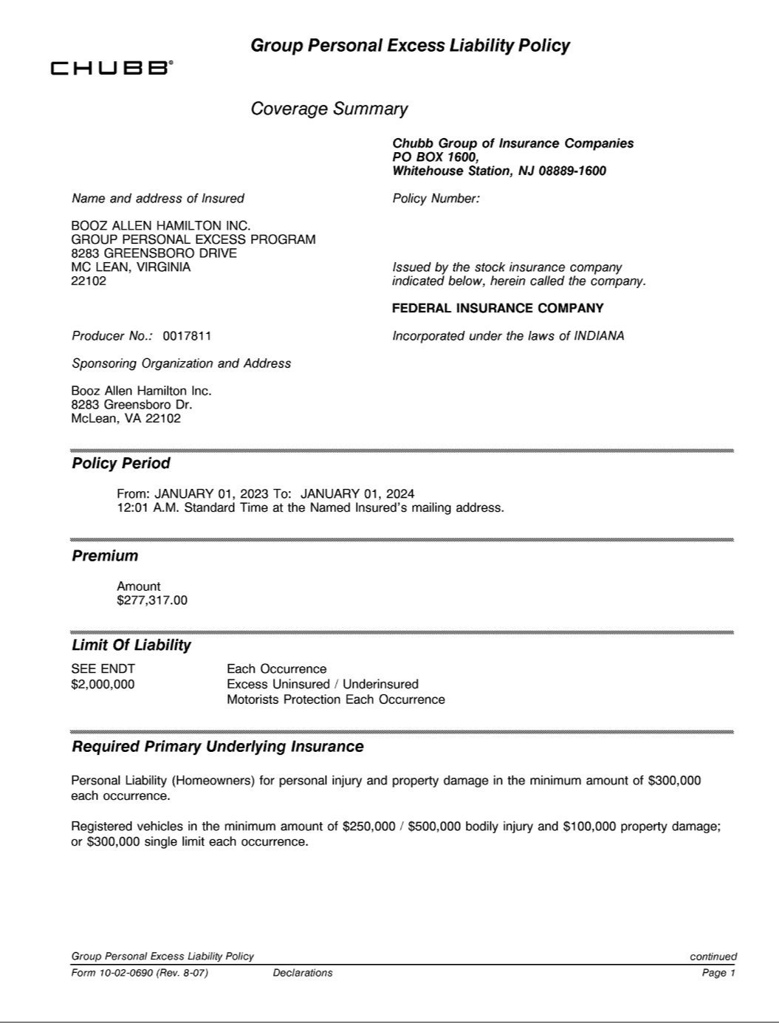

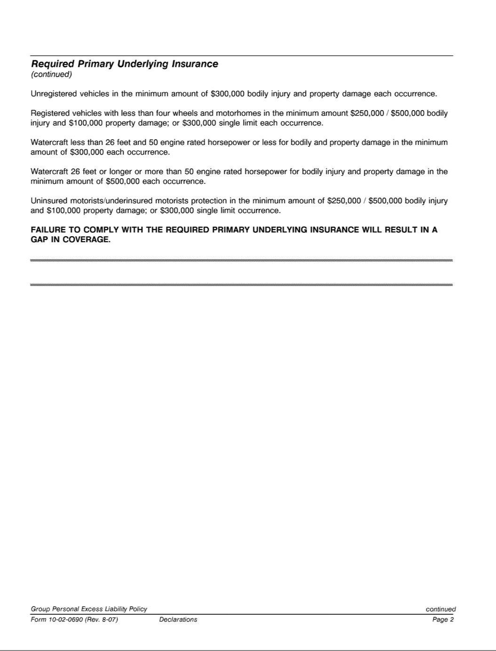

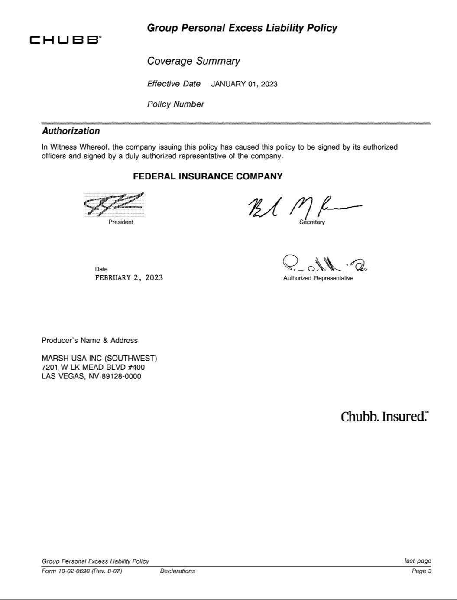







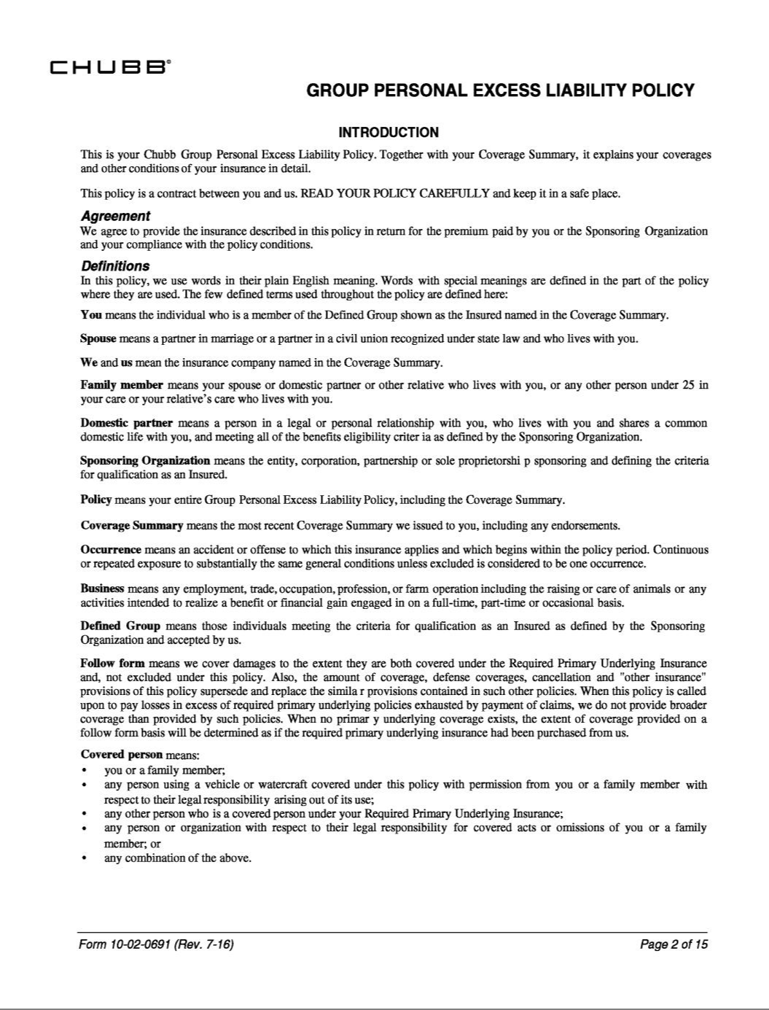

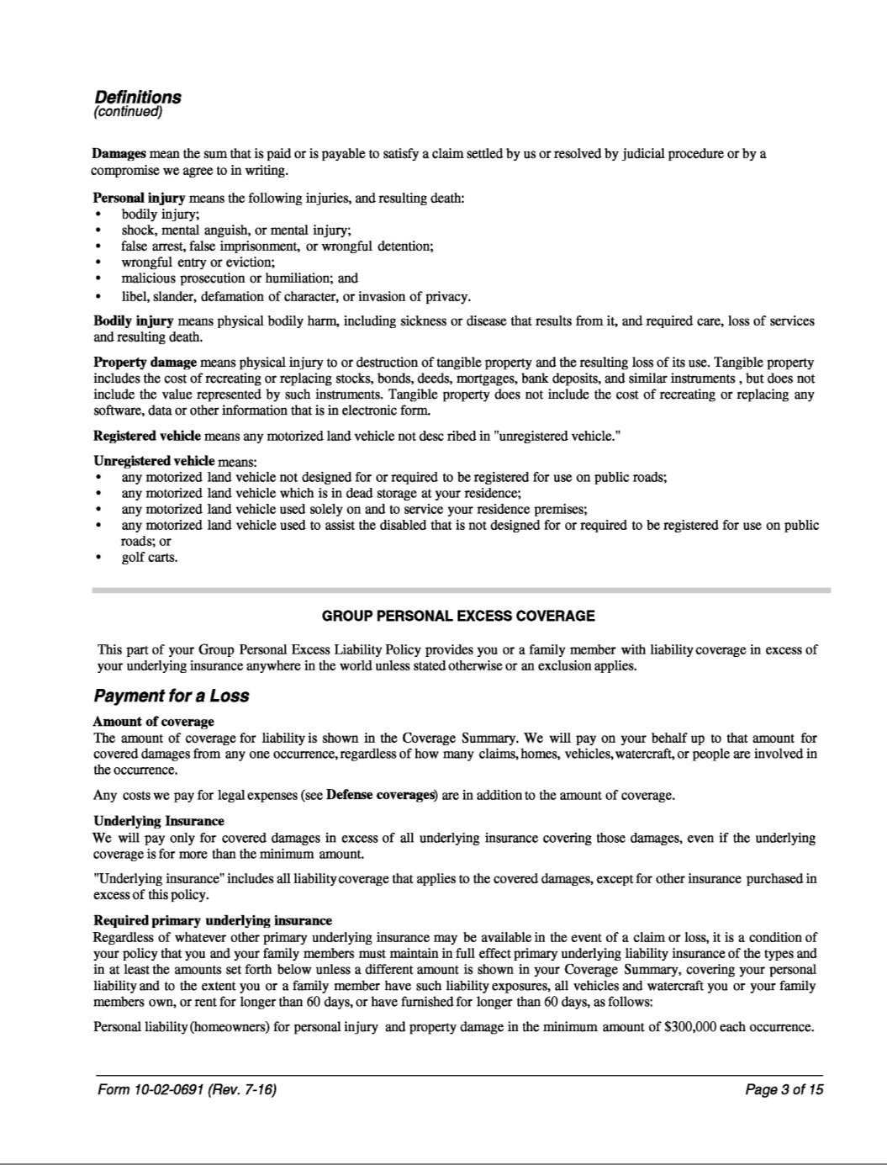

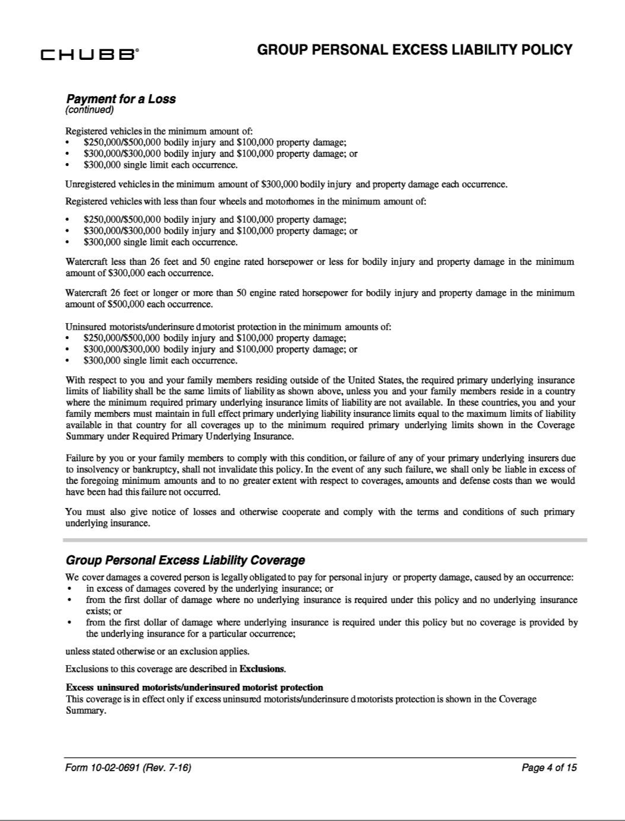

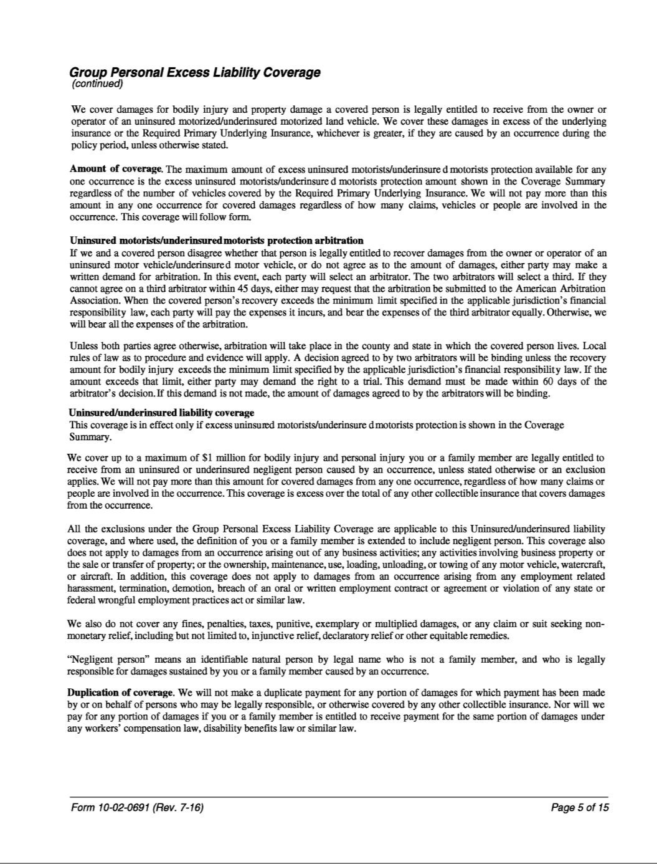

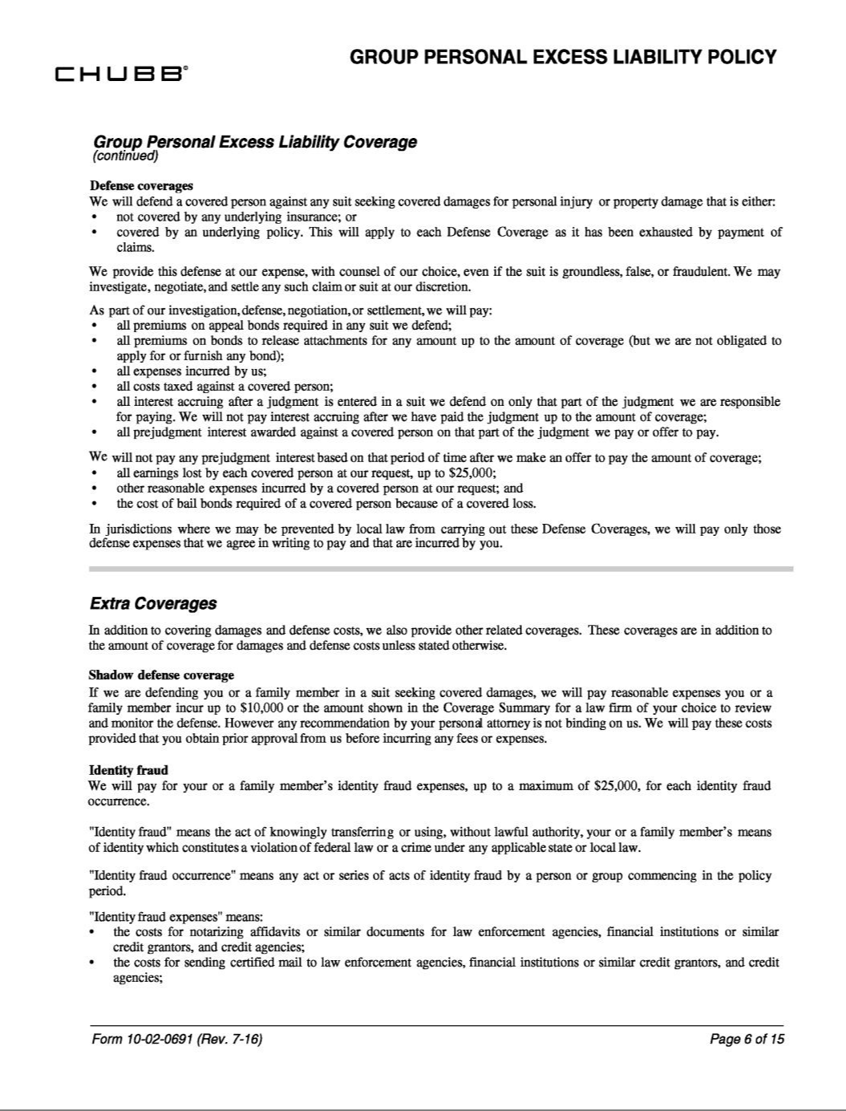

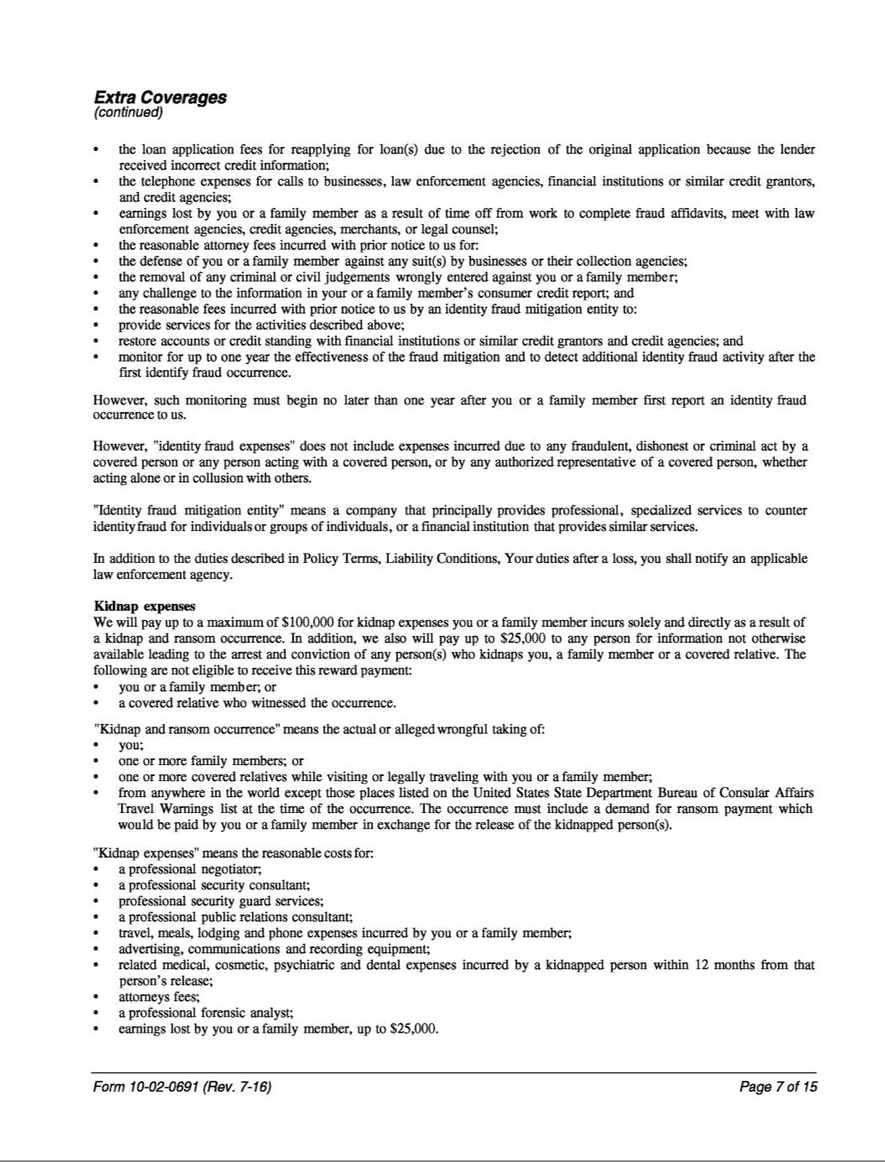

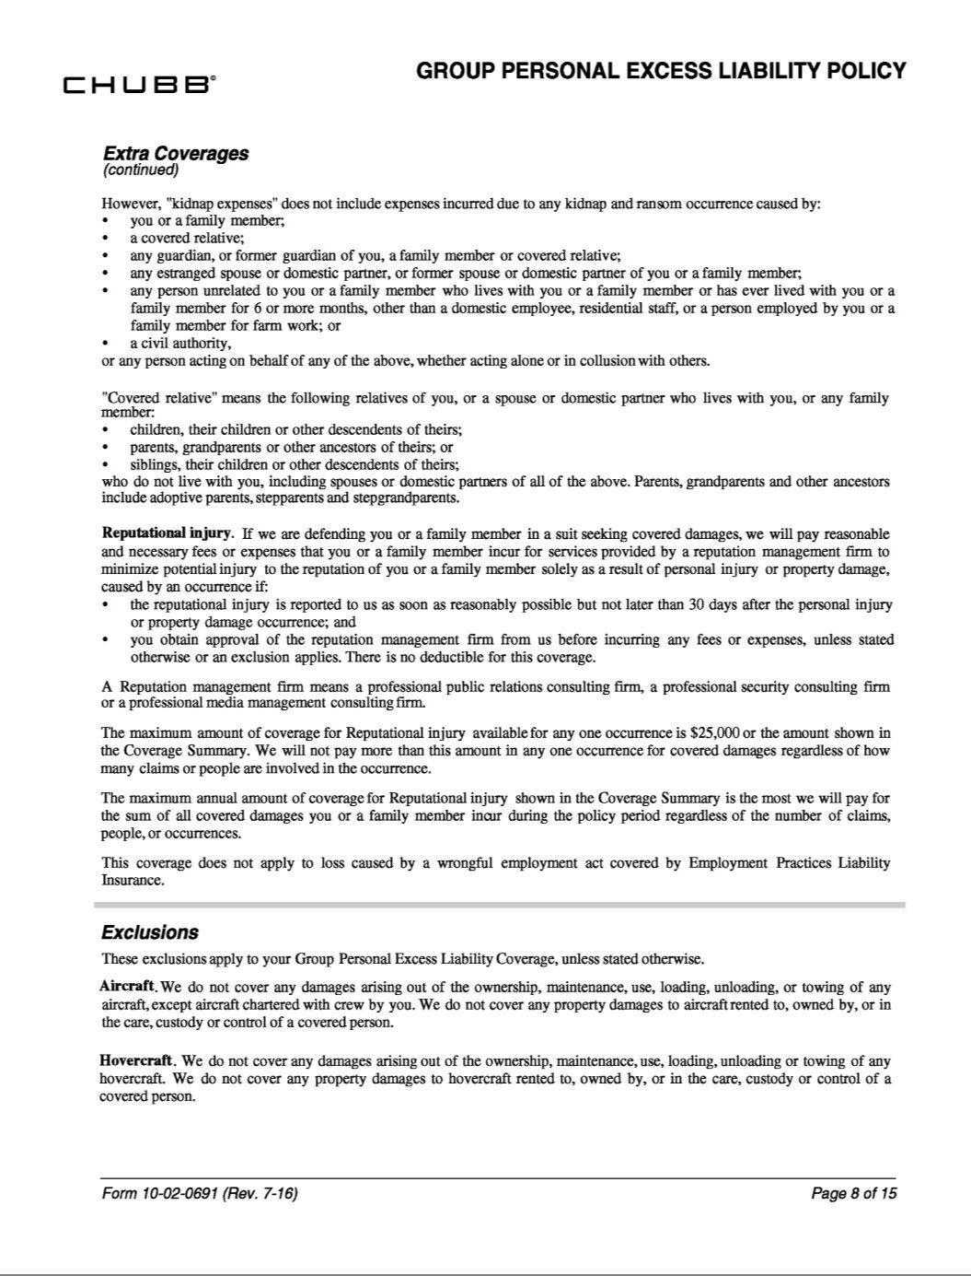

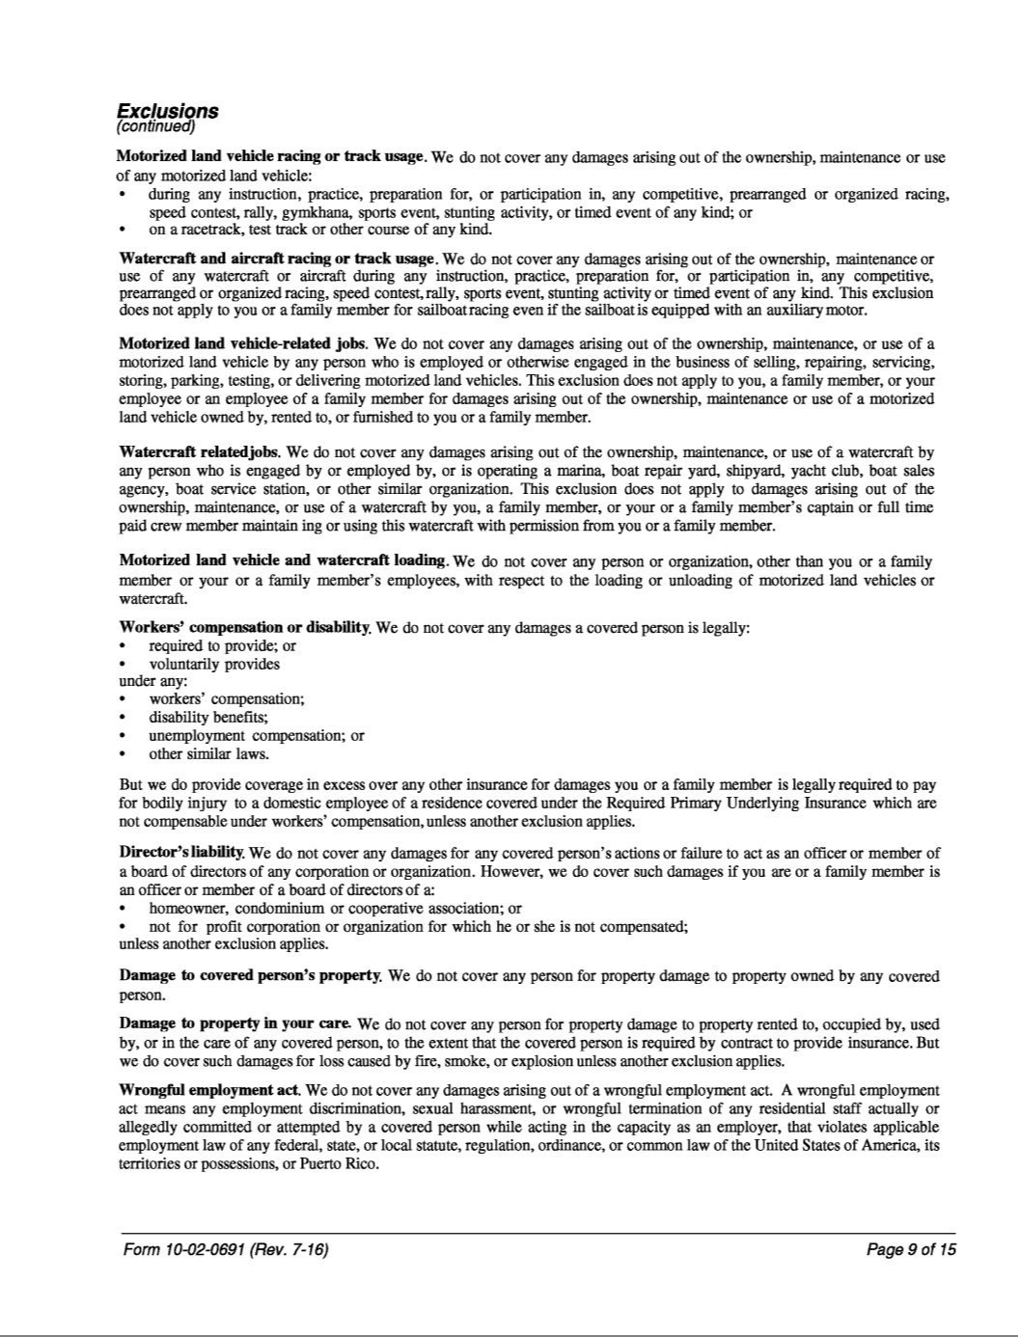

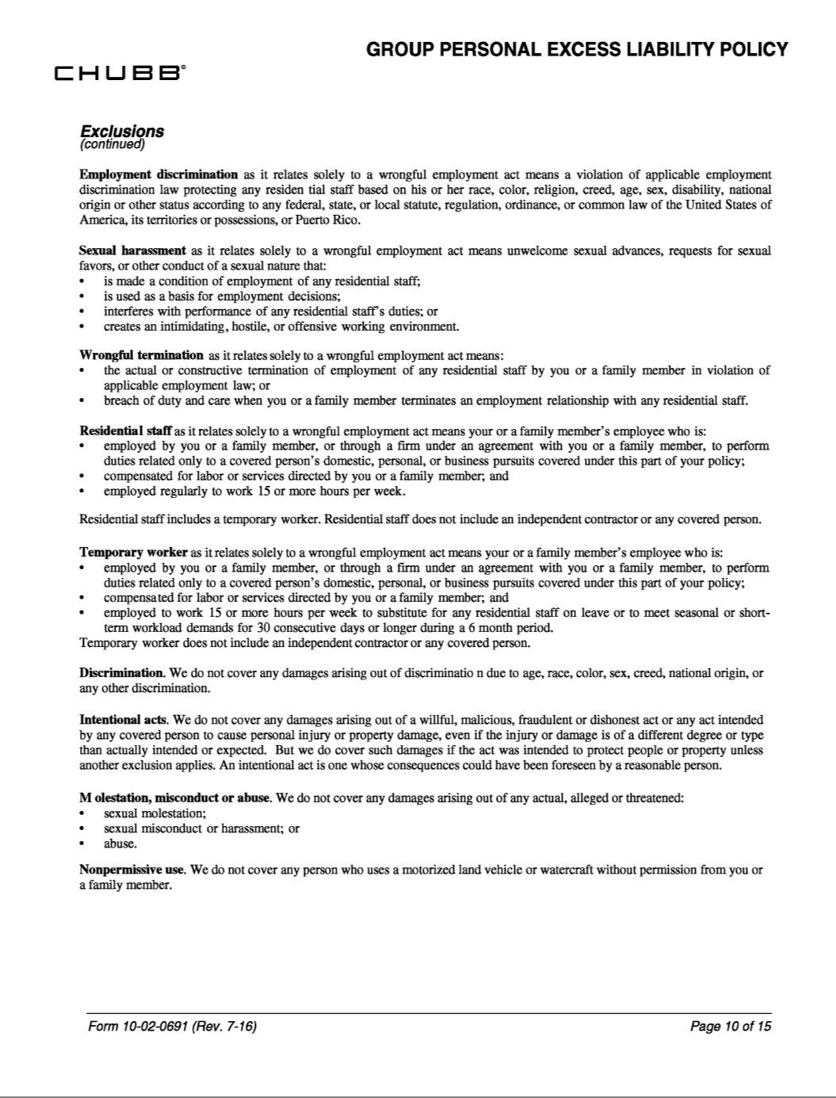

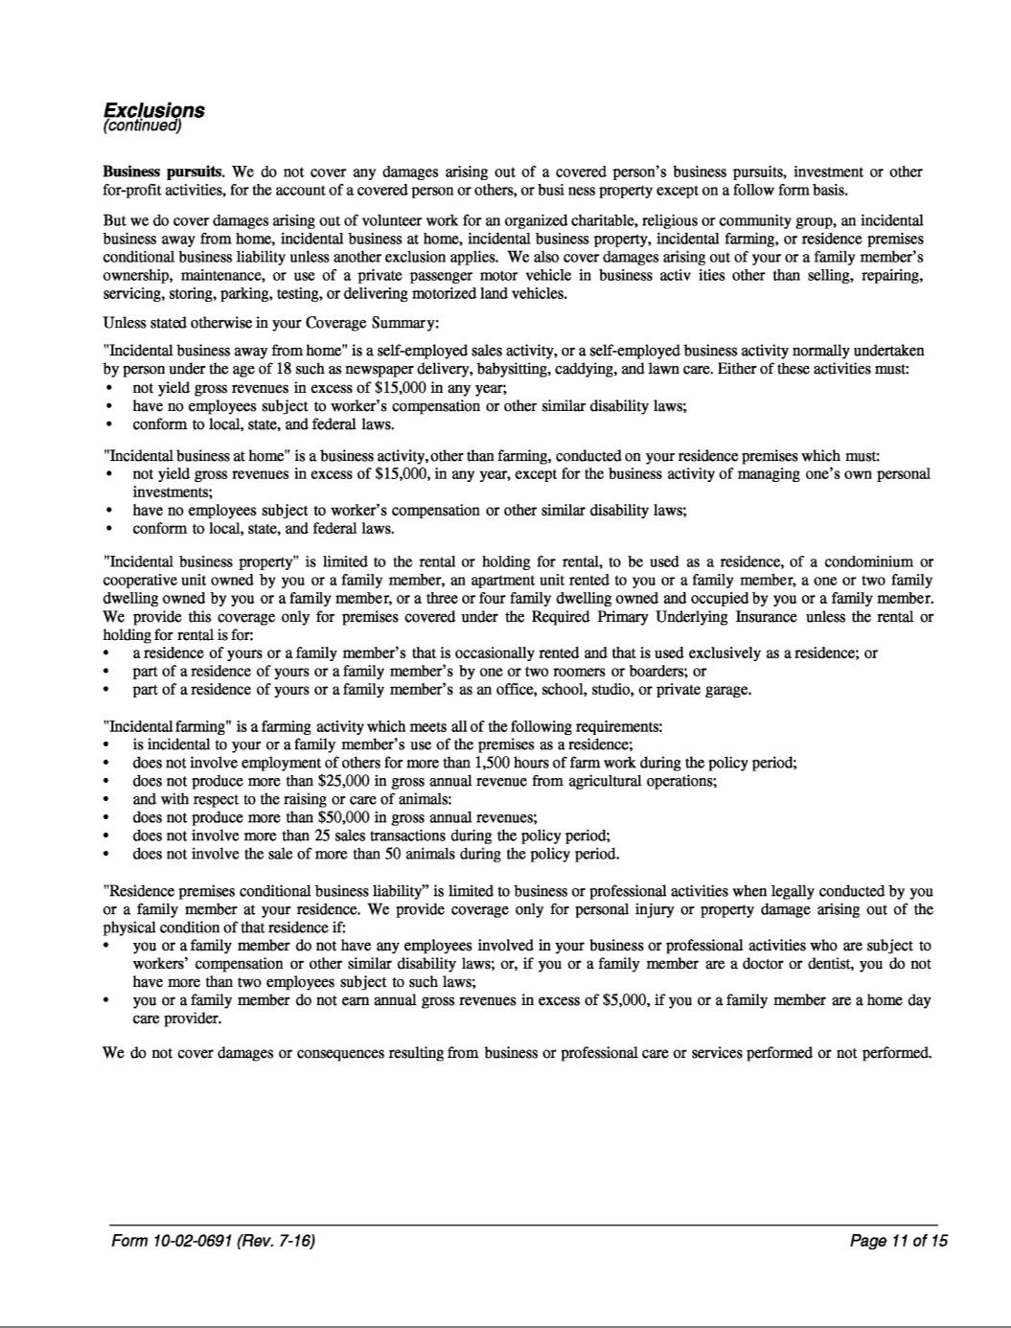

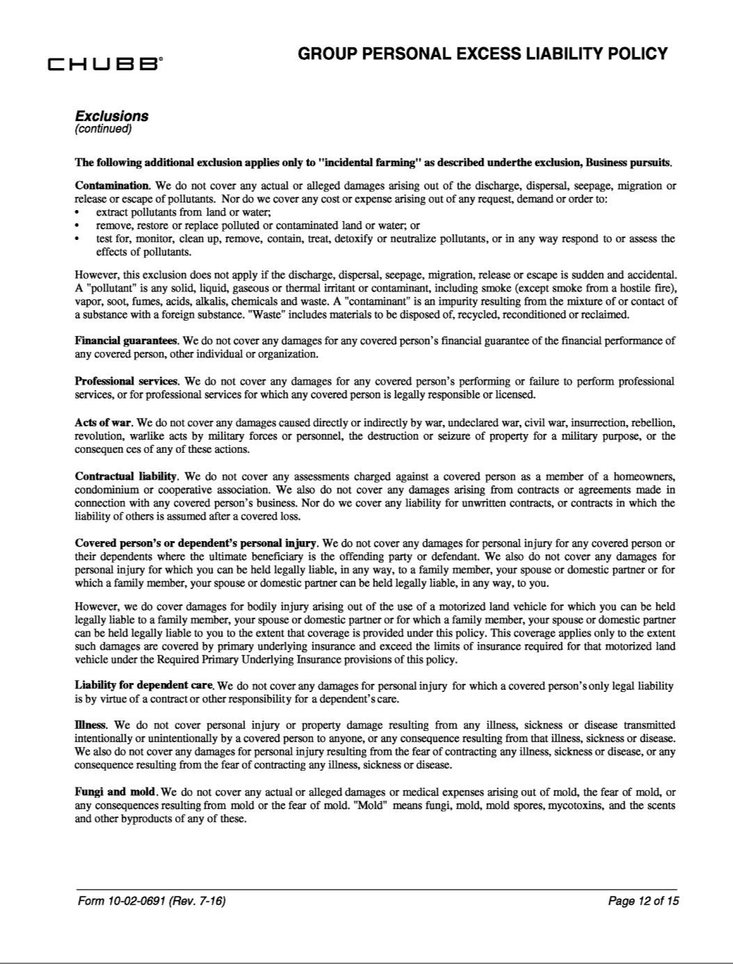

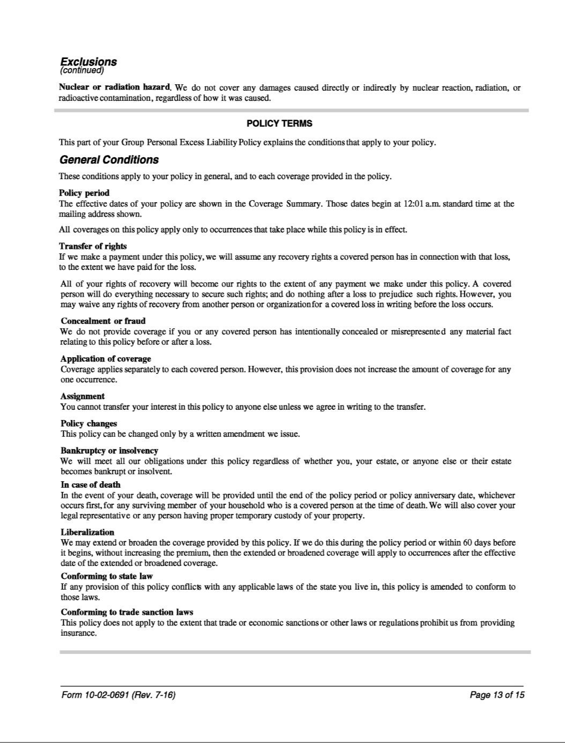

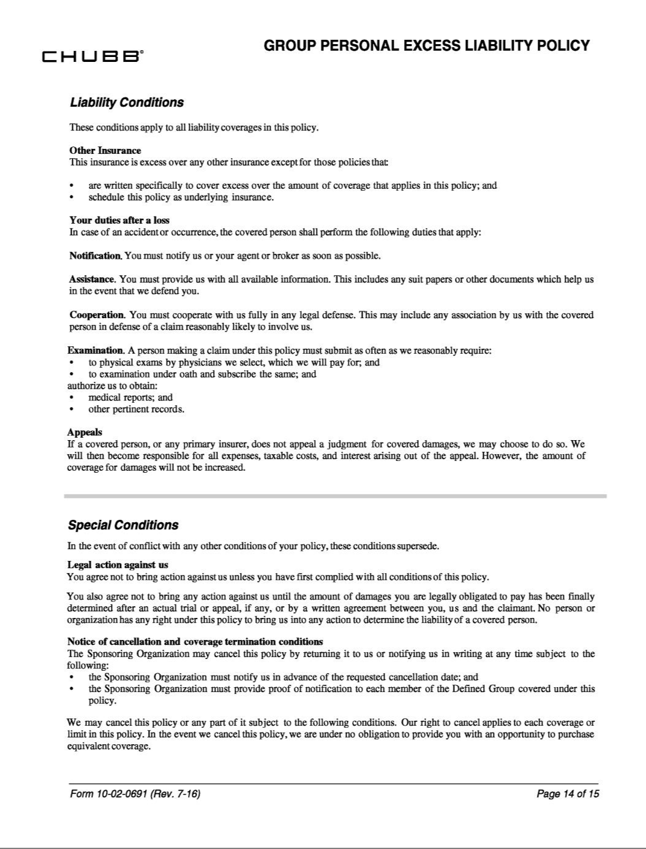

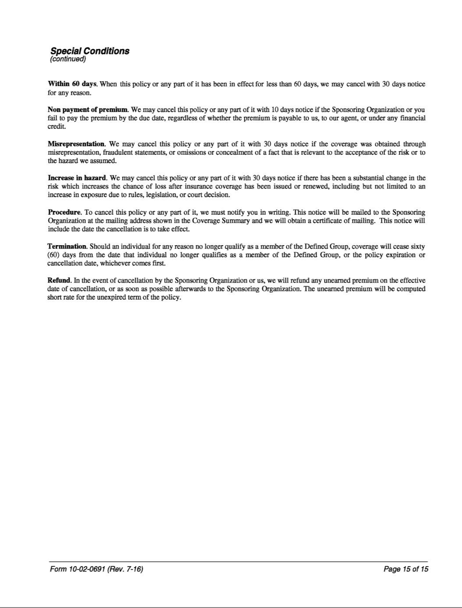

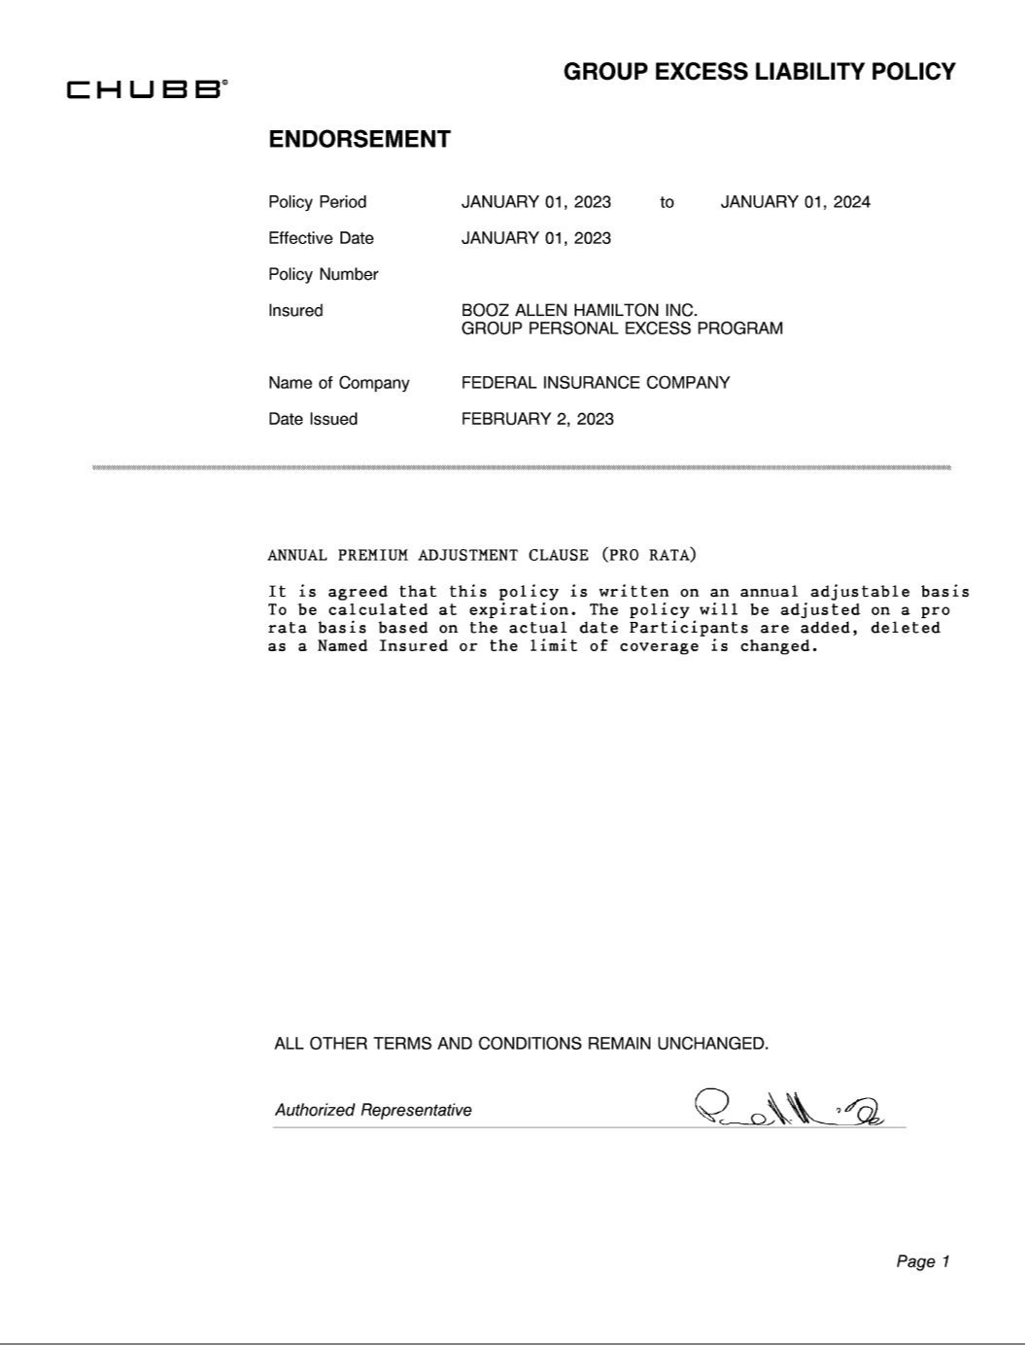

Restricted Stock Unit Agreement

THIRD AMENDED AND RESTATED EQUITY INCENTIVE PLAN OF

BOOZ ALLEN HAMILTON HOLDING CORPORATION

RESTRICTED STOCK UNIT AGREEMENT

GRANT NOTICE

Unless otherwise defined herein, the terms defined in the Third Amended and Restated Equity Incentive Plan (the “Plan”) of Booz Allen Hamilton Holding Corporation (the

“Company”) shall have the same defined meanings in this Restricted Stock Unit Agreement, which includes the terms in this Grant Notice, including Exhibit A (the “Grant Notice”), Appendix A attached hereto and any special terms and conditions set out in Appendix B attached hereto for your country of employment and/or residence (collectively, the
“Agreement”).

You have been granted restricted stock units, subject to the terms and conditions of the Plan and this Agreement in an amount and vesting schedule (as set forth on Exhibit A to this Agreement) as delivered and made available to you by the Company, which shall be deemed part of and incorporated by reference into this Grant Notice. Your acceptance of
this grant indicates your agreement and understanding that the Restricted Stock Units granted herein are subject to all of the terms and conditions contained in the Agreement and
the Plan. ACCORDINGLY, PLEASE BE SURE TO READ ALL OF THE PLAN AND APPENDIX A, APPENDIX B AND EXHIBIT A, WHICH CONTAIN THE
SPECIFIC TERMS AND CONDITIONS OF THE RESTRICTED STOCK UNITS.

In order to view the grant details and to accept this grant, please go to Fidelity NetBenefits at www.netbenefits.com and follow the instructions regarding this grant.

APPENDIX A TO RESTRICTED STOCK UNIT AGREEMENT

- Grant of Restricted Stock Units. Subject to the terms, conditions, and restrictions set forth in this Agreement (including the Grant Notice and any special terms and conditions for the Participant’s country set forth in Appendix B to this Agreement) and in the Plan, the Company hereby evidences and confirms its grant to the Participant, effective as of the Grant Date, of the number of restricted stock units specified in the Grant Notice (the “Restricted Stock Units”). This Agreement is subordinate to, and the terms and conditions of the Restricted Stock Units granted hereunder are subject to, the terms and conditions of the Plan, which are incorporated by reference herein. If there is any inconsistency between the terms hereof and the terms of the Plan, the terms of the Plan shall govern.

- Vesting of Restricted Stock Units.

- Vesting. Except as otherwise provided in this Section 2, the Restricted Stock Units shall become vested, in the amount(s), and on the vesting date(s) set forth in Exhibit A (each, a “Vesting Date”), subject to the continued employment of the Participant by the Company or any Subsidiary thereof through such date.

- Termination of Employment.

  - Termination Due to Death. If a Participant’s employment or service terminates due to the Participant’s death, all unvested Restricted Stock Units shall
immediately vest.

  - Termination Due to Disability. If a Participant’s employment or service terminates due to Disability, all unvested Restricted Stock Units shall not be forfeited upon such termination and shall continue to vest in accordance with the schedule provided in Section 2(a).

  - Termination for Cause. If a Participant’s employment or service terminates for Cause, all unvested Restricted Stock Units shall be immediately forfeited and canceled, effective as of the date of the Participant’s termination of service. In addition, any Restricted Stock Units that vested during the twelve (12) months prior to or any time after the Participant engaged in the conduct that gave rise to the termination for Cause (and any stock or cash issued in settlement of such Restricted Stock Units) shall upon demand by the Administrator be immediately forfeited and disgorged or paid to the Company together with all gains earned or accrued due to the sale of Company Common Stock issued in settlement of any Restricted Stock Units.

  - Termination for Any Other Reason. If a Participant’s employment is terminated for any reason other than death, Disability or by the Company for Cause, all unvested Restricted Stock Units shall immediately be forfeited.

- Change in Control. In the event of a Change in Control prior to the applicable Vesting Date, notwithstanding anything in Article XIII of the Plan to the contrary, any unvested Restricted Stock Units shall remain outstanding and shall vest on the applicable Vesting Date, subject to the continued employment or service of the Participant by the Company or any Subsidiary thereof through such date; provided, that, if the Participant’s employment or service is terminated by the Company without Cause or for Good Reason (each, a “Qualifying CIC Termination”) within two (2) years following the effective date of the Change in Control, such outstanding Restricted Stock Units shall vest as of the date of such Qualifying CIC Termination. Vested Restricted Stock Units shall be settled as set forth in Section 3. For purposes of this Agreement, “Good Reason” means (i) if a Participant is a party to an employment or service agreement with the Company and such agreement provides for a definition of Good Reason, the definition contained therein; or (ii) if no such agreement exists or if such agreement does not define Good Reason, the occurrence of one or more of the following without the Participant’s express written consent, which circumstances are not remedied by the Company within thirty (30) days of its receipt of a written notice from the Participant describing the applicable circumstances (which notice must be provided by the

2

Participant within ninety (90) days of the Participant’s knowledge of the applicable circumstances): (A) any material, adverse change in the Participant’s duties, responsibilities or

authority; (B) a material reduction in the Participant’s base salary or bonus opportunity; or (C) a geographical relocation of the Participant’s principal office location by more than fifty (50) miles (other than a temporary geographical relocation for business reasons).

- Other Forfeiture Provisions. The Restricted Stock Units shall also be forfeited and subject to disgorgement and/or repayment to the Company in the event the Participant (i) engages in financial or other misconduct (including but not limited to engaging in Competitive Activity (excluding, only of if the Participant is located in California, clause (a) of the definition of Competitive Activity contained in the Plan)) or as required by Applicable Law, as provided in the Plan or (ii) materially violates any restrictive covenant agreement (or any other agreement containing restrictive covenants) that the Participant has entered into with the Company.

- Administrator Discretion. Notwithstanding anything contained in this Agreement to the contrary, subject to Article XIII of the Plan, the Administrator, in its sole discretion, may waive forfeiture provisions or accelerate the vesting with respect to any Restricted Stock Units under this Agreement, at such times and upon such terms and conditions as the Administrator shall determine; provided, however, that such waiver or acceleration of vesting shall not change the settlement date of the Restricted Stock Units provided in Section 3 of this Agreement.

- Post-Termination Informational Requirements. Before the settlement of any Restricted Stock Units following termination of employment or service, the Company may require the Participant (or the Participant’s Eligible Representative, if applicable) to make such representations and provide such documents as the Administrator deems necessary or advisable to determine whether the provisions of Section 2(b)(iii) or 2(d) apply. Such representations and documents may include tax returns and all other relevant information and records from which the Company can determine the current or former employment status of the Participant during the vesting period. Notwithstanding anything in this Agreement to the contrary, the settlement of the Restricted Stock Units may be withheld until information deemed sufficient by the Company is delivered to it, and any unvested Restricted Stock Units shall be forfeited if the requested information is not provided in sufficient detail to the Company before the earlier of (i) ninety (90) calendar days after the issue of a request from the Company for such information and (ii) December 31 of the calendar year in which the applicable Vesting Date occurs.

- Settlement of Restricted Stock Units. Subject to Section 8(d) and Section 2(f), the Company shall deliver to the Participant one (1) share of Company Common Stock (or the value thereof) in settlement of each outstanding Restricted Stock Unit that has vested as provided in Section 2(a) on the first to occur of (i) the Vesting Date (or within 30 days thereafter), (ii) in the event of a termination of employment or service due to death, as soon as practicable following the Participant’s termination of employment or service by reason of death or (iii) in the event of a Qualifying CIC Termination, within thirty (30) days following the effective date of the Participant’s Qualifying CIC Termination, in each case (A) in Company Common Stock by either, (x) issuing one or more certificates evidencing the Company Common Stock to the Participant or (y) registering the issuance of the Company Common Stock in the name of the Participant through a book entry credit in the records of the Company’s transfer agent, or (B) in the event of settlement upon a Change in Control, a cash payment equal to the Change in Control Price, multiplied by the number of vested Restricted Stock Units. No fractional shares of Company Common Stock shall be issued in settlement of Restricted Stock Units. Fractional shares shall be rounded up to the nearest whole share; provided, that the Participant may not vest in more than the number of Restricted Stock Units specified in the Grant Notice.

Notwithstanding the foregoing, the Company, in its sole discretion, may provide for the settlement of the Restricted Stock Units in the form of Company Common Stock, but require the Participant to sell such Common Stock immediately or within a specified period following the Participant’s termination of

3

service (in which case, the Participant hereby agrees that the Company shall have the authority to issue sale instructions in relation to such Common Stock on the Participant’s behalf).

- Securities Law Compliance. Notwithstanding any other provision of this Agreement, the Participant may not sell the shares of Company Common Stock acquired upon vesting of the Restricted Stock Units unless such shares are registered under the Securities Act of 1933, as amended (the “Securities Act”), or, if such shares are not then so registered, such sale would be exempt from the registration requirements of the Securities Act. The sale of such shares must also comply with other applicable laws and regulations governing the shares and Participant may not sell the shares of Company Common Stock if the Company determines that such sale would not be in material compliance with such laws and regulations.

- Participant’s Rights with Respect to the Restricted Stock Units.

- Restrictions on Transferability. The Restricted Stock Units granted hereby are not assignable or transferable, in whole or in part, and may not, directly or indirectly, be offered, transferred, sold, pledged, assigned, alienated, hypothecated or otherwise disposed of or encumbered (including without limitation by gift, operation of law or otherwise) other than by will or by the laws of descent and distribution to the estate of the Participant upon the Participant’s death; provided that the deceased Participant’s beneficiary or representative of the Participant’s estate shall acknowledge and agree in writing, in a form reasonably acceptable to the Company, to be bound by the provisions of this Agreement and the Plan as if such beneficiary or the estate were the Participant.

- No Rights as Stockholder. The Participant shall not have any rights as a stockholder including any voting, dividend or other rights or privileges as a stockholder of the Company with respect to any Company Common Stock corresponding to the Restricted Stock Units granted hereby unless and until shares of Company Common Stock are issued to the Participant in respect thereof.

- Dividend Equivalents. The Participant shall be credited with Dividend Equivalents in the form of a right to a cash payment when cash dividends are paid on the Company Common Stock. Such cash payment shall equal the amount obtained by multiplying the amount of the dividend declared and paid for each share of Company Common Stock by the number of Restricted Stock Units held by the Participant on the record date. Any cash amounts credited to the Participant’s account shall be paid to the Participant on the applicable payment date for the related cash dividends.

- Participant’s Representations, Warranties and Covenants.

- No Conflicts; No Consents. The execution and delivery by the Participant of this Agreement, the consummation of the transactions contemplated hereby and the performance of the Participant’s obligations hereunder do not and will not (i) materially conflict with or result in a material violation or breach of any term or provision of any Law applicable to either the Participant or the Restricted Stock Units or (ii) violate in any material respect, conflict with in any material respect or result in any material breach of, or constitute (with or without notice or lapse of time or both) a material default under, or require either the Participant to obtain any consent, approval or action of, make any filing with or give any notice to any Person as a result or under the terms of, any contract, agreement, instrument, commitment, arrangement or understanding to which the Participant is a party.

- Compliance with Rule 144. If any shares of Company Common Stock issued in respect of the Restricted Stock Units are to be disposed of in accordance with Rule 144, the Participant shall transmit to the Company an executed copy of Form 144 (if required by Rule 144) no later than the time such form is required to be transmitted to the Commission for filing and such other documentation as the Company may reasonably require to assure compliance with Rule 144 in connection with such disposition.

4

- Participant Status. The Participant represents and warrants that, as of the date hereof, the Participant is an officer, employee, director or Consultant of the Company
or a Subsidiary.

- Adjustment in Capitalization. The number, class or other terms of any outstanding Restricted Stock Units shall be adjusted by the Committee to reflect any stock dividend, stock split or share combination or any recapitalization, business combination, merger, consolidation, spin-off, exchange of shares, liquidation or dissolution of the Company or other similar transaction affecting the Company Common Stock in such manner as it determines in its sole discretion.

- Tax Withholding. The Participant acknowledges that, regardless of any action taken by the Company or the Employer with respect to any or all income tax (including U.S. federal, state and local taxes and/or non-U.S. taxes), social insurance, payroll tax, fringe benefits tax, payment on account or other tax-related items related to the Participant's participation in the Plan and legally applicable to the Participant (“Tax-Related Items”), the ultimate liability for all Tax-Related Items is and remains the Participant’s personal responsibility and may exceed the amount, if any, actually withheld by the Company or the Employer. The Participant further acknowledges that the Company and/or the Employer (a) make no representations or undertakings regarding the treatment of any Tax-Related Items in connection with any aspect of the Participant’s participation in the Plan, including, but not limited to, the grant of Restricted Stock Units, the vesting of Restricted Stock Units, issuance or sale of shares of Company Common Stock, or the receipt of any dividends or Dividend Equivalents; and (b) do not commit to and are under no obligation to structure the terms of the Restricted Stock Units or any aspect of the Plan to reduce or eliminate the Participant’s liability for Tax-Related Items or achieve any particular tax result. Further, if the Participant is subject to Tax-Related Items in more than one jurisdiction, the Participant acknowledges that the Company and/or the Employer (or former employer, as applicable) may be required to withhold or account for Tax-Related Items in more than one jurisdiction.

Prior to any relevant taxable or tax withholding event, as applicable, the Participant agrees to make arrangements satisfactory to the Company and/or the Employer to satisfy

all Tax-Related Items. In this regard, the Participant authorizes the Company and/or the Employer, or their respective agents, at their discretion, to satisfy their withholding obligations with regard to any Tax-Related Items by one or a combination of the following: (a) withholding from the Participant’s wages or other cash compensation payable to the
Participant by the Company and/or the Employer, (b) withholding from proceeds of the sale of shares of Company Common Stock under the Plan, either through a voluntary sale or

through a mandatory sale arranged by the Company (on the Participant’s behalf pursuant to this authorization without further consent) to cover the Tax-Related Items required to be withheld, and (c) withholding in shares of Company Common Stock to be issued upon vesting of the Restricted Stock Units.

If the obligation for Tax-Related Items is satisfied by withholding in shares of Company Common Stock, for tax purposes, the Participant will be deemed to have been issued the full number of shares of Company Common Stock, notwithstanding that a number of the shares of Company Common Stock are held back solely for the purpose of
paying the Tax-Related Items.

The Company or the Employer may defer the settlement of Restricted Stock Units until such withholding or other tax requirements are satisfied and if the Participant has not satisfied such withholding or other tax requirements as of the last day of the calendar year in which the Vesting Date occurs, the Restricted Stock Units shall be forfeited.

- Nature of Grant. By accepting the Restricted Stock Units, the Participant acknowledges, understands and agrees that:

- the Plan is established voluntarily by the Company, it is discretionary in nature and it may be terminated, suspended or amended by the Company at any time, to the extent permitted by the Plan;

5

- the grant of Restricted Stock Units is voluntary and does not create any contractual or other right to receive future Restricted Stock Units or benefits in lieu of Restricted Stock Units, even if Restricted Stock Units have been granted in the past;

- all decisions with respect to future Restricted Stock Units or other grants, if any, will be at the sole discretion of the Company;

- the grant of Restricted Stock Units and the Participant’s participation in the Plan shall not create a right to employment or be interpreted as forming an employment or service contract with the Company, the Employer or any other Subsidiary and shall not interfere with the ability of the Company, the Employer or any other Subsidiary to terminate the Participant’s employment relationship (if any);

- the Participant is voluntarily participating in the Plan;

- the Restricted Stock Units and any shares of Company Common Stock acquired under the Plan, and the income from and value of the same, are not intended to replace any pension rights or compensation;

- the Restricted Stock Units and any shares of Company Common Stock acquired under the Plan, and the income from and value of the same, are extraordinary items that do not constitute compensation of any kind for services of any kind rendered to the Company or the Employer, and which are outside the scope of the Participant’s employment and the Participant’s employment or service agreement, if any;

- the Restricted Stock Units and any shares of Company Common Stock acquired under the Plan, and the income from and value of the same, are not part of normal or expected compensation or salary for any purpose, including, without limitation, calculating any severance, resignation, termination, redundancy, dismissal, end-of-service payments, holiday pay, bonuses, long-service awards, leave-related payments, pension or retirement or welfare benefits or similar mandatory payments;

- the future value of the underlying shares of Company Common Stock is unknown, indeterminable and cannot be predicted with certainty and the value of such shares of Company Common Stock may increase or decrease in the future;

- no claim or entitlement to compensation or damages shall arise from forfeiture of the Restricted Stock Units or recoupment of any shares of Company Common Stock acquired under the Plan resulting from (1) termination of the Participant’s employment (regardless of the reason for the termination and whether or not the termination is later found to be invalid or in breach of employment laws in the jurisdiction where the Participant is employed or the terms of the Participant’s employment or service agreement, if any) and/or (2) the application of any recoupment policy or any recovery or clawback policy otherwise required by law; and

- neither the Company, the Employer nor any other Subsidiary shall be liable for any foreign exchange rate fluctuation between the Participant’s local currency and the United States Dollar that may affect the value of the shares of Company Common Stock or any amounts due pursuant to the issuance of the shares of Company Common Stock, or the subsequent sale of any shares of Company Common Stock acquired under the Plan.

- Employee Data Privacy. The collection, use, disclosure and transfer, in electronic or other form, of personally identifiable information to facilitate the grant of the Award and the administration of the Plan by and among, as applicable, the Company and the Participant’s employer, if different, any of the Company’s affiliates, any agent of the Company administering or providing Plan services is governed by the Employee Privacy Notice (the “Privacy Notice”) that Participant received in the course of his or her relationship with Company. The Participant understands that he or she may review

6

the Privacy Notice or contact his or her local human resources representative to request a copy of the Privacy Notice. Please contact ethics@bah.com if the Participant has any questions or concerns about how the Company or its subsidiaries and affiliates process personally identifiable information.

- Miscellaneous.

- Binding Effect; Benefits. This Agreement shall be binding upon and inure to the benefit of the parties to this Agreement and their respective successors and assigns. Nothing in this Agreement, express or implied, is intended or shall be construed to give any person other than the parties to this Agreement or their respective successors or assigns any legal or equitable right, remedy or claim under or in respect of any agreement or any provision contained herein.

- No Advice Regarding Grant. The Participant acknowledges that neither the Company nor the Employer are providing any tax, legal or financial advice, nor is the Company or the Employer making any recommendations regarding the Participant’s participation in the Plan. The Participant should consult his or her own personal tax, legal and financial advisors regarding the Participant’s participation in the Plan before taking any action related to the Plan.

- Interpretation. For purposes of this Agreement, if the Participant is not employed by the Company, “Employer” means the Subsidiary that employs the Participant. This Agreement is subject to the terms and conditions of the Plan. In the event of any inconsistency between the provisions of this Agreement and the Plan, the Plan shall govern. The Administrator, acting pursuant to the Plan, as constituted from time to time, shall, except as expressly provided otherwise herein, have the right to determine reasonably and in good faith any questions that arise in connection with this Agreement, and any such determination shall be final, binding and conclusive on all Participants and other individuals claiming any right under the Plan. The failure of the Company or the Participant to insist upon strict performance of any provision hereunder, irrespective of the length of time for which such failure continues, shall not be deemed a waiver of such party’s right to demand strict performance at any time in the future. No consent or waiver, express or implied, to or of any breach or default in the performance of any obligation or provision hereunder shall constitute a consent or waiver to or of any other breach or default in the performance of the same or any other obligation hereunder.

- Country-Specific Provisions. The Participant’s participation in the Plan shall be subject to any special terms and conditions set forth in Appendix B attached hereto for the Participant’s country. Moreover, if the Participant relocates to one of the countries included in Appendix B, the special terms and conditions for such country will apply to the Participant, to the extent the Company determines that the application of such terms and conditions is necessary or advisable for legal or administrative reasons. Appendix B constitutes part of this Agreement.

- Other Requirements. The Company reserves the right to impose other requirements on the Participant’s participation in the Plan and on any shares of Company Common Stock acquired under the Plan, to the extent the Company determines it is necessary or advisable for legal or administrative reasons, and to require the Participant to sign any additional agreements or undertakings that may be necessary to accomplish the foregoing.

- Applicable Law. The Participant acknowledges that the Company is organized under the laws of the State of Delaware, U.S.A. The Participant and the Company agree that this Agreement shall be construed in accordance with and governed by the laws of the State of Delaware, U.S.A., without reference to principles of conflict of laws that would apply the laws of any other jurisdiction.

- Forum Selection. The Participant acknowledges that the Company’s principal place of business is in, and a substantial portion of the Company’s business is based out of, the Commonwealth of Virginia, U.S.A. The Participant also acknowledges that, as such, during the course of the Participant’s service with the Company and its Subsidiaries, the Participant shall have substantial contacts with the

7

Commonwealth of Virginia, U.S.A. Accordingly, the Participant and the Company agree that the exclusive forum for any action, demand, claim or counterclaim relating to the terms

and provisions of this Agreement, or to their breach, shall be in the appropriate state or federal court located in the Commonwealth of Virginia, U.S.A. The Participant and the Company hereby consent to the personal jurisdiction of such courts over the parties to this Agreement. The Participant expressly waives any defense that such courts lack personal
jurisdiction or are inconvenient. The Participant and the Company further agree that in any such action for breach or enforcement of this Agreement, no party will seek to challenge the validity or enforceability of any part of this Agreement.

- Amendment. This Agreement may not be amended, modified or supplemented orally, but only by a written instrument executed by the Participant and the Company.

- Assignability. Neither this Agreement nor any right, remedy, obligation or liability arising hereunder or by reason hereof shall be assignable by the Company or the Participant without the prior written consent of the other party, provided that the Company may assign all or any portion of its rights or obligations under this Agreement to one or more persons or other entities designated by it.

- Severability; Blue Pencil. In the event that any one or more of the provisions of this Agreement shall be or become invalid, illegal or unenforceable in any respect, the validity, legality and enforceability of the remaining provisions contained herein shall not be affected thereby.

- Consent to Electronic Delivery. By entering into this Agreement and accepting the Restricted Stock Units evidenced hereby, Participant hereby consents to the delivery of information (including, without limitation, information required to be delivered to the Participant pursuant to applicable securities laws) regarding the Company and the Subsidiaries, the Plan, this Agreement and the Restricted Stock Units via Company website, the Fidelity NetBenefits website or any other online access system of the Company’s third party Plan administrator, email or other electronic delivery.

- Section 409A of the Code. This Agreement is intended to be administered in a manner consistent with the requirements, where applicable, of Section 409A of the Code and the regulations promulgated thereunder (“Section 409A”). Where reasonably practicable, the Agreement shall be administered in a manner to avoid the imposition on the Participant of immediate tax recognition and additional taxes pursuant to Section 409A. In addition, to the extent permissible under Section 409A, any series of installment payments under this Agreement shall be treated as a right to a series of separate payments. Notwithstanding the foregoing, the Company shall not have any liability to any Person in the event Section 409A applies to any payment hereunder in a manner that results in adverse tax consequences to the Participant or any of the Participant’s beneficiaries.

- Specified Employee Delay. If the Participant is deemed a “specified employee” within the meaning of Section 409A, as determined by the Committee, at a time when the Participant becomes eligible for settlement of the Restricted Stock Units upon his or her “separation from service” within the meaning of Section 409A, then to the extent necessary to prevent any accelerated or additional tax under Section 409A, such settlement will be delayed until the earlier of: (a) the date that is six months following the Participant’s termination of service and (b) the Participant’s death. Notwithstanding anything to the contrary in this Agreement, if settlement is to occur upon a termination of service other than due to death or Disability and the Participant is a specified employee, to the extent necessary to comply with, and avoid imposition on the Participant of any additional tax or interest imposed under, Section 409A, settlement shall instead occur on the first business day following the six-month anniversary of the Participant’s termination of service (or, if earlier, upon the Participant’s death), or as soon thereafter as practicable (but no later than 90 days thereafter).

- Headings and Captions. The section and other headings contained in this Agreement are for reference purposes only and shall not affect the meaning or interpretation of this Agreement.

8

- Notices. All notices under this Agreement shall be (i) delivered by hand, (ii) sent by commercial overnight courier service, (iii) sent by registered or certified mail, return receipt requested, and first-class postage prepaid, (iv) sent by e-mail or any other form of electronic transfer or delivery approved by the Administrator, or (v) faxed, in each case to the parties at their respective addresses and facsimile numbers set forth in the records of the Company or at such other address or facsimile number as may be designated in a notice by either party to the other.

- Counterparts. This Agreement may be executed in any number of counterparts, each of which shall be deemed to be an original and all of which together shall constitute one and the same instrument.

9

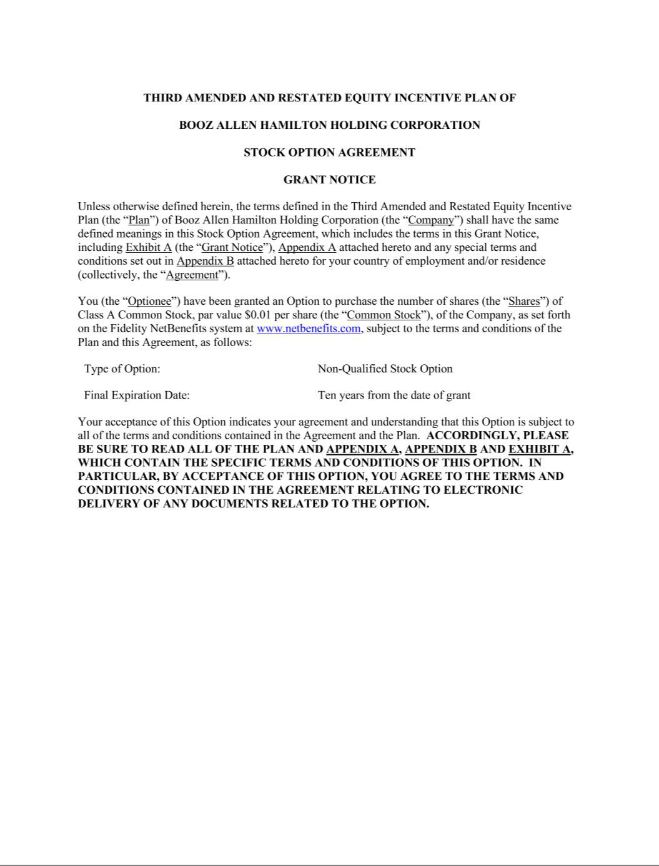

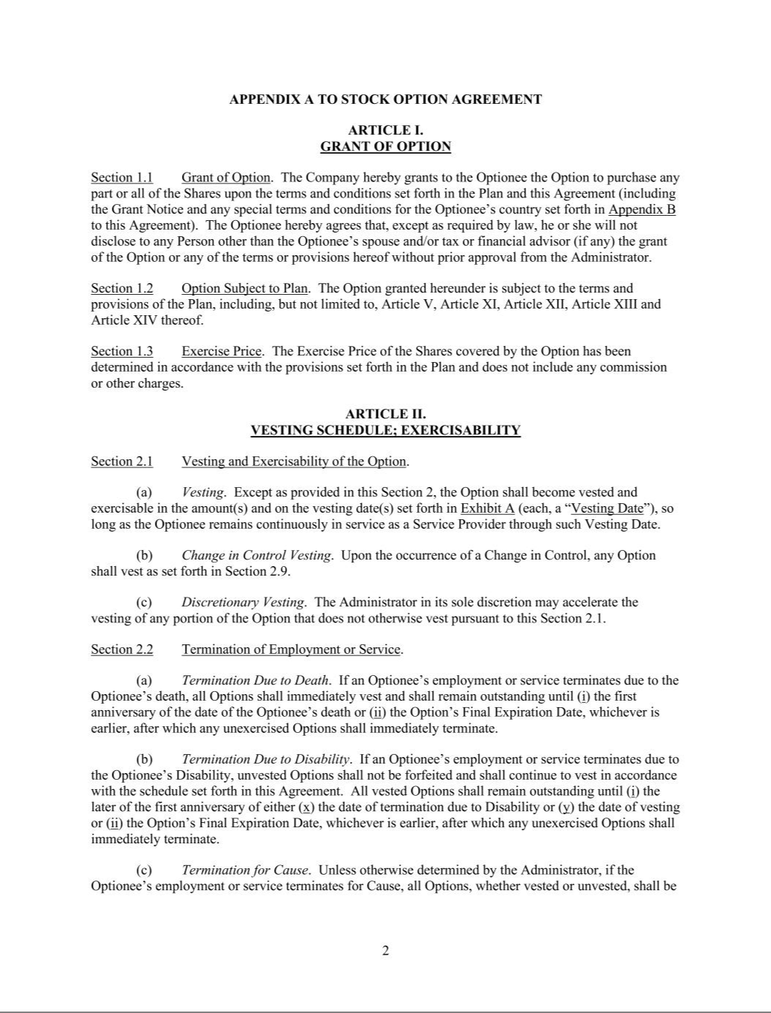

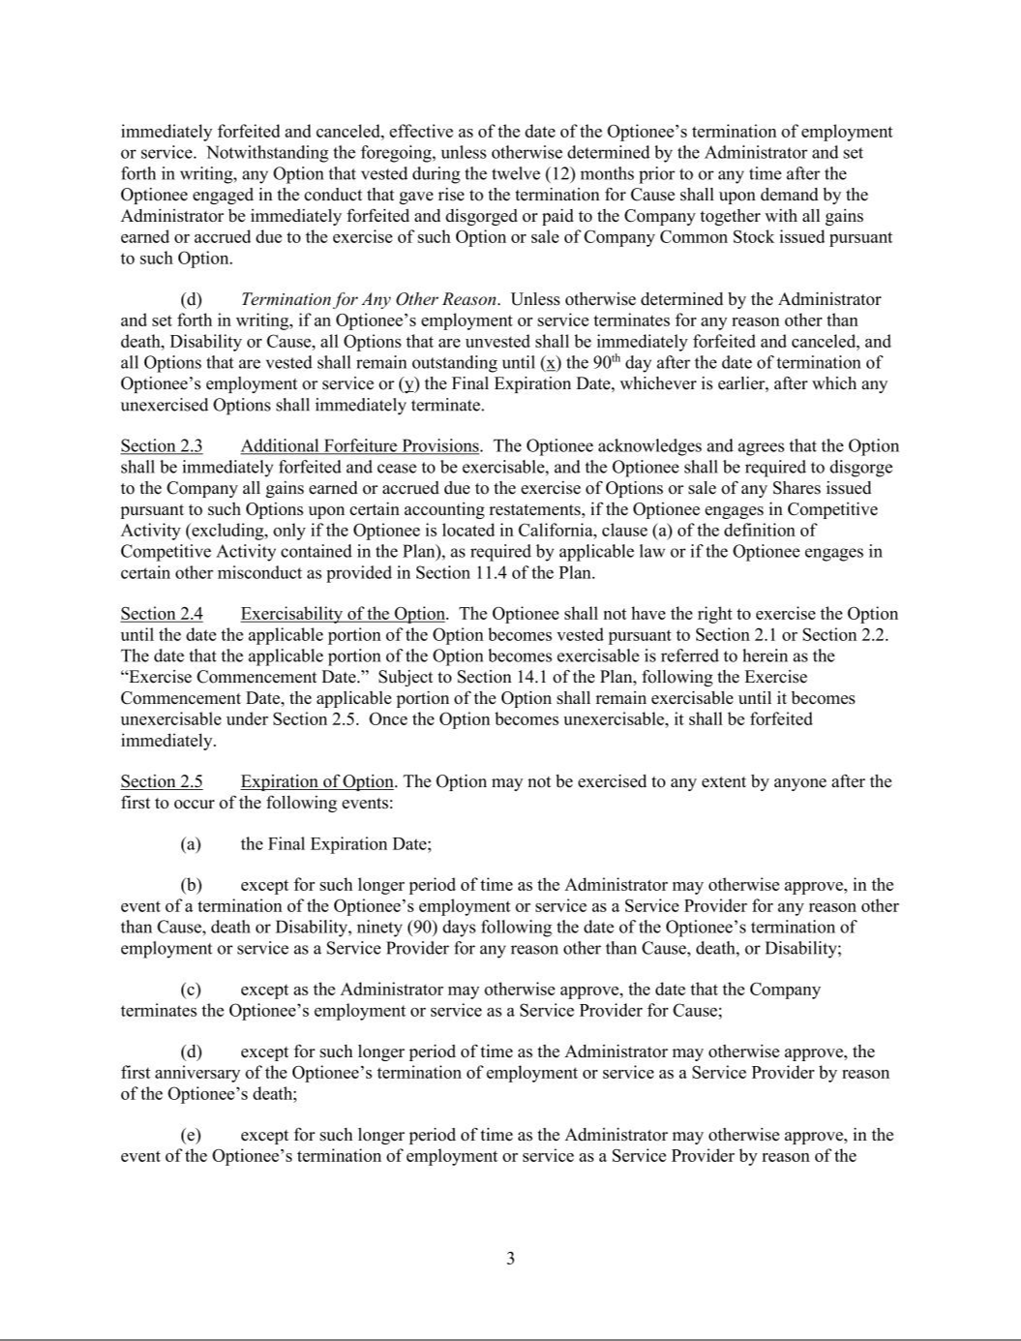

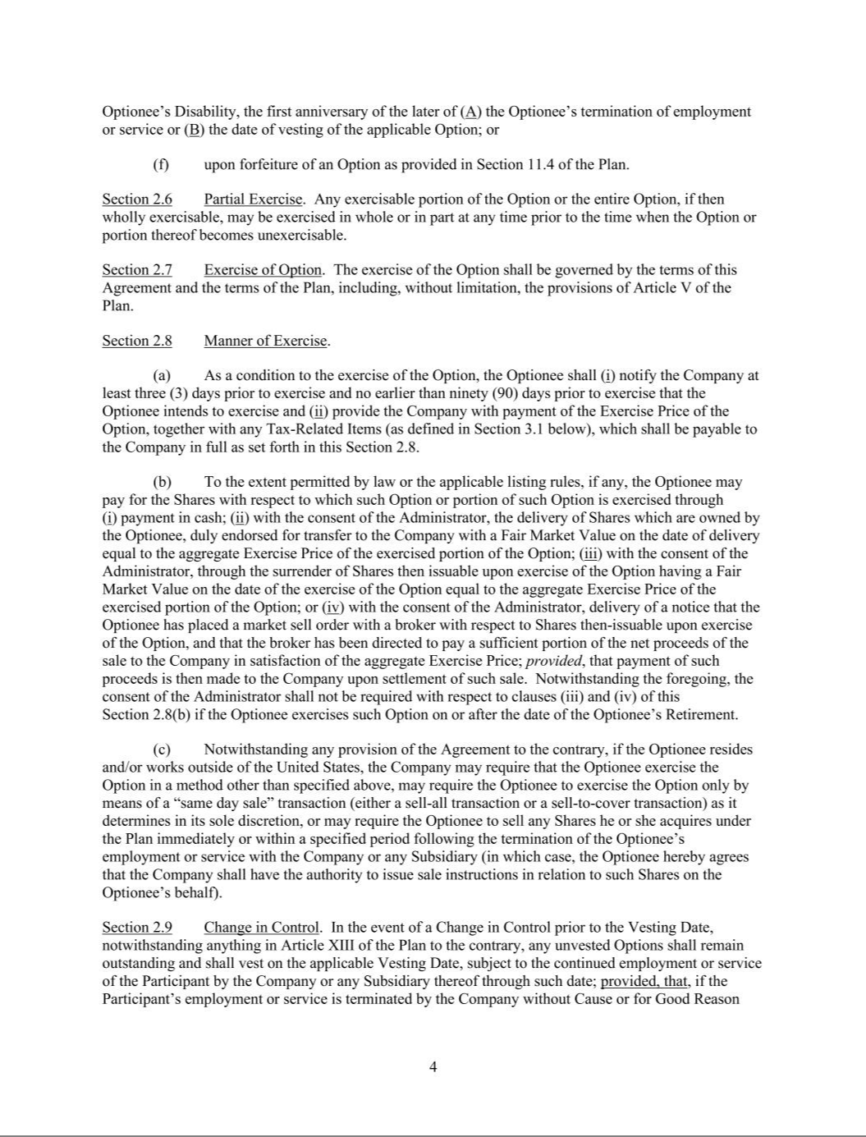

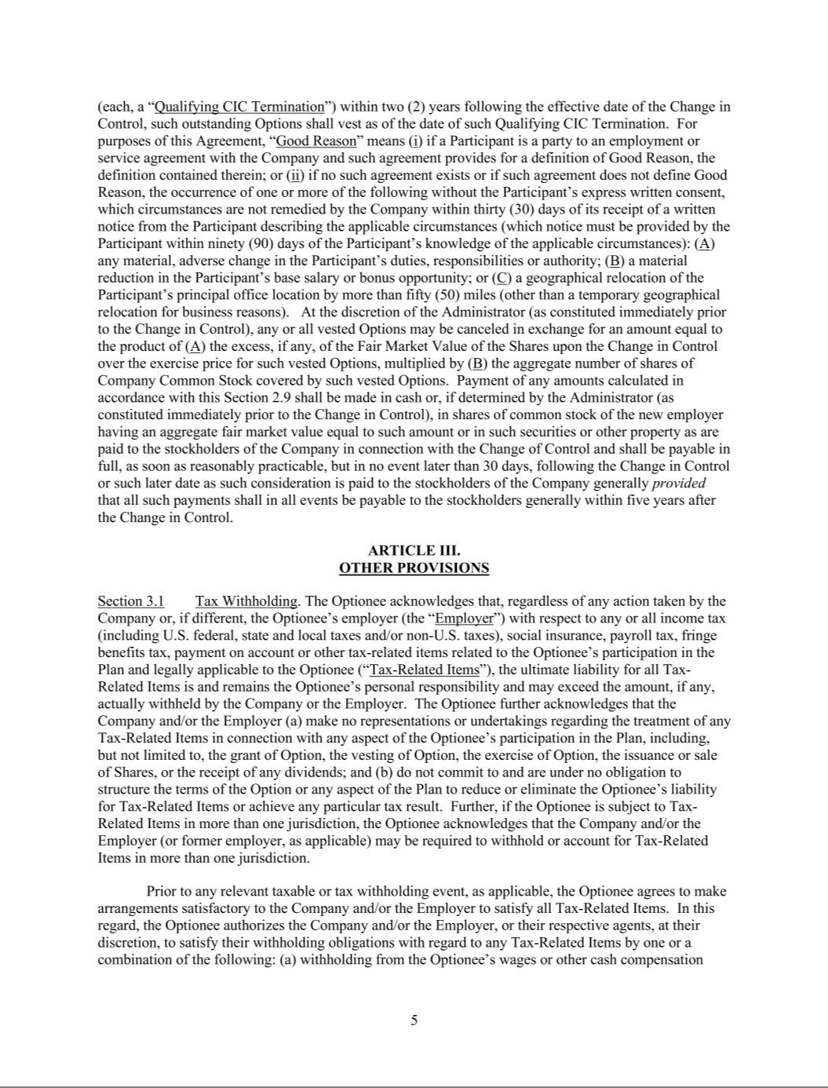

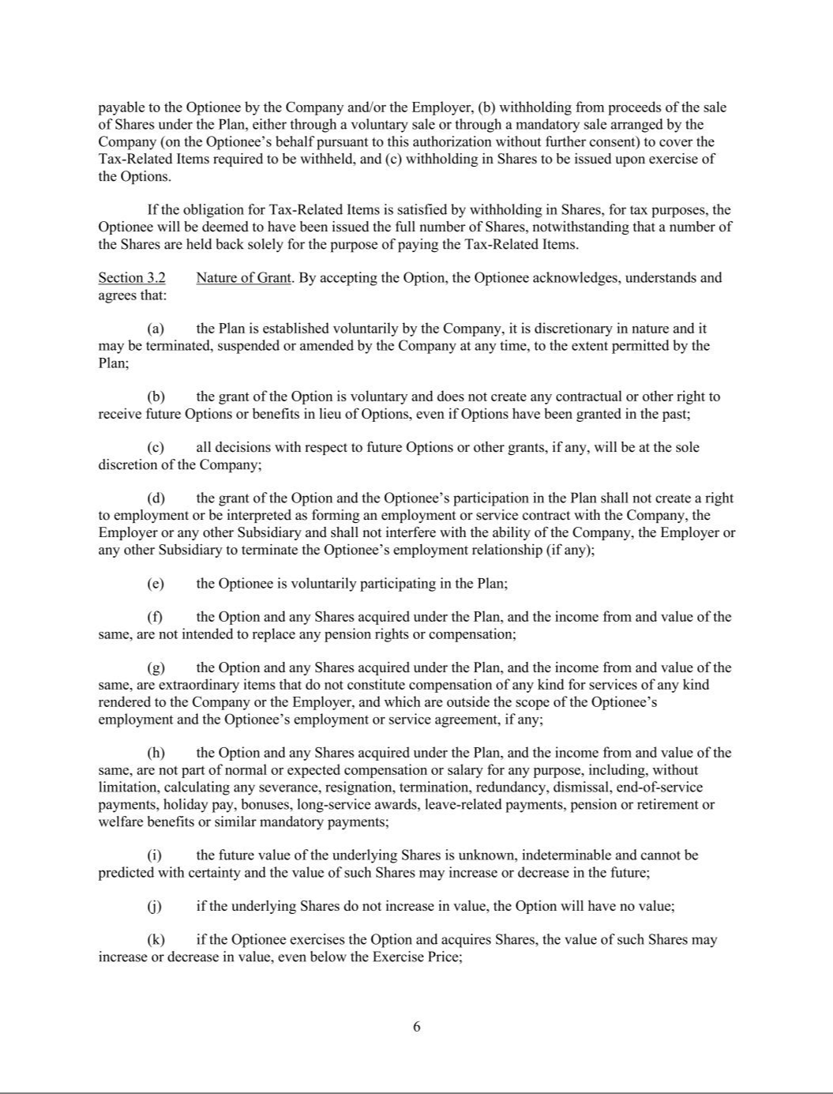

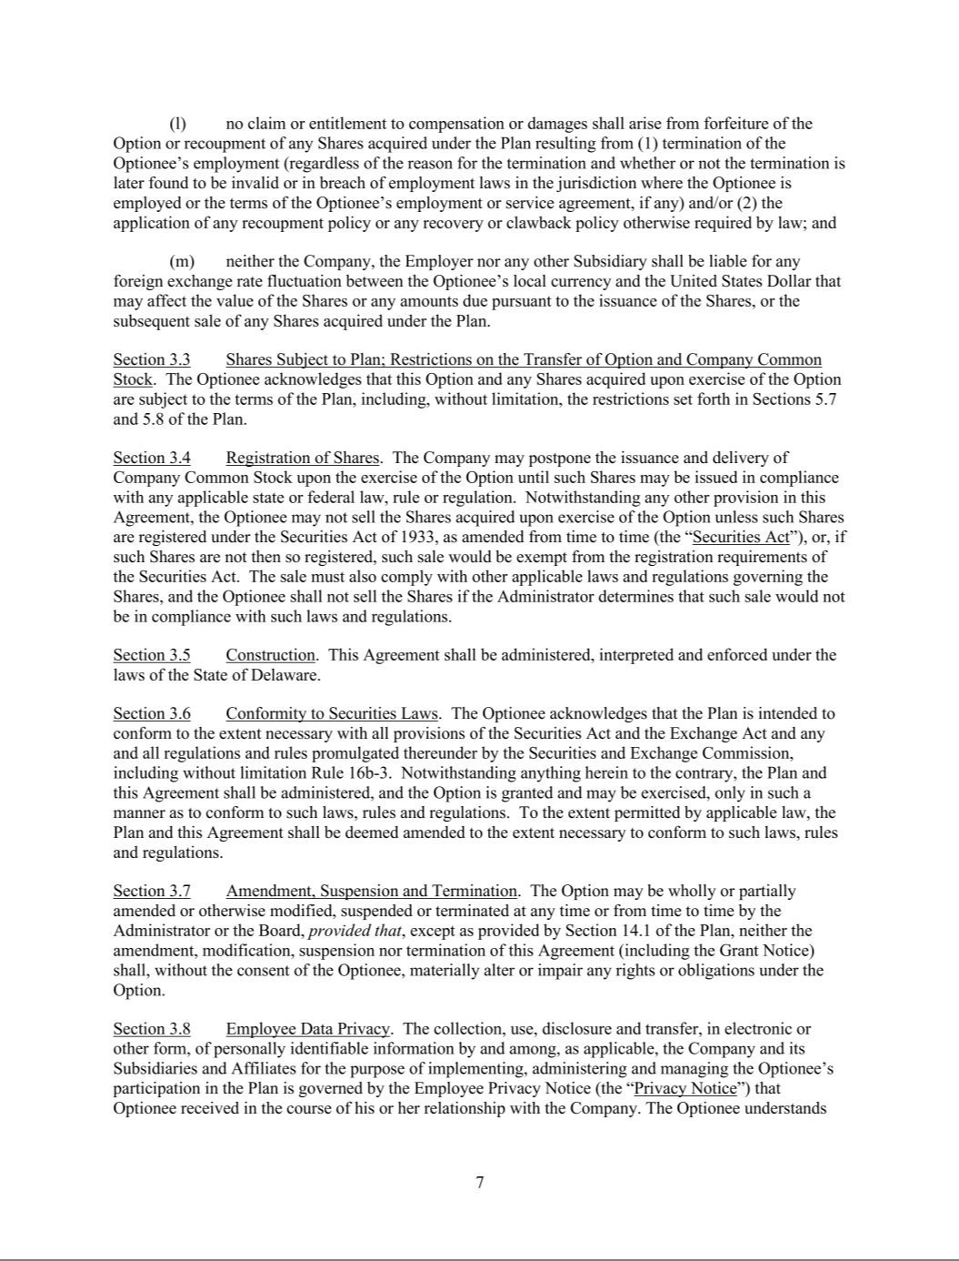

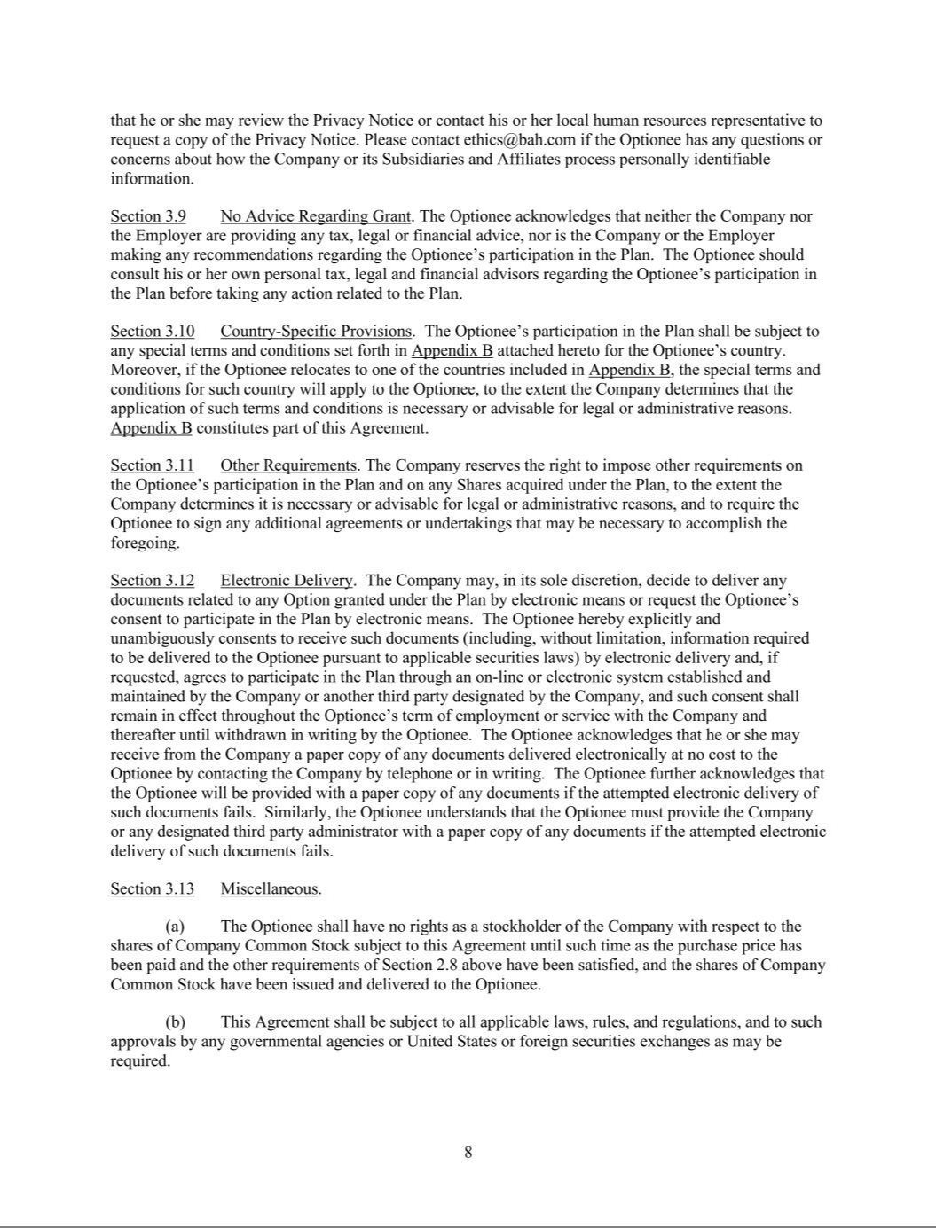

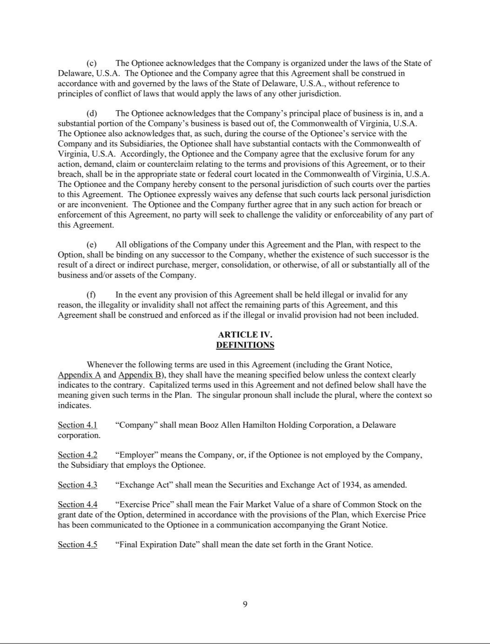

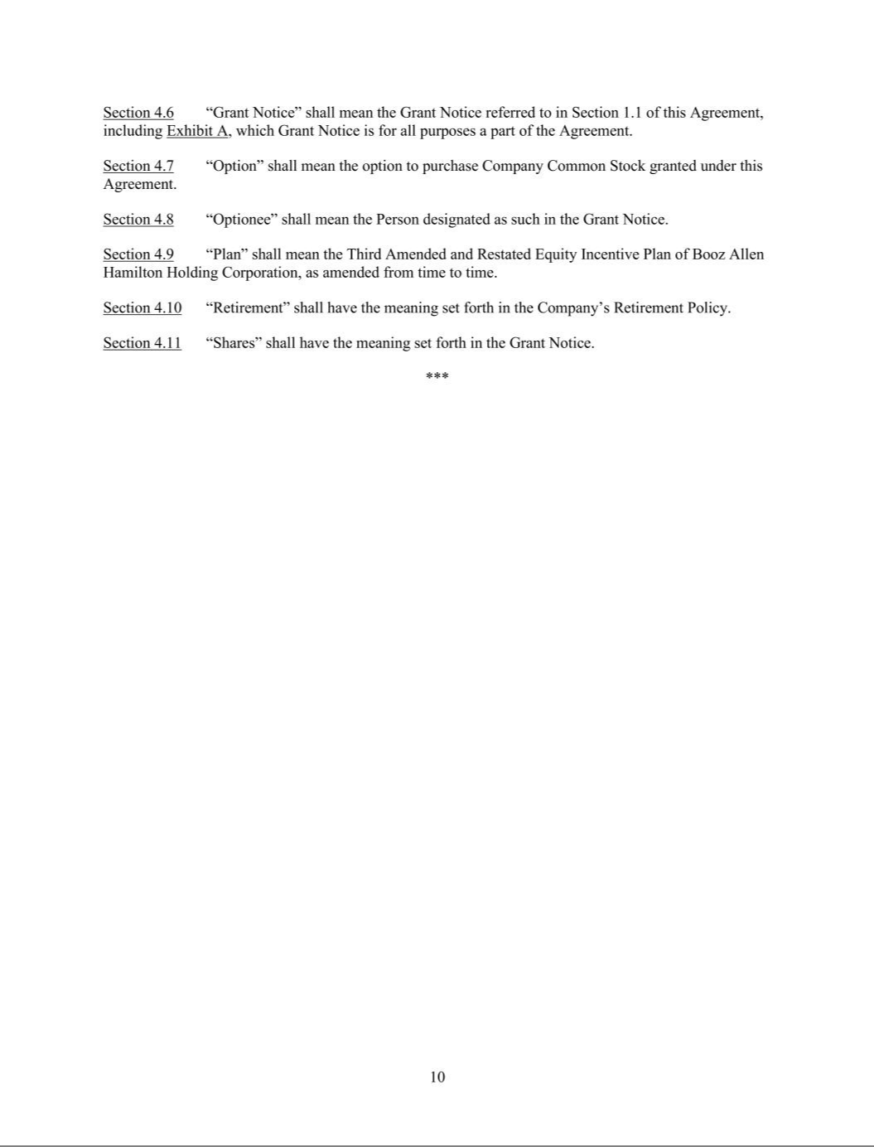

Performance Restricted Stock Unit Agreement

THIRD AMENDED AND RESTATED EQUITY INCENTIVE PLAN OF

BOOZ ALLEN HAMILTON HOLDING CORPORATION

PERFORMANCE RESTRICTED STOCK UNIT AGREEMENT

GRANT NOTICE

Unless otherwise defined herein, the terms defined in the Third Amended and Restated Equity Incentive Plan (the “Plan”) of Booz Allen Hamilton Holding Corporation (the “Company”) shall have the same defined meanings in this Performance Restricted Stock Unit Agreement, which includes the terms in this Grant Notice, including Exhibit A (the
“Grant Notice”), Appendix A attached hereto and any special terms and conditions set out in Appendix B attached hereto for your country of employment and/or residence (collectively, the “Agreement”).

You have been granted performance-based restricted stock units, subject to the terms and conditions of the Plan and this Agreement in an amount, vesting schedule and

subject to satisfaction of the performance goals for the applicable performance period (as set forth on Exhibit A to this Agreement), as delivered and made available to you by the Company, which shall be deemed part of and incorporated by reference into this Grant Notice.

Your acceptance of this grant indicates your agreement and understanding that the Performance Restricted Stock Units granted herein are subject to all of the terms and
conditions contained in the Agreement and the Plan. ACCORDINGLY, PLEASE BE SURE TO READ ALL OF THE PLAN AND APPENDIX A, APPENDIX B AND
EXHIBIT A, WHICH CONTAIN THE SPECIFIC TERMS AND CONDITIONS OF THE PERFORMANCE RESTRICTED STOCK UNITS.

In order to view the grant details and to accept this grant, please go to Fidelity NetBenefits at www.netbenefits.com and follow the instructions regarding this grant.

APPENDIX A TO PERFORMANCE RESTRICTED STOCK UNIT AGREEMENT

- Grant of Restricted Stock Units. Subject to the terms, conditions, and restrictions set forth in this Agreement (including the Grant Notice and any special terms and conditions for the Participant’s country set forth in Appendix B to this Agreement) and in the Plan, the Company hereby evidences and confirms its grant to the Participant, effective as of the Grant Date, of the target number of performance restricted stock units (the “Target Award”) specified in the Grant Notice. Each performance restricted stock unit (a “Restricted Stock Unit”) represents the right to receive a number of shares of Company Common Stock (which could be less than or greater than one share), subject to the terms and conditions set forth in this Agreement (including Exhibit A and Appendix B) and in the Plan. Except as otherwise provided in Section 2, the number of Restricted Stock Units that the Participant shall actually earn for the Performance Period (up to the maximum specified in the Grant Notice) will be determined by the Administrator based on the level of achievement of the performance goals specified in Exhibit A (the “Performance Goals”). This Agreement is subordinate to, and the terms and conditions of the Restricted Stock Units granted hereunder are subject to, the terms and conditions of the Plan, which are incorporated by reference herein. If there is any inconsistency between the terms hereof and the terms of the Plan, the terms of the Plan shall govern. Any capitalized terms used herein without definition shall have the meanings set forth in the Plan.

- Vesting of Restricted Stock Units.

- Vesting. For purposes of this Agreement, the term “Performance Period” shall mean the period set forth in Exhibit A. The Restricted Stock Units are subject to forfeiture until they vest. Except as otherwise provided in this Section 2, the Restricted Stock Units shall become vested as of the vesting date specified in Exhibit A (the “Vesting Date”), subject to the continued employment or service of the Participant by the Company or any Subsidiary thereof through the Vesting Date, and to the achievement of the Performance Goals set forth in Exhibit A for the Performance Period as determined by the Administrator pursuant to Section 3(a). Restricted Stock Units that do not vest in accordance with this Section 2 shall be forfeited.

- Termination of Employment.

  - Termination Due to Death. If a Participant’s employment or service terminates due to the Participant’s death prior to the Vesting Date, all unvested Restricted Stock Units shall vest on the effective date of such termination of employment or service at Target Award levels. Vested Restricted Stock Units shall be settled as set forth in Section 3.

  - Termination by Reason of Disability. If a Participant’s employment or service terminates prior to the Vesting Date by reason of the Participant’s Disability, then, the Participant’s unvested Restricted Stock Units shall vest as of the Vesting Date in a pro rata amount of the Restricted Stock Units that would have been earned and vested in accordance with Section 2(a) based on actual achievement of the Performance Goals as if the Participant’s employment or service had not terminated, with such amount prorated for the portion of the Performance Period that lapsed prior to the Participant’s termination of employment or service; provided, that, any transition period (within the meaning of the Company’s Transition Policy, as may be amended from time to time) shall not be considered a period of employment or service for purposes of calculating the pro rata amount. Vested Restricted Stock Units shall be settled as set forth in Section 3.

  - Termination by Reason of Retirement. (A) If a Participant’s employment or service terminates prior to the Vesting Date by reason of a Participant’s Qualifying Permanent Retirement (as defined below), provided that such termination occurs on or after March 31 (or if March 31 is not a business day, the last business day prior to March 31) of the first fiscal year of the Performance Period, the unvested Restricted Stock Units shall vest in accordance with Section 2(a) based on actual achievement of the Performance Goals as if the Participant’s employment or service had not terminated; (B) if a Participant’s employment or service terminates prior to March 31 (or if March 31 is not a business day, the last business day prior to March 31) of the first fiscal year of the Performance Period by reason of a Participant’s retirement (notwithstanding that such retirement may otherwise qualify as a Qualifying Permanent Retirement), all unvested Restricted Stock Units shall immediately be forfeited as of the

termination date; and (C) if a Participant’s employment or service terminates at any point prior to the Vesting Date by reason of a Participant’s retirement that at any point during the

Performance Period does not constitute a Qualifying Permanent Retirement, all unvested Restricted Stock Units shall immediately be forfeited as of the termination date or, if later, the date such retirement does not constitute a Qualifying Permanent Retirement. Vested Restricted Stock Units shall be settled as set forth in Section 3. “Qualifying Permanent
Retirement” means a termination of the Participant’s employment or service by reason of a retirement (I) in accordance with the applicable Company retirement policy (as may be

amended from time to time) and (II) that is a permanent retirement from all current and future employment, including but not limited to self-employment, unless such employment is approved by the Company in writing in advance of the Participant commencing such employment.

  - Termination for Cause. If a Participant’s employment or service terminates for Cause, all unvested Restricted Stock Units shall be immediately forfeited and canceled, effective as of the date of the Participant’s termination of service. In addition, any Restricted Stock Units that vested during the twelve (12) months prior to or any time after the Participant engaged in the conduct that gave rise to the termination for Cause (and any stock or cash issued in settlement of such Restricted Stock Units) shall upon demand by the Administrator be immediately forfeited and disgorged or paid to the Company together with all gains earned or accrued due to the sale of Company Common Stock issued in settlement of any Restricted Stock Units.

  - Termination for Any Other Reason. If a Participant’s employment terminates for any reason other than death, Disability, in a Qualifying Permanent Retirement or by the Company for Cause, all unvested Restricted Stock Units shall immediately be forfeited.

- Change in Control. In the event of a Change in Control prior to the Vesting Date, notwithstanding anything in Article XIII of the Plan to the contrary, an amount of Restricted Stock Units equal to the Target Award shall remain outstanding and shall vest on the Vesting Date, subject to the continued employment or service of the Participant by the Company or any Subsidiary thereof through such date, but without regard to achievement of any Performance Goals; provided, that, if the Participant’s employment or service is terminated by the Company without Cause or for Good Reason (each, a “Qualifying CIC Termination”) within two (2) years following the effective date of the Change in Control, such outstanding Restricted Stock Units shall vest as of the date of such Qualifying CIC Termination. Vested Restricted Stock Units shall be settled as set forth in Section 3. For purposes of this Agreement, “Good Reason” means (i) if a Participant is a party to an employment or service agreement with the Company and such agreement provides for a definition of Good Reason, the definition contained therein; or (ii) if no such agreement exists or if such agreement does not define Good Reason, the occurrence of one or more of the following without the Participant’s express written consent, which circumstances are not remedied by the Company within thirty (30) days of its receipt of a written notice from the Participant describing the applicable circumstances (which notice must be provided by the Participant within ninety (90) days of the Participant’s knowledge of the applicable circumstances): (A) any material, adverse change in the Participant’s duties, responsibilities or authority; (B) a material reduction in the Participant’s base salary or bonus opportunity; or (C) a geographical relocation of the Participant’s principal office location by more than fifty (50) miles (other than a temporary geographical relocation for business reasons).

- Other Forfeiture Provisions. The Restricted Stock Units shall also be forfeited and subject to disgorgement and/or repayment to the Company in the event the Participant (i) engages in financial or other misconduct (including but not limited to engaging in Competitive Activity (excluding, only of if the Participant is located in California, clause (a) of the definition of Competitive Activity contained in the Plan)) or as required by Applicable Law, as provided in the Plan or (ii) materially violates any restrictive covenant agreement (or any other agreement containing restrictive covenants) that the Participant has entered into with the Company.

- Administrator Discretion. Notwithstanding anything contained in this Agreement to the contrary, subject to Article XIII of the Plan, the Administrator, in its sole discretion, may waive forfeiture provisions or accelerate the vesting with respect to any Restricted Stock Units under this Agreement, at such times and upon such terms and conditions as the Administrator shall determine; provided, however,

that such waiver or acceleration of vesting shall not change the settlement date of the Restricted Stock Units provided in Section 3 of this Agreement.

- Post-Termination Informational Requirements. Before the settlement of any Restricted Stock Units following termination of employment or service, the Company may require the Participant (or the Participant’s Eligible Representative, if applicable) to make such representations and provide such documents as the Administrator deems necessary or advisable to determine whether the provisions of Section 2(b)(iii), 2(b)(iv) or 2(d) apply. Such representations and documents may include tax returns and all other relevant information and records from which the Company can determine the current or former employment status of the Participant during the Performance Period. Notwithstanding anything in this Agreement to the contrary, the settlement of the Restricted Stock Units may be withheld until information deemed sufficient by the Company is delivered to it, and any unvested Restricted Stock Units shall be forfeited if the requested information is not provided in sufficient detail to the Company before the earlier of (i) ninety (90) calendar days after the issue of a request from the Company for such information and (ii) December 31 of the calendar year in which the Vesting Date occurs.

- Administrator Certification; Settlement of Restricted Stock Units.

- Certification. As soon as practicable following completion of the Performance Period, the Administrator will review and determine (i) whether, and to what extent, the Performance Goals for the Performance Period have been achieved, in whole or in part, and (ii) the number of Restricted Stock Units that the Participant shall earn, if any, subject to compliance with the requirements of Section 2 (the “Administrator Certification”). All determinations of whether the Performance Goals have been achieved, the number of Restricted Stock Units earned by the Participant, and all other matters related to this Section 3(a) shall be made by the Administrator in its sole discretion and shall be final, conclusive and binding on the Participant.

- Settlement of Restricted Stock Units. Subject to Sections 8(d), 2(f) and 3(a), the Company shall deliver to the Participant one (1) share of Company Common Stock (or the value thereof) in settlement of each Restricted Stock Unit that has become earned and vested as provided in Section 2 on the first to occur of the following: (i) on or as soon as practicable following the date of the Administrator Certification (but in no event later than 2½ months after the Vesting Date); (ii) in the event of a termination of employment or service due to death, as soon as practicable following the Participant’s termination of employment or service by reason of death; (iii) in the event of a Qualifying CIC Termination, within thirty (30) days following the effective date of the Participant’s Qualifying CIC Termination, in each case (A) in Company Common Stock by either, (x) issuing one or more certificates evidencing the Company Common Stock to the Participant or (y) registering the issuance of the Company Common Stock in the name of the Participant through a book entry credit in the records of the Company’s transfer agent, or (B) in the event of settlement upon a Change in Control, a cash payment equal to the Change in Control Price, multiplied by the number of vested Restricted Stock Units. No fractional shares of Company Common Stock shall be issued in settlement of Restricted Stock Units. Fractional shares shall be rounded up to the nearest whole share; provided, that the Participant may not vest in more than the maximum number of Restricted Stock Units specified in the Grant Notice.

Notwithstanding the foregoing, the Company, in its sole discretion, may provide for the settlement of the Restricted Stock Units in the form of Company Common Stock, but require the Participant to sell such Common Stock immediately or within a specified period following the Participant’s termination of service (in which case, the Participant hereby agrees
that the Company shall have the authority to issue sale instructions in relation to such Common Stock on the Participant’s behalf).

- Securities Law Compliance. Notwithstanding any other provision of this Agreement, the Participant may not sell the shares of Company Common Stock acquired upon vesting of the Restricted Stock Units unless such shares are registered under the Securities Act of 1933, as amended (the “Securities Act”), or, if such shares are not then so registered, such sale would be exempt from the registration requirements of the Securities Act. The sale of such shares must also comply with other applicable laws and regulations governing the shares and Participant may not sell the shares of Company Common Stock if the Company determines that such sale would not be in material compliance with such laws and regulations.

- Participant’s Rights with Respect to the Restricted Stock Units.

- Restrictions on Transferability. The Restricted Stock Units granted hereby are not assignable or transferable, in whole or in part, and may not, directly or indirectly, be offered, transferred, sold, pledged, assigned, alienated, hypothecated or otherwise disposed of or encumbered (including without limitation by gift, operation of law or otherwise) other than by will or by the laws of descent and distribution to the estate of the Participant upon the Participant’s death; provided that the deceased Participant’s beneficiary or representative of the Participant’s estate shall acknowledge and agree in writing, in a form reasonably acceptable to the Company, to be bound by the provisions of this Agreement and the Plan as if such beneficiary or the estate were the Participant.

- No Rights as Stockholder. The Participant shall not have any rights as a stockholder including any voting, dividend or other rights or privileges as a stockholder of the Company with respect to any Company Common Stock corresponding to the Restricted Stock Units granted hereby unless and until shares of Company Common Stock are issued to the Participant in respect thereof.

- Dividend Equivalents. If the Company declares a cash dividend on the shares of Company Common Stock, then the Participant shall be credited with Dividend Equivalents in the form of a right to a cash payment equal to (i) the amount of the dividend declared and paid for each share of Company Common Stock, multiplied by (ii) (x) the number of Restricted Stock Units earned by the Participant as determined by the Administrator pursuant to Section 3(a) or (y) in the case of a termination of employment or service by reason of Death or a Qualifying CIC Termination, the number of Restricted Stock Units equal to the Target Award. Dividend Equivalents shall be subject to the same forfeiture restrictions as the Restricted Stock Units to which they are attributable and shall be paid on the same date the Restricted Stock Units to which they are attributable are settled in accordance with Section 3 hereof. Dividend Equivalents credited to a Participant shall be distributed in cash or, at the discretion of the Administrator, in shares of Company Common Stock having a Fair Market Value equal to the amount of the Dividend Equivalents, if any.

- Participant’s Representations, Warranties and Covenants.

- No Conflicts; No Consents. The execution and delivery by the Participant of this Agreement, the consummation of the transactions contemplated hereby and the performance of the Participant’s obligations hereunder do not and will not (i) materially conflict with or result in a material violation or breach of any term or provision of any Law applicable to either the Participant or the Restricted Stock Units or (ii) violate in any material respect, conflict with in any material respect or result in any material breach of, or constitute (with or without notice or lapse of time or both) a material default under, or require either the Participant to obtain any consent, approval or action of, make any filing with or give any notice to any Person as a result or under the terms of, any contract, agreement, instrument, commitment, arrangement or understanding to which the Participant is a party.

- Compliance with Rule 144. If any shares of Company Common Stock issued in respect of the Restricted Stock Units are to be disposed of in accordance with Rule 144, the Participant shall transmit to the Company an executed copy of Form 144 (if required by Rule 144) no later than the time such form is required to be transmitted to the Commission for filing and such other documentation as the Company may reasonably require to assure compliance with Rule 144 in connection with such disposition.

- Participant Status. The Participant represents and warrants that, as of the date hereof, the Participant is an officer, employee, director or Consultant of the Company

or a Subsidiary.

- Adjustment in Capitalization. The number, class or other terms of any outstanding Restricted Stock Units shall be adjusted by the Committee to reflect any stock dividend, stock split or share combination or any recapitalization, business combination, merger, consolidation, spin-off, exchange of shares, liquidation or dissolution of the Company or other similar transaction affecting the Company Common Stock in such manner as it determines in its sole discretion.

- Tax Withholding. The Participant acknowledges that, regardless of any action taken by the Company or the Employer with respect to any or all income tax (including U.S. federal, state and local taxes and/or non-U.S. taxes), social insurance, payroll tax, fringe benefits tax, payment on account or other tax-related items related to the Participant’s participation in the Plan and legally applicable to the Participant (“Tax-Related Items”), the ultimate liability for all Tax-Related Items is and remains the Participant’s personal responsibility and may exceed the amount, if any, actually withheld by the Company or the Employer. The Participant further acknowledges that the Company and/or the Employer (a) make no representations or undertakings regarding the treatment of any Tax-Related Items in connection with any aspect of the Participant’s participation in the Plan, including, but not limited to, the grant of Restricted Stock Units, the vesting of Restricted Stock Units, issuance or sale of shares of Company Common Stock, or the receipt of any dividends or Dividend Equivalents; and (b) do not commit to and are under no obligation to structure the terms of the Restricted Stock Units or any aspect of the Plan to reduce or eliminate the Participant’s liability for Tax-Related Items or achieve any particular tax result. Further, if the Participant is subject to Tax-Related Items in more than one jurisdiction, the Participant acknowledges that the Company and/or the Employer (or former employer, as applicable) may be required to withhold or account for Tax-Related Items in more than one jurisdiction.

Prior to any relevant taxable or tax withholding event, as applicable, the Participant agrees to make arrangements satisfactory to the Company and/or the Employer to satisfy all Tax-Related Items. In this regard, the Participant authorizes the Company and/or the Employer, or their respective agents, at their discretion, to satisfy their withholding
obligations with regard to any Tax-Related Items by one or a combination of the following: (a) withholding from the Participant’s wages or other cash compensation payable to the

Participant by the Company and/or the Employer, (b) withholding from proceeds of the sale of shares of Company Common Stock under the Plan, either through a voluntary sale or through a mandatory sale arranged by the Company (on the Participant’s behalf pursuant to this authorization without further consent) to cover the Tax-Related Items required to be
withheld, and (c) withholding in shares of Company Common Stock to be issued upon vesting of the Restricted Stock Units.

If the obligation for Tax-Related Items is satisfied by withholding in shares of Company Common Stock, for tax purposes, the Participant will be deemed to have been issued the full number of shares of Company Common Stock, notwithstanding that a number of the shares of Company Common Stock are held back solely for the purpose of
paying the Tax-Related Items.

The Company or the Employer may defer the settlement of Restricted Stock Units until such withholding or other tax requirements are satisfied and if the Participant has not satisfied such withholding or other tax requirements as of the last day of the calendar year in which the Vesting Date occurs, the Restricted Stock Units shall be forfeited.

- Nature of Grant. By accepting the Restricted Stock Units, the Participant acknowledges, understands and agrees that:

- the Plan is established voluntarily by the Company, it is discretionary in nature and it may be terminated, suspended or amended by the Company at any time, to the extent permitted by the Plan;

- the grant of Restricted Stock Units is voluntary and does not create any contractual or other right to receive future Restricted Stock Units or benefits in lieu of Restricted Stock Units, even if Restricted Stock Units have been granted in the past;

- all decisions with respect to future Restricted Stock Units or other grants, if any, will be at the sole discretion of the Company;

- the grant of Restricted Stock Units and the Participant’s participation in the Plan shall not create a right to employment or be interpreted as forming an employment or service contract with the Company, the Employer or any other Subsidiary and shall not interfere with the ability of the Company, the Employer or any other Subsidiary to terminate the Participant’s employment relationship (if any);

- the Participant is voluntarily participating in the Plan;

- the Restricted Stock Units and any shares of Company Common Stock acquired under the Plan, and the income from and value of the same, are not intended to replace any pension rights or compensation;

- the Restricted Stock Units and any shares of Company Common Stock acquired under the Plan, and the income from and value of the same, are extraordinary items that do not constitute compensation of any kind for services of any kind rendered to the Company or the Employer, and which are outside the scope of the Participant’s employment and the Participant’s employment or service agreement, if any;

- the Restricted Stock Units and any shares of Company Common Stock acquired under the Plan, and the income from and value of the same, are not part of normal or expected compensation or salary for any purpose, including, without limitation, calculating any severance, resignation, termination, redundancy, dismissal, end-of-service payments, holiday pay, bonuses, long-service awards, leave-related payments, pension or retirement or welfare benefits or similar mandatory payments;

- the future value of the underlying shares of Company Common Stock is unknown, indeterminable and cannot be predicted with certainty and the value of such shares of Company Common Stock may increase or decrease in the future;

- no claim or entitlement to compensation or damages shall arise from forfeiture of the Restricted Stock Units or recoupment of any shares of Company Common Stock acquired under the Plan resulting from (1) termination of the Participant’s employment (regardless of the reason for the termination and whether or not the termination is later found to be invalid or in breach of employment laws in the jurisdiction where the Participant is employed or the terms of the Participant’s employment or service agreement, if any) and/or (2) the application of any recoupment policy or any recovery or clawback policy otherwise required by law; and

- neither the Company, the Employer nor any other Subsidiary shall be liable for any foreign exchange rate fluctuation between the Participant’s local currency and the United States Dollar that may affect the value of the shares of Company Common Stock or any amounts due pursuant to the issuance of the shares of Company Common Stock, or the subsequent sale of any shares of Company Common Stock acquired under the Plan.

- Employee Data Privacy. The collection, use, disclosure and transfer, in electronic or other form, of personally identifiable information to facilitate the grant of the Award and the administration of the Plan by and among, as applicable, the Company and the Participant’s employer, if different, any of the Company’s affiliates, any agent of the Company administering or providing Plan services is governed by the Employee Privacy Notice (the “Privacy Notice”) that Participant received in the course of his or her relationship with Company. The Participant understands that he or she may review the Privacy Notice or contact his or her local human resources representative to request a copy of the Privacy Notice. Please contact ethics@bah.com if the Participant has any questions or concerns about how the Company or its subsidiaries and affiliates process personally identifiable information.

- Miscellaneous.

- Binding Effect; Benefits. This Agreement shall be binding upon and inure to the benefit of the parties to this Agreement and their respective successors and assigns. Nothing in this Agreement, express or implied, is intended or shall be construed to give any person other than the parties to this Agreement or their respective successors or assigns any legal or equitable right, remedy or claim under or in respect of any agreement or any provision contained herein.

- No Advice Regarding Grant. The Participant acknowledges that neither the Company nor the Employer are providing any tax, legal or financial advice, nor is the Company or the Employer making any recommendations regarding the Participant’s participation in the Plan. The Participant should consult his or her own personal tax, legal and financial advisors regarding the Participant’s participation in the Plan before taking any action related to the Plan.

- Interpretation. For purposes of this Agreement, if the Participant is not employed by the Company, “Employer” means the Subsidiary that employs the Participant. This Agreement is subject to the terms and conditions of the Plan. In the event of any inconsistency between the provisions of this Agreement and the Plan, the Plan shall govern. The Administrator, acting pursuant to the Plan, as constituted from time to time, shall, except as expressly provided otherwise herein, have the right to determine reasonably and in good faith any questions that arise in connection with this Agreement, and any such determination shall be final, binding and conclusive on all Participants and other individuals claiming any right under the Plan. The failure of the Company or the Participant to insist upon strict performance of any provision hereunder, irrespective of the length of time for which such failure continues, shall not be deemed a waiver of such party’s right to demand strict performance at any time in the future. No consent or waiver, express or implied, to or of any breach or default in the performance of any obligation or provision hereunder shall constitute a consent or waiver to or of any other breach or default in the performance of the same or any other obligation hereunder.

- Country-Specific Provisions. The Participant’s participation in the Plan shall be subject to any special terms and conditions set forth in Appendix B attached hereto for the Participant’s country. Moreover, if the Participant relocates to one of the countries included in Appendix B, the special terms and conditions for such country will apply to the Participant, to the extent the Company determines that the application of such terms and conditions is necessary or advisable for legal or administrative reasons. Appendix B constitutes part of this Agreement.

- Other Requirements. The Company reserves the right to impose other requirements on the Participant’s participation in the Plan and on any shares of Company Common Stock acquired under the Plan, to the extent the Company determines it is necessary or advisable for legal or administrative reasons, and to require the Participant to sign any additional agreements or undertakings that may be necessary to accomplish the foregoing.

- Applicable Law. The Participant acknowledges that the Company is organized under the laws of the State of Delaware, U.S.A. The Participant and the Company agree that this Agreement shall be construed in accordance with and governed by the laws of the State of Delaware, U.S.A., without reference to principles of conflict of laws that would apply the laws of any other jurisdiction.

- Forum Selection. The Participant acknowledges that the Company’s principal place of business is in, and a substantial portion of the Company’s business is based out of, the Commonwealth of Virginia, U.S.A. The Participant also acknowledges that, as such, during the course of the Participant’s service with the Company and its Subsidiaries, the Participant shall have substantial contacts with the Commonwealth of Virginia, U.S.A. Accordingly, the Participant and the Company agree that the exclusive forum for any action, demand, claim or counterclaim relating to the terms and provisions of this Agreement, or to their breach, shall be in the appropriate state or federal court located in the Commonwealth of Virginia, U.S.A. The Participant and the Company hereby consent to the personal jurisdiction of such courts over the parties to this Agreement. The Participant expressly waives any defense that such courts lack personal jurisdiction or are inconvenient. The Participant and the Company further agree that in any such action for breach or enforcement of this Agreement, no party will seek to challenge the validity or enforceability of any part of this Agreement.

- Amendment. This Agreement may not be amended, modified or supplemented orally, but only by a written instrument executed by the Participant and the Company.

- Assignability. Neither this Agreement nor any right, remedy, obligation or liability arising hereunder or by reason hereof shall be assignable by the Company or the Participant without the prior written consent of the other party, provided that the Company may assign all or any portion of its rights or obligations under this Agreement to one or more persons or other entities designated by it.

- Severability; Blue Pencil. In the event that any one or more of the provisions of this Agreement shall be or become invalid, illegal or unenforceable in any respect, the validity, legality and enforceability of the remaining provisions contained herein shall not be affected thereby.

- Consent to Electronic Delivery. By entering into this Agreement and accepting the Restricted Stock Units evidenced hereby, Participant hereby consents to the delivery of information (including, without limitation, information required to be delivered to the Participant pursuant to applicable securities laws) regarding the Company and the Subsidiaries, the Plan, this Agreement and the Restricted Stock Units via Company website, the Fidelity NetBenefits website or any other online access system of the Company’s third party Plan administrator, email or other electronic delivery.

- Section 409A of the Code. This Agreement is intended to be administered in a manner consistent with the requirements, where applicable, of Section 409A of the Code and the regulations promulgated thereunder (“Section 409A”). Where reasonably practicable, the Agreement shall be administered in a manner to avoid the imposition on the Participant of immediate tax recognition and additional taxes pursuant to Section 409A. In addition, to the extent permissible under Section 409A, any series of installment payments under this Agreement shall be treated as a right to a series of separate payments. Notwithstanding the foregoing, the Company shall not have any liability to any Person in the event Section 409A applies to any payment hereunder in a manner that results in adverse tax consequences to the Participant or any of the Participant’s beneficiaries.

- Specified Employee Delay. If the Participant is deemed a “specified employee” within the meaning of Section 409A, as determined by the Committee, at a time when the Participant becomes eligible for settlement of the Restricted Stock Units upon his or her “separation from service” within the meaning of Section 409A, then to the extent necessary to prevent any accelerated or additional tax under Section 409A, such settlement will be delayed until the earlier of: (a) the date that is six months following the Participant’s termination of service and (b) the Participant’s death. Notwithstanding anything to the contrary in this Agreement, if settlement is to occur upon a termination of service other than due to death or Disability and the Participant is a specified employee, to the extent necessary to comply with, and avoid imposition on the Participant of any additional tax or interest imposed under, Section 409A, settlement shall instead occur on the first business day following the six-month anniversary of the Participant’s termination of service (or, if earlier, upon the Participant’s death), or as soon thereafter as practicable (but no later than 90 days thereafter).

- Headings and Captions. The section and other headings contained in this Agreement are for reference purposes only and shall not affect the meaning or interpretation of this Agreement.

- Notices. All notices under this Agreement shall be (i) delivered by hand, (ii) sent by commercial overnight courier service, (iii) sent by registered or certified mail, return receipt requested, and first-class postage prepaid, (iv) sent by e-mail or any other form of electronic transfer or delivery approved by the Administrator, or (v) faxed, in each case to the parties at their respective addresses and facsimile numbers set forth in the records of the Company or at such other address or facsimile number as may be designated in a notice by either party to the other.

- Counterparts. This Agreement may be executed in any number of counterparts, each of which shall be deemed to be an original and all of which together shall constitute one and the same instrument.

Exhibit 21

List of Subsidiaries of Booz Allen Hamilton Holding Corporation

Name
Booz Allen Commercial Cyber (SG), Pte. Ltd. |  | Singapore
Booz Allen Commercial Cyber (UK), Ltd. |  | United Kingdom
Booz Allen Commercial Cyber Holdings, LLC |  | Delaware
Booz Allen Commercial Cyber, LLC |  | Delaware
Booz Allen Cyber Solutions, LLC |  | Delaware
Booz Allen Hamilton (Dubai) Limited |  | Dubai, UAE
Booz Allen Hamilton (Ireland) Limited |  | Ireland
Booz Allen Hamilton Consulting Pte. Ltd. |  | Singapore
Booz Allen Hamilton Egypt, LLC |  | Egypt
Booz Allen Hamilton Engineering Holding Co., LLC |  | Delaware
Booz Allen Hamilton Engineering Services, LLC |  | Lebanon
Booz Allen Hamilton Inc. |  | Delaware
Booz Allen Hamilton Intellectual Property Holdings, LLC |  | Delaware
Booz Allen Hamilton International (U.K.) Ltd. |  | United Kingdom
Booz Allen Hamilton International Pte. Ltd. |  | Singapore
Booz Allen Hamilton International, Inc. |  | Delaware
Booz Allen Hamilton Investor Corporation |  | Delaware
Booz Allen Hamilton Lebanon S.a.r.l. |  | Lebanon
Booz Allen Hamilton Netherlands B.V. |  | Netherlands
Booz Allen Hamilton Philippines Inc. |  | Philippines
Booz Allen Hamilton Saudi |  | Saudi Arabia
Booz Allen Hamilton Singapore Holding Company Pte. Ltd. |  | Singapore
Booz Allen Hamilton Singapore LLP |  | Singapore
Booz Allen Hamilton Tanzania Limited |  | Tanzania
Booz Allen Ventures, LLC |  | Delaware
PT Booz Allen Hamilton Indonesia |  | Indonesia
Analysis, Computing & Engineering Solutions, Inc. |  | Maryland

Exhibit 21

Aquilent, Inc. |  | Delaware
BrainTrust Holdings, LLC |  | Maryland
Cloud Solutions Group, Inc. |  | Delaware
DataPoint Services, LLC |  | Delaware
eGov Holdings, Inc. |  | Delaware
Epic Acquisition Software, Inc. |  | Delaware
Epidemico, Inc. |  | Delaware
EverWatch Corp. |  | Delaware
HELworks, LLC |  | Delaware
Ian, Evan & Alexander Corporation |  | Colorado
Liberty IT Solutions, LLC |  | Delaware
Morphick, Inc. |  | Delaware
Northwood Global Solutions, LLC |  | Virginia
RAI Government Services LLC |  | Virginia
SDI Technology Corporation |  | Virginia
Threatology, Inc. |  | Delaware
ThunderYard Liberty JV LLC |  | Delaware
ThunderYard Solutions LLC |  | Delaware
Tracepoint Holdings, LLC |  | Delaware
Tracepoint LLC |  | Delaware
Warrior Technology LLC |  | Delaware

Consent of Independent Registered Public Accounting Firm

We consent to the incorporation by reference in the following Registration Statements:

- Form S-8 (No 333-205956) pertaining to the Second Amended and Restated Equity Incentive Plan of Booz Allen Hamilton Holding Corporation
- Form S-8 (No 333-171288) pertaining to the Amended and Restated Equity Incentive Plan of Booz Allen Hamilton Holding Corporation, Booz Allen Hamilton Holding Corporation Officers’ Rollover Stock Plan, and Booz Allen Hamilton Holding Corporation Employee Stock Purchase Plan

of our reports dated May 26, 2023, with respect to the consolidated financial statements of Booz Allen Hamilton Holding Corporation and the effectiveness of internal control over financial reporting of Booz Allen Hamilton Holding Corporation, included in this Annual Report (Form 10-K) of Booz Allen Hamilton Holding Corporation for the year ended
March 31, 2023.

/s/ Ernst & Young LLP

Tysons, Virginia
May 26, 2023

Exhibit 31.1

CERTIFICATION OF THE CHIEF EXECUTIVE OFFICER PURSUANT TO RULE 13A-14(A) OF THE

SECURITIES EXCHANGE ACT OF 1934, AS AMENDED

I, Horacio D. Rozanski, certify that:

- I have reviewed this Annual Report on Form 10-K of Booz Allen Hamilton Holding Corporation.

- Based on my knowledge, this report does not contain any untrue statement of a material fact or omit to state a material fact necessary to make the statements made, in light of the circumstances under which such statements were made, not misleading with respect to the period covered by this report.

- Based on my knowledge, the financial statements, and other financial information included in this report, fairly present in all material respects the financial condition, results of operations and cash flows of the registrant as of, and for, the periods presented in this report.

- The registrant’s other certifying officer and I are responsible for establishing and maintaining disclosure controls and procedures (as defined in Exchange Act Rules 13a-15(e) and 15d-15(e)) and internal control over financial reporting (as defined in Exchange Act Rules 13a-15(f) and 15d-15(f)) for the registrant and have:

- Designed such disclosure controls and procedures, or caused such disclosure controls and procedures to be designed under our supervision, to ensure that material information relating to the registrant, including its consolidated subsidiaries, is made known to us by others within those entities, particularly during the period in which this report is being prepared;

- Designed such internal control over financial reporting, or caused such internal control over financial reporting to be designed under our supervision, to provide reasonable assurance regarding the reliability of financial reporting and the preparation of financial statements for external purposes in accordance with generally accepted accounting principles;

- Evaluated the effectiveness of the registrant's disclosure controls and procedures and presented in this report our conclusions about the effectiveness of the disclosure controls and procedures, as of the end of the period covered by this report based on such evaluation; and

- Disclosed in this report any change in the registrant's internal control over financial reporting that occurred during the registrant's most recent fiscal quarter (the registrant's fourth fiscal quarter in the case of an annual report) that has materially affected, or is reasonably likely to materially affect, the registrant's internal control over financial reporting.

- The registrant's other certifying officer and I have disclosed, based on our most recent evaluation of internal control over financial reporting, to the registrant's auditors and the audit committee of the registrant's Board of Directors (or persons performing the equivalent function):

- All significant deficiencies and material weaknesses in the design or operation of internal control over financial reporting which are reasonably likely to adversely affect the registrant's ability to record, process, summarize and report financial information; and

- Any fraud, whether or not material, that involves management or other employees who have a significant role in the registrant's internal control over financial reporting.

Date: May 26, 2023 By: /s/ Horacio D. Rozanski

Horacio D. Rozanski
President and Chief Executive Officer
(Principal Executive Officer)

Exhibit 31.2

CERTIFICATION OF THE CHIEF FINANCIAL OFFICER PURSUANT TO RULE 13A-14(A) OF THE

SECURITIES EXCHANGE ACT OF 1934, AS AMENDED

I, Matthew A. Calderone, certify that:

- I have reviewed this Annual Report on Form 10-K of Booz Allen Hamilton Holding Corporation.

- Based on my knowledge, this report does not contain any untrue statement of a material fact or omit to state a material fact necessary to make the statements made, in light of the circumstances under which such statements were made, not misleading with respect to the period covered by this report.

- Based on my knowledge, the financial statements, and other financial information included in this report, fairly present in all material respects the financial condition, results of operations and cash flows of the registrant as of, and for, the periods presented in this report.

- The registrant’s other certifying officer and I are responsible for establishing and maintaining disclosure controls and procedures (as defined in Exchange Act Rules 13a-15(e) and 15d-15(e)) and internal control over financial reporting (as defined in Exchange Act Rules 13a-15(f) and 15d-15(f)) for the registrant and have:

- Designed such disclosure controls and procedures, or caused such disclosure controls and procedures to be designed under our supervision, to ensure that material information relating to the registrant, including its consolidated subsidiaries, is made known to us by others within those entities, particularly during the period in which this report is being prepared;

- Designed such internal control over financial reporting, or caused such internal control over financial reporting to be designed under our supervision, to provide reasonable assurance regarding the reliability of financial reporting and the preparation of financial statements for external purposes in accordance with generally accepted accounting principles;

- Evaluated the effectiveness of the registrant's disclosure controls and procedures and presented in this report our conclusions about the effectiveness of the disclosure controls and procedures, as of the end of the period covered by this report based on such evaluation; and

- Disclosed in this report any change in the registrant's internal control over financial reporting that occurred during the registrant's most recent fiscal quarter (the registrant's fourth fiscal quarter in the case of an annual report) that has materially affected, or is reasonably likely to materially affect, the registrant's internal control over financial reporting.

- The registrant's other certifying officer and I have disclosed, based on our most recent evaluation of internal control over financial reporting, to the registrant's auditors and the audit committee of the registrant's Board of Directors (or persons performing the equivalent function):

- All significant deficiencies and material weaknesses in the design or operation of internal control over financial reporting which are reasonably likely to adversely affect the registrant's ability to record, process, summarize and report financial information; and

- Any fraud, whether or not material, that involves management or other employees who have a significant role in the registrant's internal control over financial reporting.

Date: May 26, 2023 By: /s/ Matthew A. Calderone

Matthew A. Calderone
Executive Vice President and Chief Financial Officer (Principal Financial Officer)

Exhibit 32.1

CERTIFICATIONS PURSUANT TO

SECTION 906 OF THE SARBANES-OXLEY ACT OF 2002

(18 U.S.C. SECTION 1350)

In connection with the report on Form 10-K of Booz Allen Hamilton Holding Corporation (the “Company”) for the fiscal year ended March 31, 2023, as filed with the Securities and Exchange Commission on the date hereof (the “Report”), the undersigned President and Chief Executive Officer of the Company certifies, to the best of his knowledge and belief pursuant to 18 U.S.C. Section 1350, as adopted pursuant to Section 906 of the Sarbanes-Oxley Act of 2002, that:

- The Report fully complies with the requirements of Section 13(a) or 15(d) of the Securities Exchange Act of 1934.

- The information contained in the Report fairly presents, in all material respects, the financial condition and results of operations of the Company.

Date: May 26, 2023 By: /s/ Horacio D. Rozanski

Horacio D. Rozanski
President and Chief Executive Officer
(Principal Executive Officer)

A signed original of this written statement required by Section 906, or other document authenticating, acknowledging, or otherwise adopting the signature that appears in typed form within the electronic version of this written statement required by Section 906, has been provided to Booz Allen Hamilton Holding Corporation and will be retained by Booz Allen Hamilton Holding Corporation and furnished to the Securities and Exchange Commission or its staff upon request.

Exhibit 32.2

CERTIFICATIONS PURSUANT TO

SECTION 906 OF THE SARBANES-OXLEY ACT OF 2002

(18 U.S.C. SECTION 1350)

In connection with the report on Form 10-K of Booz Allen Hamilton Holding Corporation (the “Company”) for the fiscal year ended March 31, 2023, as filed with the Securities and Exchange Commission on the date hereof (the “Report”), the undersigned Executive Vice President and Chief Financial Officer certifies, to the best of his knowledge and belief pursuant to 18 U.S.C. Section 1350, as adopted pursuant to Section 906 of the Sarbanes-Oxley Act of 2002, that:

- The Report fully complies with the requirements of Section 13(a) or 15(d) of the Securities Exchange Act of 1934.

- The information contained in the Report fairly presents, in all material respects, the financial condition and results of operations of the Company.

Date: May 26, 2023 By: /s/ Matthew A. Calderone

Matthew A. Calderone
Executive Vice President and Chief Financial Officer (Principal Financial Officer)

A signed original of this written statement required by Section 906, or other document authenticating, acknowledging, or otherwise adopting the signature that appears in typed form within the electronic version of this written statement required by Section 906, has been provided to Booz Allen Hamilton Holding Corporation and will be retained by Booz Allen Hamilton Holding Corporation and furnished to the Securities and Exchange Commission or its staff upon request.

